LORQ Graphify / CRG Comparison - Final Findings
Corrected default Graphify matrix, strict content re-judging, and prompt-time-only value analysis
Date: 2026-06-25

1. Executive summary
This artifact consolidates the full comparison of Base, Graphify, CRG, and Graphify + CRG across six nopCommerce code-understanding tasks. It supersedes the earlier Graphify-plus comparison.
- Graphify is the best steady-state default mode in the corrected run.
- Base remains a strong low-complexity fallback and wins the order-total-impact case.
- CRG-only is not compelling as an out-of-box daily default in this benchmark.
- Graphify + CRG is useful for auth-discovery but too heavy and inconsistent as a default.
- Graphify improved quality and steady-state prompt latency, but did not reduce model cost.
Global prompt-time value summary
Mode | Strict content | Cost USD | Prompt time s | Setup time s (separate) | Balanced score | Quality/min
Graphify | 82.8 | 0.98 | 129.1 | 87.0 | 82.2 | 39.4
Base | 79.6 | 0.91 | 145.5 | 0 | 77.7 | 33.7
Graphify + CRG | 74.1 | 1.04 | 151.8 | 108.7 | 70.0 | 29.8
CRG | 73.1 | 0.87 | 135.2 | 24.8 | 69.1 | 33.1

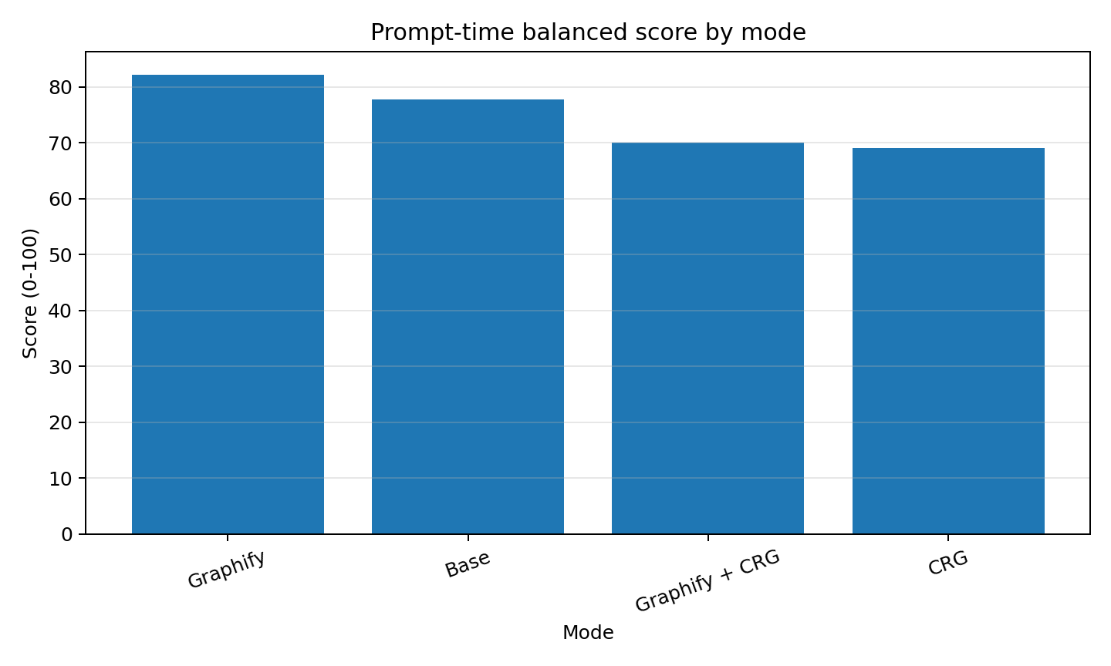

2. Analysis contract
- Matrix: 6 cases x 4 modes = 24 runs.
- Case weighting: everyday cases = 70%, hard graph-friendly cases = 30%.
- Judging: strict, presentation-grade qualitative scoring.
- Balanced score uses prompt execution time only; setup time is reported separately.
- Deterministic validation is diagnostic, not the quality score.

3. Per-case winners
Case | Class | Quality winner | Quality score | Value winner | Value score | Cost winner | Cost USD | Prompt speed winner | Prompt time s
Admin permissions | Everyday | Graphify | 84 | Graphify | 83.7 | Base | 0.94 | Graphify | 128.9
Admin product edit field | Everyday | Graphify | 83 | Graphify | 82.5 | CRG | 0.73 | CRG | 109.4
Auth discovery | Hard graph-friendly | Graphify + CRG | 84 | Graphify + CRG | 82.8 | Base | 0.8 | CRG | 114.7
Cart to order flow | Hard graph-friendly | Graphify | 87 | Graphify | 86.9 | Base | 0.86 | Graphify | 125.8
Inactive customers CSV | Everyday | Graphify | 83 | Graphify | 82.7 | CRG | 0.62 | Graphify | 101.9
Order total impact | Hard graph-friendly | Base | 84 | Base | 83.5 | Graphify | 0.87 | Graphify + CRG | 157.3

4. Score matrices
Strict content score matrix
Case | base | crg | graphify | graphify+crg
admin-permissions | 78 | 79 | 84 | 68
admin-product-edit-field | 80 | 70 | 83 | 76
auth-discovery | 77 | 72 | 80 | 84
cart-to-order-flow | 82 | 66 | 87 | 74
inactive-customers-csv | 79 | 75 | 83 | 72
order-total-impact | 84 | 70 | 78 | 79

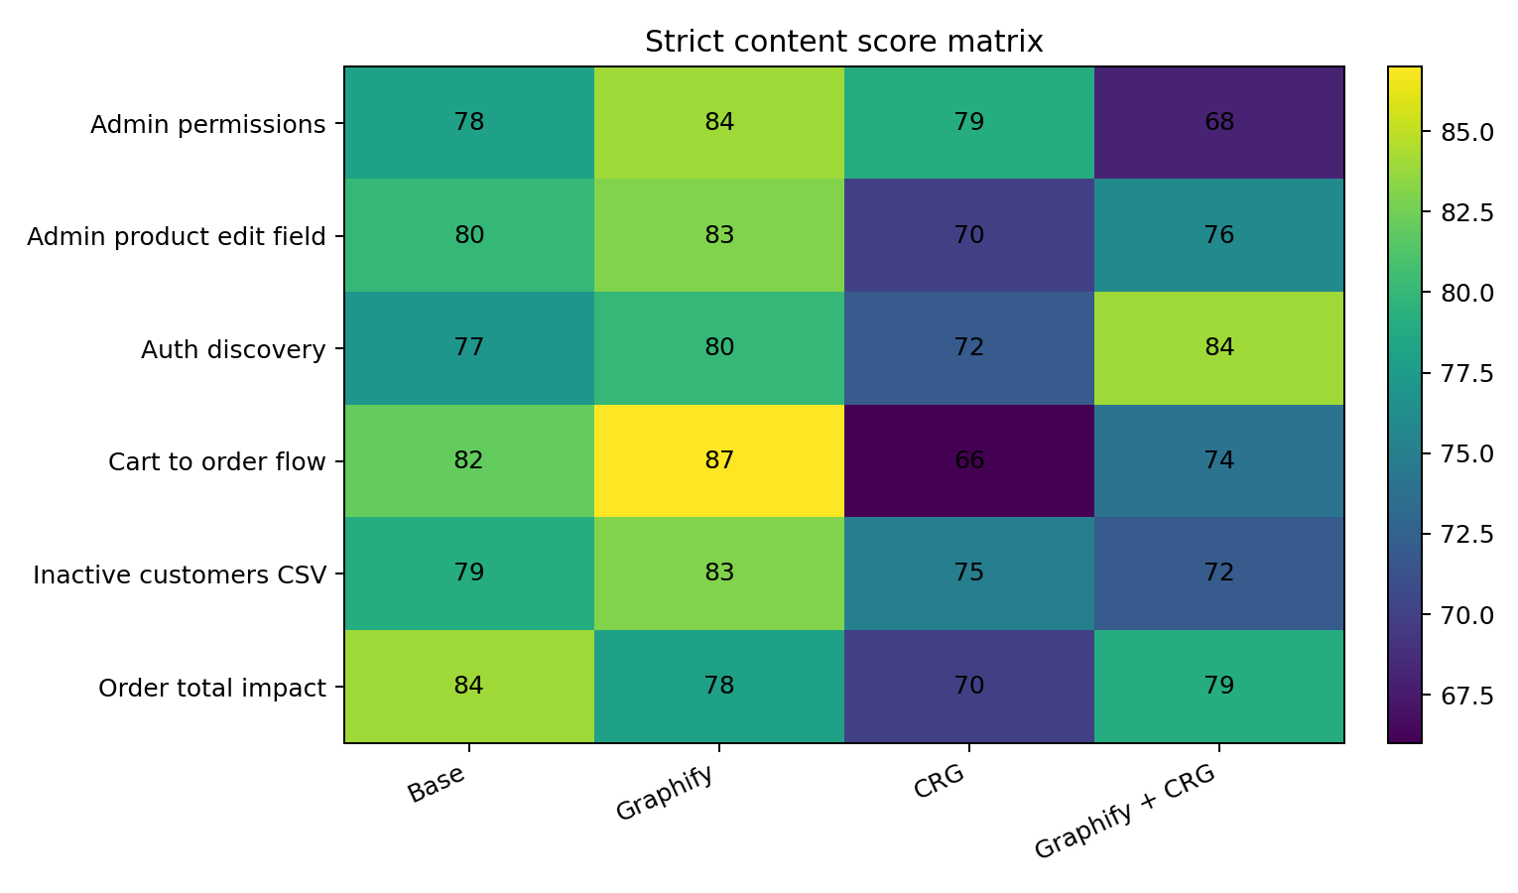
Prompt-time balanced score matrix
Case | base | crg | graphify | graphify+crg
admin-permissions | 75.7 | 76.9 | 83.7 | 62.0
admin-product-edit-field | 78.8 | 65.4 | 82.5 | 73.3
auth-discovery | 74.4 | 67.8 | 78.2 | 82.9
cart-to-order-flow | 80.2 | 58.5 | 86.9 | 69.1
inactive-customers-csv | 76.6 | 71.9 | 82.7 | 66.7
order-total-impact | 83.5 | 64.5 | 75.8 | 77.0

5. Cost, token, and time findings

5.1 Cost and prompt time
Mode | Cost USD | Prompt time s | Setup time s (separate) | Balanced score
Graphify | 0.981 | 129.1 | 87.0 | 82.1
Base | 0.91 | 145.5 | 0 | 77.7
Graphify + CRG | 1.044 | 151.8 | 108.7 | 70.0
CRG | 0.869 | 135.2 | 24.8 | 69.1

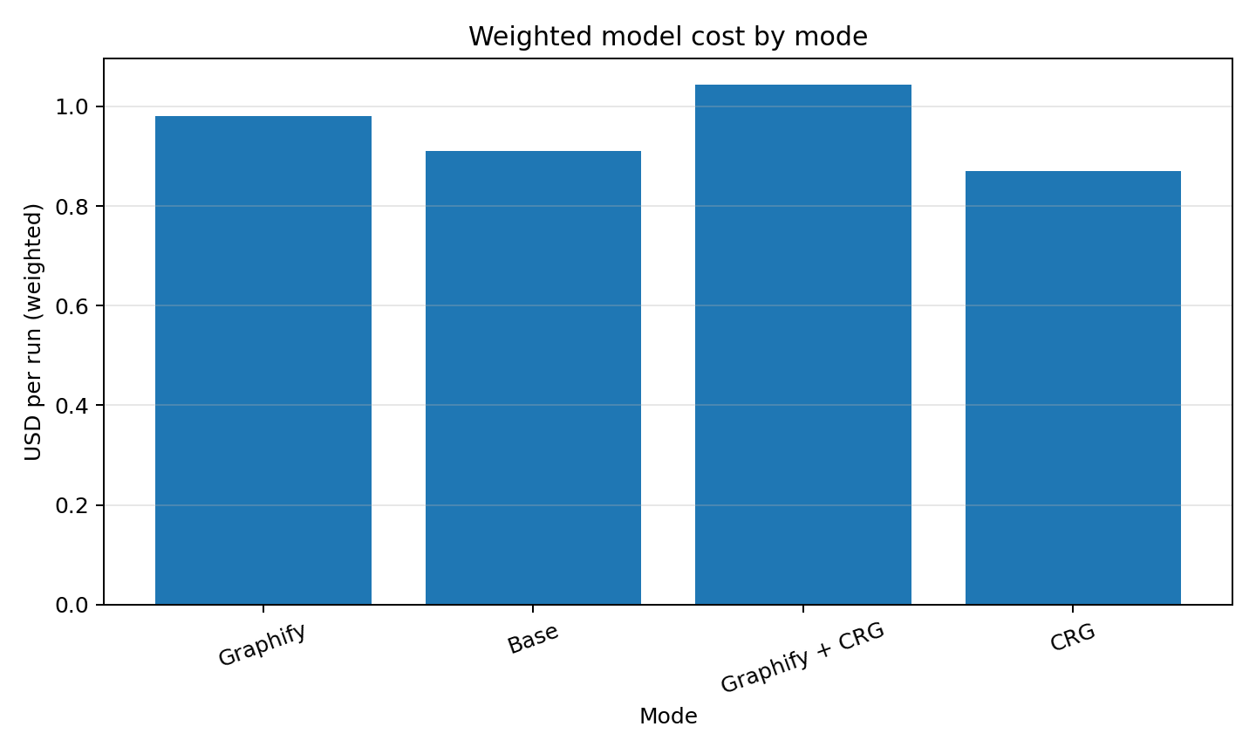
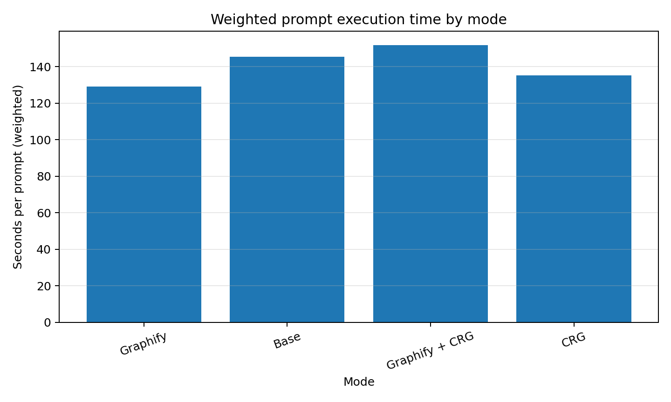

5.2 Token and tool summary
Mode | Input | Cached input | Uncached input | Output | Reasoning output | Total tokens | Avg cost USD | Prompt time s | Setup time s | Tool calls | CRG calls | Graphify calls | Cache hit rate | Answer words
Base | 554389.5 | 453717.3 | 100672.2 | 6044.7 | 1218.8 | 560434.2 | 0.91 | 147.8 | 0 | 36.5 | 0 | 0 | 0.81 | 969.5
CRG | 643125.3 | 549120.0 | 94005.3 | 5425.2 | 1089.2 | 648550.5 | 0.91 | 137.5 | 24.8 | 33.0 | 4.33 | 0 | 0.85 | 884.2
Graphify | 562340.5 | 445653.3 | 116687.2 | 5414.5 | 455.3 | 567755.0 | 0.97 | 133.6 | 86.5 | 65.7 | 0 | 10.3 | 0.79 | 814.2
Graphify + CRG | 821598.0 | 722986.7 | 98611.3 | 6386.3 | 1693.7 | 827984.3 | 1.05 | 157.6 | 108.7 | 29.3 | 0.33 | 6.67 | 0.88 | 905.0

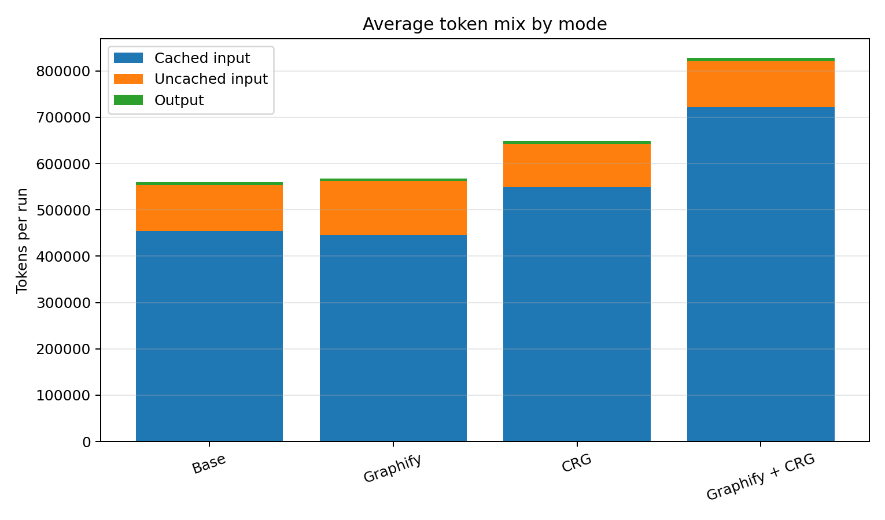
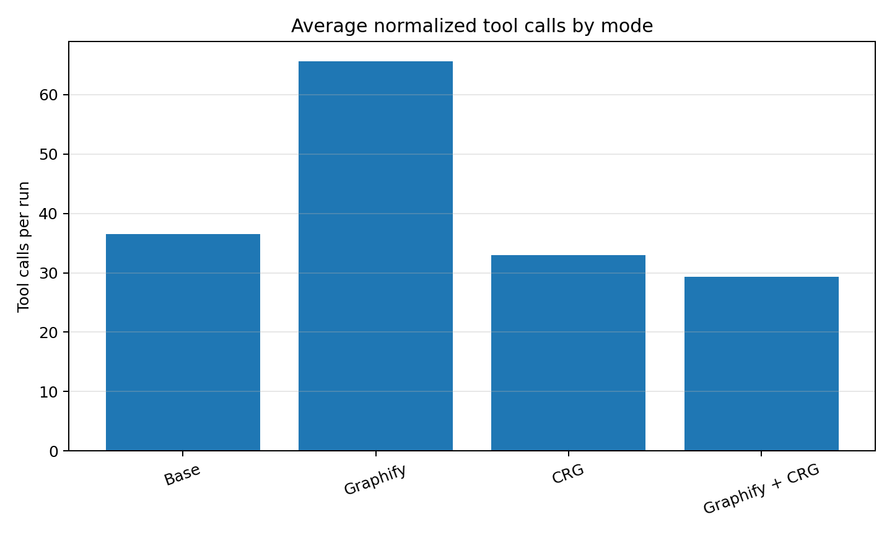

5.3 Graphify cost surprise
Graphify did not reduce model cost in this run. It improved strict content quality and prompt-time value, but it had higher uncached input than Base. The result is better answers, not cheaper prompts.
- Base average uncached input: about 101k tokens per run.
- Graphify average uncached input: about 117k tokens per run.
- Graphify output was slightly lower than Base, but not enough to offset higher uncached input.
- Graphify likely improved navigation but still required source reads for evidence.

6. Tool usage findings
CRG MCP calls by case
Case | base | graphify | crg | graphify+crg
admin-product-edit-field | 0 | 0 | 6 | 0
admin-permissions | 0 | 0 | 2 | 2
inactive-customers-csv | 0 | 0 | 6 | 0
auth-discovery | 0 | 0 | 6 | 0
order-total-impact | 0 | 0 | 6 | 0
cart-to-order-flow | 0 | 0 | 0 | 0

Normalized tool calls by case
Case | base | graphify | crg | graphify+crg
admin-product-edit-field | 28 | 58 | 38 | 26
admin-permissions | 26 | 70 | 34 | 28
inactive-customers-csv | 32 | 64 | 22 | 30
auth-discovery | 61 | 74 | 32 | 32
order-total-impact | 38 | 64 | 42 | 30
cart-to-order-flow | 34 | 64 | 30 | 30

- Graphify + CRG made only 2 total CRG MCP calls across six combined-mode runs.
- CRG-only made no CRG MCP calls on cart-to-order-flow, the most flow-oriented case.
- Graphify used more tool calls than Base, which partly explains the lack of token savings.

7. Mode-by-mode interpretation

Graphify
Role: Best default steady-state workflow
Strengths:
- Best global strict content score.
- Best prompt-time balanced score.
- Wins three everyday cases plus cart-to-order-flow.
- Improves navigation and developer handoff.
Weaknesses:
- Does not reduce model cost globally.
- Uses more tool calls and more uncached input than expected.
- Can encourage broader exploration than necessary.

Base
Role: Strong low-complexity fallback
Strengths:
- No setup cost.
- Strong quality for plain code navigation.
- Wins order-total-impact.
- Cheaper than Graphify on weighted cost.
Weaknesses:
- Slightly weaker global strict quality.
- More prompt execution time than Graphify under steady-state scoring.
- Can be dense and broad.

CRG-only
Role: Not recommended as daily default from this run
Strengths:
- Lowest weighted cost.
- Moderate setup time.
- Sometimes finds useful relationship context.
Weaknesses:
- Lower strict content than Base and Graphify.
- No clear out-of-box advantage.
- Weak on cart-to-order-flow.
- Tool usage inconsistent.

Graphify + CRG
Role: Selective hard-discovery escalation
Strengths:
- Wins auth-discovery.
- Can produce broad discovery maps.
Weaknesses:
- Highest weighted cost.
- Slowest weighted prompt execution.
- Often did not use CRG MCP tools.
- Worse than Graphify alone on everyday cases.

8. Case-by-case interpretation

Admin product edit field
Winner: Graphify
Best implementation map across controller, model, factory, view, domain/persistence, validation, localization, and migrations. Base was close; CRG was thinner.

Admin permissions
Winner: Graphify
Best permission-flow architecture, including authorization attributes, OR semantics, permission service/records, and registration flow.

Inactive customers CSV
Winner: Graphify
Best everyday export path through controller, search model, factory/service/export manager, and inactivity semantics.

Auth discovery
Winner: Graphify + CRG
Best broad map across login, registration, password recovery, MFA, external auth, routes, views, and services. This is the main case where combined mode looked justified.

Order total impact
Winner: Base
Most directly useful impact-analysis answer: direct consumer table, contract/service/plugin/test surfaces, and useful prioritization.

Cart to order flow
Winner: Graphify
Best strict answer overall: clear sequence from add-to-cart through checkout/order creation and ShoppingCartItem-to-OrderItem conversion.

9. Caveats and recommended follow-ups
- One repetition per cell; results are directional rather than statistically definitive.
- Single repository: nopCommerce.
- LLM judging is strict but still subjective.
- Tool usage depends on agent choices; available tools can be underused.
- Graph setup was repeated for sandboxing; real-life setup economics differ.
- Graphify token savings were not shown and need separate tool-budget experiments.
Recommended follow-up experiments:
- Repeat the close cells: Base vs Graphify on everyday cases and order-total-impact.
- Test Graphify with a source-read budget to see whether it can become a token saver.
- Run CRG with verified tool usage on flow/impact tasks.
- Repeat on additional repositories.
- Run 3+ repetitions for key cells before making strong product claims.

Appendix - strict notes by run

admin-product-edit-field

graphify — 83.0
Best strict answer for this case: complete and practical, but still not a near-perfect artifact because it is broad and caveats are implicit.
Strengths: Very complete MVC/admin-field map with good file evidence and supporting implementation path.
Weaknesses: Over-complete for the prompt; could be tighter and explicitly mark optional vs mandatory files.

base — 80.0
Strong implementation map, but stricter grading penalizes breadth, shortened paths, and lack of crisp source-verified next-step sequencing.
Strengths: Covers controller/model/factory/view/domain/persistence path and gives usable implementation guidance.
Weaknesses: Too broad for candidate-path task; deterministic source path formatting issues; not enough separation between confirmed files and inferred follow-ups.

graphify+crg — 76.0
Good but not efficient or crisp: it maps the area well, but strict grading penalizes over-breadth and some plausible-but-not-proven migration/version guidance.
Strengths: Broad end-to-end coverage with controller/model/factory/view/persistence guidance.
Weaknesses: Too exhaustive; some guidance reads inferred rather than source-demonstrated; not better than Graphify alone.

crg — 70.0
Usable but clearly weaker than base/Graphify under stricter grading: it covers the main path, but with thinner implementation specificity.
Strengths: Finds required files and most adjacent components.
Weaknesses: Less concrete on existing field examples, UI binding, and exact implementation sequence; weaker developer handoff.

admin-permissions

graphify — 84.0
Strongest strict answer for permissions: clear architecture and permission-flow evidence, though still not flawless as a step-by-step change guide.
Strengths: Excellent coverage of authorization attributes, OR semantics, permission service/records, and registration flow.
Weaknesses: Less explicit on admin UI management and concrete add-new-permission checklist.

crg — 79.0
Very usable but not presentation-perfect: broad structural coverage, but less crisp as a workflow handoff.
Strengths: Broad permission structure, plugin/admin notes, authorization behavior, service details.
Weaknesses: Verbose; weaker concrete “do this next” guidance; risks overwhelming a daily-workflow user.

base — 78.0
Solid answer, but stricter grading lowers it because it is explanatory rather than a concise implementation-ready path.
Strengths: Explains admin authorization layers and key permission components.
Weaknesses: Could better prioritize exact files/actions for adding/checking a permission; somewhat verbose.

graphify+crg — 68.0
Acceptable but noticeably behind: main layers are present, but it lacks enough concrete examples and implementation guidance for a high score.
Strengths: Covers attributes, service, records, startup, and management areas.
Weaknesses: Too generic in places; less evidence and less actionable than other modes.

inactive-customers-csv

graphify — 83.0
Best strict answer: gives a strong everyday export implementation path with useful nuance, but still leaves a few UI/localization details underdeveloped.
Strengths: Clear path through controller, search model, factory/service/export manager; good inactive-definition discussion.
Weaknesses: Could be more explicit on button placement/localization and exact CSV formatter reuse.

base — 79.0
Strong and usable, but strict scoring penalizes length and incomplete UI/localization specificity.
Strengths: Good controller/search model/service/export path; useful inactivity semantics.
Weaknesses: Long; should more clearly distinguish query/filter/export/UI changes and exact CSV precedent.

crg — 75.0
Usable but not as strong as base/Graphify: good semantics, thinner controller/UI details.
Strengths: Good inactivity semantics and service/export coverage.
Weaknesses: Less complete on UI binding, controller action details, and implementation sequence.

graphify+crg — 72.0
Usable concise map, but strict grading penalizes thinner source evidence and less complete action detail.
Strengths: Good integration-point table and service/export/resource mentions.
Weaknesses: Less exhaustive evidence; less concrete about existing export action and where exactly to add UI.

auth-discovery

graphify+crg — 84.0
Best strict answer for auth: complete and well grouped, though still long and with some broad/glob references.
Strengths: Strong workflow grouping across controller/service/MFA/external auth/routes/views.
Weaknesses: Long; a few view references are broad rather than exact; not all uncertainty is explicit.

graphify — 80.0
Strong auth discovery answer with broad coverage and better completeness, but still a large map rather than a concise workflow-level synthesis.
Strengths: Covers primary auth flows, external auth, MFA, services, models, routes/views.
Weaknesses: Large and somewhat undifferentiated; caveats and source-confirmed vs inferred boundaries could be clearer.

base — 77.0
Good broad auth map, but strict scoring penalizes candidate-map format and limited workflow narrative/uncertainty separation.
Strengths: Covers login, registration, password recovery, MFA, external auth and important files.
Weaknesses: More of a file inventory than a verified flow map; long and not sharply prioritized.

crg — 72.0
Usable source-verified map, but under strict grading it is less precise and more directory-level than the leaders.
Strengths: Includes core controller/service and several auth-related areas.
Weaknesses: Some references are broad or directory-level; less polished organization and lower precision.

order-total-impact

base — 84.0
Best strict answer for impact: comprehensive and directly useful, though length keeps it below exceptional.
Strengths: Direct consumer table, contract/implementation/service/plugin/test surface, useful prioritization.
Weaknesses: Long and dense; some shortened display paths; could separate highest-risk changes more sharply.

graphify+crg — 79.0
Strong broad map but not clearly better than base; strict grading penalizes length and unnecessary tool/method note.
Strengths: Good contract/order-processing/checkout/payment/discount/tax/test coverage.
Weaknesses: Long; Graphify note is irrelevant; not clearly more actionable than base.

graphify — 78.0
Good impact map, but strict scoring penalizes density, weaker prioritization, and limited caveats.
Strengths: Covers contract, DI, order processing, checkout/payment/discount/tax/plugins/tests.
Weaknesses: Dense affected-surface list; not as risk-prioritized as base; limited caveats.

crg — 70.0
Usable but not strong enough: relationship evidence is useful, but prioritization and direct-consumer framing lag behind.
Strengths: Good relationship-style coverage of checkout/payment/plugins/tax/discount/tests.
Weaknesses: Verbose; less structured; misses useful direct-consumer framing and priority ranking.

cart-to-order-flow

graphify — 87.0
Best strict answer overall: clear source-backed cart-to-order sequence, excellent transition point, still not perfect because caveats are limited.
Strengths: Clear sequence from add-to-cart through checkout/order creation; strong ShoppingCartItem-to-OrderItem conversion explanation.
Weaknesses: Could add more explicit uncertainty/caveat notes and distinguish core vs side-effect paths.

base — 82.0
Strong flow trace with detailed source evidence, but strict grading penalizes density and lack of concise executive sequence.
Strengths: Detailed chain from route/controller to cart service, checkout, PlaceOrderAsync, post-processing and cleanup.
Weaknesses: Long and dense; could better isolate the minimal flow from supporting detail.

graphify+crg — 74.0
Solid but not top-tier: covers the required flow, but lacks richness and precision compared with base/Graphify.
Strengths: Good high-level sequence through add-to-cart, checkout, PlaceOrderAsync, SaveOrderDetailsAsync, cleanup.
Weaknesses: Less detail on routes, payment request, post-processing, events, persistence; not enough evidence of combined-tool value.

crg — 66.0
Weakest strict flow answer: it is usable, but the CRG advantage did not materialize and the answer itself is less complete.
Strengths: Covers main required files and broad flow stages.
Weaknesses: Less route/post-processing/persistence detail; final note about graph MCP cancellation undermines the run; weaker evidence depth.

