 San Francisco Bay University

EE461 Verilog-HDL
2023 Spring Final Exam

Student Name: Student ID:

- Write Verilog module in behavioral level to create a clock signal divided by 2.5 from the given input clock and verify the design by the testbench.
module Div25(
clk,
rst,
clkOut_o
);

input clk;
input rst;
output clkOut_o;
reg[3:0] rEdgeCnt_r;
reg[3:0] fEdgeCnt_r;

assign clkOut_o = ((rEdgeCnt >0 && rEdgeCnt < 2) || fEdgeCnt > 3 ) ? 1'b0: 1'b1;

always@(posedge clk)begin
if(rst) rEdgeCnt_r <= 0;
else if(rEdgeCnt_r == 4)rEdgeCnt_r <= 0;
else rEdgeCnt_r <= rEdgeCnt_r + 1;
end

always@(negedge clk)begin
if(rst) fEdgeCnt_r <= 0;
else if(fEdgeCnt_r == 4)fEdgeCnt_r <= 0;
else fEdgeCnt_r <= fEdgeCnt_r+ 1;
end

endmodule

module tb();
reg clk, rst;
wire clkOut_o;

Div25 u1 (clk, rst, clkOut_o);

always #5 clk = ~clk;

initial begin
{clk, rst} = 1'b0;
#3 rst = 1'b1;
#5 rst = 1'b0;
#50 $finish();
end

always @(posedge clk) begin
$display("clkOut_o=%b", clkOut_o);
end
endmodule

- Design RTL module using mealy machine for digital lock. If 3 inputs from 3 buttons are "2010", then create open signal to 1. And verify your design by the testbench.

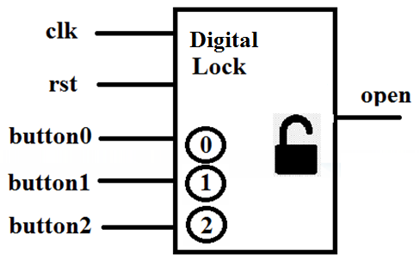

module ECL(clk, rst, button0, button1, button2, open);
input clk, rst;
input button0, button1, button2;
output open;

design
module ECL(input clk, rst, b0, b1, b2,
output reg open);

parameter pidel = 3'b000;
parameter p2 = 3'b001;
parameter p20 = 3'b010;
parameter p201 = 3'b011;
parameter p2010 = 3'b100;

reg [2:0] curt;
reg [2:0] next;

always@(posedge clk)begin
if(rst) curt <= pidel;
else curt <= next;
end

always@(*)begin
open = 1'b0;
case(curt)
pidel: begin
if (b2) next = p2;
else next = pidel;
end

p2: begin
if (b0) next = p20;
else next = pidel;
end

p20: begin
if (b1) next = p201;
else next = pidel;
end

p201: begin
if (b0) begin
open = 1'b1;
next = p2010;
end
else next = pidel;
end

p2010: begin
next = pidel;
end

default: begin
next = pidel;
end

endcase

end

endmodule

Testbench:
module tb();
reg clk, rst, b0, b1, b2;
wire open;

ECL u1 (clk, rst, b0, b1, b2, open);

always #5 clk = ~clk;

initial begin
{clk, rst, b0, b1, b2} = 1'b0;
// $monitor("b0=%b, b1=%b, b2=%b, open=%b", b0, b1, b2, open);
$dumpfile("wave.vcd");
$dumpvars;
#3 rst = 1'b1;
#5 rst = 1'b0;
#5 b2 = 1'b1;
#5 b0 = 1'b1;
#5 b1 = 1'b1;
#5 b0 = 1'b1;
#10;

#5 $finish();

end

endmodule
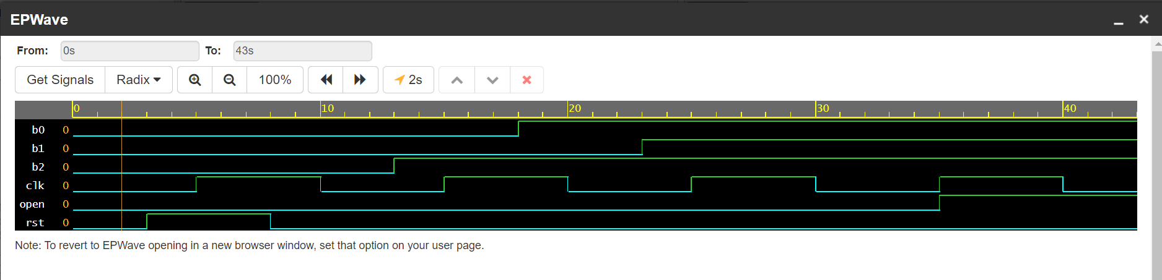
Figure successfully open

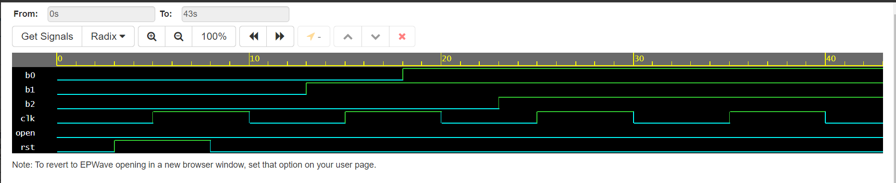
Figure when not open

- Design mealy machine in minimum number of states with one-hot encoding to detect "0101" from serial input bit stream in Verilog module and draw the FSM logic bubble diagram. After that, verify your design by the testbench.

Design:
module detecter(input in, rst, clk,
output out);

parameter S0 = 4'b0001;
parameter S01 = 4'b0010;
parameter S010 = 4'b0100;
parameter S0101 = 4'b1000;

reg [3:0] curt;
reg [3:0] next;

reg out;

always@(posedge clk)begin
if (rst) curt <= S0;
else curt <= next;
end

always@(*)begin
out = 1'b0;
case(curt)
S0: begin
if (in)begin
next = S01;
end else begin
next = S0;
end
end

S01: begin
if (in)begin
next = S0;
end else begin
next = S010;
end
end

S010: begin
if (in)begin
out = 1'b1;
next = S0101;
end else begin
next = S0;
end
end

S0101: begin
if (in) begin
next = S0;
end else begin
next = S010;
end

end

default: begin
next = S0;
end

endcase

end

endmodule

Testbench:
module tb();
reg in, rst, clk;
wire out;

detecter u1 (in, rst, clk, out);

always #5 clk = ~clk;

initial begin
{rst, in} = 1'b0;
$monitor("in = %b, out = %b, rst = %b", in, out, rst);
#2 rst = 1'b1;
#5 rst = 1'b0;
#5 in = 1'b0;
#5 in = 1'b0;
#5 in = 1'b0;
#5 in = 1'b1;
#5 in = 1'b0;
#10;
#5 $finish();

end

endmodule

- Given that 3-bits Pseudo-random number generation polynomial is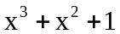,
write Verilog RTL module and logic diagram in inverse LFSR using "xor" gates with seed value 3’b111. And verify your design by the testbench. After 3 clock cycles, what random number will you get?

`define kBitW 3
`define kBitS `kBitW-1:0

module question4(input clk, rst, en_i,
output [`kBitS] cnt_o,
output bitStr_o);

reg [`kBitS] cnt_o;

assign bitStr_o = cnt_o[2];

always@(posedge clk)begin
if (rst) cnt_o <= 3'b111;
else if(en_i) begin
cnt_o[0] <= cnt_o[2] ^ cnt_o[0];
cnt_o[1] <= cnt_o[0];
cnt_o[2] <= cnt_o[1];
end
end

endmodule

module tb();
reg clk, rst, en_i;
output [2:0] cnt_o;
output bitStr_o;

question4 u1 (clk, rst, en_i, cnt_o, bitStr_o);

always #5 clk = ~clk;

initial begin
{rst, en_i, clk} = 1'b0;
#3 rst =1'b1;
#5 rst = 1'b0;
#5 en_i = 1'b1;
#10 $display("rand = %b", cnt_o);
#10 $display("rand = %b", cnt_o);
#10 $display("rand = %b", cnt_o);
#10 $display("rand = %b", cnt_o);
end
endmodule

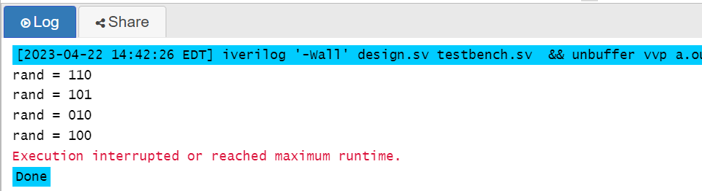

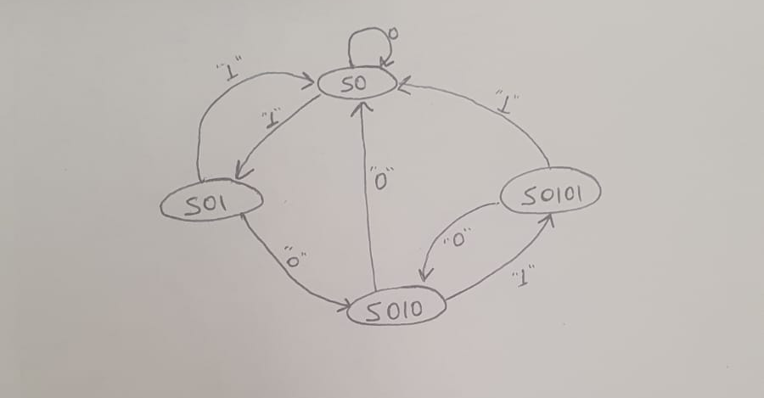

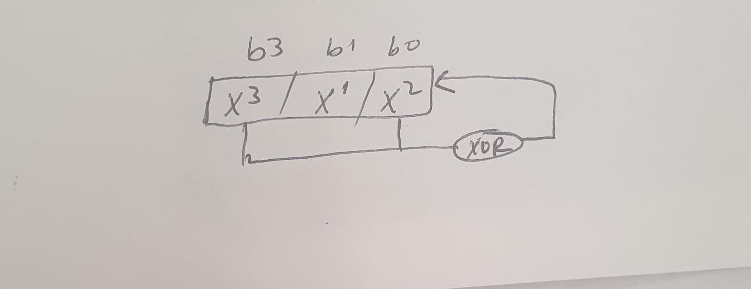

Diagram for question 3 and 4

