 San Francisco Bay University

EE461 Verilog-HDL
Homework #5
Due day: 4/12/2023

Instruction:

- Push answer sheets/source code to Github
- Please follow the code style rule like programs on handout.
- Overdue homework submission could not be accepted.
- Takes academic honesty and integrity seriously (Zero Tolerance of Cheating & Plagiarism)

- Draw FSM logic chart to detect bit stream pattern “1110” and design FSM in Verilog to output flag signal.

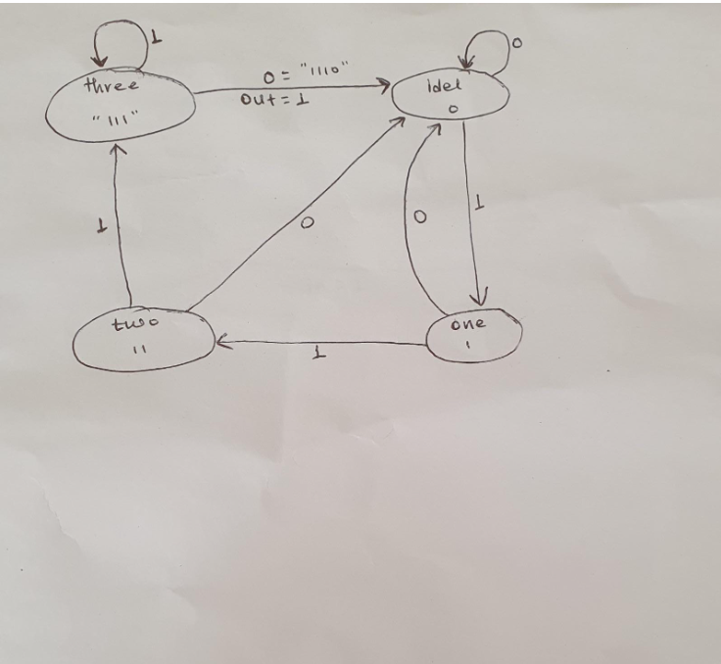

module d(input in,
input clk,
input rst,
output reg out);

parameter pidel= 3'b00;
parameter one = 3'b01;
parameter two = 3'b10;
parameter three = 3'b11;

reg [2:0] cutst;
reg [2:0] nxtst;

always@(posedge clk, posedge rst)begin
if(rst) cutst <= #1 pidel;
else cutst <= #1 nxtst;
end

always@(*)begin
out = 1'b0;
case(cutst)
pidel:begin
if(in) nxtst = one;
else begin
nxtst = pidel;
end
end

one: begin
if(in) nxtst = two;
else nxtst = pidel;
end

two: begin
if(in) nxtst = three;
else nxtst = pidel;
end

three: begin
if(in) nxtst = three;
else begin
nxtst = pidel;
out = 1'b1;
end
end

default:
nxtst = pidel;
endcase
end

endmodule

Testbench:

module tb;
reg in, clk, rst;
wire out;

d u1 (in, clk, rst, out);

always #5 clk = ~clk;

initial begin
{in, clk, rst} = 0;
$monitor("out = %b in = %b", out, in);
#5 rst = 1;
#5 rst = 0;
#5 in = 1;
#5 in = 1;
#5 in = 1;
#5 in = 1;
#5 in = 0;
#5;
#5 $finish;

end
endmodule

- Design FSM in Verilog to detect bit stream which could be divided by 7 and output flag signal.

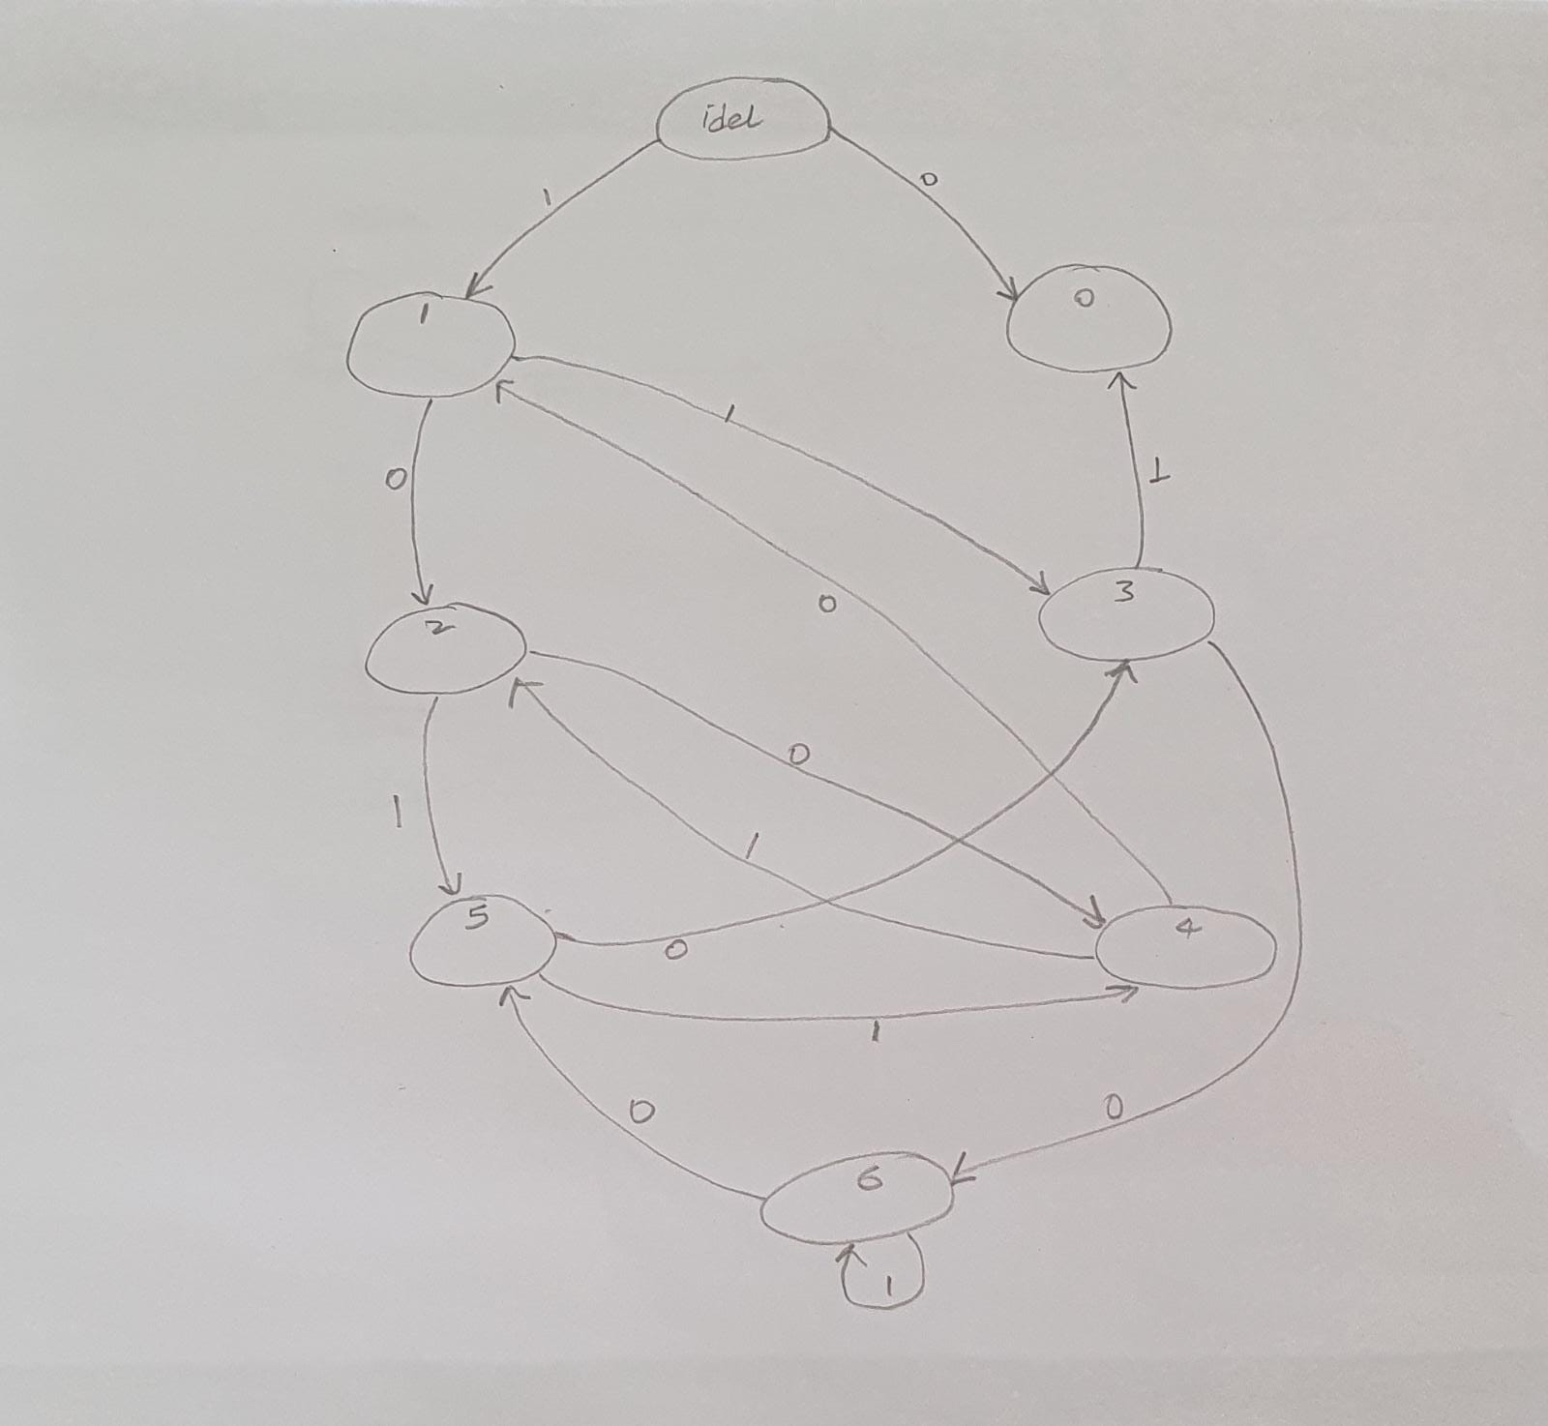

module div7(input in, clk, rst,
output out);

reg out;

parameter pIdle = 3'b000;
parameter pRem0 = 3'b001;
parameter pRem1 = 3'b010;
parameter pRem2 = 3'b011;
parameter pRem3 = 3'b100;
parameter pRem4 = 3'b101;
parameter pRem5 = 3'b110;
parameter pRem6 = 3'b111;

reg[2:0] curt;
reg[2:0] nxt;

always@(posedge clk)begin
if(rst) curt <= #1 pIdle;
else curt <= #1 nxt;
end

always@(*)begin
out = 1'b0;
case(curt)
pIdle: begin
if(rst) nxt = pIdle;
else begin
if(in) nxt = pRem1;
else begin
out = 1'b1;
nxt = pRem0;
end
end
end
pRem0: begin
if(in) nxt = pRem1;
else begin
out = 1'b1;
nxt = pRem0;
end
end
pRem1: begin
if(in) nxt = pRem3;
else nxt = pRem2;
end
pRem2: begin
if(in) nxt = pRem5;
else nxt = pRem4;
end
pRem3: begin
if(in) begin
out = 1'b1;
nxt = pRem0;
end else nxt = pRem6;
end
pRem4: begin
if(in) nxt = pRem2;
else nxt = pRem1;
end
pRem5: begin
if(in) nxt = pRem4;
else nxt = pRem3;
end
pRem6: begin
if(in) nxt = pRem6;
else nxt = pRem5;
end
default: nxt = pIdle;
endcase
end
endmodule

Testbench:

module tbb;

reg in, clk, rst;
wire out;

div7 u1 (in, clk, rst, out);

always #5 clk = ~clk;

initial begin
$dumpfile("wave.vcd");
$dumpvars;
$monitor("in = %b out = %b", in, out);
{clk, rst, in} = 0;
#2 rst = 1'b0;
#2 in = 1;
#2 in = 0;
#2 in = 1;
#2 in = 1;
#2 in = 1;
#2 in = 0;
#2 in = 1;
#2 in = 1;
#2 $finish;
end
endmodule

