**Deep Learning - Assignment 1**

**Group 1**

Instructor:

Yimin Yang

Group Members:

HaoRan Li

**1. Task Background**

To familiarize myself with deep learning, I implemented a neural network from beginning to end and adjusted the parameters

**2.Overview of the overall plan**

Implement a neural network that should learn exactly the same output and input, while modularizing the entire project. Implement multiple tuning functions in utils.py to improve learning rate, learning rate decrease, loss function, beta1, beta2, iteration count, batch_ Adjust the size to find the optimal parameter combination, and finally train the test set provided by the instructor and demonstrate the training effect

**3. Parameter fine-tuning experiment**

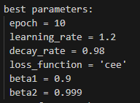

**4. Test Set Effect**

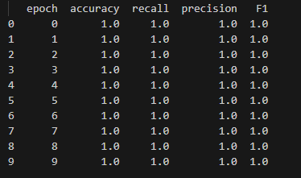

**5. Conclusion**

I have greatly improved my self perception and have gained a preliminary understanding of the implementation of neural networks. I have gained a deep impression of the entire workflow of neural networks and learned that code cannot be written dead, but should be modular, which is easy to maintain and modify in the future. And I am more proficient in fixing bugs than before. I can understand the error message and trace back to the source of the error message to determine which line of code is malfunctioning. Then, I simulate running this line of code in my mind, and I know which point is malfunctioning. I just need to correct it.

Also, during the implementation of this project, I learned some shortcut keys and became more proficient in Python and Python library functions, such as Pandas and Matplotlib. I also understood and learned some principles of deep learning

I don't care about the intensity of teaching methods. I am only grateful to the mentor, Yang Yimin. The main purpose is to enable me to enter the field of scientific research. I think this kind of learning can achieve the goal

**Appendix**

