The Lighthouse Keeper's Letter (followed by three newlines)

Chapter 1
Textbox

Mara climbed the spiral bold and italic for the first time in twenty years. The iron steps groaned beneath her boots, and salt air pressed against the narrow windows like an old insistent friend. Her grandfather had kept this lighthouse for four decades and now, three months after his funeral the deed had finally passed to her. This is yellow highlight.
Textbox over teksst with spelling error
Here is an image
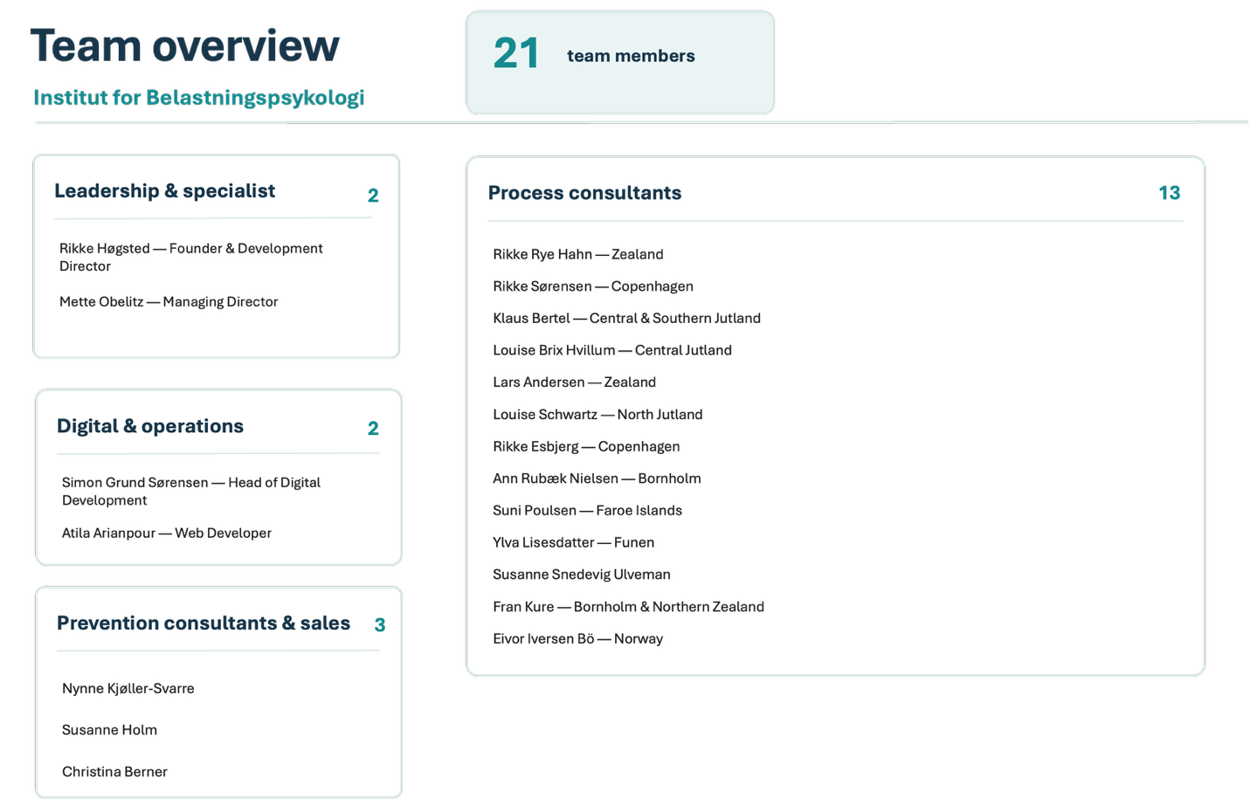
At the top the lantern room was exactly as she remembered: brass fittings polished to a soft glow, the great lens silent and watchful, a logbook open on the small oak desk. She set down her bag and ran a finger along the windowsill. No dust. Someone had been here recently. Here are some sunglasses.
A folded sheet of paper lay tucked beneath the logbook, her name writen on the front in her grandfather's careful hand. Mara sat down before she opened it, because her knees had began to tremble and she did not want to admit why. This is bold and italic.
"Mara, the letter began, "if you are reading this, then I have finally ran out of excuses to tell you the truth myself. Forgive an old man his cowardice."
She read slowly. He wrote about the night her mother had left, about the storm that had driven a small fishing boat onto the rocks below the cliff, about the woman he had pulled from the surf and carried up these very stairs. He wrote about the choice he had made to keep her secret, and about the daughter that woman had left behind in his care. Now a newline.

"You was three years old," he wrote. "You called me Grandfather because that is what I asked you to call me. I am sorry. I loved you no less for the lie, and perhaps a little more, because I knew what it cost."
***
Mara set the letter down. Outside, gulls turned slow circles above the water and the sea moved with the same patient rhythm it had kept since long before her birth. She thought she ought to feel angry, or betrayed, or unmoored. Instead she felt only a quiet surprising tenderness, as though a door she had never noticed had opened in a familiar room.

She picked up the logbook and turned to the most recent entry. It was dated the morning of his death. In a hand grown thin and shakey, he had written: "wind light from the southwest. Visibility good. Told M. about the letter today. She did not understand, but she will, when the time comes. The light is ready. So am I."
Mara closed the book. She stood, walked to the great lens, and laid her palm flat against the cool glass. The sea stretched away in every direction, vast and bright and indifferent and somewhere out there, she understood now, was a story that belonged to her and that she had only just begun too learn.
She would stay the night. In the morning, she would light the lamp.

Chapter 2
Mara climbed the spiral staircase for the first time in twenty years. The iron steps groaned beneath her boots, and salt air pressed against the narrow windows like an old insistent friend. Her grandfather had kept this lighthouse for four decades and now, three months after his funeral the deed had finally passed to her.
***
At the top the lantern room was exactly as she remembered: brass fittings polished to a soft glow, the great lens silent and watchful, a logbook open on the small oak desk. She set down her bag and ran a finger along the windowsill. No dust. Someone had been here recently.

A folded sheet of paper lay tucked beneath the logbook, her name writen on the front in her grandfather's careful hand. Mara sat down before she opened it, because her knees had began to tremble and she did not want to admit why.
"Mara, the letter began, "if you are reading this, then I have finally ran out of excuses to tell you the truth myself. Forgive an old man his cowardice."
She read slowly. He wrote about the night her mother had left, about the storm that had driven a small fishing boat onto the rocks below the cliff, about the woman he had pulled from the surf and carried up these very stairs. He wrote about the choice he had made to keep her secret, and about the daughter that woman had left behind in his care.
"You was three years old," he wrote. "You called me Grandfather because that is what I asked you to call me. I am sorry. I loved you no less for the lie, and perhaps a little more, because I knew what it cost."
Mara set the letter down. Outside, gulls turned slow circles above the water and the sea moved with the same patient rhythm it had kept since long before her birth. She thought she ought to feel angry, or betrayed, or unmoored. Instead she felt only a quiet surprising tenderness, as though a door she had never noticed had opened in a familiar room.
She picked up the logbook and turned to the most recent entry. It was dated the morning of his death. In a hand grown thin and shakey, he had written: "wind light from the southwest. Visibility good. Told M. about the letter today. She did not understand, but she will, when the time comes. The light is ready. So am I."
Mara closed the book. She stood, walked to the great lens, and laid her palm flat against the cool glass. The sea stretched away in every direction, vast and bright and indifferent and somewhere out there, she understood now, was a story that belonged to her and that she had only just begun too learn.
She would stay the night. In the morning, she would light the lamp.

