Investigation into the relationship between traffic pollution and health

Simon Gunning
MSc Data Science project report,
Department of Computer Science and Information Systems, Birkbeck College,
University of London
2018
This report is substantially the result of my own work,
expressed in my own words, except where explicitly indicated in
the text. I give my permission for it to be submitted to the
JISC Plagiarism Detection Service.
The report may be freely copied and distributed provided the
source is explicitly acknowledged.

Abstract
The abstract is a brief synopsis of your work, a bit like an
executive summary
It should be no longer than about 250 words
It's usually a good idea to write this at the end (when
everything else is known)
Beneath the abstract, put the name of your supervisor

Introduction

Air pollution has long been associated with poor health. There is epidemiological evidence for an association between traffic pollution and respiratory disease.

This project will explore and visualise disease prevalence data and traffic air pollution data. The project will gather data on air pollution in London and combine it with epidemiological data from the National Health Service (NHS). Data Science tools will then be used to analyse the data and methods developed to visualise the data and the results of the analysis. This project will require both a software design and implementation effort and a statistical modelling and analysis exercise.
The disease that will be considered is Asthma. However, the software developed for the project will also be able to be used to investigate other diseases. Asthma is a disease of the lungs and airways. It is thought that its causes are both environmental and genetic. A significant environmental factor is air quality. Air quality is thought to play a part in the incidence of Asthma by causing inflammation to the lungs and airways. Air quality is affected by several types of pollution including smoking, industrial pollution and traffic pollution. There is medical literature describing the mechanisms of how airborne pollution can cause Asthma. It is thought that it is caused by a combination of genetic and environmental factors.
The UK National Health Service (NHS) accurately monitors several diseases including Asthma at the level of General Practitioner (GP) Practices. A GP Practice is a local provider of medical services. There are approximately 1,000 GP Practices in Greater London. Data about disease prevalence at GP practices is made available by NHS Digital as part of the Qualities and Outcomes Framework (QOF). The QOF is a system for measuring GPs in the National Health Service (NHS). It is compiled annually and aggregates data at a practice level. The data is anonymous and it does not refer to specific patients. The data for each year (1st April to 31st March) is held in spreadsheets which can be downloaded from the NHS Digital website, https://digital.nhs.uk/ .

The spreadsheets contain details of the Practices including the number of patients known as the ListSize. The QOF spreadsheet also contains the number of patients that suffer from various diseases this is known as the Register. There is a prevalence of each disease calculated for each practice. Each practice has a name and a unique Practice Code, e.g. “M85063”. The Practices data also include Region Names and Region Codes, e.g., London which has the code “Y56”.

Air pollution data is provided in statistics published by the Department for Environment, Food and Rural Affairs (DEFRA). DEFRA manages a national network of monitoring stations which monitor airborne pollution levels. Their monitoring covers the whole of the UK. There are around 300 monitoring sites around the whole of the UK. A greater concentration of monitors for a smaller geographic area is provided by the London Air Quality Network, which manages monitoring sites for London. The London Air Quality Network (LAQN) is a project run by King’s College London. LAQN has around 100 monitors in the Greater London Area. The monitors measure Nitrogen Dioxide (NO2), particles (PM10) and DUST. The data from the LAQN is available as Web Services from their website. Details of the API can be found at http://api.erg.kcl.ac.uk/AirQuality/help .
As the QOF is an annual collection of statistics I have used annual statistics from the LAQN. There is a webservice that returns annual summaries of pollution levels for all monitors. The results are in Javascript Object Notation (JSON). For each Site there is longitude, latitude and an annual mean for different types of pollution. Not all sites collect data on all pollutants. The readings are expressed as micrograms per cubic meter, ug/m3.
Because of the relatively high number of monitors for London I have chosen to restrict the health data to London GP practices. So when I process the QOF data I restrict the data to the London region based on the “Y56” code. As I plan to visualise the datasets I have chosen a geographical sub region of London for the visualization. I have chosen the Ward level. A ward is a unit of electoral geography. Wards are smaller than boroughs and contain on average 5,500 people. There is a larger geographical unit called a Clinical Commissioning Group which is recorded in the QOF. However I was concerned that the effects of pollution are based on the distances from the sources so a smaller area seemed preferable. In order to find out which ward each practice belongs to I use a reference file provided by NHS Digital which gives the PostCode for each Practice Code. I then call a web service on https://postcodes.io/ which provides location information including Ward, WardCode, latitude and longitude. I use another process to aggregate QOF data for each ward. I do not use the prevalence per practice from the QOF. Instead I recalculate prevalences based on ListSize and Register. This is to avoid any version of Simpson’s Paradox.
The annual pollution data also needs to be processed. For each monitor there is a latitude and longitude. This is used in a web service provided by https://postcodes.io/ to look up the ward and ward code for each monitor. The outputs from the QOF process and the Pollution Monitors process form the basis of subsequent map production and statistical analysis. There is further descriptions of the processing in Section XXXX
To the best of my knowledge no attempt has so far been made to analyse the co-occurrence in geographic wards of air pollution levels based on these monitors and particular disease occurrences for London.

See Particulate air pollution and acute health effects , Lancet Issue 8943, panel ProfA.SeatonMD D.GoddenMD W.MacNeeMD K.DonaldsonPhD

Aims and objectives of the project
The objective of the project is to investigate the relationship between health and pollution datasets.
The investigation will consist of the following parts :
- create a dataset of health data for the London region
- create a corresponding dataset of pollution data for the London region for the same years
- create a combined dataset of pollution and health data for a number of years
- create visualisations of the health and pollution dataset using maps
- statistical analysis of the health and pollution datasets consisting of
  - trends
  - correlations
  - predictions

In particular the relationship between road traffic related pollution and asthma will be investigated. Although the software developed for this project can be used to investigate several different diseases.

The research hypothesis (H₁) is that there is an association between high levels of pollution as measured by the monitoring system and a high prevalence of Asthma at a ward level in the surrounding area of a monitor.
The null hypothesis (H₀) is that there is no association between high levels of pollution as measured by the monitoring system and a high prevalence of Asthma at a ward level in the surrounding area of a monitor.

Background

Geographical Information Systems
John Snow famously used a combination of maps and statistics to identify the source of a cholera outbreak in London in 1854. He mapped the locations of where the cholera occurred and used this information to identify the source of the cholera as a water pump in Soho. This was one of the first instances of combining geographic and health data in the field of epidemiology.
With the advent of computer systems means of storing and processing maps have been developed. Maps can be stored as raster images or as vectors files. Vector images are defined in terms of points which are connected by lines to form polygons and other shapes. An advantage of using vector files to store maps is that the images can be exanded without loss of resolution.
The maps that I use for this project are stored as shapefiles. Shapefiles for London can be download from the London local government site https://data.london.gov.uk/ . The shapefile is actually a folder containing at least 3 different file types: .shp, .shx and .dbf.

In order to render maps from shapefiles you need to specify the coordinate reference system (CRS) that you will use. This defines the projection of the map. This is the way that points on an ellipsoid (the earth) are mapped onto a plane (the map). The map of London wards that I used had a default CRS of “OSGB36” which I converted to “epsg:4326” in order to position the monitors onto the map using longitude and latitude.
When running statistical analysis on geographic data it is necessary to factor in the extent to which events that are close to each other are likely to be similar. This is known as spatial dependency. Spatial dependency means that we cannot necessarily assume that the occurrence of nearby events is independent.
One of the assumptions of ordinary least squares regression is that all observations are independent and identically distributed. If we are to perform regression analysis on geographic data it is useful to compensate for spatial dependency.
A linear regression line will have the formula Y = a + bX + ε .
The spatial lag model includes a spatial lag of the dependent variable (average value in neighbouring units). The idea here is that the outcome in a given area will depend not only on the characteristics of that area, but also on the outcome in adjacent areas. The spatial lag model looks just like the standard OLS model with an added autoregressive term:
y = ρW_{Y} + bX + ε

ρ is a spatial autoregressive term W_{Y} is the spatial lag of the dependent variable.
In order to perform a spatial regression we create an adjacency matrix that defines links between geographic areas. So for example if we were modelling a ward the matrix would hold links to the surrounding wards. This can be generated from the shapefile. There are different algorithms that can be used known as rook or queen. These represent building links in a similar fashion to the way the chess pieces move. Then we assign weights to the links. The weights can be binary (1 for each neighbour) or row standardized (4 neighbours will each be weighted 25%). There will be weight for every Y term. Then we can use a specialised library like pysal to run the regression passing in the weighted matrix.
This geographic approach to analysing data can be applied to many scenarios apart from epidemiology. An example is behaviour (e.g. crime, shopping) modelled with geographic data.
Ref http://andrewgaidus.com/Spatial_Econonometric_Modeling/

Software Architecture
I have developed the code for the project using Python. I have used the Pandas library throughout. This is used to hold the data in Dataframes. Dataframes are an extremely useful way to hold large amounts of data in a 2 dimensional structure that is similar to a spreadsheet of a SQL Table. In the project I merge, concatenate and aggregate Dataframes.
Geopandas is a library that provides the capability to enhance a Dataframe with geographic data (from shapefiles). This data can then be displayed as maps using the matplotlib library.
For standard regressions I used the sklearn library.
To create the spatial weights matrix I have used the pysal library. I found this library difficult to use, there is a new version due at the end of 2018 which may be more simple.
The overall architecture pattern is a pipeline. Data is persisted in between steps in the pipeline in csv files. This is more convenient than using a database as the files are easier to check and there is no technical overhead.

Overall results

Maps

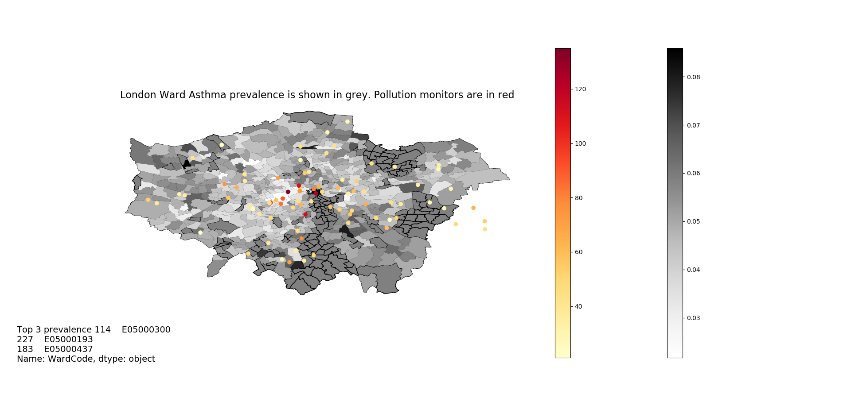
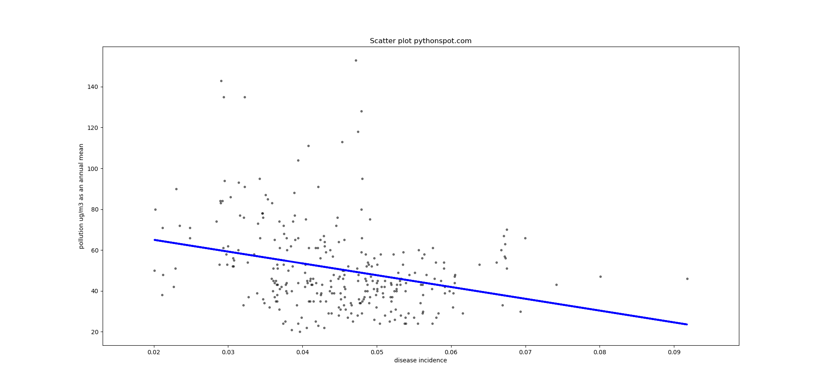

Software architecture

User Manual
- Run the QOFProcessor for each year that you want to create disease statistics for.

  - Description.

The QOF is an annual summary of different diseases that occur at GP surgeries. The data is publicly available from NHS Digital. The data is held in Excel files for each year, which have been downloaded to a local computer. When you run the QOFProcessor you will need to select the year to process. The format of the QOF has changed slightly over the years and the columns which contain the ListSize and the Register are in different positions. There is a dataframe that maps the year to the column positions. The QOF spreadsheet is parsed. Then all the practices for the Region = “London” are selected.
These are merged with a file that contains postcodes for the practices. For all the practices a web service is called using the postcodes. This returns the location details of the practices. The program outputs a file of Practices with the select disease occurences the size of the practice list, the ward and the longitude and latitude.

  - Inputs
    - Input the year that you wish to process into console.
    - QOF Excel file form local machine. Use FileDialogue to select.
    - The epracur file. This is a CSV file of the current GP practices and maps them to postcodes based on the 6 character practice code. Use FileDialogue to select.
    - The web service hosted at https://api.postcodes.io/postcodes . This returns location details for the practice in JSON format. It includes the ward, ward code, longitude and latitude.
  - Outputs
    - A csv file called LondonQOF with the year appended on the name, e.g, LondonQOF-2016

- Run the GetMonitorsWards
  - Description. This program accepts a year as input. Then it calls a webservice which returns a list of pollution monitors in the London region. Each monitor has among other things: an id, a location specified in latitude and longitude and details of the annual annual mean readings of the pollutants. The pollutants are NO2, SO2, DUST and PM10.
  - Inputs
    - The year that you want the data for. Entered at the console.
    - The webservice at http://api.erg.kcl.ac.uk/AirQuality/Annual/MonitoringObjective/GroupName=LAQN/Year=2018/Json
    - The webservice at http://api.postcodes.io/postcodes?lon=0.074372&lat=51.541119
  - Outputs
    - A csv file containing the annual pollution readings for each monitor. Called MonitorWardsFile-yyyy

- Run the AggregateQOF programme
  - Description. This program takes the output from the QOFProcessor. It sums the list and prevalence for each practice in each ward. It then calculates the ListSize / Register for each ward.Then it outputs a
  - file called LondonQOFAggregated-yyyy
  - Inputs
    - The LondonQOF-yyyy file
  - Outputs
    - The LondonQOFAggregated-yyyy file. Contains the following fields:
WardCode, Register, ListSize, Prevalence_perc, Year

- Run the CreateMap program for each year that we want to produce a map
  - Description. This program produces Choropleth maps for the London region. This show by colour grading areas of high incidence of a selected disease. They also show the location of monitors and the levels of pollutant at the monitors. Where there is missing data I have used median values.
  - Inputs
    - For each year use a LondonQOFAggregated-yyyy file and a MonitorWardsFile
    - The underlying map is produced using the London-wards-2014 ESRI files
  - Outputs
    - Map files

- Run the CombineQOFMonitorSets program
  - Description. This program will read the aggregated QOF File.
Then it will read the Monitors file for the pollution data.
Then it will merge them both based on WardCode.
  - Inputs
    - LondonQOFAggregated-yyyy file and the corresponding MonitorWardsFile-yyyy for the same year
  - Outputs
    - a CombinedFile-yyyy file

- Run the ConcatYears programme
  - Description. This program concatenates selected annual files to produce a single large dataset
  - Inputs
    - multiple CombinedFile-yyyy files
  - Outputs
    - the HealthPolltionDS file

- Run the StatisticalRegression program
    - Description. This program uses the sklearn library to run regressions and other statistical analyses on the combined historical data from the previous steps.
    - Inputs
      - At the command prompt enter thr type of pollutant you want statistics for. The choices are: NO2, PM10 and DUST
      - the HealthPolltionDS file
    - Outputs
      - Plots and summaries
t

Testing
Example Test Case
from QOF file

The following are the ward , longitude, latitude, practice code, CCG code List and Register for one ward in 2014

The process produced the following aggregation:

Describe the veri_cation process you used in your project
I Unit Testing, Static Analysis etc. - give an actual code
example with a short explanation and a link to where test are
stored. It is not su_cient to say you did this
I System testing, which can include manual testing, Selenium,
Cucumber etc. Describe your testing plan and the
consequences. It is not su_cient just to tell a story of how
your testing was done

Implementation
I Software development process (beware of buzzwords like
SCRUM, you are either admitting to group work or to a
serious overkill)
I Describe the technologies used in the project, why they where
chosen and what were the other options:
I Tools and programming languages.
I Data-base, servers etc.
I In most cases, the description should start from the choice,
proceed to the motivation and end with a discussion of other
possible choices that could have been made

Summary and Conclusions
I The final section
I summarizes the project as a whole
I A critical evaluation by the student, emphasizing
I strong points and weak points
I lessons learnt
I design decisions which, looking back, would be made
di_erently
I ways in which the project could be improved or extended
I etc.
I recommendations for the project
I You can also describe possible future work in the area of your
project

References
I You have to provide a complete list of all the works mentioned
in the text
I For a book, this normally includes the name(s) of the
author(s), the title, the publisher and date of publication
I For an article, it would include the name(s) of the author(s),
the title of the article, the name of the journal, the
volume/issue number and date and page numbers
I Examples:
I Bloggs F, Advanced Widget Design, Gargoyle Press, 2002
I Hardy O and Laurel S, _A software approach to _ne mess
avoidance_, Journal of Disaster Studies, Vol 4, 2000, pp
123-134

User Manual

Appendix: Code
I Additional relevant material which did not make it into the
main sections should appear in an appendix
I It can also include lengthy items such as
I program code
I raw data
I detailed statistical analysis
I If you have very lengthy items, you can include a CD or DVD
that contains these items
I Usually, there's no need to print out the complete source code

--------
Acknowledgements: if there are persons who you would like to
thank for their support and help
List of Figures/Tables: if you have used lots of figures and
tables
Abbreviation list: if you have used abbreviations (it's also a
good idea to spell out the meaning the first time you use an
abbreviation in the text)

