SIMON TRAN CPAN111 0NB

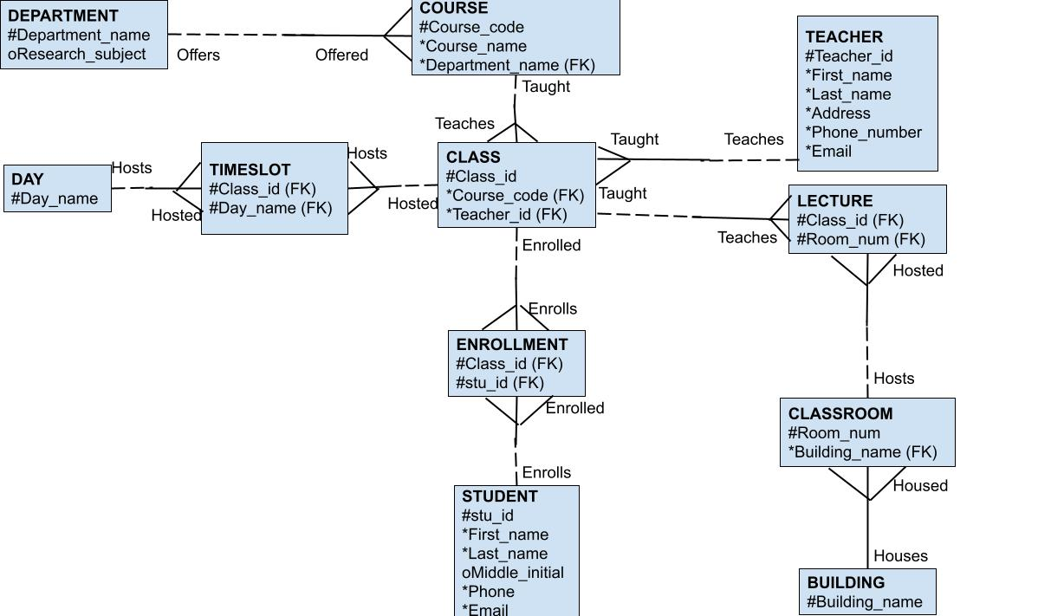Each Department may offer one or more Courses.

Each Course must be offered by only Department.

Each Course may be taught by one or more Classes.

Each Class must teach only one Course.

Each Class may be hosted by one or more Timeslots.

Each Class may be taught in one or more Lectures.

Each Class may be enrolled in one or more Enrollments.

Each Class must be taught by only one Teacher.

Each Timeslot must host only one Class.

Each Timeslot must be hosted by only one Day.

Each Day may host one or more Timeslots.

Each Lecture must teach only one Class.

Each Lecture must be hosted by only one Classroom.

Each Classroom may host one or more Lectures.

Each Classroom must be housed in only one Building.

Each Building must house one or many Classrooms.

Each Teacher may teach one or many Classes.

Each Enrollment must enroll in only one Class.

Each Enrollment must be enrolled by only one Student.

Each Student may enroll in one or many Enrollments.

|  |  |  |  |  |  |
| --- | --- | --- | --- | --- | --- |
| **Entity Name** | **Primary Key** | **Foreign Key** | **Dependency** |  |  |
| Department | Department_name | null | Independent |  |  |
| Course | Course_code | Department_name | Dependent |  |  |
| Class | Class_id | Course_code, Teacher_id | Dependent |  |  |
| Timeslot | Class_id, Day_name | Class_id, Day_name | Dependent |  |  |
| Day | Day_name | null | Independent |  |  |
| Teacher | Teacher_id | null | Independent |  |  |
| Lecture | Class_id, Room_num | Class_id, Room_num | Dependent |  |  |
| Classroom | Room_num | Building_name | Dependent |  |  |
| Building | Building_name | null | Independent |  |  |
| Enrolment | Class_id, stu_id | Class_id, stu_id | Dependent |  |  |
| Student | stu_id | null | Independent |  |  |
|  |  |  |  |  |  |
| **CLASS** | | |  |  |  |
| #Class_id | Course_code | Teacher_id |  |  |  |
| JELCP33 | CPAN133 | n003452 |  |  |  |
| JELCP34 | CPAN134 | n004828 |  |  |  |
| JELCP11 | CPAN111 | n001123 |  |  |  |
| GSCWR20 | WRIT120 | n002567 |  |  |  |
| ZZDEE45 | ELEC145 | n009881 |  |  |  |
| FGKAN10 | ANTH110 | n007456 |  |  |  |
|  |  |  |  |  |  |
| **STUDENT** | | | | | |
| #stu_id | First_name | Last_name | Middle_initial | Phone | Email |
| n104555 | Simon | Tran | null | 6472314444 | simontran18@gmail.com |
| n103882 | Jane | Doe | JD | 4169290888 | jane.doe@gmail.com |
| n102984 | Kevin | Nguyen | G | 9059790123 | k.nugyen@gmail.com |
| n109999 | Bucky | Buckson | null | 4372221111 | buckbuck@gmail.com |
| n107842 | Jagmeet | Singh | K | 5021217845 | JaggySingh@yahoo.com |
| n101509 | Marco | Rodriguez | SGH | 4162215490 | marco.rod@hotmail.com |
|  |  |  |  |  |  |
| **ENROLLMENT** | |  |  |  |  |
| #stu_id | #Class_id |  |  |  |  |
| n104555 | JELCP33 |  |  |  |  |
| n103882 | JELCP34 |  |  |  |  |
| n102984 | JELCP11 |  |  |  |  |
| n109999 | GSCWR20 |  |  |  |  |
| n107842 | ZZDEE45 |  |  |  |  |
| n101509 | FGKAN10 |  |  |  |  |