Program: Budget Tracker

Course:
CPE007 – Programming Logic and Design

Section:
CPE11S6

Instructor:
Engr. Robin Valenzuela

Group 1
Members:
Simon Patrick P. Lapuz
Bien Macaraeg
Thea Padilla
Gian Carlo Veruen

Date:
November 13, 2025
Objectives
- To allow the user to input their monthly income, expenses, and spending limit.
- Calculate how much the user will have saved based on their monthly income and spending limit.
- To allow the user to calculate reduced spending based on percentage for them to see how much they can save instead.

Statement of the Problem
As we all know, managing our finances may prove to be quite a challenge. Many people often have difficulties keeping track of their monthly savings and expenses which usually leads to poor management of their finances. In order to give these people a helping hand, our group will be developing a C++ program that allows users to efficiently track their monthly savings and expenses.

Pseudocode
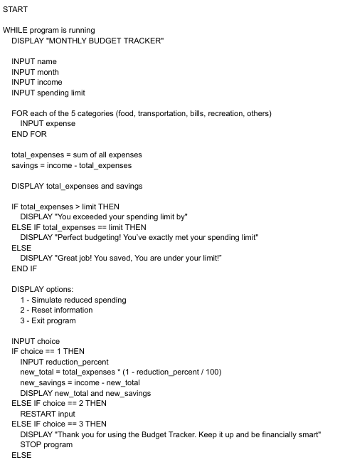
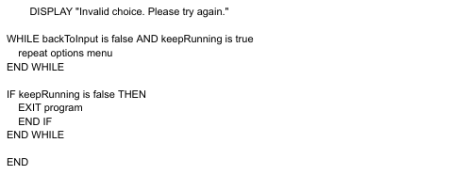

Flowchart
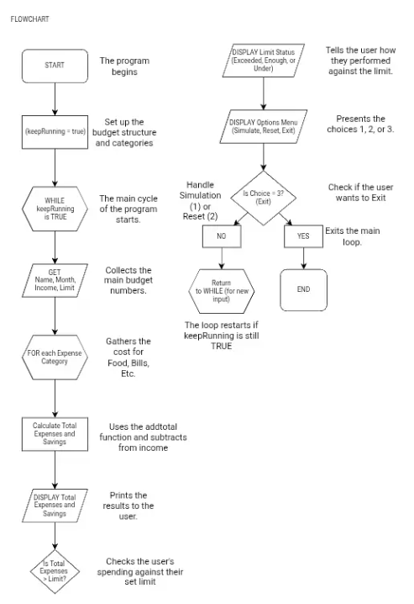
Program
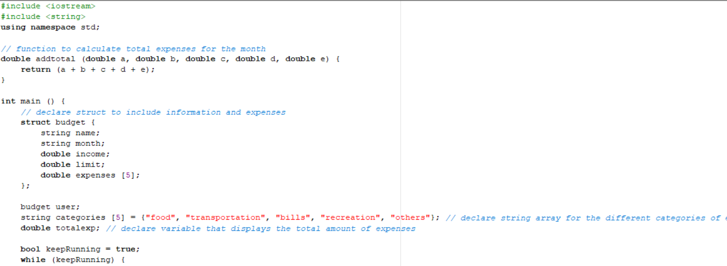
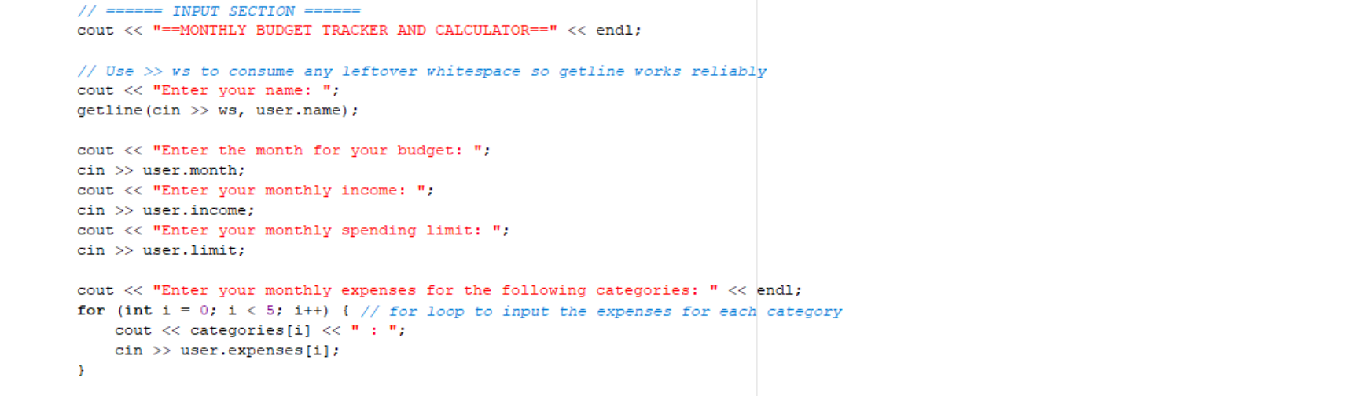
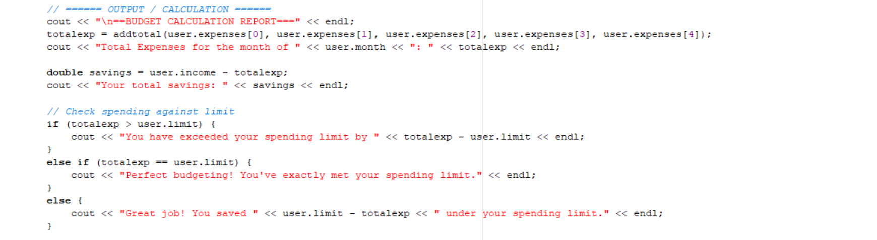
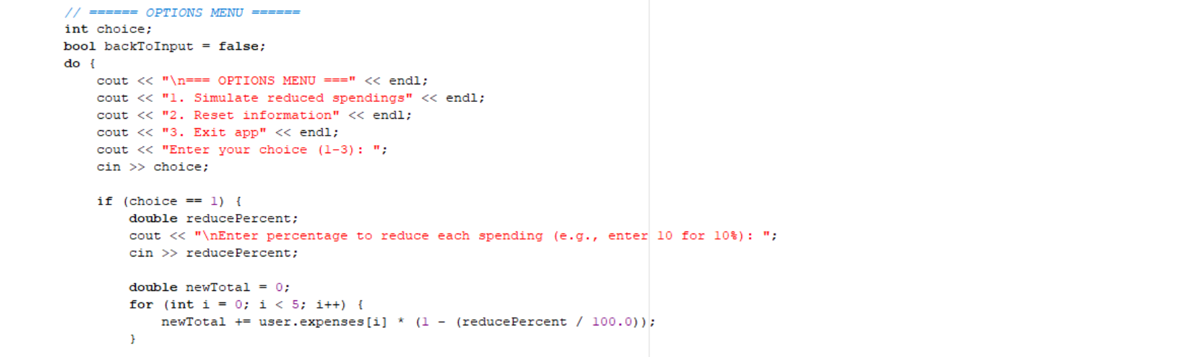
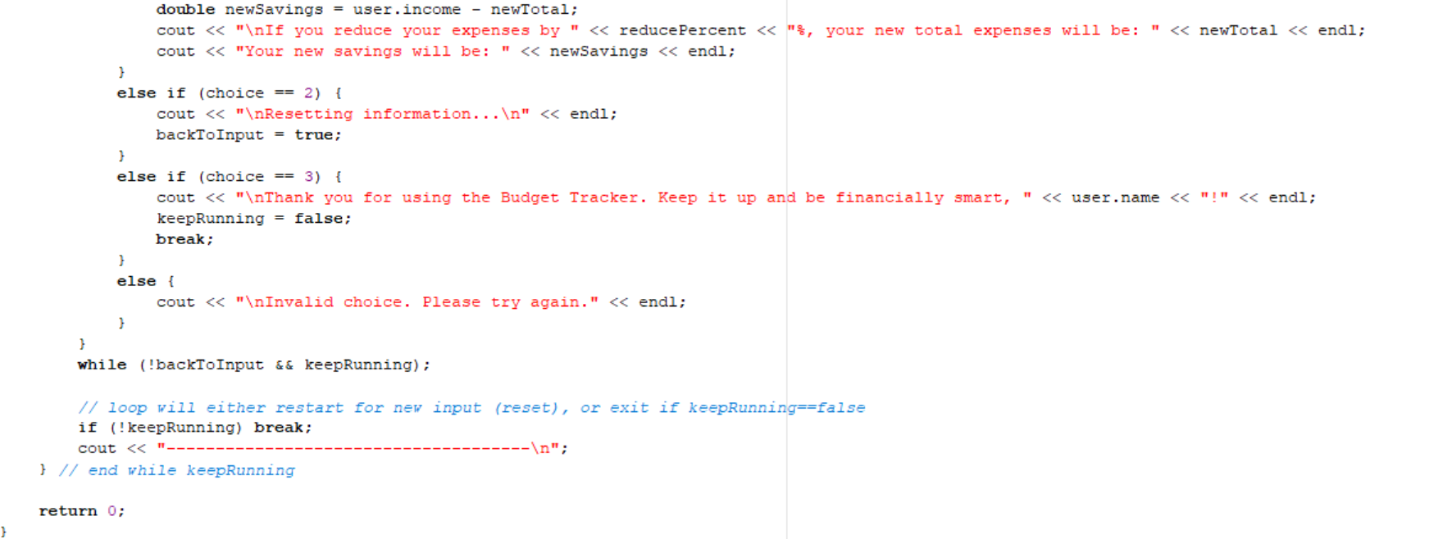

Outputs
Output (Spend under the spending limit)
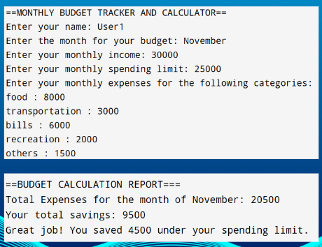
Output (Reset information)
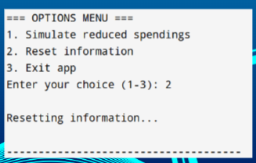

Output (Exactly meet the spending limit)
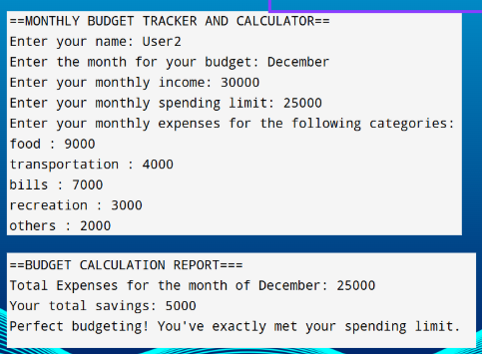
Output (Reset information)
Output (Exceeded the spending limit)
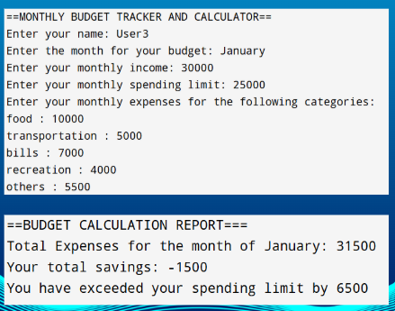
Output (Simulate reduced spendings)
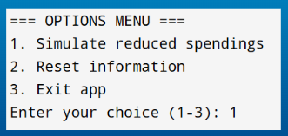
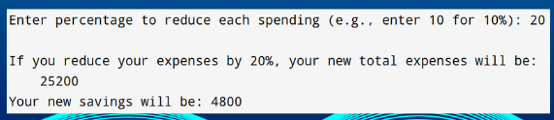
Output (Exit and thank you message)
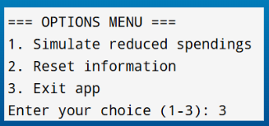

Output (Invalid choice)
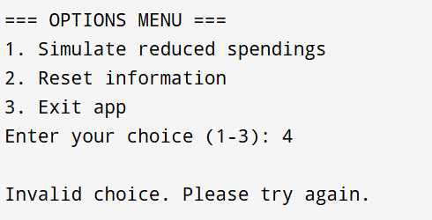

Conclusion
We created a C++ program that lets users input their monthly income, expenses, and spending limit and our program will calculate their total savings based on their expenses. Additionally, we also give them the option to simulate how much they could save if they were to reduce their expenses to a specified percentage. This will help people keep track of where their money is spent for the month and it can also help people better manage their expenses which creates an opportunity for them to efficiently manage their expenses and grow their savings.

