# Install the Payment Module

1. Upload the content to the correct folder structure.
2. The Paydollar Payment Module for OpenCart contains ***\*** folder which has to be uploaded to the platforms root directory.
3. Originally, OpenCart has **<root-directory>/** for the front store and **<root-directory>/ /admin** for the admin site. However, if the folder name has changed, you will need to upload the content in ***\*** to the correct folder structure.

Eg: **<root-directory>/<new-folder-name>**

1. Check the payment module at the admin site. (Home -> Extensions -> Payment )
2. If you do not see **Paydollar** in the Payment List just as the below screenshot, please restart the server.

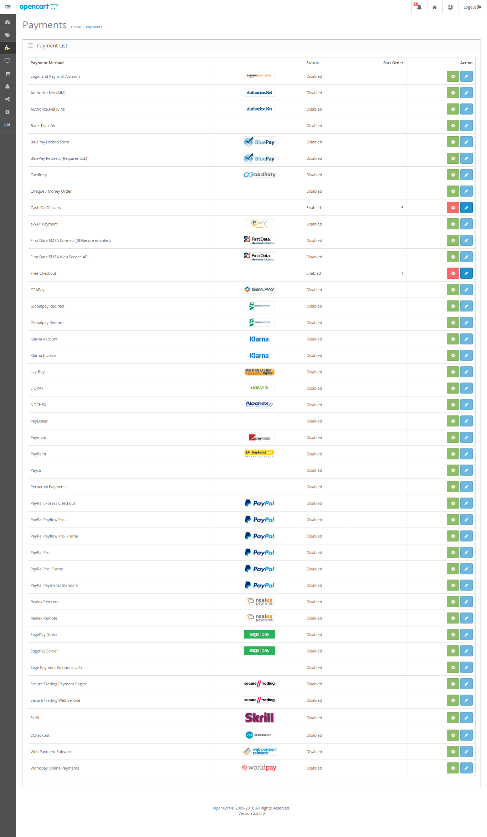

1. Install the module and configure the payment setting



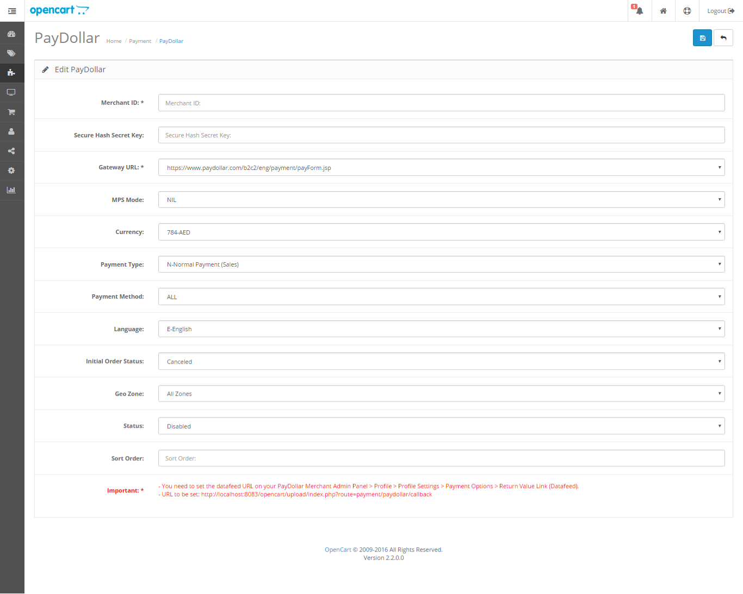

Field Description

1. **Merchant ID**: merchant ID issued to you by AsiaPay. Default: (none)
2. **Secure Hash Secret**: Optional, if secureHash function is enabled on your merchant account, set the secret word here. Default: blank
3. **Gateway URL**: URL to which the data from the merchant website is being passed to (use the test server indicated if the merchant is performing trials; use the live production server URL if the live account has been formally issued by AsiaPay)
4. MPS Mode
5. **Currency**: Select the currency
6. **Payment Type**: N for Normal/Sale, H for Hold/Authorize. Please check with PayDollar/PesoPay/SiamPay
7. **Payment Method**: Default: ALL
8. **Language**: The language that will be used by the gateway, type: C for Traditional Chinese, X for Simplified Chinese, E for English, K for Korean, J for Japanese, T for Thai, G for German, S for Spanish, F for French, R for Russian, V for Vietnamese; Default: E
9. **Initial Order Status**: refers to the status of the order upon checkout (Pending – default statuses for orders / Processing – refers to a paid approved transaction by the gateway; as much as possible, do not use this method as it may cause confusion for when the order transaction has been paid or not); Default: Pending – absolutely NOT advised to change to Processing
10. Geo Zone
11. **Status**: turns the module on or off (also affects visibility of the module on the front end)
12. **Sort Order**: Order of the module on the front end; Default: blank

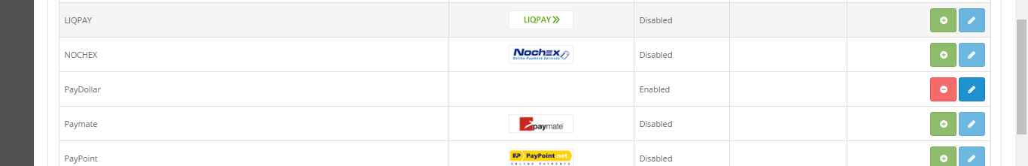

Above screenshot shows the enabled payment module. This means it will appear during customer checkout.

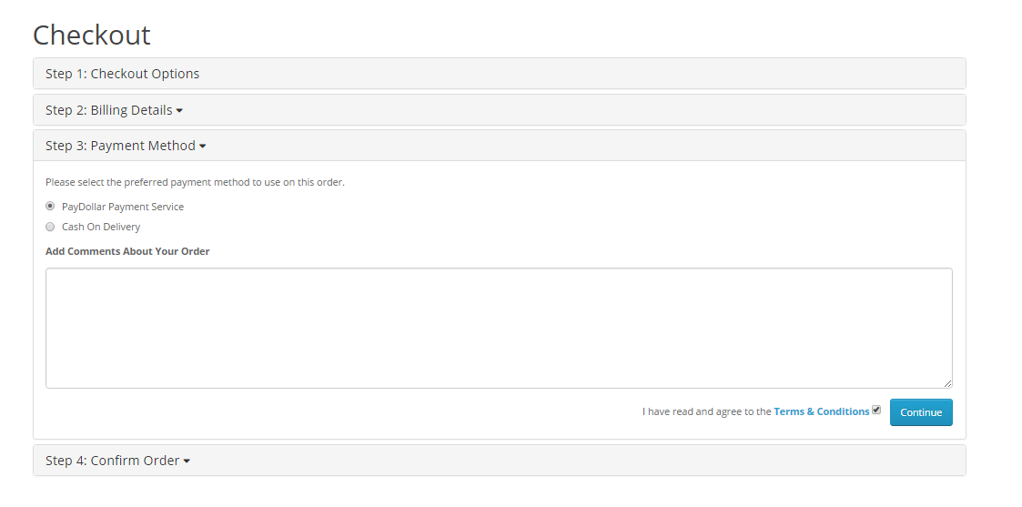

-End of Document-