Assignment 3

**ML Data Product**



36120 - Advanced Machine Learning Application

Master of Data Science and Innovation

University of Technology of Sydney

Table of Contents

**1. Executive Summary** 2

**2. Business Understanding** 2

a. Business Use Cases 2

b. Key Objectives 3

**3. Data Understanding** 3

**4. Data Preparation** 8

**5. Modelling** 11

a. Minimum Fare **Error! Bookmark not defined.**

b. Median Fare **Error! Bookmark not defined.**

c. Mean Fare **Error! Bookmark not defined.**

d. Modal Fare **Error! Bookmark not defined.**

**6. Evaluation** 11

a. Evaluation Metrics 11

b. Results and Analysis 11

c. Business Impact and Benefits 12

d. Data Privacy and Ethical Concerns 13

**7. Deployment** 13

a. Model Serving 13

b. Web App 14

**8. Conclusion** 15

**9. References** 16

**10. Appendix** 17

# 

# 1. Executive Summary

Airlines record millions of flight information in order to guide competitive pricing, plan new strategies for marketing and optimise flight schedules and revenue streams. Furthermore, flight information such as flight fare and flight duration can be helpful for travellers to estimate costs for different dates and routes and manage their schedules. In this regard, our data scientists team has been requested to build a product that helps users in the USA to better estimate their local travel airfare. The main objective of the project is to build an application that can predict the expected flight fare for different airport trips. In particular, this project split the travel airfare into 4 different fares, including minimum, median, modal and mean of airfare. Together, these metrics aim to provide a comprehensive overview of potential fares to users. The minimum fare highlights the best case, while the median and mean demonstrate more typical costs users can expect. Also, the mode shows the most common price point among all options. Since this project aims at building user-friendly applications for users, a minimum of features were used as predictor variables, including airport departure and destination, date, days from flight, cabin type, time category and day of week. The performance of models is mainly based on RMSE scores, measuring the average difference between predicted values and actual values. The project conducts four different experiments (one experiment per a data scientist) to predict median, minimum, modal and mean of travel airfare. Prior to training models, the process of data preparation, feature engineering, EDA, data transformation and data pipeline have been performed. Models for each airfare were successfully established with a moderate performance. To enable model’s access to users, Docker and Gradio were used for model deployment, enabling users to use the models as a application.



# 2. Business Understanding

## a. Business Use Cases

This project focuses on developing a machine learning model to predict airfare prices for flights within the United States. The ability to estimate ticket prices is extremely valuable in the travel industry across various business use cases.

Travellers can leverage the app when planning vacations to estimate costs for different dates and routes, enabling selection of lower-priced options. Airlines use fare data to guide competitive pricing decisions and inventory management. Online travel agencies can also integrate the prediction API to recommend optimal booking dates and times to users.

However, accurately forecasting flight fares is challenging due to complex factors like demand fluctuations, variable airline and flight routes, competitive pricing strategies, and more. Traditional rules-based approaches fail to account for these dynamics. Machine learning algorithms can unlock deeper insights from historical fare data to uncover patterns linking trip details to ticket prices.

## b. Key Objectives

The primary goal of this project is to develop a machine learning model to accurately predict airfares for non-stop flights based on trip parameters like origin, destination, travel dates, and cabin class. Since the model does not forecast fares for specific airlines, we utilize multiple statistical metrics to provide robust fare estimates:

* Minimum Fare: To represent the cheapest available fare across airlines
* Median Fare: To indicate the middle value, reducing the impact of outliers
* Mean Fare: To reflect the average fare across airlines
* Modal Fare: To capture the most frequently occurring fare

Together, these metrics aim to provide a comprehensive overview of potential fares to users. The minimum fare highlights the best case, while the median and mean demonstrate more typical costs users can expect. The mode shows the most common price point among all options. By blending multiple indicators, we mitigate the lack of airline-specific pricing and deliver actionable fare estimates that users can trust for budgeting and planning.



# 3. Data Understanding

The dataset used in this project contains important information related to flight bookings, including details such as flight date, starting and destination airports, and total fare. The data was sourced from Expedia and provided a comprehensive view of flight bookings.

The dataset consisted of a lot of diverse features. Some notable ones are listed below:

* Flight details such as flightDate (date of the flight), startingAirport (Airport from which the flight is starting), destinationAirport (Final destination of the flight).
* Fare Information such as totalFare (the total fare of the flight including taxes).
* Time Information such as segmentsDepartureRaw (departure time of each segment of the flight in ISO 8601 format)
* Airline and flight segment details such as segmentsAirlineName (name of the airlines for each segment) and segmentsDistance (distance travelled for each segment).

While the dataset provided very detailed information about the flight bookings, not all features were used in the modelling process, which was tailored to accommodate the end user’s limited input. The end user is expected to provide specific details like the departure and destination airports, departure date, departure time, and cabin type. As a result, only these user-provided features and the features derived from them were used in the data modelling phase.

The full data dictionary of the dataset used in this project can be found in the Appendix.

### Exploratory Data Analysis

Exploratory data analysis was carried out on the dataset to find useful insights.

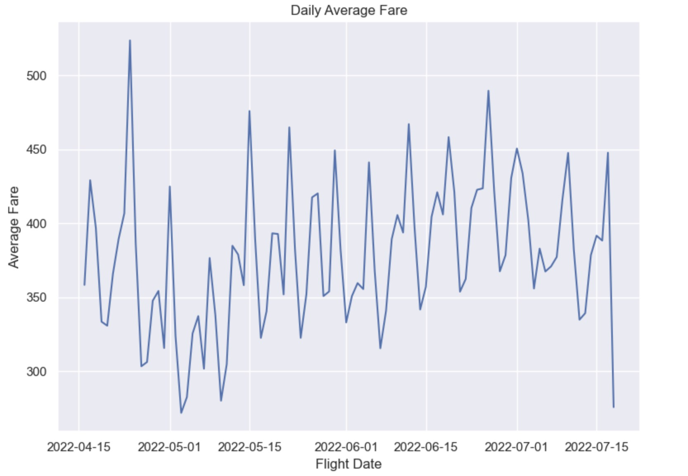

As can be seen from the above plot, the average airfare had a daily trend, i.e., for certain days the fare went down and for others, it went up. However, as the dataset only had data from 16th April 2022 to 18th July 2022, it did not show any seasonality or holiday trends.

The monthly average airfare had an upward trend from April 2022 to July 2022, as shown by the plot on the next page.

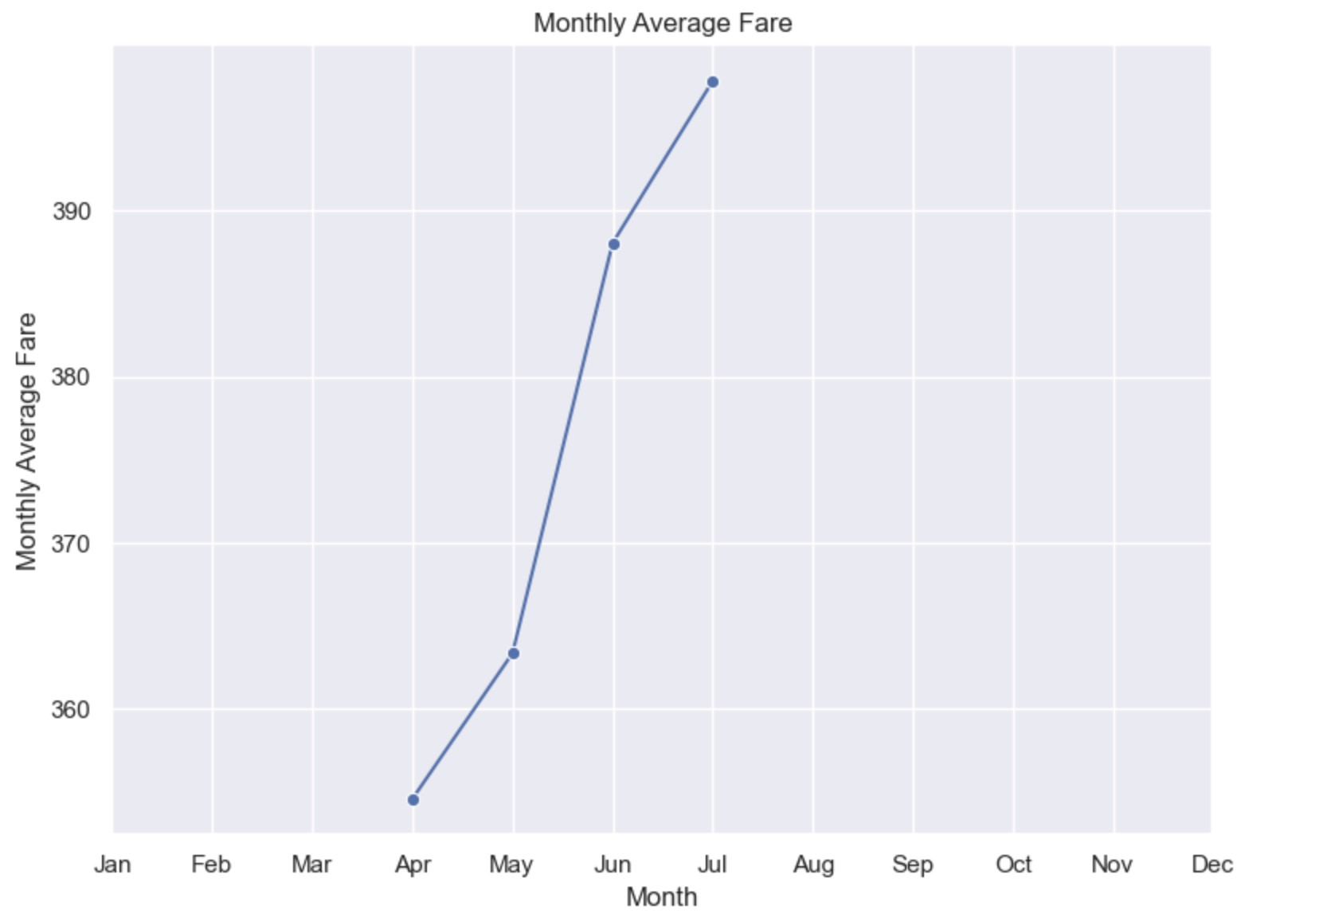

In terms of average airfare on each day of the week, Tuesdays and Wednesdays had the cheapest airfares, whereas Sundays had the most expensive ones. This is shown by the following plot:

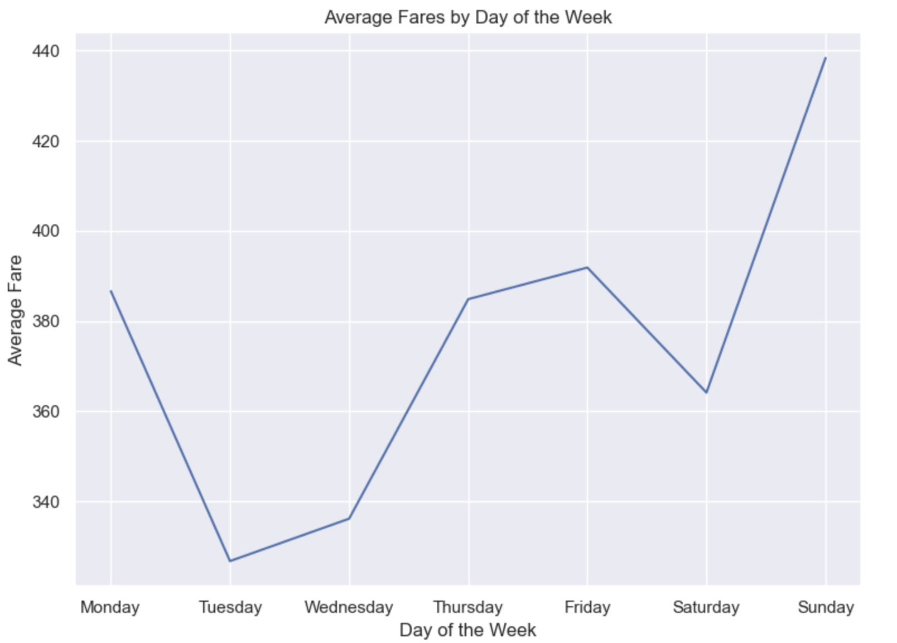

The following plot shows the average airfares by each time category.

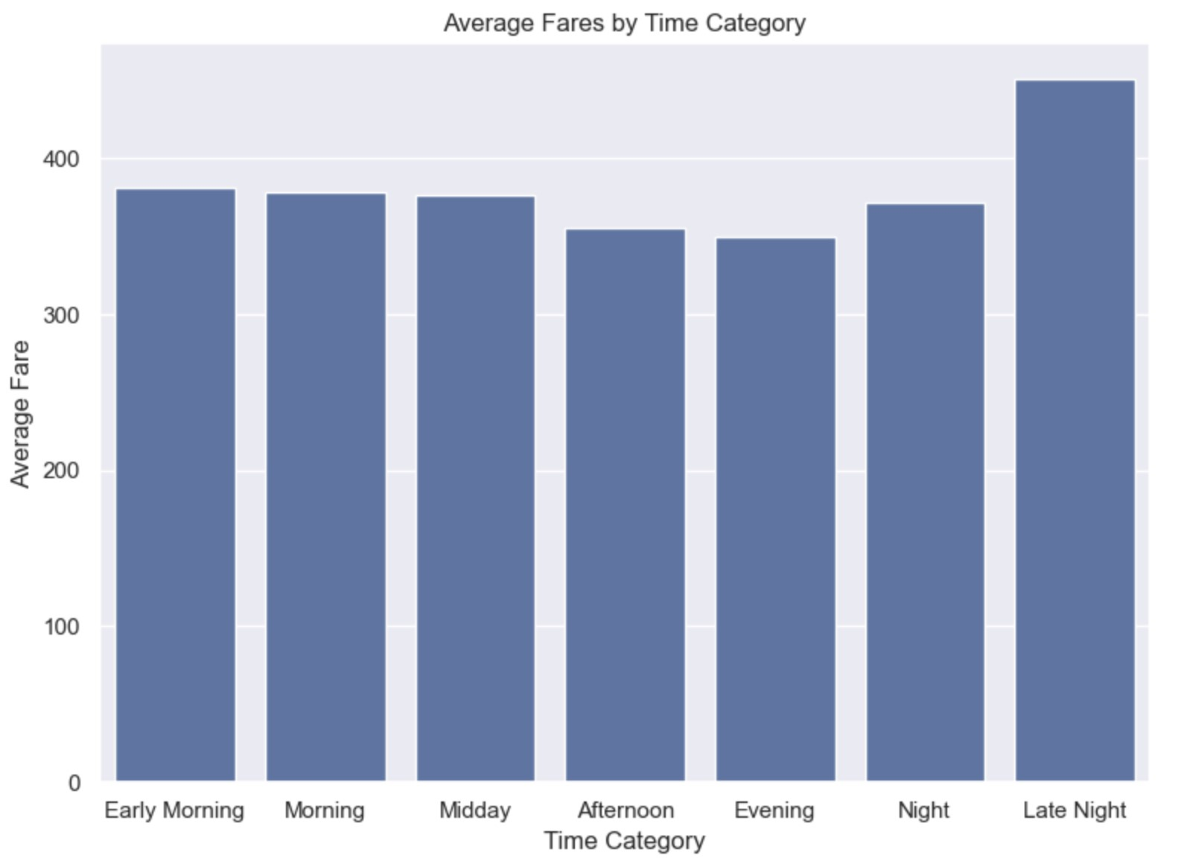

As can be seen from the plot, air ticket prices were the highest during late night (11pm - 2am) and the cheapest during afternoon (2pm - 5pm) and evening (5pm - 8pm).

The plot on the next page shows the average fares by cabin type.

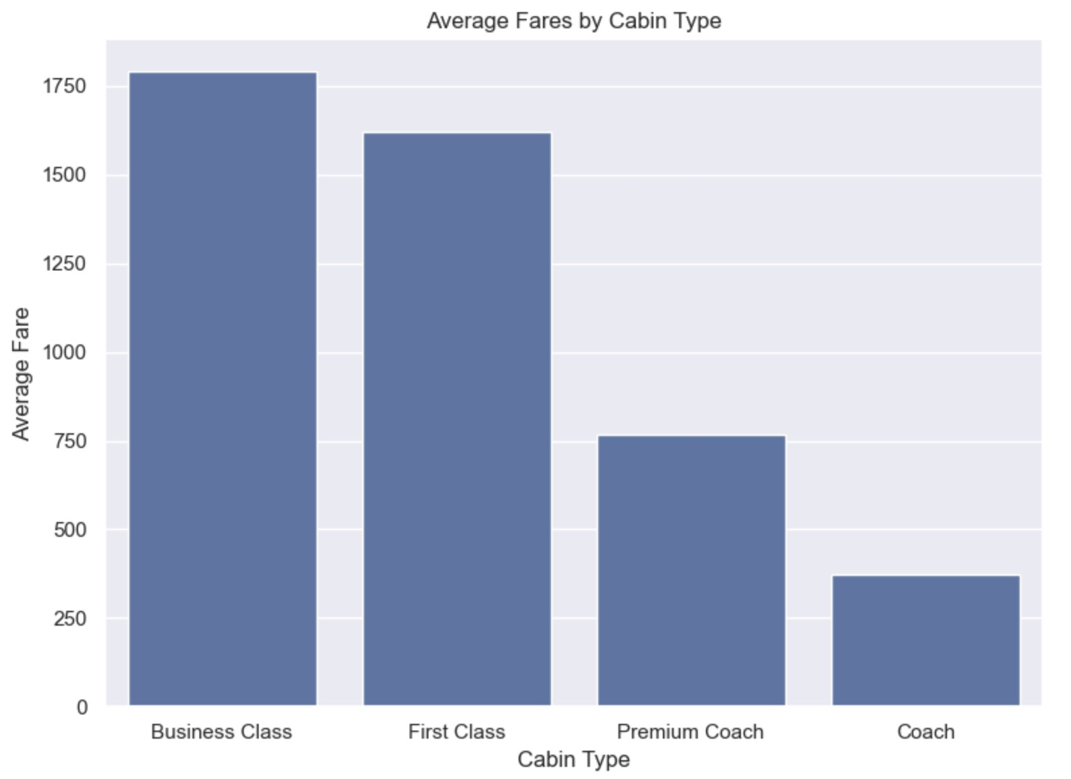

As expected, Business Class and First Class had the highest ticket prices, whereas Coach had the cheapest ones.

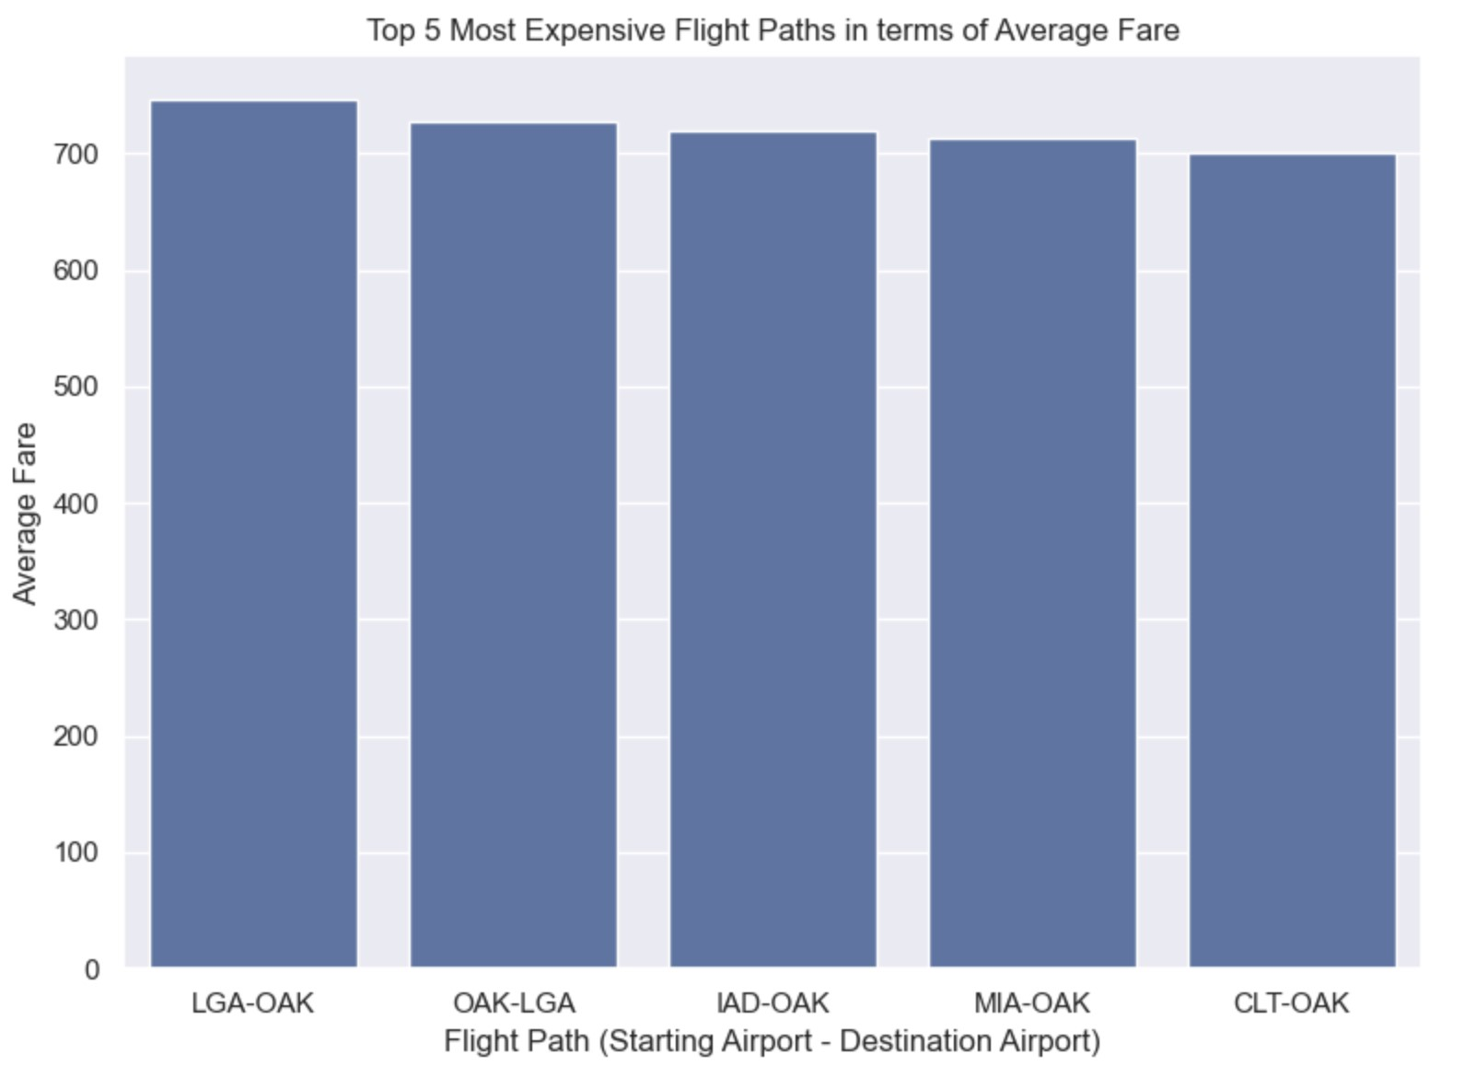

The above plot shows the top 5 most expensive flight paths in terms of average fare. As expected, these flights were the ones with the longest travel distance as they were all cross-country trips. For example, LGA (LaGuardia Airport) to OAK (Oakland International Airport) was a east coast to west coast trip.



# 4. Data Preparation

In the process of preparing our dataset for modelling, we took several deliberate steps to refine our data and create meaningful features. Here is a summary of what was done:

1. Filtering Non Stop Flights:

We began by filtering our dataset to focus exclusively on non-stop flights, thereby excluding any flights with multiple stopovers. This step was crucial to ensure consistency and accuracy in our analysis of direct flight patterns.

1. Converting Departure Times:

The raw departure times were converted into a more informative feature, categorizing the departure into distinct time categories. These categories are based on the hour of the day and provide a clear framework for segmenting flights into time slots that reflect typical daily routines.

The time categories were defined as follows:

|  |  |
| --- | --- |
| Hour Range | Time Category |
| 5:00 - 8:00 | Early Morning |
| 8:00 - 11:00 | Morning |
| 11:00 - 14:00 | Midday |
| 14:00 - 17:00 | Afternoon |
| 17:00 - 20:00 | Evening |
| 20:00 - 23:00 | Night |
| 23:00 - 2:00 | Late Night |

It's important to note that flights up to 2:00 AM were considered to be part of the previous day, effectively categorising them as 'Late Night' flights.

1. Lead Time Calculation:

We calculated the difference between the search date and the departure date as 'days from the flight'. This represents the lead time or the time before booking, which is a significant factor in flight pricing strategies and demand forecasting.

1. Summary Metrics:

We derived summary metrics for the data, which included the minimum, mean, median, and mode for the flight fares. These metrics were computed with respect to input features such as airports, cabin type, and the newly created datetime features. These summary statistics are instrumental in understanding the central tendencies and dispersion of flight prices.

1. Data Splitting for Model Training:

For the purpose of model training and testing, we split the datasets based on the date 6-17-2022. The data from before this date was used to create a training set, while the data following this date formed the testing set. This resulted in a training set that comprised approximately 80% of the total data. This consistent split ratio was maintained across all modelling experiments to ensure comparability and reliability of the results.

These steps contributed to creating robust datasets, ready for various modelling experiments.



# 5. Modelling

In the evaluation of three machine learning algorithms—CatBoost, XGBoost, and Random Forest—applied to a specific task, CatBoost emerges as the top performer with an R2 of 0.69, indicating a superior fit to the data. It also exhibits lower RMSE and competitive MAPE values compared to XGBoost and Random Forest. While XGBoost closely follows CatBoost in performance metrics, Random Forest lags behind with lower R2 and higher RMSE and MAPE values. Notably, all three algorithms share similar MAE values. The results suggest that CatBoost is the most suitable model for the task at hand, but ongoing optimization efforts may further enhance overall performance, particularly in reducing RMSE and MAPE. Stakeholders should consider these findings when making decisions related to model selection and tuning.



# 6. Evaluation

## a. Evaluation Metrics

The evaluation of the machine learning models involved four key metrics: R2 (Coefficient of Determination), RMSE (Root Mean Squared Error), MAPE (Mean Absolute Percentage Error), and MAE (Mean Absolute Error). R2 is a measure of how well the model predicts the variability in the data, with a higher value indicating a better fit. RMSE quantifies the average magnitude of the model's prediction errors, providing a comprehensive assessment of prediction accuracy. MAPE measures the average percentage difference between the predicted and actual values, offering insights into the model's performance relative to the scale of the data. Finally, MAE represents the average magnitude of errors without considering their direction, providing a straightforward measure of model accuracy. The choice of these metrics reflects a comprehensive evaluation strategy, considering aspects of fit, accuracy, percentage errors, and absolute errors, which are all crucial in understanding and optimising the models for the specific project goals. These metrics collectively enable a nuanced assessment of model performance, informing decisions on model selection and refinement.

## b. Results and Analysis

The median, minimum, mean and modal of airport fares models were trained, predicted and their performance were assessed based on RMSE and R2 metrics. To accurately predict airport fares, the performance of models was the most important part in our project. Hence, we all tried to use fast and accurate algorithms that can handle large and complex nature of features. XGBoost was the most common algorithm that was used in most of the experiments and consequently outperformed most of the models with other algorithms. Nevertheless, the performance of models we obtained for mean, median, minimum and modal airfares were poorer than expected due to insufficient optimal number of features that were used in modelling.

RMSE of our models was a range from 90 to 103 and r2 obtained was a range from 0.60 to 0.72. There could be a slight performance gap between models of airfare, as we prepared and transformed features in different ways.

The best **RMSE** scores for each part of airfare were as follow :

**Minimum Fare: 90.97**

**Median Fare: 89.46**

**Mean Fare: 91.90**

**Modal Fare: 92.45**

On the other hand, there may be few ways to improve the performance of our models. First, the project aimed at building user-friendly applications that can help people to estimate their travel fates. Hence, a minimum information of flight was used as features but if more relevant and influential features such as distance and time of flight are included as features, the performance of models will significantly increase. Moreover, if we use more optimal hyperparameters for our models using search tools, such as ‘GridSearchCV’ or ‘RandomSearchCV’, the performance of models can be improved. Lastly, subsampling methods, such as training subsampling and feature subsamplings can be considered to increase the performance of models.

## c. Business Impact and Benefits.

The final model, despite relying on limited user features, emerges as a practical and impactful tool for businesses, particularly due to its simplicity in required user inputs. This simplicity enhances its accessibility and usability for a wide range of users. Notably, the model's performance, particularly the robust CatBoost model for median fares, holds significant implications for both travellers and airlines. Travellers would be able to leverage the final app to estimate costs for different dates and routes, facilitating effective budgeting and travel planning. The accuracy of the model would empower users to make well-informed decisions on optimal booking dates, potentially leading to cost savings and improved travel experience.

Moreover, the benefits extend to airlines, providing them with a strategic advantage in the competitive market. The fare predictions generated by the final app offer valuable insights for airlines to refine and guide their competitive pricing strategies. This capability would allow airlines to have a competitive edge over rivals. The inclusion of multiple statistical measures, including minimum, mean, median, and modal fares, in the final app addresses the challenge of limited airline-specific pricing data. This comprehensive approach offers users a well-rounded set of actionable fare estimates, covering various scenarios from best-case to typical and most common fare values.

The final app's ability to provide trustworthy estimates is a key factor in mitigating data limitations. Users can rely on the estimates for budgeting and planning, fostering trust in the tool's predictive capabilities. The user-friendly interface further enhances its real-world applicability, catering to diverse user needs, from budget-conscious travelers to business travel coordinators and travel agencies.

## d. Data Privacy and Ethical Concerns

This section provides a thorough examination of the data privacy implications associated with the project, emphasizing considerations related to data collection, usage, and deployment, with a specific focus on sensitive information. Notably, the dataset utilized in this project excludes any personal information, resulting in the absence of inherent data privacy risks. The project demonstrates a commitment to ethical principles, proactively addressing privacy concerns throughout its lifecycle.

The careful execution of the project underscores its dedication to maintaining the highest ethical standards. The combination of the dataset's lack of personal information and proactive privacy measures showcases a commitment to safeguarding privacy. However, ethical challenges arise from the economic implications of accurate fare predictions, particularly in dynamic pricing strategies, necessitating a focus on preventing pricing discrimination and ensuring equal access.

A comprehensive approach is essential, integrating robust data protection measures, transparent model development, unbiased algorithms, clear user consent mechanisms, and adherence to regulations. Moreover, the project addresses the environmental impact of resource-intensive model training, highlighting the importance of sustainability in technological development.

A multifaceted strategy that incorporates ethical considerations and data protection measures is imperative. This approach ensures the project addresses the complex ethical and data privacy implications, emphasizing transparency, fairness, regulatory compliance, and environmental responsibility.



# 7. Deployment

## a. Model Serving

The product was deployed as a containerized Gradio web application, utilising inputs such as origin and destination airports, cabin type, date and time category to yield four predictive fare estimates corresponding to each summary metric. Gradio boasts an ease of setup that is particularly advantageous; it can run directly from a notebook, which streamlines the process for users familiar with notebook environments. While it offers much of the same functionality as Streamlit, Gradio is specifically optimised for machine learning models, making it the preferred choice for developers looking to quickly deploy and share their models.

On the flip side, Gradio is relatively new compared to Streamlit and thus lacks some customization options, such as a dedicated date picker. To circumvent this limitation, we implemented separate inputs for day, month, and year, which, although not as elegant as a single date picker, effectively allows for precise date selection within the application's user interface.

To enhance real-world applicability, deployment was refined to accept only extant flight routes, and the user interface was streamlined for ease and speed in obtaining fare predictions. Date input validation enforces day entries between 1 and 31 and year entries between 2020 and 2030. However, given the model's training on data from the same years, it may not effectively discern seasonal trends.

The model's reliability is limited by its training dataset, which spans only two months, potentially undermining its predictive accuracy for periods beyond this duration. Consequently, it may not fully encapsulate annual or seasonal fluctuations. Moreover, the lack of airline-specific differentiation means the model provides general averages rather than precise, airline-specific fare predictions; thus, it functions as an indicative tool rather than a booking engine. It is important to note the difference.

Another challenge is the search date parameter's reliance on the proximity to the flight date, rendering predictions for past dates invalid. While the model presupposes daily flight availability across all time categories, its accuracy is susceptible to volatility in fuel costs, unforeseen events such as natural disasters or conflicts, and economic changes like tax adjustments.

For future deployment efforts, it is recommended to extend the training dataset to cover a full annual cycle, allowing for the capture of comprehensive temporal trends. Additionally, incorporating airline-specific data could significantly refine fare estimates. To account for dynamic factors affecting flight prices, it might be prudent to integrate real-time data feeds or establish periodic model retraining schedules to maintain prediction accuracy.

## b. Web App

The application takes inputs such as origin and destination airports, cabin type, date and time category to yield four predictive fare estimates corresponding to each summary metric. These metrics collectively offer a comprehensive view of the expected price range.

The instructions for deploying the application have been provided below:

1. Clone the main branch for the github repo: <https://github.com/naeer/at3_advanced_ml.git>
2. In a terminal, navigate to the root folder containing the repo and build the docker image by running the command: docker build -t flight-fare-app .
3. Launch the application with the command: docker run -p 7860:7860 flight-fare-app 4. The application will be available on the URL: [http://localhost:7860](https://localhost:7860/)

5. Fill in the input form and hit submit!

The application is designed to cater to a variety of users who require quick and reliable fare estimates for air travel. Some examples include:

* Budget-conscious travellers can use the application to explore different flight options and find the best deals that align with their travel dates and preferences.
* Business travel coordinators and corporate finance teams may find the application invaluable for forecasting travel expenses and managing budgets.
* Travel agencies and independent travel consultants can leverage the tool to provide clients with immediate and comprehensive fare estimates, enhancing their service offering and efficiency.

The main limitations concerning the web application pertain to the models and training data they have been discussed in more detail in 7a. Model Serving.





# 8. Conclusion

In conclusion, the project focused on developing machine learning models to predict airfare prices for non-stop flights within the United States, catering to both travellers and the airline industry. Extensive data preparation, feature engineering, and model evaluation processes were undertaken, leading to the selection of CatBoost as the top-performing algorithm. The project addressed the complexities of airfare estimation by considering minimum, median, mean, and modal fares, providing users with a comprehensive overview of potential costs. Despite achieving moderate success in model performance, there is room for improvement, particularly in incorporating additional relevant features such as flight distance and time. The deployment of the models as a Gradio web application enhances accessibility, offering a user-friendly interface for estimating airfare costs based on minimal input parameters. Ethical considerations and data privacy concerns were proactively addressed throughout the project, ensuring compliance with ethical principles. Overall, the project's success lies in its impactful and practical tool for estimating airfare prices, contributing to better planning and decision making for both travellers and airlines.



# 9. References

* *Sklearn.impute.SimpleImputer*. scikit. (n.d.). https://scikit-learn.org/stable/modules/generated/sklearn.impute.SimpleImputer.html
* *Target encoder*. Target Encoder - Category Encoders 2.6.3 documentation. (n.d.). https://contrib.scikit-learn.org/category_encoders/targetencoder.html
* Ray, S. (2023, September 25). *8 ways to improve accuracy of machine learning models*

*(updated 2023)*. Analytics Vidhya.

https://www.analyticsvidhya.com/blog/2015/12/improve-machine-learning-results/#:~:text= There%20are%20several%20ways%20to,bagging%2C%20boosting%2C%20and%20stac king.



# 10. Appendix

Data Dictionary of the dataset used in this project:

|  |  |
| --- | --- |
| **Field** | **Description** |
| flightDate | The date (YYYY-MM-DD) of the flight. |
| searchDate | The date (YYYY-MM-DD) on which this entry was taken from Expedia. |
| startingAirport | Three-character IATA airport code for the initial location. |
| destinationAirport | Three-character IATA airport code for the arrival location. |
| departureTimeRaw | String containing the departure time (ISO 8601 format: YYYY-MM-DDThh:mm:ss.000±[hh]:00) for the flight. |
| cabinType | String containing the cabin type of the flight (e.g. coach, premium coach, business). |
| totalFare | The price of the ticket (in USD) including taxes and other fees. |