BTS Cloud Computing
VIRCL — Virtualisation Project
Server Virtualisation Systems
Implementation and Comparison of
Proxmox VE and VMware ESXi
Specialisation: High Availability
Author: Simon Max, Eric Wurth, Sven Kugener
Lycée Guillaume Kroll
June 2026

Table of Contents

Introduction
Server virtualisation has become a cornerstone of modern IT infrastructure. Where previously each service required its own dedicated hardware, virtualisation enables system administrators to share the resources of a single physical server across several isolated virtual machines, dramatically improving energy efficiency, hardware utilisation, and operational flexibility.
This documentation describes the practical implementation of a full server virtualisation environment using two leading type 1 hypervisors:
- Proxmox VE — an open-source virtualisation platform supported by a strong community.
- VMware ESXi (vSphere 8) — the industry-leading commercial virtualisation product.

For each feature required by the project specification, both hypervisors are implemented and compared. The documentation also covers the specialisation topic chosen by the team — High Availability — which is explained conceptually and demonstrated practically on the VMware ESXi platform within a three-host vSphere cluster backed by shared iSCSI storage.

Environment Overview
The physical lab environment consists of HP ProLiant servers managed via Integrated Lights-Out (iLO 5) interfaces, connected to a shared TrueNAS Community Edition storage server providing iSCSI block storage.
Component | Details
vCenter Server | 10.0.10.119 (VCSA 8.0 U2)
ESXi Host 1 | 10.0.10.96
ESXi Host 2 | 10.0.10.111
ESXi Host 3 | 10.0.10.121
Proxmox VE Host | 10.0.10.101
TrueNAS Server | 10.0.13.3 (Community Edition)
Storage Pool | areca_raid5
iSCSI Target | iqn.2005-10.org.freenas.ctl:vmware

Part I — Proxmox VE Implementation
This part documents the implementation of all required features on the Proxmox VE hypervisor. Proxmox VE is a Debian-based open-source virtualisation platform combining KVM virtualisation and LXC container technology under a unified web-based management interface.

1.1 Hypervisor Installation
The Proxmox VE installation is performed remotely via the HP iLO 5 management interface, which provides a virtual console to the physical server.
- Connect to the iLO 5 management interface at 192.168.0.10 using credentials user: student, password: $Bt6RnWH!tgKGRJ1T!ntTf.
- Click on Console and choose HTML5 to launch a browser-based remote console session.
- In the virtual media menu, click Disk → Local → Choose ISO and mount the Proxmox VE installation ISO.
- Boot the server from the mounted ISO and select "Install Proxmox VE (Graphical)".

- Choose the target installation disk.

- Set the country and time zone.
- Configure the root password and administrative email address.
- Set the hostname (e.g. pve01).
- Configure the static IP address, gateway, and DNS server.
- Once the installation is complete, restart the server and open the Proxmox web interface at https://10.0.10.101:8006/ in any modern browser.
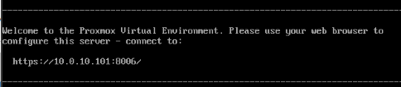

1.2 Creating a Virtual Machine via the GUI
Proxmox VE provides a comprehensive web-based interface for managing virtual machines.
- Log in to the Proxmox web interface.
- Navigate to Datacenter → pve → local (pve) and click on ISO Images → Upload.
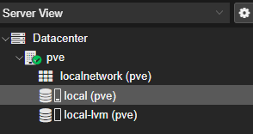
- Select the ISO file from the file picker and click Upload again. The ISO will appear in the list once the upload completes.
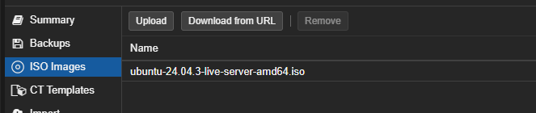
- In the top right corner of the web interface, click "Create VM".
- On the General tab, give the VM a name and leave the rest as default.
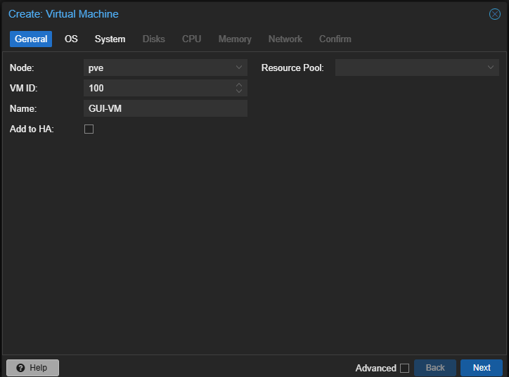
- On the OS tab, check "Use CD/DVD disc image file (iso)", choose local as the storage, and select the uploaded ISO as the image.
- Leave the remaining tabs at their defaults and click Finish on the Confirm tab.

1.3 Creating a Virtual Machine via the CLI
Proxmox VE can also be managed entirely from the command line using the qm utility. This is useful for automation and scripting.

Upload the ISO to the Proxmox host
Use SCP from a Windows PowerShell session to upload the ISO image:
scp C:\Users\YourName\Downloads\YourISO.iso root@YOUR_PROXMOX_IP:/var/lib/vz/template/iso/
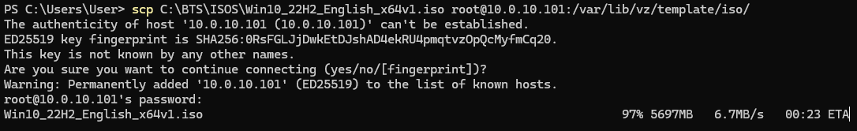

Verify the ISO is present on the Proxmox host
Open the iLO 5 HTML5 terminal and list the ISO directory:
ls /var/lib/vz/template/iso/

Create the virtual machine
qm create 300 \
--name "ubuntu-server" \
--memory 2048 \
--cores 2 \
--net0 virtio,bridge=vmbr0 \
--ostype l26

Attach the disk and ISO
qm set 300 --scsi0 local-lvm:20,cache=writeback
qm set 300 --ide2 local:iso/YourISO.iso,media=cdrom
qm set 300 --boot order=ide2;scsi0

Start the virtual machine
qm start 300

Accessing the VM console via CLI
To access the VM terminal directly from the command line, add a serial port and configure the display to use it:
qm set 300 --serial0 socket --vga serial0
qm start 300
qm terminal 300

1.4 Operating System Installation
After creating the VM, click on it in the left navigation pane and open the console. The virtual machine will boot from the attached ISO image and present the operating system installer.
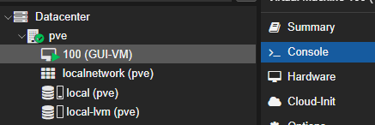
VirtIO Drivers for Windows: When installing Windows, the VirtIO drivers must be supplied during the installer if the VM uses SCSI virtual disks; otherwise the disk will not be detected.
Once the installation completes, the virtual machine is ready for use immediately. No additional configuration is required for the guest operating system to function within Proxmox VE.

1.5 Changing VM Configuration
Proxmox VE allows on-the-fly modification of virtual machine resources through the Hardware tab of the VM. Some resources (such as RAM and CPU) support hot-plug, while others (such as disks and NICs) generally require the VM to be in an appropriate state.

CPU
- Navigate to VM → Hardware → Processors and click Edit.
- Adjust the number of sockets and cores as required, then save.
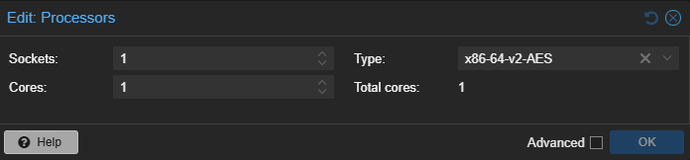

RAM
- Navigate to VM → Hardware → Memory and click Edit.
- Set the desired memory size in MiB and save.
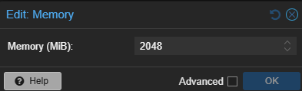

Adding a Hard Disk
- Navigate to VM → Hardware and click Add → Hard Disk.
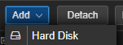
- Configure the storage location, size, and bus type (e.g. SCSI with VirtIO controller), then click Add.
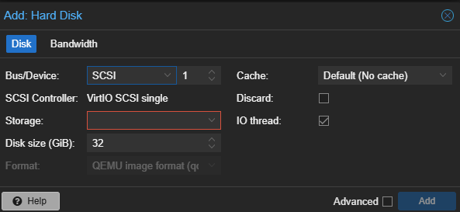

Removing a Hard Disk
- In the Hardware view, select the disk and click Detach and confirm.
- Select the now-detached entry and click Remove to delete it completely.

Resizing a Hard Disk
- Select the disk in Hardware and click Disk Action → Resize.
- Enter the additional space to add (only growth is supported) and click Resize Disk.

1.6 Duplicating a Virtual Machine
Proxmox VE provides a built-in clone function that creates a new independent VM from an existing source.
- Right-click an existing VM in the resource tree and select Clone.
- In the popup, enter the name for the new VM and click Clone.
A full clone is independent of the source VM; a linked clone shares disk space with the source but requires a template.

1.7 Backup of the Proxmox Hypervisor Configuration
The Proxmox host configuration can be backed up using standard Linux command-line tools. The configuration files reside under /etc/pve and a few related system directories.
- Log in to the Proxmox host shell via SSH or the iLO HTML5 terminal.
- Create a compressed tarball of the relevant configuration directories:
tar czf proxmox-config-backup.tar.gz \
/etc/pve/ \
/etc/network/ \
/etc/hosts \
/etc/hostname
After the command completes, the file proxmox-config-backup.tar.gz contains the complete host configuration and can be safely stored externally for disaster recovery.

1.8 Backing up a Proxmox Virtual Machine
Proxmox VE offers an integrated VM backup mechanism that supports both scheduled and on-demand operation.

Scheduled Backup
- Navigate to Datacenter → Backup and click Add.
- Configure the following options:
- Node: Which Proxmox server to back up.
- Storage: Where the backup files will be written.
- Schedule: How frequently the backup should run.
- Mode: Snapshot (VM stays running, near-zero downtime) or Stop (more reliable, brief downtime).
- Selection: Which VMs to include in the job.
- Click Create to save the backup job.

Immediate Backup
- Navigate to VM → Backup and click Backup now.
- Choose the storage and backup mode and click Backup.

Restoring a VM from Backup
- Navigate to local (pve) → Backups.
- Select the backup file and click Restore.
- Choose the target VM ID and storage and click Restore.

1.9 Using Snapshots
Snapshots capture the state of a virtual machine at a specific point in time, enabling rollback if subsequent changes cause problems.
Snapshots are not backups: Snapshots are stored on the same storage as the VM itself. They protect against software-level issues but not against hardware failure or storage loss.

Creating a Snapshot
- Navigate to VM → Snapshots and click Take Snapshot.
- Enter a name and optionally a description.
- Click Take Snapshot.

Restoring a Snapshot
- Navigate to VM → Snapshots.
- Select the snapshot to restore and click Rollback.
- Confirm with Yes.

1.10 Creating a VM Template
A template is a read-only base VM from which new VMs can be cloned quickly. This is useful for standardising deployments.
- Choose the VM to convert and ensure it is shut down.
- Right-click the VM in the sidebar and select Convert to Template.
- Confirm with Yes.
Template behaviour: Once a VM is converted to a template, it can no longer be started. To boot it, clone it back into a regular VM first.

1.11 Live Storage Migration (Proxmox)
Storage migration moves the virtual disks of a VM from one storage location to another. To demonstrate this with shared remote storage, the TrueNAS server is integrated as an NFS share.

Step 1 — Configure the NFS Share on TrueNAS
- In TrueNAS, navigate to Shares.
- Under UNIX (NFS) Shares, click Add.
- Choose the path where the VM disk files should be stored later and enable NFS.
- Click the three dots next to the new share and select Edit.
- Under Networks, add the network of the Proxmox host so that it is permitted to access the share.

Step 2 — Mount the NFS Share on Proxmox
- In Proxmox, navigate to Datacenter → Storage and click Add → NFS.
- Give the storage an ID, set the Server field to the TrueNAS IP address, and enter the export path chosen in TrueNAS.
- Click Add.

Step 3 — Move the VM Disk
- Navigate to VM → Hardware and select the hard disk to migrate.
- Click Disk Action → Move Storage.
- Select the TrueNAS NFS storage as the target.
- Check Delete source if the original disk should be removed once the migration completes.
- Click Move Disk.
The VM remains operational throughout the migration; the actual storage move is performed in the background.

1.12 Live Migration Between Proxmox Hypervisors
Moving a VM live between two Proxmox hosts requires both hosts to be members of the same cluster.

Configure a Cluster Network
- Navigate to System → Network → Create and choose a Linux bridge.
- Assign a static IP address and gateway to the bridge.
- Click Create.

Create a Cluster
- Navigate to Datacenter → Cluster and click Create Cluster.
- Give the cluster a name and select the previously created cluster network.
- Click Create.
- Open Join Information and copy the cluster join token.
- On the second Proxmox host, navigate to Datacenter → Cluster and click Join Cluster.
- Paste the join information, enter the password of the first server, and click Join.

Migrate the VM
- Navigate to VM → Hardware and remove any attached CD/DVD media, which would block the migration.
- Right-click the VM and select Migrate.
- Choose the target node and click Migrate.
The VM is transferred live to the destination host with negligible downtime (typically only the brief switch-over period of vMotion-equivalent technology).

1.13 High Availability on Proxmox
High Availability in Proxmox is built directly on top of the cluster mechanism described above. Once at least three nodes are clustered (for proper quorum), VMs can be configured as HA resources via Datacenter → HA. The Proxmox HA stack automatically restarts the affected VMs on surviving nodes after a host failure. As the specialisation of this project focuses on the VMware implementation of HA, the detailed configuration is documented in Part III.

Part II — VMware ESXi Implementation
This part documents the implementation of all required features on the VMware ESXi hypervisor. Where the standalone ESXi host UI is sufficient for a feature, the implementation is shown via the host web client; where vCenter Server is required (clustering, vMotion, HA, central permission management, etc.), the vSphere Client is used.

2.1 ESXi Hypervisor Installation
The VMware ESXi installation procedure is similar to that of Proxmox VE, using the HP iLO 5 management interface to mount the installation ISO remotely.
- Connect to iLO 5 and click Console.
- Choose the HTML5 console.
- Click Disk → Local and select the ESXi installer ISO.
Keyboard issues: During the project, the in-browser HTML5 console exhibited keyboard mapping problems. As a workaround, the HPE iLO Remote Console application was installed locally and used instead, which resolved the issue.
- When the installer boots, confirm with Enter.
- Press F11 to accept the End User License Agreement.
- Select the SSD as the installation target and press Enter.
- Choose the Swiss French keyboard layout.
- Set the root password.
A warning may appear stating that the CPU may not be supported in future ESXi releases. This warning is acknowledged with Next; in the lab the current hardware is fully supported.
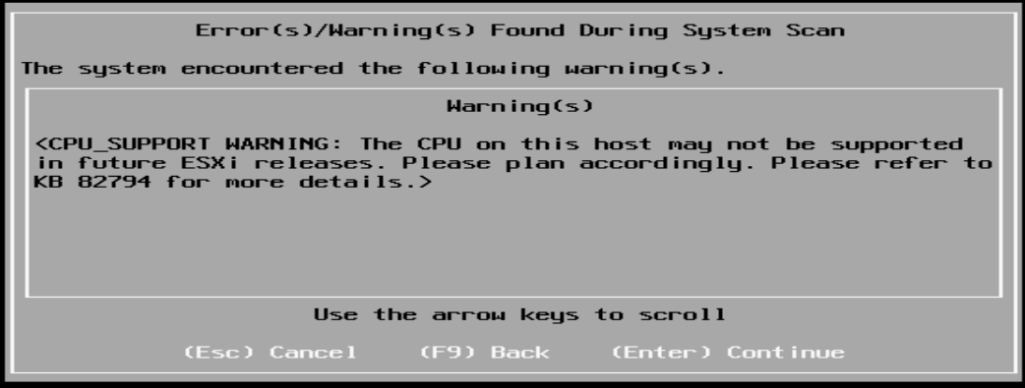
- Press F11 to confirm the installation.
- Once the installer completes, remove the installation media and press Enter to reboot.

Network Configuration
After installation, the server displays a temporary DHCP-assigned IP address (in this lab, https://10.0.96.155/). To assign a static IP:
- Press F2 on the host console.
- Choose Configure Management Network.
- Select IPv4 Configuration.
- Choose "Set static IPv4 address" and enter the desired address, subnet mask, and gateway.
- Press Enter to apply the change, then restart the management agents.
The host is now reachable at its static IP address from the management network.

2.2 Working Without vCenter — ESXi Host Client
Before vCenter is deployed, all VM management is done via the per-host ESXi web interface.

Creating a VM via the GUI
- Connect to the ESXi web interface and log in as root.
- Navigate to Virtual Machines → Create / Register VM.
- Select "Create a new virtual machine", choose a name, an OS family, and an OS version.
- Select the storage device for the VM files.
- Configure the hardware (CPU, RAM, disk, network).
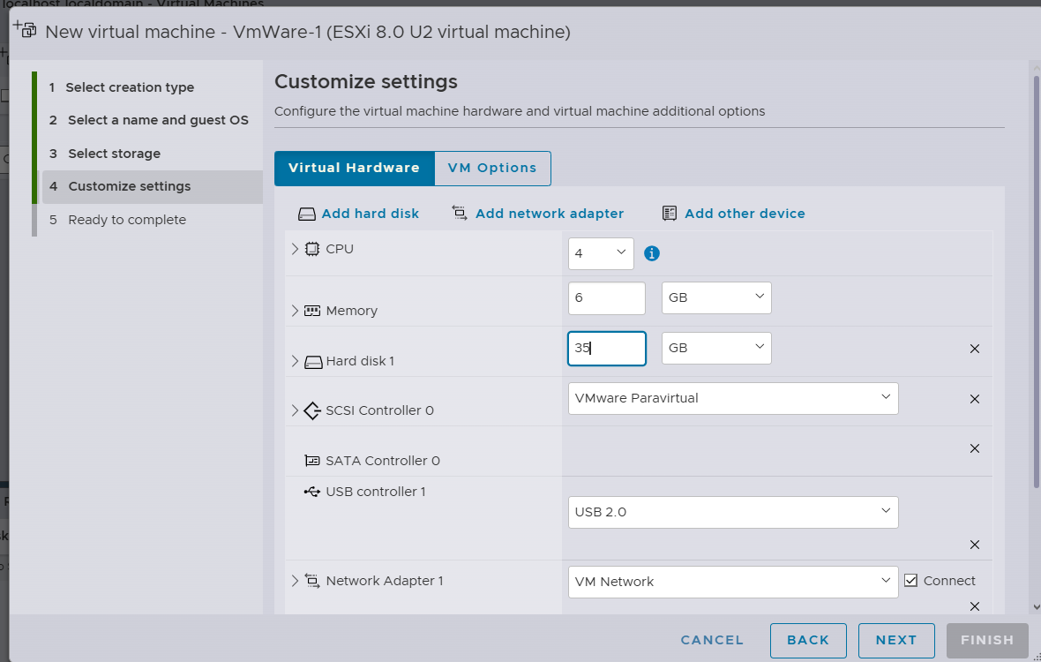
- On the Review tab, click Finish.
The newly created VM appears in the Virtual Machines list and can be managed by clicking on it.

Creating a VM via the CLI
VMware ESXi exposes an extensive command-line interface accessible via SSH. To prepare for CLI VM creation, SSH must be enabled on the host:
- In the ESXi host web client, navigate to Host → Manage → Services → TSM-SSH and click Start.
Then connect via SSH (e.g. using MobaXterm) and execute the following commands:

Create the VM directory
mkdir /vmfs/volumes/datastore1/MeineVM

Create the virtual disk (20 GB, thin-provisioned)
vmkfstools -c 20G -d thin /vmfs/volumes/datastore1/MeineVM/MeineVM.vmdk

Create a minimal VMX configuration file
cat >> /vmfs/volumes/datastore1/MeineVM/MeineVM.vmx <<EOF
pciBridge0.present = "TRUE"
pciBridge4.present = "TRUE"
pciBridge4.virtualDev = "pcieRootPort"
pciBridge4.functions = "8"
pciBridge5.present = "TRUE"
pciBridge5.virtualDev = "pcieRootPort"
pciBridge5.functions = "8"
pciBridge6.present = "TRUE"
pciBridge6.virtualDev = "pcieRootPort"
pciBridge6.functions = "8"
pciBridge7.present = "TRUE"
pciBridge7.virtualDev = "pcieRootPort"
pciBridge7.functions = "8"
EOF

Register and start the VM
vim-cmd solo/registervm /vmfs/volumes/datastore1/MeineVM/MeineVM.vmx
vim-cmd vmsvc/power.on <vmid>

Adding an ISO Image to a Datastore
- Navigate to Storage, right-click the datastore and select Browse.
- Click Upload and select the ISO file.

Windows / Linux Installation
After the VM is created and the ISO is attached, opening the console and starting the VM presents the installer of the chosen operating system, which is then completed in the normal way.
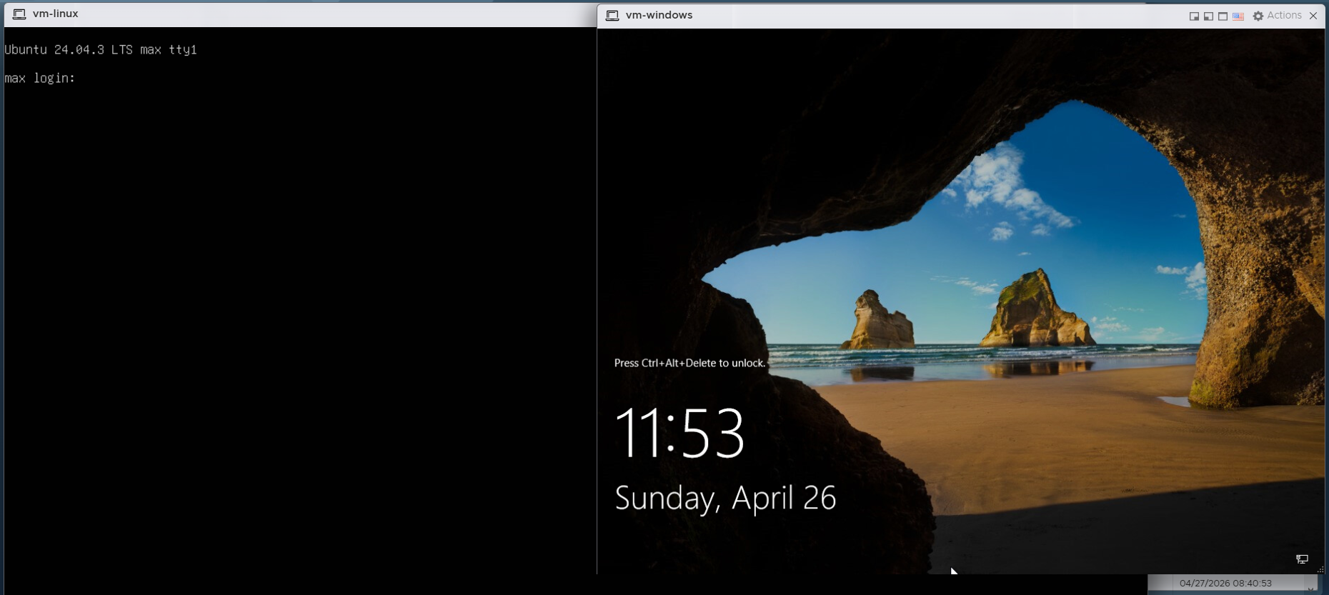

Changing the VM Hardware
- Power off the VM, then choose Edit, adjust the resource values, click Save and start the VM again.

Duplicating a VM (Without vCenter)
Without vCenter, cloning a VM on a standalone ESXi host requires a manual procedure:
- Navigate to Storage → Datastore Browser, select the VM directory, and download the .vmx and .vmdk files.
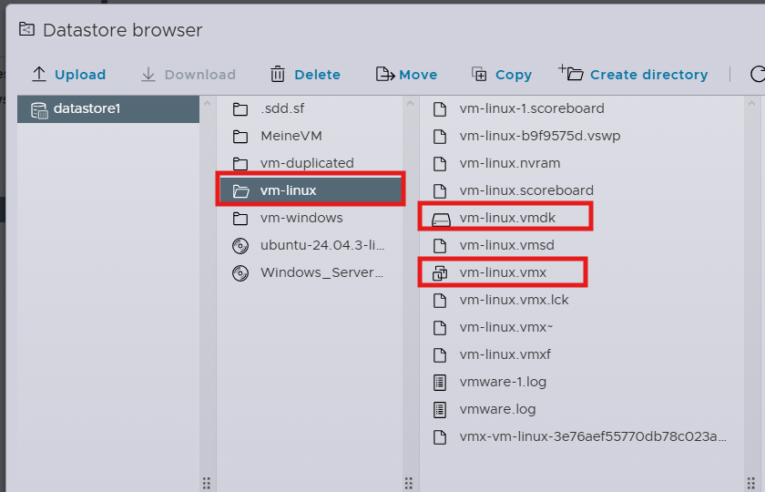
- Open the .vmx file locally and apply the following changes:
- Set a new displayName = "vm-copy".
- Update scsi0:0.fileName = "vm-copy.vmdk" to match the new disk filename.
- Delete the following lines so ESXi generates new identifiers on first power-on: uuid.bios, uuid.location, ethernet0.generatedAddress, ethernet0.generatedAddressOffset.
- Save the modified file under a new name.
- In the Datastore Browser, create a new directory for the copy and upload the modified .vmx and .vmdk files.
- Right-click the .vmx and choose "Register the VM".
The cloned VM now appears under Virtual Machines and can be powered on as an independent system.
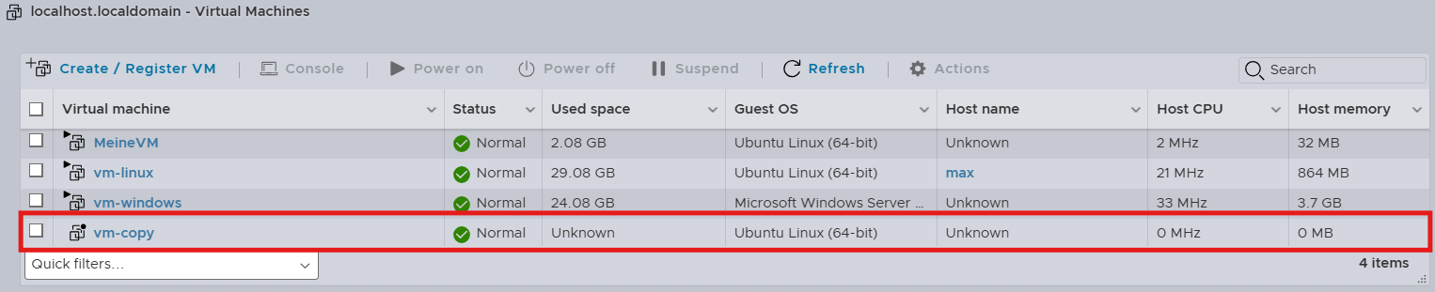

2.3 Exporting a VM (Standalone ESXi)
- Navigate to Storage → Datastore Browser, select the VM directory, and download the VM files.
The exported files (.vmx and .vmdk) can be re-imported on any compatible ESXi host.

2.4 Backup of the ESXi Hypervisor Configuration
ESXi provides built-in commands to back up and restore the host configuration. The backup includes networking, storage, security, and licensing settings.

Creating the Backup
- Connect to the ESXi host via SSH.
- Synchronise the current configuration to the firmware bundle:
vim-cmd hostsvc/firmware/sync_config
- Generate the backup bundle:
vim-cmd hostsvc/firmware/backup_config
The command returns a download URL containing an asterisk placeholder which must be replaced with the host IP. Example URL after substitution:
http://10.0.10.111/downloads/525be5e5-333a-aa1f-c1b5-4c1ac1723ce4/configBundle-localhost.tgz
Open the resulting URL in a browser to download the configuration bundle.

Restoring the Backup
- Place the host in maintenance mode:
vim-cmd hostsvc/maintenance_mode_enter
- Restore the configuration from the downloaded bundle:
vim-cmd hostsvc/firmware/restore_config /tmp/configBundle-localhost.tgz
The host reboots automatically after the restore.

2.5 Snapshots on Standalone ESXi

Taking a Snapshot
- Open the VM in the host client.
- From the action bar select Actions → Snapshot → Take Snapshot.
- Enter a name and optionally a description.
- Click Take Snapshot.

Restoring a Snapshot
- Open the VM.
- Select Actions → Snapshot → Restore Snapshot.
- Click Restore to confirm.

2.6 Backing Up a VM via OVF Export
- Open the VM in the host client.
- Select Actions → Export.
- Enable all components (VMDK, MF, OVF).
- Click Export — the browser downloads the files.

Restoring an OVF Backup
- In the sidebar, click Host.
- Select Create / Register VM in the action bar.
- Choose "Deploy a virtual machine from an OVF or OVA file" and click Next.
- Enter a name for the new VM and drag-and-drop the .vmdk and .ovf files.
- Choose the storage and network configuration.
- Click Finish.

2.7 Creating a VM Template via CLI
Standalone ESXi limitation: ESXi Free / standalone does not offer a built-in template feature. The procedure below replicates template functionality manually via CLI cloning.
- Connect to the ESXi host via SSH.
- Create a folder for the template:
mkdir /vmfs/volumes/datastore1/mein-template
- Clone the source VM disk into the template folder:
vmkfstools -i /vmfs/volumes/datastore1/vm-linux/vm-linux.vmdk \
/vmfs/volumes/datastore1/mein-template/mein-template.vmdk -d thin
- Source: /vmfs/volumes/datastore1/vm-linux/vm-linux.vmdk — the original VM disk.
- Destination: /vmfs/volumes/datastore1/mein-template/mein-template.vmdk — the cloned disk; the name is freely chosen but should match the folder for consistency.
- -i — clone or import a VMDK.
- -d thin — use thin provisioning (only consumes actual disk space).
- Copy the VMX configuration file:
cp /vmfs/volumes/datastore1/vm-linux/vm-linux.vmx \
/vmfs/volumes/datastore1/mein-template/mein-template.vmx
- Modify the VMX file: rename references and remove identifiers that would otherwise conflict with the source VM:
sed -i 's/vm-linux/mein-template/g' /vmfs/volumes/datastore1/mein-template/mein-template.vmx
sed -i '/uuid.bios/d' /vmfs/volumes/datastore1/mein-template/mein-template.vmx
sed -i '/uuid.location/d' /vmfs/volumes/datastore1/mein-template/mein-template.vmx
sed -i '/vc.uuid/d' /vmfs/volumes/datastore1/mein-template/mein-template.vmx
sed -i '/vmci0.id/d' /vmfs/volumes/datastore1/mein-template/mein-template.vmx
sed -i '/ethernet0.generatedAddress/d' /vmfs/volumes/datastore1/mein-template/mein-template.vmx
sed -i '/ethernet0.generatedAddressOffset/d' /vmfs/volumes/datastore1/mein-template/mein-template.vmx
sed -i '/scsi0.sasWWID/d' /vmfs/volumes/datastore1/mein-template/mein-template.vmx
sed -i '/sched.swap.derivedName/d' /vmfs/volumes/datastore1/mein-template/mein-template.vmx
sed -i '/migrate.hostLog/d' /vmfs/volumes/datastore1/mein-template/mein-template.vmx
sed -i '/extendedConfigFile/d' /vmfs/volumes/datastore1/mein-template/mein-template.vmx
sed -i '/scsi0:0.redo/d' /vmfs/volumes/datastore1/mein-template/mein-template.vmx
sed -i '/checkpoint.vmState/d' /vmfs/volumes/datastore1/mein-template/mein-template.vmx
- Register the template VM:
vim-cmd solo/registervm /vmfs/volumes/datastore1/mein-template/mein-template.vmx

Using the Template
- In the ESXi host client, choose Create / Register VM.
- Select "Register an existing virtual machine", or copy the template files to a new folder and register the copy.
- On first boot, choose "I copied it" so that ESXi generates fresh MAC addresses and UUIDs.
Important notes: The source VM must be shut down before cloning. When starting a copied VM, always choose "I copied it" to avoid MAC address and UUID conflicts with the original. Do not start the template itself — always create copies from it instead.

2.8 Installation of the vSphere Client (vCenter Server Appliance)
Centralised management of multiple ESXi hosts is provided by vCenter Server, which in modern versions is deployed as a Linux-based appliance (VCSA — vCenter Server Appliance). The installation is performed in two stages.

Stage 1 — Appliance Deployment
- Mount the VCSA ISO locally on the management workstation.
- Launch installer.exe from the mounted ISO.
- Click Install.
- Enter the ESXi host that will host the appliance: IP 10.0.10.121, port 443, user root, and the corresponding password. Accept the certificate.
- Set the VM name (e.g. vCenter) and the appliance root password.
- Choose the deployment size — Tiny — and enable Thin Disk Mode.
- Select the destination datastore.
- Configure the network: static IPv4 address, subnet mask 255.255.0.0, gateway 10.0.0.1, DNS 10.0.0.1.

Stage 2 — Appliance Configuration
- Configure NTP using a reachable time source such as pool.ntp.org.
- Create the SSO domain vsphere.local with administrator user administrator and a strong password.
- Deselect the Customer Experience Improvement Program.
- Click Finish and wait approximately 15–20 minutes for the configuration to complete.

Accessing the vSphere Client
Once Stage 2 completes, the vSphere Client is available at:
https://10.0.10.119/ui
Log in with the SSO credentials:
- User: administrator@vsphere.local
- Password: (the password set during Stage 2)

2.9 Creating a Datacenter (vSphere Client)
Before any ESXi host can be added to vCenter, a Datacenter object must exist in the inventory.
- Right-click the vCenter IP address in the inventory tree and select New Datacenter…
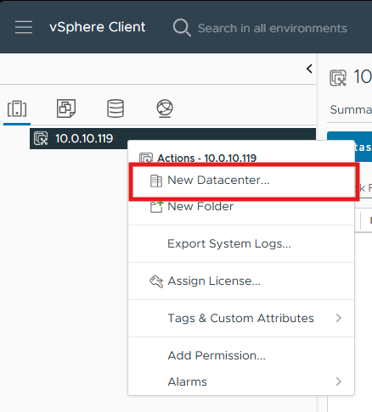
- Give the Datacenter a name and click OK.

2.10 Adding an ESXi Host to vCenter
- Right-click the Datacenter and select Add Host.
- In the wizard, configure the following pages:
- Name and location: IP or FQDN of the ESXi host (e.g. 10.0.10.111) → Next.
- Connection settings: user root and the ESXi root password → Next.
- Security Alert: Accept the host certificate → Yes.
- Host summary: Verify and click Next.
- Assign license: Keep the Evaluation license → Next.
- Lockdown mode: Disabled → Next.
- VM location: Choose the Datacenter → Next.
- Ready to complete: Click Finish.

2.11 Uploading an ISO via the vSphere Client
- Expand Datacenter → datastore1 in the inventory.
- Click Upload Files and select the ISO image to upload.

2.12 Creating a VM via the vSphere Client
- In the navigation bar, switch to Hosts and Clusters (the first icon).
- Right-click the IP address of the desired ESXi host and select New Virtual Machine.
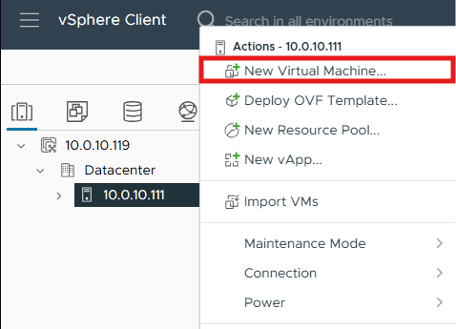
- Step through the wizard:
- Select a creation type: Create a new virtual machine → Next.
- Select a name and folder: Name (e.g. ubuntu-server-01), location is the existing Datacenter → Next.
- Select a compute resource: Pre-selected ESXi host → Next.
- Select storage: Choose the datastore → Next.
- Select compatibility: Leave at the default (e.g. ESXi 8.0 U2 and later) → Next.
- Select a guest OS: Family Linux, Version Ubuntu Linux (64-bit) → Next.

Customize hardware (the critical step)
- CPU: 2
- Memory: 4096 MB (4 GB)
- New Hard disk: 40 GB, expand the disk options and set Disk Provisioning to Thin Provision (to save space).
- New CD/DVD Drive: Click the dropdown and select Datastore ISO File, then browse to the ISOs folder and choose the Ubuntu ISO. Check "Connect At Power On" — otherwise the VM will not boot from the ISO.
- Ready to complete: review all settings and click Finish.
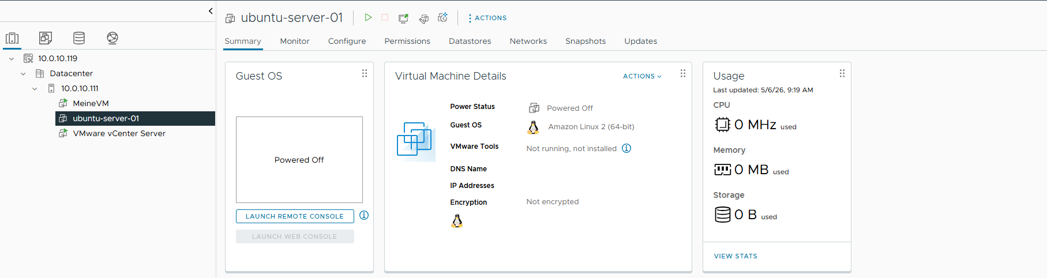

2.13 Changing VM Hardware (vSphere Client)
- Shut down the VM (Right-click VM → Power → Power off).
- Right-click the VM again and choose Edit Settings.
- Adjust the hardware as required and click OK.
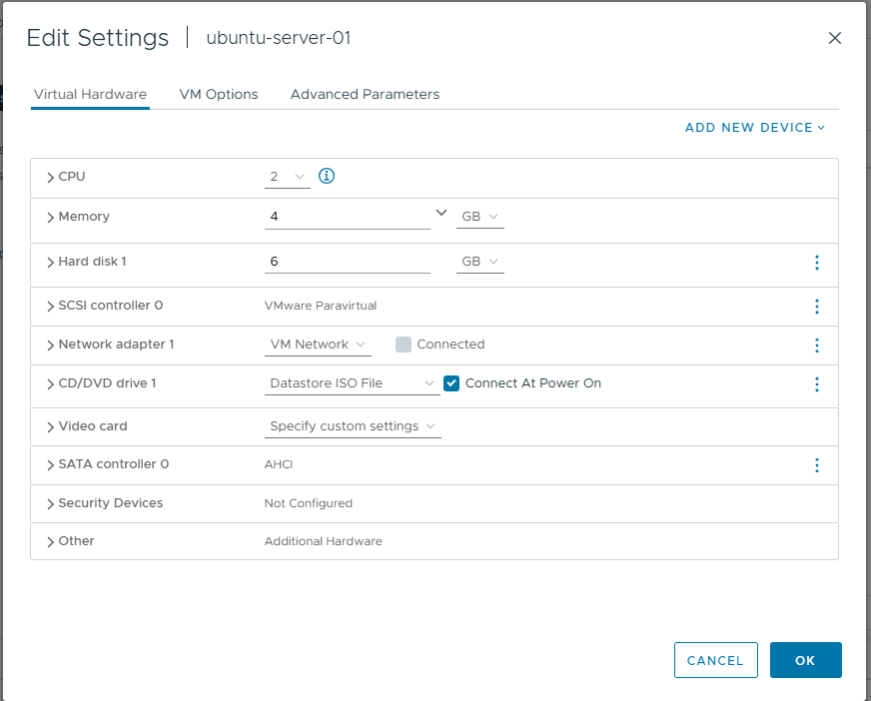
Hot-plug support: CPU and RAM can be increased while the VM is running, provided that "CPU Hot Plug" and "Memory Hot Plug" are enabled in the VM's Options tab. Other hardware components generally require the VM to be powered off.

2.14 Cloning a VM (vSphere Client)
- Right-click ubuntu-server-01 → Clone → Clone to Virtual Machine….
- Step through the wizard:
- Select a name and folder: Name (e.g. ubuntu-server-01-clone), Location: the Datacenter → Next.
- Select a compute resource: Choose the ESXi host → Next.
- Select storage: Choose the datastore → Next.

Select clone options
Three checkboxes are available:
- Customize the operating system — leave off. This would re-personalise hostname / IP / SID and requires a Customization Specification.
- Customize this virtual machine's hardware — leave off. Use the standard Edit Settings dialog afterwards if needed.
- Power on virtual machine after creation — leave off for the first test.
- Ready to complete: review and click Finish.
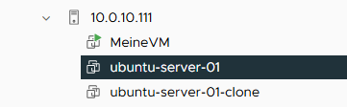

2.15 Exporting a VM as OVF (vSphere Client)
- Right-click the VM → Template → Export OVF Template….
- Enter a name in the popup and click OK.
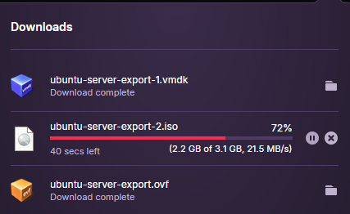
Browser popups: The export downloads several files via the browser. Make sure popups are allowed for the vCenter URL, and keep the browser tab open until the .ovf, .mf, and .vmdk files have all finished downloading.

2.16 Backing Up a VM via Script (ghettoVCB)
The ghettoVCB script (created and maintained by William Lam) provides reliable VMware-aware VM backups directly from the ESXi shell. It uses native vSphere snapshots so that running VMs can be backed up without downtime.

Preparing the Script
- Connect to the ESXi host via SSH as root.
- Navigate to the datastore and create a working directory:
cd /vmfs/volumes/datastore1/
mkdir ghettoVCB
cd ghettoVCB
- Download the script. The official source is:
https://raw.githubusercontent.com/lamw/ghettoVCB/master/ghettoVCB.sh
If the ESXi host has restricted internet access, download the script on the management workstation and transfer it to the host using MobaXterm drag-and-drop or SCP.
- Make the script executable:
chmod +x ghettoVCB.sh
- Create the backup target directory (in the lab on the same datastore — in production this should always be on separate storage):
mkdir /vmfs/volumes/69e5cb3f-c2b3ee88-e01d-d4f5ef8b6f14/Backups

Creating the Configuration File
Create a file named ghettoVCB.conf containing the backup parameters. Because the ESXi shell does not provide nano, the file is created using cat with a heredoc (vi is also available if preferred):
cat > ghettoVCB.conf << 'EOF'
VM_BACKUP_VOLUME=/vmfs/volumes/69e5cb3f-c2b3ee88-e01d-d4f5ef8b6f14/Backups
DISK_BACKUP_FORMAT=thin
VM_BACKUP_ROTATION_COUNT=3
POWER_VM_DOWN_BEFORE_BACKUP=0
ENABLE_HARD_POWER_OFF=0
ITER_TO_WAIT_SHUTDOWN=3
POWER_DOWN_TIMEOUT=5
ENABLE_COMPRESSION=0
VM_SNAPSHOT_MEMORY=0
VM_SNAPSHOT_QUIESCE=0
ENABLE_NON_PERSISTENT_NFS=0
UNMOUNT_NFS=0
EMAIL_LOG=0
WORKDIR_DEBUG=0
VM_SHUTDOWN_ORDER=
VM_STARTUP_ORDER=
RSYNC_LINK=0
BACKUP_FILES_CHMOD=
EOF

Listing VMs and Creating the VM List
To identify the exact VM names, list all registered VMs on the host:
vim-cmd vmsvc/getallvms
Create the vms_to_backup file with one VM name per line:
cat > vms_to_backup << 'EOF'
ubuntu-server-01
ubuntu-server-01-clone
EOF

Running the Backup
./ghettoVCB.sh -f vms_to_backup -g /vmfs/volumes/69e5cb3f-c2b3ee88-e01d-d4f5ef8b6f14/ghettoVCB/ghettoVCB.conf
Successful log output:
2026-05-06 08:42:43 -- info: Successfully completed backup for ubuntu-server-01!
2026-05-06 08:42:50 -- info: Successfully completed backup for ubuntu-server-01-clone!

2.17 Snapshots in the vSphere Client
- Connect to the vSphere Client.
- Right-click the VM → Snapshot → Take Snapshot.
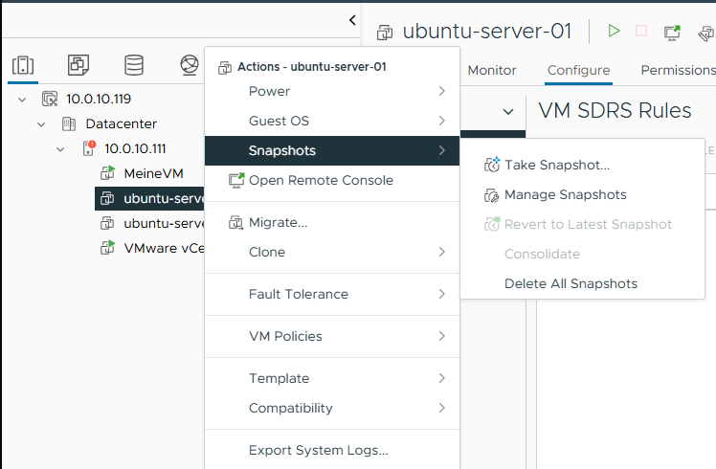
- Enter a name and optional description, then click Create.

Reverting a Snapshot
- Navigate to Snapshots → Revert to Latest Snapshot.
- Confirm with Revert in the popup.

Managing Snapshots
- Open Snapshots → Manage Snapshots to view all snapshots of the VM. Each snapshot can be selected, edited, or deleted from this view.

2.18 Creating a VM Template (vSphere Client)
Template behaviour: Once a VM is converted to a template, it can no longer be powered on. To use it, deploy a new VM from the template instead.
- Right-click the VM → Template → Convert to Template.
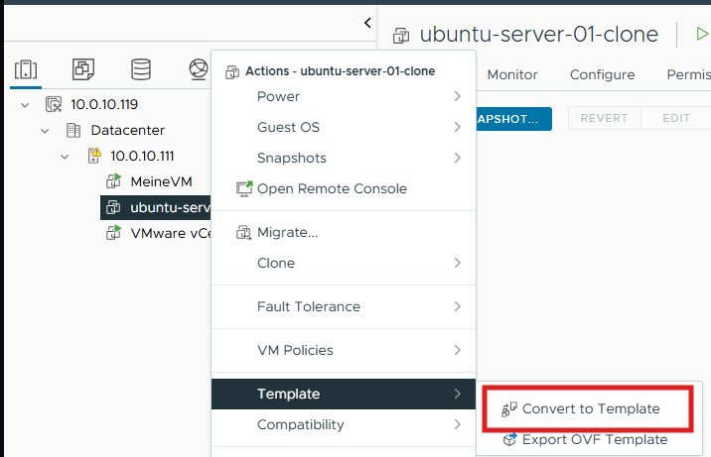
The template now appears in the VMs and Templates view of the inventory:
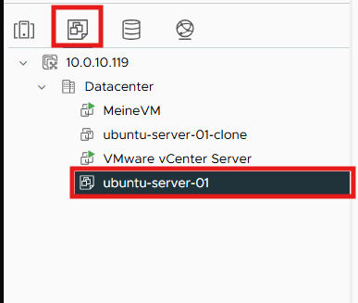

2.19 Using Remote iSCSI Storage
Shared storage is essential for advanced vSphere features such as vMotion, HA, and DRS. In this lab, the CLOIF2 TrueNAS server provides iSCSI block storage to the ESXi hosts.

Phase 1 — Preparation on TrueNAS

Step 1.1 — Verify the iSCSI Service
In the TrueNAS web interface, navigate to System Settings → Services and ensure the iSCSI service is Running with "Start Automatically" enabled.

Step 1.2 — Verify the Existing Setup
- Navigate to Shares → Block (iSCSI) Shares Targets and open the Targets tab.
- Confirm that the target vmware exists and has at least one associated extent.

Step 1.3 — Provision the Zvol for ESXi
- Under Datasets, size the zvol vmware-esxi in the areca_raid5 pool to a reasonable value. In this project the original 80 MiB zvol was too small for VMFS and was resized to 80 GiB.
Minimum VMFS size: A VMFS-6 volume requires approximately 1.3 GB of available space at minimum. When working on a shared NAS, always agree changes with the administrator and prefer creating a dedicated zvol with a user-specific name prefix rather than modifying existing zvols.

Step 1.4 — Connection Parameters
Parameter | Value
TrueNAS IP | 10.0.13.3
iSCSI Port | 3260
Target Base IQN | iqn.2005-10.org.freenas.ctl
Target Name | vmware
LUN | 1 (zvol vmware-esxi, 80 GiB)

Phase 2 — Configuration on ESXi (vSphere Client)

Step 2.1 — Enable the Software iSCSI Adapter
- Open the vSphere Client at https://10.0.10.119/ui.
- Navigate to Hosts and Clusters and select the ESXi host.
- Open the Configure tab and navigate to Storage → Storage Adapters.
- Click ADD SOFTWARE ADAPTER → Add iSCSI adapter → OK.
A new adapter (typically vmhbaXX of type "iSCSI Software Adapter") appears in the list.

Step 2.2 — Configure Dynamic Discovery
- Select the new iSCSI adapter.
- In the lower details pane, open the Dynamic Discovery tab and click ADD.
- Enter the following values:
- iSCSI Server: 10.0.13.3
- Port: 3260
- Authentication: Inherit from parent (no CHAP).
- Click OK.

Step 2.3 — Storage Rescan
- Click RESCAN STORAGE… at the top of the Storage Adapters view, keep both options enabled, and confirm with OK.
Monitor progress in the Recent Tasks panel.

Step 2.4 — Verify Storage Devices
- In the Configure menu, click Storage Devices.
A new TrueNAS iSCSI Disk should be visible with the configured size (80 GiB) and status "Not Consumed".

Step 2.5 — Create the VMFS Datastore
- Right-click the ESXi host → Storage → New Datastore….
- Choose Type: VMFS → Next.
- Enter the name (e.g. iSCSI-Datastore-01), choose the host, and select the TrueNAS LUN → Next.
- Select VMFS Version: VMFS 6 → Next.
- Partition Configuration: Use all available partitions → Next.
- Click Finish.

Step 2.6 — Functional Test via Storage Migration
- Right-click an existing VM → Migrate….
- Migration Type: Change storage only → Next.
- Target datastore: iSCSI-Datastore-01 → Next → Finish.
- Verify success in Recent Tasks and in the VM's Datastore column.

Verification
Check | Expected Result
TrueNAS → iSCSI Connections | Active ESXi initiator connection visible
ESXi → Storage Adapters | iSCSI Software Adapter is active
ESXi → Storage Devices | TrueNAS iSCSI Disk with 80 GiB visible
ESXi → Datastores | iSCSI-Datastore-01 visible with correct capacity
VM Migration | VM files reside on the new datastore

Notes on a Shared Lab NAS
In this lab the CLOIF2 TrueNAS is shared between multiple student groups. To avoid disrupting other users, every modification (resize, extent creation, target configuration) was coordinated with the administrator. Dedicated zvols with user-specific naming would be preferred in a production scenario to prevent accidental impact across teams.

2.20 VM Storage Migration (vSphere)
With shared storage in place, migrating a VM's files from one datastore to another is a straightforward operation. The VM can remain powered on during the migration.
- Right-click the VM → Migrate.
- Choose "Change storage only" as the migration type.
- Select the target datastore and proceed through the wizard.
- Click Finish.
The transfer runs in the background. For a thin-provisioned VM the operation typically takes only a few minutes for small disks.

2.21 VM Migration Between Hypervisors (vMotion)
Live migration of a powered-on VM between two ESXi hosts requires both hosts to share the underlying storage and to be managed by the same vCenter.

Adding a Second Hypervisor
- Right-click the Datacenter → Add Host.
- Step through the wizard:
- Name and location: IP or FQDN of the second ESXi host → Next.
- Connection settings: user root and the host password → Next.
- Security Alert: Accept the certificate → Yes.
- Host summary: Verify and click Next.
- Assign license: Evaluation → Next.
- Lockdown mode: Disabled → Next.
- VM location: Datacenter → Next.
- Ready to complete: Finish.

Shared Storage on the Second Host
The second host must access the same shared iSCSI storage as the first. The procedure repeats the iSCSI adapter configuration described in section 2.19.

Step 1 — Select the Second Host
In the vSphere Client inventory pane, click on the second ESXi host. Make sure not to select the first host, as configuration changes would otherwise be applied to the wrong target.

Step 2 — Enable the Software iSCSI Adapter
- Open the Configure tab.
- In the left menu, navigate to Storage → Storage Adapters.
- Click ADD SOFTWARE ADAPTER → Add iSCSI adapter, then confirm with OK.
A new adapter (typically vmhbaXX of type "iSCSI Software Adapter") appears in the list.

Step 3 — Configure Dynamic Discovery
- Select the newly created iSCSI adapter.
- In the details pane, open the Dynamic Discovery tab and click ADD.
- Enter the following values:
- iSCSI Server: 10.0.13.3
- Port: 3260
- Confirm with OK.

Step 4 — Trigger a Storage Rescan
- In the Storage Adapters view, click RESCAN STORAGE… and leave both checkboxes enabled.

Step 5 — Verify Storage Devices
- In the left menu, navigate to Storage Devices.
The TrueNAS iSCSI disks that were visible on the first host now appear here as well (e.g. an 80 GiB device).

vMotion Network Configuration
vMotion traffic requires that the vMotion service is enabled on a VMkernel adapter. This must be done on every host that participates in vMotion.
- On each host: Configure → VMkernel adapters.
- Click the three dots next to the management VMkernel (vmk0) and choose Edit.
- Enable the vMotion service in the Services section.
Best practice: In production environments, vMotion should run on a dedicated VMkernel adapter on its own physical NIC and VLAN (ideally with jumbo frames enabled, MTU 9000). In this lab, sharing the vmk0 management interface was acceptable for simplicity.

Migrating the VM
Requirements for live migration:
- The VM must reside on shared storage that both source and destination hosts can access.
- Any locally attached CD/DVD ISO must be disconnected (an ISO referencing a local datastore cannot be reached by the destination host).
- Right-click the VM → Migrate.
- Step through the wizard:
- Select a migration type: Change compute resource only.
- Select a compute resource: Choose the new host.
- Select networks: Map the source network to a matching network on the destination → Next.
- Select vMotion priority: "Schedule vMotion with high priority" → Next.
- Ready to complete: Finish.
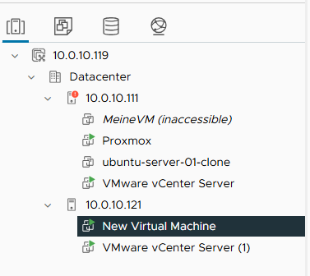
During the vMotion the VM remains responsive; only the final cutover causes a brief network pause of typically less than a second.

2.22 Managing Users, Roles, and Permissions
vCenter integrates a Single Sign-On (SSO) domain that holds users and groups. By default the domain is vsphere.local. Permissions are assigned by combining a user (or group) with a role on a specific inventory object.

Creating a User
- Open the navigation menu (☰) and choose Administration.
- Under Single Sign On → Users and Groups, confirm that the domain is set to vsphere.local.
- Click ADD → Create User and provide the user details.
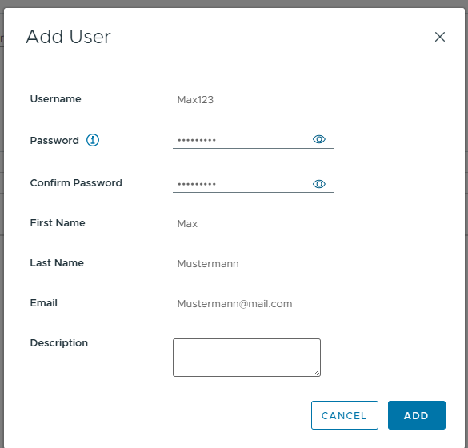

Creating a Custom Role
- In the left sidebar, navigate to Access Control → Roles and click New.
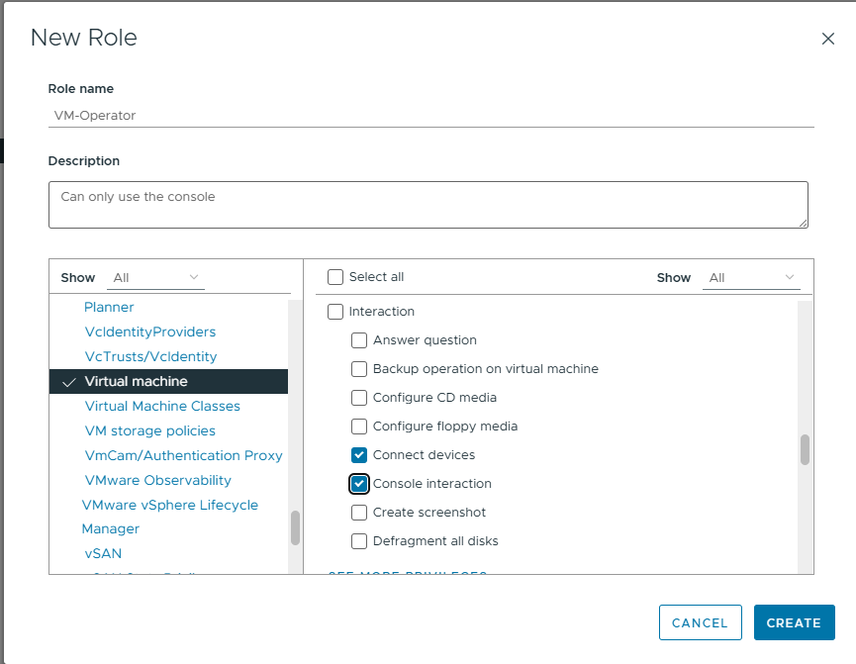
- Choose only the privileges actually required for the role (principle of least privilege). For example, a "VM Operator" role might be limited to Virtual machine → Interaction → Power On / Power Off and Console interaction.
- Click Create.

Assigning Permissions
- In Hosts and Clusters, select the inventory object on which the permission should apply (Datacenter, Cluster, Host, or individual VM).
- Right-click and choose Add Permission.
- Fill in the wizard:
- Domain: vsphere.local
- User / Group: Select the user.
- Role: Select the custom role (e.g. VM-Operator).
- Propagate to children: Enable to inherit the permission on all child objects of the selected object.

2.23 Patching the Hypervisor
vSphere Lifecycle Manager (vLCM) is the central tool for tracking and applying patches to ESXi hosts. Patches are organised in baselines that describe a desired patch level.

Initial State
The ESXi hosts in this project were installed with a current ESXi 8.0 U2 image. The patch workflow described below was therefore executed to demonstrate the procedure even though no patches were pending at the time.

Step 1 — Open the vSphere Lifecycle Manager
- In the vSphere Client, navigate to Menu → Lifecycle Manager.

Step 2 — Verify the Patch Source
- Open Settings → Patch Downloads and confirm that the VMware Online Depot is configured and reachable. Trigger a manual Sync Updates if needed.

Step 3 — Attach a Baseline to the Host
- Navigate to Hosts and Clusters → [ESXi Host] → Updates → Baselines.
- Click ATTACH and select the predefined baseline Critical Host Patches (Predefined).
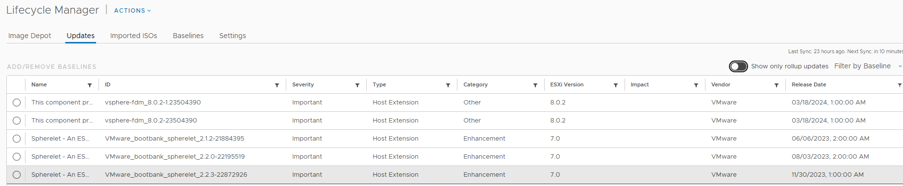

Step 4 — Run a Compliance Check
- Click CHECK COMPLIANCE. The host is compared against the attached baseline.
Result: the host was reported as Compliant, indicating that no updates from the baseline were missing.

Theoretical Remediation Workflow
Had the host been reported as non-compliant, the patch procedure would continue as follows:
- Migrate all running VMs to another host via vMotion.
- Place the host in Maintenance Mode.
- Click REMEDIATE on the Updates tab, select the baseline, and confirm the operation.
- The host downloads, installs the patches, and reboots automatically.
- Run another compliance check to confirm the new patch level.
- Exit Maintenance Mode and (optionally) migrate VMs back.
Production best practice: Patches should always be staged: apply them first to a non-production host or cluster to detect compatibility issues, then progress through production hosts one at a time. A host configuration backup (see section 2.4) should be taken beforehand.

Part III — Specialisation: High Availability

3.1 Concept
vSphere High Availability (HA) is a cluster-level feature that protects virtual machines against the failure of a physical ESXi host. When a host becomes unreachable, HA automatically restarts the affected VMs on the remaining healthy hosts in the cluster. HA is not a "live" technology — affected VMs incur a brief downtime equivalent to a forced reboot — but the recovery is fully automatic and requires no operator intervention.

How HA Detects Failures
Each cluster has an automatically elected HA master host. The master continuously communicates with the other (slave) hosts via two independent channels:
- Network heartbeats over the management network — the primary detection channel.
- Datastore heartbeats written to shared datastores — a secondary channel that allows the master to distinguish between an actual host failure and a network-only isolation event.
If a host stops responding on both channels, HA treats it as failed and begins restarting its VMs on the surviving hosts.

What HA Is and Is Not
Feature | Provides
vMotion | Live VM migration with no downtime — for planned operations only.
HA | Automatic restart of VMs after an unexpected host failure — brief downtime.
Fault Tolerance (FT) | Continuous mirroring of a VM on two hosts — zero downtime, but doubles the resource cost.
Backup | Point-in-time recovery from data loss, corruption, ransomware — not an HA replacement.

Prerequisites
- A vCenter Server managing the cluster.
- A vSphere Cluster object containing at least two hosts (three or more recommended for sensible Admission Control).
- Shared storage accessible from every cluster member — without it HA cannot restart VMs on another host.
- Reliable network connectivity between hosts (management network) and to the shared storage (heartbeat datastores).
- DNS resolution between hosts (both forward and reverse).

3.2 Cluster Creation
- In the vSphere Client, navigate to Hosts and Clusters.
- Right-click the Datacenter → New Cluster…
- In the wizard:
- Name: LabCluster.
- vSphere HA: Enabled.
- vSphere DRS: (optional) — enabling DRS also automatically rebalances VMs by load.
- Manage all hosts in the cluster with a single image: Disabled — baselines are used in this lab.
- Click Next → Finish.
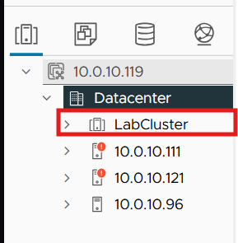

Adding Hosts to the Cluster
Drag the existing hosts from the Datacenter onto the newly created cluster. For each host, a dialog asks how to handle the existing VMs and resource pools — choose "Put all of this host's virtual machines in the cluster's root resource pool".

3.3 Fine-Tuning HA Settings
- Select the cluster → Configure → Services → vSphere Availability → EDIT….

Failures and Responses
- Host failure response: Restart VMs.
- Response for host isolation: Power off and restart VMs.
- Datastore with PDL: Power off and restart VMs.
- Datastore with APD: Power off and restart VMs (conservative restart policy).
- VM Monitoring: VM Monitoring Only.

Admission Control
- Host failures cluster tolerates: 1. The cluster reserves enough CPU and memory to absorb the failure of any single host.

Heartbeat Datastores
- Selection policy: Use datastores from the specified list and complement automatically if needed.

Apply
Click OK. vCenter propagates the HA configuration to all hosts (visible in Recent Tasks). The process typically completes within 1–2 minutes.

3.4 Adding a Second Heartbeat Datastore

Background
After enabling vSphere HA on the cluster, the following warning appeared on each host:
"The number of vSphere HA heartbeat datastores for this host is 1, which is less than required: 2"
vSphere HA uses datastores as a secondary communication channel between hosts, in addition to the management network. These so-called heartbeat datastores allow the HA master to distinguish between two very different failure scenarios:
- A host has actually failed (no network heartbeats, no datastore heartbeats) — HA restarts the VMs on other hosts.
- A host is only network-isolated but still running (no network heartbeats, but datastore heartbeats still present) — HA reacts more cautiously to avoid a split-brain situation where the same VM would run on two hosts.
To make this fallback reliable, vSphere HA requires at least two heartbeat datastores that are accessible by all hosts in the cluster. If only one is available and that datastore becomes unreachable, HA loses its ability to correctly assess host states.
Initially the cluster had only one shared datastore (iSCSI-Datastore-01, 78 GB), so a second one had to be added.

Procedure

Step 1 — Create a New Zvol on TrueNAS
- Datasets → areca_raid5 → Add Zvol
- Name: max-heartbeat
- Size: 5 GiB (sufficient for heartbeat purposes only).
- Sparse: Enabled (thin-provisioned).

Step 2 — Create a New Extent
- Shares → Block (iSCSI) Shares Targets → Extents → Add
- Name: max-heartbeat-extent
- Extent Type: Device
- Device: zvol/areca_raid5/max-heartbeat
- Sharing Platform: VMware: Extent block size 512b, TPC enabled, no Xen compat mode, SSD speed.

Step 3 — Associate the Extent with the iSCSI Target
In the target vmware configuration, add a new LUN association:
- LUN ID: 2
- Extent: max-heartbeat-extent

Step 4 — Rescan iSCSI Adapter on All Hosts
On each of the three ESXi hosts:
Configure → Storage Adapters → iSCSI Adapter → RESCAN STORAGE
The new 5 GiB LUN appears under Storage Devices with status "Not Consumed".

Step 5 — Create the VMFS Datastore
- Right-click any host → Storage → New Datastore
- Type: VMFS
- Name: iSCSI-Heartbeat
- Disk: the new 5 GiB TrueNAS LUN
- Version: VMFS 6
The new datastore is automatically mounted on all three hosts because the underlying target is shared.

Step 6 — Reconfigure HA to Use Both Datastores
- Cluster → Configure → vSphere Availability → EDIT → Heartbeat Datastores
- Policy: Use datastores from the specified list and complement automatically if needed
- Select both shared datastores: iSCSI-Datastore-01 and iSCSI-Heartbeat
- Apply.

Result
After HA was reconfigured, Monitor → vSphere HA → Heartbeat showed two heartbeat datastores per host, and the warning disappeared. The cluster is now resilient against the failure of a single heartbeat datastore: if one becomes unreachable, the second one continues to provide secondary failure-detection signalling.

Why This Matters
A single heartbeat datastore is a single point of failure for HA's failure-detection logic. Without redundancy, HA can no longer reliably distinguish between an actual host failure and a transient network or storage issue, which can lead to incorrect failover decisions, unnecessary VM restarts, or — worse — failed restarts when they are actually needed. Maintaining at least two heartbeat datastores is therefore a fundamental requirement for any production HA cluster.

3.5 Do's and Don'ts

Do
- Provide at least two heartbeat datastores accessible from every host in the cluster.
- Use shared storage for all VMs that must be HA-protected — VMs on local-only datastores cannot be restarted elsewhere.
- Run with a minimum of three hosts to allow sensible Admission Control configuration.
- Configure redundant management networks (or dedicated VMkernel adapters with separate physical NICs).
- Maintain proper DNS — forward and reverse — between cluster members to avoid HA agent communication issues.
- Keep Admission Control enabled. It guarantees there is enough spare capacity to restart VMs after a host failure.
- Test the failover regularly — do not discover during a real outage that HA is misconfigured.
- Enable an appropriate EVC mode at the cluster level when hosts have different CPU generations; otherwise vMotion (and HA-driven restart on heterogeneous CPUs) can fail.

Don't
- Do not treat HA as a backup solution — HA protects against hardware failure, not against data loss, corruption, ransomware, or accidental deletion.
- Do not place HA-protected VMs on local (non-shared) datastores.
- Do not place all hosts in Maintenance Mode simultaneously — HA loses its quorum and cannot function.
- Do not size individual VMs so large that they cannot run on any single surviving host — they will fail to restart.
- Do not disable Admission Control "to be safe" — without it the failover scenario it is designed to protect against will eventually break.
- Do not rely on a single iSCSI path or a single NIC for storage — a storage outage defeats HA entirely.

Conclusion
This project covered the full breadth of features required to operate a modern server virtualisation environment, implementing each feature on two leading hypervisor platforms — Proxmox VE and VMware ESXi — and going into depth on the High Availability specialisation.
Working with both hypervisors highlighted the fundamentally different design philosophies of the two platforms. Proxmox VE is open-source, accessible, and combines KVM and LXC under a unified web interface that exposes most operations in a clear, scriptable fashion. VMware ESXi together with vCenter Server represents the matured enterprise-grade product line, with a richer ecosystem of advanced features such as vMotion, DRS, HA, FT, and Lifecycle Manager. The trade-off is one of cost and complexity — Proxmox achieves a remarkable amount of the same functionality without licensing fees but requires more manual integration work for advanced features (clustering, HA, shared storage), whereas VMware delivers polished, integrated tooling at the price of commercial licensing.
Implementing the High Availability specialisation on VMware in particular reinforced how much careful design goes into a robust HA setup. The seemingly small detail of providing two independent heartbeat datastores turned out to be a fundamental requirement, and the principles of Admission Control, shared storage, and redundant networking are non-negotiable. The lab also surfaced practical lessons — from carefully sizing the vCenter appliance and its datastore, to coordinating modifications on a shared CLOIF2 NAS to avoid disrupting other student teams, to the importance of working with a stable management network for any vCenter-based operation.
Beyond the technical content, the project served as an extensive exercise in incremental problem-solving: every feature implementation surfaced its own constellation of edge cases and dependencies, and recovering from situations such as a corrupted vCenter VM or an out-of-space datastore was as instructive as the planned curriculum. Documenting the process in parallel with implementing it helped tremendously in retracing decisions later and in building a coherent narrative across two different hypervisor stacks.
Both Proxmox VE and VMware ESXi are credible enterprise virtualisation platforms in 2026. The choice between them in a real deployment is rarely a purely technical one — operational cost, in-house expertise, ecosystem integration, and support requirements drive the decision at least as much as feature parity. Having worked extensively with both for this project leaves a much clearer picture of where each platform excels and how they complement the broader infrastructure stack — and that, ultimately, was the central learning outcome of this project.

