Codebook

Lukas Fesenfeld, Leon Sistek, Simon Montfort, Dionis Anderegg, Jürg Rohrer, Tobias Schmidt

Last update: 15.12.2025

Contents
1 Control Variables 3
2 Treatment Variable (NIMBY) 5
3 Comprehension/Manipulation Check 7
4 Dependent Variables 8
5 Conjoint Analysis 11
6 Other Variables 17

- Control Variables
  - age
Variable name | age
Dataset | data
Question text | How old are you (in years)?
Item text
Variable type | Numeric
Variable range | 18 - 79

  - gender
Variable name | gender
Dataset | data
Question text | Which gender do you feel you belong to?
Variable type | Numeric
Item text
Variable range | 1 (Male), 2 (Female)

Variable name | gender_f
Dataset | data
Question text | Which gender do you feel you belong to?
Variable type | Factor
Item text
Variable range | Male, Female

  - environment_score
Average of three different variables (1.3.1-1.3.3) measuring the respondent’s attitude towards the environment.
Variable name | environment_score
Dataset | data
Question text | None
Item text
Variable type | Numeric
Variable range | 1-7

    - environ_behaviour
Variable name | environ_behaviour
Dataset | data
Question text | Please indicate whether you agree or disagree with the following statements
Item text | Environmentally friendly behavior is an important part of my being.
Variable type | Numeric
Variable range | 1 (Completely disagree)-7 (Completely agree)

    - crisis_exag
The scale has been manually inversed compared to the coding in the survey to ensure the same direction as the other two variables.
Variable name | crisis_exag
Dataset | data
Question text | Please indicate whether you agree or disagree with the following statements
Item text | The so-called “environmental crisis” facing humanity is greatly exaggerated.
Variable type | Numeric
Variable range | 1 (Completely agree)-7 (Completely disagree)

    - environment_disaster
Variable name | environment_disaster
Dataset | data
Question text | Please indicate whether you agree or disagree with the following statements
Item text | If things continue as they are, we will soon experience a major environmental disaster.
Variable type | Numeric
Variable range | 1 (Completely disagree)-7 (Completely agree)

  - familiar_agri_pv
Variable name | familiar_agri_pv
Dataset | data
Question text | How familiar are you, if at all, with agri-photovoltaics?
Item text
Variable type | Numeric
Variable range | 1 (Not familiar)-7 (Very familiar)

  - like_energy_agri_pv
Variable name | like_energy_agri_pv
Dataset | data
Introduction text | The following questions continue to ask your opinion on agri-photovoltaics, a dual land use concept that combines the cultivation of agricultural crops with the installation of solar panels on land.
Question text | I find energy from agri-photovoltaics
Item txt
Variable type | Numeric
Variable range | 1 (Very bad)-7 (Very good)

  - Urban Characteristics
Respondents were asked to assess the spatial characteristics of the area they live in. Because this self-assessment is subjective, a different variable is introduced (urban_rural_true) based on the real spatial typology defined by the Swiss Federal Statistical Office and the municipality the respondent is living in.
    - urban_rural
Variable name | urban_rural
Dataset | data
Introduction text
Question text | In which area do you live?
Item text
Variable type | Numeric
Variable range | 1 (Urban), 2 (Suburban), 3 (Rural)

    - urban_rural_true
Variable name | urban_rural_true
Dataset | data
Introduction text
Question text
Item text
Variable type | Numeric
Variable range | 1 (Urban), 2 (Suburban), 3 (Rural)

- Treatment Variable (NIMBY)
Variable name | NIMBY
Dataset | data
Introduction text
Question text
Item text
Variable type | Numeric
Variable range | 0 (Control), 1 (Treatment)

The treatment is designed as follows:
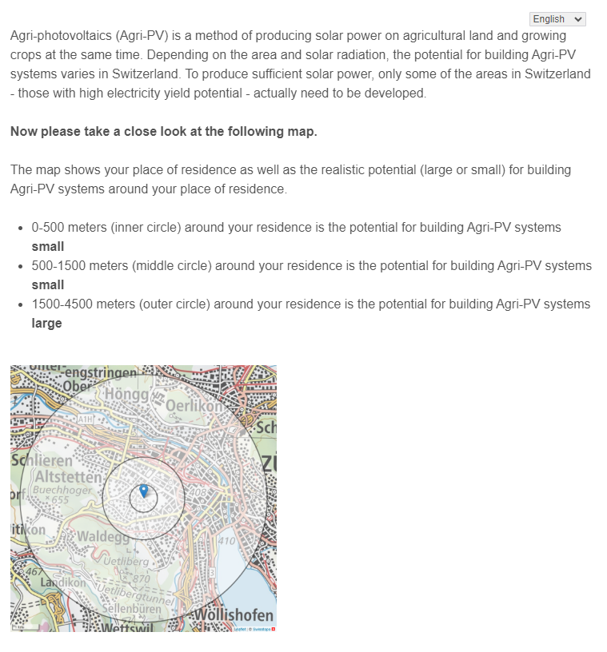
The control group was presented with the following:
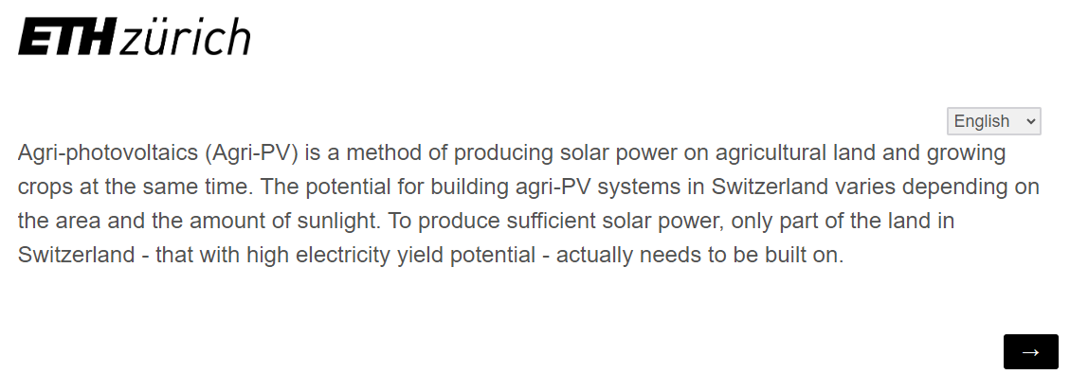
- Comprehension/Manipulation Check
  - potential_known
Variable name | potential_known
Dataset | data
Introduction text
Question text | The potential for the development of agri-photovoltaic projects within a radius of up to 4500 meters from my house/apartment is...
Item text
Variable type | Numeric
Variable range | 1 (Is not known to me), 2 (Known to me roughly), 3 (Known to me)

  - potential_known_1
Variable name | potential_known_1
Dataset | data
Introduction text
Question text | To your knowledge, how big or small is the potential for building agri-PV systems in the area around your apartment/house?
Item text | 0-500 meters around your residence
Variable type | Numeric
Variable range | 0 (Small), 1 (Large)

  - potential_known_2
Variable name | potential_known_2
Dataset | data
Introduction text
Question text | To your knowledge, how big or small is the potential for building agri-PV systems in the area around your apartment/house?
Item text | 500-1500 meters around your residence
Variable type | Numeric
Variable range | 0 (Small), 1 (Large)

  - potential_known_3
Variable name | potential_known_3
Dataset | data
Introduction text
Question text | To your knowledge, how big or small is the potential for building agri-PV systems in the area around your apartment/house?
Item text | 1500-4500 meters around your residence
Variable type | Numeric
Variable range | 0 (Small), 1 (Large)

  - personal_advantage
Variable name | personal_advantage
Dataset | data
Introduction text
Question text | For you personally: Do you see the construction of agri-photovoltaic projects in Switzerland as an advantage or a disadvantage?
Item text
Variable type | Numeric
Variable range | 1 (Very disadvantageous) – 7 (Very advantageous)

  - ch_advantage
Variable name | ch_advantage
Dataset | data
Introduction text
Question text | For Switzerland and its population as a whole: Do you consider the construction of agri-photovoltaic projects in Switzerland to be an advantage or a disadvantage?
Item text
Variable type | Numeric
Variable range | 1 (Very disadvantageous) – 7 (Very advantageous)

- Dependent Variables
  - attitude_expansion_small
Variable name | attitude_expansion_small
Dataset | data
Introduction text
Question text | What is your personal attitude towards the expansion of the following agri-photovoltaic systems?
Item text | Small agri-PV system (up to 1 football field, approx. 1ha)
Variable type | Numeric
Variable range | 1 (I completely oppose) – 7 (I completely support)

  - attitude_expansion_medium
Variable name | attitude_expansion_medium
Dataset | data
Introduction text
Question text | What is your personal attitude towards the expansion of the following agri-photovoltaic systems?
Item text | Medium-sized agri-PV plant (up to 5 football fields, approx. 5ha)
Variable type | Numeric
Variable range | 1 (I completely oppose) – 7 (I completely support)

  - attitude_expansion_large
Variable name | attitude_expansion_large
Dataset | data
Introduction text
Question text | What is your personal attitude towards the expansion of the following agri-photovoltaic systems?
Item text | Large agri-PV plant (up to 10 football fields, approx. 10ha)
Variable type | Numeric
Variable range | 1 (I completely oppose) – 7 (I completely support)

  - attitude_expansion_nearby
Variable name | attitude_expansion_nearby
Dataset | data
Introduction text | Imagine that an agri-photovoltaic project is planned near where you live. Together with other people from your neighborhood, you are asked to give your opinion on the project.
Question text | What is your personal attitude to the expansion of agri-photovoltaic systems in your immediate neighborhood?
Item text
Variable type | Numeric
Variable range | 1 (I completely reject) – 7 (I completely support)

  - attitude_expansion
Variable name | attitude_expansion
Dataset | data
Introduction text
Question text | What is your personal attitude towards the expansion of agri-photovoltaic systems in Switzerland?
Item text
Variable type | Numeric
Variable range | 1 (I completely oppose) – 7 (I completely support)

  - support_policies
Variable name | support_policies
Dataset | data
Introduction text | Imagine that the government is planning to change its renewable energy policy. Part of this policy is to increase the number of agri-photovoltaic projects in the country. You are asked to give your opinion on this policy.
Question text
Item text | I intend to support policies aimed at increasing the number of agri-photovoltaic projects in the country.
Variable type | Numeric
Variable range | 1 (Completely disagree) – 7 (Completely agree)

  - Policies
    - support_policy_1
Variable name | support_policy_1
Dataset | data
Introduction text
Question text | What is your personal attitude to the following concrete political instruments for the expansion of agri-photovoltaic systems in Switzerland?
Item text | Simplified approval procedures
Variable type | Numeric
Variable range | 1 (I completely oppose) – 7 (I completely support)

    - support_policy_2
Variable name | support_policy_2
Dataset | data
Introduction text
Question text | What is your personal attitude to the following concrete political instruments for the expansion of agri-photovoltaic systems in Switzerland?
Item text | State financial support for agri-PV projects (support with a one-off payment of up to 60 percent of the eligible investment costs for large-scale systems)
Variable type | Numeric
Variable range | 1 (I completely oppose) – 7 (I completely support)

    - support_policy_4
Variable name | support_policy_4
Dataset | data
Introduction text
Question text | What is your personal attitude to the following concrete political instruments for the expansion of agri-photovoltaic systems in Switzerland?
Item text | Advisory services for farmers to promote the expansion of agri-PV systems on their fields
Variable type | Numeric
Variable range | 1 (I completely oppose) – 7 (I completely support)

    - support_policy_6
Variable name | support_policy_6
Dataset | data
Introduction text
Question text | What is your personal attitude to the following concrete political instruments for the expansion of agri-photovoltaic systems in Switzerland?
Item text | Increase in the one-off payment for the construction of agri-PV systems
Variable type | Numeric
Variable range | 1 (I completely oppose) – 7 (I completely support)

- Conjoint Analysis
  - Introduction
The next part of the survey will now look at possible concrete projects for the expansion of solar energy in Switzerland. In particular, we are interested in your opinion on agri-photovoltaics, a dual land use concept that combines the cultivation of agricultural crops with the installation of photovoltaic systems on land. Specifically, we will conduct a thought experiment with you in which we ask you to compare and evaluate alternative projects for the expansion of agri-photovoltaics in Switzerland. Each project has different aspects that can influence your evaluation.
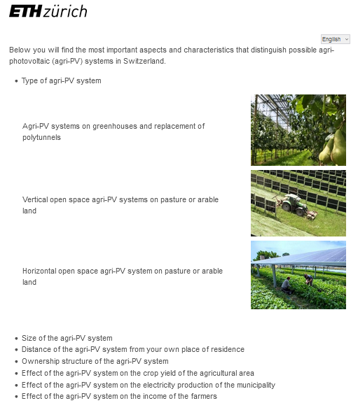
We will now start the thought experiment on the construction of possible agri-PV systems in Switzerland. In four different voting rounds, we will present you with two alternative investment options side by side. In each round, please compare the two options for agri-PV systems carefully and indicate which option you prefer and to what extent you support or reject the respective systems. Thank you. Now let's get started.

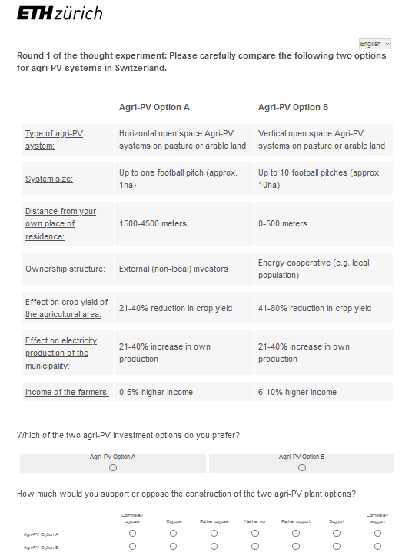

  - Conjoint Attributes
    - attrib1_lab
Variable name | attrib1_lab
Dataset | exp_dat
Introduction text
Question text
Item text | Type of Agri-PV system
Variable type | Factor
Variable range | Agri-PV systems on greenhouses and replacement of polytunnels, Vertical open space agri-PV systems on pasture or arable land, Horizontal open space agri-PV system on pasture or arable land

    - attrib2_lab
Variable name | attrib2_lab
Dataset | exp_dat
Introduction text
Question text
Item text | Size of the Agri-PV system
Variable type | Factor
Variable range | Up to one football pitch, Up to 5 football pitches, Up to 10 football pitches

    - attrib3_lab
Variable name | attrib3_lab
Dataset | exp_dat
Introduction text
Question text | Distance of the agri-PV system from your own place of residence
Item text
Variable type | Factor
Variable range | 0-500 meters, 500-1500 meters, 1500-4500 meters

    - attrib4_lab
Variable name | attrib4_lab
Dataset | exp_dat
Introduction text
Question text | Ownership structure of the agri-PV system
Item text
Variable type | Factor
Variable range | Municipality, Regional energy supplier, Farmers, Landowner, Energy cooperative, External investors

    - attrib5_lab
Variable name | attrin5_lab
Dataset | exp_dat
Introduction text
Question text | Effect of the agri-PV system on the crop yield of the agricultural area
Item text
Variable type | Factor
Variable range | 0-5% reduction in crop yield, 6-10% reduction in crop yield, 11-20% reduction in crop yield, 21-40% reduction in crop yield, 41-80% reduction in crop yield

    - attrib6_lab
Variable name | attrin6_lab
Dataset | exp_dat
Introduction text
Question text | Effect of the agri-PV system on the electricity production of the municipality
Item text
Variable type | Factor
Variable range | 0-5% increase in own production, 6-10% increase in own production, 11-20% increase in own production, 21-40% increase in own production, 41-80% increase in own production

    - attrib7_lab
Variable name | attrin7_lab
Dataset | exp_dat
Introduction text
Question text | Effect of the agri-PV system on the income of the farmers
Item text
Variable type | Factor
Variable range | 0-5% higher income, 6-10% higher income, 11-20% higher income, 21-40% higher income, 41-80% higher income

  - Conjoint Choice Variables
    - Round 1
      - Q15.8
Variable name | Q15.8
Dataset | data
Introduction text
Question text | Which of the two agri-PV investment options do you prefer?
Item text
Variable type | Numeric
Variable range | 1 (Agri-PV Option A), 2 (Agri-PV Option B)

      - Q15.9_1
Variable name | Q15.9_1
Dataset | data
Introduction text
Question text | How much would you support or oppose the construction of the two agri-PV plant options?
Item text | Agri-PV Option A
Variable type | Numeric
Variable range | 1 (Completely oppose) – 7 (Completely support)

      - Q15.9_2
Variable name | Q15.9_2
Dataset | data
Introduction text
Question text | How much would you support or oppose the construction of the two agri-PV plant options?
Item text | Agri-PV Option B
Variable type | Numeric
Variable range | 1 (Completely oppose) – 7 (Completely support)

    - Round 2
      - Q15.14
Variable name | Q15.14
Dataset | data
Introduction text
Question text | Which of the two agri-PV investment options do you prefer?
Item text
Variable type | Numeric
Variable range | 1 (Agri-PV Option A), 2 (Agri-PV Option B)

      - Q15.15_1
Variable name | Q15.15_1
Dataset | data
Introduction text
Question text | How much would you support or oppose the construction of the two agri-PV plant options?
Item text | Agri-PV Option A
Variable type | Numeric
Variable range | 1 (Completely oppose) – 7 (Completely support)

      - Q15.15_2
Variable name | Q15.15_2
Dataset | data
Introduction text
Question text | How much would you support or oppose the construction of the two agri-PV plant options?
Item text | Agri-PV Option B
Variable type | Numeric
Variable range | 1 (Completely oppose) – 7 (Completely support)

    - Round 3
      - Q15.20
Variable name | Q15.20
Dataset | data
Introduction text
Question text | Which of the two agri-PV investment options do you prefer?
Item text
Variable type | Numeric
Variable range | 1 (Agri-PV Option A), 2 (Agri-PV Option B)

      - Q15.21_1
Variable name | Q15.21_1
Dataset | data
Introduction text
Question text | How much would you support or oppose the construction of the two agri-PV plant options?
Item text | Agri-PV Option A
Variable type | Numeric
Variable range | 1 (Completely oppose) – 7 (Completely support)

      - Q15.21_2
Variable name | Q15.21_2
Dataset | data
Introduction text
Question text | How much would you support or oppose the construction of the two agri-PV plant options?
Item text | Agri-PV Option B
Variable type | Numeric
Variable range | 1 (Completely oppose) – 7 (Completely support)

    - Round 4
      - Q15.26
Variable name | Q15.26
Dataset | data
Introduction text
Question text | Which of the two agri-PV investment options do you prefer?
Item text
Variable type | Numeric
Variable range | 1 (Agri-PV Option A), 2 (Agri-PV Option B)

      - Q15.27_1
Variable name | Q15.27_1
Dataset | data
Introduction text
Question text | How much would you support or oppose the construction of the two agri-PV plant options?
Item text | Agri-PV Option A
Variable type | Numeric
Variable range | 1 (Completely oppose) – 7 (Completely support)

      - Q15.27_2
Variable name | Q15.27_2
Dataset | data
Introduction text
Question text | How much would you support or oppose the construction of the two agri-PV plant options?
Item text | Agri-PV Option B
Variable type | Numeric
Variable range | 1 (Completely oppose) – 7 (Completely support)

- Other Variables
  - circle
Binary variable is 1 when the potential for Agri-PV is high in any of the three circles that are depicted during the NIMBY-treatment.
Variable name | circle
Dataset | data
Introduction text
Question text
Item text
Variable type | numeric
Variable range | 0 (low potential in all circles), 1 (high potential in at least one circle)

  - circle1
Variable name | circle1
Dataset | data
Introduction text
Question text
Item text
Variable type | numeric
Variable range | 0 (low potential 0m – 500m), 1 (high potential 0-500m)

  - circle2
Variable name | circle2
Dataset | data
Introduction text
Question text
Item text
Variable type | numeric
Variable range | 0 (low potential 500m – 1500m), 1 (high potential 500-1500m)

  - circle3
Variable name | circle3
Dataset | data
Introduction text
Question text
Item text
Variable type | numeric
Variable range | 0 (low potential 1500m – 4500m), 1 (high potential 1500-4500m)

  - solar_roofs
Variable name | solar_roofs
Dataset | data
Introduction text
Question text | To what extent do you agree with the following statements: To ensure the Swiss electricity supply in the future, ...
Item text | …more solar power systems should be installed on buildings
Variable type | numeric
Variable range | 1 (Completely disagree)-7 (Completely agree)

  - solar_open_space
Variable name | solar_open_space
Dataset | data
Introduction text
Question text | To what extent do you agree with the following statements: To ensure the Swiss electricity supply in the future, ...
Item text | …more solar systems should be installed in open spaces (e.g. meadows, fields, etc.).
Variable type | numeric
Variable range | 1 (Completely disagree)-7 (Completely agree)

  - Political Ideology
    - left_right
Variable name | left_right
Dataset | data
Introduction text
Question text | Where would you place your own political views on this scale?
Item text
Variable type | numeric
Variable range | 1 (left) – 10 (right)

    - left_right_binary
left_right_binary is a variable derived from the left_right variable. All answers that are 5 or lower are classified as “Left”, all answers above 5 are classified as “Right”.
Variable name | left_right_binary
Dataset | data
Introduction text
Question text
Item text
Variable type | Character
Variable range | “Left”, “Right”

  - UserLanguage
Variable name | UserLanguage
Dataset | data
Introduction text
Question text
Item text
Variable type | Character
Variable range | “DE”, “FR”, “EN”

