**Dataset**

WISDM: Contains data collected from accelerometer sensors of 6 human daily activities:

Walking: 424400 (38.6%)

Jogging: 342177 (31.2%)

Upstairs: 122869 (11.2%)

Downstairs: 100427 (9.1%)

Sitting: 59939 (5.5%)

Standing: 48395 (4.4%)

Link: <http://www.cis.fordham.edu/wisdm/dataset.php>

**Method**

1. CNN

***Model***

* ip = Input(SEGMENT_TIME_SIZE, N_FEATURES)
* x = conv1D(32,7, RELU, BatchNormalization)(ip)
* x = conv1D(64,5, RELU)(x)
* x = GlobalAveragePooling1D()(x)
* out = Dense(N_CLASSES, softmax)(x)
* model = Model(ip, out)

***Result***

|  |  |
| --- | --- |
| Accuracy: 0.9695038689121529  precision recall f1-score support  0 0.93 0.86 0.89 212  1 0.99 0.99 0.99 676  2 0.99 0.98 0.99 140  3 0.97 0.97 0.97 78  4 0.89 0.93 0.91 258  5 0.99 0.99 0.99 833  avg / total 0.97 0.97 0.97 2197 | Confusion matrix  [[182 3 0 0 22 5]  [ 1 672 0 0 2 1]  [ 1 0 137 2 0 0]  [ 0 0 1 76 1 0]  [ 9 6 0 0 239 4]  [ 3 1 0 0 5 824]] |

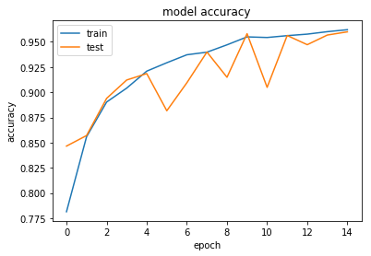 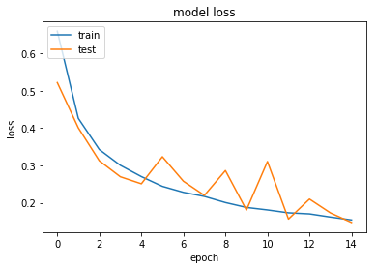

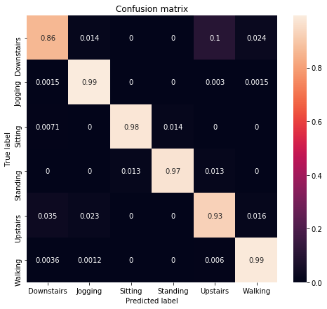

1. LSTM

***Model***

* ip = Input(SEGMENT_TIME_SIZE, N_FEATURES)
* x = LSTM(64)(ip)
* x = LSTM(64)(x)
* out = Dense(N_CLASSES, softmax)(x)
* model = Model(ip, out)

***Result***

|  |  |
| --- | --- |
| Accuracy: 0.9280837505689576  precision recall f1-score support  0 0.83 0.71 0.76 212  1 0.98 0.97 0.98 676  2 0.94 0.96 0.95 140  3 0.95 0.96 0.96 78  4 0.80 0.79 0.80 258  5 0.94 0.98 0.96 833  avg / total 0.93 0.93 0.93 2197 | Confusion matrix  [[151 1 3 0 36 21]  [ 3 659 0 0 5 9]  [ 0 1 134 4 1 0]  [ 0 1 1 75 1 0]  [ 22 8 4 0 205 19]  [ 7 2 0 0 9 815]] |

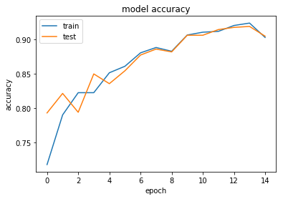 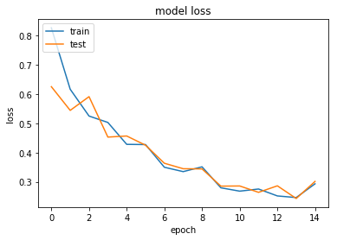

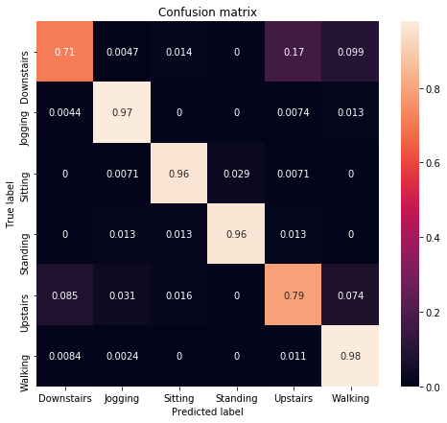

1. CNN-LSTM

***Model***

* ip = Input(SEGMENT_TIME_SIZE, N_FEATURES)
* x = conv1D(16,7, RELU, BatchNormalization)(x)
* x = conv1D(32,5, RELU)(x)
* x = LSTM(32)(x)
* x = LSTM(32)(x)
* out = Dense(N_CLASSES, softmax)(x)
* model = Model(ip, out)

***Result***

|  |  |
| --- | --- |
| Accuracy: 0.8984979517523897  precision recall f1-score support  0 0.60 0.75 0.67 212  1 0.96 0.99 0.98 676  2 0.95 0.91 0.93 140  3 0.88 0.96 0.92 78  4 0.76 0.51 0.61 258  5 0.96 0.98 0.97 833  avg / total 0.90 0.90 0.90 2197 | Confusion matrix  [[158 7 3 0 33 11]  [ 5 669 0 0 0 2]  [ 0 0 127 10 2 1]  [ 0 1 0 75 1 1]  [ 89 16 3 0 131 19]  [ 11 2 0 0 6 814]] |

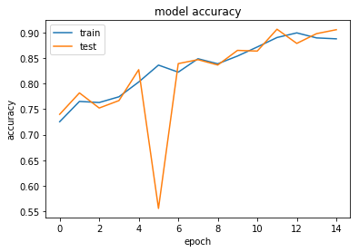 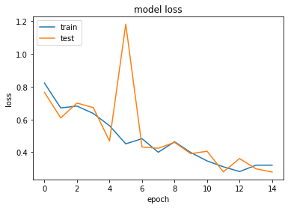

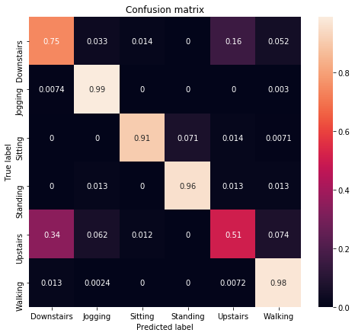

**Implementation**

Code: <https://github.com/SimonNgj/DL-ung-dung/blob/master/2019July7/simon.py>

Using: Keras (Tensorflow backend), Python3.6

Other publication uses the WISDM dataset

1. Andrey Ignatov, “Real-time human activity recognition from accelerometer data using Convolutional Neural Networks” Applied Soft Computing, pp. 915-922, 2018.