Thyrovision: Thyroid Cancer Detection Report
Date : 2026-05-23 16:28:01

Analysis Results, 1
Prediction: Malignant (Cancerous)
Confidence Score: 0.9152
Confidence Percentage: 91.52%

Original Image
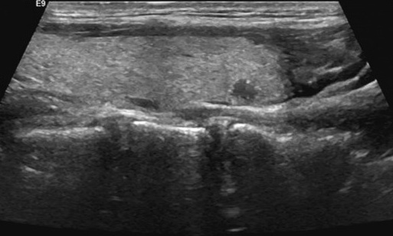

Grad-CAM Interpretability
The heatmap below visualizes the regions of the image
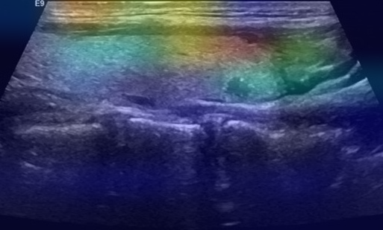

Disclaimer:
This report is generated by an artificial intelligence system and intended for assistive decision-making
only. It does not constitute a final medical diagnosis. All findings should be reviewed and verified by a
qualified radiologist or medical professional.

