Iz tabele sem izbral 3 sintetične funkcije
Koza-3 [33] 1: x^6 - 2x^4 + x^2 U[-1, 1, 20] None Koza
Nguyen-5 [45] 1: sin(x^2)cos(x) - 1 U[-1, 1, 20] None Koza
Nguyen-10 [45] 2: 2sin(x)cos(y) U[-1, 1, 100] None Koza

Prva implementacija je imale enake
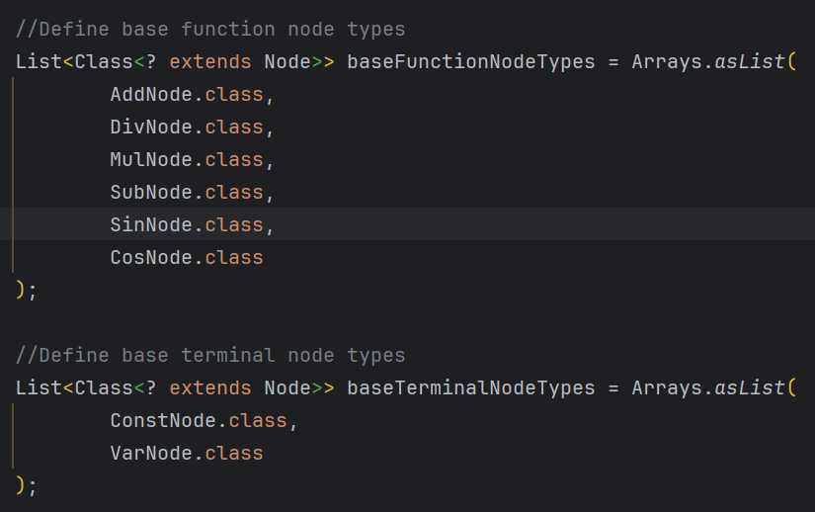

--- KOZA3 ---
Press E to pause the algorithm:
Fitness: 2.746680912396917E-4
Expression:
(((sin(((-3.8655441465404428 + x) * sin(x))) + cos(sin(((-4.034894601799386 * 6.570779376355219) - (x * x))))) * ((sin(-2.662570576038819) + cos(x)) - sin((sin(x) - 5.099190916275722)))) * sin(sin(x)))

--- NGUYEN5 ---
Fitness: 2.746680912396917E-4
Expression:
(((sin(((-3.8655441465404428 + x) * sin(x))) + cos(sin(((-4.034894601799386 * 6.570779376355219) - (x * x))))) * ((sin(-2.662570576038819) + cos(x)) - sin((sin(x) - 5.099190916275722)))) * sin(sin(x)))

--- NGUYEN10 ---
Fitness: 0.0
Expression:
((cos(y) * sin(x)) + (cos(y) * sin(x)))

Ločen nastavljeni baseFunctionNodeTypes in baseTerminalNodeTypes za vsak problem

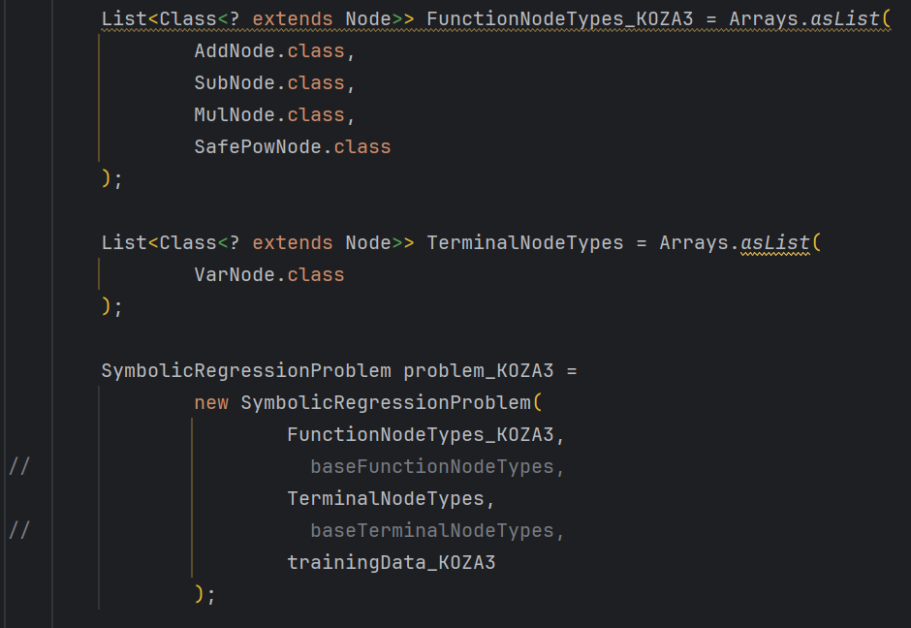

Fitness: 0.007379983600010515
Expression:
(((((((x x) (x x)) ((x x) - (x x))) * ((x (x * x)) * ((x - x) - (x x)))) ((((x - x) - x) + ((x - x) + (x * x))) * (((x x) - (x + x)) + ((x * x) + (x - x))))) (((((x * x) (x x)) + ((x x) * (x - x))) * (((x - x) * (x x)) - ((x + x) * x))) - x)) - ((x + x) (((x - ((x - x) + x)) - (x - ((x - x) (x - x)))) * ((x ((x x) + x)) * (((x - x) * (x x)) - ((x x) (x x)))))))

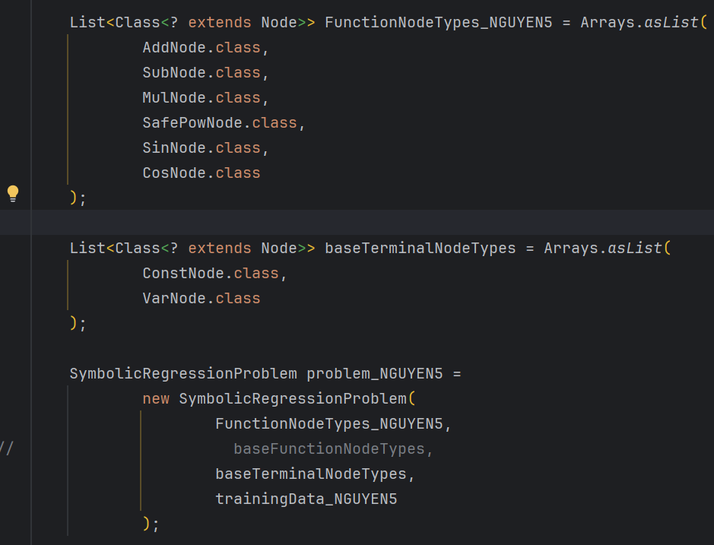

Fitness: 1.8398243896262398E-5
Expression:
sin((3.984098545541908 + (x + cos(sin((cos(x) + (x + 7.573450392168077)))))))

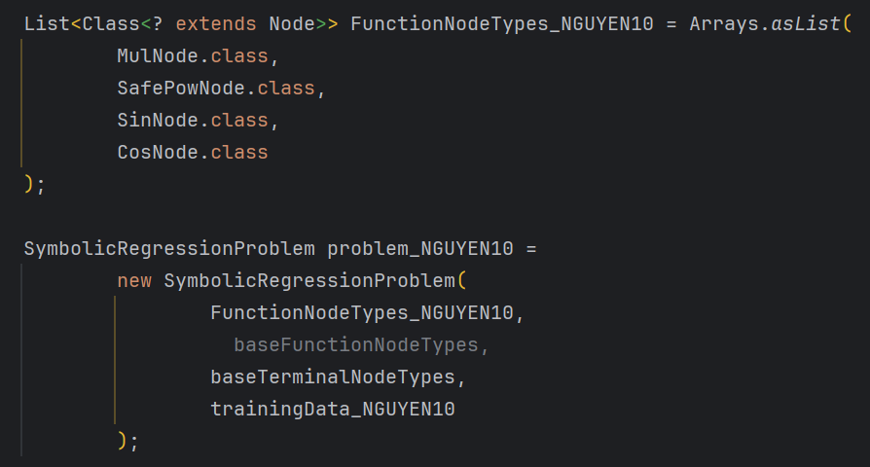

Fitness: 1.8245712984995445E-9
Expression:
((cos(sin(-6.059195467229386)) * ((-6.059195467229386 cos(x)) * sin(x))) * ((cos(y) * sin(((x cos(5.28711419907876)) cos(y)))) * 2.436773029985769))

KOZA3:
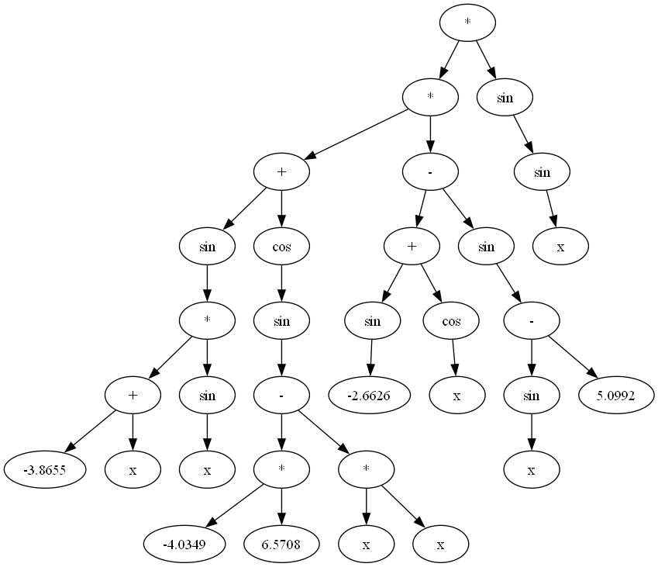

NGUYEN5

NGUYEN10
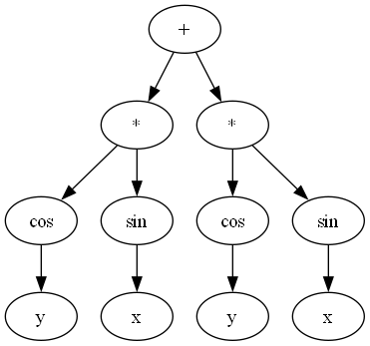

Spotify regressor
https://www.kaggle.com/datasets/maharshipandya/-spotify-tracks-dataset/data
dataset vnaprej očiščen in izbrane samo numerične vrednosti
'popularity', 'danceability', 'energy', 'loudness', 'speechiness', 'acousticness', 'instrumentalness', 'liveness', 'valence', 'tempo'

SAMPLE_SIZE = 5k | MAX_EVAL = 50k
Total rows loaded: 89741
Total rows for regression: 5000
Press E to pause the algorithm:
Training fitness (MSE): 405.98761721158775
Best expression:
(((-1.557893902651987 * ((danceability + -1.557893902651987) * (danceability - ((5.8035614285550725 + 5.8035614285550725) + (-4.241025875362078 - 3.099589311838283))))) + ((danceability * ((valence + -1.557893902651987) / ((1.0029195628934495 + -1.557893902651987) * (5.8035614285550725 * speechiness)))) - 3.099589311838283)) + (((5.8035614285550725 * (7.139500683457495 + danceability)) + ((tempo / ((7.198717190870571 + -1.557893902651987) * (acousticness + 7.011849124674573))) / (((danceability * 4.9965607656368665) - tempo) * ((instrumentalness * 5.18857358285527) + (energy + 3.3871984730366638))))) + ((tempo / ((danceability + -1.557893902651987) * ((instrumentalness + 5.8035614285550725) + (-4.241025875362078 - 3.099589311838283)))) / (((danceability * 4.9965607656368665) - 7.139500683457495) * (((instrumentalness / 5.8035614285550725) * (instrumentalness + -2.4677503259585043)) + ((5.8035614285550725 + 5.8035614285550725) + (-4.241025875362078 - 3.099589311838283)))))))
Testing fitness (MSE): 424.1950273839684

SAMPLE_SIZE = 10k | MAX_EVAL = 100k
Total rows loaded: 89741
Total rows for regression: 10000
Press E to pause the algorithm:
Training fitness (MSE): 407.41093882960155
Best expression:
((((danceability + -1.4416895400831269) * (acousticness + (acousticness + (acousticness + 5.8035614285550725)))) + valence) + (((0.17555180097232714 + (((acousticness / -3.5705043167018164) - (valence + speechiness)) + 5.8035614285550725)) * (7.139500683457495 + danceability)) + (((tempo / (-1.4416895400831269 / (instrumentalness + speechiness))) / (0.17555180097232714 + acousticness)) / ((((danceability + -1.4416895400831269) * 5.852672330457555) - ((0.17555180097232714 + acousticness) - (speechiness - -1.6299073224099399))) * (((9.693157161141471 / -5.037773211756402) / (-3.5705043167018164 * danceability)) + (-5.056059397354568 + -5.923240569907726))))))
Testing fitness (MSE): 411.10777811681913

SAMPLE_SIZE = 10k | MAX_EVAL = 50k | novi Nodi
Total rows loaded: 89741
Total rows for regression: 10000
Press E to pause the algorithm:
Training fitness (MSE): 409.36860046405457
Best expression:
((((((sin(instrumentalness) - sin(9.998989200425058)) - sqrt((instrumentalness - acousticness))) - sqrt(sqrt(sqrt(instrumentalness)))) - sin(acousticness)) - -9.266525924225311) * (((((danceability - sin(instrumentalness)) - valence) - speechiness) - sqrt((sqrt((speechiness - acousticness)) - valence))) + 3.8188295468302))
Testing fitness (MSE): 411.5522855066129

SAMPLE_SIZE = 50k | MAX_EVAL = 50k |
AddNode.class, SubNode.class, MulNode.class, DivNode.class, LogNode.class

Total rows loaded: 89741
Total rows for regression: 50000
Press E to pause the algorithm:
Training fitness (MSE): 412.85029612561414
Best expression:
((log(((-1.0530938789495394 / ((-0.10041526797721367 + acousticness) + (instrumentalness + -9.873499212452455))) + (speechiness * instrumentalness))) * (speechiness + (2.149923239474763 - 8.09568854926702))) / log(1.45573573338684))
Testing fitness (MSE): 408.8024833776891
