Chaotic evolution optimization
Gre za populacijski algoritem, ki združuje ideje diferencialne evolucije, kaotičnih preslikav in križanja.
- Inicializacija
  - Ustvari populacijo Np kandidatnih rešitev (vektorjev dimenzije Dim) znotraj mej [Varmin, Varmax].
  - Izračuna začetne vrednosti ciljne funkcije (fitness).
  - Shrani trenutno najboljšo rešitev (Best).
- Glavna optimizacijska zanka (optimize)
  - Dokler ne doseže maksimalnega števila evaluacij (MaxFES):
    - Naključno premeša populacijo.
    - Rešitve obdeluje v parih.
    - Vsak par normalizira glede na trenutno populacijo in preslika v kaotični prostor.
    - Uporabi EDM (eksponentno-dinamični kaos) za generiranje novih kandidatov.
    - Izvede mutacijo (glede na trenutno rešitev ali globalno najboljšo).
    - Izvede binarno križanje (binomial crossover).
    - Popravi rešitve, ki presežejo meje (odboj od robov).
    - Opravi selekcijo: nova rešitev zamenja staro samo, če je boljša.
- Sledenje najboljšemu rezultatu
  - Po vsaki iteraciji posodobi globalno najboljšo rešitev.
  - Beleži zgodovino najboljših vrednosti.
- Ustavitveni pogoji
  - Doseženo maksimalno število evaluacij ali
  - stagnacija (če se najboljša vrednost dolgo ne izboljšuje).
Rezultat
- Vrne:
  - najboljšo najdeno rešitev,
  - njeno vrednost funkcije,
  - zgodovino izboljševanja.
Opis pomanjkljivosti in razlik med izvorno kodo in člankom:
Kaotično preslikovanje (E-DM mapa)
V Pythonu je E-DM mapiranje implementirano tako, da se v enem klicu generira celotno zaporedje kaotičnih točk (za oba starša), ki se nato razdeli na dva dela. V Javi se kaotične točke generirajo ločeno za vsakega starša, metoda pa neposredno vrne N kaotičnih vzorcev. Python uporablja enoten, vektoriziran izračun, Java pa ločene izračune za vsakega posameznika.

Mutacija
V obeh implementacijah se uporablja ista mutacijska strategija (enačbi (7) in (8)), kjer se z verjetnostjo 0,5 kot osnovna točka uporabi trenutni osebek ali globalno najboljša rešitev. V Javi je mutacija izvedena po posameznih dimenzijah, v Pythonu pa v vektorski obliki.

Binominalno križanje
Python implementacija uporablja vektorizirano binominalno križanje z zagotovilom, da je vsaj ena komponenta podedovana od mutanta. Java implementacija sledi enaki logiki, vendar eksplicitno nadzoruje vrstni red klicev generatorja naključnih števil, da zagotovi skladnost z izvorno implementacijo. Java implementacija je podrobnejša in bolj deterministična glede generiranja naključnih števil.

Rezultate (Rating intervali) primerjalnega testa CEC2015Benchmark:
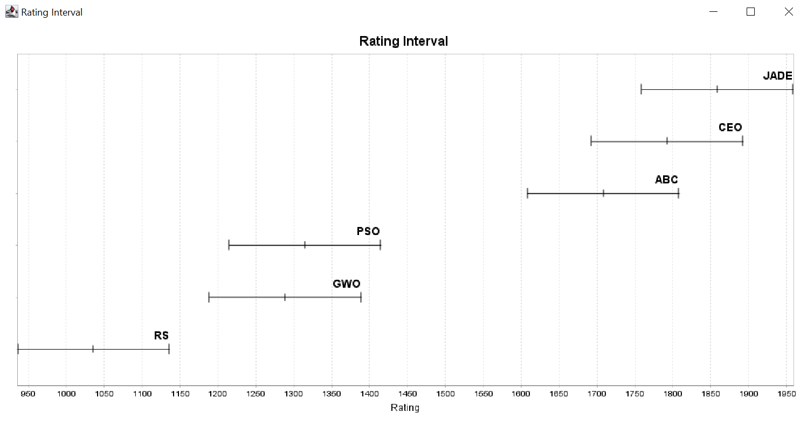

JADE [win=630, lose=110, draw=10]
Against:{RS=[win=150, lose=0, draw=0], ABC=[win=102, lose=48, draw=0], CEO=[win=86, lose=54, draw=10], PSO=[win=145, lose=5, draw=0], GWO=[win=147, lose=3, draw=0]}
Problems:{CEC2015F02=[win=50, lose=0, draw=0], CEC2015F13=[win=40, lose=0, draw=10], CEC2015F01=[win=45, lose=5, draw=0], CEC2015F12=[win=37, lose=13, draw=0], CEC2015F04=[win=42, lose=8, draw=0], CEC2015F15=[win=36, lose=14, draw=0], CEC2015F14=[win=44, lose=6, draw=0], CEC2015F03=[win=41, lose=9, draw=0], CEC2015F11=[win=39, lose=11, draw=0], CEC2015F10=[win=50, lose=0, draw=0], CEC2015F09=[win=44, lose=6, draw=0], CEC2015F06=[win=33, lose=17, draw=0], CEC2015F05=[win=48, lose=2, draw=0], CEC2015F08=[win=45, lose=5, draw=0], CEC2015F07=[win=36, lose=14, draw=0]}
CEO [win=582, lose=158, draw=10]
Against:{RS=[win=150, lose=0, draw=0], ABC=[win=83, lose=67, draw=0], JADE=[win=54, lose=86, draw=10], PSO=[win=146, lose=4, draw=0], GWO=[win=149, lose=1, draw=0]}
Problems:{CEC2015F02=[win=40, lose=10, draw=0], CEC2015F13=[win=40, lose=0, draw=10], CEC2015F01=[win=45, lose=5, draw=0], CEC2015F12=[win=40, lose=10, draw=0], CEC2015F04=[win=32, lose=18, draw=0], CEC2015F15=[win=36, lose=14, draw=0], CEC2015F14=[win=38, lose=12, draw=0], CEC2015F03=[win=48, lose=2, draw=0], CEC2015F11=[win=36, lose=14, draw=0], CEC2015F10=[win=40, lose=10, draw=0], CEC2015F09=[win=40, lose=10, draw=0], CEC2015F06=[win=37, lose=13, draw=0], CEC2015F05=[win=30, lose=20, draw=0], CEC2015F08=[win=45, lose=5, draw=0], CEC2015F07=[win=35, lose=15, draw=0]}
ABC [win=526, lose=224, draw=0]
Against:{RS=[win=147, lose=3, draw=0], JADE=[win=48, lose=102, draw=0], CEO=[win=67, lose=83, draw=0], PSO=[win=128, lose=22, draw=0], GWO=[win=136, lose=14, draw=0]}
Problems:{CEC2015F02=[win=20, lose=30, draw=0], CEC2015F13=[win=30, lose=20, draw=0], CEC2015F01=[win=30, lose=20, draw=0], CEC2015F12=[win=41, lose=9, draw=0], CEC2015F04=[win=46, lose=4, draw=0], CEC2015F15=[win=48, lose=2, draw=0], CEC2015F14=[win=38, lose=12, draw=0], CEC2015F03=[win=14, lose=36, draw=0], CEC2015F11=[win=45, lose=5, draw=0], CEC2015F10=[win=24, lose=26, draw=0], CEC2015F09=[win=25, lose=25, draw=0], CEC2015F06=[win=48, lose=2, draw=0], CEC2015F05=[win=38, lose=12, draw=0], CEC2015F08=[win=30, lose=20, draw=0], CEC2015F07=[win=49, lose=1, draw=0]}
PSO [win=241, lose=509, draw=0]
Against:{RS=[win=134, lose=16, draw=0], ABC=[win=22, lose=128, draw=0], JADE=[win=5, lose=145, draw=0], CEO=[win=4, lose=146, draw=0], GWO=[win=76, lose=74, draw=0]}
Problems:{CEC2015F02=[win=9, lose=41, draw=0], CEC2015F13=[win=18, lose=32, draw=0], CEC2015F01=[win=10, lose=40, draw=0], CEC2015F12=[win=19, lose=31, draw=0], CEC2015F04=[win=20, lose=30, draw=0], CEC2015F15=[win=5, lose=45, draw=0], CEC2015F14=[win=14, lose=36, draw=0], CEC2015F03=[win=22, lose=28, draw=0], CEC2015F11=[win=15, lose=35, draw=0], CEC2015F10=[win=26, lose=24, draw=0], CEC2015F09=[win=31, lose=19, draw=0], CEC2015F06=[win=11, lose=39, draw=0], CEC2015F05=[win=19, lose=31, draw=0], CEC2015F08=[win=10, lose=40, draw=0], CEC2015F07=[win=12, lose=38, draw=0]}
GWO [win=222, lose=528, draw=0]
Against:{RS=[win=130, lose=20, draw=0], ABC=[win=14, lose=136, draw=0], JADE=[win=3, lose=147, draw=0], CEO=[win=1, lose=149, draw=0], PSO=[win=74, lose=76, draw=0]}
Problems:{CEC2015F02=[win=17, lose=33, draw=0], CEC2015F13=[win=11, lose=39, draw=0], CEC2015F01=[win=20, lose=30, draw=0], CEC2015F12=[win=13, lose=37, draw=0], CEC2015F04=[win=9, lose=41, draw=0], CEC2015F15=[win=19, lose=31, draw=0], CEC2015F14=[win=16, lose=34, draw=0], CEC2015F03=[win=25, lose=25, draw=0], CEC2015F11=[win=15, lose=35, draw=0], CEC2015F10=[win=10, lose=40, draw=0], CEC2015F09=[win=2, lose=48, draw=0], CEC2015F06=[win=20, lose=30, draw=0], CEC2015F05=[win=7, lose=43, draw=0], CEC2015F08=[win=20, lose=30, draw=0], CEC2015F07=[win=18, lose=32, draw=0]}
RS [win=39, lose=711, draw=0]
Against:{ABC=[win=3, lose=147, draw=0], JADE=[win=0, lose=150, draw=0], CEO=[win=0, lose=150, draw=0], PSO=[win=16, lose=134, draw=0], GWO=[win=20, lose=130, draw=0]}
Problems:{CEC2015F02=[win=14, lose=36, draw=0], CEC2015F13=[win=1, lose=49, draw=0], CEC2015F01=[win=0, lose=50, draw=0], CEC2015F12=[win=0, lose=50, draw=0], CEC2015F04=[win=1, lose=49, draw=0], CEC2015F15=[win=6, lose=44, draw=0], CEC2015F14=[win=0, lose=50, draw=0], CEC2015F03=[win=0, lose=50, draw=0], CEC2015F11=[win=0, lose=50, draw=0], CEC2015F10=[win=0, lose=50, draw=0], CEC2015F09=[win=8, lose=42, draw=0], CEC2015F06=[win=1, lose=49, draw=0], CEC2015F05=[win=8, lose=42, draw=0], CEC2015F08=[win=0, lose=50, draw=0], CEC2015F07=[win=0, lose=50, draw=0]}
Rezultate članka in primerjalnega testa.
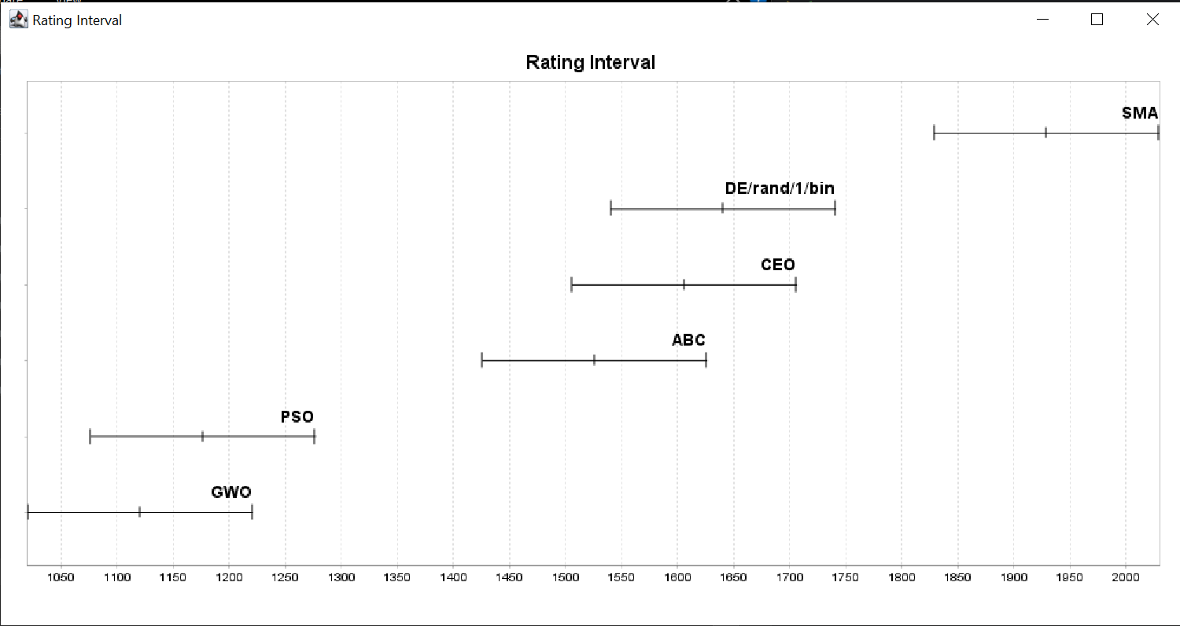
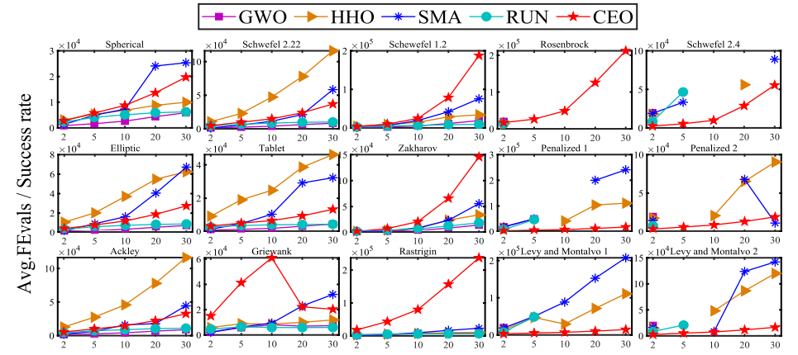
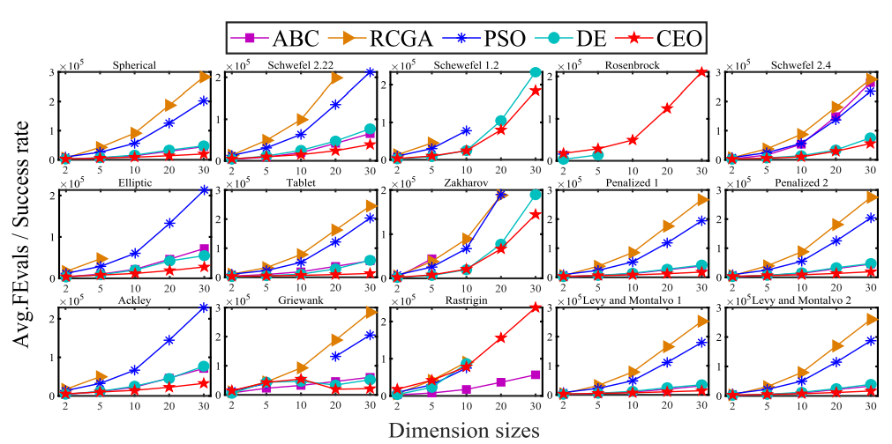

SMA [win=686, lose=64, draw=0]
Against:{DE/rand/1/bin=[win=136, lose=14, draw=0], ABC=[win=138, lose=12, draw=0], CEO=[win=136, lose=14, draw=0], PSO=[win=138, lose=12, draw=0], GWO=[win=138, lose=12, draw=0]}
Problems:{CEC2015F13=[win=50, lose=0, draw=0], CEC2015F02=[win=45, lose=5, draw=0], CEC2015F12=[win=50, lose=0, draw=0], CEC2015F01=[win=41, lose=9, draw=0], CEC2015F15=[win=50, lose=0, draw=0], CEC2015F04=[win=50, lose=0, draw=0], CEC2015F14=[win=50, lose=0, draw=0], CEC2015F03=[win=0, lose=50, draw=0], CEC2015F11=[win=50, lose=0, draw=0], CEC2015F10=[win=50, lose=0, draw=0], CEC2015F09=[win=50, lose=0, draw=0], CEC2015F06=[win=50, lose=0, draw=0], CEC2015F05=[win=50, lose=0, draw=0], CEC2015F08=[win=50, lose=0, draw=0], CEC2015F07=[win=50, lose=0, draw=0]}
DE/rand/1/bin [win=477, lose=273, draw=0]
Against:{ABC=[win=92, lose=58, draw=0], SMA=[win=14, lose=136, draw=0], CEO=[win=86, lose=64, draw=0], PSO=[win=140, lose=10, draw=0], GWO=[win=145, lose=5, draw=0]}
Problems:{CEC2015F13=[win=26, lose=24, draw=0], CEC2015F02=[win=41, lose=9, draw=0], CEC2015F12=[win=38, lose=12, draw=0], CEC2015F01=[win=38, lose=12, draw=0], CEC2015F15=[win=27, lose=23, draw=0], CEC2015F04=[win=21, lose=29, draw=0], CEC2015F14=[win=39, lose=11, draw=0], CEC2015F03=[win=47, lose=3, draw=0], CEC2015F11=[win=39, lose=11, draw=0], CEC2015F10=[win=38, lose=12, draw=0], CEC2015F09=[win=29, lose=21, draw=0], CEC2015F06=[win=23, lose=27, draw=0], CEC2015F05=[win=9, lose=41, draw=0], CEC2015F08=[win=36, lose=14, draw=0], CEC2015F07=[win=26, lose=24, draw=0]}
CEO [win=452, lose=298, draw=0]
Against:{DE/rand/1/bin=[win=64, lose=86, draw=0], ABC=[win=85, lose=65, draw=0], SMA=[win=14, lose=136, draw=0], PSO=[win=140, lose=10, draw=0], GWO=[win=149, lose=1, draw=0]}
Problems:{CEC2015F13=[win=40, lose=10, draw=0], CEC2015F02=[win=31, lose=19, draw=0], CEC2015F12=[win=27, lose=23, draw=0], CEC2015F01=[win=37, lose=13, draw=0], CEC2015F15=[win=23, lose=27, draw=0], CEC2015F04=[win=29, lose=21, draw=0], CEC2015F14=[win=21, lose=29, draw=0], CEC2015F03=[win=41, lose=9, draw=0], CEC2015F11=[win=22, lose=28, draw=0], CEC2015F10=[win=32, lose=18, draw=0], CEC2015F09=[win=33, lose=17, draw=0], CEC2015F06=[win=28, lose=22, draw=0], CEC2015F05=[win=29, lose=21, draw=0], CEC2015F08=[win=34, lose=16, draw=0], CEC2015F07=[win=25, lose=25, draw=0]}
ABC [win=394, lose=356, draw=0]
Against:{DE/rand/1/bin=[win=58, lose=92, draw=0], SMA=[win=12, lose=138, draw=0], CEO=[win=65, lose=85, draw=0], PSO=[win=123, lose=27, draw=0], GWO=[win=136, lose=14, draw=0]}
Problems:{CEC2015F13=[win=24, lose=26, draw=0], CEC2015F02=[win=11, lose=39, draw=0], CEC2015F12=[win=25, lose=25, draw=0], CEC2015F01=[win=22, lose=28, draw=0], CEC2015F15=[win=40, lose=10, draw=0], CEC2015F04=[win=40, lose=10, draw=0], CEC2015F14=[win=27, lose=23, draw=0], CEC2015F03=[win=15, lose=35, draw=0], CEC2015F11=[win=27, lose=23, draw=0], CEC2015F10=[win=13, lose=37, draw=0], CEC2015F09=[win=14, lose=36, draw=0], CEC2015F06=[win=39, lose=11, draw=0], CEC2015F05=[win=38, lose=12, draw=0], CEC2015F08=[win=20, lose=30, draw=0], CEC2015F07=[win=39, lose=11, draw=0]}
PSO [win=141, lose=609, draw=0]
Against:{DE/rand/1/bin=[win=10, lose=140, draw=0], ABC=[win=27, lose=123, draw=0], SMA=[win=12, lose=138, draw=0], CEO=[win=10, lose=140, draw=0], GWO=[win=82, lose=68, draw=0]}
Problems:{CEC2015F13=[win=9, lose=41, draw=0], CEC2015F02=[win=11, lose=39, draw=0], CEC2015F12=[win=6, lose=44, draw=0], CEC2015F01=[win=2, lose=48, draw=0], CEC2015F15=[win=0, lose=50, draw=0], CEC2015F04=[win=10, lose=40, draw=0], CEC2015F14=[win=9, lose=41, draw=0], CEC2015F03=[win=21, lose=29, draw=0], CEC2015F11=[win=9, lose=41, draw=0], CEC2015F10=[win=17, lose=33, draw=0], CEC2015F09=[win=24, lose=26, draw=0], CEC2015F06=[win=2, lose=48, draw=0], CEC2015F05=[win=17, lose=33, draw=0], CEC2015F08=[win=1, lose=49, draw=0], CEC2015F07=[win=3, lose=47, draw=0]}
GWO [win=100, lose=650, draw=0]
Against:{DE/rand/1/bin=[win=5, lose=145, draw=0], ABC=[win=14, lose=136, draw=0], SMA=[win=12, lose=138, draw=0], CEO=[win=1, lose=149, draw=0], PSO=[win=68, lose=82, draw=0]}
Problems:{CEC2015F13=[win=1, lose=49, draw=0], CEC2015F02=[win=11, lose=39, draw=0], CEC2015F12=[win=4, lose=46, draw=0], CEC2015F01=[win=10, lose=40, draw=0], CEC2015F15=[win=10, lose=40, draw=0], CEC2015F04=[win=0, lose=50, draw=0], CEC2015F14=[win=4, lose=46, draw=0], CEC2015F03=[win=26, lose=24, draw=0], CEC2015F11=[win=3, lose=47, draw=0], CEC2015F10=[win=0, lose=50, draw=0], CEC2015F09=[win=0, lose=50, draw=0], CEC2015F06=[win=8, lose=42, draw=0], CEC2015F05=[win=7, lose=43, draw=0], CEC2015F08=[win=9, lose=41, draw=0], CEC2015F07=[win=7, lose=43, draw=0]}

