|  |  |  |
| --- | --- | --- |
|  | **JKU - JOHANNES KEPLER UNIVERSITÄT LINZ | JKU LINZ**  **ISSE - Institute of Software Systems Engineering** |  |

|  |  |  |
| --- | --- | --- |
| **Course:** UE Software Engineering | **Course ID:** 343.309 | **Semester:** 2021W |
| Simon Primetzhofer  11942035  simon.primetzhofer@live.at | Stefan Haslhofer  11908757  haslhofer.stefan@gmail.com |  |
| Kaan Baylan  11910231  kaan.baylan28@gmail.com | Jonas Reichhardt  11908755  office@jonasreichhardt.at |  |

## Milestone 1 Report – Team 2

### 1. Overall Architecture

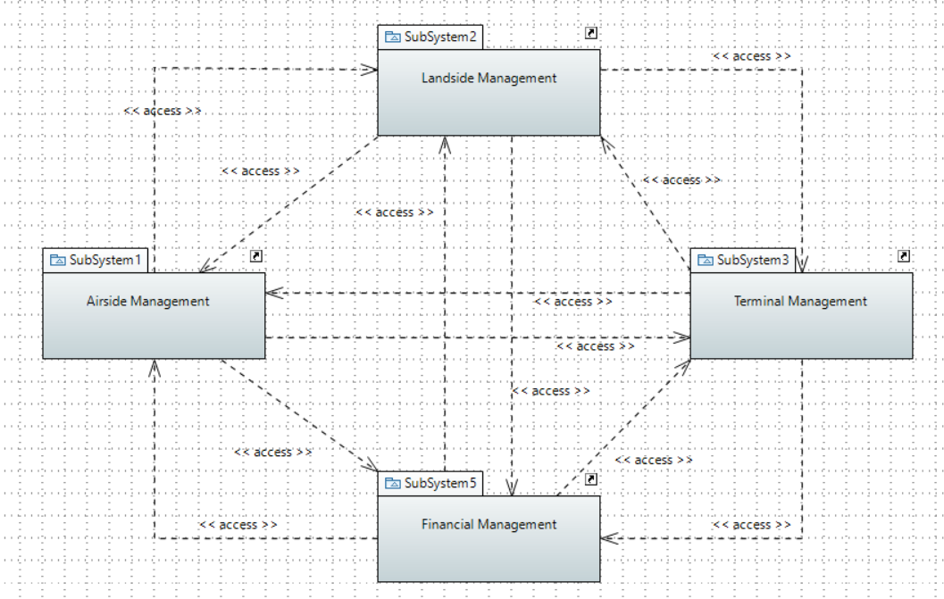

The airport management system is based on the four subsystems like they are displayed in the above package diagram. Every subsystem directly communicates with all other subsystems since the control system management as a central part is not available in this case. This specifically means that Airside and Landside management provide their vehicles’ route information and consume them from the respective other part instead of having the control system management between them. We can see that every subsystem provides and consumes information from every other subsystem which makes it quite interconnected.

### 2. System

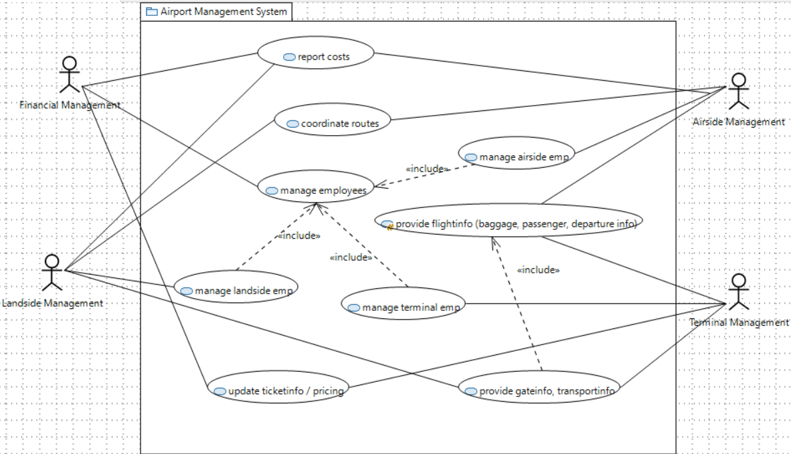

Financial Management is responsible for gathering information about the flights from the airlines, calculating the ticket prices, booking facilities for airlines, assigning employees to the respective management and managing maintenance of vehicles, fuel, material and equipment.

Airside Management is responsible for landings and takeoffs of aircrafts, monitoring flights and managing the traffic in the air as well as on the ground.

Landside Management is responsible for coordination of land-vehicles such as baggage carts and buses transporting luggage and persons from either gate to plane or vice versa. Furthermore, it is tasked to react to emergency calls as well as providing maintenance services to each plane.

Terminal Management is responsible for checking in passengers, handling all baggage related tasks, performing security checks and also displaying flight information publicly for all passengers.

**Report costs**

Step 1: Landside management gathers all costs from refueling, maintenance and facility usage

Step 2: Airside management gathers all costs for using the runway

Step 3: Financial management requests a cost report from Landside management

Step 4: Financial management requests a cost report from Airside management

Step 5: Airside and Landside management send cost report

Step 6: Financial Management sends out bills to airlines

Step 7: Financial Management monitors payment of the bills

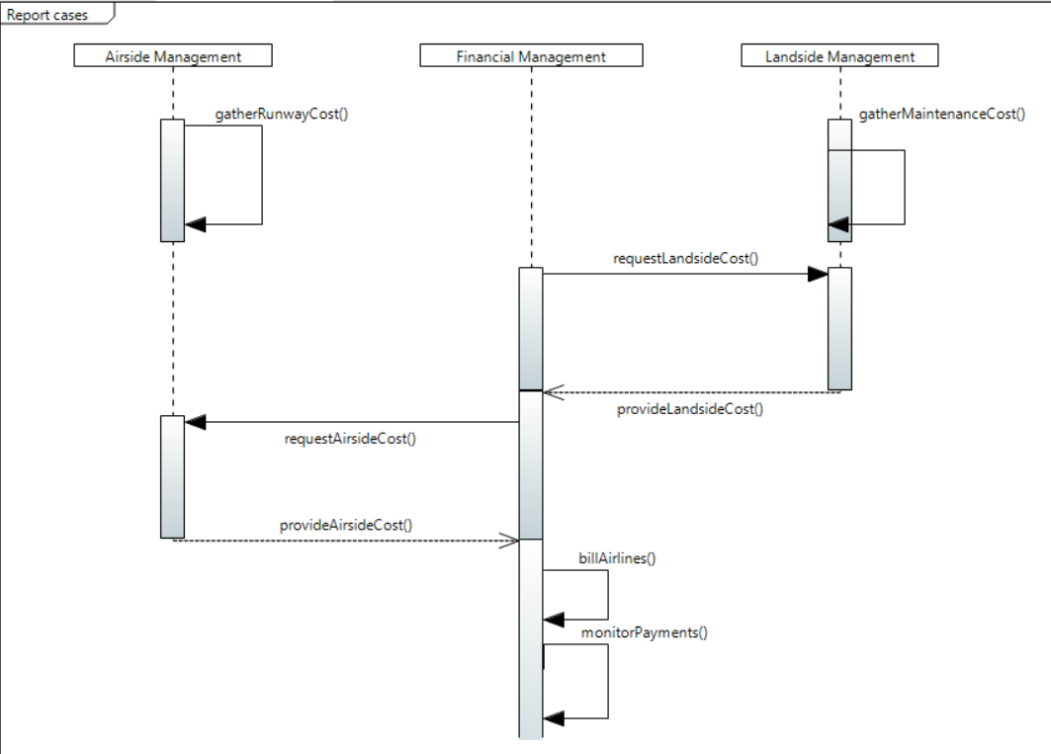

**Coordinate routes**

Step 1: Airside management requests fuel truck, stair truck, etc. from Landside Management

Step 2: Landside Management requests parking location of aircraft

Step 3: Airside Management provides parking location and arrival/departure time

Step 4: Landside Management calculates needed resources

Step 5: Landside Management plans best route for vehicles

Step 6: Landside Management assigns driver

Step 7: Landside Management executes requested service

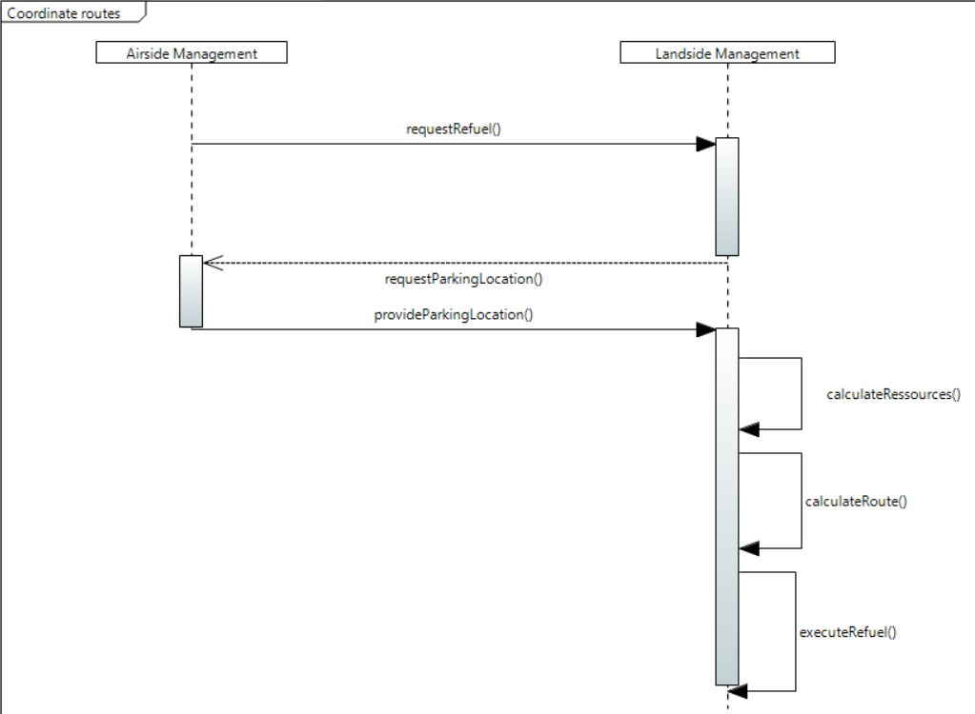

**Manage employees**

Step 1: Landside-, Airside and Terminal Management report desired amount of employees to Financial Management

Step 2: Financial Management searches for suitable employees according to knowledge and abilities

Step 3: Financial Management assigns employees to Landside, Airside and Terminal Management

Step 4: Landside, Airside and Terminal Management report working hours of employees to Financial Management

Step 5: Landside, Airside and Terminal Management report absences to Financial Management

Step 6: Financial Management pays salaries to employees

Step 7: Financial Management regulates hours of labor according to working hours

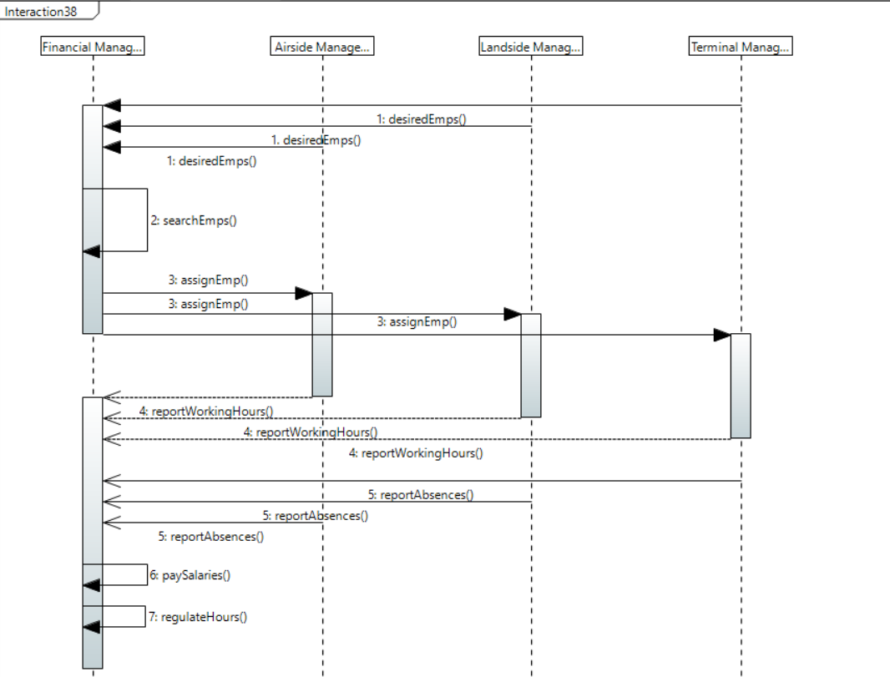

**Manage landside employees**

Step 1: Landside Management requests security clothing for its employees from Financial Management

Step 2: Financial Management buys requested clothing from an external vendor

Step 3: Landside Management requests driving licence courses for the drivers for being able to drive the vehicles

Step 4: Financial Management books driving instructor and coordinates appointments

Step 5: Financial Management supervises attendance of employees at appointments

Step 6: Financial Management pays for course and requests driving licence for Landside Management employees

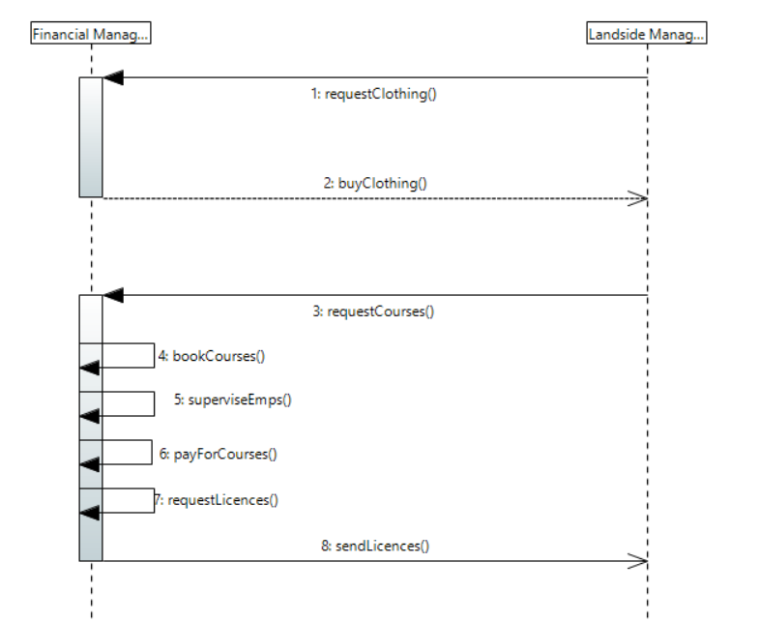

**Manage terminal employees**

Step 1: Terminal Management requests adequate clothing for employees from Financial Management

Step 2: Financial Management buys requested clothing from an external vendor

Step 3: Terminal Management requests computers with access to flight information and passenger data in order to do work

Step 4: Terminal Management requests security utils (metal detector, scanner, ...) from Financial Management

Step 5: Terminal Management requests big screens for display flight information from Financial Management

Step 6: Financial Management provides requested utils and buys the from an external vendor if needed

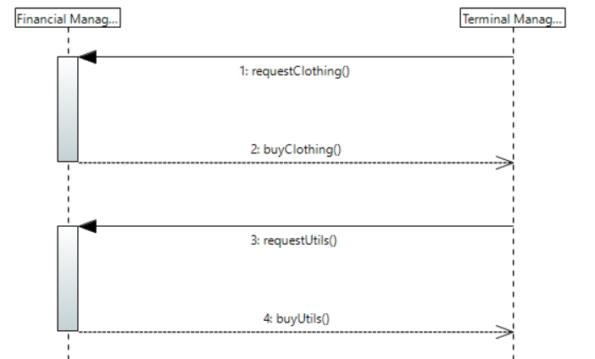

**Manage airside employees**

Step 1: Landside Management requests security clothing for its employees from Financial Management

Step 2: Financial Management buys requested clothing from an external vendor

Step 3: Airside Management requests courses for air traffic controllers, tower personnel, etc. from Financial Management in order to ensure operability

Step 4: Financial Management books instructors and coordinates appointments

Step 5: Financial Management supervises attendance of employees at appointments

Step 6: Financial Management pays for course and requests driving licence for Airside Management employees

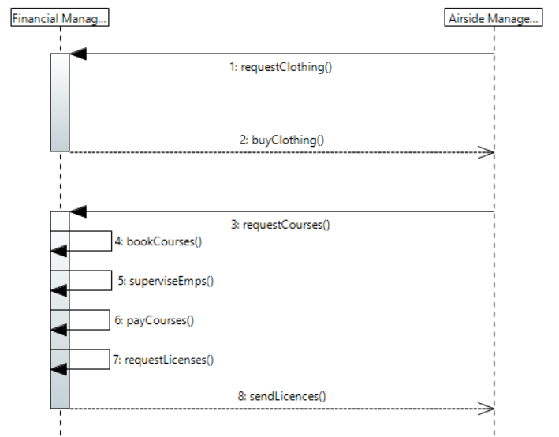

**Provide gate and transport information**

Step 1: Terminal Management requests passenger/cargo transport from Landside Management

Step 2: Landside Management requests gate and transport information from Terminal Management

Step 3: Terminal Management assigns gate

Step 4: Terminal Management forwards baggage to transportation units

Step 5: Terminal Management and Airside management coordinate flight details to ensure that baggage gets delivered correctly and on time

Step 6: Landside Management transports baggage and passengers to the airplane

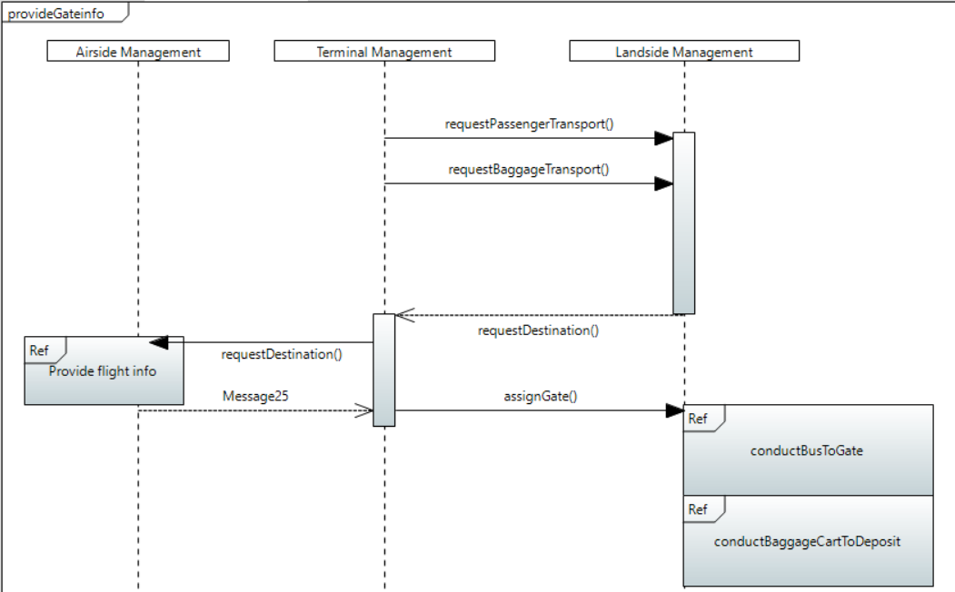

**Provide flight information**

Step 1: Airside Management requests flight information from Terminal management (scheduled departure/arrival)

Step 2: Terminal Management adjusts departure/landing time according to check-in status of passengers

Step 3: Airside Management provides actual departure/landing time (possible delays)

Step 4: Terminal Management displays possibly changed flight information to passengers

Step 5: Terminal Management coordinates baggage and passenger transportation according to aircraft status

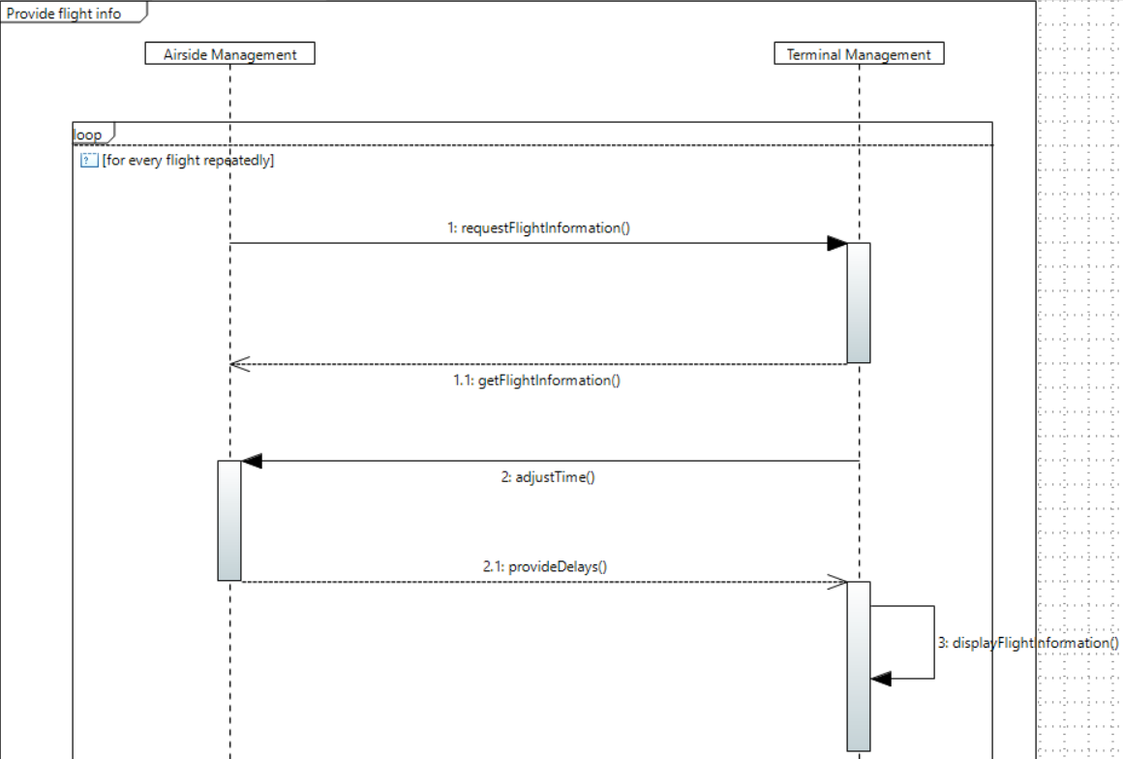

**Update ticket information / pricing**

Step 1: Terminal Management reports check-in status of flights to Financial Management

Step 2: Terminal Management reports payments (too heavy baggage, better seat category, ...) to Financial Management

Step 3: Financial Management updates ticket prices, departure times and flight states

Step 4: Terminal Management displays updated data on flight information system

Step 5: Financial Management executes payments depending on the payment method (excluding cash since that is paid immediately)

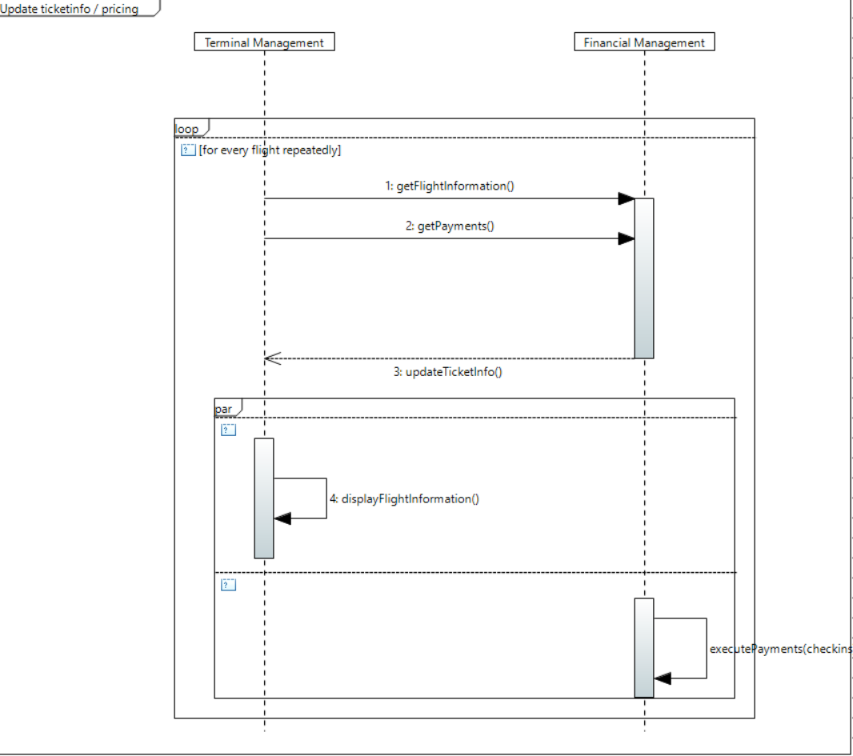

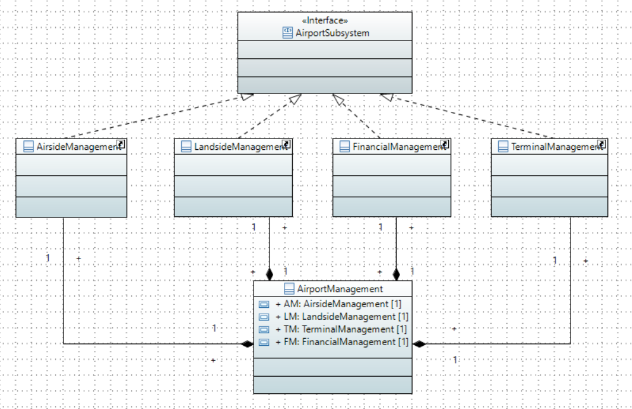

#### 2.1 Sub-system 1 / Airside management - [Jonas **Reichhardt**]

The airside management handles aircraft related information and actions. For example, aircraft landing and takeoff.

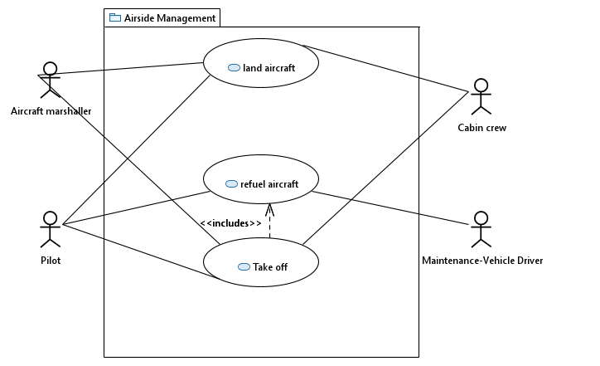

The aircraft marshaller is ground personnel which guides pilots from starting/landing strip to parking spot and vice versa, in our case he also gives landing/starting permission.

On the aircraft the cabin crew manages customer request, safety briefing and it acts as a communication relay between pilot and passengers.

Regardless of the situation pilots are involved in every action in the airside management. They land the aircraft, notify the landside management to get the aircraft refueled and takeoff when all passengers and cargo is loaded.

The fuel truck driver is part of the landside management but is necessary to get aircrafts refueled and ready to takeoff.

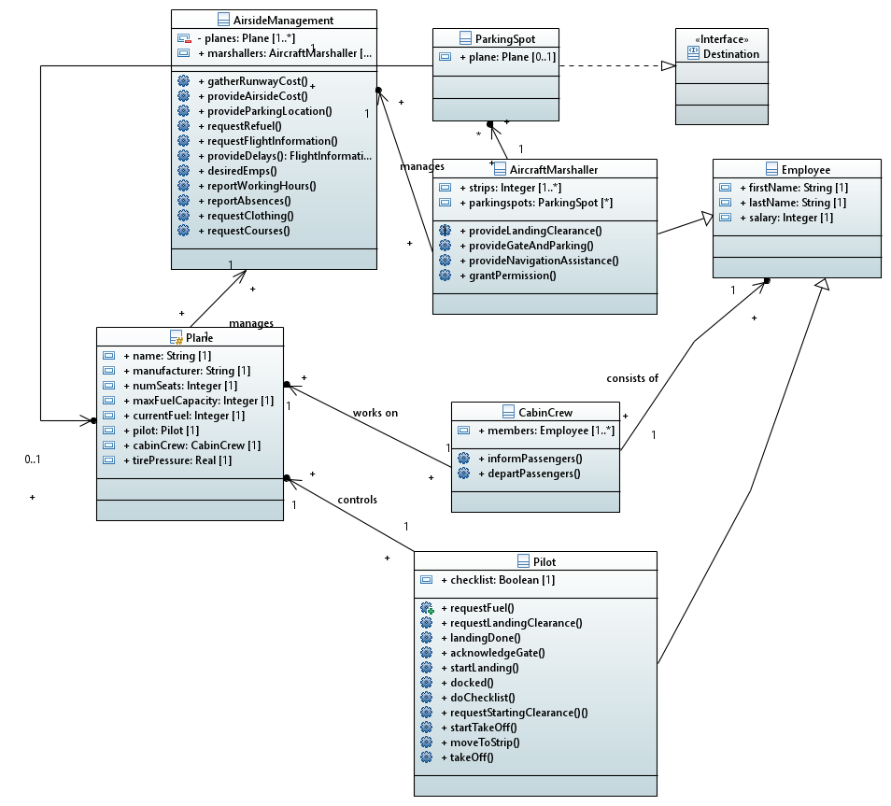

To support the described use-cases, this class diagram was created. Most classes represent an actor from the use-case diagram. Each class has it’s set of functions which are defined by the various sequence diagram which are described later. The Interface “Destination” is imported from Subsystem2 to guarantee that both subsystems have the same understanding what a “Destination” is. The personnel classes inherit from the base class which represents an employee of the airport.

**Land aircraft**

Step 1: Pilot requests landing clearance from the aircraft marshaller

Step 2: Pilot notifies cabin crew that the aircraft will land soon

Step 3: Cabin crew informs the passengers that they should put on their seatbelts

Step 4: Aircraft marshaller gives clearance and provides the landing strip

Step 5: Pilot performs landing

Step 6: Aircraft marshaller provides a gate number and the parking spot after the passengers left.

Step 7: Aircraft marshaller signals instructions to the pilot to ease parking.

Step 8: Pilot acknowledges the information provided

Step 9: Pilot informs Cabin crew that gate docking is completed

Step 10: Cabin crew departs the passengers row-wise

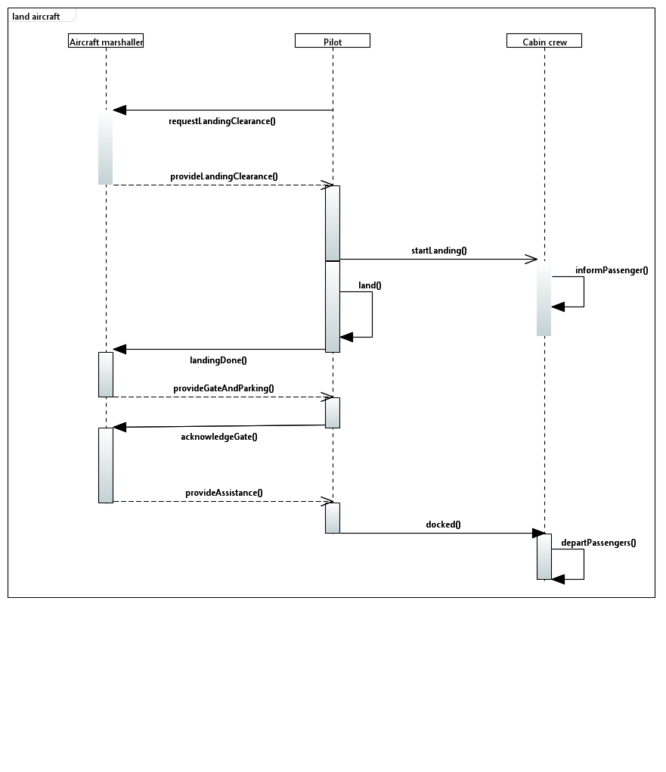

**Refuel aircraft**

Step 1: Pilot requests fuel truck from landside management and provides location information

Step 2: Fuel truck driver gets information

Step 3: Fuel truck driver reports to pilot that the truck will refuel the aircraft

Step 4: Fuel truck moves to aircraft

Step 5: Fuel truck refills aircraft

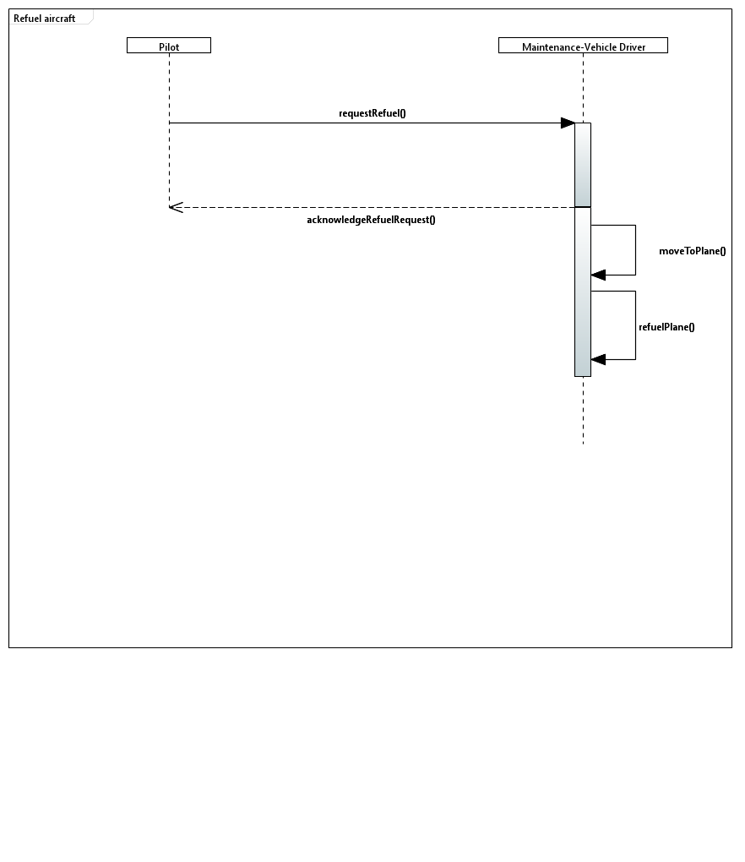

**Take off**

Step 1: Pilot goes through all checklists

Step 2: Pilot requests start permission from aircraft marshaller

Step 3: Aircraft marshaller gives permission together with starting strip

Step 4: Pilot acknowledges the information provided

Step 5: Pilot informs cabin crew that the aircraft has started the takeoff procedure

Step 6: Cabin crew informs passengers that they should put on their seatbelts

Step 7: Pilot moves the aircraft to the designated starting strip

Step 8: Pilot performs take-off

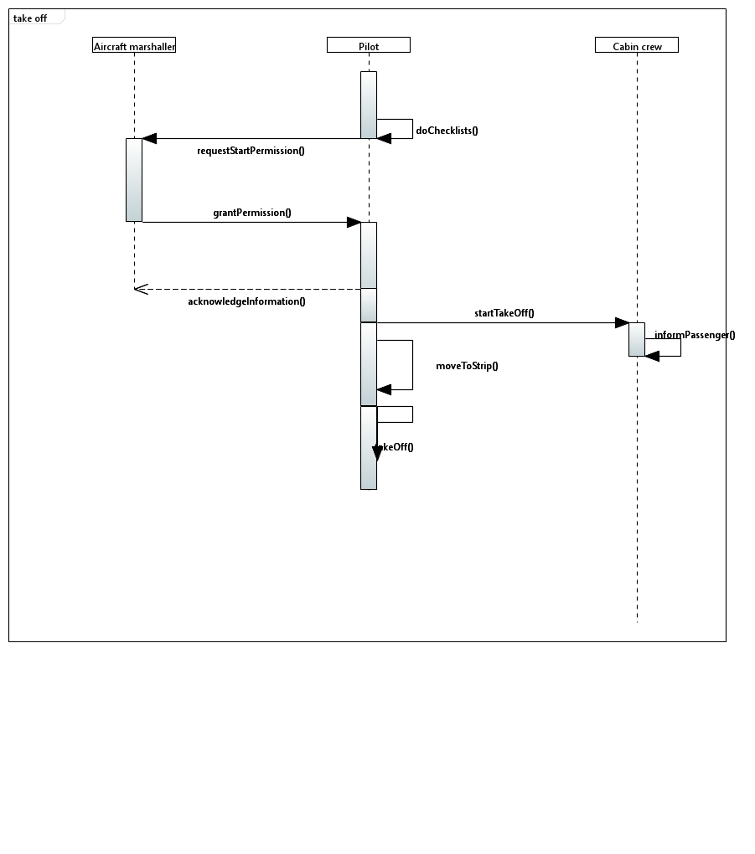

2.2 Sub-system 2/Sub-system name - [Stefan **Haslhofer**]

#### The landside management coordinates land vehicles picking up passengers and baggage, maintaining aircrafts as well as handling emergencies such as fires.

The landside management is responsible for the assignments of land vehicles to planes or gates. It provides the necessary information such that a land vehicle driver is able to head for the correct destination at the correct time.

The bus driver brings persons either from a plane to a gate or vice versa. He receives his destinations from the landside management.

The baggage-cart driver delivers all the baggage from a plane to a baggage deposit.

The maintenance vehicle driver checks tire pressure off plane tires as well as refueling the plane itself. The amount of fuel needed is communicated by the management.

The firetruck driver responds to emergency calls in case of a fire or other malfunctions that need specialists on the runway.

**Conduct bus to gate**

Step 1: management assigns a gate to a bus driver

Step 2: bus driver drives to the gate

Step 3: bus driver arrives at gate

Step 4: the bus driver **transports the passengers** to a plane

Step 5: bus driver drives back to garage

Step 6: bus driver awaits new orders

**Transport passengers**

Step 1: bus driver opens bus doors

Step 2: bus driver waits until bus is full or no more people are left

Step 3: bus driver requests clearance from management

Step 4: bus driver closes doors

Step 5: bus driver drives to destination

Step 6: bus driver arrives at destination

Step 7: bus driver opens doors

Step 8: bus driver waits until bus is empty

Step 9: bus driver reports status back to management

Step 10: bus driver closes doors

**Conduct vehicle to plane**

Step 1: management assigns a plane to a driver

Step 2: driver drives to the plane

Step 3: driver arrives at plane

Step 4: the bus driver **transports the passengers** to the gate

Step 5: the baggage vehicle driver **transports baggage** to a baggage deposit

Step 5: driver drives back to garage

Step 6: driver awaits new orders

**Transport baggage**

Step 1: baggage-cart driver opens baggage hatch

Step 2: baggage-cart driver waits until baggage is fully deposited inside the vehicle

Step 3: baggage-cart driver requests clearance from management

Step 4: baggage-cart driver closes and locks baggage hatch

Step 5: baggage-cart driver drives to destination

Step 6: baggage-cart driver arrives at destination

Step 7: baggage-cart driver opens hatch

Step 8: baggage-cart driver waits until baggage is unloaded

Step 9: baggage-cart driver reports status back to management

Step 10: baggage-cart driver closes hatch

**Conduct baggage cart to baggage deposit**

Step 1: management assigns a baggage deposit to a baggage-cart driver

Step 2: baggage-cart driver drives to the baggage deposit

Step 3: baggage-cart driver arrives at baggage deposit

Step 5: the baggage-cart driver **transports the baggage**

Step 5: baggage-cart driver drives back to garage

Step 6: baggage-cart driver awaits new orders

**Request refuel status**

Step 1: the management asks a driver for his fuel status

Step 2: the management waits until the driver returns from his assignment

Step 3: if the vehicle is low on fuel the driver needs to **refuel**

**Refuel**

Step 1: the management assigns the driver to the nearest fuel depot

Step 2: driver drives to the depot

Step 3: driver arrives at the depot

Step 4: driver opens the fuel cap

Step 5: driver puts the gasoline hose into the open tank

Step 6: driver starts pumping gasoline

Step 7: driver waits until the tank is full

Step 8: driver stops pumping gasoline

Step 9: driver puts gasoline hose back

Step 10: driver closes the fuel cap

Step 11: driver reports consumed liters back to the management

**Communicate needed services**

Step 1: management assigns vehicles/driver to plane

Step 2: management tells the driver what to do

**Maintain plane**

Step 1: maintenance vehicle driver drives to plane

Step 2: maintenance vehicle driver arrives

Step 3: maintenance vehicle driver refuels plane

Step 4: maintenance vehicle driver check tire pressure

Step 5: maintenance vehicle driver reports status back to management

Step 6: maintenance vehicle driver drives back to garage

Step 7: maintenance vehicle driver awaits new orders

**Refuel plane**

Step 1: maintenance vehicle driver opens fuel hatch of plane

Step 2: maintenance vehicle driver attaches gasoline hose to hatch

Step 3: maintenance vehicle driver starts pumping kerosine

Step 4: maintenance vehicle driver stops pumping

Step 5: maintenance vehicle driver disconnects gasoline hose

Step 6: maintenance vehicle driver closes hatch

Step 7: maintenance vehicle driver reports amount of gasoline used to management

Step 8: maintenance vehicle driver double checks if planes fuel hatch is closed

**Check tire pressure**

Step 1: maintenance vehicle driver starts compressor to fill the land vehicles high pressure air tank

Step 2: maintenance vehicle driver retrieves tire pressure gauge from vehicle

Step 3: maintenance vehicle driver connects tire pressure gauge to the vehicles high pressure air tank

Step 4: maintenance vehicle driver connects tire pressure gauge to the plane´s tire

Step 5: maintenance vehicle driver uses the tire pressure gauge to measures tire pressure

Step 6: maintenance vehicle driver pumps air into the tire until pressure is high enough

Step 7: maintenance vehicle driver stops the pump

Step 8: maintenance vehicle driver stops the compressor

Step 9: maintenance vehicle driver disconnects the tire pressure gauge from the tire

Step 10: maintenance vehicle driver puts the tire pressure gauge back into the vehicle

**React to emergency**

Step 1: firetruck driver drives to plane

Step 2: firetruck driver arrives

Step 3: firetruck driver starts water pump

Step 4: firetruck driver extinguishes fire

Step 5: firetruck driver stays until all passengers are brought to safety

Step 6: firetruck driver stops water pump

Step 7: firetruck driver reports status back to management

Step 8: firetruck driver drives back to garage

Step 9: firetruck driver refills water tank

Step 10: firetruck driver awaits new orders

#### 2.3 Sub-system 3/Terminal management - [Simon **Primetzhofer**]

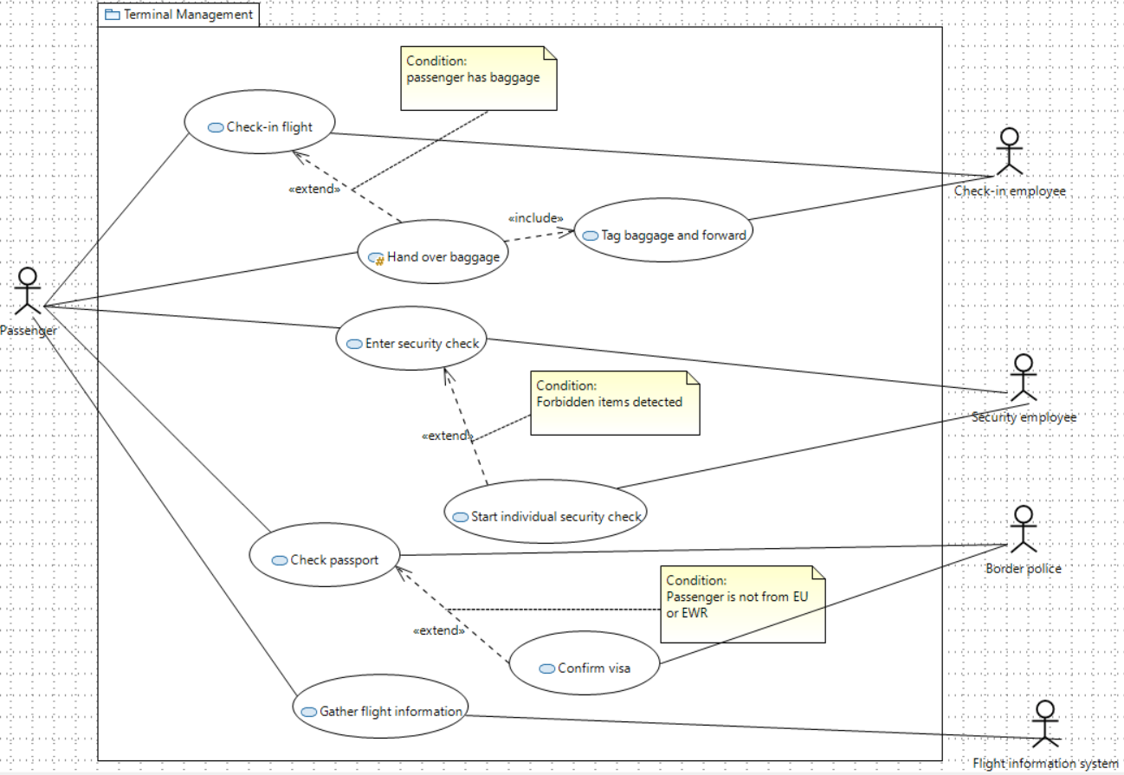

A passenger is a natural person who enters the airport in order to travel to another destination. Passengers may have some baggage with them – depending on the size, it must be handed over at the check-in. Furthermore, a passenger must enter the security check in any case and when arriving, already have a valid visa to enter the respective country.

Check-in employees are sitting at the check-in counter and have two tasks: Checking in a passenger for the booked flight and if a passenger has baggage, they must tag and forward it to the landside management.

Security employees are responsible for inspecting the hand baggage and the passengers themselves. They remove forbidden items and are also allowed to examine a passenger in detail. They have the permission to deny entrance to the gate area when security concerns are present.

Border police officers are monitoring arriving passengers and confirm their admission. They must have knowledge about which nationalities need a visa and which can enter without further checks.

The flight information system is a digital system which allows passenger to gather all necessary flight information at any time. There are big screens all over the airport and also small screens directly at the gates which provide more detailed information.

**Check-in flight**

Step 1: Passenger approaches check-in counter

Step 2: Check-in employee asks for passport

Step 3: Passenger hands over passport

Step 4: Check-in employee checks identity

Step 5: Check-in employee prints out flight tickets

Step 6: If the passenger has some baggage, he/she hands it over to the check-in employee

Step 7: Check-in employee gives back the passport including the flight tickets

Step 8: Passenger leaves counter

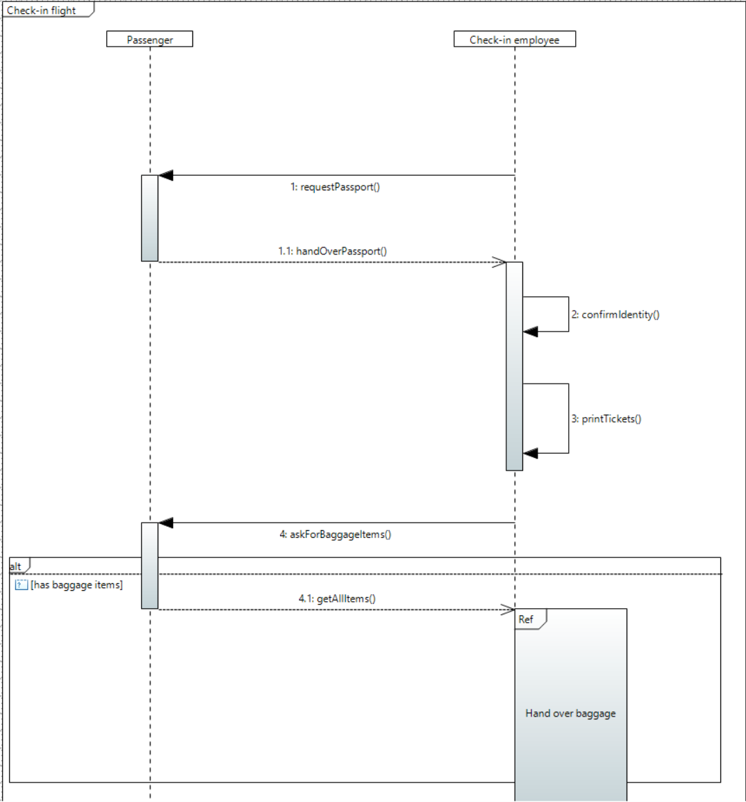

**Hand over baggage**

Step 1: Passenger hands over baggage

Step 2: Check-in employee weighs every baggage item

Step 3: Check-in employee checks weight limit of all baggage items

Step 4: Passenger pays additional fee for every kilogram which exceeds the weight limit

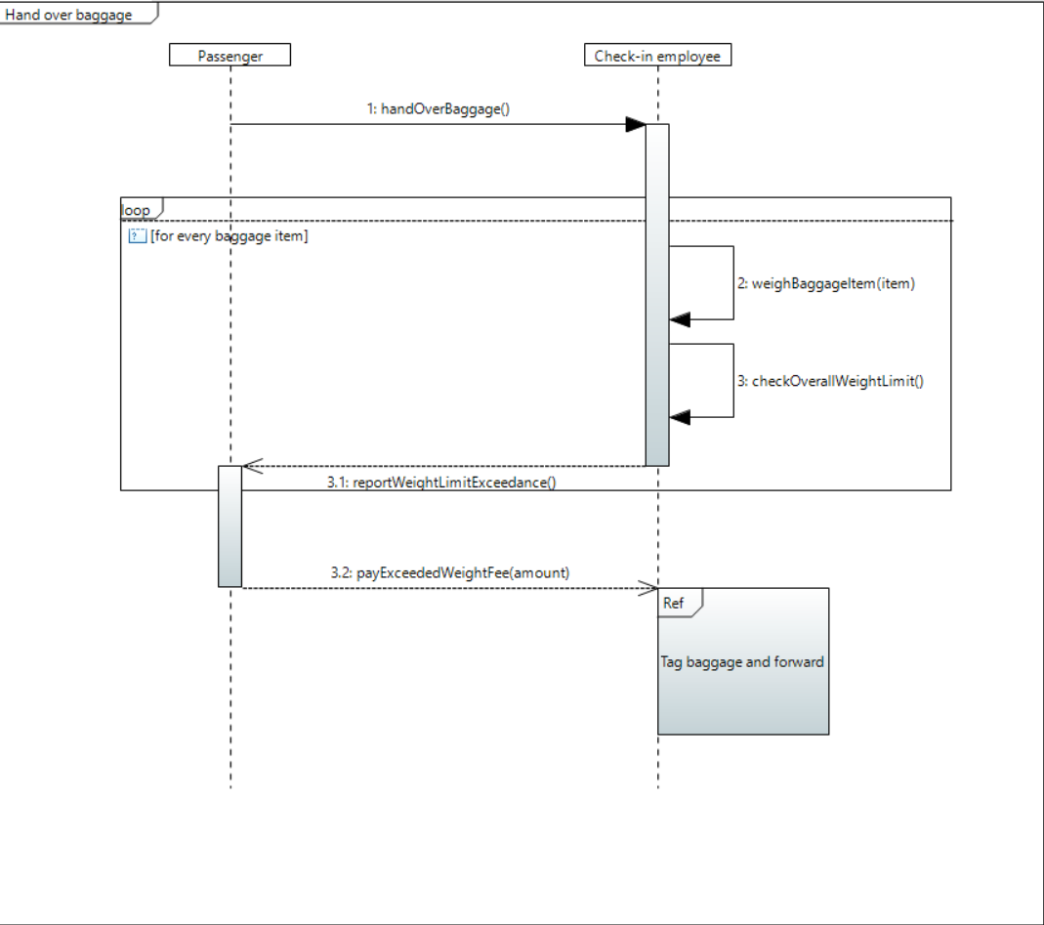

**Tag baggage and forward**

Step 1: Check-in employee prints out one tag per baggage item

Step 2: Check-in employee puts tag on every baggage item

Step 3: Check-in employee forwards all baggage items via the conveyor to the transportation location

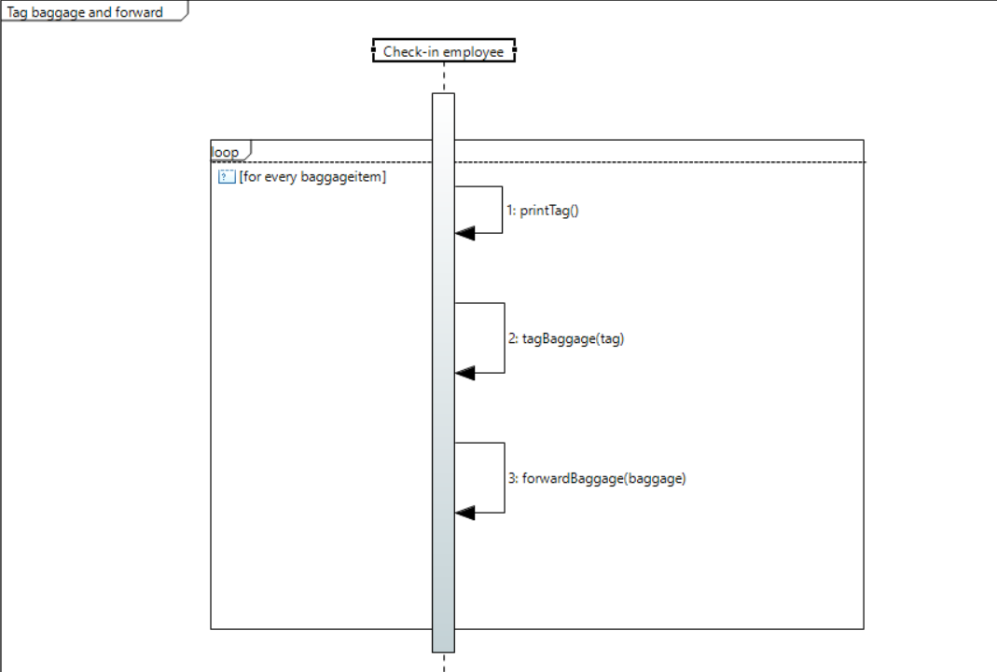

**Enter security check**

Step 1: Passenger enters security area with flight ticket

Step 2: Passenger throws all forbidden items into a bin

Step 3: Passenger puts all remaining personal items into a box

Step 4: Security employee scans personal items

Step 5: Passenger goes through metal detector

Step 6: Passenger takes back personal items

Step 7: Passenger leaves security area

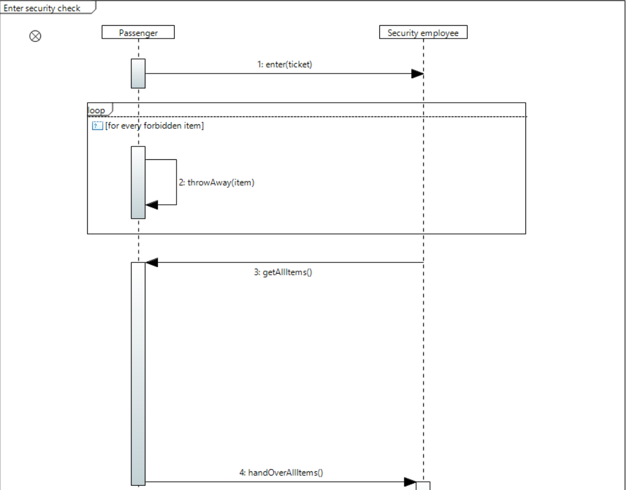

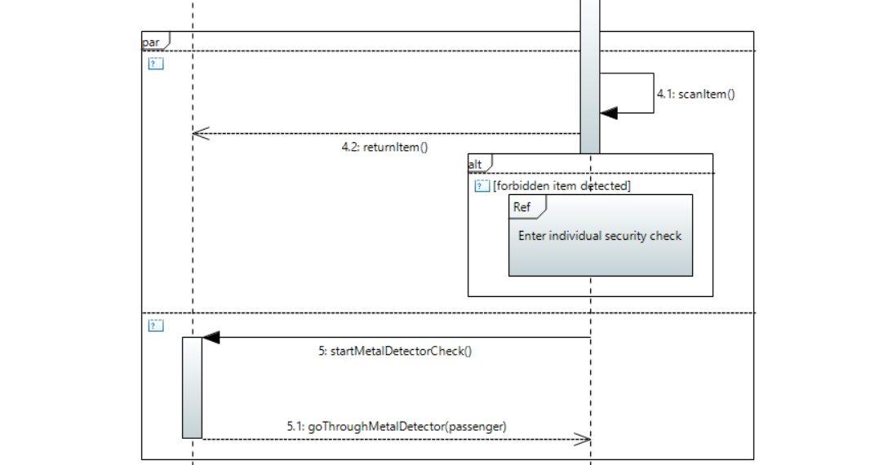

**Start individual security check**

Step 1: Security employee removes forbidden items from the passenger's personal belongings if present

Step 2: Security employee performs an individual scan on the passengers' body

Step 3: Security employee asks relevant questions

Step 4: Security employee resolves the situation

Step 5: Passenger leaves individual security check

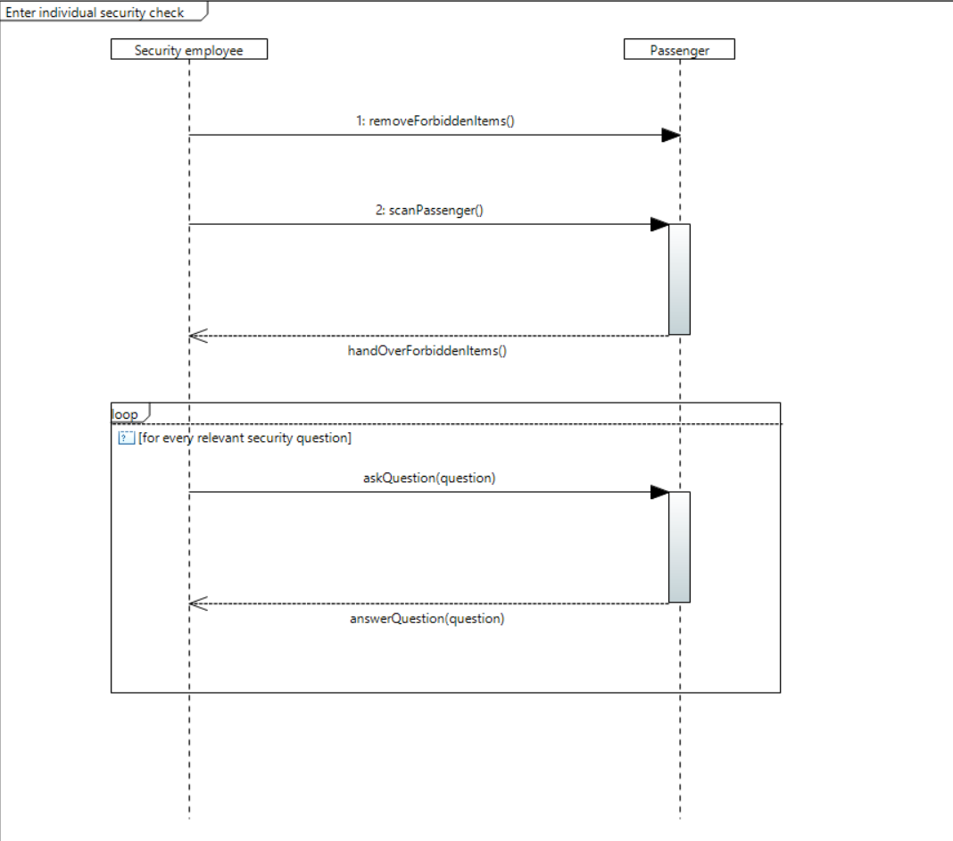

**Check passport**

Step 1: Passenger approaches border police

Step 2: Passenger hands over passport

Step 3: Border police checks nationality and possible warrants, fees, etc.

Step 4: Border police gives back the passport

Step 5: Passenger leaves border police check

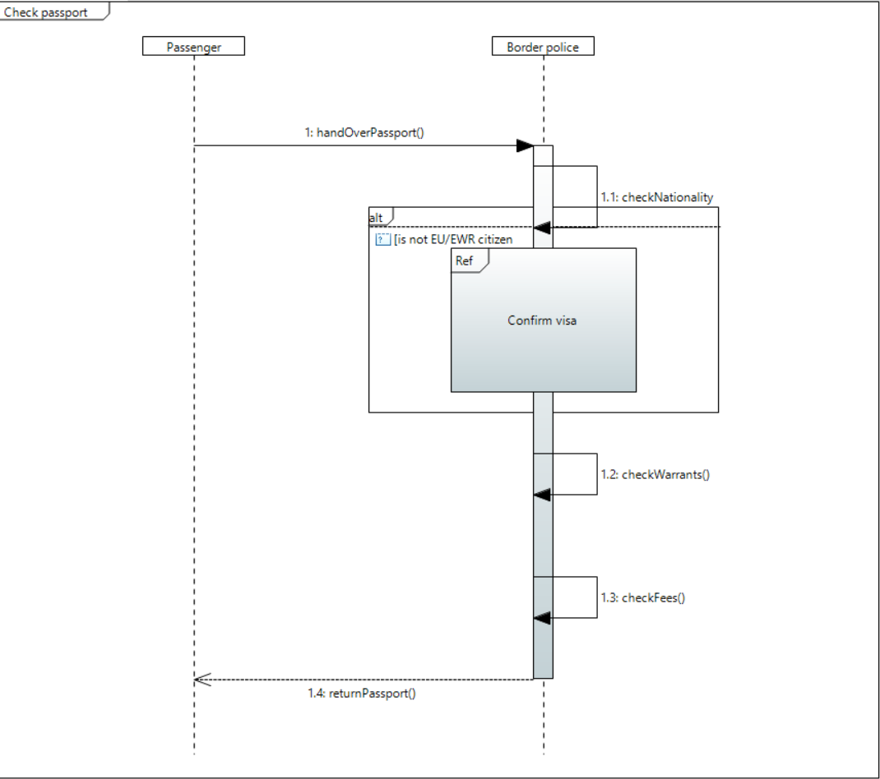

**Confirm visa**

Step 1: Border police inspects passport for visa

Step 2: Border police checks if visa is valid

Step 3: Border police confirms identity of passenger

Step 4: Border police gathers reason and duration of stay

Step 5: Passenger leaves border police office

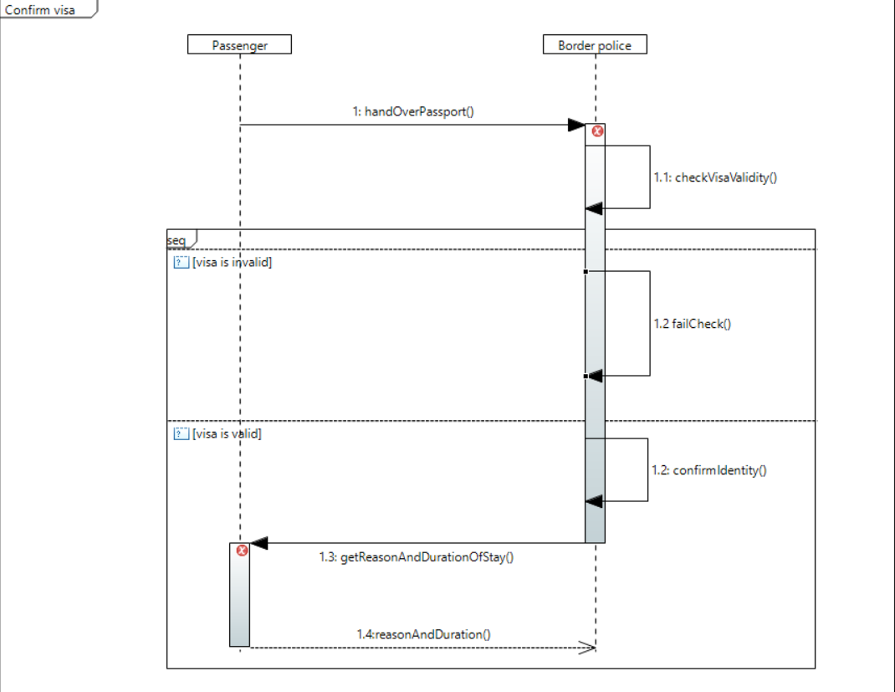

**Gather flight information**

Step 1: Passenger spots flight information display

Step 2: Passenger looks for his/her own flight in the list of all upcoming flights

Step 3: Flight information provides flight number, departure/landing gate and time

Step 4: Passenger notes down important information

Step 5: Passenger leaves information area

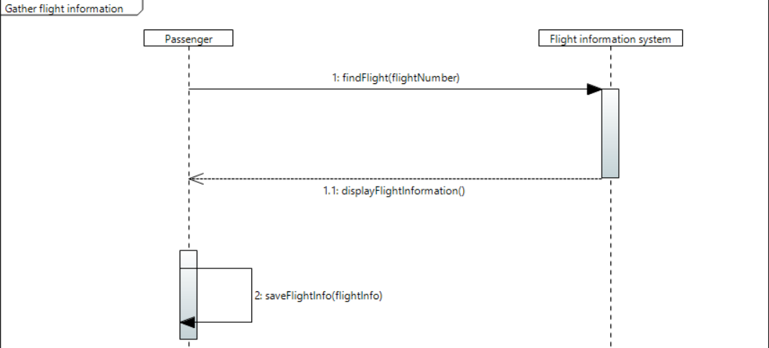

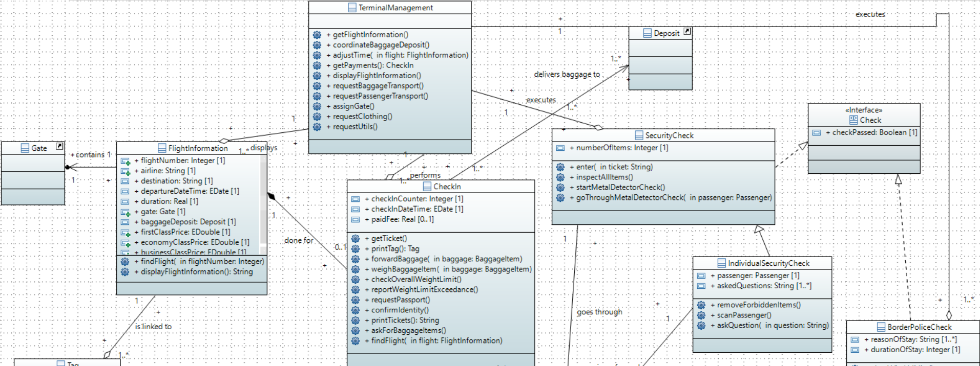

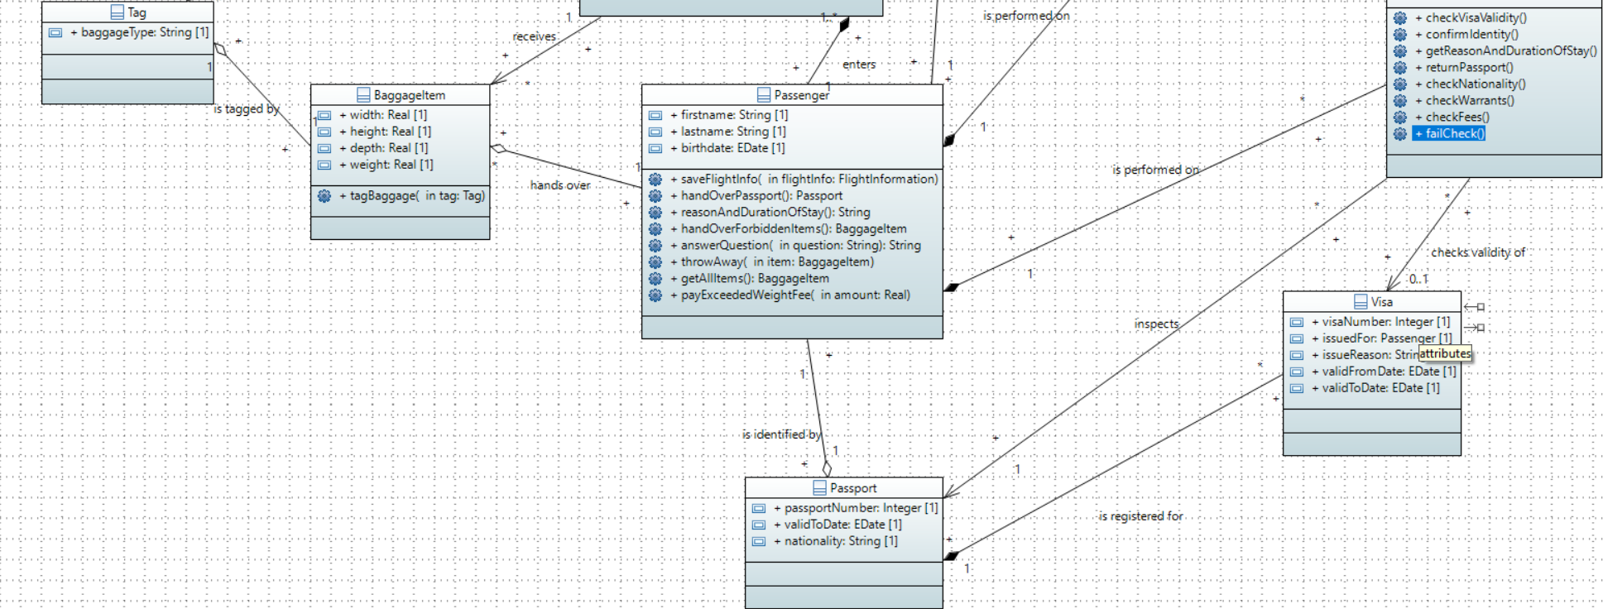

#### 2.5 Sub-system 5/Financial Management - [Kaan **Baylan**]

The Airline is a business which operates regular services for carrying passengers or cargo by plane. This business will book a facility of the airside to park their aircrafts and will give the financial management info about their designated flight.

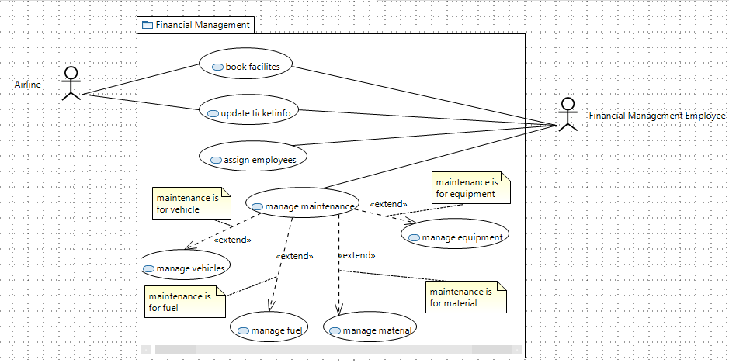The FME is a person who works for the Financial Management department in our Airside. These employees will be receiving the desired bookings of the airside and reserve the facilities. Moreover, this department has got the task to assign employees to the other managements.

Furthermore, the employees are to be expected to manage the information of the tickets for the flight when the flight information gets changed. (Date, Time, and Gate)  
Another important task is to manage the different maintenances.

**Book facilites:**

Step 1: Airline gets information about which facilities can be booked through the system

Step 2: FME gives Airline information about which facilities are free

Step 3: Airline gives info about which facilities they would like to book

Step 4: FME gives Airline a contract about the booking

Step 5: Airline accepts and signs contract

Step 6: Airline pays the discussed amount

Step 7: FME registers the facilities as booked

**Update Ticketinfo:**

Step 1: Airline prepares a flight or changes a scheduled flight

Step 2: Airline gives the information to the FME

Step 3: FME checks info and (re-)schedules the flight

Step 4: FME calculates new ticket prices

Step 5: FME publishes new ticket information

**Assign Employees:**

Step 1: FME checks the employee lists of the different managements

Step 2: FME gathers info about the work rate of the other managements

Step 3: FME checks if any employee left the airside or one of the managements work rates is dropping or has dropped

Step 4: FME signs new employees

Step 5: FME assigns these employees to the management

**Manage Maintenances:**

Step 1: Another management informs FME about needed maintenance

Step 2: FME checks which kind of maintenance it is

Step 3: Use case X is executed

**Manage Vehicles:**

Step 1: FME gets info about vehicle

Step 2: FME sends vehicle to inspection

Step 3: FME get info about the cost of repairment

Step 4: If repairment cost is too much FME pays for new vehicle

Step 5: FME accounts the cost of repairing / new vehicle

**Manage Fuel:**

Step 1: FME checks which fuel is needed

Step 2: FME checks if the needed fuel is stored in a depo of ours

Step 3: If fuel is in our depo, it gets delivered

Step 4: FME calculates how much fuel is left

Step 5: if fuel is low or no fuel was found in depo FME orders new

Step 6: FME accounts the cost of the new fuel

**Manage Material:**

Step 1: FME checks which material is needed

Step 2: FME checks if the needed material is stored in a depo of ours

Step 3: If material is in our depo, it gets delivered

Step 4: FME calculates how much material is left

Step 5: if material is low or no material was found in depo FME orders new

Step 6: FME accounts the cost of the new material

**Manage Equipment:**

Step 1: FME gets info about equipment

Step 2: FME checks if equipment can be repaired

Step 3: FME get info about the cost of repairment

Step 4: If repairment cost is too much FME pays for new equipment

Step 5: FME accounts the cost of repairment / new equipment

### 3. Design Decisions

**Overall architecture package diagram:**

We decided to connect every subsystem with the other ones since we have no central unit like the control system management. Therefore, Airside and Landside Management have to communicate directly with each other.

**System level use case diagram:**  
Managing employees is split into one overall use-case which contains generic tasks of employee management and the subsystem specific use-cases (manage landside/terminal/airside employee) contain steps which are only needed for the respective subsystem.

**General style of use-cases:**

We decided to structure conditions and exceptions with <<extend>> since this was the best way to display such flows. Note that the condition which is formulated in the yellow box must be satisfied in order to enter the extending use-case.

**System level class diagram:**

We decided to use the composition relation between the different subsystems and the overall system since every subsystem is specifically modelled for an airport management system. It would be possible to extend this for other management systems as well and if that would be the case, we could exchange the composition for an aggregation in order to share these subsystems with other systems as well. But that would need some adaptions and this is not in the scope of this project.

It was not possible to create associations between the referenced subsystem classes in the system-level class diagram since papyrus throws an error in that case. But every subsystem directly communicates with all other subsystems and therefore, an association between all subsystems is present.

### 4. Change Log

|  |  |
| --- | --- |
| **Deliverable** | **Changes** |
| D1 | Formed team and choose subsystems |
| D2 | Added overall architecture (one version per team member) |
| D3 | Combined and refined overall architecture using a package diagram  Added use-case diagrams for overall system and subsystems |
| D4 | Added detailed use-case specification for every use-case |
| Report and Presentation | Refined use-case specifications to be more detailed |
| Feedback on Report | Discussed and updated use-case specifications according to feedback |
| D5 | Added domain model |
| D6 | Defined actions in sequence diagram per usecase  Converted domain model to class diagram  Added sequence diagram actions as methods in class diagram |
| Report and Presentation 2 | Integrated changes from M2 Correction Guideline (especially to show one exception case in the sequence diagram) |
| Feedback on Report 2 |  |