# Assignment 3 – Code Coverage

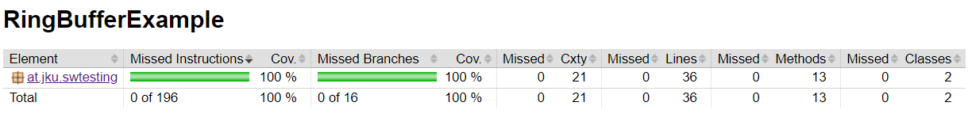

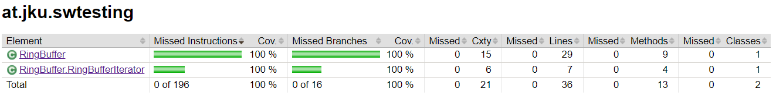

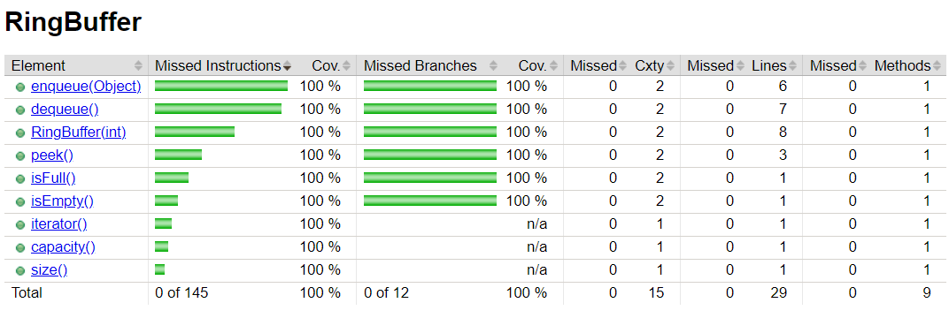

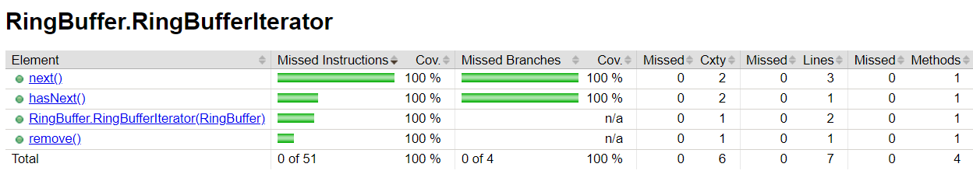

Since we already had 100% coverage initially, we didn’t have to add any tests in this part of the assignment.