test

Simon Ress

3 8 2021

Table of Contents

R Markdown 1

Including Plots 1

## R Markdown

This is an R Markdown document. Markdown is a simple formatting syntax for authoring HTML, PDF, and MS Word documents. For more details on using R Markdown see <http://rmarkdown.rstudio.com>.

When you click the **Knit** button a document will be generated that includes both content as well as the output of any embedded R code chunks within the document. You can embed an R code chunk like this:

summary(cars)

## speed dist   
## Min. : 4.0 Min. : 2.00   
## 1st Qu.:12.0 1st Qu.: 26.00   
## Median :15.0 Median : 36.00   
## Mean :15.4 Mean : 42.98   
## 3rd Qu.:19.0 3rd Qu.: 56.00   
## Max. :25.0 Max. :120.00

## Including Plots

You can also embed plots, for example:

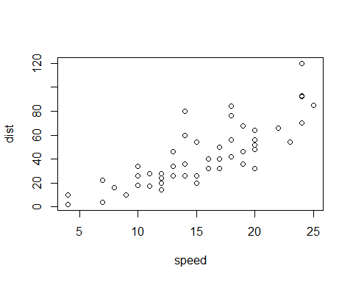

Note that the echo = FALSE parameter was added to the code chunk to prevent printing of the R code that generated the plot.

This is an R Markdown document. Markdown is a simple formatting syntax for authoring HTML, PDF, and MS Word documents. For more details on using R Markdown see <http://rmarkdown.rstudio.com>.

When you click the **Knit** button a document will be generated that includes both content as well as the output of any embedded R code chunks within the document. You can embed an R code chunk like this:

This is an R Markdown document. Markdown is a simple formatting syntax for authoring HTML, PDF, and MS Word documents. For more details on using R Markdown see <http://rmarkdown.rstudio.com>.

When you click the **Knit** button a document will be generated that includes both content as well as the output of any embedded R code chunks within the document. You can embed an R code chunk like this:

This is an R Markdown document. Markdown is a simple formatting syntax for authoring HTML, PDF, and MS Word documents. For more details on using R Markdown see <http://rmarkdown.rstudio.com>.

When you click the **Knit** button a document will be generated that includes both content as well as the output of any embedded R code chunks within the document. You can embed an R code chunk like this:

##   
## Attaching package: 'dplyr'

## The following objects are masked from 'package:stats':  
##   
## filter, lag

## The following objects are masked from 'package:base':  
##   
## intersect, setdiff, setequal, union

My Table in Word

|  |  |  |
| --- | --- | --- |
| x | y | z |
| 1.111 | one | 5 |
| 2.222 | two | 6 |
| 3.333 | three | 7 |

## Loading required package: flextable

| x | | y | z | |
| --- | --- | --- | --- | --- |
| 1.111 | | one | 5 | |
| 2.222 | | two | 6 | |
| 3.333 | | three | 7 | |
| x | y | | | z | |
| 1.111 | one | | | 5 | |
| 2.222 | two | | | 6 | |
| 3.333 | three | | | 7 | |