IT work

[Full Day In The Life of a Software Engineer](https://www.youtube.com/watch?v=cMy9LxUQa8M)

**What kind of work is done by the IT professional?**

Work done by this software engineer is mostly fixing bugs or deploying security patches. He spends most of his time coding, and or asking help from fellow coworkers. Not much else is explained in the video.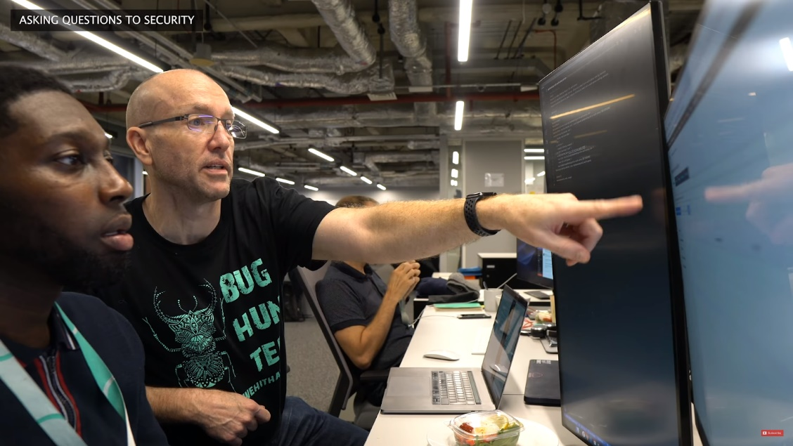

**What kinds of people does the IT professional interact with? Are they other IT professionals? Clients? Investors? The general public?**

When he enters the building, we are shown him introducing IT professionals working in different departments. He walks around the room greeting other teams, such as the infrastructure team, payment processing team, legal and compliance. After preparing for an interview, he has to talk to the product managers.

**Where does the IT professional spend most of their time?**

The IT professional spends most of their time at the computer desk, looking at the dual screens to code. If they are not at their desk, it would be because they have a break.

**What aspect of their position is most challenging?**

It looks like the most challenging aspect of this software engineer is the amount of tasks that he has to do for the day. At the start, he has to organise his workflow with his partner ‘carlitos’ using kubernetes. After breakfast, he has to prepare an interview. After, they have to recieve help by asking questions with other software engineers specialised in that field. Communication skills are necessary in this line of work, as it looks like they need to communicate with coworkers everyday on problems or everyday activities.

[Day In The Life: Software Engineer Intern @ WeWork](https://www.youtube.com/watch?v=Ub5GAhUNEas)

**What kind of work is done by the IT professional?**

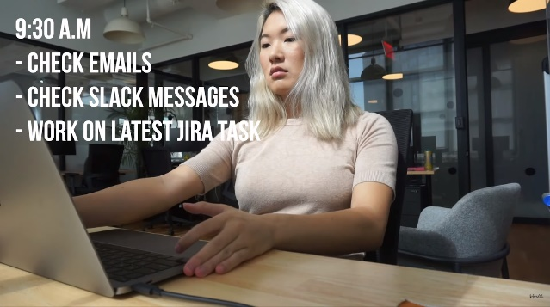

Work done by this IT professional includes checking emails, reading and writing/repairing code. Not much else is explained in the video, as for some reason 40% is about her talking about food at lunchtime.

**What kinds of people does the IT professional interact with? Are they other IT professionals? Clients? Investors? The general public?**

This IT professional does not interact with others, working in a private room by themselves. Maybe they talk to their manager, but it is not shown in this video.

**Where does the IT professional spend most of their time?**

This person spends most of their time at a desk, following a timetable and work plan that someone or themselves worked on the previous week. Their macbook is connected to a larger 27? Inch display above the laptop, and she uses that as the primary monitor.

**What aspect of their position is most challenging?**

The most challenging aspect in this job looks like working alone, without a partner. At around 8 minutes, it looks like she is having trouble with some code, and could not ask anyone for help, and it takes “an entire day to figure out my bug”. If this software engineer intern works with fellow coworkers, maybe they can help each other figure out problems quicker.

[Day in the Life of a Japanese Game Programmer](https://www.youtube.com/watch?v=e_TxH59MclA)

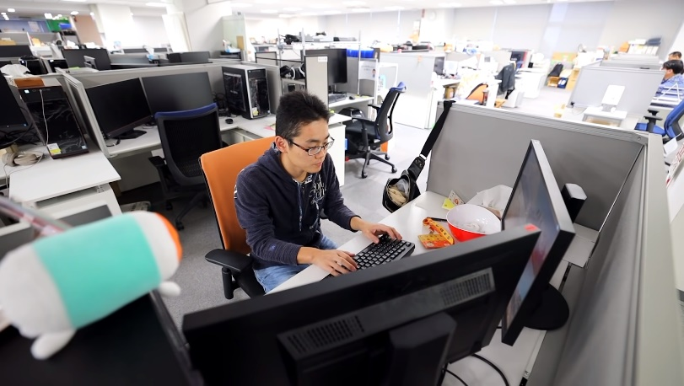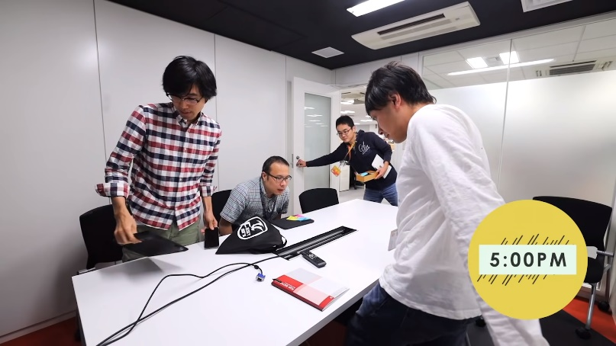

**What kind of work is done by the IT professional?**

This person works for Bandai Namco Entertainment, as a game developer. Checking emails, work plans updates and coding all day. He works for 8 hours a day, which in japan is perfectly acceptable. Every day at 2 pm, he has a quick 30 minute meeting with his fellow coworkers, discussing what they have done yesterday and what to do today. The meeting at 5pm happens every 2 weeks, they usually combine both meetings into one but due to scheduling issues it was booked twice.

**What kinds of people does the IT professional interact with? Are they other IT professionals? Clients? Investors? The general public?**

This game developer usually works alone in his cubicle. He interacts only in meetings, or when asking a question. In the video, he goes to the finance department on the 5th floor to ask about expenses. Other IT professionals that are seen interacting with him are his coworkers.

**Where does the IT professional spend most of their time?**

He spends most of his time at his computer desk, where he spends the majority of the time working. At the end of the day, he says that the day working was 8 hours. If he isn’t at the computer, he could be taking a nap at the company sleeping area, where there is a private room, or be eating food at the cafeteria.

**What aspect of their position is most challenging?**

The aspect that is most challenging for this developer is the amount of hours worked everyday. With japanese workers expected to work overtime without pay, it would severely demoralise people who already work 8 hour days. It is so bad, that this game programmer has to take a nap midway though the job, as how demanding it is. Having no time for socialising at work, he spends the night with friends eating, but he has to sacrifice sleep which can affect him the next day.

[A REAL Day in the Life of a Google Software Engineer](https://www.youtube.com/watch?v=oHBFD8cfXho)



**What kind of work is done by the IT professional?**

He does not work at google anymore, but in this video there is a lot of informative information about the job. Most of the days working at google varies from person to person, where someone who is about to finish a project would review and do coding all day, while another person could be managing interns and other people. The video explains that most software engineers don’t code every day, and really depends on their team, the project they are working on and the office they are working out of.

**What kinds of people does the IT professional interact with? Are they other IT professionals? Clients? Investors? The general public?**

There are a lot of professionals that he interacted with, as software engineers have to create a design dock and share it around with other coworkers. They can peer review each other's projects to give better feedback, or look at the ‘gears’ of the system. Meetings are also contributed at the job, where most of the day would be about status meetings, team wide meetings, one on one meetings with managers or other coworkers or even to make sure that everyone is on track.

**Where does the IT professional spend most of their time?**

As explained it really depends on person to person, as each task differs and varies. There is no set schedule for the engineers, as they can come in for work and leave any time they like. There are six things that most engineers including him do, which includes doing coding and testing, reviewing other people's code to make sure it follows style guidelines and has no bugs, designing products and creating design docks, going to meetings, making sure that everyone is on the right track with performance updates and other miscellaneous tasks, like managing interns or developing a project.

**What aspect of their position is most challenging?**

The most challenging thing in their position is the flexibility of their work. Because there is no set schedule, most days would vary with different tasks assigned to each day. I would think because of this it would be hard to plan out what you would do for the whole day, but maybe there is a work plan that this engineer follows.

[Day of Amazon Software Developer](https://www.youtube.com/watch?v=c8dd9f5MamU)

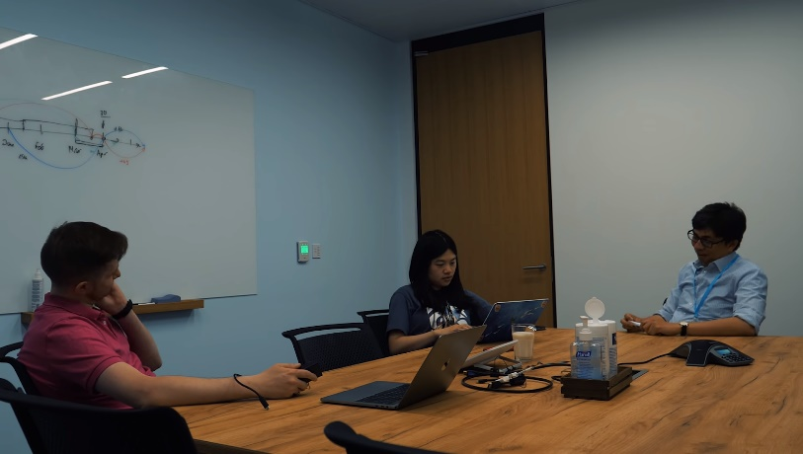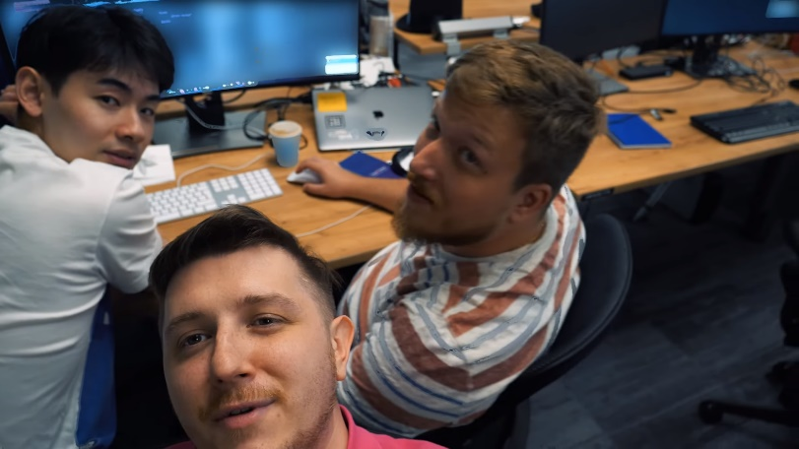

**What kind of work is done by the IT professional?**

As an amazon software developer, he has to communicate with his coworkers and code. In the video, he shows how he works. He goes to work early, around 8am and checks his emails, announcements. Today, he has a conference meeting with his workers to share project ideas.

**What kinds of people does the IT professional interact with? Are they other IT professionals? Clients? Investors? The general public?**

As a software developer, he has a team that he works with and communicates with. The video shows us of him introducing fellow software developers. The room that he interacts with is a department, and everyone in there is part of the same team. In the video, he asks everyone around what they are getting for lunch, and shows coworkers talking and giving ideas to each other.

**Where does the IT professional spend most of their time?**

This software developer spends most of their time around other people, working from his desk. In the morning he is there checking emails. If he isn’t at his desk, he would be at another table seeking or giving help. There is a cafeteria, but at lunchtimes he would ask everyone where they want to eat together.

**What aspect of their position is most challenging?**

I would think that the most challenging aspect of a software developer is that they have to sit in front of a computer all day. With how flexible the job is, it would be hard to not get distracted all day and to stay on track. There is not much information about this in the video, as he skims through everything.