**HarmonizR Software Instructions**

**Dependencies**

The HarmonizR package depends on a couple of different R packages and of course the R environment for statistical computing itself. The necessary imports are included within the DESCRIPTION file, which is uploaded together with the rest of the package on GitHub and must not be changed by the user. The dependencies and imports are as follows:

|  |  |
| --- | --- |
| **Dependency** | **Required Version** |
| R  sva | >= 4.0.4  >= 3.36.0 |
| doParallel | >= 1.0.16 |
| foreach | >= 1.5.1 |
| janitor | >= 2.1.0 |
| plyr | >= 1.8.6 |

The ‘sva’ package must be installed from Bioconductor. It is easiest to use the BiocManager for this. Make sure to be within the R environment. The installed ‘sva’ package should have the version 3.36.0 or newer:

if (!requireNamespace("BiocManager", quietly = TRUE))

install.packages("BiocManager")

BiocManager::install("sva")

HarmonizR wraps around the ComBat and limma implementations from the ‘sva’ package.

When ‘sva’ has been installed successfully, all other dependencies get installed automatically upon installing the HarmonizR package. It is recommended to accept the installation of the newest updated versions of these dependencies while installing the HarmonizR package. For the HarmonizR algorithm to function, these dependencies must be met. In case that the automatic installation of the dependencies does not work, please try installing them manually and separately under consideration of the minimum required version using install.packages().

**Installation**

The HarmonizR implementation is 100 % written in the programming language R. The easiest way to install it is using the package ‘devtools’ that can be installed from CRAN via install.packages(“devtools”) while in the R environment. For further information refer to the ‘devtools’ documentation in R.

*Installation from Github Repository*

With access to the HarmonizR package (https://github.com/SimonSchlumbohm/HarmonizR), the package can be installed directly from GitHub via the command devtools::install_github(“SimonSchlumbohm/HarmonizR”), while in the R software environment. In order to work correctly, R has to be installed on version >= 4.0.4 as well as the ‘devtools’ package.

*Installation from HarmonizR.zip file*

If not done already, install the ‘sva’ package via BiocManager as described in the ‘Dependencies’ section above and make sure to have ‘devtools’ installed. Unzip the .zip file. Create a new folder to put the HarmonizR package in (the HarmonizR package is the folder called HarmonizR, which was within the .zip file). From this new folder, while in the R environment enter in the command line: devtools::install("HarmonizR") to install the package.

**Input and Output**

The HarmonizR package expects two files to be passed as an argument: A tab-delimited (.tsv) file containing the raw, unadjusted data and a comma-separated (.csv) file describing the batch layout. We provide one correctly formatted example for both file types (‘murine_medulloblastoma_data.tsv’ and ‘murine_medulloblastoma_description.csv’).

After calling the harmonizR() function, the overall workflow of the algorithm looks like the following (Figure 1):

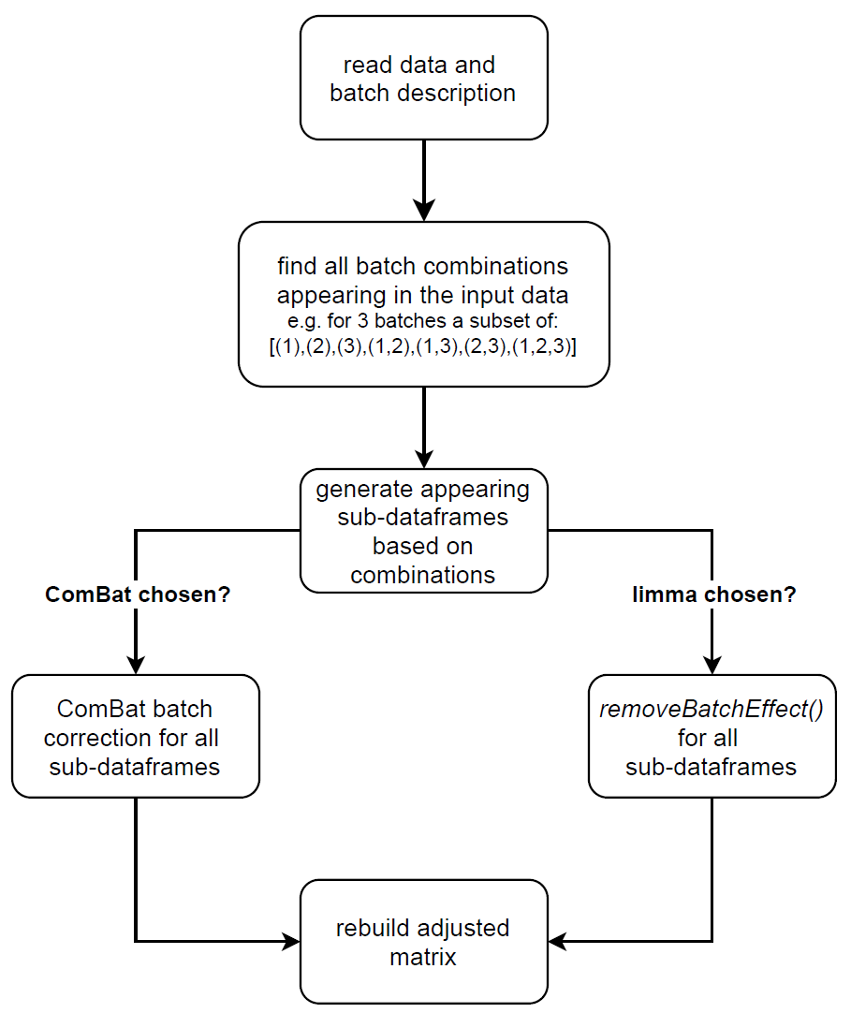

Figure 1: Overall workflow of the HarmonizR algorithm after calling the harmonizR() function.

The file with the raw data is expected to contain the samples in columns and the features in rows. The very first column should contain the feature IDs, whereas the first row should contain the sample IDs. Missing values should be indicated via a string such as *NaN* like in the example file. *NA*, *n. def.* or any other indication is also fine, however, zeroes (0) will not be treated as missing values.

An example (for a real example see ‘murine_medulloblastoma_data.tsv’):

Protein.ID Sample1 Sample2 Sample3 ...

Protein1 1130 2231 718 ...

Protein2 563 NaN 2112 ...

Protein3 921 7997 901

… … …

Secondly, each sample has to be assigned to a batch. For this, a ‘description’ .csv (comma separated values) file is required, which holds the sample ID in column 1, the overall number of the sample in column 2 and the batch number it is assigned to in column 3, very much like what the default ComBat or limma algorithms would require as input. It is important to have the samples ordered like they are within the .tsv file and have all samples from batch 1 listed before listing batch 2 and so on.

An example (for a real example see ‘murine_medulloblastoma_description.csv’):

ID,sample,batch

Sample1,1,1

Sample2,2,1

Sample3,3,2

…

The HarmonizR algorithm will write the resulting ‘harmonized’ matrix into a .tsv file directly. The resulting file (by default called ‘cured_data.tsv’) will be written to the directory the R file with the harmonizR function is executed in. The resulting .tsv file will closely mirror the input file, however, the batch effect within the data will be removed and the proteins will be reordered based on the missing values found during the computation.

**Example usage**

Load the HarmonizR package:

library(HarmonizR)

HarmonizR expects 2 mandatory and four optional arguments. The first argument is the *path* to the raw data, second argument the *path* to the description file. Both input files must be given via their file path and do not have to be read in separately by hand. The first optional argument is the algorithm of choice. ComBat will be used by default, but using the parameter ‘algorithm’, either “ComBat” or “limma” can be chosen for data adjustment. ComBat serves as the default. The second optional argument is the ComBat-mode. This parameter is only valid once ComBat is chosen for the adjustment.

The ComBat mode is abbreviated for simplicity by:

|  |  |
| --- | --- |
| ComBat Mode | Corresponding ComBat Arguments |
| 1 (default) | par.prior = TRUE, mean.only = FALSE |
| 2 | par.prior = TRUE, mean.only = TRUE |
| 3 | par.prior = FALSE, mean.only = FALSE |
| 4 | par.prior = FALSE, mean.only = TRUE |

Please refer to the ComBat documentation for further details.

The third optional parameter is ‘plot’. ‘plot’ can be set to either “samplemeans”, “featuremeans” or “CV” and will show a boxplot with a box for each batch depicting the chosen method. This will be either the mean for all samples, the mean for all features or the coefficient of variation. There will be a separate plot for the original, unaltered input dataset and for the ComBat/limma adjusted dataset. By default, this parameter is turned off. Since a log transformation is assumed, this will also be accounted for before plotting. The fourth and last optional parameter is ‘output_file’. Setting this parameter will grant the user the ability to choose the name of their output .tsv file. Also, a path can be set. A string is expected as input. This parameter will default to “cured_data”, yielding a file called ‘cured_data.tsv’.

Call the ‘harmonizR’ function under usage of the provided example files:

harmonizR(“murine_medulloblastoma_data.tsv”, “murine_medulloblastoma_description.csv”)

Al call containing all optional parameters might for example look like this:

harmonizR(“murine_medulloblastoma_data.tsv”, “murine_medulloblastoma_description.csv”, algorithm = “ComBat”, ComBat_mode = 1, plot = “samplemeans”, output_file = “result_file”)

Here we assume that the input files are in the same folder as the executed .r file. It is safest, however, to include the complete path. The resulting plot looks like this (Figure 2):

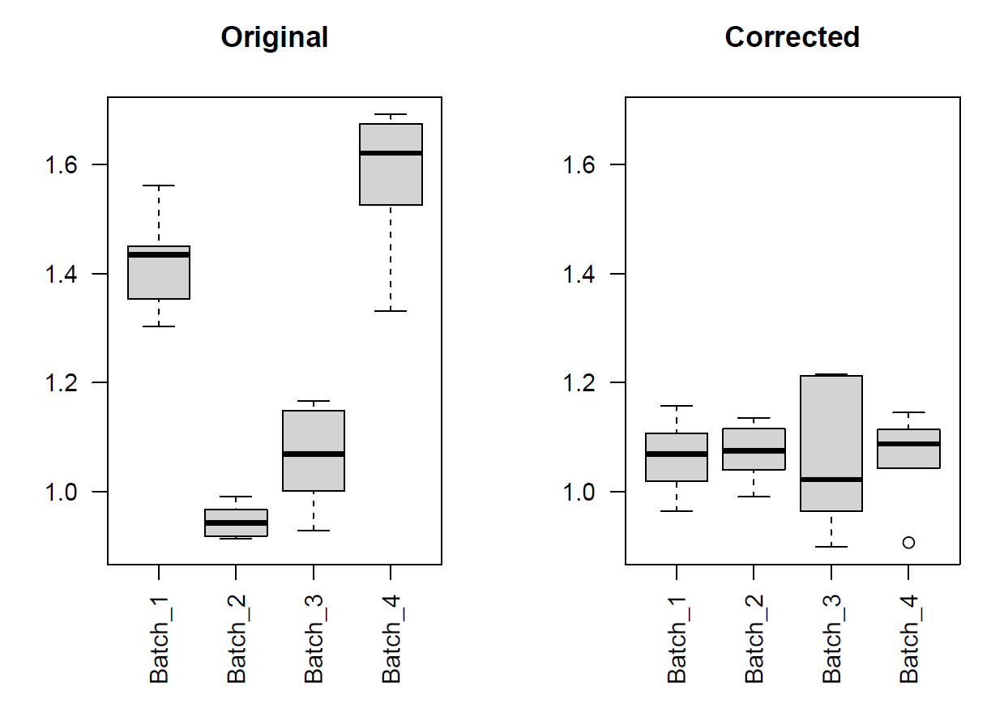

Figure 2: Example output plot when executing the harmonizR() function with the parameters shown above. The provided and referenced example dataset and description have been used to create the plot showing the CV difference for each batch for the original and the adjusted dataset.

While the HarmonizR algorithm will write the results directly to a .tsv file (in this example ‘result_file.tsv’ due to the set ‘output_file’ parameter above), it can also directly return the cured dataframe for further use in the user’s script.