**Perseus Plugin instructions**

**Dependencies**

First of all, make sure to have Perseus and the HarmonizR package installed. For Perseus see <https://maxquant.net/perseus/>, for HarmonizR see the HarmonizR SOP for an installation guide.

In order to use a R based plugin in Perseus, the libraries ‘argparser’ and ‘PerseusR’ have to be installed. This can achieved by using install.packages() to install both packages while in the R environment.

install.packages(“argparser”)

install.packages(“PerseusR”)

Alternatively the PluginPerseusHarmonizR.r file can be opened in RStudio, which will then offer to install the packages.

**Usage: Creating an example matrix**

For explanatory purpose, we can use a random matrix that can be created in Perseus directly. Create a random matrix by clicking the dice symbol in the top left:

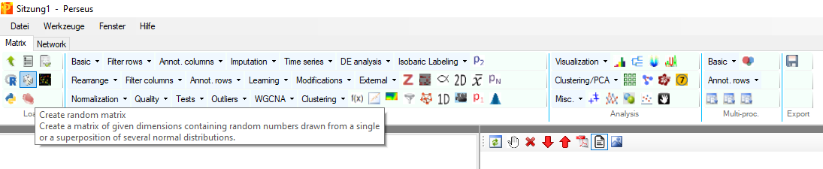

In this example we use the following parameters:

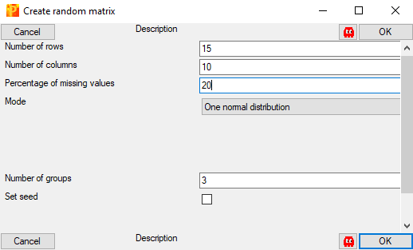

**Usage: Preparing Perseus**

Next, a plugin can be used by clicking ‘External’:

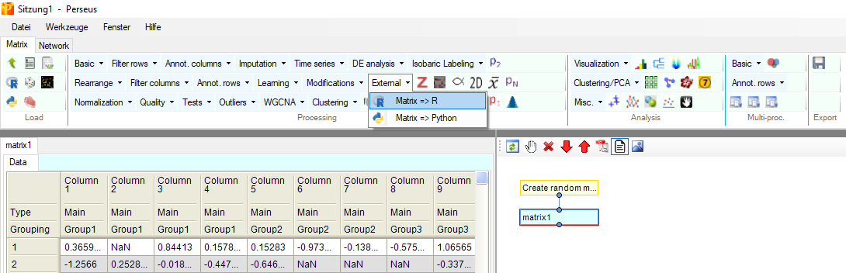

The following window will pop up:

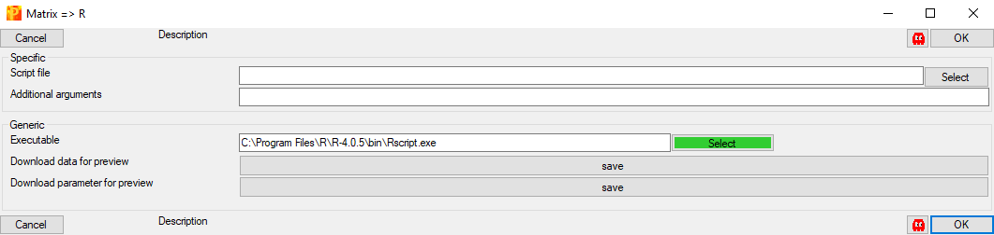

Make sure to have the path for your installed R set correctly. In the example shown, the plugin is used on Windows and therefore the path leads to ‘Rscript.exe’. It might be necessary to add the Rscript executable to the PATH environment variable of the operating system.

**Usage: Calling the Plugin**

In order to use the plugin, use the ‘Select’ button next to the ‘Script file’ line and select the PluginPerseusHarmonizR.r file. It does not matter where exactly it is located. Selected, it should look similar to this:

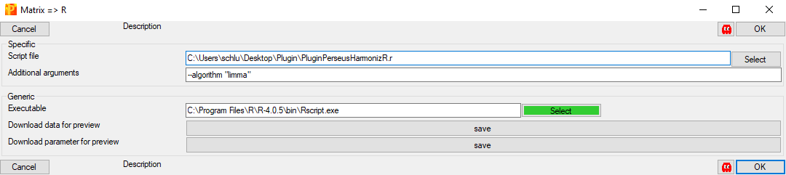

As an additional argument, the parameters *--algorithm* and *--ComBat_mode* are supported. *--algorithm* takes two possible arguments:

*--algorithm “ComBat”*

*--algorithm “limma”*

*--ComBat_mode* is only active if the ComBat algorithm is chosen for adjustment. The parameter takes four possible arguments:

*--ComBat_mode 1*

*--ComBat_mode 2*

*--ComBat_mode 3*

*--ComBat_mode 4*

For an explanation of the different ComBat modes, please read the HarmonizR SOP.

If that box is left empty, *--algorithm* defaults to the ComBat algorithm and *--ComBat_mode* defaults to 1. In the example above, the additional argument *--algorithm “limma”* has been provided.

Clicking the ‘OK’ button will execute the plugin and therefore the HarmonizR algorithm on the given matrix.