TUSTIN PT1 open step response  
T1 = 5 sec, kp = 1  
Simtime = 60 sec, ts = 1/60

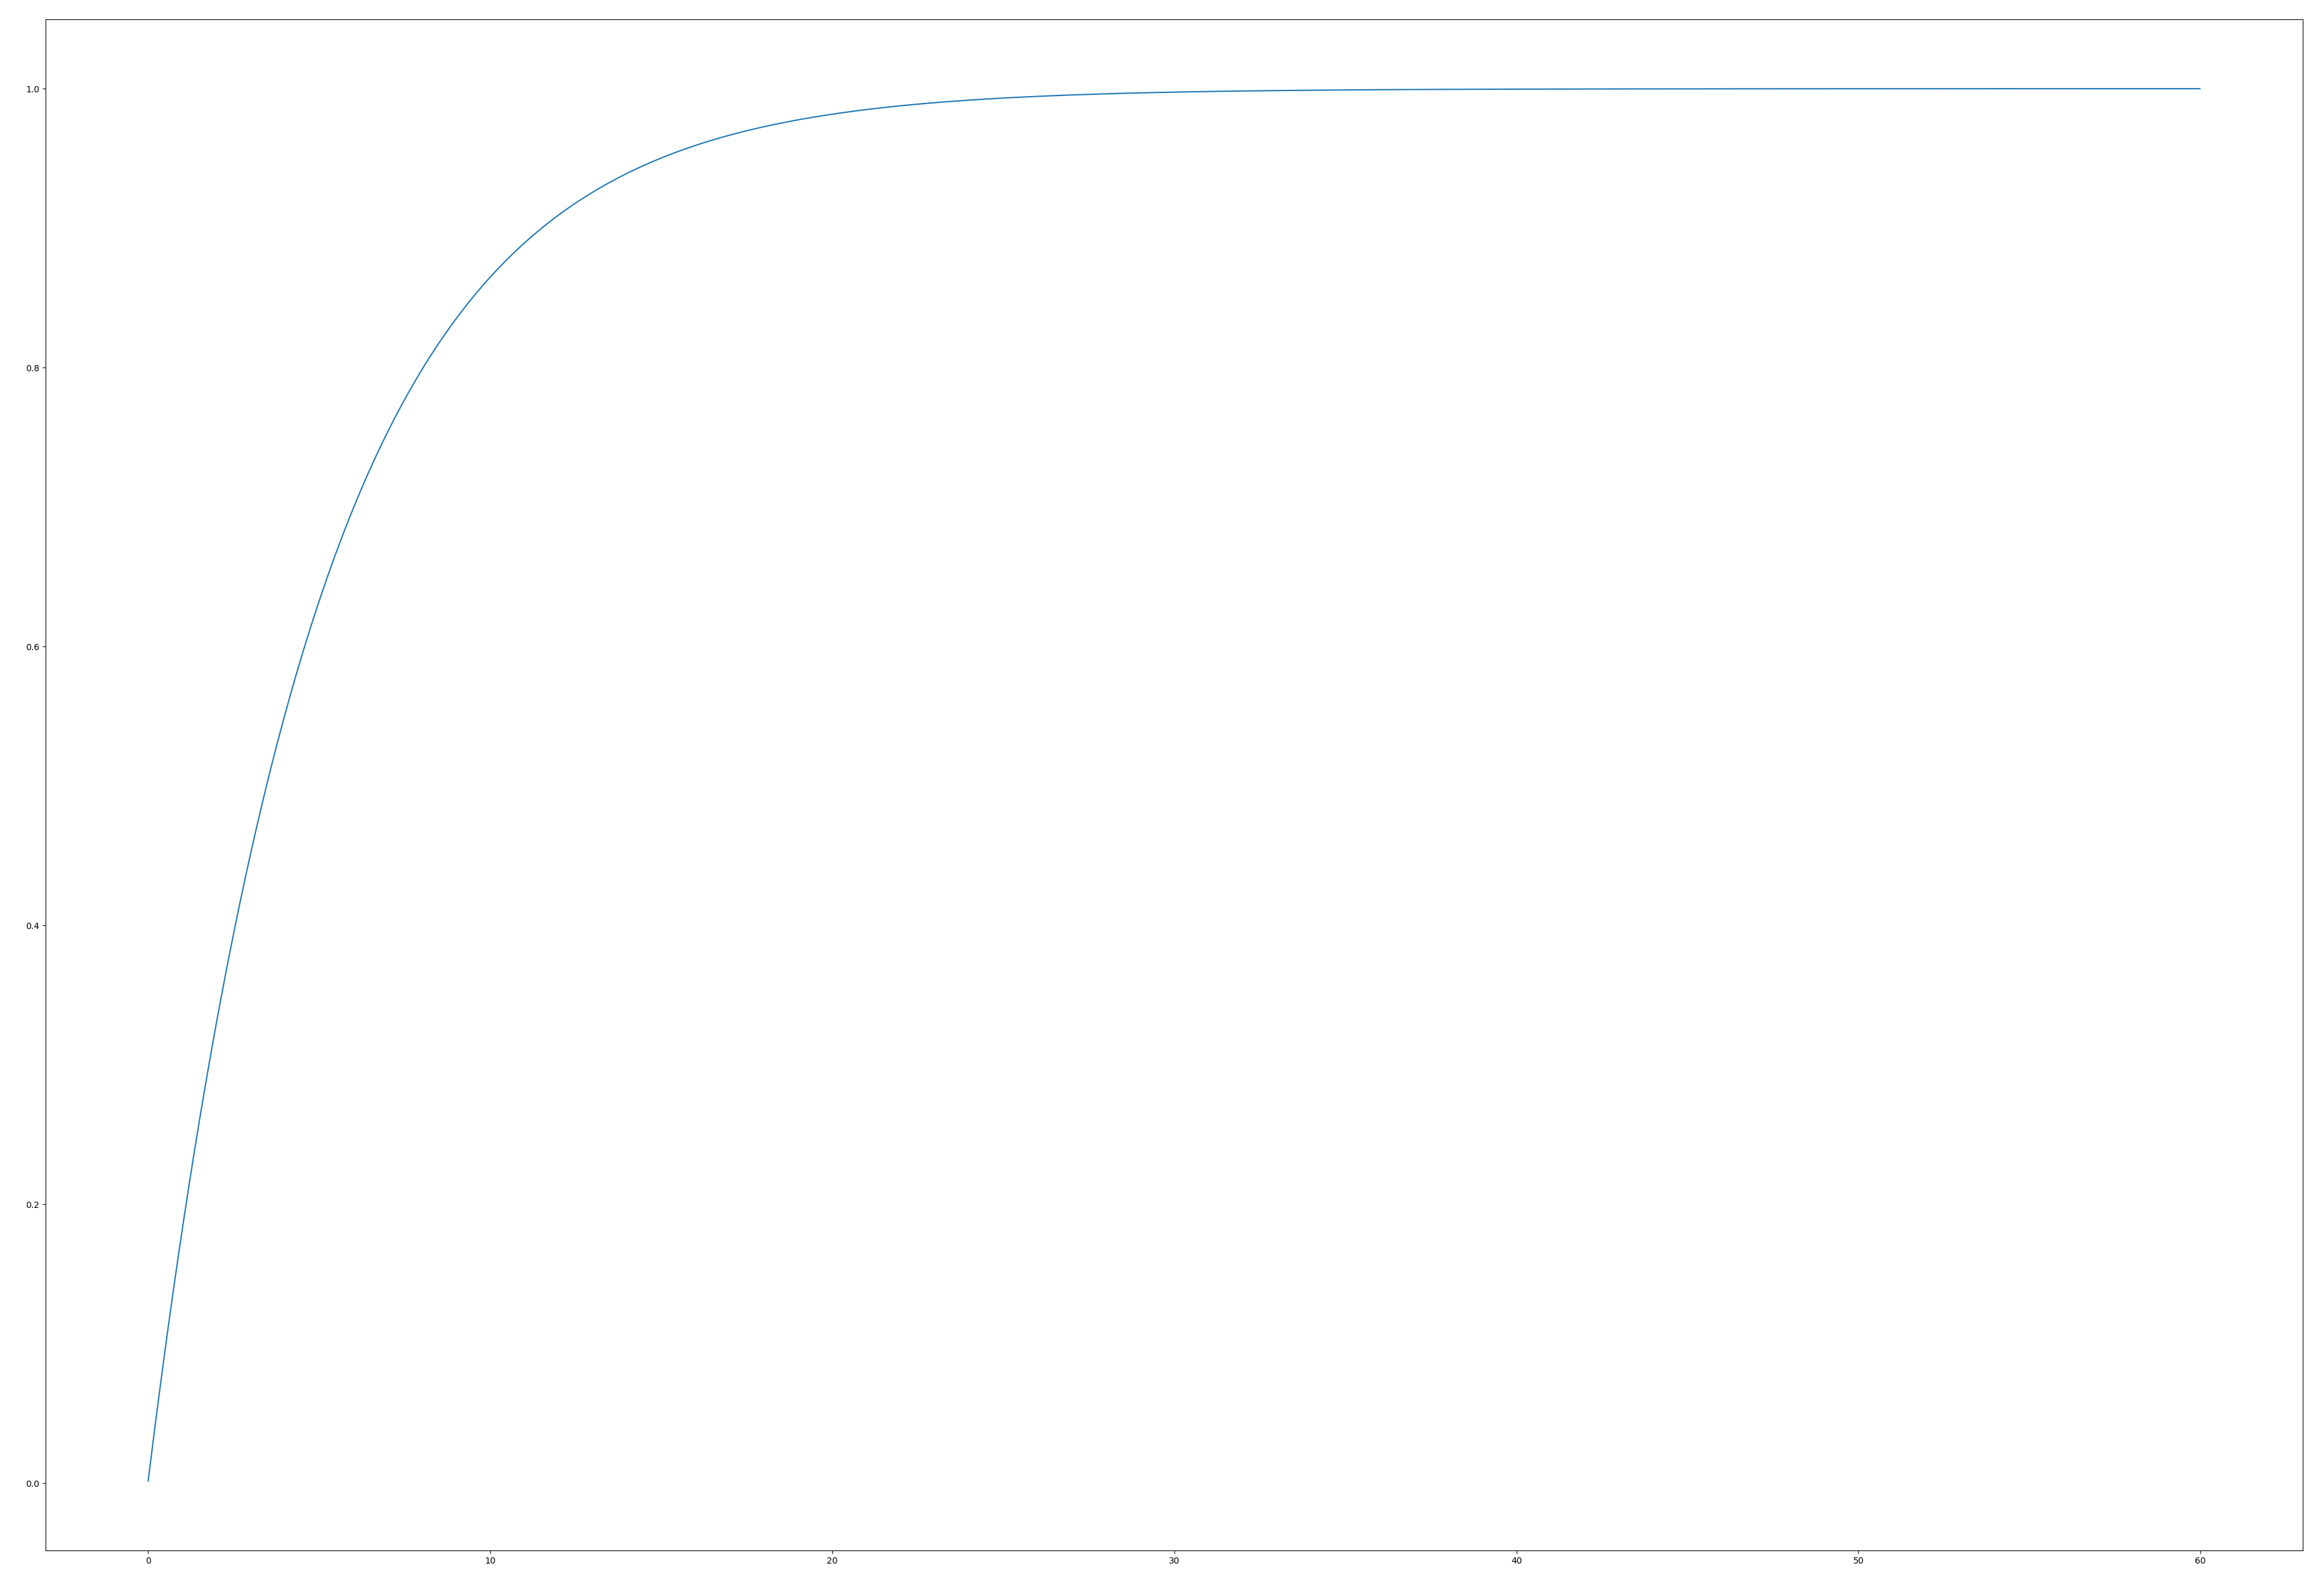

DT1 Open Loop Step Response  
T1 = 5 sec, kd = 1  
Simtime = 60 sec, ts = 1/60

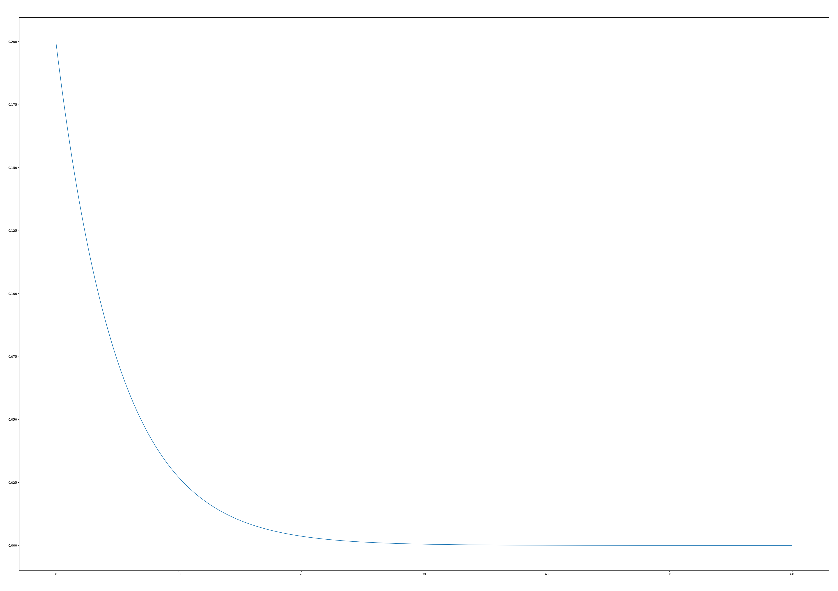

Tustin PID-T1 Closed Loop Step Response  
kp = ki = kd = 1  
t1 = 5 sec  
Simtime = 60 sec, ts = 1/60

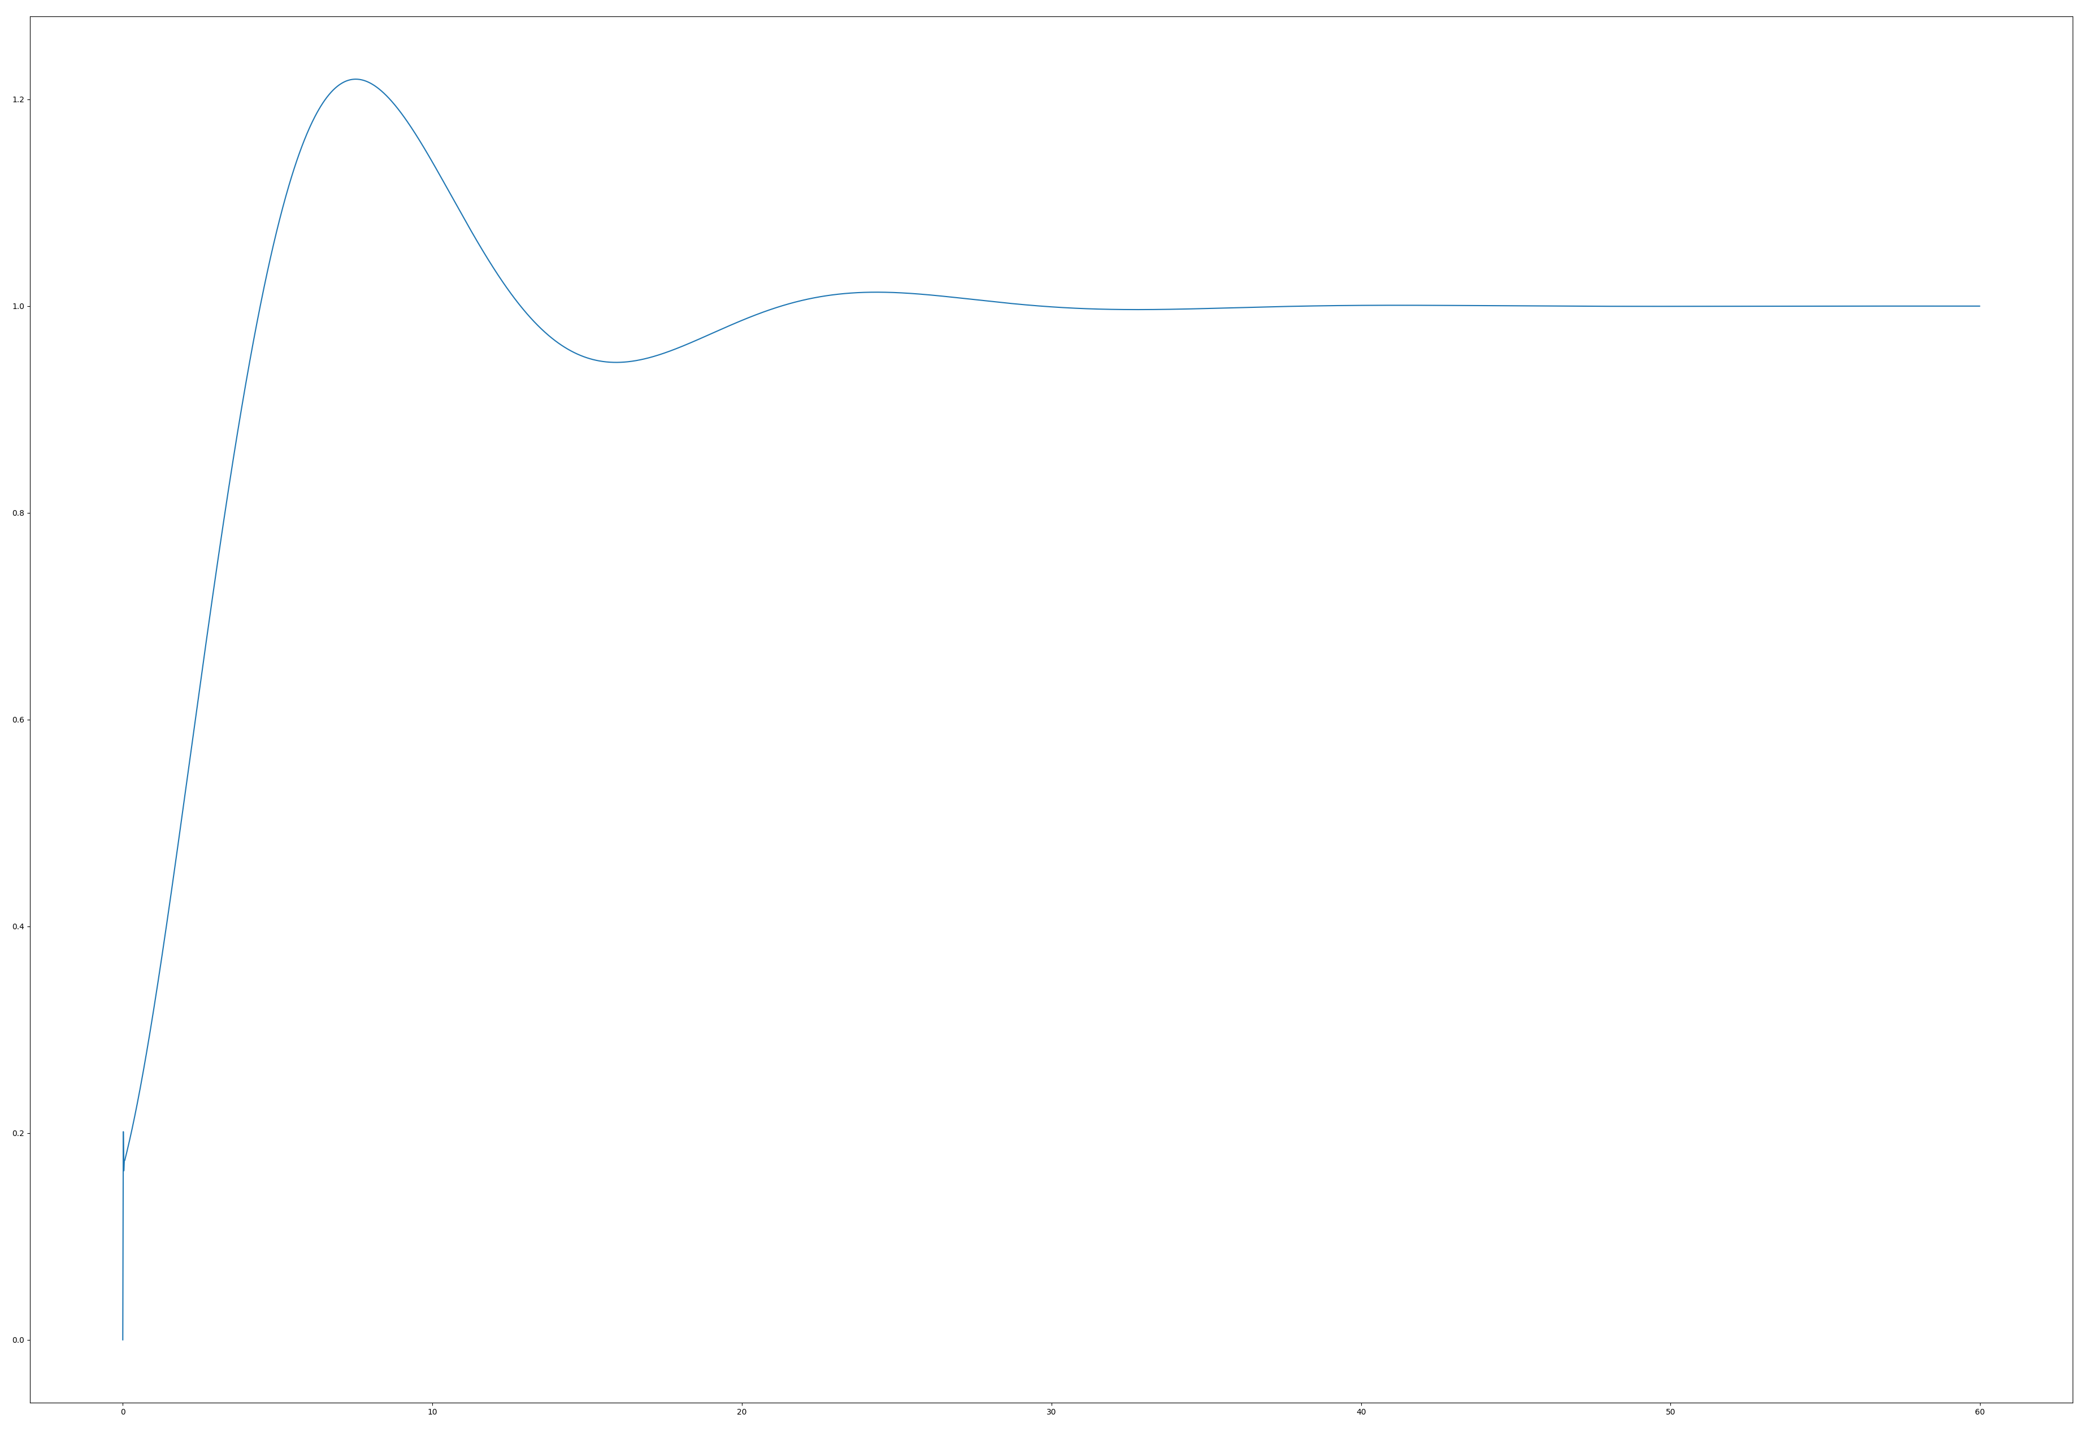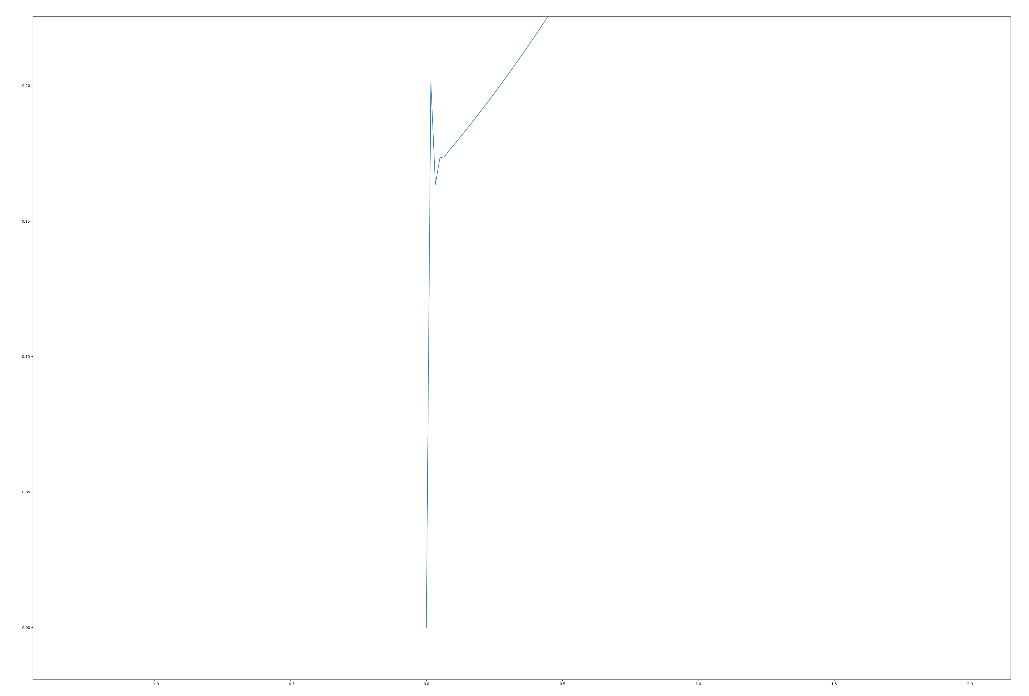

Strategy 4 Controller Open Loop Step Response  
HEBI X5-4 standard Gains, i_clamp & d_on_error not implemented  
https://docs.hebi.us/resources/gains/X5-4_STRATEGY4.xml

