This document explains the derivation of my alternate, and possibly novel, method of calculating the permutation-packed representative integer.
This is referred to in the Cuckoo Filters paper as a semi-sort space optimisation.

Please note: I’ve over-explained a lot of this to the point of probably being irritating. This is deliberate. I’d prefer to do that and waste a bit of the reader’s time than under-explain and leave anything unclear or ambiguous.

If you have any to combinations of 0 and 1 and allocate a number to
these combinations and store that number instead of the combination
directly:

(0, 0) -> 0
(0, 1) -> 1
(1, 0) -> 2
(1, 1) -> 3

This saves you nothing, however if you don't care about the order then:

(0, 0) -> 0
(0, 1) -> 1
(1, 0) -> 1 because (0,1) = (1,0)
(1, 1) -> 2
The following show a way of generalising this,using a very small amount of memory (though it does require sorting).

Terminology:

A bucket contains one value of 0..x, for convenience in computer terms, let’s say 3 bits = 8 values stored.

A row is a set of buckets. Cuckoo filters have 4 buckets per row but I’ll use as many/few as necessary here to illustrate.

Trivial example to start:

Very briefly indeed, I noticed that if you took increasing permutations, and sorted them, as a bit string where 1 means sorted and 0 means not, you get this:

permutation: write this bit:
(0, 0) (0 < 0, is already sorted so write 1)
(0, 1) (0 < 1, is already sorted so write 1)
(1, 0) (1 < 0 ? nope, unsorted so write 0)
(1, 1) (1 < 1, is already sorted so write 1)

you get the bitstring

1101

It’s easier to see if I write this with ‘+’ = 1 and ‘.’ = 0 so the above bitstring is:

++.+

To find the encoded value of a combination, simply count the number of bits preceding it (including itself), starting from zero.

Combo | (0, 0) | (0, 1) | (1, 0) | (1, 1)
bitstring | 1 | 1 | 0 | 1
Sum at or below | 1 = 1 | 1 + 1 = 2 | 1 + 1 + 0 = 2 (again) | 1 + 1 + 0 + 1= 3

So the permutation-packed value for (1, 0) is 2, for (1, 1) it’s 3.
(Note the ordering was built up counting from (0,0), (0,1), (1,0), (1,1) ie. rightmost ‘digit’ varies fastest, exactly as with decimal digits. That’s important).

A larger example of 2 buckets with 3 bits (values), as a bitstring is:

++++++++.+++++++..++++++...+++++....++++.....+++......++.......+

wrapping it produces a very regular structure:

++++++++
.+++++++
..++++++
...+++++
....++++
.....+++
......++
.......+

it turns out that this very regular pattern is basically bits in an n-dimensional cube in general. The dimensions of the cube are the number of buckets (here 2 buckets = 2 dimensions), and the width of the cube at each edge is the number of items each bucket can take (3 bits = 8 values).

The above 2-D cube is comprised of a stack of 1-D cubes.

Here’s a 3D cube (3 buckets by 8 values/bucket) comprised of a stack of 2-D cubes, each of those being a stack of 1-D cubes:

++++++++
.+++++++
..++++++
...+++++
....++++
.....+++
......++
.......+

........
.+++++++
..++++++
...+++++
....++++
.....+++
......++
.......+

........
........
..++++++
...+++++
....++++
.....+++
......++
.......+

........
........
........
...+++++
....++++
.....+++
......++
.......+

........
........
........
........
....++++
.....+++
......++
.......+

........
........
........
........
........
.....+++
......++
.......+

........
........
........
........
........
........
......++
.......+

........
........
........
........
........
........
........
.......+

and here’s a 4D cube (as an image not text, to preserve the formatting, 4 buckets by 8 values/bucket):
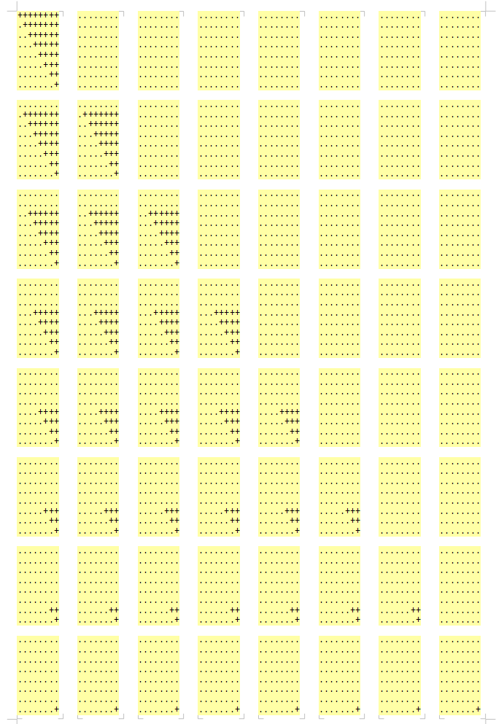

Obviously each higher dimension cube is simply the lower dimension cube repeated and “offset” one place more. The shape is a kind of cone and I’ll refer to it as such.

In each case, though, the perm-packed value of a combination is found by sorting the values you want to pack and counting the number of 1-bits (‘+’ signs here) that precede it, including itself, where the first ‘+’ is the zeroth.

So for a 3D cube, if we want to perm-pack the values (6, 2, 5), first we sort them to give (2, 5, 6) (that it looks like a notable binary number is just coincidence) which is the index into the cube: (counting from zero)

the 2nd 2-D cube (large & bold),
the 5th 1-D cube (green) and
the 6th 0-D cube (in red)

++++++++
.+++++++
..++++++
...+++++
....++++
.....+++
......++
.......+

........
.+++++++
..++++++
...+++++
....++++
.....+++
......++
.......+

........
........
..++++++
...+++++
....++++
.....+++
......++
.......+

........
........
........
...+++++
....++++
.....+++
......++
.......+

(etc., rest of cube removed)

Count the number of ‘+’ signs up to an including the red ‘+’, which = 80, counted from zero (which is correct).

So the triple (6, 2, 5) can be encoded as 80 instead of the full triple (of course decoding 80 back to the triple is another matter but that’s not discussed here. I don’t think there’s a compact & fast way of doing that).

Given the regularity of the cubes above it’s obvious that calculation of the values should be trivial. So for a 2-D cube

++++++++
.+++++++
..++++++
...+++++
....++++
.....+++
......++
.......+

the ‘volume‘ of the plus signs is the traditional

n(n+1) / 2

which generalises to higher dimensions, so for 3D it’s

n(n+1)(n+2) / 3!

and the obvious extension 4 and higher dimensions.

However, notice the offset that occurs; the 0th cube is fully populated, the next is offset by 1, the next is offset by 2, eg. for the 3 D cube, the first few ‘slices’ (2-D cubes) are:

++++++++
.+++++++
..++++++
...+++++
....++++
.....+++
......++
.......+

........
.+++++++
..++++++
...+++++
....++++
.....+++
......++
.......+

........
........
..++++++
...+++++
....++++
.....+++
......++
.......+

etc

That has to be accounted for.

Notation: a cone is the shape overall, the frustrum has the usual meaning – some part below the pointy bit of the cone – and the offset (if present) is a sub-frustrum which is empty.
So overall is the cone, and the green part is the frustrum and the red is the offset. This cube has been offset by 2:

........ | } offset | } frustrum | } cone
........ | } offset | } frustrum | } cone
..++++++ |  | } frustrum | } cone
...+++++ |  | } frustrum | } cone
....++++ |  | } frustrum | } cone
.....+++ |  |  | } cone
......++ |  |  | } cone
.......+ |  |  | } cone

Going back to the full cube, summarise that into a lookup table. I’ll do that for this 2-D example:

index | Bitstring | ‘+’ count
0 | ++++++++ | 8
1 | .+++++++ | 7
2 | ..++++++ | 6
3 | ...+++++ | 5
4 | ....++++ | 4
5 | .....+++ | 3
6 | ......++ | 2
7 | .......+ | 1

As we want a fast sum and quick offset subtraction, just use a running total instead:

index | Bitstring | ‘+’ count | Running total
0 | ++++++++ | 8 | 8
1 | .+++++++ | 7 | 15
2 | ..++++++ | 6 | 21
3 | ...+++++ | 5 | 26
4 | ....++++ | 4 | 30
5 | .....+++ | 3 | 33
6 | ......++ | 2 | 35
7 | .......+ | 1 | 36

It’s useful to have an index of -1 which is always zero, to simplify calculations with the offset:

index | Bitstring | ‘+’ count | Running total
-1 | (n/a) | 0 | 0
0 | ++++++++ | 8 | 8
1 | .+++++++ | 7 | 15
2 | ..++++++ | 6 | 21
3 | ...+++++ | 5 | 26
4 | ....++++ | 4 | 30
5 | .....+++ | 3 | 33
6 | ......++ | 2 | 35
7 | .......+ | 1 | 36

So the full volume of this cube is 36. If the cube has been offset by 3, we subtract the the offset (full value 36 – offset value 21 = 15) so the volume of the part of the cube that we want is 15:

What we’ve got | Whole cube | Running total | Volume we want
........ | ++++++++ | 8
........ | .+++++++ | 15
........ | ..++++++ | 21 | ...subtract this
...+++++ | ...+++++ | 26
....++++ | ....++++ | 30
.....+++ | .....+++ | 33
......++ | ......++ | 35
.......+ | .......+ | 36 | From this...

(talk about over explaining things but at least it’s clear!)

That’s pretty well the entire algorithm, except that you recursively descend through each sub-cube, subtracting the offset each time. At the end, add up everything.

Note: the index starting from -1 can be done for free in C/C++ by incrementing the pointer to the base of the array, something like

int * LUT = malloc(…)
LUT += sizeof(int)

Or similar. My C is beyond rusty.

Also I referred to “... recursively descend through...” which in practice, for a known row size, can be unrolled trivially.

Worked example.

Going back to the cube above, 3 buckets per row, each of 8 items per bucket, graphically this is:

++++++++
.+++++++
..++++++
...+++++
....++++
.....+++
......++
.......+

........
.+++++++
..++++++
...+++++
....++++
.....+++
......++
.......+

........
........
..++++++
...+++++
....++++
.....+++
......++
.......+

........
........
........
...+++++
....++++
.....+++
......++
.......+

(etc., rest of cube removed)

And we want to perm-pack (6, 2, 5), as before.

The running total lookup tables for this are (done with some Python code):

for 0-D cube: [0, 1, 2, 3, 4, 5, 6, 7, 8]
for 1-D cube: [0, 8, 15, 21, 26, 30, 33, 35, 36]
for 2-D cube: [0, 36, 64, 85, 100, 110, 116, 119, 120]

Reminder; these arrays are indexed from -1

The 0-D cube is always trivial and can be replaced by a subtraction because in indexing it,
cube0[x] -cube0[] = x - y
always. It’s shown just for completeness.

Sort (6, 2, 5) = (2, 5, 6)

Subtract 1 from all but the last = (1, 4, 6)

Add offsets. “x offset y” is denoted “x:y”.
I’m going to fudge this slightly for now, but the largest cube (which we look at first) never has and offset, so we use -1. That’s the index we added above that always contains zero.

Subsequent offsets are just the higher cube index shifted over one place, except for the last, so in general
the offsets for (p, q, r, s) will be (-1, p-1, q-1, r).
So the indexes with offsets for this would be ( p-1:-1, q-1:p-1, r-1:q-1, s:r)

So (1, 4, 6) with offsets = (1:-1, 4:1, 6:5)

If that doesn’t make sense I’ll drill into it later! Determining the offsets is a little messy but very simple to explain when diagrammed. xxx todo

So now with (1:-1, 4:1, 6:5)

Look up into the 2-D cube [0, 36, 64, 85, 100, 110, 116, 119, 120] with 1:-1
sum (red) – offset (green)
= 64 – 0 = 64

Look up into the 1-D cube [0, 8, 15, 21, 26, 30, 33, 35, 36] with 4:1
= sum (red) – offset (green)
= 30 – 15 = 15

Look up into the 0-D cube [0, 1, 2, 3, 4, 5, 6, 7, 8] with 6:5
= sum (red) – offset (green)
= 7 – 6 = 1
(again, we never need actually use the 0-D LUT, just replace it with a subtraction).

add them up 64 + 15 + 1 = 80. Same as before.

I’ve done some python that exhaustively tests this algo for a pretty decent combination of rows of buckets and bucket sizes, it runs for an hour and finds no failures.

I’ve never seen anything like this before but it’s so straightforward surely it’s well known?

Cuckoo filters use 4 buckets with 4 bits each = 16 bits = a LUT of 65,536 entries, each of 2 bytes for a total of 128K. They store every combination. If they sorted the combinations into the LUT they could get by with about 3,876 combinations but they don’t (don’t know why not). With the above it becomes almost negligible in space for a trivial calculation.
The cube LUT for 4 buckets of 16 values is 85 bytes (discarding the unnecessary 0-D cube). This almost fits into a cache line. An L1 indexed cache read is 5 cycles. For 4 by 16, this needs 5 such reads = 25 cycles, plus a few subtractions.
Sorting is required but sorting 4 values can be done with 4 full scans of the row with a cmov to make it branch free.

