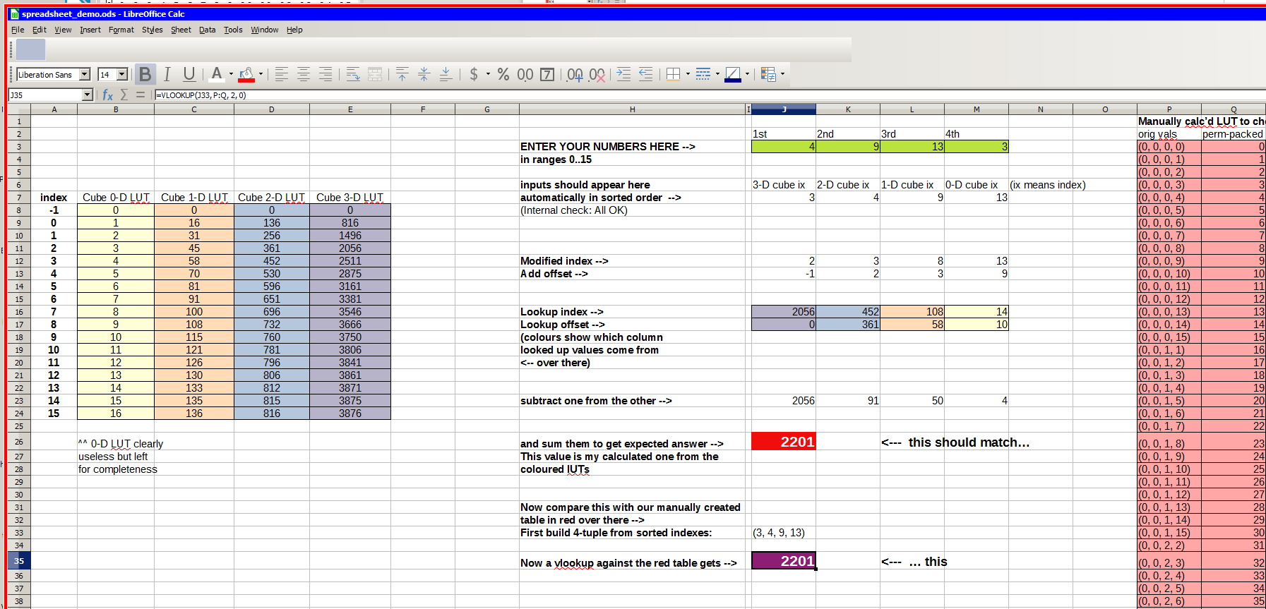

See attached spreadsheet. There’s not much checking so only modify the 4 lime-green cells in a row at the top, indicated on the spreadsheet.

Enter your data into the green areas only; 4 items in range 0..15. This corresponds to the Cuckoo filter’s 4 buckets of 4 bits each. Any order will do as the sheet sorts it for you.

Data is automatically sorted, then an index and offset are calculated – details to follow in a separate document. Don’t worry for now.

These index/offsets are then looked up in the pastel-rainbow LUT on the left, subtracted from each other, then summed. The result is shown in bright red (next to message “<-- this should match...”). This is the answer.

To verify that, a python-generated LUT of sorted 4-tuples matched to the perm-packed integer representative, is shown on the right (pinkish colour). There are 3,768 entries.
The values you entered are turned back into a string which is then looked up in this, and is displayed in dark purple, next to the message “<-- this...”

The bright red should match the dark purple.

Note my pastel LUT is tiny, and one of the columns is redundant anyway (“Cube 0-D LUT”).
“Cube 1-D LUT” is 17 entries that will fit integers.
“Cube 2-D LUT” and “Cube 3-D LUT” are 17 entries needing 2 bytes.
So total 2 * 17 + 2 * 17 + 1 * 17 = 5 * 17 = 85 bytes.

