

T-Pot: A Multi-Honeypot Platform

  - Simon Timi - B00163297

School of Informatics and Cybersecurity, Faculty of Computing, Digital & Data,
Technological University Dublin
Submitted to Technological University Dublin in partial fulfilment of the
requirements for the degree of
Bachelor of Science in Computing in Digital Forensics & Cyber Security

Lecturer: Mark Lane
Submission Date: 1st November 2026

Declaration of Academic Integrity
I, declare that this report is my own work. All external works, sources and have been referenced to the best of my ability. Generative AI (Claude, by Anthropic) was used to assist with writing the analysis python scripts, formatting the document, and revising the graphs. I reviewed the outputs and take responsibility for the analysis, findings and conclusions presented.

1. Introduction and Objectives
In a test carried out by NSIDE ATTACK LOGIC, a freshly started web server received its first automated requests 33 seconds after going live, and bots began probing for vulnerabilities about 12 seconds later. In less than the amount of time that it would take for anyone to even realize the server existed, it was already under attack.
That is the environment this report studies: a digital landscape where new addresses meet automated scanners almost as soon as they appear. Over 20 days, a T-Pot honeynet on Google Cloud and Azure recorded what those scanners, and the attackers behind them, did next (NSIDE ATTACK LOGIC, n.d.).
Using T-Pot on 3 debian-13 virtual machines, one Hive was deployed on the Google Cloud Platform, and two Sensors were deployed - one on the Google Cloud Platform and one via Microsoft Azure. These virtual machines collected attack data for 20 days before their logs were extracted to a Windows 11 system for analysis.
This report answers three questions:
- Are the same attackers reaching both cloud providers, and in what order and timing?
- What do attackers do once they get a session, and which MITRE ATT&CK techniques does that map to?
- What credentials do they try, and do these match a known botnet's dictionary?
Sections 2 and 3 describe the deployment and the data, Sections 4 to 6 report the three findings, and Sections 7 to 9 discuss the value of honeynets, the limitations and the conclusions.

2. Deployment and Methodology
The honeynet used three T-Pot 24.04 instances: a hive on Google Cloud (europe-west1-b, Belgium), a sensor on Google Cloud (asia-southeast1-a, Singapore) and a sensor on Azure (South India). The Google VMs were e2-standard-4 (4 vCPUs, 16 GB memory, 80 GB disk) and the Azure sensor was a Standard B2as v2 (64 GB disk). A firewall rule opened all inbound ports so that every honeypot was reachable, including SSH (22), Telnet (23) and HTTP (80); management used ports 64295 (SSH), 64297 (web interface) and 64294 (sensor-to-hive forwarding). The sensors labelled their events and forwarded them to the hive for viewing in the T-Pot Attack Map and Kibana.
All three analyses used the Cowrie honeypot logs (Oosterhof, n.d.): the cowrie.json files from each sensor were merged into one event table labelled by sensor and analysed in Python (pandas, scikit-learn, matplotlib), using login, session, command and file-download events.
Self-generated test traffic was identified by timestamp and source IP and excluded, and a script restricted cross-sensor comparisons to the time period when all sensors were active and collecting data, which also kept the hive's sync traffic out of the dataset.

3. Data Overview
The honeynet recorded 1,243,493 Cowrie events from 11,679 unique source IPs between 1 and 30 October 2026, and every sensor exceeded the two-week minimum (20.7 to 29.4 days).
Table 1: Collection window and Cowrie volume per sensor (UTC).
Sensor | Provider and region | First event | Last event | Days | Events | Unique IPs
google_hive | Google Cloud, europe-west1 (Belgium) | 1 Oct 04:16 | 30 Oct 13:19 | 29.4 | 499,129 | 6,037
google_sensor | Google Cloud, Singapore | 5 Oct 15:52 | 30 Oct 22:39 | 25.3 | 420,913 | 5,517
azure_sensor | Azure, South India | 7 Oct 19:42 | 28 Oct 11:51 | 20.7 | 323,451 | 2,736
All sensors (unique IPs combined) |  | 1 Oct | 30 Oct | 29.8 | 1,243,493 | 11,679
Cross-sensor analysis uses the common window of 7 October 19:42 to 28 October 11:51 (20.7 days), which holds 1,072,199 events from 10,678 IPs. The Azure sensor began on 7 October after being reinstalled, and the window ends on 28 October because the Singapore sensor logged almost nothing that day and nothing on 29 October (the hive also logged nothing on 29 October). Daily volume was uneven: the hive peaked at 54,888 events on 11 October and fell to 479 on 13 October.

4. Finding 1: Cross-Sensor Attacker Correlation
Of the 10,678 source IPs that reached the honeynet during the 20-day common window, 868 reached both Azure and at least one Google sensor, and 284 reached all three (Shown in Table 2 below). This equates to 32% of the 2,736 IPs seen at Azure, so a substantial share of Azure's visitors were also scanning Google's address space in a different region.
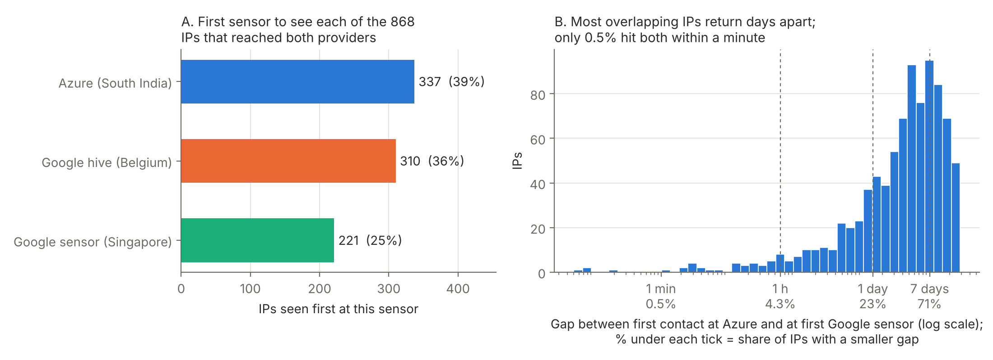
Figure 1: (a) First sensor to see each of the 868 IPs that reached both providers. (b) Gap between first contact at Azure and at the first Google sensor, on a log scale.
Table 2: Cross-sensor overlap for the 868 source IPs seen at Azure and at least one Google sensor (first-contact times, UTC).
Measure | Result
IPs seen at Azure and the Google hive only | 287
IPs seen at Azure and the Singapore sensor only | 297
IPs seen at all three sensors | 284
First sensor to see the IP: Azure / hive / Singapore | 337 (38.8%) / 310 (35.7%) / 221 (25.5%)
Median gap, Azure against first Google sensor | 3.6 days (5,225 min)
Gap under 1 min / 1 h / 1 day / 7 days | 0.5% / 4.3% / 23.2% / 71.1%
Hive against Singapore (284 IPs seen at both): Singapore first | 125 (44%), median gap 2.4 days
The gaps between first contact and subsequent hits are long, rather than tight bunches (Figure 1b). The median gap between first contact at Azure and at the first Google sensor was 3.6 days; 23% of IPs reached both within a day and 71% within a week. Most overlapping IPs therefore look like independent scanners returning at intervals, not one campaign sweeping the providers in sequence. Only four IPs (0.5%) reached both within 12 seconds (Table 3), including two neighbouring 45.148.10.x addresses with almost the same 4.5 s lag, which signals the regular pattern of a scanner working through targets in order.
Table 3: The four IPs that reached Azure and a Google sensor within 12 seconds of each other (UTC).
Source IP | First sensor | Then Azure | Gap
65.49.20.69 | Hive, 9 Oct 11:40:40 | 11:40:44 | 4.0 s
45.148.10.121 | Singapore, 24 Oct 19:09:10 | 19:09:14 | 4.5 s
45.148.10.141 | Singapore, 16 Oct 16:06:10 | 16:06:14 | 4.6 s
65.49.1.212 | Singapore, 16 Oct 04:26:28 | 04:26:39 | 11.3 s
No sensor was consistently first - as Azure saw 39% of these IPs first, the hive 36% and the Singapore sensor 25% (Figure 1a), so neither cloud nor region received attackers systematically earlier. Of the 284 IPs that reached both Google sensors, Singapore was first 44% of the time and the median gap was 2.4 days.
These overlaps do not prove coordination, since large internet-wide scanners sweep every public address and would give the same picture. Stronger evidence comes from shared behaviour: 286 of the 1,423 IPs that ran the SSH-key persistence script in Section 5 appeared on both providers.

5. Finding 2: Session Behaviour and MITRE ATT&CK Mapping
Most sessions never got past authentication. Of 335,625 sessions in the common window, 85.5% were brute force only and 10.8% were connection-only scans; just 2.4% (7,918 sessions) ran any command and 1.1% attempted persistence (Figure 2). Azure was the quietest sensor, with 91.3% of its sessions brute force only against 81.2% at the hive and 84.7% in Singapore.
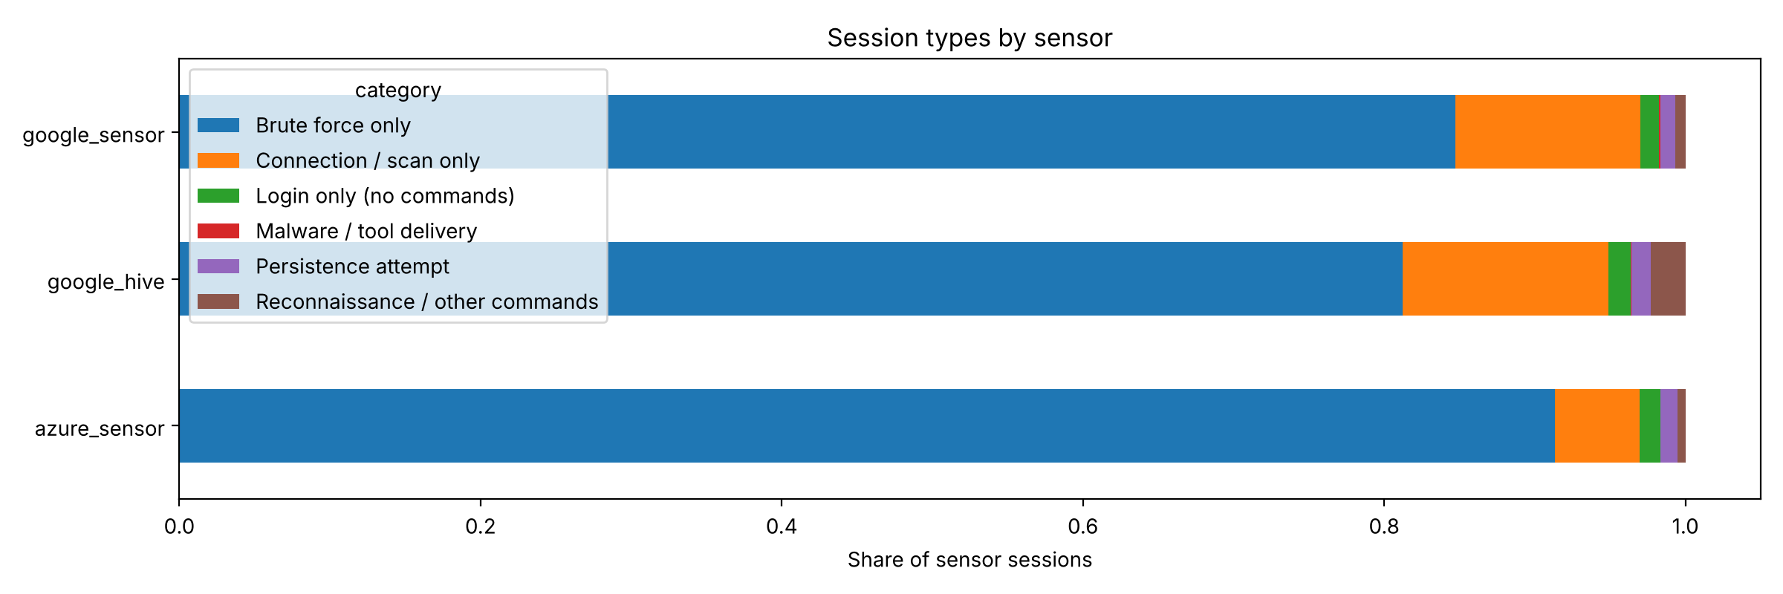
Figure 2: Session types as a share of each sensor's sessions.
The hive's higher command rate (3.6%, against 1.7% elsewhere) came mostly from 160.119.66.206, which produced 2,077 of its 2,629 reconnaissance sessions running "ls /home; /bin/busybox BOTNET", a BusyBox check typical of Mirai-derived bots.
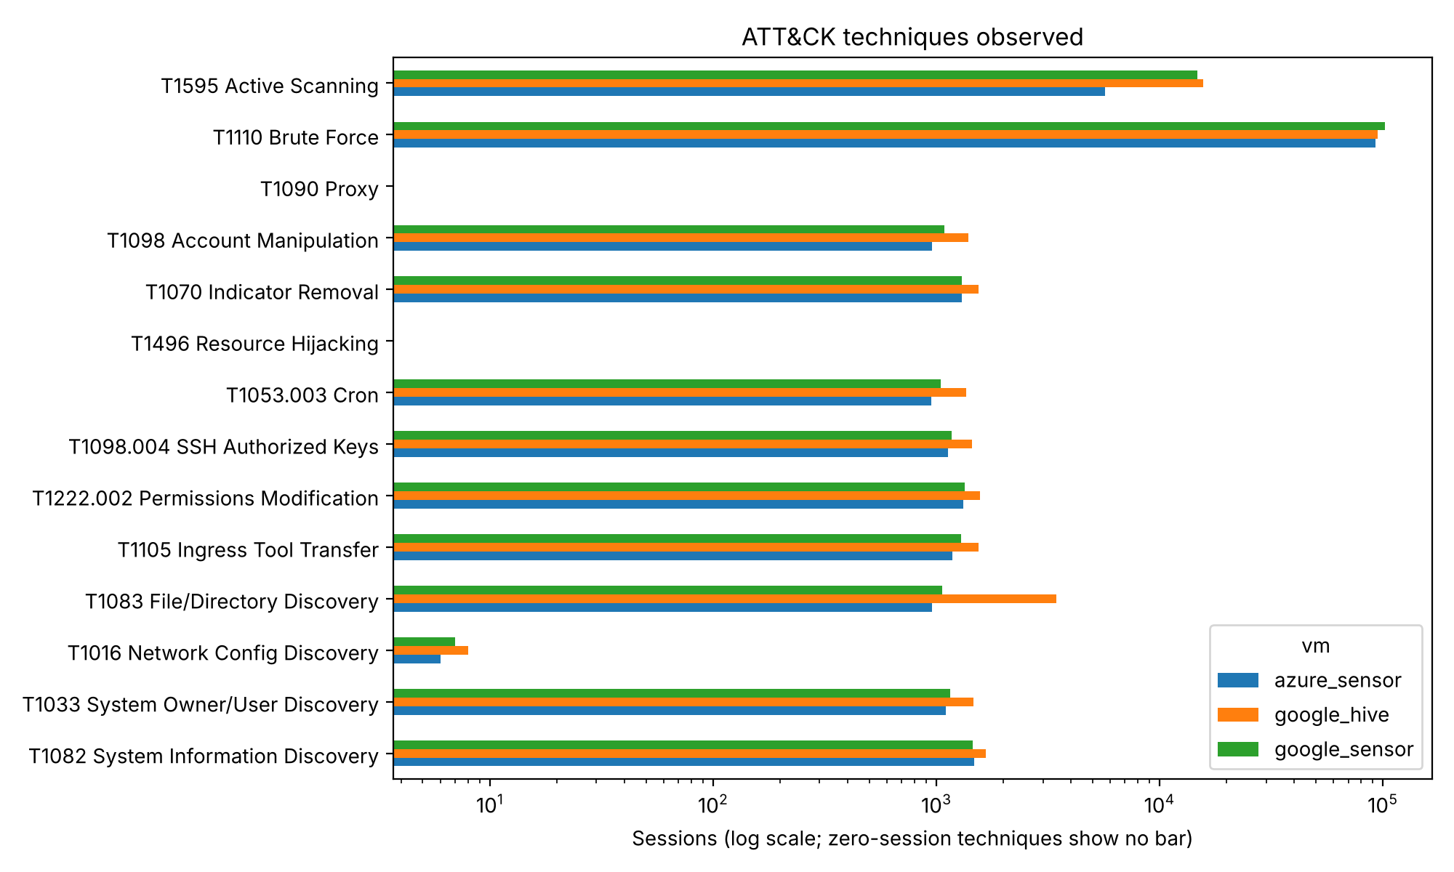
Figure 3: ATT&CK techniques observed, in sessions per sensor (log scale).
Brute force (T1110, 289,535 sessions) and active scanning (T1595, 36,085) dominate. Next came file and directory discovery (T1083, 5,481), system information discovery (T1082, 4,593), permissions modification (T1222.002, 4,226) and SSH authorized-keys injection (T1098.004, 3,748) (MITRE, n.d.). No session matched cryptominer commands (T1496) or proxying (T1090).
One script dominated. In 3,724 sessions (47% of command-running sessions) from 1,423 IPs, attackers removed the immutable attribute on the .ssh folder, appended an RSA public key commented "mdrfckr" to authorized_keys, profiled the host (uname -a, /proc/cpuinfo, free -m, crontab -l) and reset the root password. Sessions lasted a median of 22 seconds. This matches the mdrfckr campaign, which public reporting links to the Outlaw group (Aviatrix Threat Research Center, 2026); 286 of these IPs reached both providers, giving the Section 4 overlap a behavioural link.
Malware delivery by URL was rare: only 32 sessions from 8 IPs downloaded files from a URL (93 events, 18 hashes), all at the Google sensors (Table 4). The other 5,968 file-download events had no URL, and two hashes made up 96.6% of them. VirusTotal identifies the most common (3,724 events, equal to the mdrfckr session count) as a 389-byte authorized_keys file holding an OpenSSH RSA public key, flagged by 33 of 61 vendors (Figure 4), and the second (2,042 events) as the SHA-256 of a single newline. Of the 29 unique hashes, 19 were flagged malicious (by 26 to 43 vendors) and 15 carried Mirai-family labels, including every ELF binary and the cat.sh and kla.sh droppers. Seven had no detections, among them 274- and 162-byte HTML pages returned in place of binaries, which suggests those downloads failed, and three were not in VirusTotal at all. Most binaries were first submitted during the collection period, so the samples were fresh.
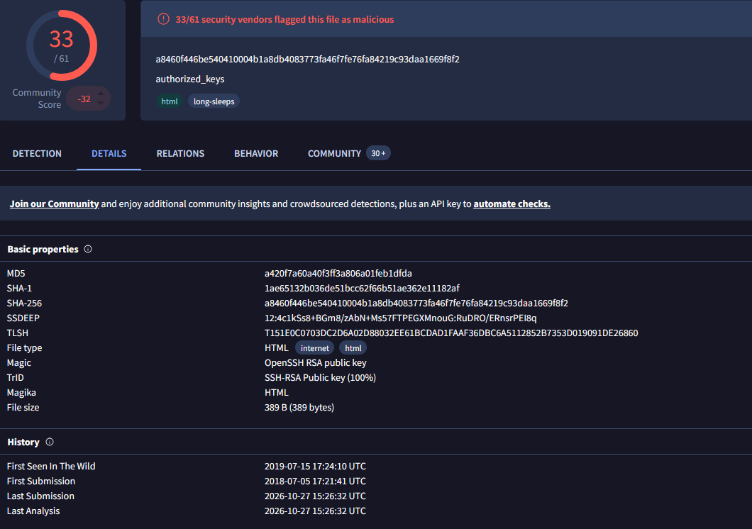
Figure 4: VirusTotal report for the most common downloaded file (SHA-256 a8460f44...), flagged malicious by 33 of 61 vendors.
Table 4: Malware delivery sources in Cowrie file downloads (29 unique SHA-256 hashes from 16 source IPs). Full hashes are in hashes_for_virustotal.csv.
Source IP | Sensor | Payload host | Files | Hashes | VirusTotal result
91.92.43.221 | Hive | 91.92.43.221 | cat.sh; iranbot-ultimate (x86_64, aarch64, mips, mipsel) | 5 | 4 of 5 flagged (26 to 34 vendors), all Mirai family; x86_64 download was a 274 B HTML page (0)
220.158.233.62 | Hive | 208.87.241.147 | bins.sh; onyx (x86, mips, x86_64, i686) | 5 | 4 of 5 flagged (27 to 38): three Mirai (onyx) binaries and a Medusa downloader script; i686 download was a 162 B HTML page (0)
152.42.223.6 | Hive, via Singapore | 152.42.195.115:80 | main_arm7 (Hive); main_mpsl, main_mips, main_arm6, main_arm7 (Singapore) | 5 | 5 of 5 flagged (40 to 43), Mirai/Gafgyt
160.119.66.206 | Hive | 160.119.66.206 | bins/kla.sh | 1 | 32/60; Mirai downloader script
62.210.173.100 | Hive | 31.56.209.86 | x86_64 | 1 | 35/64; Mirai/Gafgyt, ELF x86-64
180.93.193.100 | Hive | 180.93.193.100 | mips | 1 | 34/50; Mirai/Gafgyt, ELF MIPS
10 first-seen IPs | Azure (4 IPs, 5 hashes), Hive (4), Singapore (2) | no URL recorded | n/a | 11 | 3 flagged (33 to 40/61): the SSH key and two IRC-bot scripts; 5 with 0 detections; 3 not in VirusTotal
As a check on the rule-based labels, k-means clustering (k = 6, chosen by silhouette score) recovered the same structure: 99.3% of persistence sessions (3,725 of 3,752) fell into one cluster, and 285,605 brute-force-only sessions formed another.

6. Finding 3: Credential Intelligence and Botnet Attribution
Credential guessing was concentrated in a short list of passwords and a few sources. The 314,658 login attempts in the common window (98,166 at Azure, 216,492 at Google) used 10,926 distinct passwords at Azure and 30,978 at Google. The top 10 passwords made up 13.5% of Azure and 11.8% of Google attempts, the top 100 made up 27.5% and 25.1%, and the top 1,000 made up 71.3% and 61.3% (Figure 5). Sources were more concentrated still: 113 IPs made 1,000 or more attempts, and the busiest 100 IPs account for 66.6% of all attempts.
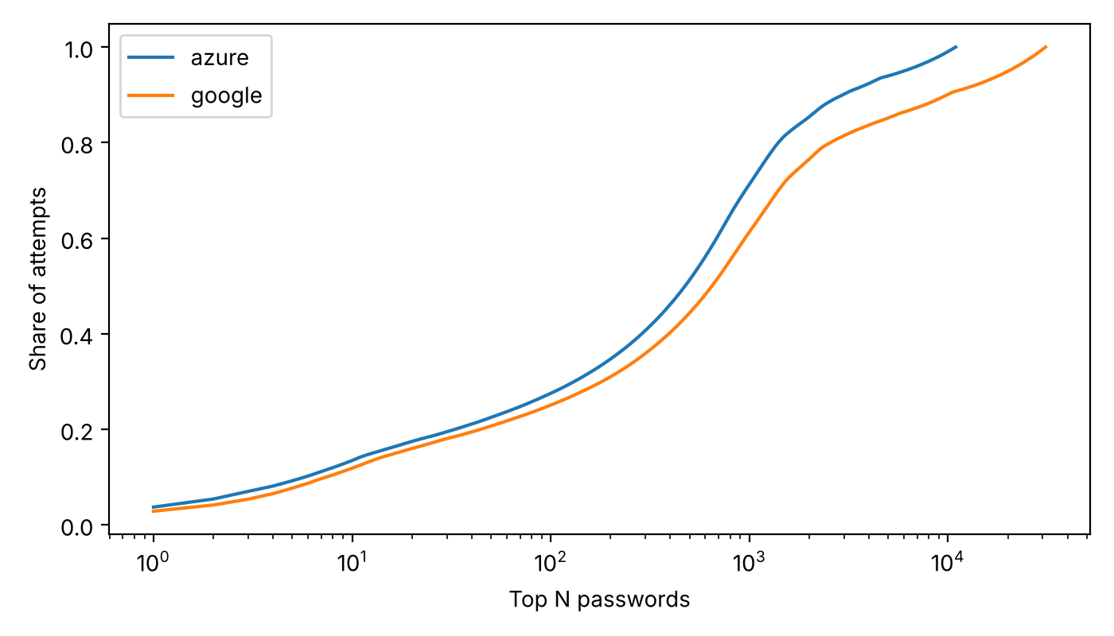
Figure 5: Cumulative share of attempts covered by the top N passwords.
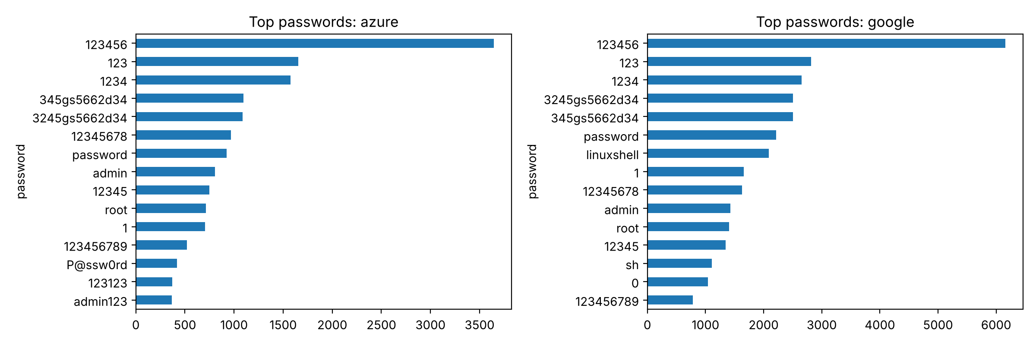
Figure 6: Most-tried passwords at each provider; 123456 led at both (3.7% of Azure and 2.8% of Google attempts).
Two signatures point to shared tooling. First, 345gs5662d34 (as username and password) and its variant 3245gs5662d34 appeared on all three sensors: 3,597 attempts from 1,368 IPs, 275 of which reached both providers. A credential shared by over a thousand IPs suggests a distributed botnet or common toolkit, though no published attribution was found. Second, the Telnet-style pairs enable:linuxshell (2,084 attempts) and system:sh (1,096) came from one IP, 160.119.66.206, which also served the bins/kla.sh payload (Table 4) and ran the BusyBox check in Section 5, consistent with a Mirai-derived IoT bot. By contrast, only 1.9% of attempts matched the subset of Mirai's published default credentials tested (Antonakakis et al, 2017), so Mirai's own dictionary was a minor part of the traffic.
Attacker style differed by provider. Counting distinct username-password pairs per IP, 16.7% of the 1,099 Azure IPs that attempted logins tried a single pair and 62.4% tried more than five, against 25.2% and 41.6% of the 3,904 Google IPs; the median IP made 8 attempts at Azure and 4 at Google. Azure therefore saw fewer IPs that worked through larger lists, while Google saw more one-guess visitors with activity that resembled botnet nodes.
The providers shared much of their credential lists: 151 passwords appear in both top-200 lists (Jaccard index 0.61), suggesting common dictionaries, while linuxshell, sh and 0 appeared only at Google, traced to single sources. Root made up 26.8% of Azure and 28.9% of Google attempts, followed by admin and ubuntu, and 17.9% and 17.7% of passwords were digits only.

7. Discussion: Value of Honeynets
As a security tool, the honeynet produced indicators a defender could use directly. The 100 busiest IPs made 66.6% of login attempts and the 1,000 most common passwords covered 61% to 71%, so an IP blocklist and a password blocklist seeded from the observed dictionary would stop most guessing. Because only 2.4% of sessions ran any command, the best control is at authentication: disable password SSH and root login.
As a learning tool, the deployment showed how automated attacks are: brute-force sessions lasted a median of 2.5 seconds, and the same credentials and scripts arrived from over a thousand IPs. Real traffic also differed from textbook descriptions, as almost no sessions looked like a person exploring a system and many apparent malware downloads were tiny files or HTML error pages.
Returning to the three questions: (1) the same attackers do reach both providers (868 IPs), but usually days apart, which fits independent scanners; (2) once logged in, attackers mostly ran fixed scripts, above all mdrfckr key injection; and (3) credentials came from a short common dictionary, with only 1.9% matching the Mirai defaults tested.

8. Limitations
Cross-sensor comparisons use only the common period of 7 to 28 October 2026 (20.7 days) because sensor windows differed, so early and late first contacts could not be matched. Only Cowrie logs were analysed, further insights could be gleaned from other honeypots. IPs seen on both providers may be independent scanners, and one IP can be shared by many users. Three sensors in three locations may not generalise, VirusTotal labels are vendor opinions, and the Mirai test used a subset of the published list (USENIX, 2017). Geography was also not factored in from either side: attacker IPs were not geolocated, and the sensors' regions (Belgium, Singapore and South India) were used only as labels, so differences between sensors cannot be attributed to where the sensor or the attacker was located.

9. Conclusion
The strongest finding is that cross-provider overlap is common but not coordinated: 868 IPs (32% of Azure's visitors) reached both clouds, yet the median gap was 3.6 days. Second, 85.5% of sessions never got past brute force, and the commands that followed were dominated by one script, mdrfckr SSH-key injection, in 3,724 sessions. Third, guessing was concentrated, with the 100 busiest IPs making 66.6% of attempts, and the malware delivered was largely Mirai-family (15 of 29 hashes). A small honeynet is a cheap source of threat intelligence, and the clearest recommendation is to disable SSH password login and monitor authorized_keys changes. A natural next step is a third region over several months, correlating hashes with a live feed through the VirusTotal API.

References
Antonakakis, M., April, T., Bailey, M., Bernhard, M., Bursztein, E., Cochran, J., Durumeric, Z., Halderman, J.A., Invernizzi, L., Kallitsis, M. and Kumar, D., 2017. Understanding the mirai botnet. In 26th USENIX security symposium (USENIX Security 17) (pp. 1093-1110) (Accessed 30 October 2026).
Aviatrix Threat Research Center (2026) mdrfckr campaign adopts updated SSH client in April 2026 attacks. Aviatrix, 15 May. Available at: https://aviatrix.ai/threat-research-center/mdrfckr-campaign-libssh-0-11-1-hassh-03a80b21afa810682a776a7d42e5e6fb/ (Accessed: 1 November 2026).
MITRE (n.d.) ATT&CK for Enterprise. Available at: https://attack.mitre.org/ (Accessed: 30 October 2026).
NSIDE ATTACK LOGIC (n.d.) 33 seconds: that's how long it takes before a new web server comes under attack. Available at: https://www.nsideattacklogic.de/en/33-seconds-thats-how-long-it-takes-before-a-new-web-server-comes-under-attack/ (Accessed: 30 October 2026).
Oosterhof, M. (n.d.) Cowrie SSH and Telnet honeypot. GitHub. Available at: https://github.com/cowrie/cowrie (Accessed: 30 October 2026).
USENIX (2017) USENIX Security '17 - Understanding the Mirai Botnet [Video]. YouTube, 15 September. Available at: https://www.youtube.com/watch?v=1pywzRTJDaY (Accessed: 30 October 2026).

