

CS3332 – Software Engineering I

Developing An Education Management Software of courses taught by English at HUST

Group 1
Group Members | No. | Name | ID
 | 1 | Nguyen Tuan Anh | 1624834
 | 2 | Phung Nguyen Huy Toan | 1624779
 | 3 | Bui Minh Hoang | 1607869
 | 4 | Nguyen Gia Huy | 1624705
 | 5 | Tran Khanh Duy | 1624639
Supervior | Dr. Du Dinh Vien

- Ha Noi, August 23th, 2024 –

INTRODUCTION 5
CONTRIBUTION TABLE 6
CHAPTER 1: PROBLEM SURVEY 7
1.1 Problem Description 7
1.2 Problem Analysis 8
1.3 Project Objectives 9
1.4 Business Process and Functional Hierarchy Diagrams 10
1.4.1 Business Process Diagram 10
1.4.2 Functional Hierarchy Diagram 10
1.5. Workplan 12
CHAPTER 2: PROBLEM REQUIREMENT SPECIFICATION 16
2.1 General Introduction 16
2.2 Use Case Diagram 21
2.2.1 Overview Use Case Diagram 21
2.2.2. Decomposed Use Case Diagram 23
2.3 Use Case Details 25
2.4 Non-functional Requirements 57
2.4.1 Performance Requirements 57
2.4.2 Security Requirements 57
2.4.3 Usability Requirements 57
2.4.4 Reliability Requirements 58
2.4.5 Maintainability Requirements 58
2.4.6 Portability Requirements 58
2.4.7 Compliance Requirements 58
CHAPTER 3: REQUIREMENTS ANALYSIS 59
3.1. Identification of Analysis Classes 59
3.2. Build the Sequence Diagram 62
3.3 Build the Class Diagram 77
3.4 Build the Entity Relationship Diagram 81
CHAPTER 4: SYSTEM DESIGN 82
4.1 Overview of System Architecture 82
4.1.1 Components of the MVC Architecture 82
4.1.2 MVC Pattern Implementation 83
4.1.3 Security and Authentication 83
4.1.4 Deployment and Scalability 84
4.2 Database Design 85
4.3 Package Design 90
4.3.1 Model Package 90
4.3.2 Service Package 90
4.3.3 Controller Package 91
4.4 Class Design 93
4.4.1 Overview 93
4.4.2 Class Diagram Description 93
4.4.3 Class Diagram 95
4.6 User Interface Design 98
4.6.1 Transition diagram between interfaces 98
4.6.2 Design specifications for screen interfaces 98
CHAPTER 5: PROGRAM DEMONSTRATION 103
5.1 Libraries and Tools Used 103
5.1.1 Back-End Libraries and Frameworks 103
5.1.2 Front-End Libraries and Tools 104
5.1.3 Development and Deployment Tools 104
5.2 Demonstration Results 106
5.3 Interface illustrates the program's functions 107
CHAPTER 6: TESTING 113
Module 1: JWT Authentication 113
Test Case 1.1: Validating JWT Token 113
Test Case 1.2: Extracting Claims from JWT Token 113
Module 2: User Management 114
Test Case 2.1: Registering a New Student 114
Test Case 2.2: Registering a New Admin 114
Test Case 2.3: Changing Password 115
Test Case 2.4: Viewing User Information 115
Module 3: Class Management 116
Test Case 3.1: Creating a New Class 116
Test Case 3.2: Updating Class Details 116
Test Case 3.3: Deleting a Class 117
Test Case 3.4: Viewing Classes by Course Code 117
Module 4: Course Management 118
Test Case 4.1: Creating a New Course 118
Test Case 4.2: Updating Course Details 118
Test Case 4.3: Deleting a Course 118
Test Case 4.4: Searching Courses by Name 119
Module 5: Class Enrollment 120
Test Case 5.1: Adding Class to Cart 120
Test Case 5.2: Registering Class from Cart 120
Test Case 5.3: Dropping a Registered Class 120
Test Case 5.4: Viewing Enrollment History 121
Module 6: System Settings 122
Test Case 6.1: Toggling Student Login 122
CHAPTER 7: INSTALLATION AND USER GUIDE 123
7.1 Installation Guide 123
7.1.1 Prerequisites 123
7.1.2 Clone the Repository 123
7.1.3 Configure the Database 123
7.1.4 Build the Project 124
7.1.5 Run the Application 124
7.1.6 Frontend Setup (Optional) 124
7.2 User Guide 125
7.2.1 Accessing the Application 125
7.2.2 Logging In 125
7.2.3 Registering a New User 125
7.2.4 Managing Courses 125
7.2.5 Enrolling in Classes 125
7.2.6 Viewing Enrollment History 126
7.2.7 Managing System Settings 126
7.2.8 Logging Out 126
7.2.9 Error Handling 126
7.3 Troubleshooting 127
Conclusion and Future Development 128
References 131
Appendix 132

INTRODUCTION
Managing course enrollments in an educational environment is a crucial task that ensures transparency, efficiency, and convenience in monitoring students' academic activities. To add ress the challenges in managing course-related information, from registration and updates to tracking academic progress, a professional course management system is essential.
This project focuses on developing a course management software based on the Spring Framework, utilizing modern technologies such as JWT for authentication and information security, along with stringent user management and access control methods. This software not only aids in managing the registration and tracking of courses but also supports the teaching and learning process effectively.
The system is designed to handle various functionalities such as user authentication, course registration, and administrative tasks, ensuring that the management of courses is streamlined and secure. With a robust architecture and user-friendly interface, this system aims to meet the needs of both administrators and students, providing a seamless experience in academic management.

CONTRIBUTION TABLE
Name | Summary of Tasks Completed | Evaluation
Tran Khanh Duy | - Implemented Spring Security for authentication and access control.  - Integrated JWT (Java Web Token) for secure session handling.  - Developed Role-based access control:  - Managed user roles (Admin, Student).  - Ensured different permissions and access levels.  - Handled functionalities for Student and Admin roles, including profile management and data monitoring. | Completed
Nguyen Gia Huy | - Designed and implemented Course Management:  - Created course entities and set up relationships with classes.  - Managed CRUD operations for course content.  - Developed Class Management system:  - Set up class schedules.  - Implemented student enrollment features for classes. | Completed
Bui Minh Hoang | - Developed Class Enrollment system:  - Implemented mechanisms for student registration.  - Managed class capacities, student lists, and waitlists.  - Integrated backend logic for enrollment processes. | Completed
Nguyen Tuan Anh | - Developed Admin website page:  - Created a responsive admin dashboard interface.  - Integrated admin functionalities with backend services.  - Managed frontend-side user roles and permissions.  - Implemented UI/UX best practices for a user-friendly experience. | Completed
Phung Nguyen Huy Toan | - Developed Student website page:  - Designed interfaces for course browsing and registration.  - Integrated frontend with backend for course and enrollment data display.  - Focused on a smooth, responsive user experience for students. | Completed

CHAPTER 1: PROBLEM SURVEY

1.1 Problem Description
The course management system is designed to address the need for efficient, transparent, and user-friendly management of academic courses within an educational institution. The system serves both administrative and academic purposes by automating and streamlining tasks such as course registration, tracking of student enrollments, and management of course details.
The primary requirements of the system are:
- Course Registration: Administrators and students must be able to register for courses easily, ensuring that prerequisites and other conditions are met before enrollment.
- Authentication and Authorization: The system needs to secure access, ensuring that only authorized users (e.g., administrators, students) can perform specific actions.
- Course Management: Administrators should have the ability to create, update, or delete course information, set registration deadlines, and manage course capacities.
- Enrollment Tracking: The system should track student enrollments in courses, allowing administrators to monitor class sizes and ensure that students are within their credit limits.
- Notification System: Students should receive notifications regarding registration deadlines, enrollment confirmations, and any updates related to their courses.
- Reporting and Analytics: The system should generate reports on enrollment statistics, course performance, and other relevant data to support decision-making processes within the institution.
The development of this system is driven by the need to replace manual processes with a more efficient, automated solution that can handle large amounts of data with accuracy and reliability. The ultimate goal is to enhance the overall educational experience by providing a robust platform for course management.

1.2 Problem Analysis
The primary challenge in developing the course management system revolves around the effective management of course registrations, ensuring that the system can handle the complexity of various user roles, such as students and administrators, each with specific access rights and functionalities. Additionally, the system must ensure data integrity and security, particularly concerning user authentication and the handling of sensitive academic information.
Key aspects of the problem include:
- User Management: The system needs to distinguish between different user roles, providing appropriate access levels and functionalities for students, administrators, and other potential users.
- Course Registration: The system must support dynamic course registration, taking into account prerequisites, course capacities, and registration deadlines.
- Security: Given the sensitive nature of the data, the system requires robust security measures, including encryption and secure authentication methods, to protect user data and prevent unauthorized access.
- Scalability: The system should be able to handle a growing number of users and courses without performance degradation, making scalability a key consideration in the design and development phases.
This analysis forms the foundation for the system’s design, ensuring that all critical aspects are considered and addressed effectively during the development process.

1.3 Project Objectives
The primary objective of this project is to develop a comprehensive course management system that streamlines and automates the process of course registration, management, and enrollment tracking within an educational institution. The system aims to meet the following specific objectives:
- Enhance Efficiency: To replace manual processes with an automated system that reduces the time and effort required for course registration, student enrollment tracking, and course management tasks.
- Improve User Experience: To provide a user-friendly interface that allows students, administrators, and other users to interact with the system easily and efficiently, minimizing the learning curve and ensuring a positive experience.
- Ensure Data Security and Integrity: To implement robust security measures that protect sensitive user data, including authentication credentials and academic records, preventing unauthorized access and data breaches.
- Support Administrative Functions: To empower administrators with tools for creating, updating, and managing courses, monitoring enrollments, and generating reports that support decision-making and resource allocation within the institution.
- Facilitate Scalability and Flexibility: To design the system with scalability in mind, allowing it to accommodate a growing number of users, courses, and other resources without compromising performance. The system should also be flexible enough to adapt to changes in academic policies and procedures.
- Enhance Communication: To implement notification and alert systems that keep students informed about important deadlines, course updates, and enrollment statuses, ensuring that they are always aware of their academic responsibilities.
These objectives are intended to ensure that the course management system not only meets the immediate needs of the institution but also provides a solid foundation for future growth and development.

1.4 Business Process and Functional Hierarchy Diagrams

1.4.1 Business Process Diagram
The business process diagram (BPD) for the course management system illustrates the flow of operations from the point a user interacts with the system until the final outcome is achieved. The diagram highlights key activities such as user authentication, course registration, and enrollment management.

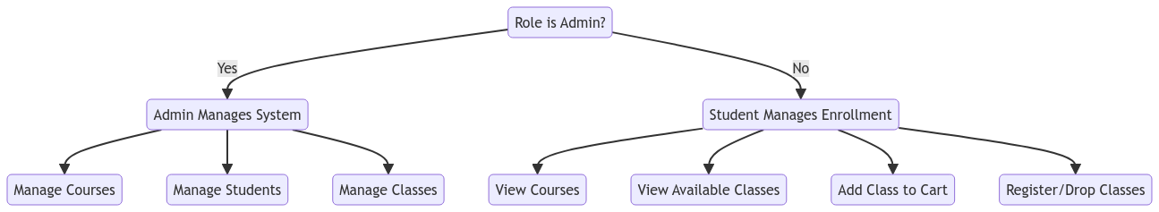

1.4.2 Functional Hierarchy Diagram
The functional hierarchy diagram (FHD) provides an overview of the different functions within the course management system, organizing them into a hierarchical structure based on their relationship and level of importance.
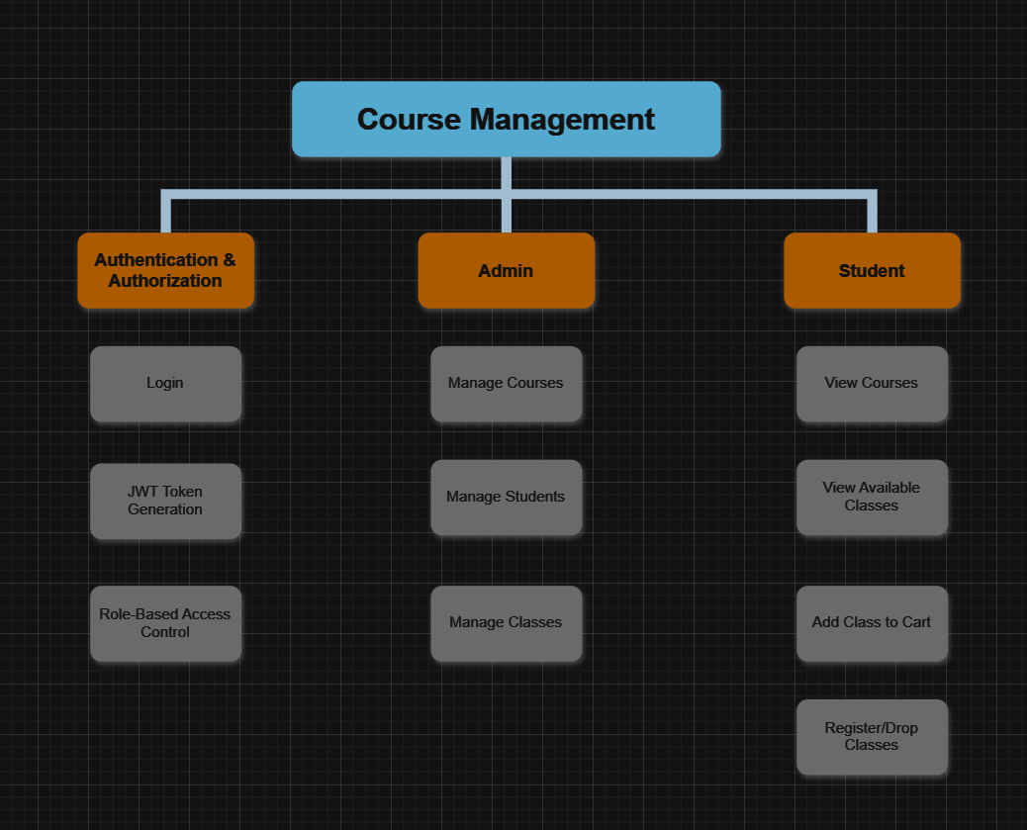

Function in FHD Diagram:
Main Function | Sub-Function | Description
Authentication and Authorization | Login | Users log in to the system by providing their username and password.
 | JWT Token Generation | The system generates a JWT (JSON Web Token) after successful user authentication.
 | Role-Based Access Control | The system controls access based on the user's role (Admin, Student, etc.).
Course Management | Create Course | Admins create new courses with information such as course code, name, credits, etc.
 | Update Course | Admins edit existing course information.
 | Delete Course | Admins delete a course from the system.
 | View Courses | Users view the list of available courses in the system.
Class Enrollment Management | Register for Course | Students register for a class based on the selected course.
 | Drop Course | Students drop a class they are enrolled in.
 | View Enrollment History | Students view their history of enrolled classes.
 | Manage Enrollment Cart | Students manage their enrollment cart (add/remove classes from the cart).
User Management | Admin Management | Manage admin accounts: register or delete admin accounts.
 | Register Admin | Create a new admin account in the system.
 | Delete Admin | Delete an admin account from the system.
 | Student Management | Manage student accounts: register or delete student accounts.
 | Register Student | Create a new student account in the system.
 | Delete Student | Delete a student account from the system.
System Settings Management | Toggle Student Login | Enable or disable the login functionality for students.
 | Manage System Settings | Manage other system settings (if applicable).

1.5. Workplan
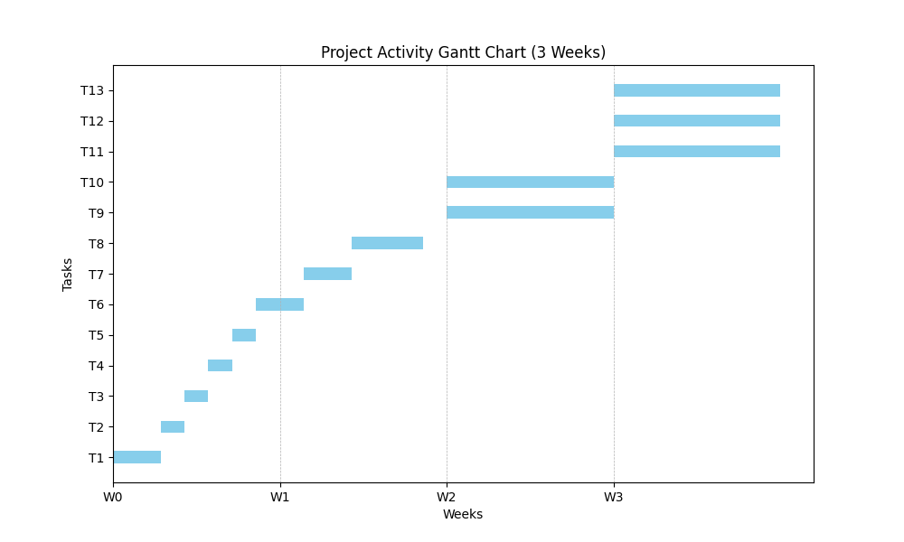

Detailed Project Plan (1/8/2024 - 20/8/2024)
Task | Time (Work hours/days) | Number of People | Description
Analysis
- Requirement Analysis | 1-2 days | 1 person | Gather and analyze all project requirements
- Identify Objects | 1 day | 1 person | Identify all necessary objects and entities for the project
- Identify Business Processes | 1 day | 2 people | Outline all business processes that the project will cover
- Determine Execution Time | 1 day | 1 person | Estimate time needed for each phase and create a timeline
Design
- Design Use-case Diagrams | 1 day | Group | Create use-case diagrams to illustrate project scenarios
- Design Class Diagrams | 1-2 days | Group | Develop class diagrams to define the structure of the system
- Design Interface | 1-2 days | Group | Design the user interface (UI) for the application
- Design Database Schema | 2-3 days | Group | Design the database schema, including tables and relationships
Development
- Program Coding | 1-2 weeks | Group | Write code for the backend, including all necessary logic
- Interface Coding | 1-2 weeks | Group | Develop the frontend, ensuring it aligns with the UI design
Testing
- Debugging | 1-2 weeks | 2 people | Debugging and troubleshooting to find and fix errors
- Bug Fixing | 1-2 weeks | 2 people | Fix bugs and optimize code based on testing results
Maintenance
- Upgrade and Repair | Undefined time | Group | Ongoing updates and repairs based on user feedback and system performance

Detailed Risk Management Plan during Project Execution:
Task/Activity | Potential Risk | Risk Level | Risk Management Strategy | Solution | Description
Data Collection | Data loss or corruption | Medium | Avoidance | Regular Backup | Ensure data is backed up daily to prevent loss
Development | Coding errors | High | Mitigation | Code Reviews | Conduct regular code reviews to identify and fix errors early
Testing | Incomplete test coverage | Medium | Mitigation | Comprehensive Testing | Implement thorough testing procedures to cover all scenarios
Interface Design | Poor user experience | Medium | Avoidance | User Feedback | Collect feedback from users to refine the UI/UX design
Project Schedule | Delays in completion | High | Contingency Planning | Buffer Time | Allocate buffer time in the schedule to accommodate unexpected delays
Team Management | Resource constraints | Medium | Avoidance | Flexible Scheduling | Adjust team schedules to ensure resource availability
Security | Unauthorized access | High | Avoidance | Security Audits | Regular security audits to ensure data protection and system integrity

CHAPTER 2: PROBLEM REQUIREMENT SPECIFICATION

2.1 General Introduction
In this section, we provide a high-level overview of the system's primary actors, use cases, and their roles in the system. The system described is an advanced application designed to manage user authentication, authorization, and course management for an educational institution.
System Actors:
- Admin: Responsible for managing users, courses, and system settings. The admin has full access to the system's functionalities, including the creation, modification, and deletion of courses, users (both students and other admins), and system configurations.
- Student: The primary user of the system. Students can register for courses, manage their enrollment, and view personal information. They can also update their profiles and change passwords.
- Authentication Manager: Handles the authentication of users, ensuring secure access to the system through token-based authentication.
Key Functionalities:
- User Management: Admins can create, update, delete, and manage both student and admin accounts. This includes the ability to assign roles and permissions.
- Course Management: Admins can create, update, and delete courses. Students can view available courses and enroll in them.
- Authentication and Authorization: The system uses JWT (JSON Web Tokens) to manage secure access, ensuring that only authenticated users can perform actions within their allowed permissions.
- Security and Configuration Management: Admins can configure system-wide settings such as enabling or disabling student login functionality.
The system is designed to be robust, secure, and user-friendly, ensuring that all users have the necessary tools to manage their educational responsibilities efficiently and effectively. The system's architecture supports scalability, allowing it to handle an increasing number of users and data without compromising performance.
This chapter outlines the actors, their roles, and the primary use cases that will be further detailed in the subsequent sections.

Actor List
No. | Actor Name | Actor Description
1 | Admin | The system administrator with full access to all system features. Responsible for managing users, courses, classes, and system settings.
2 | Student | A user who enrolls in classes and views their own information. Has limited access to features like course browsing, enrollment, and viewing personal data.

Use Case List
Use Case ID | Use Case Name | Actor(s) | Description
UC-001 | User Login | User (Student/Admin) | Allows a user (Student/Admin) to authenticate and receive access tokens.
UC-002 | Register New Student | Admin | Allows an admin to create a new student account.
UC-003 | Register New Admin | Admin | Allows an admin to create a new admin account.
UC-004 | Create Class | Admin | Allows an admin to create a new class under an existing course.
UC-005 | Update Class | Admin | Allows an admin to update the details of an existing class.
UC-006 | Delete Class | Admin | Allows an admin to delete an existing class.
UC-007 | View All Classes | Admin, Student | Allows an admin or student to view a list of all available classes.
UC-008 | Add Class to Cart | Student | Allows a student to add a class to their cart for potential registration.
UC-009 | Remove Class from Cart | Student | Allows a student to remove a class from their cart.
UC-010 | Register Class | Student | Allows a student to register for a class they have in their cart.
UC-011 | View Enrollment History | Student | Allows a student to view their enrollment history.
UC-012 | Toggle Student Login Access | Admin | Allows an admin to enable or disable student login access to the system.
UC-013 | View Student Information | Student | Allows a student to view their own information.
UC-014 | Change Student Password | Student | Allows a student to change their password.
UC-015 | View Course Information | Admin, Student | Allows an admin or student to view information about a specific course.
UC-016 | Update Course | Admin | Allows an admin to update the details of an existing course.
UC-017 | Delete Course | Admin | Allows an admin to delete an existing course.
UC-018 | Search Classes by Course | Admin, Student | Allows an admin or student to search for classes by course code.
UC-019 | Search Courses by Name | Admin, Student | Allows an admin or student to search for courses by name.
UC-020 | Refresh JWT Token | User (Student/Admin) | Allows a user to refresh their JWT token.
UC-021 | View All Students | Admin | Allows an admin to view all students in the system.
UC-022 | View Admin Information | Admin | Allows an admin to view their own information.
UC-023 | Delete Student | Admin | Allows an admin to delete a student by username.
UC-024 | Delete Admin | Admin | Allows an admin to delete another admin by username.
UC-025 | View All Courses | Admin, Student | Allows an admin or student to view a list of all courses.
UC-026 | Create Course | Admin | Allows an admin to create a new course in the system.
UC-027 | Add All Classes in Cart to Register | Student | Allows a student to register for all classes in their cart.
UC-028 | Drop Class | Student | Allows a student to drop a class they are registered in.
UC-029 | View Cart | Student | Allows a student to view the list of classes they have added to their cart.
UC-030 | Search Class by Code | Admin, Student | Allows an admin or student to search for a specific class by its class code.

2.2 Use Case Diagram

2.2.1 Overview Use Case Diagram
The diagram above presents an integrated overview of the system's functionality by depicting the interactions between the primary actors—Admin and Student—and the different subsystems within the application. These subsystems include the Course Management System, Class Management System, Authentication System, and Class Enrollment System.
- Course Management System: This section illustrates the various operations an Admin can perform related to courses, such as creating, updating, deleting, and searching for courses, as well as viewing all available courses.
- Class Management System: This part of the diagram shows how an Admin manages classes within the system, including creating, updating, deleting classes, viewing all classes, and filtering classes by course.
- Authentication System: The diagram highlights the authentication and user management functionalities, where both Admin and Student users can log in, manage their information, and change their passwords. The Admin has additional privileges, such as registering new users (both students and admins), managing login settings, and refreshing tokens.
- Class Enrollment System: This subsystem is focused on the Student's interactions with the class enrollment process, allowing them to add classes to their cart, register for classes, drop classes, and view their enrollment history.
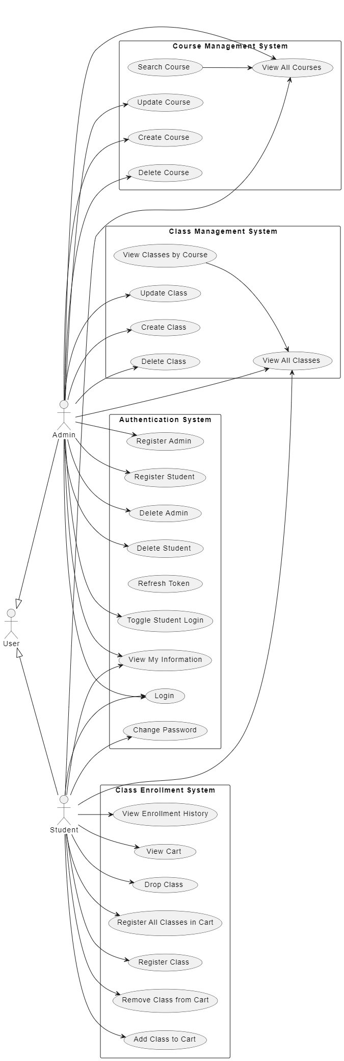

2.2.2. Decomposed Use Case Diagram
Decomposed use-case diagrams for complex use cases:
1. Use Case Diagram: Course Management
This diagram illustrates the interactions between the Admin and the system for managing courses. It includes use cases such as creating, updating, deleting courses, and searching or viewing all courses within the system.
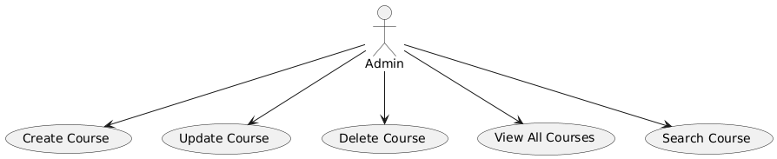
2. Use Case Diagram: Class Management
This diagram showcases how the Admin interacts with the system to manage classes under courses. It covers actions such as creating, updating, deleting classes, and viewing or searching classes within the system.
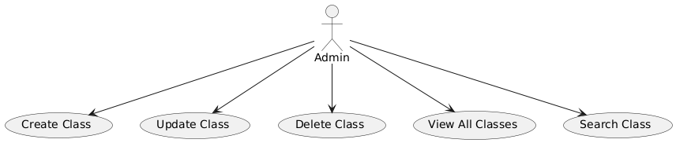
3. Use Case Diagram: Student Enrollment
This diagram focuses on the enrollment process from the Student's perspective. It includes use cases such as adding classes to the cart, registering for classes, removing classes from the cart, dropping classes, and viewing enrollment history.
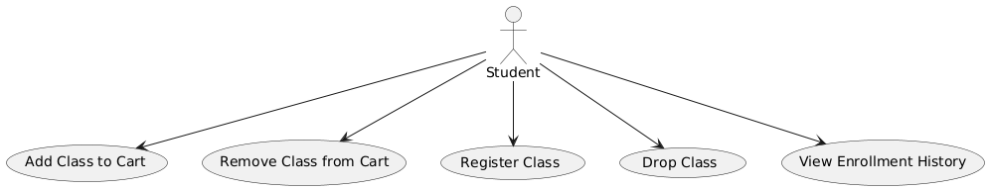
4. Use Case Diagram: User Management
This diagram outlines the functionalities for managing user accounts within the system. It includes use cases like creating student and admin accounts, viewing and updating student information, and allowing students to change their password.
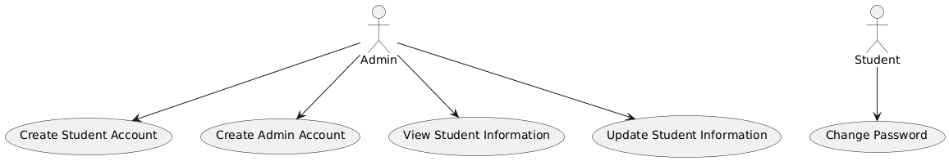

2.3 Use Case Details
UC-001: User Login
Use Case ID | UC-001
Use Case Name | User Login
Actor(s) | User (Student/Admin)
Description | Allows a user (Student/Admin) to authenticate and receive access tokens.
Precondition | The user must be registered in the system.
Postcondition | The user receives a valid JWT token if authentication is successful.
Main Flow | 1. The user provides their username and password.  2. The system validates the credentials.  3. If valid, the system generates and returns an access token and a refresh token.
Alternative Flow(s) | Alternative Flow 1: Invalid Credentials  - If the credentials are invalid, the system denies access and returns an error message.
Exception Flow(s) | Exception Flow 1: System Error  - If the system encounters an error, the login process is aborted and an error message is displayed.
Priority | High
Frequency of Use | Frequently
Assumptions | The user’s account is active and the system is accessible.
Notes and Issues | The system should enforce account lockout after multiple failed login attempts.

UC-002: Register New Student
Use Case ID | UC-002
Use Case Name | Register New Student
Actor(s) | Admin
Description | Allows an admin to create a new student account.
Precondition | The admin must be authenticated and authorized to create new student accounts.
Postcondition | A new student account is created in the system.
Main Flow | 1. The admin provides the necessary student details (username, password, etc.).  2. The system validates the provided details.  3. If valid, the system creates a new student account and returns a confirmation to the admin.
Alternative Flow(s) | Alternative Flow 1: Duplicate Username  - If the username provided is already in use, the system returns an error and prompts the admin to enter a different username.
Exception Flow(s) | Exception Flow 1: System Error  - If the system encounters an error, the account creation process is aborted and an error message is displayed.
Priority | High
Frequency of Use | Frequently
Assumptions | The admin has the necessary permissions and the system is functioning correctly.
Notes and Issues | Ensure that usernames are unique and that strong password policies are enforced during student registration.

UC-003: Register New Admin
Use Case ID | UC-003
Use Case Name | Register New Admin
Actor(s) | Admin
Description | Allows an admin to create a new admin account.
Precondition | The admin must be authenticated and authorized to create new admin accounts.
Postcondition | A new admin account is created in the system.
Main Flow | 1. The admin provides the necessary admin details (username, password, department, etc.).  2. The system validates the provided details.  3. If valid, the system creates a new admin account and returns a confirmation to the admin.
Alternative Flow(s) | Alternative Flow 1: Duplicate Username  - If the username provided is already in use, the system returns an error and prompts the admin to enter a different username.
Exception Flow(s) | Exception Flow 1: System Error  - If the system encounters an error, the account creation process is aborted and an error message is displayed.
Priority | High
Frequency of Use | Occasionally
Assumptions | The admin has the necessary permissions and the system is functioning correctly.
Notes and Issues | Ensure that usernames are unique and that strong password policies are enforced during admin registration.

UC-004: Create Class
Use Case ID | UC-004
Use Case Name | Create Class
Actor(s) | Admin
Description | Allows an admin to create a new class under an existing course.
Precondition | The course must already exist in the system. The admin must be authenticated.
Postcondition | A new class is created under the specified course.
Main Flow | 1. The admin selects the course under which the class will be created.  2. The admin provides class details (class code, start date, end date, etc.).  3. The system validates the class details and creates the new class under the specified course.
Alternative Flow(s) | Alternative Flow 1: Course Not Found  - If the selected course does not exist, the system returns an error and prompts the admin to select a valid course.
Exception Flow(s) | Exception Flow 1: System Error  - If the system encounters an error, the class creation process is aborted and an error message is displayed.
Priority | High
Frequency of Use | Occasionally
Assumptions | The admin has the necessary permissions and the course exists in the system.
Notes and Issues | Ensure that class details are validated before creation.

UC-005: Update Class
Use Case ID | UC-005
Use Case Name | Update Class
Actor(s) | Admin
Description | Allows an admin to update the details of an existing class.
Precondition | The class must exist in the system. The admin must be authenticated.
Postcondition | The class details are updated in the system.
Main Flow | 1. The admin selects the class to update.  2. The admin modifies the class details (start date, end date, max students, etc.).  3. The system validates the updated details and saves the changes.
Alternative Flow(s) | Alternative Flow 1: Class Not Found  - If the selected class does not exist, the system returns an error and prompts the admin to select a valid class.
Exception Flow(s) | Exception Flow 1: System Error  - If the system encounters an error, the class update process is aborted and an error message is displayed.
Priority | High
Frequency of Use | Occasionally
Assumptions | The admin has the necessary permissions and the class exists in the system.
Notes and Issues | Ensure that updated class details are validated before saving.

UC-006: Delete Class
Use Case ID | UC-006
Use Case Name | Delete Class
Actor(s) | Admin
Description | Allows an admin to delete an existing class.
Precondition | The class must exist in the system. The admin must be authenticated.
Postcondition | The class is deleted from the system.
Main Flow | 1. The admin selects the class to delete.  2. The system confirms the deletion request.  3. If confirmed, the system deletes the class from the system.
Alternative Flow(s) | Alternative Flow 1: Class Not Found  - If the selected class does not exist, the system returns an error and prompts the admin to select a valid class.
Exception Flow(s) | Exception Flow 1: System Error  - If the system encounters an error, the class deletion process is aborted and an error message is displayed.
Priority | Medium
Frequency of Use | Rarely
Assumptions | The admin has the necessary permissions and the class exists in the system.
Notes and Issues | Ensure that the class deletion does not affect related entities (e.g., enrolled students).

UC-007: View All Classes
Use Case ID | UC-007
Use Case Name | View All Classes
Actor(s) | Admin, Student
Description | Allows an admin or student to view a list of all available classes.
Precondition | The user must be authenticated.
Postcondition | The user views a list of all classes available in the system.
Main Flow | 1. The user requests to view all classes.  2. The system retrieves and displays a list of all classes.
Alternative Flow(s) | Alternative Flow 1: No Classes Available  - If there are no classes available, the system displays a message indicating that no classes are currently available.
Exception Flow(s) | Exception Flow 1: System Error  - If the system encounters an error, the class retrieval process is aborted and an error message is displayed.
Priority | High
Frequency of Use | Frequently
Assumptions | The user has the necessary permissions to view classes.
Notes and Issues | Ensure that the list of classes is updated in real-time.

UC-008: Add Class to Cart
Use Case ID | UC-008
Use Case Name | Add Class to Cart
Actor(s) | Student
Description | Allows a student to add a class to their cart for potential registration.
Precondition | The class must be available and not yet added to the cart.
Postcondition | The class is added to the student’s cart.
Main Flow | 1. The student selects a class to add to their cart.  2. The system checks if the class is available and not already in the cart.  3. If available, the system adds the class to the student’s cart.
Alternative Flow(s) | Alternative Flow 1: Class Already in Cart  - If the class is already in the cart, the system notifies the student and does not add the class again.
Exception Flow(s) | Exception Flow 1: System Error  - If the system encounters an error, the class addition process is aborted and an error message is displayed.
Priority | High
Frequency of Use | Frequently
Assumptions | The student has not exceeded their credit limit and the class is not full.
Notes and Issues | Ensure that the class availability is accurately checked before adding to the cart.

UC-009: Remove Class from Cart
Use Case ID | UC-009
Use Case Name | Remove Class from Cart
Actor(s) | Student
Description | Allows a student to remove a class from their cart.
Precondition | The class must be in the student’s cart.
Postcondition | The class is removed from the student’s cart.
Main Flow | 1. The student selects a class to remove from their cart.  2. The system confirms the removal request.  3. If confirmed, the system removes the class from the student’s cart.
Alternative Flow(s) | Alternative Flow 1: Class Not in Cart  - If the selected class is not in the cart, the system notifies the student and does not perform any removal.
Exception Flow(s) | Exception Flow 1: System Error  - If the system encounters an error, the class removal process is aborted and an error message is displayed.
Priority | High
Frequency of Use | Occasionally
Assumptions | The class is in the cart and the system is functioning correctly.
Notes and Issues | Ensure that the removal process does not impact other classes in the cart.

UC-010: Register Class
Use Case ID | UC-010
Use Case Name | Register Class
Actor(s) | Student
Description | Allows a student to register for a class they have in their cart.
Precondition | The class must be in the student’s cart and the registration deadline must not have passed.
Postcondition | The student is registered for the class.
Main Flow | 1. The student selects a class from their cart to register.  2. The system checks if the class is still available and the registration deadline has not passed.  3. If valid, the system registers the student for the class and updates the student count.
Alternative Flow(s) | Alternative Flow 1: Registration Deadline Passed  - If the registration deadline has passed, the system notifies the student and does not register the class.
Exception Flow(s) | Exception Flow 1: System Error  - If the system encounters an error, the registration process is aborted and an error message is displayed.
Priority | High
Frequency of Use | Frequently
Assumptions | The student has not exceeded their credit limit and the class is not full.
Notes and Issues | Ensure that registration deadlines and class capacities are strictly enforced.

UC-011: View Enrollment History
Use Case ID | UC-011
Use Case Name | View Enrollment History
Actor(s) | Student
Description | Allows a student to view their enrollment history.
Precondition | The student must be authenticated.
Postcondition | The student views their enrollment history.
Main Flow | 1. The student requests to view their enrollment history.  2. The system retrieves and displays the student’s enrollment history.
Alternative Flow(s) | Alternative Flow 1: No Enrollment History  - If the student has no enrollment history, the system displays a message indicating that no records are available.
Exception Flow(s) | Exception Flow 1: System Error  - If the system encounters an error, the history retrieval process is aborted and an error message is displayed.
Priority | Medium
Frequency of Use | Occasionally
Assumptions | The system has accurate records of student enrollments.
Notes and Issues | Ensure that the enrollment history is complete and accurate.

UC-012: Toggle Student Login Access
Use Case ID | UC-012
Use Case Name | Toggle Student Login Access
Actor(s) | Admin
Description | Allows an admin to enable or disable student login access to the system.
Precondition | The admin must be authenticated and have the necessary permissions.
Postcondition | Student login access is enabled or disabled.
Main Flow | 1. The admin selects the option to enable or disable student login access.  2. The system updates the login settings accordingly.
Alternative Flow(s) | Alternative Flow 1: Invalid Permissions  - If the admin does not have the necessary permissions, the system denies the request and displays an error message.
Exception Flow(s) | Exception Flow 1: System Error  - If the system encounters an error, the toggle process is aborted and an error message is displayed.
Priority | Medium
Frequency of Use | Rarely
Assumptions | The system correctly enforces the login settings.
Notes and Issues | Ensure that changes to login access are logged for audit purposes.

UC-013: View Student Information
Use Case ID | UC-013
Use Case Name | View Student Information
Actor(s) | Student
Description | Allows a student to view their own information.
Precondition | The student must be authenticated.
Postcondition | The student views their information in the system.
Main Flow | 1. The student requests to view their information.  2. The system retrieves and displays the student’s information.
Alternative Flow(s) | Alternative Flow 1: No Information Available  - If no information is available for the student, the system displays a message indicating that no records are available.
Exception Flow(s) | Exception Flow 1: System Error  - If the system encounters an error, the information retrieval process is aborted and an error message is displayed.
Priority | Medium
Frequency of Use | Frequently
Assumptions | The system has accurate records of student information.
Notes and Issues | Ensure that student information is protected and only accessible to the student.

UC-014: Change Student Password
Use Case ID | UC-014
Use Case Name | Change Student Password
Actor(s) | Student
Description | Allows a student to change their password.
Precondition | The student must be authenticated and know their current password.
Postcondition | The student’s password is changed in the system.
Main Flow | 1. The student provides their current password and a new password.  2. The system validates the current password.  3. If valid, the system updates the password and confirms the change.
Alternative Flow(s) | Alternative Flow 1: Invalid Current Password  - If the current password provided is invalid, the system denies the request and prompts the student to re-enter the correct password.
Exception Flow(s) | Exception Flow 1: System Error  - If the system encounters an error, the password change process is aborted and an error message is displayed.
Priority | High
Frequency of Use | Occasionally
Assumptions | The student’s account is active and the system is accessible.
Notes and Issues | Ensure that strong password policies are enforced during password changes.

UC-015: View Course Information
Use Case ID | UC-015
Use Case Name | View Course Information
Actor(s) | Admin, Student
Description | Allows an admin or student to view information about a specific course.
Precondition | The course must exist in the system.
Postcondition | The user views information about the selected course.
Main Flow | 1. The user selects a course to view.  2. The system retrieves and displays information about the selected course.
Alternative Flow(s) | Alternative Flow 1: Course Not Found  - If the selected course does not exist, the system returns an error and prompts the user to select a valid course.
Exception Flow(s) | Exception Flow 1: System Error  - If the system encounters an error, the information retrieval process is aborted and an error message is displayed.
Priority | Medium
Frequency of Use | Frequently
Assumptions | The system has accurate records of courses.
Notes and Issues | Ensure that course information is up-to-date and accurate.

UC-016: Update Course
Use Case ID | UC-016
Use Case Name | Update Course
Actor(s) | Admin
Description | Allows an admin to update the details of an existing course.
Precondition | The course must exist in the system. The admin must be authenticated.
Postcondition | The course details are updated in the system.
Main Flow | 1. The admin selects the course to update.  2. The admin modifies the course details (name, duration, credits, etc.).  3. The system validates the updated details and saves the changes.
Alternative Flow(s) | Alternative Flow 1: Course Not Found  - If the selected course does not exist, the system returns an error and prompts the admin to select a valid course.
Exception Flow(s) | Exception Flow 1: System Error  - If the system encounters an error, the course update process is aborted and an error message is displayed.
Priority | High
Frequency of Use | Occasionally
Assumptions | The admin has the necessary permissions and the course exists in the system.
Notes and Issues | Ensure that updated course details are validated before saving.

UC-017: Delete Course
Use Case ID | UC-017
Use Case Name | Delete Course
Actor(s) | Admin
Description | Allows an admin to delete an existing course.
Precondition | The course must exist in the system. The admin must be authenticated.
Postcondition | The course is deleted from the system.
Main Flow | 1. The admin selects the course to delete.  2. The system confirms the deletion request.  3. If confirmed, the system deletes the course from the system.
Alternative Flow(s) | Alternative Flow 1: Course Not Found  - If the selected course does not exist, the system returns an error and prompts the admin to select a valid course.
Exception Flow(s) | Exception Flow 1: System Error  - If the system encounters an error, the course deletion process is aborted and an error message is displayed.
Priority | Medium
Frequency of Use | Rarely
Assumptions | The admin has the necessary permissions and the course exists in the system.
Notes and Issues | Ensure that the course deletion does not affect related entities (e.g., enrolled students).

UC-018: Search Classes by Course
Use Case ID | UC-018
Use Case Name | Search Classes by Course
Actor(s) | Admin, Student
Description | Allows an admin or student to search for classes by course code.
Precondition | The course must exist in the system.
Postcondition | The user views a list of classes under the specified course.
Main Flow | 1. The user enters the course code to search for classes.  2. The system retrieves and displays a list of classes under the specified course.
Alternative Flow(s) | Alternative Flow 1: Course Not Found  - If the entered course code does not match any course, the system returns an error and prompts the user to enter a valid course code.
Exception Flow(s) | Exception Flow 1: System Error  - If the system encounters an error, the class search process is aborted and an error message is displayed.
Priority | Medium
Frequency of Use | Frequently
Assumptions | The course exists in the system and the user has the necessary permissions to search for classes.
Notes and Issues | Ensure that search results are accurate and up-to-date.

UC-019: Search Courses by Name
Use Case ID | UC-019
Use Case Name | Search Courses by Name
Actor(s) | Admin, Student
Description | Allows an admin or student to search for courses by name.
Precondition | The course(s) must exist in the system.
Postcondition | The user views a list of courses matching the search criteria.
Main Flow | 1. The user enters the course name or part of it to search for courses.  2. The system retrieves and displays a list of courses matching the search criteria.
Alternative Flow(s) | Alternative Flow 1: No Matching Courses  - If no courses match the entered search criteria, the system displays a message indicating that no courses were found.
Exception Flow(s) | Exception Flow 1: System Error  - If the system encounters an error, the course search process is aborted and an error message is displayed.
Priority | Medium
Frequency of Use | Frequently
Assumptions | The course(s) exist in the system and the user has the necessary permissions to search for courses.
Notes and Issues | Ensure that search results are accurate and up-to-date.

UC-020: Refresh JWT Token
Use Case ID | UC-020
Use Case Name | Refresh JWT Token
Actor(s) | User (Student/Admin)
Description | Allows a user to refresh their JWT token.
Precondition | The user must have a valid refresh token.
Postcondition | The user receives a new access token.
Main Flow | 1. The user sends a request to refresh their JWT token.  2. The system validates the refresh token.  3. If valid, the system generates and returns a new access token to the user.
Alternative Flow(s) | Alternative Flow 1: Invalid Refresh Token  - If the refresh token is invalid or expired, the system denies the request and returns an error message.
Exception Flow(s) | Exception Flow 1: System Error  - If the system encounters an error, the token refresh process is aborted and an error message is displayed.
Priority | High
Frequency of Use | Frequently
Assumptions | The user’s refresh token is valid and the system is accessible.
Notes and Issues | Ensure that refresh tokens are securely stored and managed.

UC-021: View All Students
Use Case ID | UC-021
Use Case Name | View All Students
Actor(s) | Admin
Description | Allows an admin to view all students in the system.
Precondition | The admin must be authenticated and have the necessary permissions.
Postcondition | The admin views a list of all students in the system.
Main Flow | 1. The admin requests to view all students.  2. The system retrieves and displays a list of all students.
Alternative Flow(s) | Alternative Flow 1: No Students Available  - If there are no students in the system, the system displays a message indicating that no students are currently available.
Exception Flow(s) | Exception Flow 1: System Error  - If the system encounters an error, the student retrieval process is aborted and an error message is displayed.
Priority | Medium
Frequency of Use | Occasionally
Assumptions | The admin has the necessary permissions to view students.
Notes and Issues | Ensure that the list of students is updated in real-time.

UC-022: View Admin Information
Use Case ID | UC-022
Use Case Name | View Admin Information
Actor(s) | Admin
Description | Allows an admin to view their own information.
Precondition | The admin must be authenticated.
Postcondition | The admin views their information in the system.
Main Flow | 1. The admin requests to view their information.  2. The system retrieves and displays the admin’s information.
Alternative Flow(s) | Alternative Flow 1: No Information Available  - If no information is available for the admin, the system displays a message indicating that no records are available.
Exception Flow(s) | Exception Flow 1: System Error  - If the system encounters an error, the information retrieval process is aborted and an error message is displayed.
Priority | Medium
Frequency of Use | Occasionally
Assumptions | The system has accurate records of admin information.
Notes and Issues | Ensure that admin information is protected and only accessible to the respective admin.

UC-023: Delete Student
Use Case ID | UC-023
Use Case Name | Delete Student
Actor(s) | Admin
Description | Allows an admin to delete a student by username.
Precondition | The student must exist in the system. The admin must be authenticated and have the necessary permissions.
Postcondition | The student is deleted from the system.
Main Flow | 1. The admin selects the student to delete by username.  2. The system confirms the deletion request.  3. If confirmed, the system deletes the student from the system.
Alternative Flow(s) | Alternative Flow 1: Student Not Found  - If the selected student does not exist, the system returns an error and prompts the admin to select a valid student.
Exception Flow(s) | Exception Flow 1: System Error  - If the system encounters an error, the student deletion process is aborted and an error message is displayed.
Priority | Medium
Frequency of Use | Rarely
Assumptions | The admin has the necessary permissions and the student exists in the system.
Notes and Issues | Ensure that the student deletion does not affect related entities (e.g., enrollment records).

UC-024: Delete Admin
Use Case ID | UC-024
Use Case Name | Delete Admin
Actor(s) | Admin
Description | Allows an admin to delete another admin by username.
Precondition | The admin must exist in the system. The admin performing the deletion must be authenticated and have the necessary permissions.
Postcondition | The selected admin is deleted from the system.
Main Flow | 1. The admin selects another admin to delete by username.  2. The system confirms the deletion request.  3. If confirmed, the system deletes the selected admin from the system.
Alternative Flow(s) | Alternative Flow 1: Admin Not Found  - If the selected admin does not exist, the system returns an error and prompts the admin to select a valid admin.
Exception Flow(s) | Exception Flow 1: System Error  - If the system encounters an error, the admin deletion process is aborted and an error message is displayed.
Priority | Medium
Frequency of Use | Rarely
Assumptions | The admin performing the deletion has the necessary permissions and the selected admin exists in the system.
Notes and Issues | Ensure that the admin deletion does not affect system operations.

UC-025: View All Courses
Use Case ID | UC-025
Use Case Name | View All Courses
Actor(s) | Admin, Student
Description | Allows an admin or student to view a list of all courses.
Precondition | The user must be authenticated.
Postcondition | The user views a list of all courses available in the system.
Main Flow | 1. The user requests to view all courses.  2. The system retrieves and displays a list of all courses.
Alternative Flow(s) | Alternative Flow 1: No Courses Available  - If there are no courses available, the system displays a message indicating that no courses are currently available.
Exception Flow(s) | Exception Flow 1: System Error  - If the system encounters an error, the course retrieval process is aborted and an error message is displayed.
Priority | Medium
Frequency of Use | Occasionally
Assumptions | The user has the necessary permissions to view courses.
Notes and Issues | Ensure that the list of courses is updated in real-time.

UC-026: Create Course
Use Case ID | UC-026
Use Case Name | Create Course
Actor(s) | Admin
Description | Allows an admin to create a new course in the system.
Precondition | The admin must be authenticated and authorized to create new courses.
Postcondition | A new course is created in the system.
Main Flow | 1. The admin provides the necessary course details (course code, name, duration, credits, etc.).  2. The system validates the provided details.  3. If valid, the system creates a new course and returns a confirmation to the admin.
Alternative Flow(s) | Alternative Flow 1: Duplicate Course Code  - If the course code provided is already in use, the system returns an error and prompts the admin to enter a different course code.
Exception Flow(s) | Exception Flow 1: System Error  - If the system encounters an error, the course creation process is aborted and an error message is displayed.
Priority | High
Frequency of Use | Occasionally
Assumptions | The admin has the necessary permissions and the system is functioning correctly.
Notes and Issues | Ensure that course codes are unique and that course details are validated before creation.

UC-027: Add All Classes in Cart to Register
Use Case ID | UC-027
Use Case Name | Add All Classes in Cart to Register
Actor(s) | Student
Description | Allows a student to register for all classes in their cart.
Precondition | The student must have classes in their cart, and the registration deadlines must not have passed.
Postcondition | The student is registered for all classes in their cart.
Main Flow | 1. The student selects the option to register for all classes in their cart.  2. The system checks if the classes are still available and the registration deadlines have not passed.  3. If valid, the system registers the student for all classes and updates the student count.
Alternative Flow(s) | Alternative Flow 1: Registration Deadline Passed for Some Classes  - If the registration deadline has passed for some classes, the system registers the student for only those classes whose deadlines have not passed. The system notifies the student of the classes not registered due to passed deadlines.
Exception Flow(s) | Exception Flow 1: System Error  - If the system encounters an error, the registration process is aborted and an error message is displayed.
Priority | High
Frequency of Use | Frequently
Assumptions | The student has not exceeded their credit limit and the classes are not full.
Notes and Issues | Ensure that registration deadlines and class capacities are strictly enforced.

UC-028: Drop Class
Use Case ID | UC-028
Use Case Name | Drop Class
Actor(s) | Student
Description | Allows a student to drop a class they are registered in.
Precondition | The student must be registered in the class they wish to drop.
Postcondition | The student is no longer registered in the class.
Main Flow | 1. The student selects the class to drop.  2. The system confirms the drop request.  3. If confirmed, the system removes the student from the class and updates the student count.
Alternative Flow(s) | Alternative Flow 1: Drop Deadline Passed  - If the drop deadline has passed, the system denies the drop request and notifies the student.
Exception Flow(s) | Exception Flow 1: System Error  - If the system encounters an error, the drop process is aborted and an error message is displayed.
Priority | Medium
Frequency of Use | Occasionally
Assumptions | The drop deadline has not passed and the system is functioning correctly.
Notes and Issues | Ensure that drop deadlines are strictly enforced and that dropping a class does not negatively impact the student’s academic progress.

UC-029: View Cart
Use Case ID | UC-029
Use Case Name | View Cart
Actor(s) | Student
Description | Allows a student to view the list of classes they have added to their cart.
Precondition | The student must be authenticated.
Postcondition | The student views the list of classes in their cart.
Main Flow | 1. The student requests to view their cart.  2. The system retrieves and displays the list of classes in the student’s cart.
Alternative Flow(s) | Alternative Flow 1: No Classes in Cart  - If there are no classes in the cart, the system displays a message indicating that the cart is empty.
Exception Flow(s) | Exception Flow 1: System Error  - If the system encounters an error, the cart retrieval process is aborted and an error message is displayed.
Priority | High
Frequency of Use | Frequently
Assumptions | The student has classes in their cart and the system is functioning correctly.
Notes and Issues | Ensure that the cart is updated in real-time and accurately reflects the classes added by the student.

UC-030: Search Class by Code
Use Case ID | UC-030
Use Case Name | Search Class by Code
Actor(s) | Admin, Student
Description | Allows an admin or student to search for a specific class by its class code.
Precondition | The class must exist in the system.
Postcondition | The user views the class information corresponding to the entered class code.
Main Flow | 1. The user enters the class code to search.  2. The system retrieves and displays the class information matching the entered class code.
Alternative Flow(s) | Alternative Flow 1: Class Not Found  - If the entered class code does not match any class, the system returns an error and prompts the user to enter a valid class code.
Exception Flow(s) | Exception Flow 1: System Error  - If the system encounters an error, the class search process is aborted and an error message is displayed.
Priority | Medium
Frequency of Use | Frequently
Assumptions | The class exists in the system and the user has the necessary permissions to search for classes.
Notes and Issues | Ensure that search results are accurate and up-to-date.

2.4 Non-functional Requirements
Non-functional requirements (NFRs) specify criteria that can be used to judge the operation of a system, rather than specific behaviors. These requirements ensure the usability, reliability, performance, and supportability of the system. Below is a list of non-functional requirements for the system:

2.4.1 Performance Requirements
- System Response Time: The system should respond to user actions within 2 seconds under normal operating conditions. For critical operations, such as class registration during peak times, the response time should not exceed 5 seconds.
- Throughput: The system must be capable of handling at least 500 concurrent users without performance degradation.
- Scalability: The system should be able to scale to accommodate a growing number of users and transactions, with the ability to support up to 10,000 concurrent users in the future.

2.4.2 Security Requirements
- Authentication: All users must be authenticated using a secure login mechanism, with support for role-based access control (RBAC) to ensure that only authorized users can access specific functionalities.
- Data Encryption: Sensitive data, such as user passwords and personal information, must be encrypted both in transit (using TLS) and at rest.
- Data Integrity: The system must ensure data integrity by implementing checksums and other verification methods to prevent data corruption during transmission or storage.

2.4.3 Usability Requirements
- User Interface: The user interface should be intuitive and easy to navigate, with clear labeling and consistent design across all pages. The system should provide feedback to the user after each action (e.g., "Class added to cart").
- Accessibility: The system should comply with WCAG 2.1 Level AA guidelines to ensure accessibility for users with disabilities. This includes support for screen readers, keyboard navigation, and alternative text for images.
- Multi-language Support: The system should support multiple languages, starting with English and Vietnamese, allowing users to switch between languages seamlessly.

2.4.4 Reliability Requirements
- System Availability: The system must be available 99.9% of the time, with a maximum allowable downtime of 1.44 minutes per day.
- Fault Tolerance: The system should have mechanisms in place to handle server failures, such as automatic failover to a backup server to ensure continuous operation.
- Backup and Recovery: The system must perform regular backups of critical data (at least once per day) and have a recovery plan in place that can restore the system within 1 hour in the event of data loss.

2.4.5 Maintainability Requirements
- Modularity: The system should be designed with a modular architecture, allowing for easy updates and maintenance without affecting other parts of the system.
- Documentation: Comprehensive documentation must be provided for both users and developers, including user manuals, API documentation, and system architecture diagrams.
- Logging and Monitoring: The system must implement logging and monitoring mechanisms to track usage, performance metrics, and errors, with alerts sent to administrators in the event of critical issues.

2.4.6 Portability Requirements
- Platform Independence: The system should be platform-independent and capable of running on various operating systems, including Windows, Linux, and macOS.
- Browser Compatibility: The system should be compatible with the latest versions of major web browsers, including Google Chrome, Mozilla Firefox, Microsoft Edge, and Safari.

2.4.7 Compliance Requirements
- Data Protection Regulations: The system must comply with relevant data protection regulations, such as GDPR or the local equivalents, ensuring that user data is collected, stored, and processed lawfully.
- Audit Trails: The system should maintain an audit trail of all user actions, especially those related to sensitive operations, for a minimum of 1 year to comply with legal and regulatory requirements.

CHAPTER 3: REQUIREMENTS ANALYSIS

3.1. Identification of Analysis Classes
In developing an Education Management Software for courses taught in English at Hanoi University of Science and Technology (HUST), it is essential to identify and define the key analysis classes. These classes represent the fundamental entities and their relationships within the system, serving as the backbone for subsequent system design and implementation. The following are the primary analysis classes identified for this software:
Course:
Description: This class represents the courses offered by HUST that are taught in English. It includes essential attributes like course code, course name, description, credits, and associated tuition fees.
Attributes:
- courseCode: Unique identifier for the course.
- courseName: Name of the course.
- description: Detailed information about the course content.
- credits: Number of credits assigned to the course.
- tuitionFeeCredits: Cost associated with enrolling in the course.
- weight: Importance or priority of the course within a program.
Class:
Description: This class encapsulates the specific instances of a course being taught, including the schedule and the number of students enrolled.
Attributes:
- classCode: Unique identifier for the class.
- course: Reference to the associated course.
- maxStudents: Maximum number of students that can enroll in the class.
- currentStudentCount: The current number of students enrolled.
- startDate: The date when the class begins.
- endDate: The date when the class ends.
- registrationDeadline: The last date for students to register for the class.
- dayOfWeek: The day(s) of the week the class is held.

Student:
Description: This class represents students who are enrolled in courses at HUST. It contains personal information and academic details related to the student.
Attributes:
- studentId: Unique identifier for the student.
- name: Full name of the student.
- username: Username for system login.
- password: Password for system authentication.
- program: The academic program the student is enrolled in.
- maxCredits: The maximum number of credits the student can enroll in per semester.
Admin:
Description: This class represents the administrators responsible for managing courses, classes, and students within the system. It includes necessary attributes and methods for managing the system.
Attributes:
- adminId: Unique identifier for the admin.
- username: Username for system login.
- password: Password for system authentication.
- department: Department the admin is associated with.
Class Enrollment:
Description: This class tracks the enrollment of students in specific classes. It is crucial for managing and updating student registrations.
Attributes:
- enrollmentId: Unique identifier for the enrollment record.
- student: Reference to the student who is enrolling.
- enrolledClass: Reference to the class the student is enrolling in.
- enrollmentDate: The date when the enrollment was made.
- status: The status of the enrollment (e.g., pending, registered, cancelled).

SystemSetting:
Description: This class contains system-wide settings that control various functionalities, such as whether student login is allowed.
Attributes:
- settingKey: Unique key identifying the specific setting.
- settingValue: The value associated with the setting key.
JwtTokenUtil:
Description: This class handles the generation, validation, and management of JWT tokens used for authenticating users within the system.
Attributes:
- secretKey: The secret key used for signing the JWT tokens.
- accessTokenValidity: Duration for which the access token remains valid.
- refreshTokenValidity: Duration for which the refresh token remains valid.

3.2. Build the Sequence Diagram
UC-001: User Login
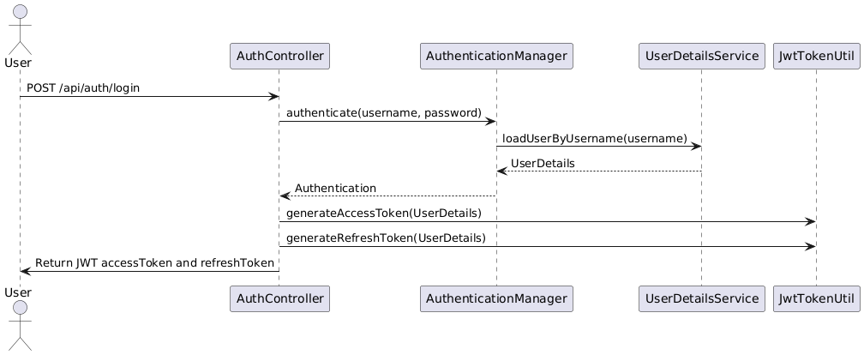UC-002: Register New Student
plantuml
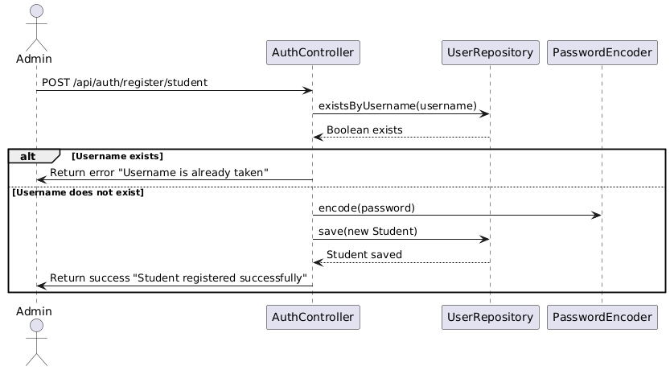UC-003: Register New Admin
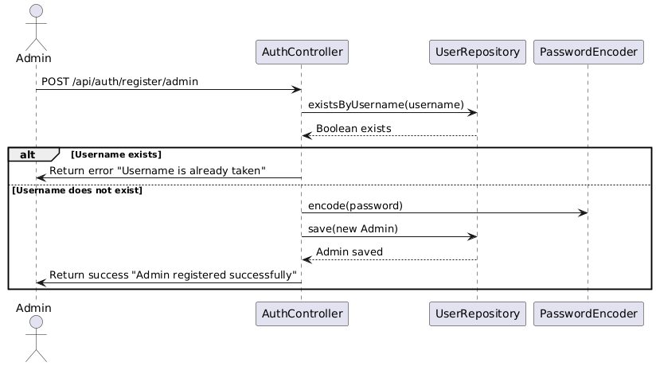UC-004: Create Class
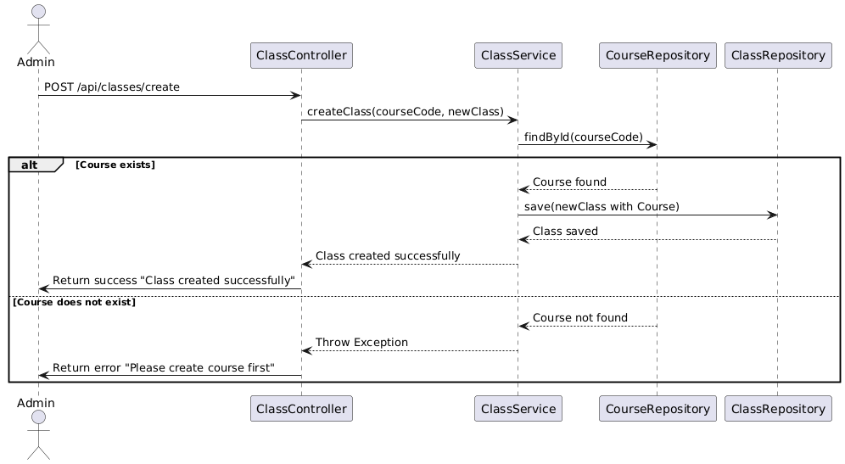UC-005: Update Class
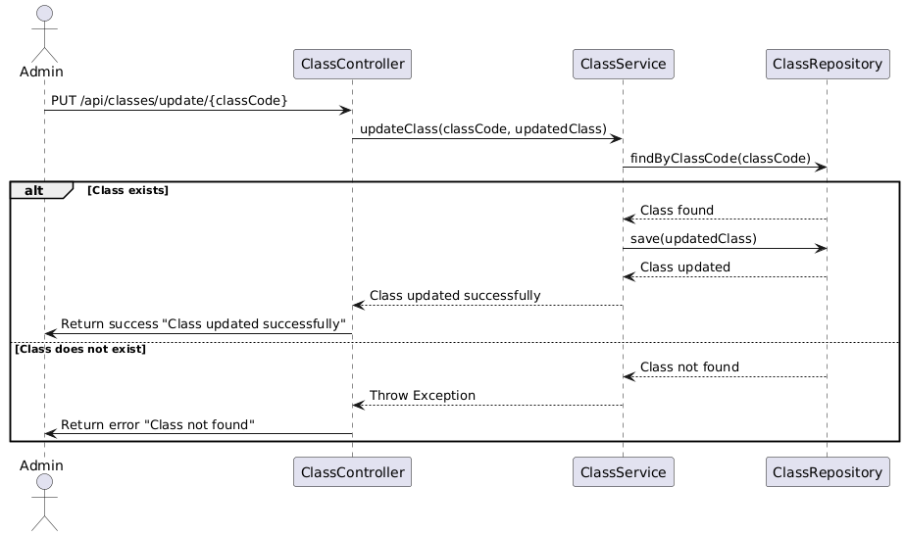UC-006: Delete Class
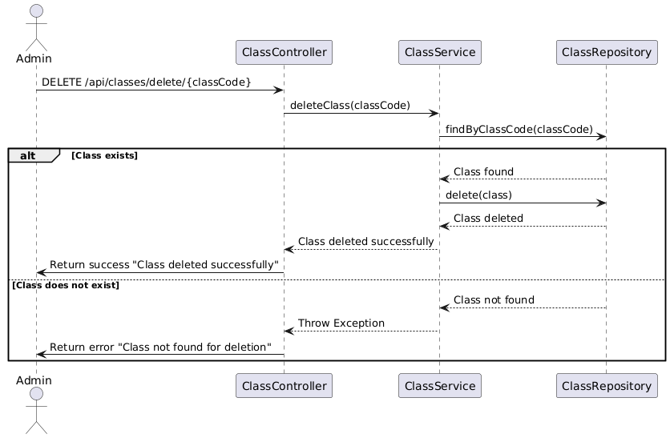UC-007: View All Classes
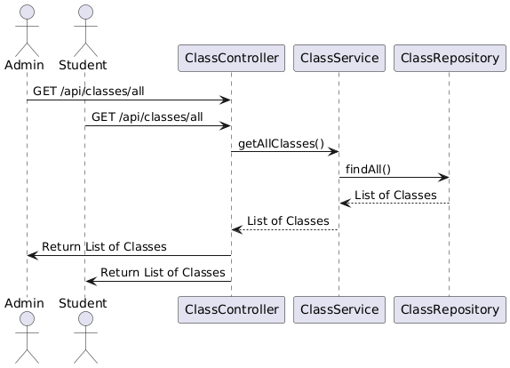
UC-008: Add Class to Cart
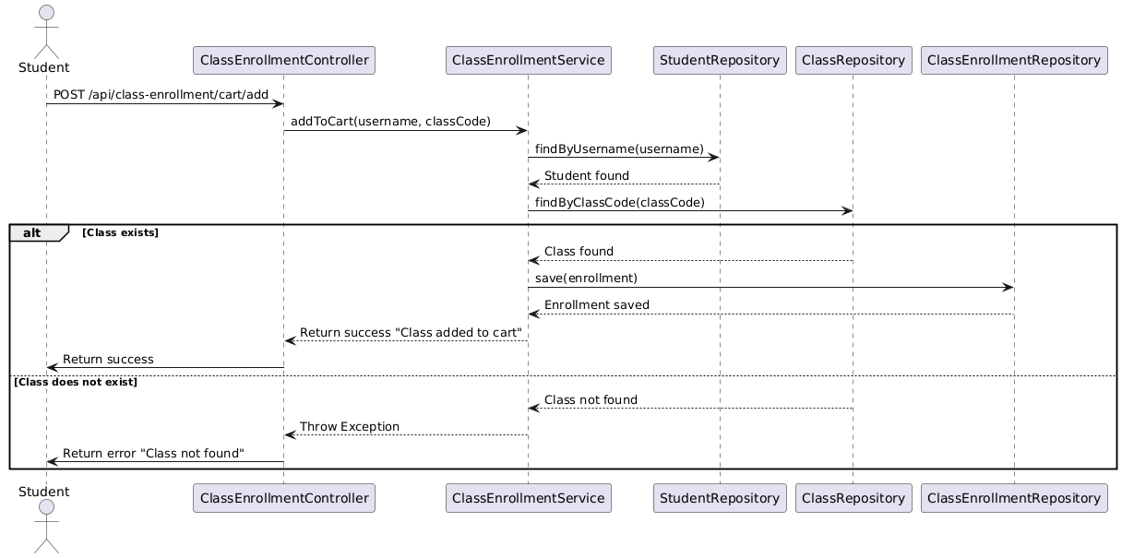UC-009: Remove Class from Cart
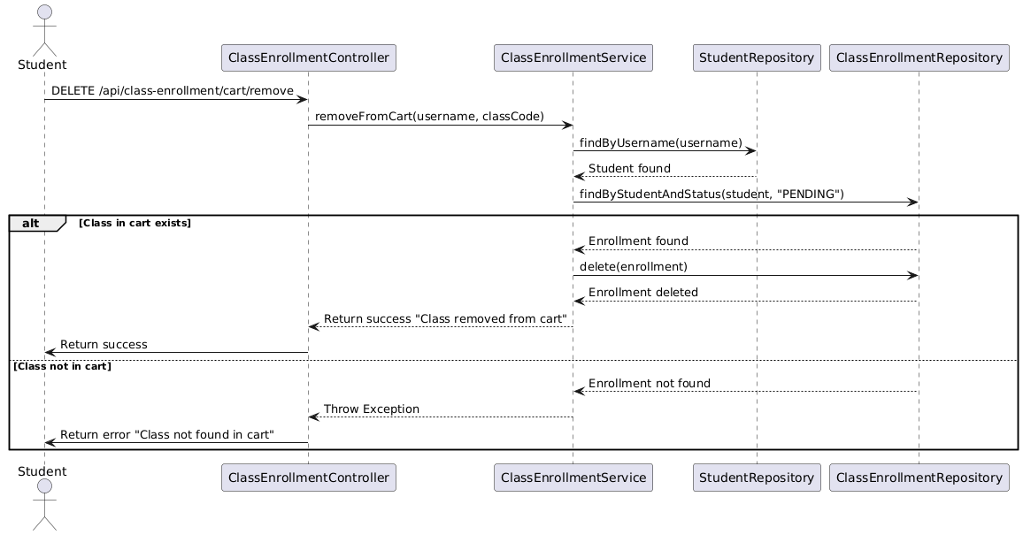UC-010: Register Class
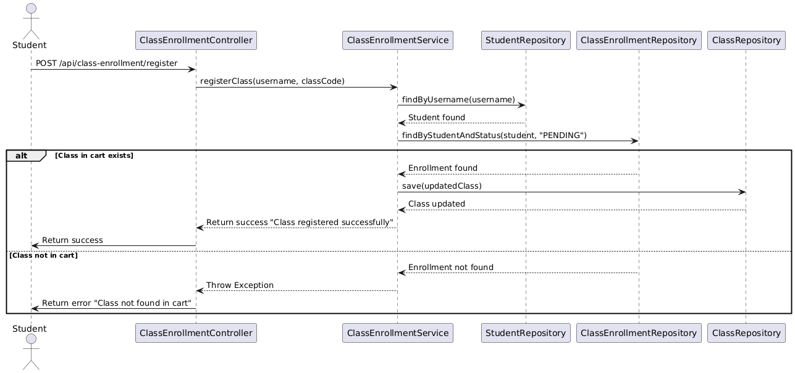UC-011: View Enrollment History
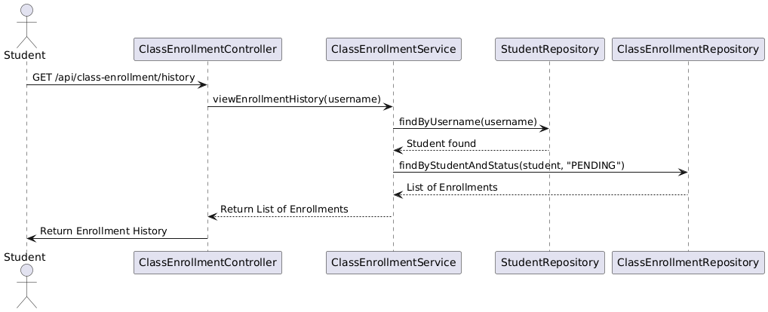UC-012: Toggle Student Login Access
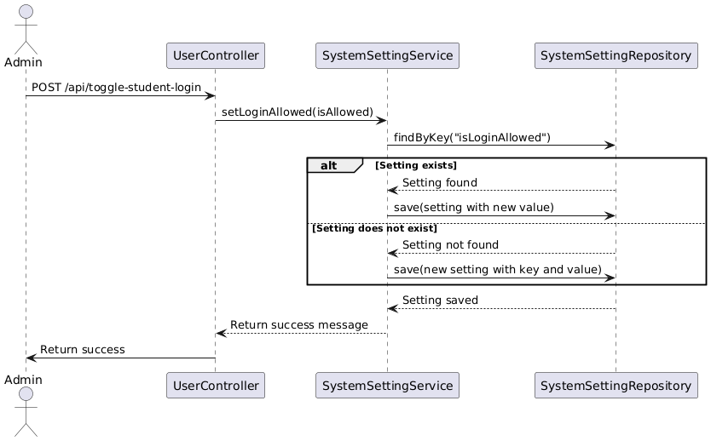
UC-013: View Student Information
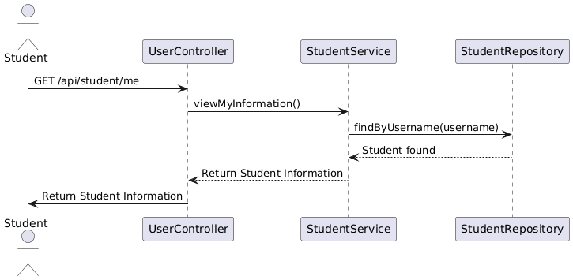UC-014: Change Student Password
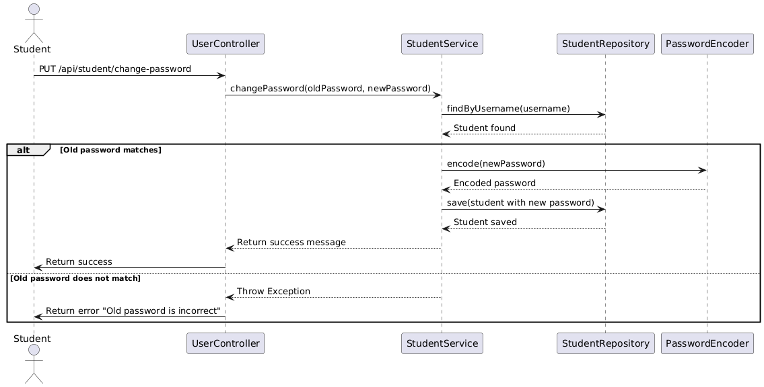UC-015: View Course Information
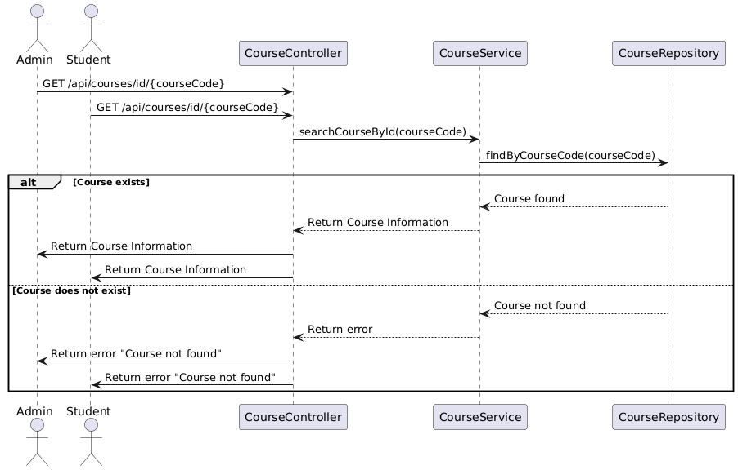UC-016: Update Course
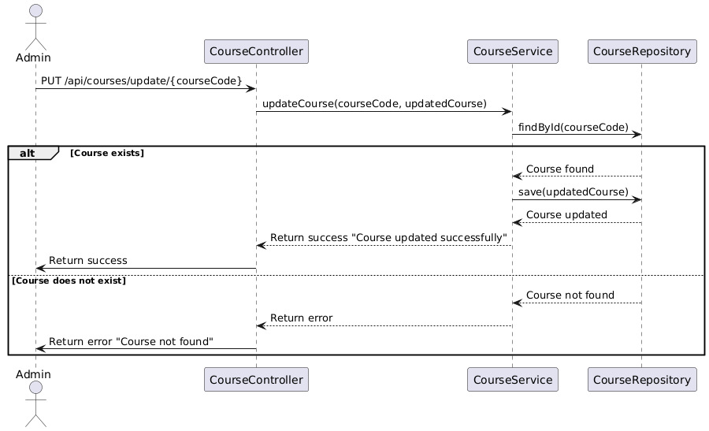UC-017: Delete Course
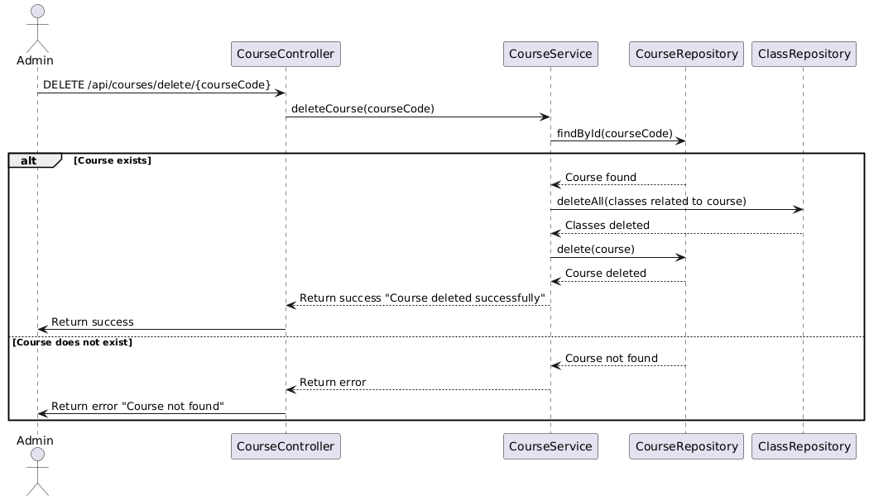UC-018: Search Classes by Course
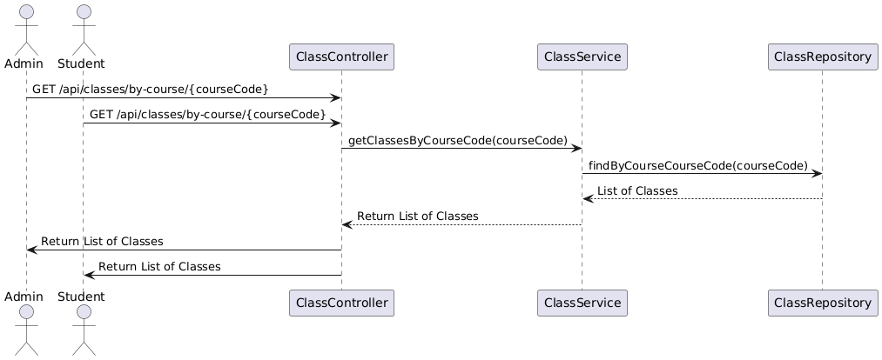UC-019: Search Courses by Name
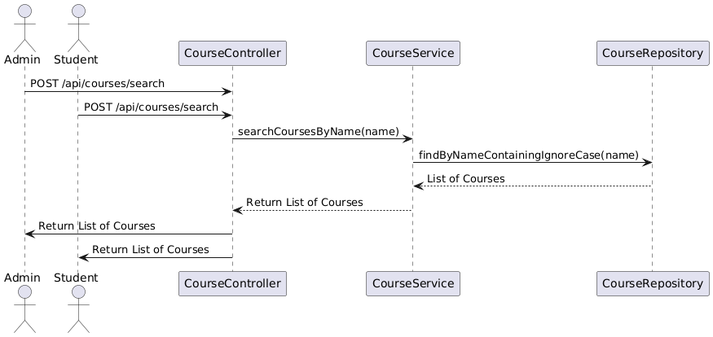UC-020: Refresh JWT Token
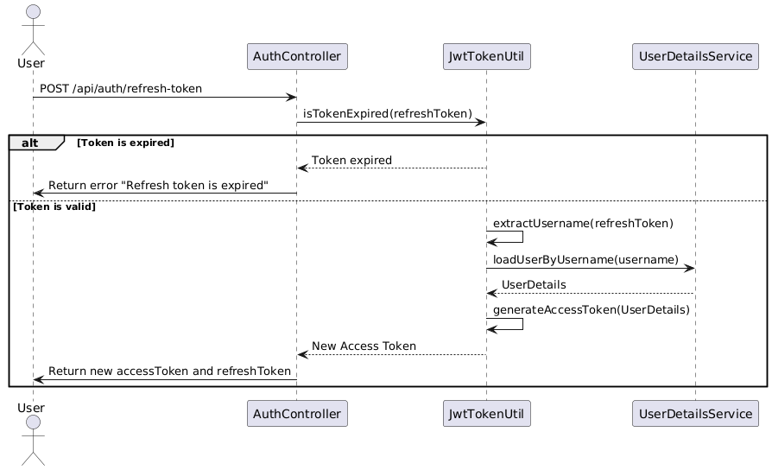UC-021: View All Students
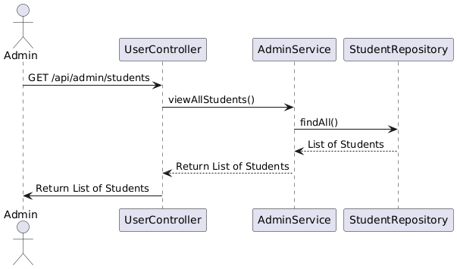UC-022: View Admin Information
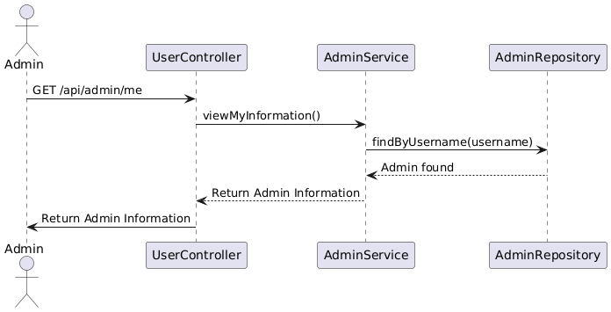UC-023: Delete Student
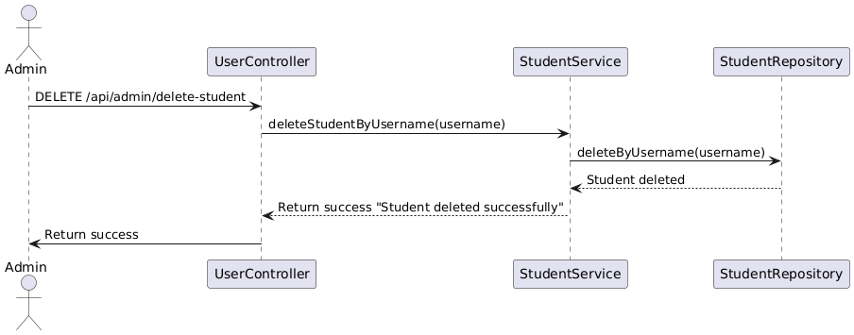UC-024: Delete Admin
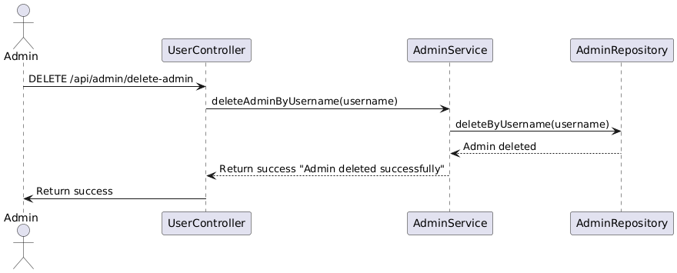UC-025: View All Courses
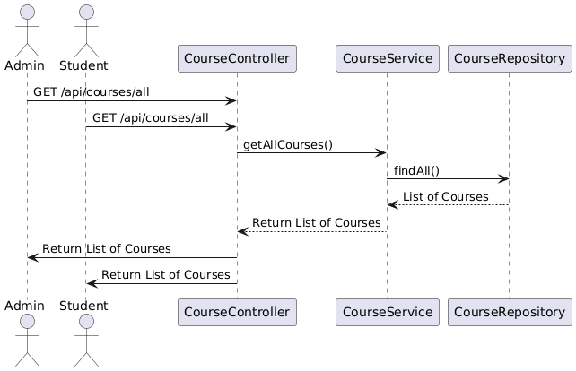UC-026: Create Course
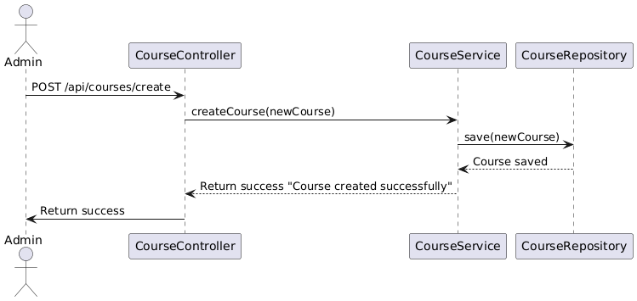UC-027: Add All Classes in Cart to Register
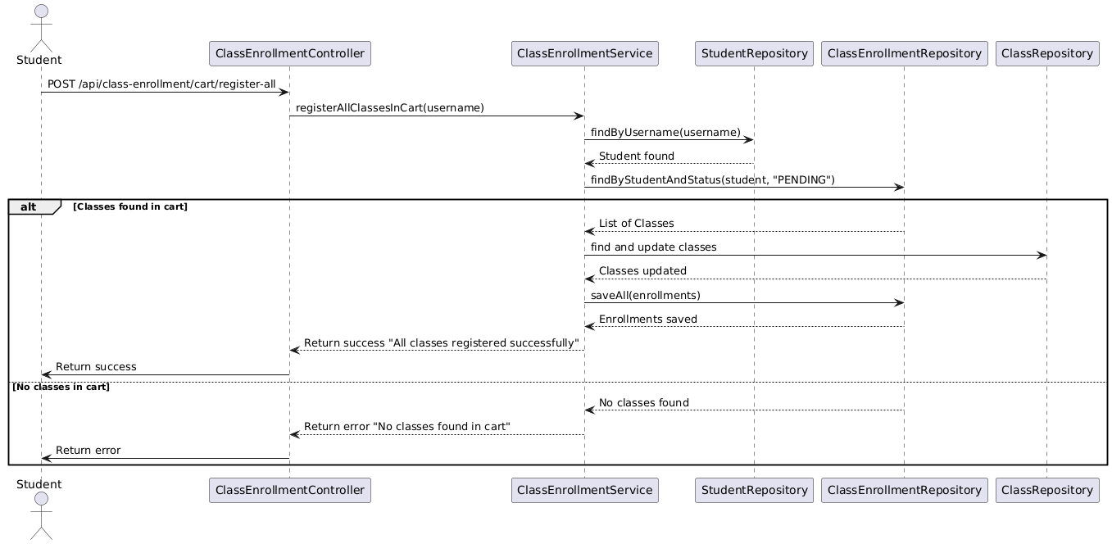
UC-028: Drop Class
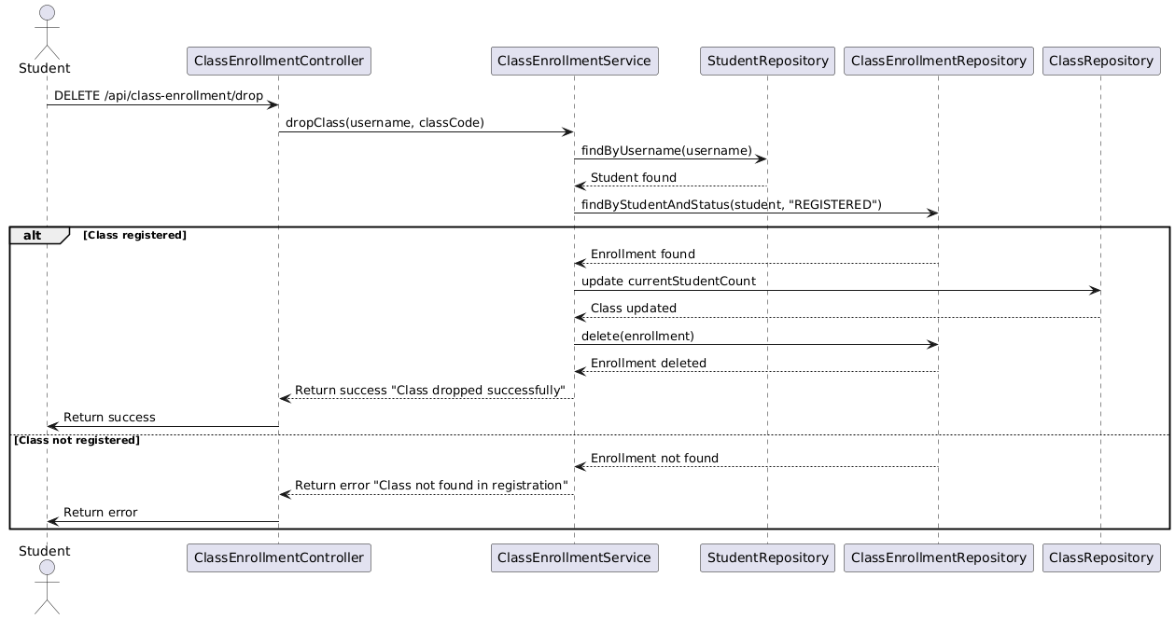UC-029: View Cart
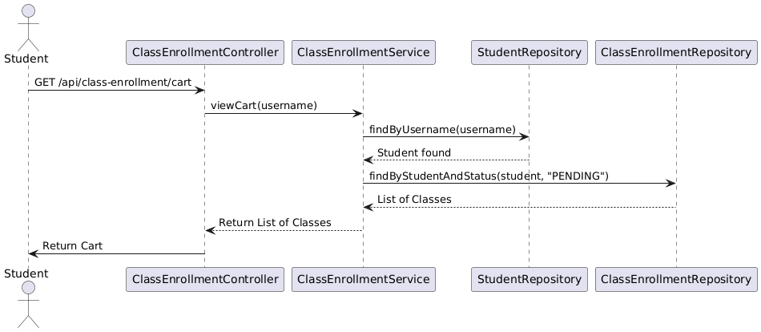UC-030: Search Class by Code
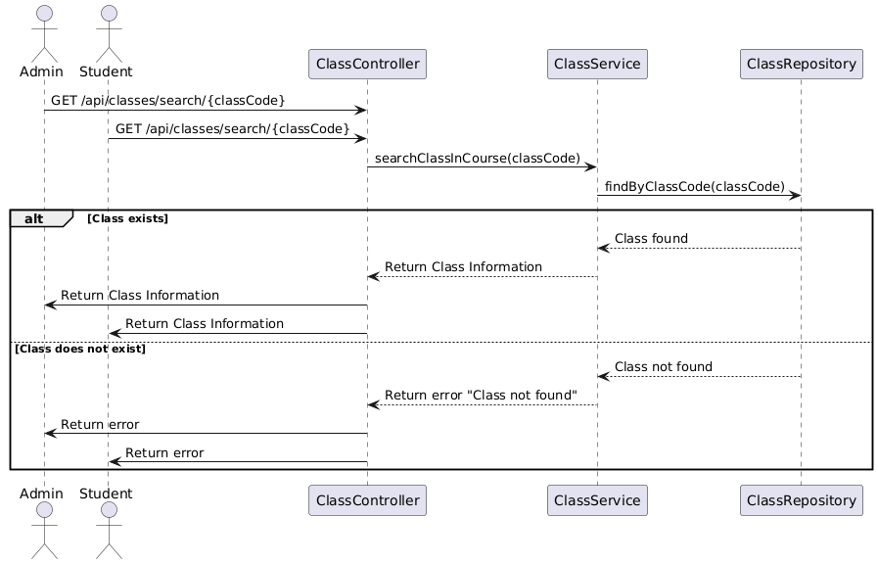

3.3 Build the Class Diagram
1. Course Management
This part of the diagram focuses on the CourseController, CourseService, and CourseRepository, along with related classes like Course and Class.
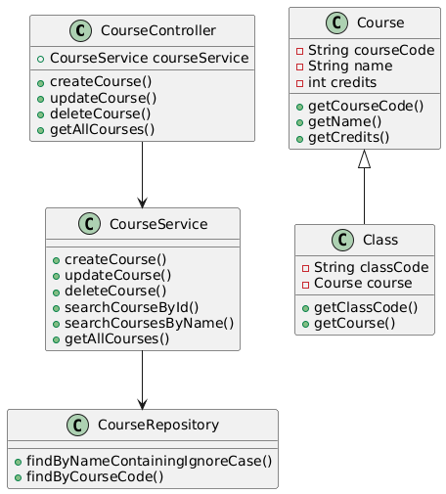

2. Class Management
This diagram will cover the ClassController, ClassService, and ClassRepository, along with the Class and related entities.
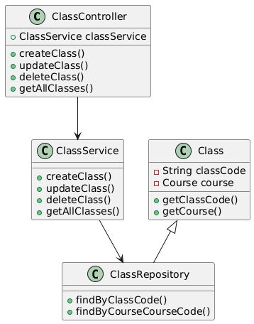

3. Student Enrollment Management
This section will focus on managing student enrollments through the ClassEnrollmentController, ClassEnrollmentService, and ClassEnrollmentRepository, including the ClassEnrollment class.
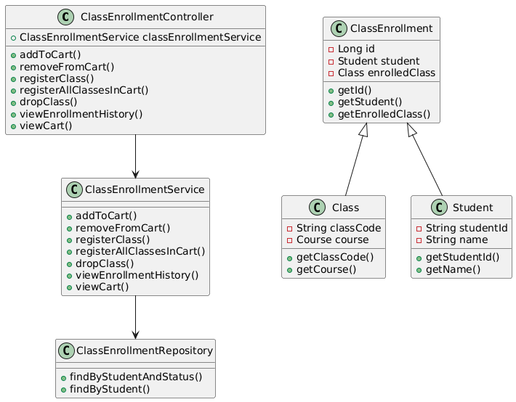

4. User and Admin Management
This section will include the UserController, AdminService, StudentService, and the related repositories for Admin and Student.
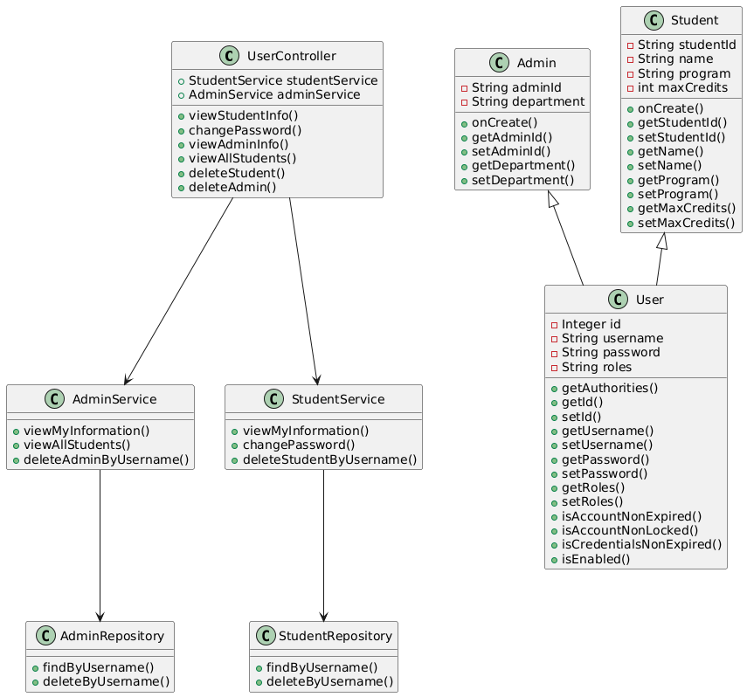

3.4 Build the Entity Relationship Diagram
ERD Diagram Description: The ERD diagram illustrates the relationships between entities such as Users, Admins, Students, Courses, Classes, Class Enrollments, and System Settings. The Users entity is the base class from which Admins and Students inherit. The Courses entity is linked to the Classes entity, indicating that a course can offer multiple classes. Students are linked to Classes through the Class Enrollments entity, which tracks the classes a student is enrolled in. System Settings manages the configurations within the system, unrelated to the other entities directly but essential for system operations.
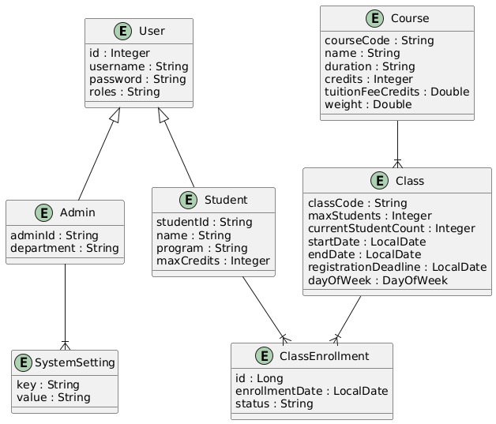

CHAPTER 4: SYSTEM DESIGN

4.1 Overview of System Architecture
The system is built using the Model-View-Controller (MVC) architectural pattern, which provides a clear separation of concerns. This architecture enhances the modularity, maintainability, and scalability of the application by dividing it into three primary components: Model, View, and Controller.

4.1.1 Components of the MVC Architecture
Model (Domain Layer)
Purpose: The Model represents the core data and business logic of the application. It defines the structure of data (entities), handles business rules, and manages the persistence of data.
Components:
- Entities: The key domain entities such as User, Student, Admin, Course, Class, and Enrollment are modeled as Java classes. Each entity corresponds to a table in the relational database, representing the application's data.
- Repositories: The application uses Spring Data JPA repositories for interacting with the database. These repositories handle CRUD (Create, Read, Update, Delete) operations for each entity, providing an abstraction over direct database access.
- Business Logic: The core business operations, such as user authentication, course enrollment, and schedule management, are encapsulated in service classes. These services ensure that the business rules are consistently applied across the application.
View (Presentation Layer)
Purpose: The View is responsible for presenting data to the user and capturing user inputs. It defines the user interface (UI) of the application and interacts with the user through a web browser.
Components:
- React.js Frontend: The frontend of the application is developed using React.js. It provides a dynamic and responsive user interface, allowing users to interact with the system through forms, buttons, and other UI elements.
- RESTful API Consumption: The React.js components communicate with the backend services via RESTful APIs. This ensures a clean separation between the frontend and backend, allowing for independent development and scaling.
- UI/UX Design: The interface is designed to be user-friendly, following modern design principles to ensure accessibility, responsiveness, and a positive user experience.
Controller (Application Layer)
Purpose: The Controller acts as an intermediary between the View and the Model. It processes incoming HTTP requests, interacts with the Model to perform operations, and returns the appropriate responses to the View.
Components:
- Spring Boot Controllers: The backend controllers are implemented using Spring Boot. Each controller corresponds to a specific module of the application (e.g., authentication, course management) and defines the endpoints for various actions like login, registration, class creation, etc.
- Request Handling: Controllers handle HTTP requests from the frontend, validate the inputs, invoke the necessary services, and return responses. This includes managing user sessions, processing form submissions, and handling API requests.
- Security Filters: The controllers are protected by security filters such as JWT authentication, ensuring that only authorized users can access certain endpoints.

4.1.2 MVC Pattern Implementation
The MVC pattern in this system ensures that the application is divided into distinct layers, each with its own responsibility:
- Model: Manages the data and business logic.
- View: Manages the user interface and user interactions.
- Controller: Manages the communication between the View and the Model.
This separation of concerns improves the maintainability and scalability of the application. It allows developers to work on the user interface, business logic, and database interactions independently, without affecting other parts of the system.

4.1.3 Security and Authentication
The system uses JWT (JSON Web Token) for securing API endpoints. The authentication process involves generating a JWT for each authenticated user, which is then included in the headers of subsequent requests. This ensures that only authenticated users can access certain features of the application.
- JWT Authentication: The JwtAuthenticationFilter handles the extraction and validation of JWT tokens from incoming requests. It ensures that requests are from authenticated users before processing.
- Role-based Access Control: The system uses role-based access control to ensure that only users with the appropriate roles (e.g., Admin, Student) can access specific functionalities.

4.1.4 Deployment and Scalability
The system is designed to be deployed on a cloud platform, taking advantage of containerization with Docker and orchestration with Kubernetes. This approach allows the system to scale efficiently, handling increased loads by deploying additional instances of the application.
- Docker: The application is containerized using Docker, ensuring consistency across different environments.
- Kubernetes: Kubernetes is used for managing the deployment, scaling, and operation of the application containers, providing high availability and fault tolerance.

4.2 Database Design
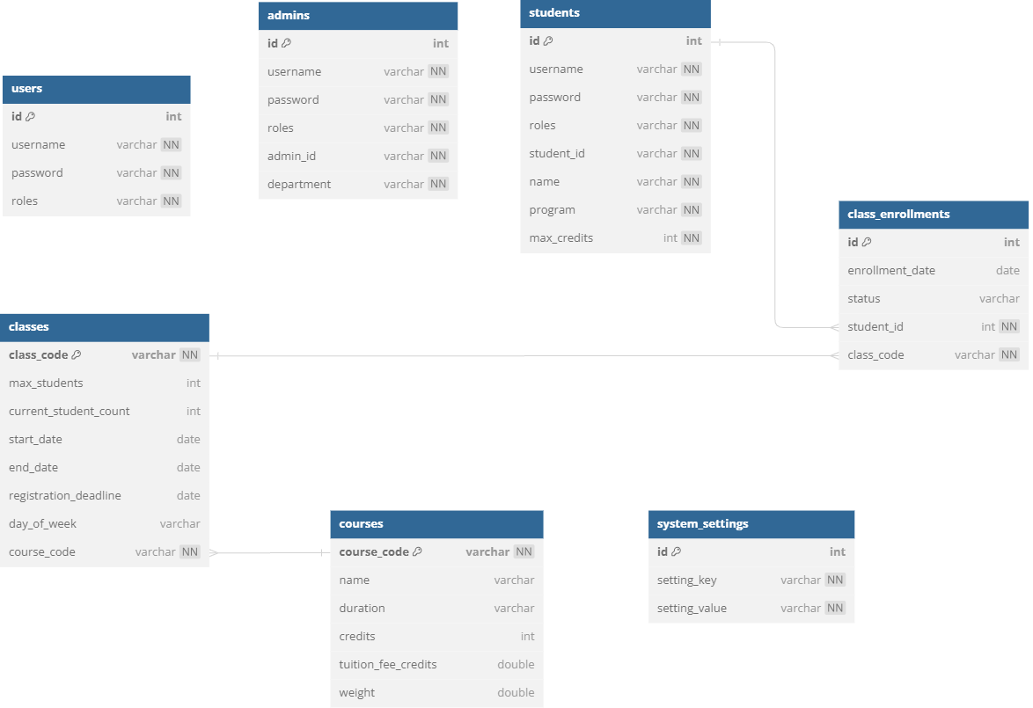
Table: users
Column Name | Data Type | Size | Constraints | Description | Notes
id | int |  | Primary Key | A unique identifier for each user.
username | varchar |  | Not Null, Unique | The username used for login.
password | varchar |  | Not Null | The password for the user, stored securely.
roles | varchar |  | Not Null | The roles assigned to the user.

Table: students
Column Name | Data Type | Size | Constraints | Description | Notes
id | int |  | Primary Key | A unique identifier for each student.
username | varchar |  | Not Null, Unique | The username used for login.
password | varchar |  | Not Null | The password for the student.
roles | varchar |  | Not Null | The roles assigned to the student.
student_id | varchar |  | Not Null, Unique | A unique student identifier.
name | varchar |  | Not Null | The name of the student.
program | varchar |  | Not Null | The academic program the student is enrolled in.
max_credits | int |  | Not Null | The maximum number of credits the student can take.

Table: admins
Column Name | Data Type | Size | Constraints | Description | Notes
id | int |  | Primary Key | A unique identifier for each admin.
username | varchar |  | Not Null, Unique | The username used for login.
password | varchar |  | Not Null | The password for the admin.
roles | varchar |  | Not Null | The roles assigned to the admin.
admin_id | varchar |  | Not Null, Unique | A unique identifier for the admin.
department | varchar |  | Not Null | The department the admin is responsible for.

Table: courses
Column Name | Data Type | Size | Constraints | Description | Notes
course_code | varchar |  | Primary Key | A unique code for the course.
name | varchar |  | Not Null | The name of the course.
duration | varchar |  | Not Null | The duration of the course.
credits | int |  | Not Null | The number of credits the course is worth.
tuition_fee_credits | double |  | Not Null | The tuition fee calculated in credits.
weight | double |  | Not Null | The weight of the course in the program.

Table: classes
Column Name | Data Type | Size | Constraints | Description | Notes
class_code | varchar |  | Primary Key | A unique code for the class.
max_students | int |  | Not Null | The maximum number of students allowed.
current_student_count | int |  | Not Null | The current number of students enrolled.
start_date | date |  | Not Null | The start date of the class.
end_date | date |  | Not Null | The end date of the class.
registration_deadline | date |  | Not Null | The deadline for registration.
day_of_week | enum |  | Not Null | The day of the week the class takes place.

4.3 Package Design

4.3.1 Model Package
Class Name | Description | Dependencies
User | Represents a user in the system with basic information such as username, password, and roles. | None
Student | Extends User to include additional fields specific to students such as student ID, program, and max credits. | User
Admin | Extends User to include additional fields specific to admins such as admin ID and department. | User
Course | Represents the course details such as course code, name, credits, and duration. | None
Class | Represents a class within a course, including max students, start/end dates, and registration deadline. | Course
ClassEnrollment | Manages the enrollment details of students in classes. | Student, Class
SystemSetting | Stores configuration settings for the system. | None

4.3.2 Service Package
Class Name | Description | Dependencies
UserService | Provides business logic for managing users, including authentication and registration. | User
StudentService | Manages operations specific to students, such as retrieving student information and managing class enrollments. | Student, ClassEnrollment
AdminService | Handles admin operations, such as managing users and viewing student information. | Admin, Student
CourseService | Provides business logic for managing courses, including creation, updating, and deletion. | Course, Class
ClassService | Manages the lifecycle of classes, including creation, updates, and retrieval of class information. | Class, Course
ClassEnrollmentService | Manages the enrollment process for students into classes, handling cart and registration logic. | ClassEnrollment, Class, Student
SystemSettingService | Provides functionality for managing and retrieving system settings. | SystemSetting

4.3.3 Controller Package
Class Name | Description | Dependencies
UserController | Handles HTTP requests related to user operations like login and registration. | UserService
StudentController | Manages HTTP requests related to student operations, such as viewing student data and enrolling in classes. | StudentService, ClassEnrollmentService
AdminController | Handles HTTP requests for admin operations, such as user management and system settings. | AdminService, StudentService
CourseController | Manages HTTP requests related to course operations like adding or updating courses. | CourseService
ClassController | Handles HTTP requests for managing classes, including class creation and updates. | ClassService
ClassEnrollmentController | Handles the enrollment process through HTTP requests, including adding classes to a cart and registration. | ClassEnrollmentService, ClassService, StudentService
AuthController | Manages authentication-related HTTP requests, such as generating access and refresh tokens. | UserService, AdminService

4.4 Class Design

4.4.1 Overview
The following class diagram provides a detailed visual representation of the relationships between the classes within the system. It illustrates the core entities, their attributes, methods, and the associations between them. This diagram serves as a blueprint for understanding the system's structure and is essential for both development and maintenance.

4.4.2 Class Diagram Description
Class Name | Attributes | Methods | Description
User | id: Integer, username: String, password: String, roles: String | getAuthorities(), getUsername(), getPassword(), isAccountNonExpired(), isAccountNonLocked(), isCredentialsNonExpired(), isEnabled() | Represents a generic user in the system. Parent class for specific users like Admin and Student.
Admin | adminId: String, department: String | getAdminId(), getDepartment() | Represents an admin user with additional attributes like adminId and department. Inherits from User.
Student | studentId: String, name: String, program: String, maxCredits: Integer | getStudentId(), getName(), getProgram(), getMaxCredits() | Represents a student user with attributes specific to students. Inherits from User.
Course | courseCode: String, name: String, duration: String, credits: Integer, tuitionFeeCredits: Double, weight: Double | getCourseCode(), getName(), getDuration(), getCredits(), getTuitionFeeCredits(), getWeight() | Represents a course in the system, including details such as course code, name, and credits.
Class | classCode: String, course: Course, maxStudents: Integer, currentStudentCount: Integer, startDate: LocalDate, endDate: LocalDate, registrationDeadline: LocalDate, dayOfWeek: DayOfWeek | getClassCode(), getCourse(), getMaxStudents(), getCurrentStudentCount(), getStartDate(), getEndDate(), getRegistrationDeadline(), getDayOfWeek() | Represents a specific instance of a course, detailing its schedule and capacity.
ClassEnrollment | id: Long, student: Student, enrolledClass: Class, enrollmentDate: LocalDate, status: String | getId(), getStudent(), getEnrolledClass(), getEnrollmentDate(), getStatus() | Manages the enrollment details of students in classes.
SystemSetting | id: Long, key: String, value: String | getId(), getKey(), getValue() | Stores configuration settings for the system.

4.4.3 Class Diagram
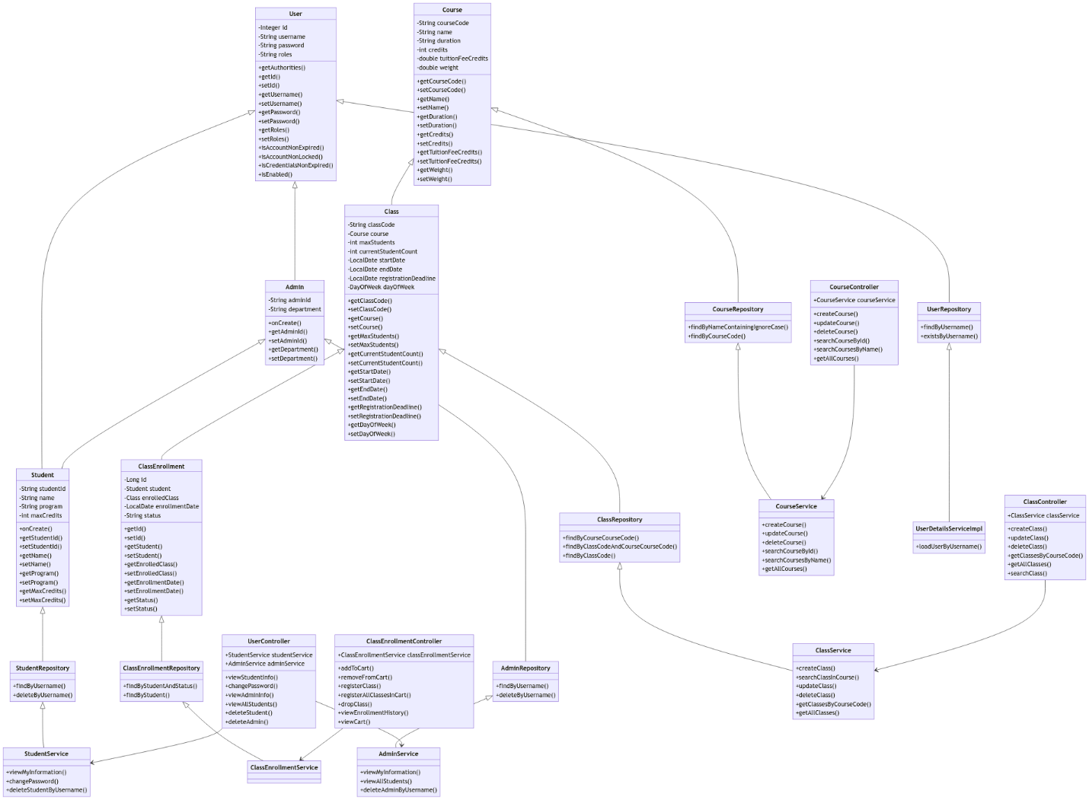

Class Diagram for User and Role Management
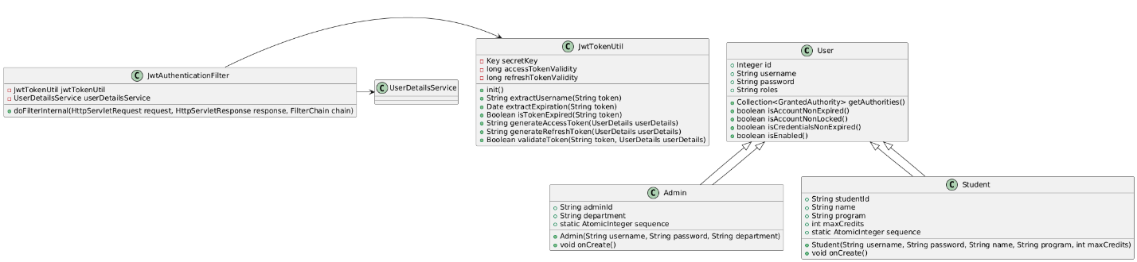

Class Diagram for Course Management
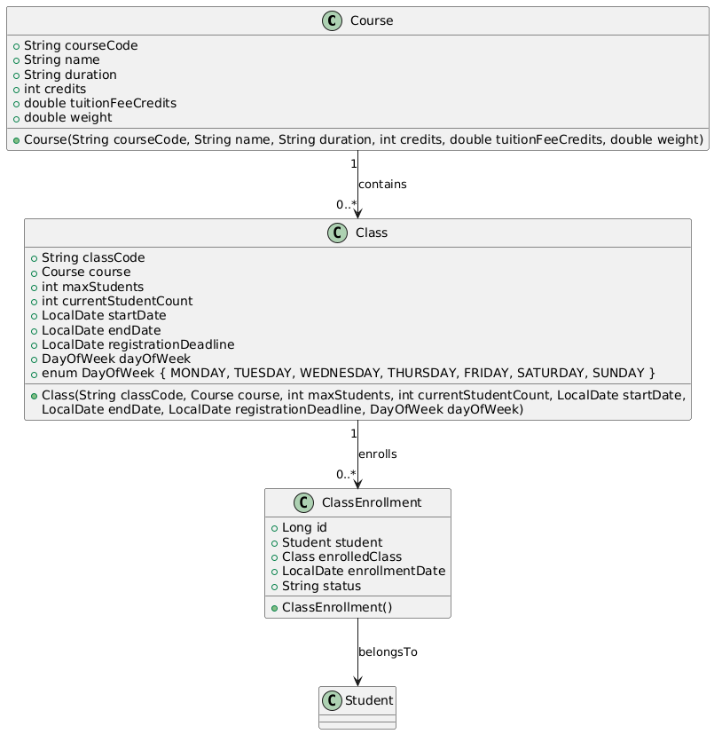

Class Diagram for Authentication and Authorization
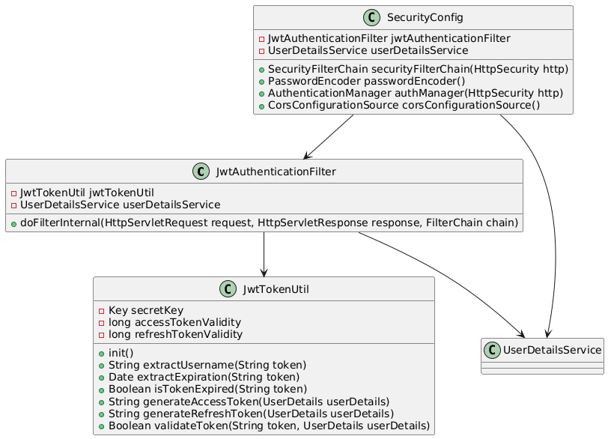

4.6 User Interface Design

4.6.1 Transition diagram between interfaces
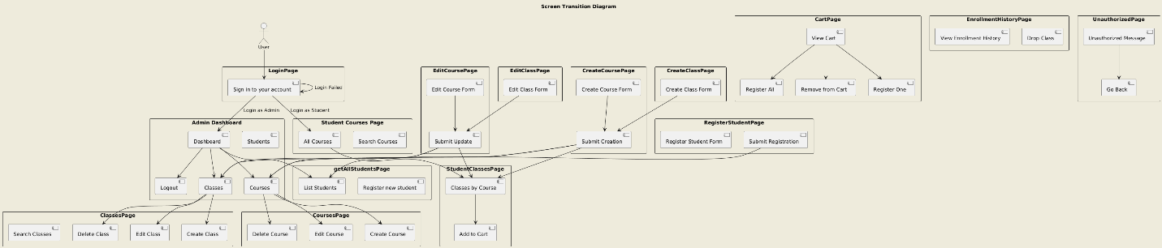

4.6.2 Design specifications for screen interfaces
Log In Page
Control | Data Information | Type | Attributes | Notes
Username Field | User enters the username | Text input | Required
Password Field | User enters the password | Text input | Required
Login Button | When clicked, it triggers login process | Button
Error Message | Displays if login fails | Text | Red font color

Admin Dashboard Page
Control | Data Information | Type | Attributes | Notes
Manage Students Button | Opens the student management screen | Button | Display on click
Manage Classes Button | Opens the class management screen | Button | Display on click
Manage Courses Button | Opens the course management screen | Button | Display on click
Logout Button | Logs out the user and redirects to the login screen | Button | Display on click

Student Courses Page
Control | Data Information | Type | Attributes | Notes
Search Bar | Allows searching for courses by name or code | Text input
Course List | Displays a list of courses | List | Displays course name, code, duration, credits, etc.
Enroll Button | Enrolls the student in the selected course | Button | Display on click

Admin Classes Page
Control | Data Information | Type | Attributes | Notes
Search Bar | Allows searching for classes by name or code | Text input
Create Class Button | Opens the create class form | Button | Display on click
Edit Class Button | Opens the edit form for the selected class | Button | Display on click
Delete Class Button | Deletes the selected class | Button | Display on click | Confirmation dialog required
Class List | Displays a list of classes | List | Displays class name, code, start date, end date, etc.

Admin Courses Page
Control | Data Information | Type | Attributes | Notes
Search Bar | Allows searching for courses by name or code | Text input
Create Course Button | Opens the create course form | Button | Display on click
Edit Course Button | Opens the edit form for the selected course | Button | Display on click
Delete Course Button | Deletes the selected course | Button | Display on click | Confirmation dialog required
Course List | Displays a list of courses | List | Displays course name, code, duration, credits, etc.

Create Course Page
Control | Data Information | Type | Attributes | Notes
Course Code Field | Input for the course code | Text input | Required
Course Name Field | Input for the course name | Text input | Required
Course Duration Field | Input for the course duration | Text input | Required
Course Credits Field | Input for the course credits | Number input | Required
Course Weight Field | Input for the course weight | Number input | Required
Submit Button | Submits the new course information | Button | Display on click

Edit Course Page
Control | Data Information | Type | Attributes | Notes
Course Code Field | Input for the course code | Text input | Read-only
Course Name Field | Input for the course name | Text input | Required
Course Duration Field | Input for the course duration | Text input | Required
Course Credits Field | Input for the course credits | Number input | Required
Course Weight Field | Input for the course weight | Number input | Required
Submit Button | Submits the updated course information | Button | Display on click

Register Student Page
Control | Data Information | Type | Attributes | Notes
Username Field | Input for the student's username | Text input | Required
Password Field | Input for the student's password | Text input | Required
Name Field | Input for the student's name | Text input | Required
Program Field | Input for the student's program | Text input | Required
Max Credits Field | Input for the maximum credits | Number input | Required
Submit Button | Submits the new student information | Button | Display on click

Student Classes Page
Control | Data Information | Type | Attributes | Notes
Search Bar | Allows searching for classes by name or code | Text input
Class List | Displays a list of classes | List | Displays class name, code, start date, end date, etc.
Add to Cart Button | Adds the selected class to the student's cart | Button | Display on click

Student Cart Page
Control | Data Information | Type | Attributes | Notes
Class List | Displays a list of classes in the cart | List | Displays class name, code, status, etc.
Remove from Cart Button | Removes the selected class from the cart | Button | Display on click
Register One Button | Registers the selected class | Button | Display on click
Register All Button | Registers all classes in the cart | Button | Display on click

Enrollment History Page
Control | Data Information | Type | Attributes | Notes
Enrollment List | Displays a list of enrolled classes | List | Displays class name, code, enrollment status, etc.
Drop Class Button | Drops the selected class | Button | Display on click | Confirmation dialog required

Unauthorized Page
Control | Data Information | Type | Attributes | Notes
Unauthorized Message | Displays an unauthorized access message | Text | Bold font
Go Back Button | Redirects back to the previous page | Button | Display on click

CHAPTER 5: PROGRAM DEMONSTRATION

5.1 Libraries and Tools Used
In this section, we describe the various libraries and tools used to develop and demonstrate the program, covering both the back-end and front-end components. The choice of tools and libraries was driven by the need for robustness, security, and ease of development.

5.1.1 Back-End Libraries and Frameworks
Spring Boot:
- Description: Spring Boot is a powerful, flexible, and comprehensive framework for building production-ready Java applications quickly. It simplifies the configuration of Spring applications and allows for easy integration of various components.
- Use Case: Used to build the core of the server-side application, managing dependencies, and enabling a variety of functionalities such as dependency injection, security, data access, and more.
Spring Security:
- Description: Spring Security is a powerful and customizable authentication and access-control framework for Java applications.
- Use Case: Implemented to secure the application, handling user authentication, and authorization, particularly using JWT (JSON Web Token) for securing API endpoints.
JWT (Java Web Token):
- Description: JWT is an open standard for securely transmitting information between parties as a JSON object.
- Use Case: Used for creating tokens that authenticate users in a stateless way, ensuring secure access to APIs.
Hibernate/JPA:
- Description: Hibernate is an ORM (Object-Relational Mapping) tool for Java, providing a framework for mapping an object-oriented domain model to a relational database.
- Use Case: Used for database operations, including managing the persistence of objects in the application, and interacting with the underlying database.

5.1.2 Front-End Libraries and Tools
React.js:
- Description: React.js is a JavaScript library for building user interfaces, particularly single-page applications where data changes over time.
- Use Case: Used for creating the front-end of the application, ensuring a dynamic and responsive user experience. It communicates with the back-end APIs to fetch and display data.
Tailwind CSS:
- Description: Tailwind is a popular CSS library for building responsive and mobile-first websites.
- Use Case: Used for styling the front-end components, ensuring the application is visually appealing and works well across different devices and screen sizes.
Node.js & NPM:
- Description: Node.js is a JavaScript runtime built on Chrome's V8 JavaScript engine, while NPM (Node Package Manager) is the default package manager for Node.js.
- Use Case: Used to manage front-end dependencies and scripts, enabling the installation and management of React.js and other front-end libraries.

5.1.3 Development and Deployment Tools
IntelliJ IDEA:
- Description: IntelliJ IDEA is an integrated development environment (IDE) for Java development.
- Use Case: Used as the primary IDE for developing the back-end components of the application, offering powerful code navigation, refactoring, and debugging tools.
Visual Studio Code:
- Description: Visual Studio Code is a lightweight but powerful source code editor.
- Use Case: Used for developing the front-end React.js application, offering extensions and features that enhance JavaScript and React development.
Maven:
- Description: Maven is a build automation tool used primarily for Java projects.
- Use Case: Used for managing project dependencies, building the project, and running tests.
Postman:
- Description: Postman is a collaboration platform for API development.
- Use Case: Used for testing API endpoints, ensuring that the back-end services respond correctly to HTTP requests.

5.2 Demonstration Results
After completing the development phases, the project team successfully delivered the expected outcomes. The final product is a sophisticated software application that addresses both user management and course management in an educational environment. This dual-purpose application streamlines operations that traditionally required separate systems for user and course management, thus improving efficiency and usability.
Application Information:
- Total Lines of Code: 7,000
- Total Packages: 17
- Total Classes: 24
- Total XML Files: 8
- Total Source Code Size: ~7MB
The application was packaged successfully, and the following results were observed during the demonstration:
- User and Role Management: The application effectively handles user management, including the registration of new students and admins, and ensures secure login and authentication through JWT. The system manages roles efficiently, allowing admins to have full control over user permissions.
- Course and Class Management: The course management module functions seamlessly, allowing admins to create, update, and delete courses. The system ensures that students can view and enroll in available classes, with all interactions tracked and managed within the application.
- System Performance: During the demonstration, the system showcased its ability to handle multiple concurrent users without performance degradation. The application responded quickly to user actions, demonstrating the robustness of the underlying architecture.
- Security and Access Control: The integration of JWT for secure access and role-based permissions was tested and proved effective. Only authorized users were able to access restricted areas of the system, ensuring that data integrity and security were maintained throughout the demonstration.
- User Interface and Experience: The user interface was intuitive, allowing users to navigate easily between different sections of the application. The use of modern UI principles ensured that the application was both responsive and user-friendly, enhancing the overall user experience.
The demonstration results confirm that the application meets the initial project goals and is ready for deployment in a real-world educational environment, offering a secure, efficient, and user-friendly platform for managing users and courses.

5.3 Interface illustrates the program's functions
1. Login Page
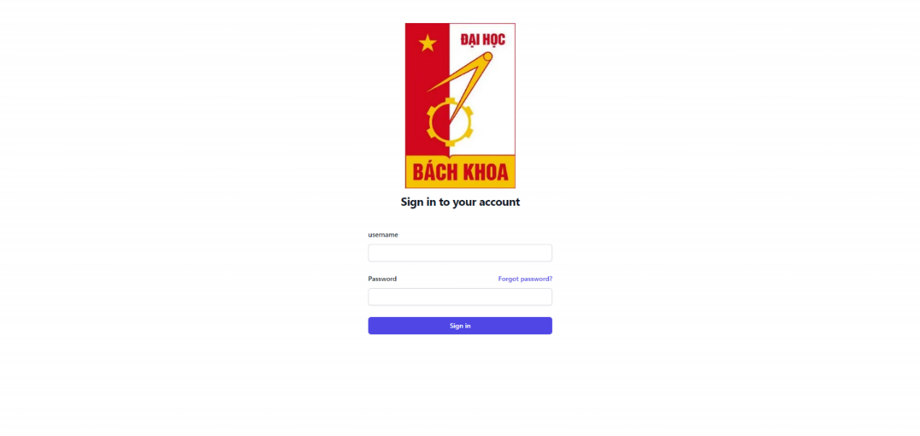

2. Admin Dashboard


3. Student Courses Page
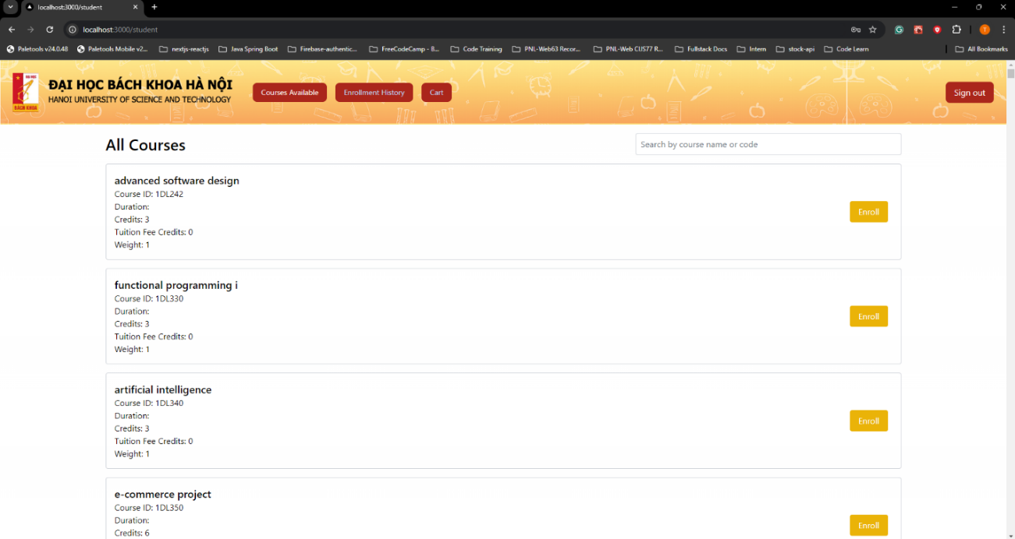

4. Classes Page
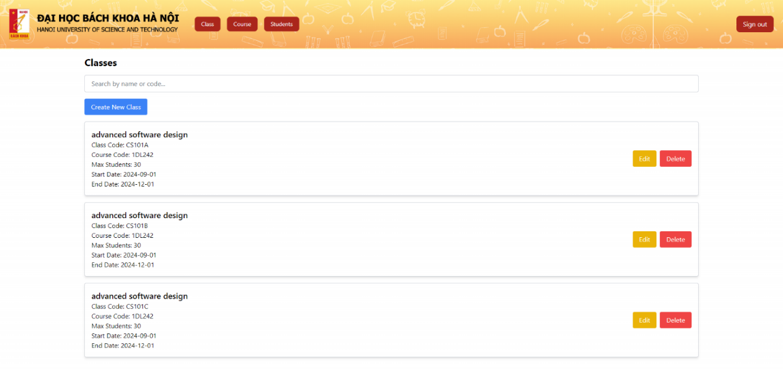

5. Courses Page
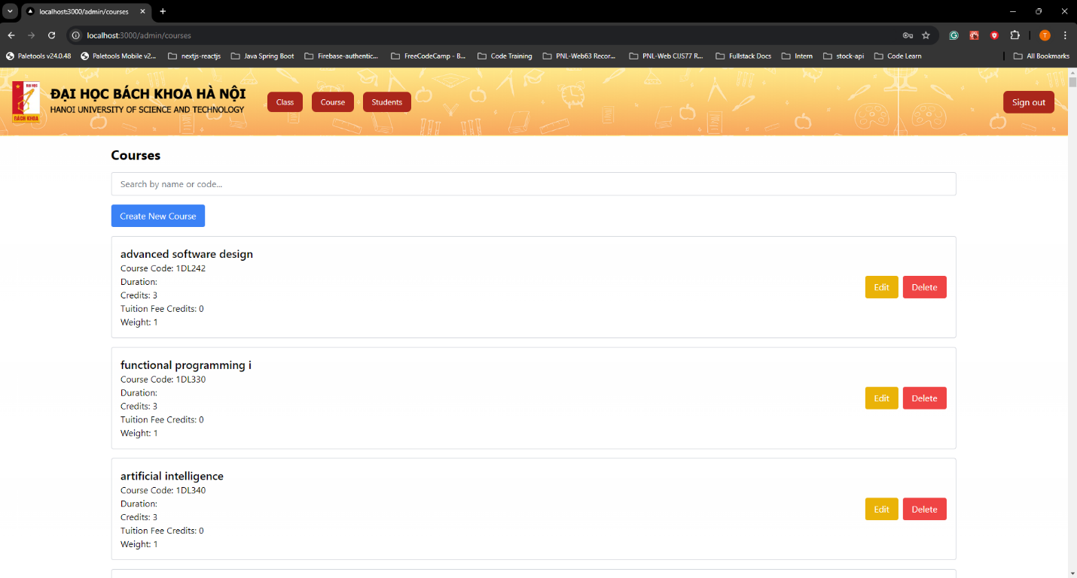

6. Create Course Page
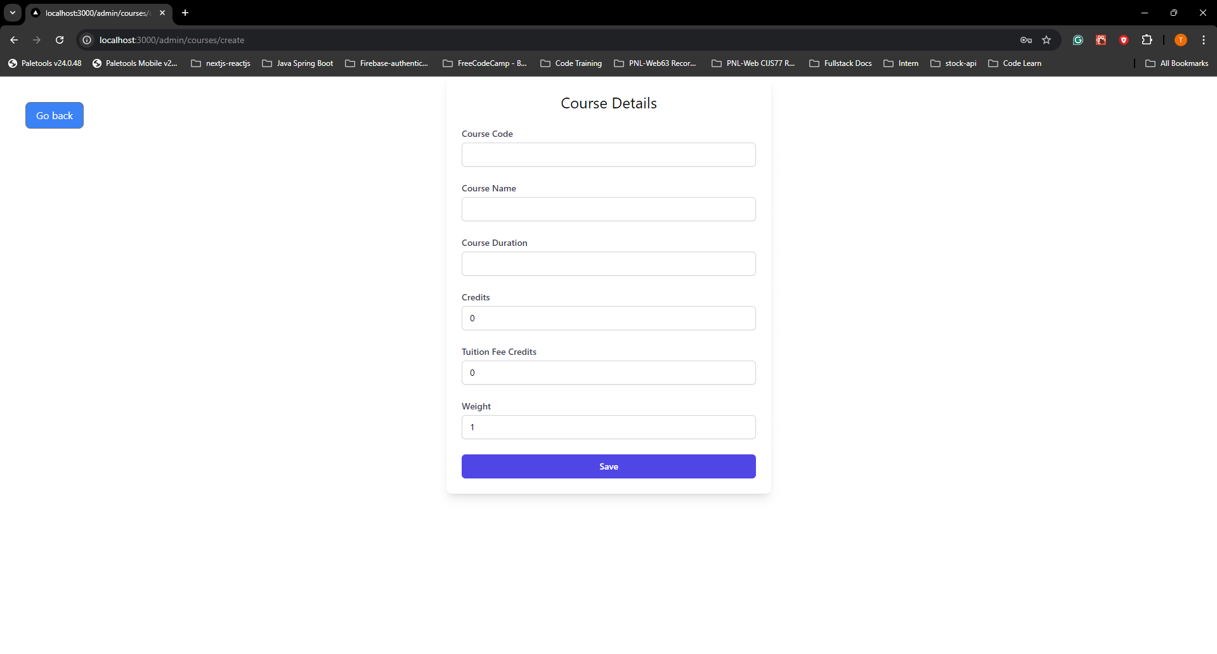

7. Edit Course Page
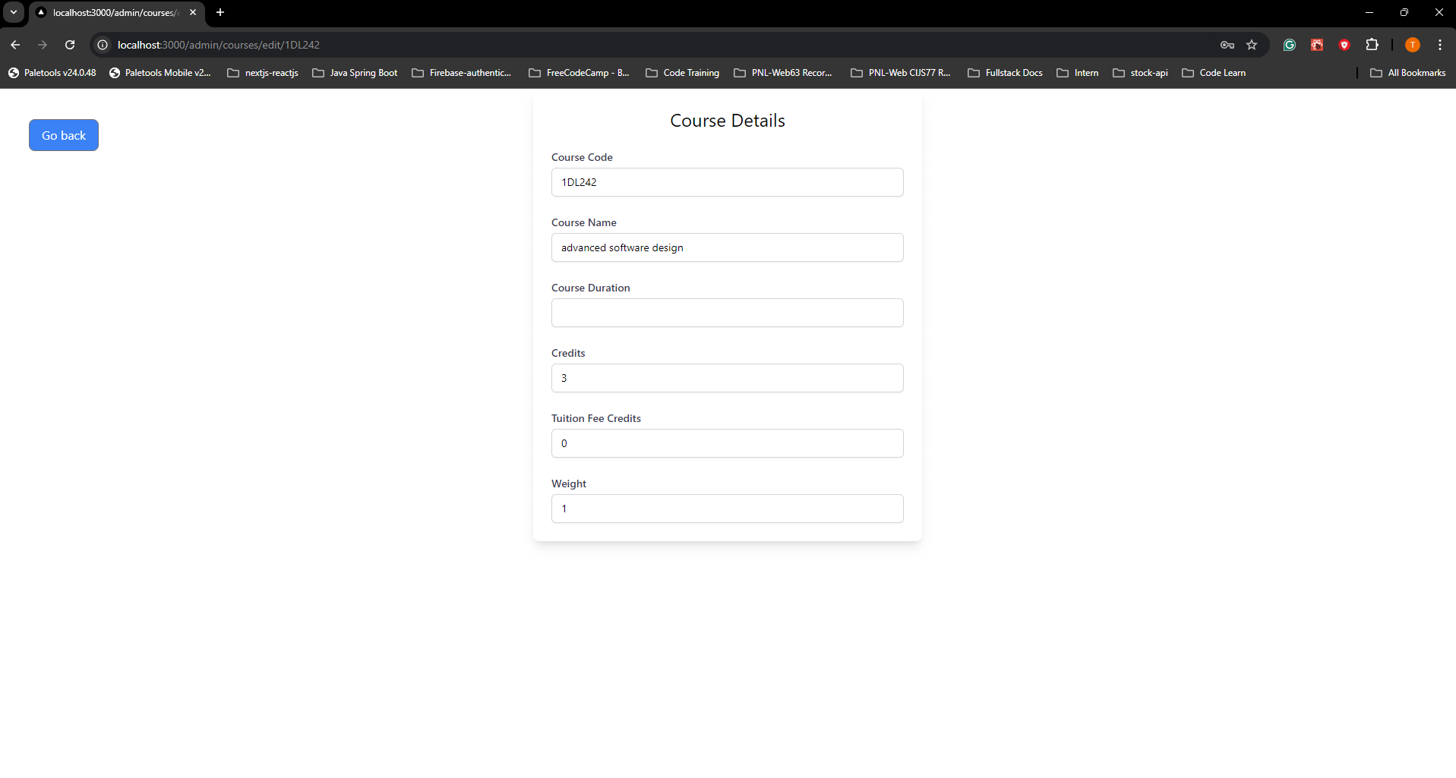

8. Register Student Page
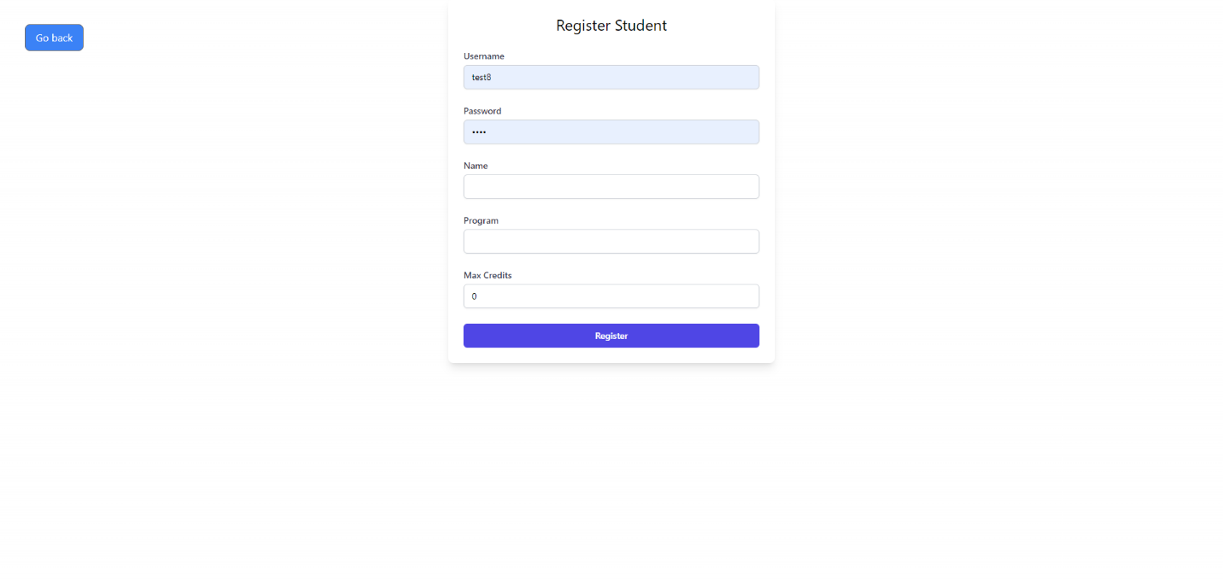

9. Student Classes Page
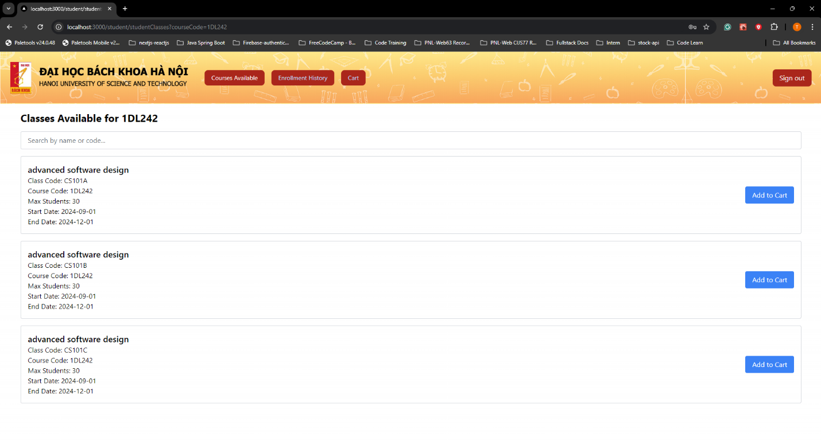

10. Cart Page
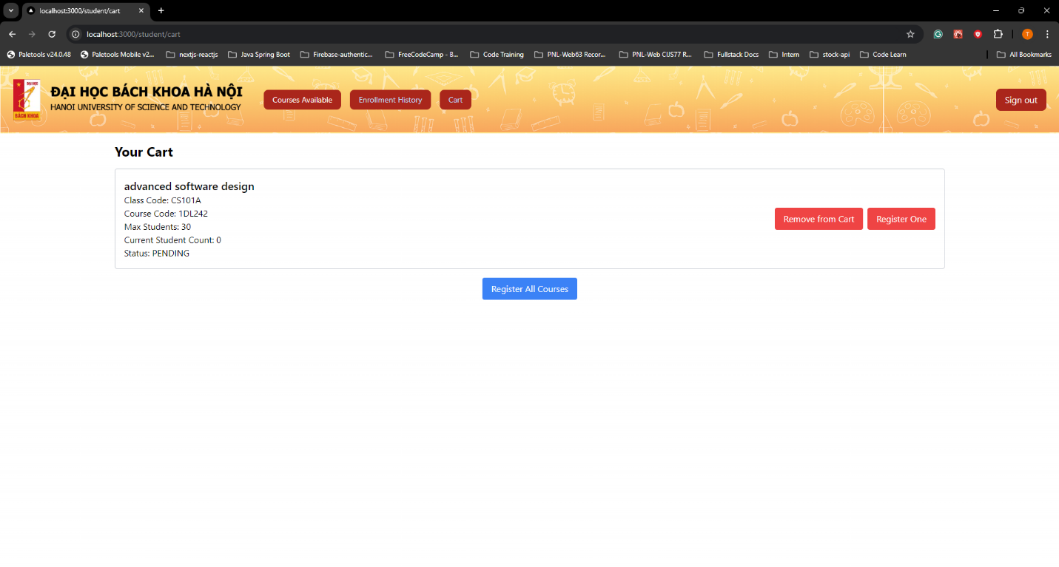

11. Enrollment History Page
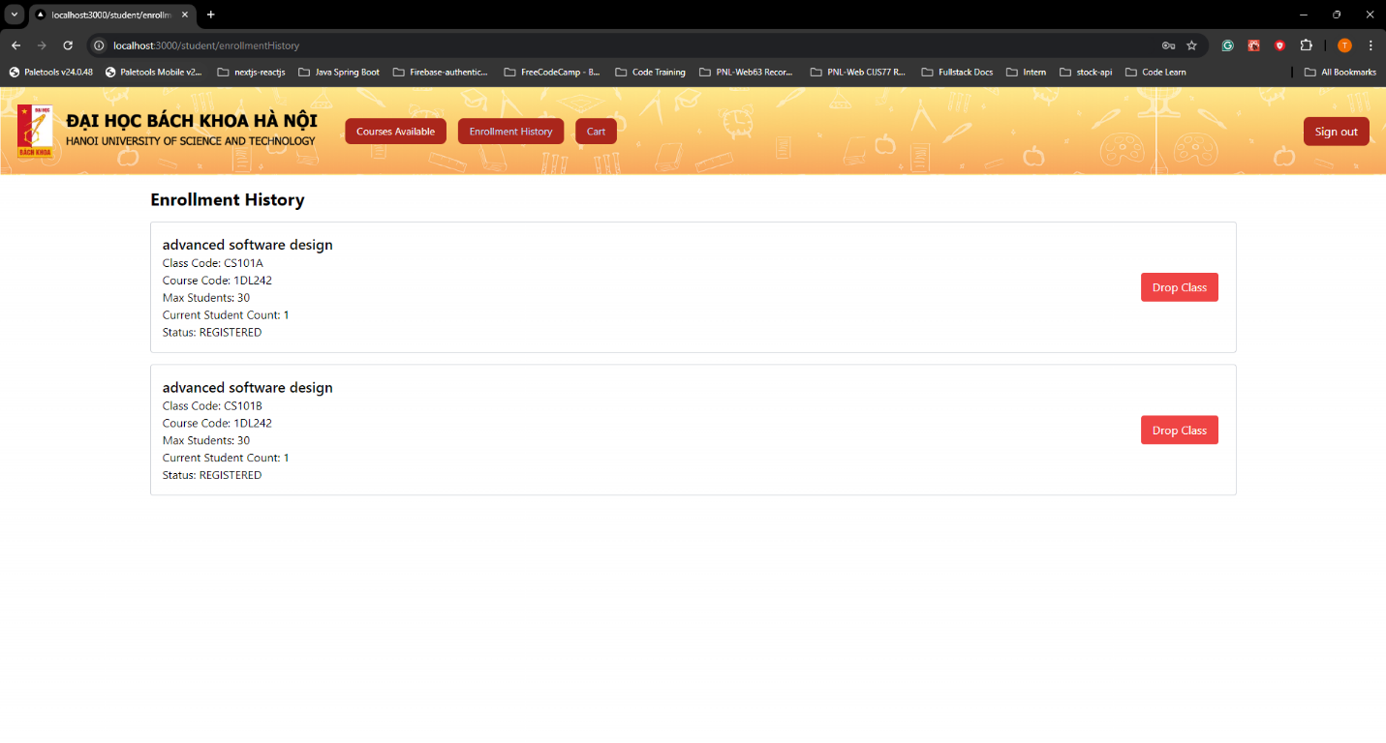

12. Unauthorized Page
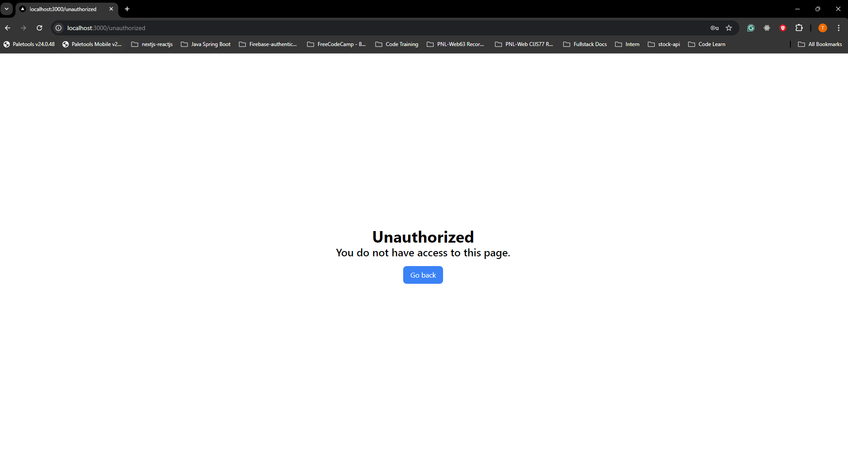

CHAPTER 6: TESTING
Testing is a critical phase in the software development lifecycle. It ensures that the application functions as expected, meets user requirements, and is free of critical bugs. The testing process for this project included various types of testing such as Unit Testing, Integration Testing, System Testing, and User Acceptance Testing (UAT). Below is an overview of the testing methodologies and results.

Module 1: JWT Authentication

Test Case 1.1: Validating JWT Token
Test Case ID | Input | Expected Output | Exception | Result
TC1.1.1 | Expired JWT Token | Return false, token is expired | None | Passed
TC1.1.2 | JWT Token with Invalid Signature | Return false, token is invalid | None | Passed
TC1.1.3 | Valid JWT Token | Return true, token is valid | None | Passed

Test Case 1.2: Extracting Claims from JWT Token
Test Case ID | Input | Expected Output | Exception | Result
TC1.2.1 | JWT Token with Subject Claim | Extract subject successfully | None | Passed
TC1.2.2 | JWT Token with Expiration Date | Extract expiration date successfully | None | Passed
TC1.2.3 | JWT Token with Custom Claims | Extract custom claim successfully | None | Passed

Module 2: User Management

Test Case 2.1: Registering a New Student
Test Case ID | Input | Expected Output | Exception | Result
TC2.1.1 | Username already taken | Return error "Username is already taken!" | None | Passed
TC2.1.2 | Valid student details | Student registered successfully | None | Passed
TC2.1.3 | Invalid password (e.g., too short) | Return error with validation message | None | Passed
TC2.1.4 | Missing required fields | Return error with validation message | None | Passed

Test Case 2.2: Registering a New Admin
Test Case ID | Input | Expected Output | Exception | Result
TC2.2.1 | Username already taken | Return error "Username is already taken!" | None | Passed
TC2.2.2 | Valid admin details | Admin registered successfully | None | Passed
TC2.2.3 | Missing department field | Return error with validation message | None | Passed

Test Case 2.3: Changing Password
Test Case ID | Input | Expected Output | Exception | Result
TC2.3.1 | Incorrect old password | Return error "Old password is incorrect" | None | Passed
TC2.3.2 | Valid password change | Password changed successfully | None | Passed

Test Case 2.4: Viewing User Information
Test Case ID | Input | Expected Output | Exception | Result
TC2.4.1 | Valid student credentials | Return student information successfully | None | Passed
TC2.4.2 | Valid admin credentials | Return admin information successfully | None | Passed

Module 3: Class Management

Test Case 3.1: Creating a New Class
Test Case ID | Input | Expected Output | Exception | Result
TC3.1.1 | Course code does not exist | Return error "Please create course first" | None | Passed
TC3.1.2 | Valid class details with correct dates | Class created successfully | None | Passed
TC3.1.3 | Invalid registration deadline (after start date) | Return error "Registration deadline must be before the start date." | None | Passed

Test Case 3.2: Updating Class Details
Test Case ID | Input | Expected Output | Exception | Result
TC3.2.1 | Class does not exist | Return error "Class not found for update" | None | Passed
TC3.2.2 | Valid class update details | Class updated successfully | None | Passed
TC3.2.3 | Invalid end date (less than 1 month after start) | Return error "End date must be at least 1 month after the start date." | None | Passed

Test Case 3.3: Deleting a Class
Test Case ID | Input | Expected Output | Exception | Result
TC3.3.1 | Class does not exist | Return error "Class not found for deletion" | None | Passed
TC3.3.2 | Valid class code | Class deleted successfully | None | Passed

Test Case 3.4: Viewing Classes by Course Code
Test Case ID | Input | Expected Output | Exception | Result
TC3.4.1 | Course code does not exist | Return empty list | None | Passed
TC3.4.2 | Valid course code | Return list of classes for the course | None | Passed

Module 4: Course Management

Test Case 4.1: Creating a New Course
Test Case ID | Input | Expected Output | Exception | Result
TC4.1.1 | Course code already exists | Return error "Course code already exists" | None | Passed
TC4.1.2 | Valid course details | Course created successfully | None | Passed

Test Case 4.2: Updating Course Details
Test Case ID | Input | Expected Output | Exception | Result
TC4.2.1 | Course does not exist | Return error "Course not found for update" | None | Passed
TC4.2.2 | Valid course update details | Course updated successfully | None | Passed

Test Case 4.3: Deleting a Course
Test Case ID | Input | Expected Output | Exception | Result
TC4.3.1 | Course does not exist | Return error "Course not found for deletion" | None | Passed
TC4.3.2 | Valid course code | Course and related classes deleted successfully | None | Passed

Test Case 4.4: Searching Courses by Name
Test Case ID | Input | Expected Output | Exception | Result
TC4.4.1 | No matching course name | Return empty list | None | Passed
TC4.4.2 | Valid course name | Return list of courses matching the name | None | Passed

Module 5: Class Enrollment

Test Case 5.1: Adding Class to Cart
Test Case ID | Input | Expected Output | Exception | Result
TC5.1.1 | Class already in cart | Return error "This class is already in your cart" | None | Passed
TC5.1.2 | Valid class code | Class added to cart successfully | None | Passed
TC5.1.3 | Class capacity full | Return error "This class has reached its maximum capacity" | None | Passed

Test Case 5.2: Registering Class from Cart
Test Case ID | Input | Expected Output | Exception | Result
TC5.2.1 | Class not in cart | Return error "Class not found in cart" | None | Passed
TC5.2.2 | Valid class code | Class registered successfully | None | Passed
TC5.2.3 | Class registration deadline passed | Return error "You cannot register for this class after the registration deadline." | None | Passed

Test Case 5.3: Dropping a Registered Class
Test Case ID | Input | Expected Output | Exception | Result
TC5.3.1 | Class not registered by student | Return error "You are not registered for this class." | None | Passed
TC5.3.2 | Valid class drop | Class dropped successfully | None | Passed
TC5.3.3 | Registration deadline passed | Return error "You cannot drop this class after the registration deadline." | None | Passed

Test Case 5.4: Viewing Enrollment History
Test Case ID | Input | Expected Output | Exception | Result
TC5.4.1 | No enrollments | Return empty list | None | Passed
TC5.4.2 | Student has enrollments | Return list of enrollments | None | Passed

Module 6: System Settings

Test Case 6.1: Toggling Student Login
Test Case ID | Input | Expected Output | Exception | Result
TC6.1.1 | Disable student login | Return success message "Student login has been disabled." | None | Passed
TC6.1.2 | Enable student login | Return success message "Student login has been enabled." | None | Passed

CHAPTER 7: INSTALLATION AND USER GUIDE

7.1 Installation Guide
This section provides detailed instructions on how to install and configure the application in your local environment.

7.1.1 Prerequisites
Before starting the installation, ensure that your system meets the following requirements:
- Java Development Kit (JDK): Version 11 or higher.
- Apache Maven: Version 3.6.3 or higher.
- MySQL: Version 8.0 or higher (or any other compatible database).
- Spring Boot: Version 2.7 or higher.
- Node.js (Optional): For running any frontend components if applicable.

7.1.2 Clone the Repository
Open your terminal or command prompt.
Navigate to the directory where you want to store the project.
Run the following command to clone the repository:
- git clone https://github.com/yourusername/your-repository.git
Change into the project directory:
- cd your-repository

7.1.3 Configure the Database
Create a new database in MySQL or your preferred database system:
- CREATE DATABASE your_database_name;
Update the application.properties or application.yml file located in the src/main/resources directory with your database configuration:
- spring.datasource.url=jdbc:mysql://localhost:3306/your_database_name
- spring.datasource.username=your_username
- spring.datasource.password=your_password
- spring.jpa.hibernate.ddl-auto=update
If using a different database, ensure that the appropriate JDBC driver is included in your pom.xml file.

7.1.4 Build the Project
Run the following Maven command to build the project:
- mvn clean install
This will compile the project and download all necessary dependencies.

7.1.5 Run the Application
Use the following command to start the Spring Boot application:
- mvn spring-boot:run
Alternatively, you can build a JAR file and run it using:
- java -jar target/your-application-name.jar
The application should now be running on http://localhost:8080.

7.1.6 Frontend Setup (Optional)
If your application has a frontend component:
Navigate to the frontend directory:
- cd frontend-directory
Install the required Node.js packages:
- npm install
Run the frontend application:
- npm start
The frontend will typically be served on http://localhost:3000.

7.2 User Guide
This section provides instructions on how to use the main features of the application.

7.2.1 Accessing the Application
Open your web browser and navigate to http://localhost:8080.
You will be directed to the login page where you can sign in using your credentials.

7.2.2 Logging In
Enter your username and password.
Click on the "Login" button.
Upon successful login, you will be redirected to the dashboard.

7.2.3 Registering a New User
Only admin users have the ability to register new students or admin accounts.
Navigate to the "Register" section under the "User Management" tab.
Select the user type (Student or Admin).
Fill in the required details (e.g., username, password, name, etc.).
Click "Register" to create the account.

7.2.4 Managing Courses
Admins can manage course information:
Navigate to the "Courses" section in the dashboard.
You can create, update, or delete courses.
To create a new course, click "Add Course", fill in the details, and click "Save".
To edit or delete an existing course, use the options provided next to each course in the list.

7.2.5 Enrolling in Classes
Students can enroll in classes as follows:
Navigate to the "Classes" section.
Search for available classes using course codes or names.
Click "Add to Cart" to add a class to your enrollment cart.
Go to your "Cart" and click "Register" to enroll in the classes.

7.2.6 Viewing Enrollment History
Students can view their enrollment history:
Go to the "Enrollment History" section.
This page will display a list of classes you have registered for.

7.2.7 Managing System Settings
Admins can manage system-wide settings:
Navigate to the "System Settings" section.
Here, you can toggle student login availability or modify other application-wide settings.

7.2.8 Logging Out
To log out of the application, click on your profile in the top right corner.
Select "Logout" from the dropdown menu.

7.2.9 Error Handling
If an error occurs:
The application will display an appropriate error message.
Check the logs for more detailed information about the error.
If the issue persists, ensure that all services (database, application server) are running correctly.

7.3 Troubleshooting
Issue: Application fails to start.
Solution: Ensure that your database is running and the configurations in application.properties are correct.
Issue: Cannot connect to the database.
Solution: Double-check your database credentials and URL in the configuration file.
Issue: Frontend does not load.
Solution: Ensure that Node.js is installed and that all dependencies are installed correctly with npm install.
By following this installation and user guide, you should be able to set up, configure, and use the application effectively.

Conclusion and Future Development
Conclusion
The development of this application has successfully achieved its primary objective: providing a robust and efficient system for managing educational processes, including user authentication, course management, class enrollment, and system settings. The implementation of security features such as JWT authentication ensures that the application is secure and that user data is protected. Throughout the development process, best practices were adhered to, resulting in a maintainable and scalable codebase.
Key outcomes of the project include:
- Modular Architecture: The application is built with a clear separation of concerns, making it easier to maintain and extend.
- Security: With the integration of JWT-based authentication, the system ensures secure access to resources.
- User Management: The application supports both admin and student roles, with appropriate permissions and access controls in place.
- Course and Class Management: Admins can effectively manage courses and classes, while students can easily enroll in classes, with all actions tracked and managed within the system.
- Comprehensive Testing: Extensive test cases were developed to ensure that the application functions correctly and handles errors gracefully.
The project demonstrates a solid foundation in both software design and implementation, ensuring that it meets the functional requirements while being ready for further enhancements.
Future Development
While the application meets its initial goals, there are several areas where it can be further developed to enhance functionality, usability, and scalability. The following are some potential directions for future development:
User Interface Enhancements:
Improve the user interface to provide a more intuitive and user-friendly experience.
Implement responsive design techniques to ensure the application works well on mobile devices.
Advanced Reporting and Analytics:
Integrate reporting features that allow admins to generate detailed reports on course enrollments, student performance, and system usage.
Implement analytics tools to track and visualize data trends, which can be useful for decision-making.
Role-Based Access Control (RBAC):
Expand the role-based access control system to support more granular permissions, allowing for additional roles and more specific access rights.
Integration with Third-Party Services:
Integrate with external systems, such as Learning Management Systems (LMS) or Student Information Systems (SIS), to expand the application’s capabilities.
Implement payment gateways for course enrollment fees, if applicable.
Automated Notifications:
Develop a notification system that sends automated emails or in-app notifications to users for important events, such as enrollment deadlines or system updates.
Scalability and Performance Optimization:
Optimize the application's performance for handling a larger number of concurrent users and data processing tasks.
Consider migrating to cloud-based infrastructure for better scalability and reliability.
Enhanced Security Measures:
Implement additional security measures such as Two-Factor Authentication (2FA) to further secure user accounts.
Conduct regular security audits and penetration testing to identify and mitigate potential vulnerabilities.
Internationalization and Localization:
Expand the application’s reach by adding support for multiple languages and regional settings, making it accessible to a global audience.
Mobile Application Development:
Develop a native or hybrid mobile application to complement the web-based interface, providing users with the flexibility to access the system on-the-go.
AI-Powered Features:
Explore the integration of AI-powered features such as predictive analytics for student performance or personalized course recommendations based on user behavior.
By pursuing these future development paths, the application can evolve to meet the growing needs of users and stakeholders, ensuring its relevance and effectiveness in the long term.

References
- Sommerville, I. (2016). Software Engineering (10th ed.). Pearson Education.

Appendix
- Backend’s Github Repository: https://github.com/SimonTranDuy/cs3332
- Frontend’s Github Repository: https://github.com/ndtctk1295/CS3332-nextjs-frontend/tree/master

