Simon Johnson a2708173

Design Patterns with C++
Assignment 2
Patient Vitals Management System

Contents
Functional Requirement 1 – Load Patients from File 2
Design Pattern: Adapter Pattern 2
How it works 2
Git Commits: 2
Functional Requirement 2 – Load Patients from File and Database 4
Design Pattern: Composite Pattern 4
How it works 4
Git Commits: 4
Functional Requirement 3 – Calculate the Patient Alert Levels 6
Design Pattern: Strategy Pattern 6
How it works 6
Git Commits: 6
Functional Requirement 4 – Alert the Hospitals and GP 7
Design Pattern: Observer Pattern 7
How it works 7
Git Commits 7
Appendix A - Final Class Diagram 9

Functional Requirement 1 – Load Patients from File
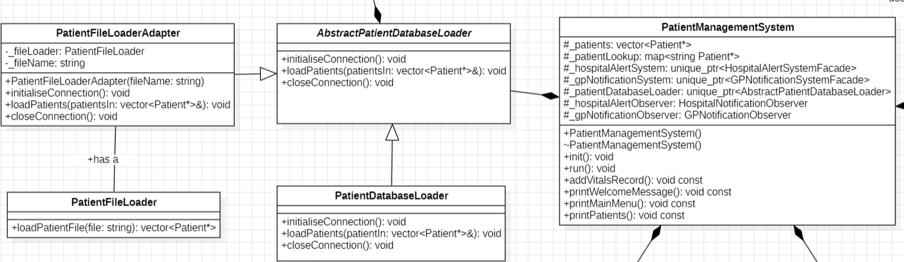
Figure 1 Excerpt from the complete UML class diagram highlighting the Adapter Pattern

Design Pattern: Adapter Pattern
The Adapter Pattern is used to allow Patient data to be loaded from a text file without changing the existing Patient loading system. The existing system expects all Patient loaders to implement the AbstractPatientDatabaseLoader interface. However, PatientFileLoader provides an incompatible interface that cannot be used directly by the existing system. To solve this, PatientFileLoaderAdapter wraps PatientFileLoader and exposes the expected interface. This allows file loading to be integrated into the system with minimal changes while maintaining compatibility with the existing design.

How it works
- PatientManagementSystem interacts only with the AbstractPatientDatabaseLoader interface.
- PatientFileLoaderAdapter inherits from AbstractPatientDatabaseLoader.
- The adapter contains a PatientFileLoader object.
- Calls to initialiseConnection(), loadPatients(), and closeConnection() are translated into the appropriate file loading operations.
- Switching between database loading and file loading only requires changing the loader configuration in PatientManagementSystem.

Git Commits:
- 70db870 - Added quick pseudocode for FR1 file handling
- b64249d - Added first pass logic to read patient details from txt file, split and separate along pipe and comma
- 8da948c - First pass Vitals reading logic added
- 2b025f7 - Added PatientFileLoaderAdapter.h and PatientFileLoaderAdapter.cpp as per FR1 - Adapter Pattern requirements
- 36d4087 - Added PatientFIleLoaderAdapter implementation as per FR1
- d399706 - Modified PatientManagementSystem constructor to use the PatientFileLoaderAdapter as per FR1
- 52725e9 - Verify loading Patient loading from file "patients.txt"

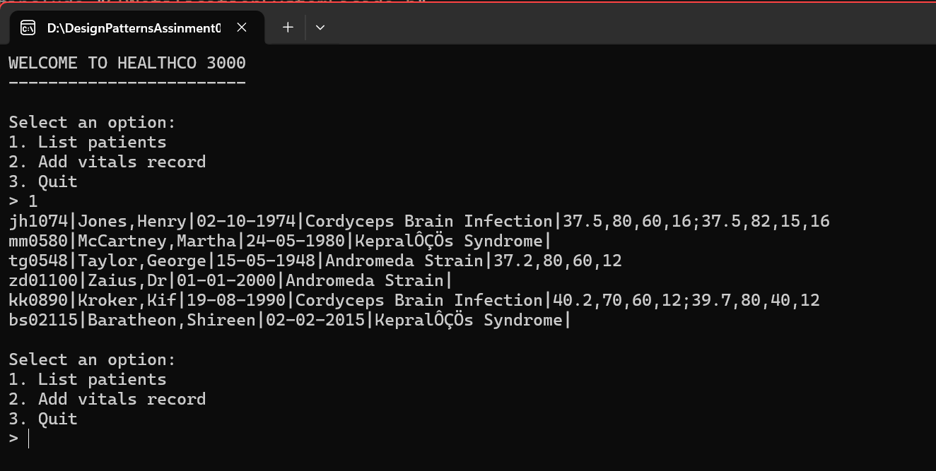
Figure 2 Load Patients from File Output

Functional Requirement 2 – Load Patients from File and Database
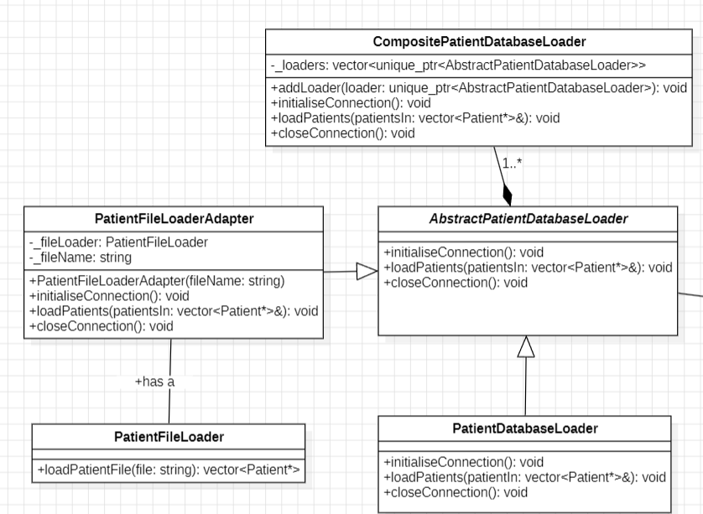
Figure 3 Excerpt from the complete UML class diagram highlighting the Composite Pattern

Design Pattern: Composite Pattern
The Composite Pattern is used to allow Patients to be loaded from multiple sources while treating all loaders through a common interface. CompositePatientDatabaseLoader inherits from AbstractPatientDatabaseLoader and stores a collection of loaders that also implement the same interface. This allows the system to load Patients from both the database and text file while maintaining a single point of interaction for PatientManagementSystem.

How it works
- PatientManagementSystem creates a CompositePatientDatabaseLoader.
- The database loader is added first to satisfy the requirement that database Patients are loaded first.
- The file loader adapter is added second so file Patients are loaded afterwards.
- The Composite stores loaders in a vector of unique_ptr<AbstractPatientDatabaseLoader>.
- Since unique_ptr enforces exclusive ownership, it cannot be copied. std::move transfers ownership of the loader into the Composite’s vector.
- When initialiseConnection(), loadPatients(), or closeConnection() are called, the Composite forwards the request to each loader in sequence.
- The system can switch between database-only, file-only, or combined loading by changing only the loader configuration.

Git Commits:
- 6f1b783 - Created CompositePatientDatabaseLoader .h and .cpp files to satisfy FR2 - Load patients from db (first) and file (second)
- 9572d37 - Added declaration for FR2 Composite Pattern implementation
- 9ff3f98 - Composite implementation complete as per FR2
- 1872518 - Configured PatientManagementSystem to use CompositePatientDatabaseLoader, db output loaded first as per FR2
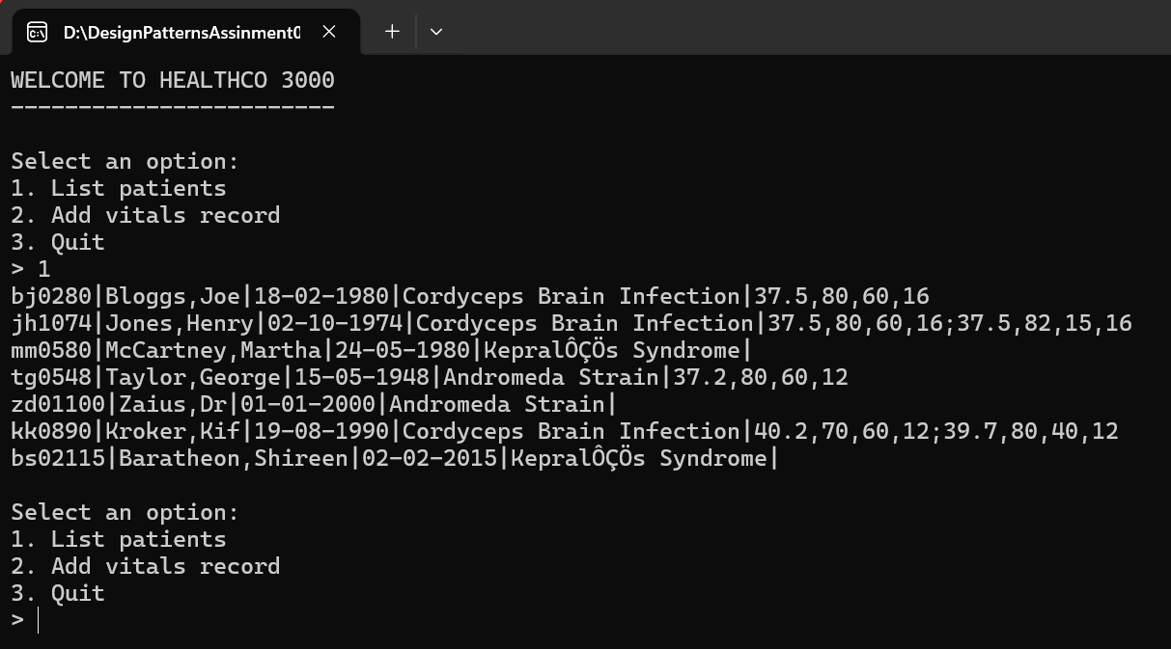
Figure 4 Load Patients from Database (first) and File (second)

Functional Requirement 3 – Calculate the Patient Alert Levels
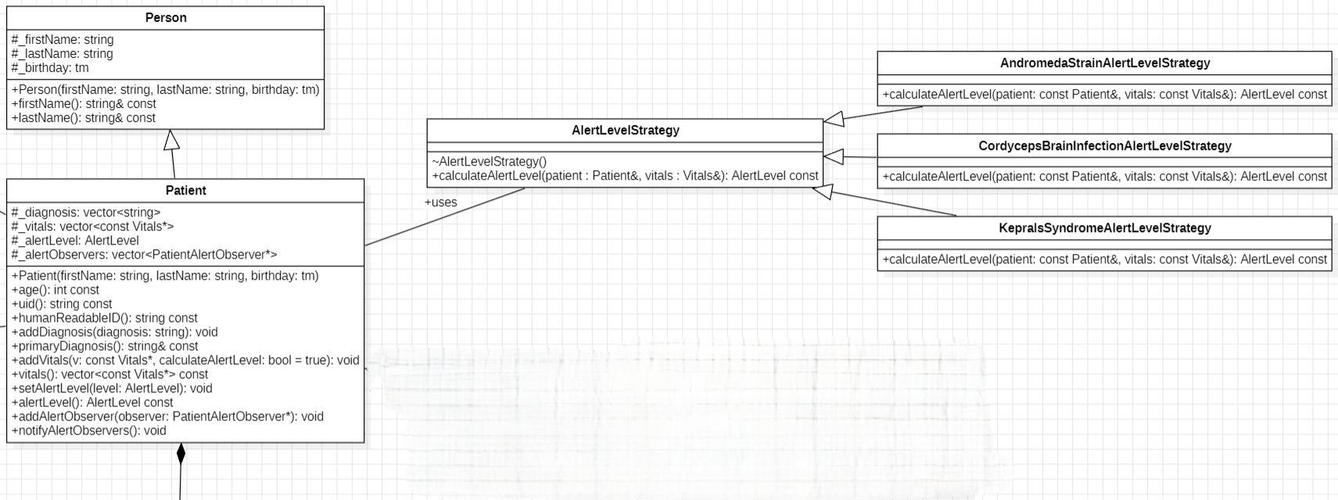
Figure 5 Excerpt from the complete UML class diagram highlighting the Strategy Pattern

Design Pattern: Strategy Pattern
The Strategy Pattern is used to support different alert level calculation algorithms for different diseases. Each disease has its own rules for determining whether a Patient should be assigned a Green, Yellow, Orange, or Red alert level. By encapsulating each algorithm in a separate strategy class, the system can select the appropriate calculation method dynamically at runtime based on the Patient’s diagnosis, allowing each disease to implement its own alert calculation rules while sharing a common interface.

How it works
- When new Vitals are recorded, the Patient’s primary diagnosis is checked.
- A factory function creates the appropriate alert level strategy.
- Each strategy inherits from AlertLevelStrategy.
- The selected strategy calculates the alert level using disease-specific rules.
- The calculated alert level is returned to the Patient.
- New diseases can be added by creating additional strategy classes without modifying existing algorithms.

Git Commits:
- 69105dd - Created AlertLevelStrategy interface from which all concrete disease alert classes inherit from
- 4b5f7bf - Created concrete AlertLevelStrategy classes for Cordyceps Brain Infection, Kepral's Syndrome, Andromeda Strain
- 40a9cdd - CordycepsBrainInfectionAlertLevelStategy.h file implemented
- c8134fd - Implemented calculation logic for CordycepsBrainInfectionAlertLevelStrategy
- ebfafa6 - AndromedaStrain and KepralsSyndrome .h files implemented
- 4d8ddd7 - KepralsSyndromeAlertLevelStrategy .cpp Alert level calculation implemented
- a374e4e - AndromedaStrainALertLevelStrategy calculation implementation complete
- c2a5a6e - Modified Patient.cpp file to #include the concrete AlertLevel classes
- 59208d5 - Added helper function to create and return the appropriate Strategy Pattern according to Patient primary diagnosis
- a9efc7c - Implemented alert level calculation using the Strategy Pattern - FR3 complete

Functional Requirement 4 – Alert the Hospitals and GP
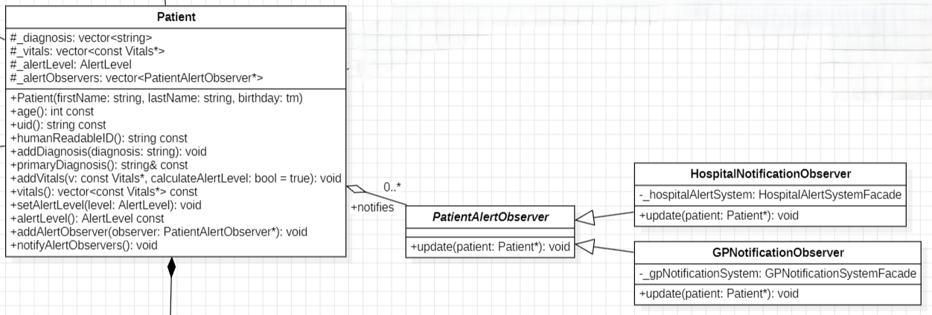
Figure 6 Excerpt from the complete UML class diagram highlighting the Observer Pattern

Design Pattern: Observer Pattern
The Observer Pattern is used to notify external systems when a Patient’s alert level changes. Patient acts as the Subject and maintains a list of registered observers. When a Patient’s alert level becomes critical, the Patient automatically notifies all registered observers. This removes direct coupling between the Patient and the notification systems and allows new notification mechanisms to be added easily.

How it works
- PatientAlertObserver defines a common observer interface.
- HospitalNotificationObserver and GPNotificationObserver implement this interface.
- During system initialisation, each Patient registers both observers.
- When a Patient’s alert level changes, Patient::setAlertLevel() triggers notification.
- notifyAlertObservers() calls update() on each registered observer.
- The observers forward notifications to their respective Façade classes, which send the hospital and GP alerts.

Git Commits
- 4d2231a - FR4 - Observer Pattern
- dd5858d - PatientAlertObserver interface implementation
- e29af77 - Created HospitalNotificationObserver and GPNotificationObserver to implement the PatientAlertObserver interface
- 928f16d - implemented declaration for HospitalNotificationObserver
- 7c6cb25 - Refactor observer interfaces to use Patient pointers to align with facade interfaces
- 8073a41 - Implemented GPNotificationObserver declaration
- 2501a4f - Implemented definition for GPNotificationObserver
- fd9796d - Added Observer registration support to Patient
- d9946ed - Implemented Observer registration and notification methods
- ba1e545 - Added functionality to notify Observers when a Patient reaches Red alert level
- 4303aee - Added Hospital and GP alert observers to PatientManagementSystem
- e2719e5 - Registered alert Observers with Patients during system initialisation
- 23f205b - Implemented Patient alert notifications using Observer Pattern...fixed small bug due to Observer duplication declaration in PatientManagmentSystem.h
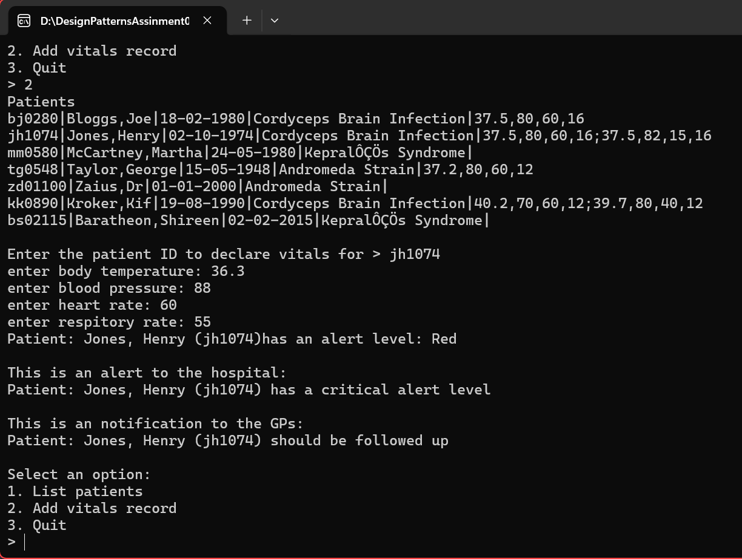
Figure 7 Patient Alert Level Test - Red
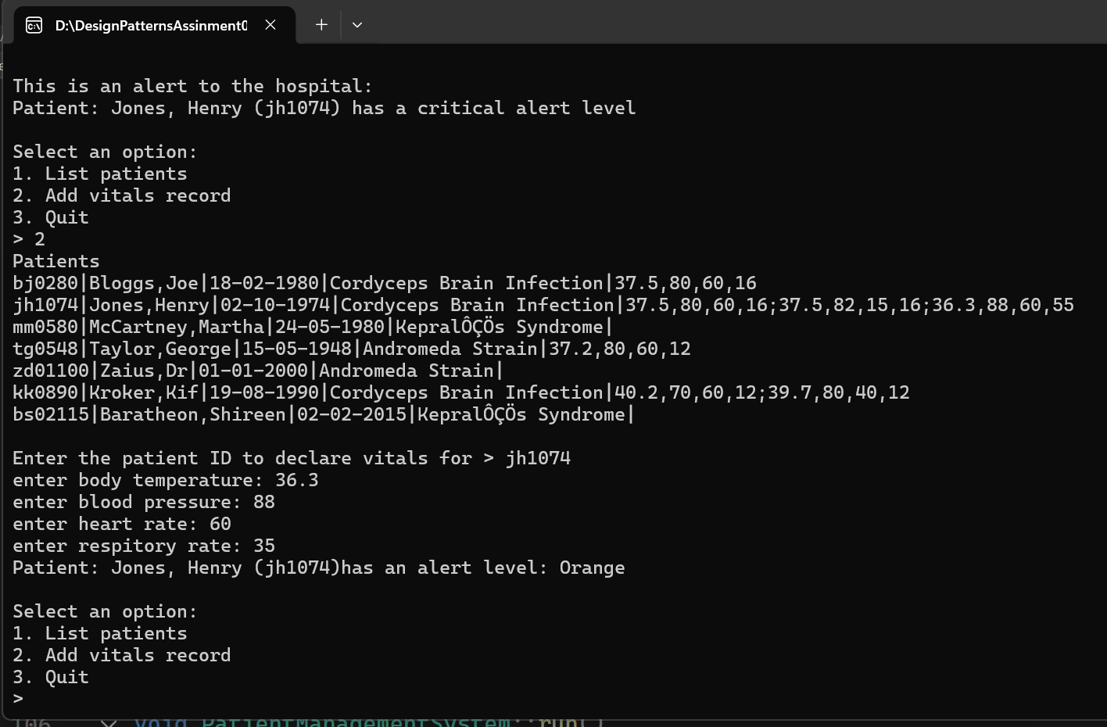
Figure 8 Patient Alert Level Test - Orange

Appendix A - Final Class Diagram
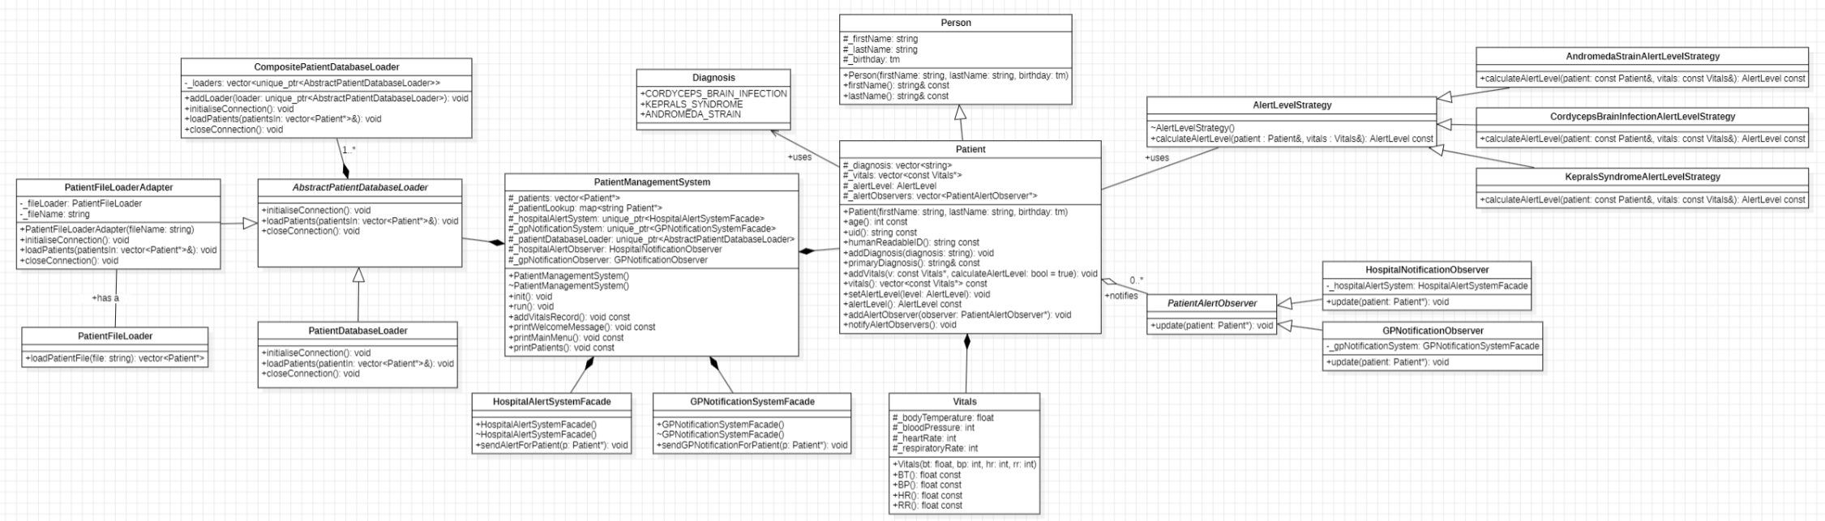
The complete UML class diagram for the final implementation. This diagram incorporates all classes, relationships, and design patterns implemented to satisfy Functional Requirements 1 – 4.

