TESTING

|  |  |  |  |
| --- | --- | --- | --- |
| Test | Estim. Hours testing | Actual hours tested | Result |
| 1 - Connect to database | 0.1 | 0.1 | Yes – connected successfully |
| 2 - View movie details | 0.1 | 0.1 | Yes – click on ‘More Info’ |
| 3 - Search by:   1. Title 2. Director 3. Writer 4. Actor 5. Genre 6. Year 7. Producer 8. Ratings | 0.1 | 0.1 | Not implemented |
| 4 – Wish List | 0.1 | 0.1 | Yes – Can view Wish List |
| 5 – GUI | 0.1 | 0.1 | Yes |
| 6 – Fast and efficient | 0.1 | 0.1 | Yes – Searches take less than a second, easy to navigate |
| 7 – Poster | 0.1 | 0.1 | Yes |
| 8 – Same name | 0.1 | 0.1 | Yes – can choose to search for multiple or just one |
| 9 – Sort films | 0.1 | 0.1 | Not implemented |
| 10 – Seen List | 0.1 | 0.1 | Yes – use the ‘Eye’ icon |
| 11 – Seen list in new window | 0.1 | 0.1 | Yes |
| 12 – Sort seen list | 0.1 | 0.1 | Not implemented |

# Test Results

All user stories implemented except 3, 9 and 12. Task 3 was expected to take a long time so this is not much of a surprise. We will add tasks 3, 9 and 12 to our next sprint.

## Test Error

A bug occurred during testing where the number of movies in the seen list is always listed as 0:

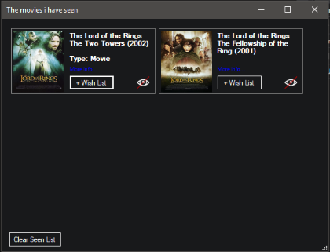

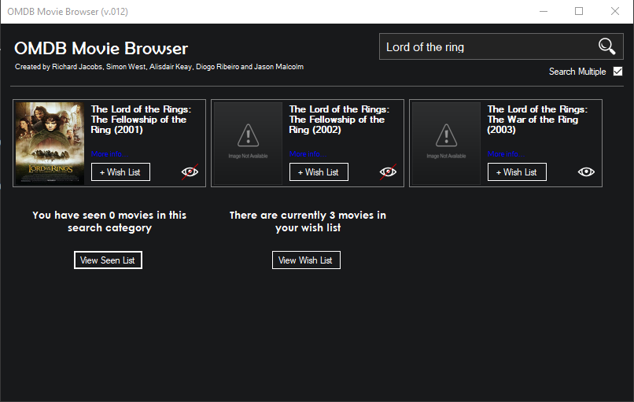

-We reported this error and it has since been fixed.