Joke generator

Roskilde University - Interactive Digital Systems F2024

By

Simona Kirilova Velichkova

An Erasmus student in 6th semester

[stud-velichkova@ruc.dk](mailto:stud-velichkova@ruc.dk)

|  |  |
| --- | --- |
| Characters with spaces |  |
| GitHub repository | <https://github.com/pren0Sima/JokeGenerator> |

Table of Contents

Introduction 2

Hardware 3

Components 3

ESP32 3

USB cable 3

Breadboard 3

Jumper wires 3

LCD 3

Button 3

Setup 3

Code 4

Reflection 5

References 6

Appendices 7

Kanban board 7

# Introduction

The inspiration for this project comes from a project I did 2 years ago on a high-level language called “Scratch”[1]. I found this course project to be the perfect opportunity to extend it. The overall idea is to make a programme which fetches jokes and displays them to the user. Since there was a big focus on ESP32, electronical components and their control over an Arduino IDE, I had to think of a way to mix the two concepts. Eventually, the formulation of the project ended up like this: A program that fetches jokes from an API when a physical button is pressed. There's also a LCD instructing the user what to do.

# Hardware

## Components

### ESP32

ESP32 is a microcontroller unit which allows us to interact with electronical components as well as make connections using Wi-Fi and Bluetooth.

### USB cable

It facilitates the connection between our computer and the microcontroller.

### Breadboard

A breadboard is the base construction used to build electrical circuits.

### Jumper wires

Jumper wires are types of electrical wires allowing connections between two points on the breadboard without soldering. We can think of them as the paths the electrical current flows through.

### LCD

A liquid-crystal display is a

### Button

## Setup

### Circuit view

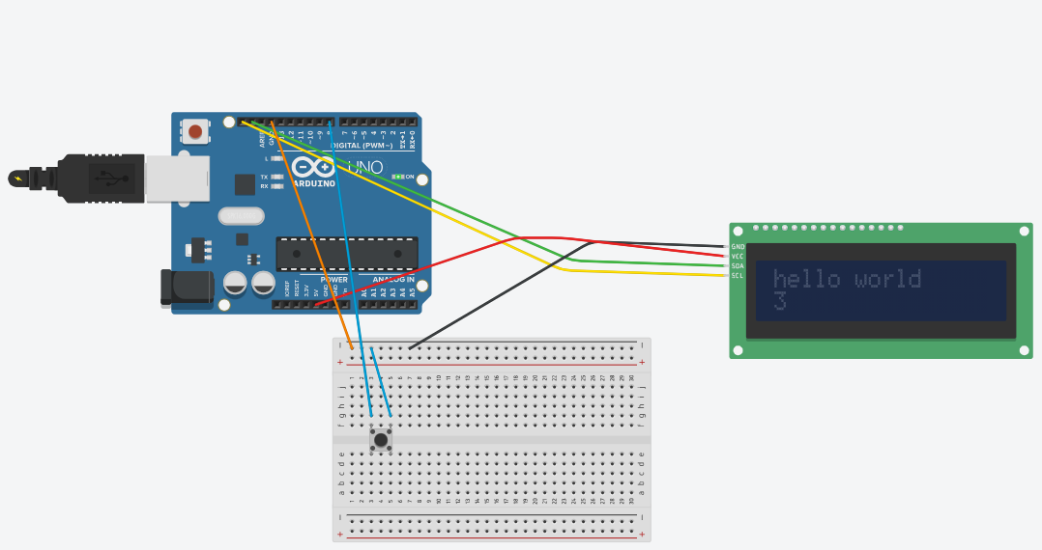

### Schematic view

### 

# Code

# Reflection

# References

# Appendices

## Kanban board

In order to keep track of the process and organize better I used the built-in kanban board in GitHub.

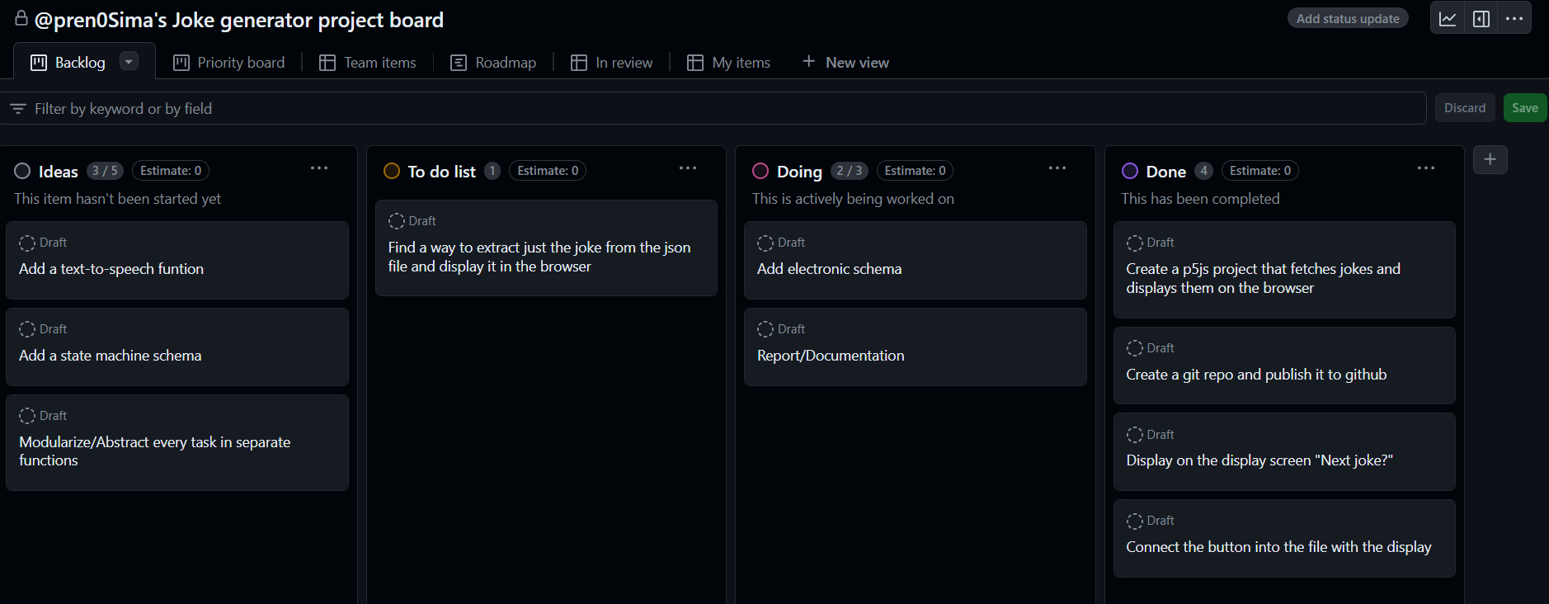

1. <https://scratch.mit.edu/projects/708151217/>