COM1008

ASSIGNMENT 1

Part 1

The general idea behind designing the website would be to create a website that showcased all the features that Students Union has to offer. It would be the perfect heaven of information mandatory for a student doing a degree in computer science to know. It would be easy to use for all users, by keeping in mind accessibility options. We would create a simple website that was convenient to use, fast to load, easy to navigate and which had a hassle-free user interface. The general design of the website is minimalistic.

We would create the website for the mobile interface first, by implementing a user-friendly navigation bar on mobile, scaling the text for appropriate viewport sizes and making links and icons clickable with fingers.

Our Site Map:

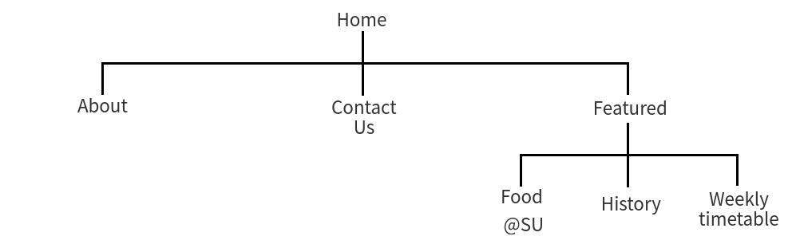

We want the user to have access to all the pages within two clicks. Hence they can know more about us or contact us and then on a drop down menu access the different web pages. If it were laid out in-line all at once, the user would be overwhelmed by the options, hence we would only want three options for the user to click or touch.

Regarding accessibility, we would include alt tags on all necessary images such that they can be read by a screen reader, our navigation bar is consistent across web pages both on mobile and desktop versions of the website. Our pages would be meaningfully titled such that they convey the right amount of information. We would use lower quality of images when using the site on mobile such that we don’t consume our users’ mobile data unnecessarily. The font would be bigger on mobile so that users can read the website and the contrast between text and background will be checked by an accessibility checker so that the users can read the website without straining their eyes.

<legal issues>

Simon...

</legal issues>

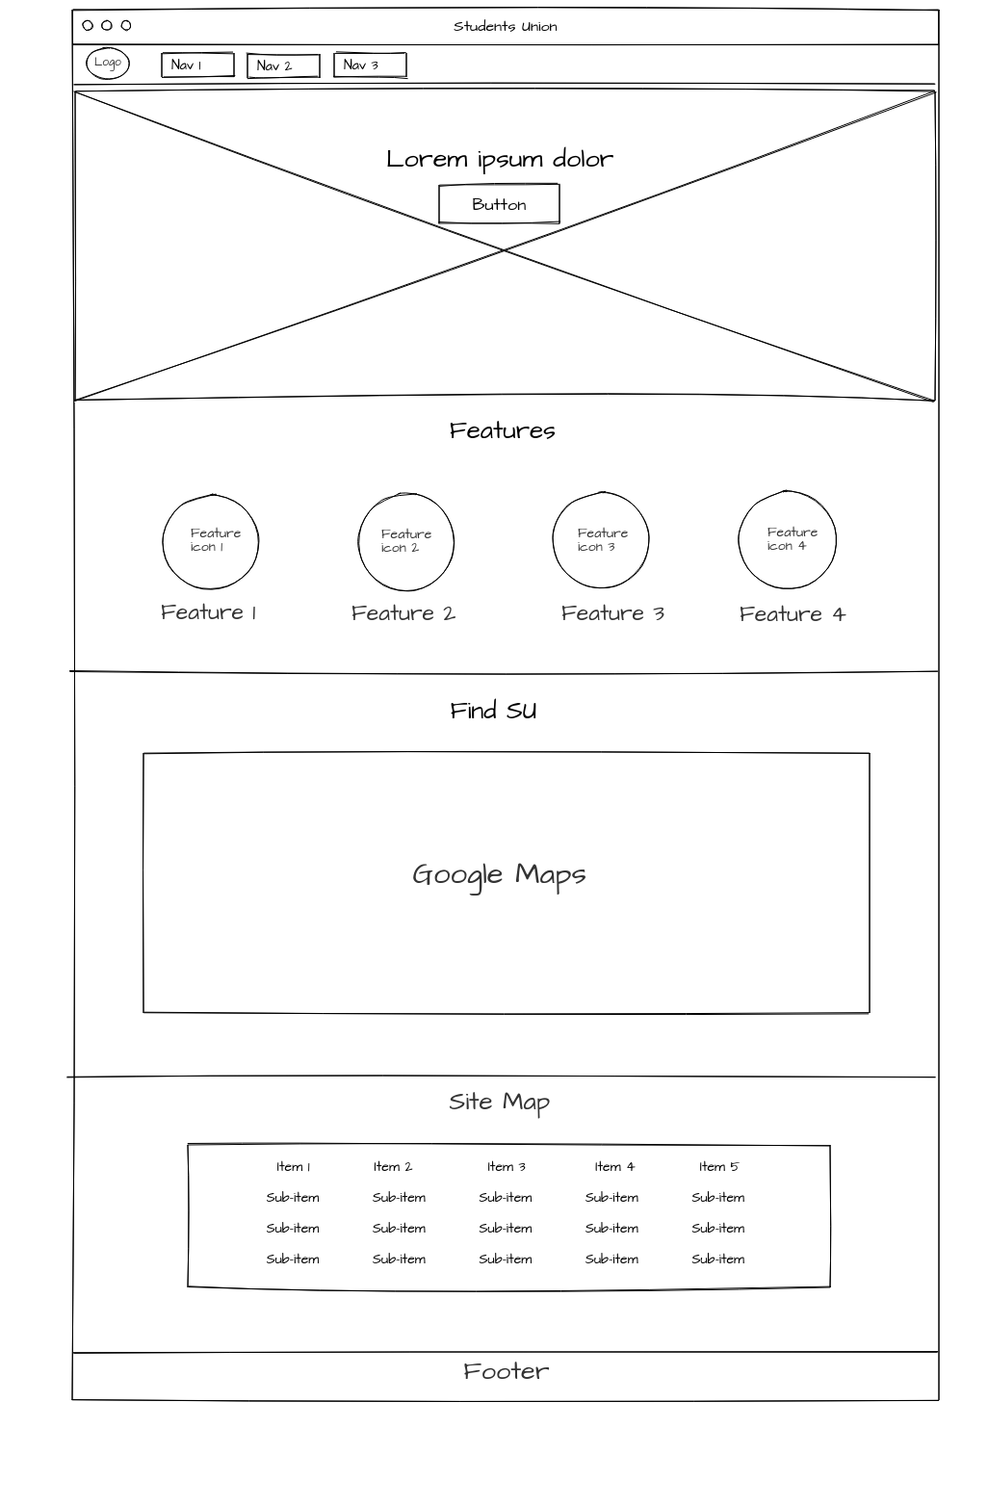Design Mock-ups:  
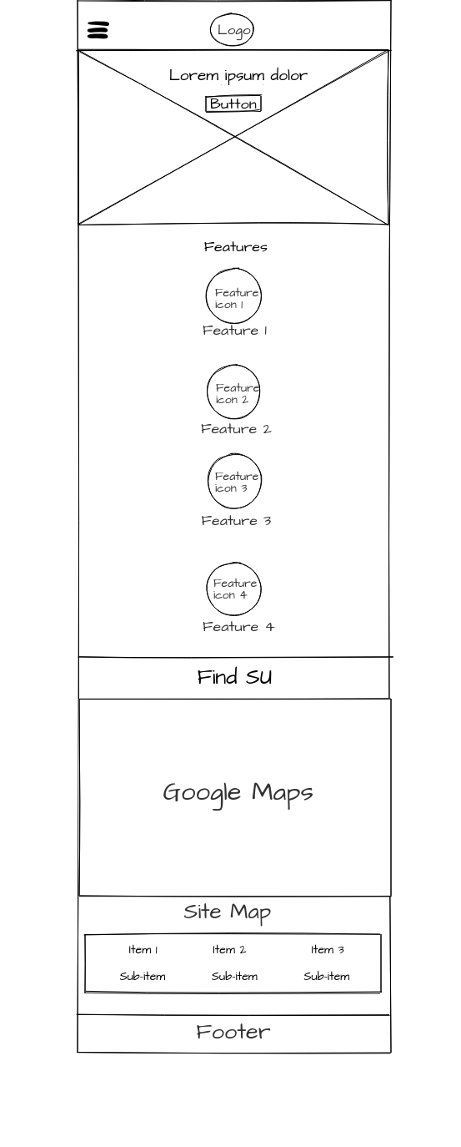

We thought in order for us to have a minimalistic design we need an appropriate font. Comfortaa is a very ‘round’ font which is perfect for our website. The logo of the website contains the same font and hence in order to have consistency we want to use the same font across all pages. The navigation bar would be a drop-down menu on mobile and an inline list on the desktop. We thought that the first page the user sees should instantly convey what the website is all about, hence we summarized it as “The complete undergraduate guide” since it was targeted towards first year students. Then we decided to have a short summary of what features are there in the Students Union and then those would then lead to more detailed pages dedicated to each feature. We decided that we would implement a map in the home page because we wouldn’t want users to go searching for it. The map would also run if javascript was turned off, it would just be a static image. Regarding the site map, it would be outside the footer for clear distinction. We decided that only one media query would be sufficient which would be for the desktop version. This was because the tablet version would be similar to mobile, and the laptop version would be similar to desktop.

Menu System:

We took a look at all the possible different navigation systems for mobile presented by Saran(2015) and we decided that we would do a simple drop-down menu for mobile using javascript.

It would have a clickable button to drop-down, and would be clickable again to cascade up. The three lines which consist of the hamburger logo would animate and become a cross to indicate to close it. For desktop we would remove one or two menu options from the drop down menu and place it in-line to a shorter dropdown menu so that we can reuse the dropdown menu.

References:

Saran.,(2015). 40+ Responsive Navigation Solutions(Examples and Codes)[online]. Sanwebe. [Viewed 19 October 2018]. Available from: https://www.sanwebe.com/2015/06/responsive-navigation-tutorials-demo