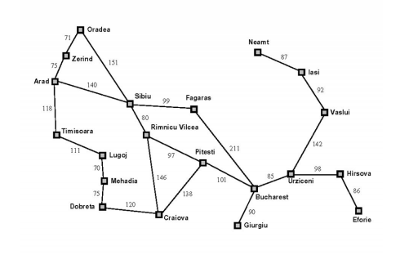
RAMIFICACION Y ACOTACION

Actual Lista de nodos
 | {A}
A | {Z/75, T/118, S/140}
Z | {T/118, S/140, O/71+75}
T | {S/140, O/146, L/118+111}
S | {O/146, S/140+80, L/229}

