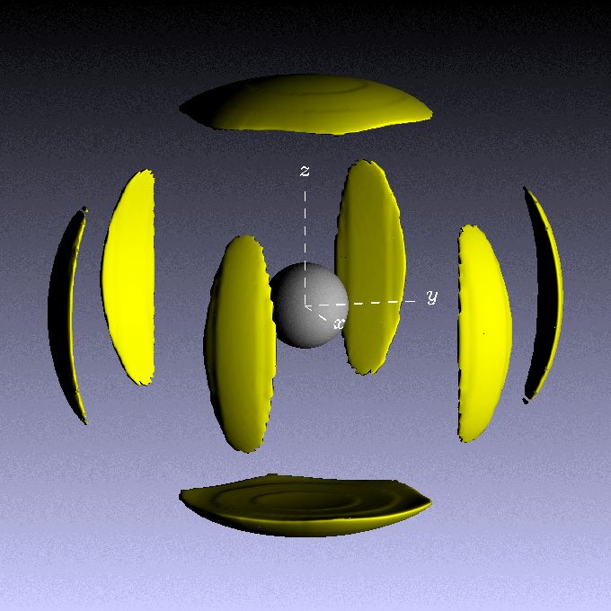
Fig 1 Benzene SDF – z-axis normal to molecule plane. Contour level set to 2.5 (-2.5 in input file to get absolute contours).
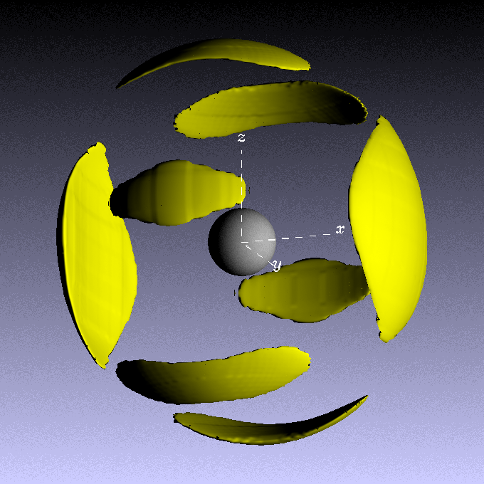
Fig 2. Benzene SDF – z-axis in plane of molecule, contour level set to 2.5 (-2.5 in input file).

Fig 3. Spherical harmonic expansion coefficients as a function of radius for liquid benzene, with the z-axis normal to the plane of the benzene ring.

Fig 4 Spherical harmonic expansion coefficients as a function of radius for liquid benzene, with the z-axis parallel to the plane of the benzene ring.
Plot g(r)'s in different directions for normal and parallel coordinate systems. Values of theta and phi used were:

Direction (z-axis normal to molecular plane, x-axis through ring carbon) | Thetal | Phil | Equivalent direction (z-axis through ring carbon, x-axis normal to molecular plane) | Thetal | Phil
001 | 0 | 0 | 100 | 90 | 0
010 | 90 | 90 | 010 | 90 | 90
100 | 90 | 0 | 001 | 0 | 0
110 | 90 | 45 | 011 | 45 | 90
101 | 45 | 0 | 101 | 45 | 0
011 | 45 | 90 | 110 | 90 | 45
111 | 54.7 | 45 | 111 | 54.7 | 45

The g(r)'s corresponding to these directions are shown below
Figure 5. g(r)'s in particular directions (Miller indices hkl) for the z-axis normal to the benzene ring (lines). The dots correspond to the equivalent directions when the z-axis is parallel to the plane of the ring. The brackets show the Miller indices corresponding to the latter axes in each case.
Fig. 6 Plot of the orientational correlation function for benzene, averaged over spatial directions theta_l and phi_l, internal rotations chi_m, for three values of the relative angle, theta_m. For this plot l = m = 0.

Fig. 7 Plot of the orientational correlation function for benzene, averaged over directions phi_l, and chi_m for three values of the relative angle, theta_m, and with theta_l = 0, corresponding to along the polar z-axis (normal to the molecular plane). For this plot m = 0.

Fig 8. Same as Fig 7, but with Theta_l = 90, i.e. the equatorial plane

