Student:
David Simonel-Olimpiu
Coordinating teacher:
Zaharie-Iosif Liziana
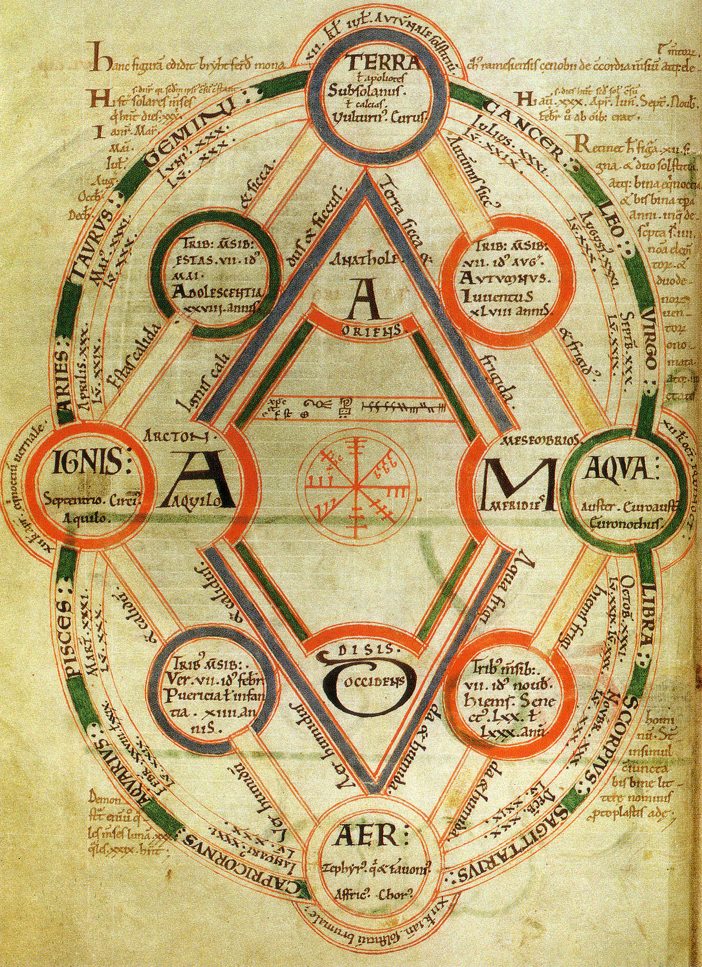
The First steps in a scientific world

Science in the anglo-saxon world

Ministerul Educației și Cercetării

IIndex:
Argument
Précis
Introduction
- Inventions and discoveries
- Asronomy, mathematics and timekeeping
- Medicine
Conclusion
Bibliography and Webliography

Argument
We know from school or from our personal general knowledges that science is a large(probably the largest) domain. I am confronting everyday with people who think that they are scientists if they know general things like what is the air, how many planets are in solar system or they know how to solve a mathematic problem with formulas or theories already given. Other people ask me or to make some chemical reactions, to show them physics experiments or tell them about the stars just for magical reasons. They are expecting from science to create unimaginable things, or to make something that does not exist. All of this are not a problem for people who are not interested in science, but is a big problem that even in 21st century they are blinded by fake news and by people who just want to make money.
I do not want everyone to be a scientist or to do know theories or anything like this but especially nowadays it is important to know why we need science, to know where it started and to make the difference between science and magic.

Précis
This project is structured in 5 chapters. The first it will be the Introduction in the Anglo-Saxon scientific world, in the second I will present some descoveries or inventions of Anglo-Saxons. The third chapter will contain some mathematic or physics theories, how they use atronomy and how they saw the night sky. After that I will pass to the other one where we will see how they solved medical problems and what descoveries they made. In th final, I will present you my conclousion and what I think that we need to remeber about those moments ftom history.

Introduction
The Anglo-Saxons had a very developed knowledge of science and the natural world. They read treatises by earlier Greek and Roman writers and, in some cases, they formulated new theories and inventions to understand everything from astronomy to medicine to the tides of the sea.
In those times, medieval science was a branch of scholarship that complemented all other studies. They made a diagram(Byrhtferth of Ramsey’s diagram) that shows what branches of medieval science they gave their successors. This it lists theology, physics and mathematics as theoretical subjects for abstract contemplation, while arithmetic, astronomy and music were identified as ‘practical subjects’. Early medieval writers combined their knowledge of different subjects to understand the world around them. Byrhtferth, a monk and teacher at the abbey of Ramsey in the late 10th and early 11th century, devised a diagram that showed the universe as an inter-connected unit, full of repeating patterns, from the four winds to the four writers of the gospels.
Likewise, the book-list of a 10th-century scholar reveals that he owned books about grammar and poetry, in addition to a copy of De natura rerum (On the Nature of Things) by Isidore of Seville (died 636), a text that discussed astronomy, geography and medicine.

I. Inventions and discoveries
Some Anglo-Saxon writers made significant contributions to scientific knowledge. The Northumbrian monk Bede (died 735) made detailed records of the movement of tides, while the accounts of explorers such as Wulfstan and Ohthere, who travelled around the Baltic Sea and Scandinavia, were recorded in Old English manuscripts.
At the same time, the Anglo-Saxons’ knowledge of geography was naturally limited. This gave rise to speculation about the creatures and monstrous races that lived in faraway lands. One extraordinary text that circulated at this time was the Marvels of the East, which described dragons, gold-digging ants and headless men with their faces in their torsos (known as ‘blemmyae’).
Aspects of Anglo-Saxon medicine even stand up to modern laboratory testing. In one remarkable example, researchers recently discovered that a remedy for eye infections found in Bald’s Leechbook, dating from the 10th century, was effective in tests against a strain of the antibiotic-resistant bacterium MRSA.
The Anglo-Saxons also experimented with a variety of scientific instruments, from portable sundials and candle clocks to flying machines. According to William of Malmesbury (died c. 1143), a monk called Æthelmaer, who lived at that abbey in the 11th century, invented a device that enabled him to glide from a tall tower, although he landed badly and was not allowed to try it again!
Other Anglo-Saxons experimented with civil engineering: Bishop Æthelwold of Winchester (963–984) reportedly diverted a stream to provide running water for one of his churches.

II. Asronomy, mathematics and timekeeping
Astronomy had practical value in this period. Knowledge of the stars was important for timekeeping, from calculating the days of the calendar year to measuring hours using sundials.
It was especially important for Christian communities to be able to calculate the solar and lunar years, since the date of their most important holy day, Easter, changed from year to year, based on when a full moon fell after the Spring equinox. The formula for calculating Easter is rather complicated and was the subject of a major meeting in 664, known as the Synod of Whitby. The form of mathematics devoted to calculating the date of Easter was known as computus. Bede was an important figure in this field, and he discussed the subject in his work De temporum ratione (‘On the reckoning of time’). As well as studying the stars to calculate the calendar, some Anglo-Saxons studied the movement of the planets. The libraries of Anglo-Saxon monasteries often contained earlier texts on the planets and the stars, while Anglo-Saxon scholars learned from their contemporaries from other regions.
For example, Abbo of Fleury spent two years in England in the 980s, and he developed a diagram showing how the planets moved through the night sky over time.

III. Medicine
Anglo-Saxon medical manuscripts typically contained remedies based on plants and animals. Many of these were inherited from the works of earlier writers living around the Mediterranean, as is the case in the remedies in this Old English illustrated Herbal. Remedies for poisonous bites were marked out with drawings of snakes and scorpions. The manuscript also includes texts on the medicinal properties of badgers and another on medicines derived from parts of four-legged animals.
The Anglo-Saxons continued to have links with, and to seek medical advice from, experts living in distant lands. For example, Patriarch Elias of Jerusalem (reigned c. 879–907) reportedly sent medical advice and medical aids to King Alfred of Wessex (reigned c. 871–899), who suffered from a chronic, debilitating disease.
In addition to herbal and animal-based salves and medicines, other medical techniques such as blood-letting were employed in Anglo-Saxon England. Our modern word ‘leech’, a creature which is synonymous with medicine of the era, is derived from the Old English word for physician, laece. Bald’s Leechbook contains a number of remedies for everyday ailments:
- For a headache (head wark), crush together some beetroot and honey, smear the juice over the patient’s head, and then have them lie on their back in the sun and let the juice run down their face.
- For swollen eyes, cut off a live crab’s eyes and put them against the patient’s neck.
- For shingles, use a salve made from the bark of 15 types of tree including ash, oak and apple.
- For excessive bleeding, apply horse dung to the wound.
Even plastic surgery, which we may think of as a modern practice, is mentioned. To cure a cleft palate, ‘pound mastic [resin from a mastic tree] very small, add an egg white… cut with a knife the edges of the lip, sew with silk, then smear the salve inside and outside or the silk will rot’. In many cases, remedies also included some element of performance, involving ritual or repeated actions and the chanting of particular formulas or forms of words, often in languages other than English. Early medieval people often turned to prayers for healing, as can be seen in prayerbooks and collections of saints’ miracles.

Conclusion

Bibliography and Webliography

