**DT228/DT282 Object Oriented Programming Assignments 2015-2016**

**Assignment 1 - Last year this was worth 20% of the CA mark (out of 100%)**

For this assignment I want you use everything you have learned in the class so far to create a striking visualisation of a dataset using Processing. Your visualisation should tell a visual story and communicate some feature of the data that is hard to see by just looking at the numbers in a table. You can use any dataset you like, but it will be most interesting if you pick a dataset and a story that has meaning for you.

Some ideas for themes/datasets:

* Visualise global warming based on weather data
* Visualise data from your favourite sport or football team
* Create an audio visualiser that draws a graphic equaliser or a spectrogram
* Capture data from a sensor and visualise it
* Visualise causes of mortality
* Make a visualisation of electricity consumption
* Make a [Worldle](http://www.wordle.net/) or a word cloud
* Do a visualisation of Twitter sentiment

You can find lots of datasets online on every topic imaginable. Datasets can be in lots of different formats, but we have used csv files in the class, so you can use csv files. Some good sources of data:

* [Irish government datasets](https://data.gov.ie/)
* [The LastFM Million song dataset](http://labrosa.ee.columbia.edu/millionsong/lastfm)
* [World Climate dataset](https://www.ncdc.noaa.gov/cdo-web/datasets)
* [Enron Email datatset](http://www.cs.cmu.edu/~enron/)
* [The Complete Works of William Shakespeare](http://www.gutenberg.org/files/100/old/shaks12.txt)

Some interesting visualisations you can look at for inspiration:

[[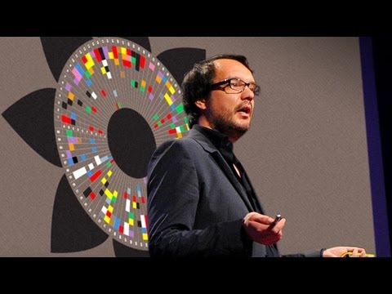](https://camo.githubusercontent.com/b5bdb7b0d317732e78aebc4006dc1fa7dec4c576/687474703a2f2f696d672e796f75747562652e636f6d2f76692f355a672d433841414947672f302e6a7067)](<https://www.youtube.com/watch?v=5Zg-C8AAIGg>

[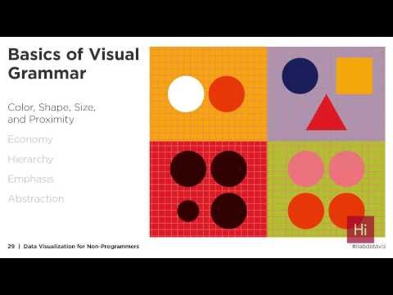](https://www.youtube.com/watch?v=-xS7QJhVbcM)

[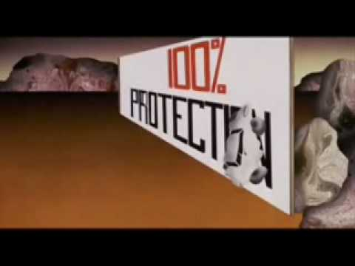](https://www.youtube.com/watch?v=SUOJzYtdTKI)

For your assignment you at least:

* Find a dataset with some data you want to investigate
* Load the dataset into a Processing sketch
* Include at least one visualisation that we made in the class
* Include at least one visualisation that you came up with yourself
* Include a menu that allows the user to choose which visualisation to show

In your solution, use colour and animation to convey the story in your data. You can also use simple stats such as average, standard deviation and correlations.

Marking Scheme

| **Category** | **Marks** |
| --- | --- |
| Core features | 50% |
| Advanced features | 50% |

In other words, if you implement the stuff above you get 50%. To get the remaining features you should come up with your own extra features. Some examples of ideas you could come up with (but don't limit yourself to these!)

* Use Control P5 to implement a GUI with controls that allow the user to interact with the visualisations
* Use classes
* Display some beautiful animations
* Do some 3D visualisation
* Build a custom sensor using an Arduino and visualise its output
* Visualise some geotagged data on a map
* Use a Kinect or Leap Motion to interact with the visualisation using gestures
* Generate the data using Fractals or some other mathematical model

**Deliverables**

* Deliverable 1: Due 9 November. You should create a git repository for your assignment code and submit your git repository link through [this Google Docs form](https://docs.google.com/forms/d/1CJxmXCLEsPuEbwZy0PrvmQR6lQqqJUmcVw_koxBL-50/viewform). In the git repository you should have a Processing sketch that loads your data into some data structure. IN other words, you should have identified your dataset at this stage. You should include a readme.md file that describes what your project is all about and what you plan to do
* Deliverable 2: Due 7 December. Final assignment submission. You should include some screen-shots and a writeup in your readme.md files. Assignments to be demoed. Everybody needs to demo otherwise the submission will not be considered.