


《数值线性代数上机》报告

学 院 数学科学学院
专业班级 数2201
姓 名 白振
学 号 20221161155

2024年 12月19日

- 【实验目的】
1.掌握古典迭代法解线性方程组的思想。
2.了解各种古典迭代法的收敛速度。
3.能编写程序用古典迭代法求解线性方程组。
- 【实验任务】
1.数值代数课本132页上机实验题3。
- 【实验程序】
import numpy as np
import matplotlib.pyplot as plt
plt.rcParams['figure.dpi'] = 300
plt.rcParams['font.sans-serif'] = ['STFangsong'] # 图中显示中文
plt.rcParams['axes.unicode_minus'] = False # 图中正常显示负号
def create_matrix(n):
dim = (n-1) ** 2
A = np.zeros((dim, dim))
#每个分块矩阵的维数
block_size = n-1
# A对角元为T_(n-1)
for i in range(block_size):
start_idx = i * block_size
# 主对角线为4
for j in range(block_size):
A[start_idx + j, start_idx + j] = 4
# 次对角线为1
for j in range(block_size - 1):
A[start_idx + j, start_idx + j + 1] = 1
A[start_idx + j + 1, start_idx + j] = 1
# A次对角线 -I_(n-1)
for i in range(block_size - 1):
start_idx = i * block_size
next_idx = (i + 1) * block_size
for j in range(block_size):
A[start_idx + j, next_idx + j] = -1
A[next_idx + j, start_idx + j] = -1
return A
def create_b(n):
dim = (n-1) ** 2
e = np.ones(dim)
A = create_matrix(n)
return A @ e
def jacobi(A, b, tol=1e-8, max_iter=1000):
n = len(A)
x = np.zeros(n)
D = np.diag(A)
R = A - np.diagflat(D)
errors = []
for i in range(max_iter):
x_new = (b - R @ x) / D
error = np.linalg.norm(b - A @ x_new)
errors.append(error)
if error < tol:
return x_new, errors, i+1
x = x_new
return x, errors, max_iter
def gauss_seidel(A, b,tol=1e-8, max_iter=1000):
n = len(A)
x = np.zeros(n)
errors = []
for iter_count in range(max_iter):
x_new = x.copy()
for i in range(n):
s1 = np.dot(A[i, :i], x_new[:i])
s2 = np.dot(A[i, i + 1:], x[i + 1:])
x_new[i] = (b[i] - s1 - s2) / A[i, i]
error = np.linalg.norm(b - A @ x_new)
errors.append(error)
if error < tol:
return x_new, errors, iter_count + 1
x = x_new
return x, errors, max_iter
def sor(A, b, omega, tol=1e-8, max_iter=1000):
n = len(A)
x = np.zeros(n)
errors = []
for iter_count in range(max_iter):
x_new = x.copy()
for i in range(n):
s1 = np.dot(A[i, :i], x_new[:i])
s2 = np.dot(A[i, i + 1:], x[i + 1:])
x_new[i] = (1 - omega) * x[i] + (omega * (b[i] - s1 - s2)) / A[i, i]
error = np.linalg.norm(b - A @ x_new)
errors.append(error)
if error < tol:
return x_new, errors, iter_count + 1
x = x_new
return x, errors, max_iter
n = 10 # 矩阵维数 + 1
A = create_matrix(n)
b = create_b(n)
omega = 1.3
_, jacobi_errors, jacobi_steps = jacobi(A, b)
_, gs_errors, gs_steps = gauss_seidel(A, b)
_, sor_errors, sor_steps = sor(A, b, omega)
# 画图
plt.figure()
plt.semilogy(jacobi_errors, label=f'Jacobi ({jacobi_steps} 步)')
plt.semilogy(gs_errors, label=f'Gauss-Seidel ({gs_steps} 步)')
plt.semilogy(sor_errors, label=f'SOR ω=1.3 ({sor_steps} 步)')
plt.grid(True)
plt.xlabel('迭代步数')
plt.ylabel('迭代误差 (对数尺度)')
plt.legend()
plt.title('不同迭代方法的每步迭代误差比较')
# 画表 3.1
n = 4 # 9x9 矩阵
A = create_matrix(n)
b = create_b(n)
omegas = [0.2, 0.4, 0.6, 0.8, 1.0]
print("\nTable 3.1:不同松弛因子的收敛速度比较")
print(f"{'ω':<10} {'Steps':<10}{'n '} {'ρ(G)':<10}{'Error':<15} ")
print("-" * 45)
for omega in omegas:
_, errors, steps = sor(A, b, omega)
D = np.diag(np.diag(A))
L = np.tril(A, -1)
U = np.triu(A, 1)
G = np.linalg.inv(D/omega + L) @ ((1-omega)/omega * D - U)
rho = np.max(np.abs(np.linalg.eigvals(G)))
print(f"{omega:<10.1f} {steps:<10d}{'4 '} {rho:<10.4f} {errors[-1]:<15.2e} ")

第二题：
import numpy as np
import time
from pyamg.relaxation.relaxation import jacobi, gauss_seidel, sor
from scipy.io import mmread
from scipy.sparse import eye, diags
import matplotlib.pyplot as plt
from tqdm import tqdm
plt.rcParams['figure.dpi'] = 300
plt.rcParams['font.sans-serif'] = ['STFangsong'] # 图中显示中文
plt.rcParams['axes.unicode_minus'] = False # 图中正常显示负号
def read_mtx_file(file_path):
sparse_matrix = mmread(file_path)
row_sums = sparse_matrix.sum(axis=1).A.flatten()
row_sums[row_sums == 0] = 1
row_diag = diags(1.0 / row_sums)
return row_diag @ sparse_matrix
class IterativeSolver:
def __init__(self, M, b, x0, tol=1e-8, max_iter=1000):
self.M = M
self.b = b
self.x0 = x0.copy()
self.tol = tol
self.max_iter = max_iter
self.residuals = []
self.times = []
self.iterations = []
def solve(self, method, method_name, **kwargs):
x = self.x0.copy()
start_time = time.time()
for i in tqdm(range(self.max_iter), desc=f"{method_name}计算中"):
method(self.M, x, self.b, **kwargs)
residual = np.linalg.norm(self.M @ x - self.b)
self.residuals.append(residual)
self.times.append(time.time() - start_time)
self.iterations.append(i + 1)
if residual < self.tol:
break
return {
"迭代次数": i + 1,
"计算时间": time.time() - start_time,
"最终残差": residual,
"解": x
}
def plot_convergence(solvers, names):
plt.figure(figsize=(15, 10))
plt.subplot(2, 1, 1)
for solver, name in zip(solvers, names):
plt.semilogy(solver.iterations, solver.residuals, label=name)
plt.grid(True)
plt.xlabel('迭代次数')
plt.ylabel('残差 (对数尺度)')
plt.title('迭代方法收敛性对比')
plt.legend()
plt.subplot(2, 1, 2)
for solver, name in zip(solvers, names):
plt.plot(solver.times, solver.residuals, label=name)
plt.grid(True)
plt.xlabel('计算时间 (秒)')
plt.ylabel('残差')
plt.title('迭代方法性能对比')
plt.legend()
plt.tight_layout()
plt.show()
# 主程序
matrix_files = {
'Wiki投票': 'wiki-Vote.mtx',
'Google网页': 'web-Google.mtx',
'Stanford网页': 'web-Stanford.mtx'
}
for name, file_name in matrix_files.items():
print(f"\n处理矩阵: {name}")
A = read_mtx_file(file_name)
print(f"矩阵维度: {A.shape}")
alpha = 0.85
n = A.shape[0]
I = eye(n, format='csr')
b = np.ones(n) / n
M = I - alpha * A
x0 = np.zeros(n)
tol = 1e-8
max_iter = 1000
solvers = []
solver_names = []
jacobi_solver = IterativeSolver(M, b, x0, tol=tol, max_iter=max_iter)
jacobi_result = jacobi_solver.solve(jacobi, "Jacobi方法")
solvers.append(jacobi_solver)
solver_names.append("Jacobi方法")
gs_solver = IterativeSolver(M, b, x0, tol=tol, max_iter=max_iter)
gs_result = gs_solver.solve(gauss_seidel, "Gauss-Seidel方法", sweep='forward')
solvers.append(gs_solver)
solver_names.append("Gauss-Seidel方法")
sor_solver = IterativeSolver(M, b, x0, tol=tol, max_iter=max_iter)
sor_result = sor_solver.solve(sor, "SOR方法", omega=1.1, sweep='forward')
solvers.append(sor_solver)
solver_names.append("SOR方法")
plot_convergence(solvers, solver_names)
for solver, name in zip(solvers, solver_names):
print(f"\n{name}:")
print(f" 迭代次数: {len(solver.iterations)}")
print(f" 计算时间: {solver.times[-1]:.4f} 秒")
print(f" 最终残差: {solver.residuals[-1]:.4e}")

- 【实验结果】
1.(1)
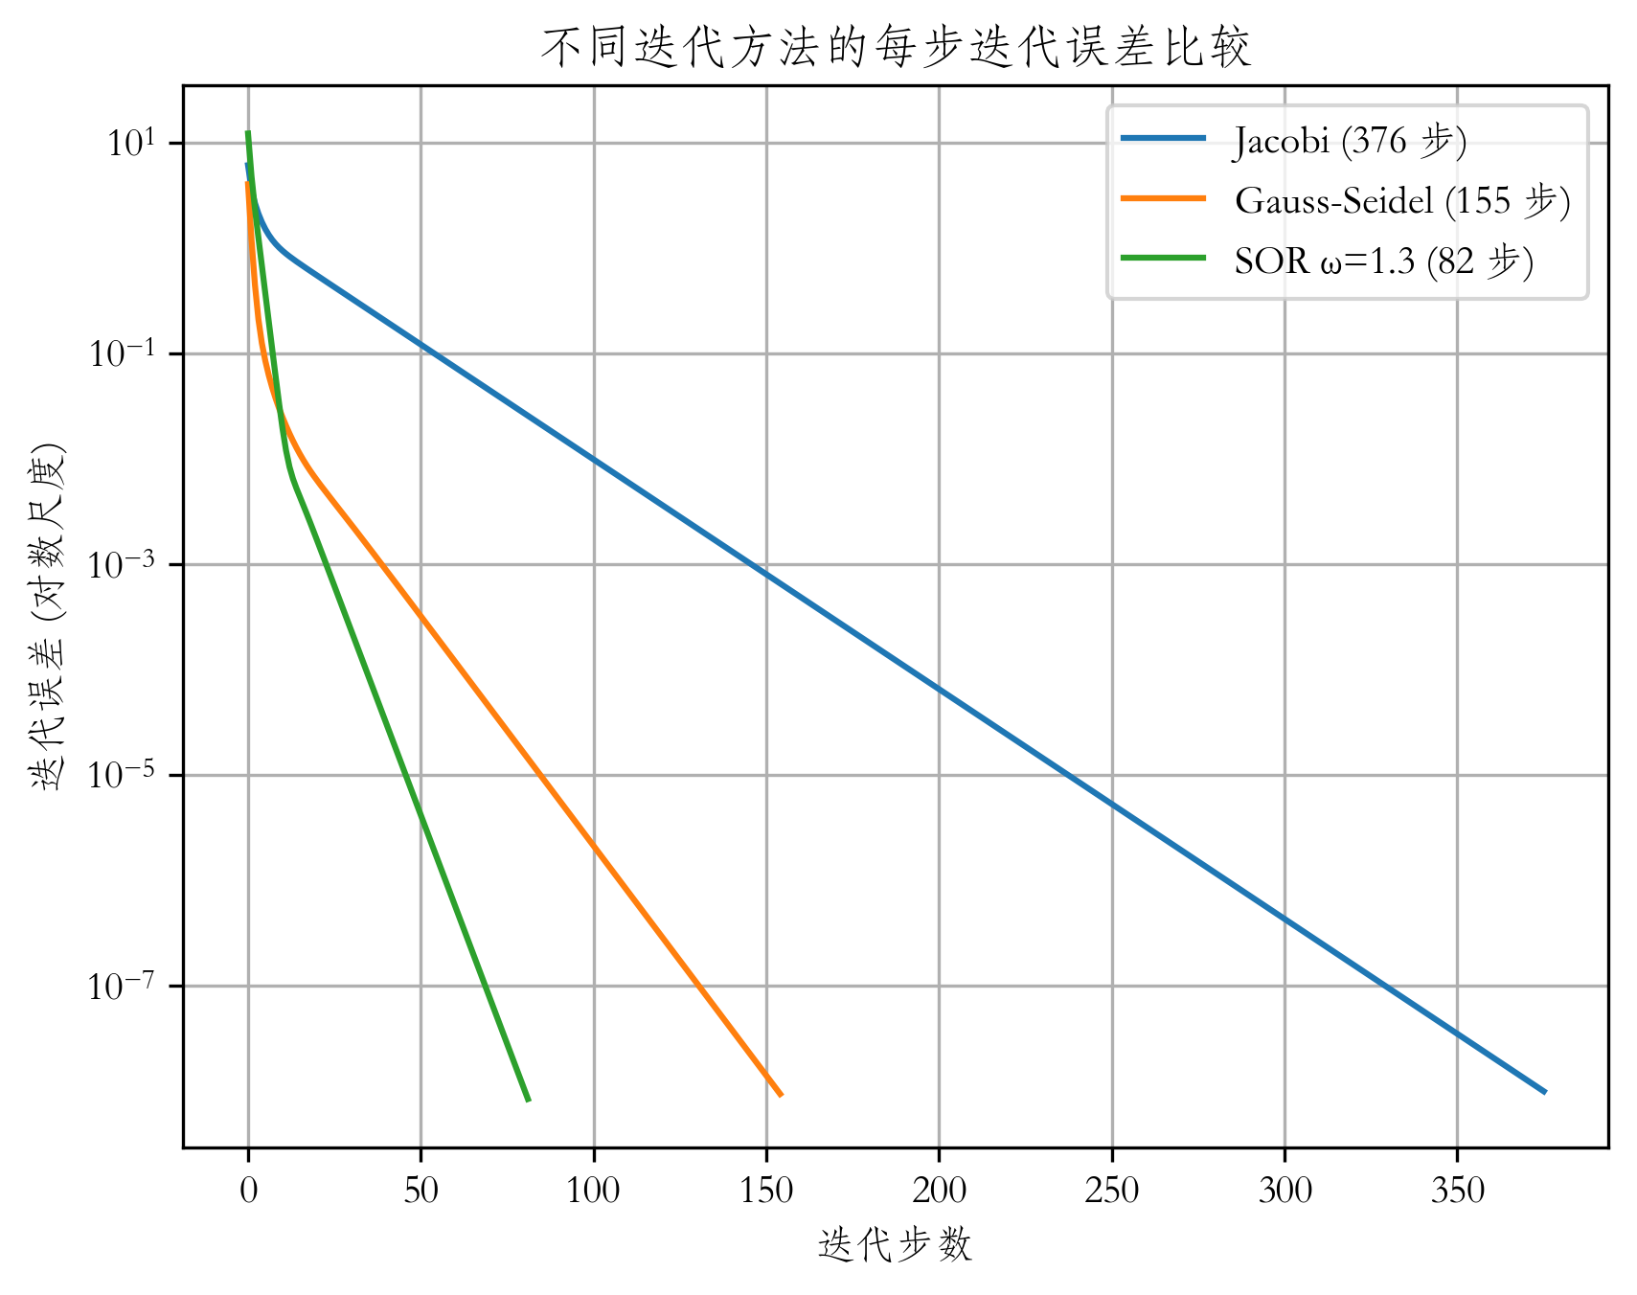
(2):
表 3.1 不同松弛因子的收敛速度比较
ω | n | 步长 | ρ(G) | 误差
0.2 | 4 | 275 | 0.9369 | 9.68E-09
0.4 | 4 | 122 | 0.8627 | 9.25E-09
0.6 | 4 | 71 | 0.7730 | 7.90E-09
0.8 | 4 | 44 | 0.6590 | 9.55E-09
1 | 4 | 28 | 0.5000 | 5.93E-09
2.
处理矩阵: Wiki-Vote
矩阵维度: (8297, 8297)
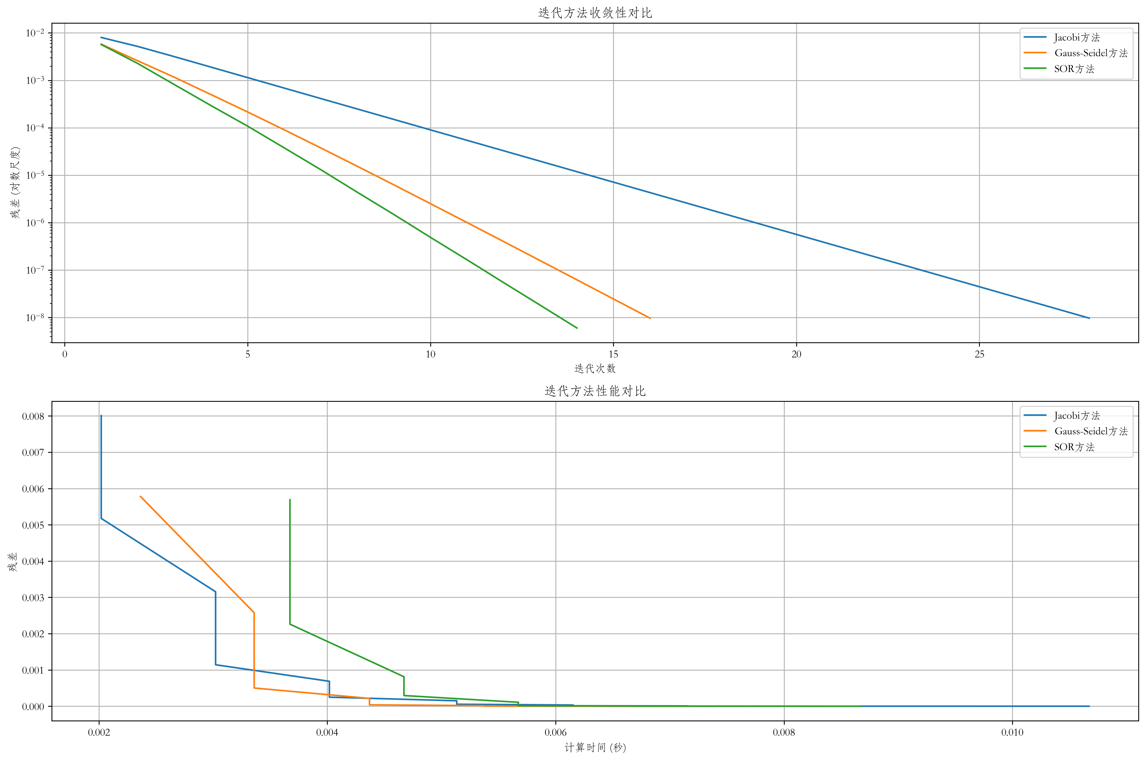
Jacobi方法:
迭代次数: 28
计算时间: 0.0107 秒
最终残差: 9.7343e-09

Gauss-Seidel方法:
迭代次数: 16
计算时间: 0.0074 秒
最终残差: 9.7127e-09

SOR方法:
迭代次数: 14
计算时间: 0.0087 秒
最终残差: 6.0260e-09

处理矩阵:web- Google
矩阵维度: (916428, 916428)
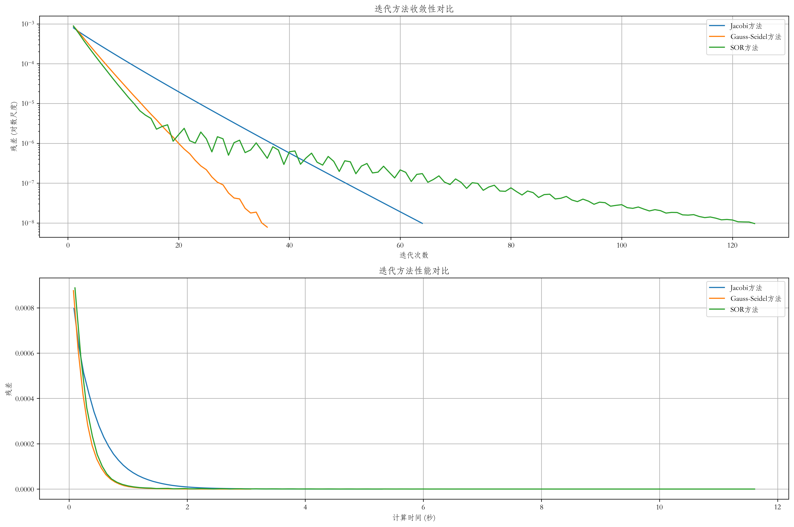
Jacobi方法:
迭代次数: 64
计算时间: 5.3027 秒
最终残差: 9.7653e-09

Gauss-Seidel方法:
迭代次数: 36
计算时间: 3.0760 秒
最终残差: 7.8500e-09

SOR方法:
迭代次数: 124
计算时间: 11.6110 秒
最终残差: 9.6462e-09

处理矩阵: web-Stanford
矩阵维度: (281903, 281903)
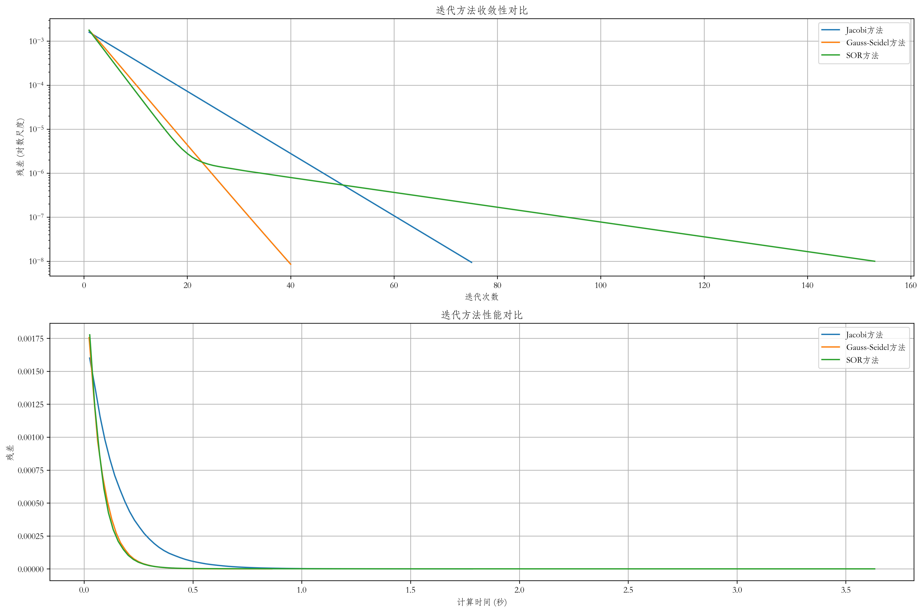
Jacobi方法:
迭代次数: 75
计算时间: 1.7847 秒
最终残差: 9.4220e-09

Gauss-Seidel方法:
迭代次数: 40
计算时间: 0.8629 秒
最终残差: 8.5585e-09

SOR方法:
迭代次数: 153
计算时间: 3.6326 秒
最终残差: 9.9966e-09
- 【实验总结】

- 【指导教师评语及成绩】
评 语: | 评语等级
评 语: | 优 | 良 | 中 | 及格 | 不及格
1.实验报告按时完成,字迹清楚,文字叙述流畅,逻辑性强
2.实验方案设计合理
3.实验过程（实验步骤详细,记录完整,数据合理,分析透彻）
4实验结论正确.
成 绩：

指导教师签名：
批阅日期：

