MUNICIFIX: A MOBILE-BASED PLATFORM FOR MUNICIPAL ISSUE REPORTING AND RESOLUTION WITH INTEGRATED K-MEANS CUSTERING

__________________________________

A Thesis Project Presented to the Faculty of the
College of Information and Computing Sciences
Cagayan State University – Carig Campus
Carig Sur, Tuguegarao City, Cagayan

__________________________________

In Partial Fulfillment of the Academic Requirement
for the Degree Bachelor of Science in Computer Science

Researchers:
BACANI, STEPHEN SIMOUN GEE L.
BERMUDEZ, KENJIE C.
DELOS SANTOS, REINHARD L.

CHAPTER 1
INTRODUCTION

1.1 Background of the Study
In many Philippine towns, especially rural and developing areas, residents regularly face unaddressed municipal issues, potholes, faulty or fading streetlights, waste disposal, and other more. These problems affect not only the safety and sanitation of communities but also weaken trust in local government systems and their ability to respond effectively.
Enrile, Cagayan, a primarily agricultural municipality is no exception. Its vulnerability to heavy rainfall and overflowing rivers leads to recurring flooding, drainage failures, and road erosion. Infrastructure problems are widespread, especially during typhoon season. Although the municipal government attempts to respond, it is limited by the absence of timely, organized, and traceable information. This prevents accurate prioritization, delays resolutions, and leads to inefficient resource use.
At present, issue reporting in Enrile is informal and fragmented. Residents typically voice complaints through word of mouth, or phone calls methods that are inconsistent, hard to verify, and offer no way to track resolution. Without a centralized system, both citizens and government workers struggle to follow the status of a report, often leading to unresolved or forgotten concerns. This lack of transparency results in public frustration, discourages civic participation, and allows small problems to escalate into larger infrastructure or public health risks.
MuniciFix was built to address these gaps. It is a mobile-based platform that allows residents to report municipal problems directly from their smartphones. Users can submit detailed descriptions, attach images, and send exact GPS coordinates of the issue, enabling the municipal office to receive accurate, actionable data without delays. The system improves the speed, consistency, and accountability of issue reporting.
However, MuniciFix goes beyond complaint submission. It functions as a decision-support tool powered by the K-Means Clustering algorithm, which analyzes patterns across submitted reports. The system identifies recurring issues such as streets that frequently flood or areas with ongoing trash buildup, road problems, water problem and clusters them into geographic and thematic problem zones. This allows the local government to move from reactive to proactive governance: anticipating problems, allocating resources more effectively, and addressing root causes instead of surface symptoms.
1.2 Objectives
1.2.1 General Objective
- The main objective of this study is to develop a mobile-based municipal reporting system that enables citizens to report community issues in real time while enhancing local government responsiveness through the integration of the K-Means clustering algorithm to identify issue patterns, optimize resource allocation, and improve public service delivery.
1.2.2 Specific Objectives
- Develop a mobile application that provides citizens with an accessible and convenient way to report municipal issues such as damaged facilities, waste problems, or safety hazards.
- Implement a secure and efficient report management system that allows both citizens and municipal staff to track, update, and manage reported concerns in real time.
- Enhance communication and transparency between citizens and the municipal office by providing timely updates and notifications on the status of reports.
- Encourage civic engagement and accountability by empowering citizens to take part in maintaining and improving their community through active reporting.
- Contribute to more efficient public service delivery by reducing communication gaps and response delays between citizens and municipal authorities.

1.3 Research Paradigm (IPO)
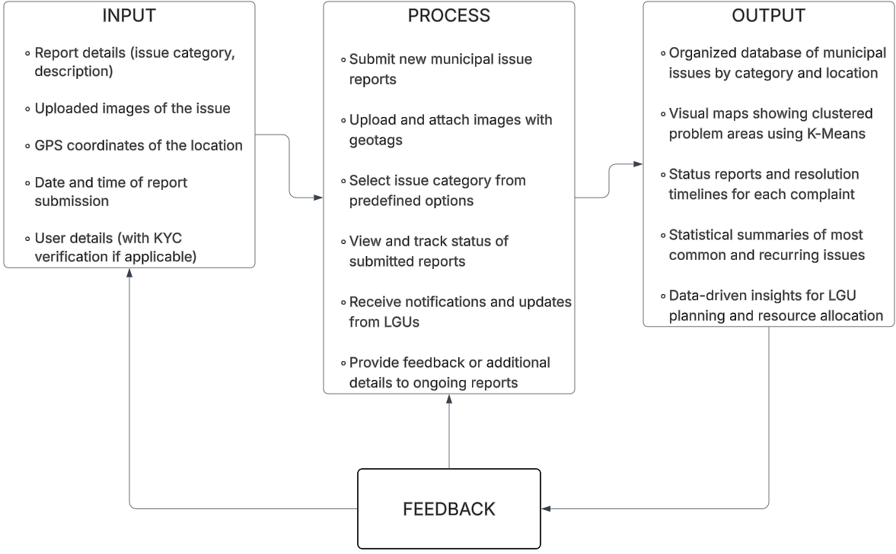

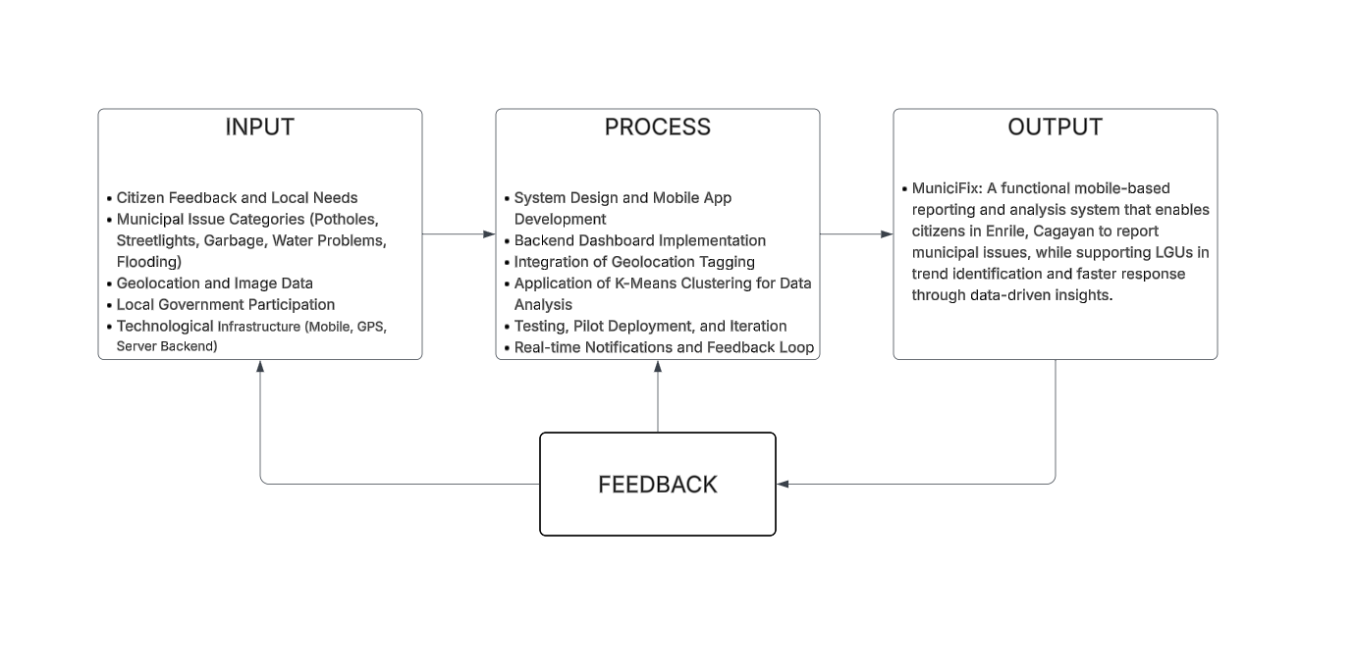

Figure 1: Research Paradigm (IPO)

This research paradigm ensures a structured approach to the development and implementation of MuniciFix, a mobile-based municipal issue reporting platform specifically tailored for the Municipality of Enrile, Cagayan. It focuses on empowering citizens to report local concerns efficiently, enhancing municipal responsiveness, and supporting data-driven decision-making through intelligent clustering of reports.

1.4 Scope and Limitation of the Study
The MuniciFix application enables citizens in Enrile, Cagayan to report municipal issues specifically floods, water supply problems, potholes, faulty or fading streetlights, and waste disposal through structured forms, images, and geolocation. Users can track report progress, receive real-time updates, and view report history. The admin dashboard allows municipal staff to verify users, manage and filter reports, update statuses, and view issues on a map. Integrated K-Means clustering identifies recurring problem areas, supporting targeted resource allocation and informed decision-making.
However, it is essential to acknowledge certain limitations associated with its implementation:
Image Verification: The system cannot automatically determine whether an uploaded image accurately represents the reported issue category.Verification of image accuracy and issue validity depends solely on the municipal administrator’s manual review.
Geographical Scope: The application is initially available only within the Municipality of Enrile, Cagayan, restricting access for users outside this area.
Internet Connectivity: The system requires stable internet connectivity for real-time reporting, data synchronization, and feedback. Users in areas with unreliable or limited internet access may experience reduced functionality.
Response Capability: The timeliness and effectiveness of issue resolution depend on the availability of resources, manpower, and operational readiness of the local government unit (LGU) of Enrile.
Scalability: The application is currently designed for a single municipality and would require modifications to support multiple localities or larger-scale deployment.
Geographical Boundary: The application operates only within a predefined geographical boundary corresponding to the Municipality of Enrile, Cagayan, defined by latitude and longitude coordinates (minLat: 17.45, maxLat: 17.66, minLng: 121.60, maxLng: 121.80). Reports submitted outside this boundary will not be accepted, processed, or displayed on the map.
Geocoding Limitation: The system uses Nominatim (OpenStreetMap) for reverse geocoding to convert coordinates into address data. As a free and open-source alternative to the paid Google Maps API, Nominatim may have limited accuracy and performance, and is used primarily for testing and research purposes in this version.

1.5 Significance of the study
This system aimed to improve the effectiveness of the present system that could be beneficial to the following:
Residents of Enrile: The system offers a faster, more transparent way to report community problems and receive updates—especially for urgent concerns like flooding or water service disruptions.
Local Government Unit Enrile: The platform provides a structured reporting system, pattern analysis, and visual tools to help municipal officers track and respond to issues more effectively.
Researchers – This study will broaden their knowledge about mobile-based reporting platforms and the integration of data clustering in public service systems. It will also serve as an avenue for them to apply and enhance the technical, analytical, and problem-solving skills they have learned in their academic subjects.
Future Implementations: The success of MuniciFix in Enrile may serve as a blueprint for deployment in other municipalities across the region or country.

1.6 Definition of terms
The following terms are used in this documentation and are defined accordingly to their meaning and function. These words are defined to further understand the documentation:
Geolocation – The identification of the geographic location of a device using GPS.
K-Means Clustering – A machine learning algorithm used to group data points based on similarity, applied in this study to identify patterns in municipal issues.
Hotspot – A geographical area where a particular type of issue occurs frequently.
Mobile-Based Platform – A system or application that runs on smartphones or tablets.
Real-Time Reporting – Submitting or accessing data immediately as it occurs.
Dashboard – A digital interface where authorities can view, manage, and analyze submitted reports.
Feedback System – A feature that updates users on the status of their submissions to keep them informed and engaged.

User Flowchart

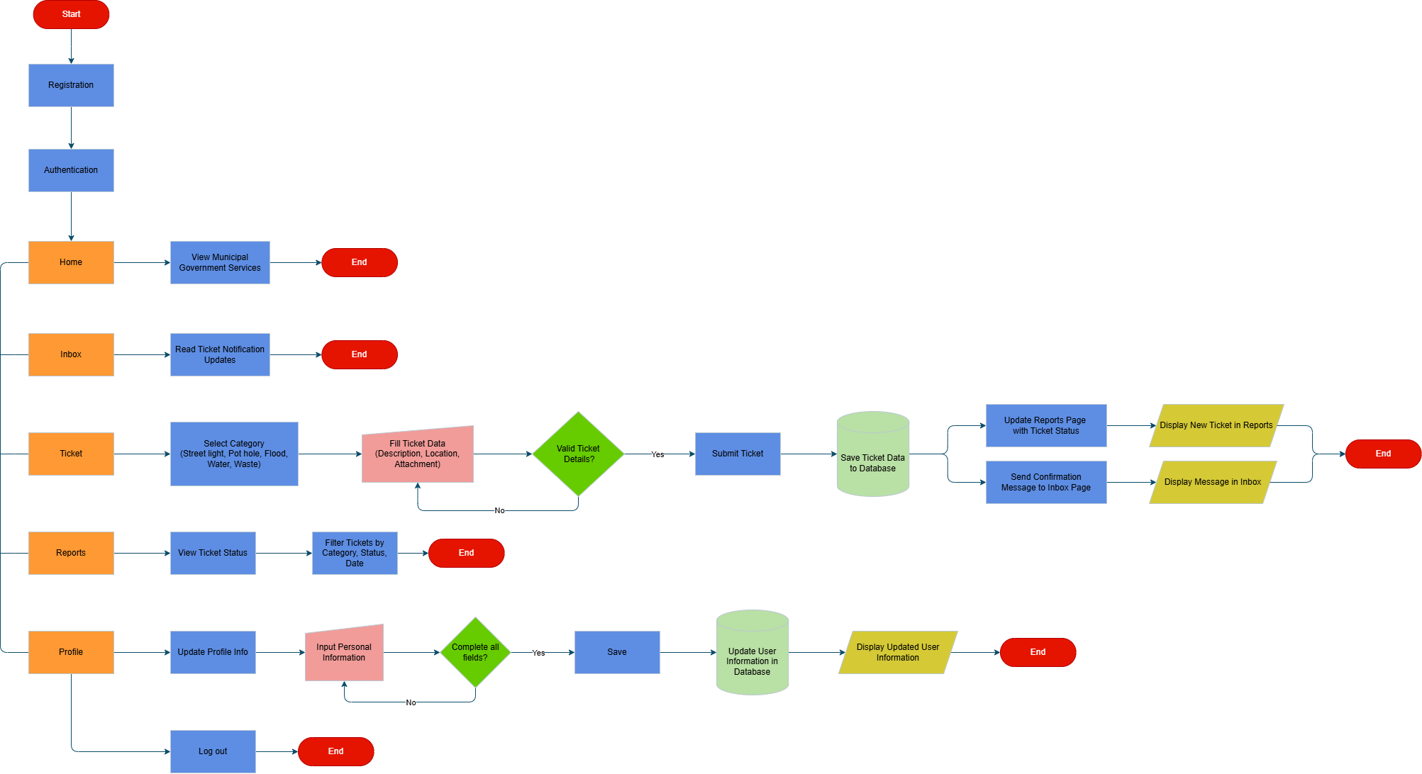

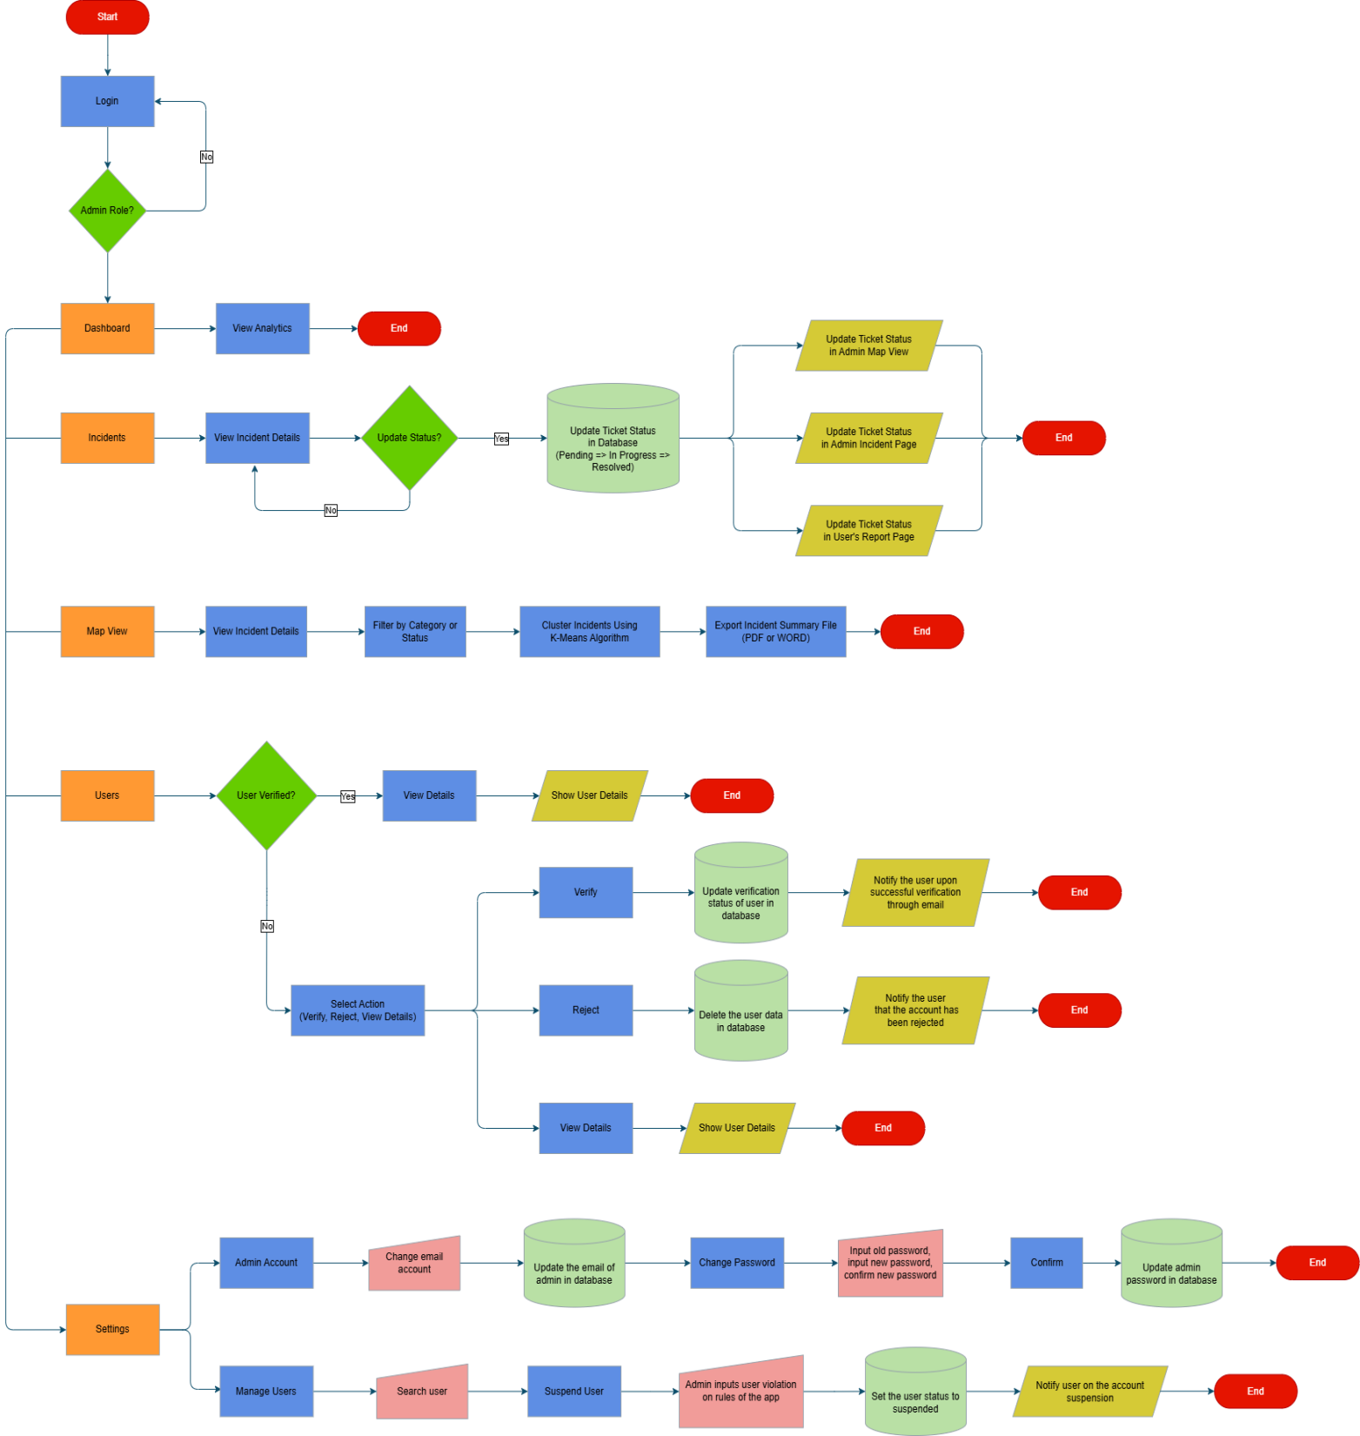
Admin Flowchart

