|  |
| --- |
| AWS Set-up and connections |
| Step-by-step guide |
|  |
| This documents will help in AWS EC2 instance creation. It also covers connecting putty and filezilla to AWS. |
|  |
| Kumar Abhishek |
| 4/15/2018 |
|  |

Contents

Create EC 2 Instance 3

Using putty to connect to AWS 7

Using filezilla to connect to AWS 12

Installation on AWS 14

Useful references 15

# Create EC 2 Instance

1. Select OS of your choice. We selected Red Hat Enterprise Linux 7.5 64-bit “free tier eligible”.

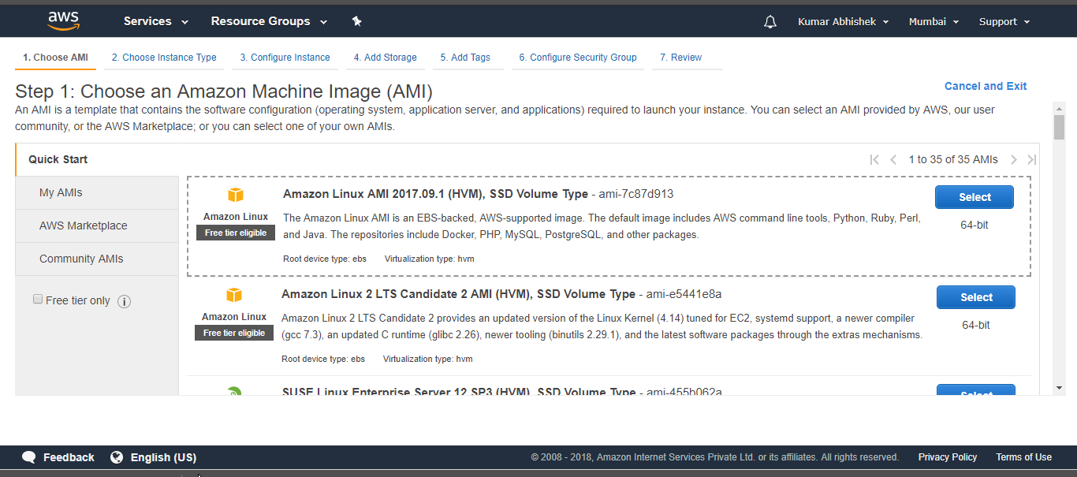

1. Choose instance type. Go with default. Hit ‘Next’.

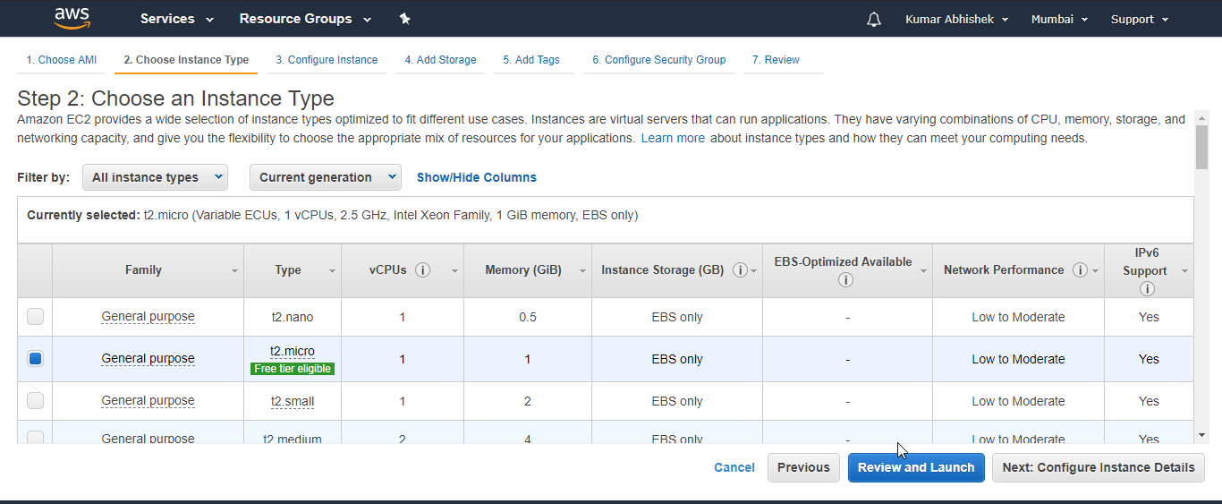

1. Configure Instance details. No change. Hit ‘Next’ to add storage

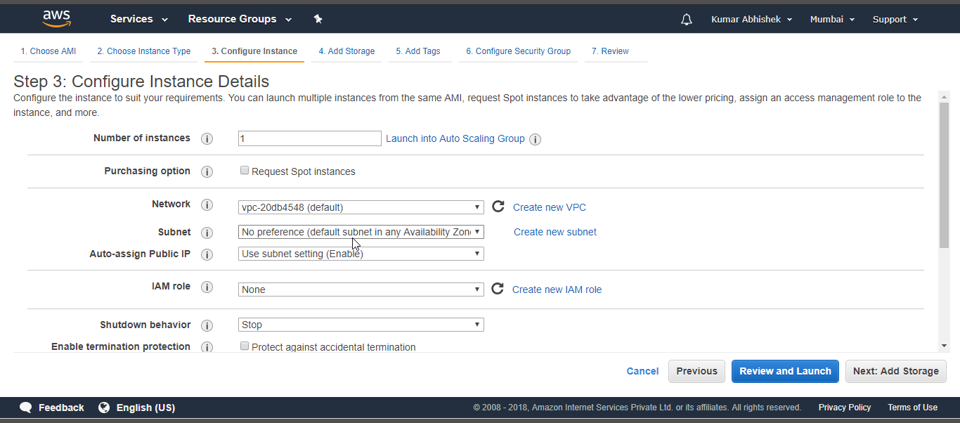

1. Add storage. Remove delete on termination. Hit next.

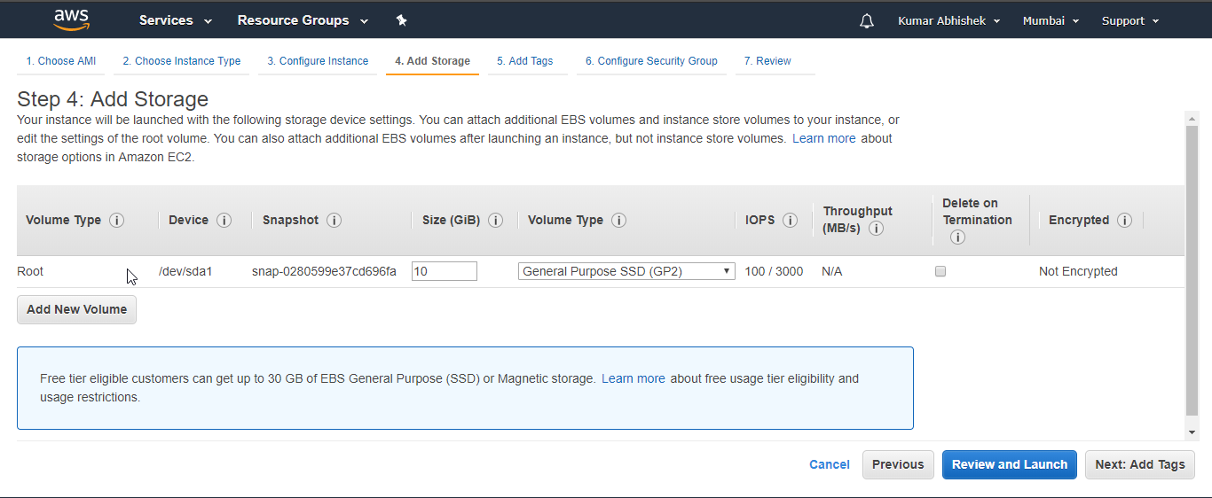

1. Add a tag if required. Nothing added yet. Hit next.

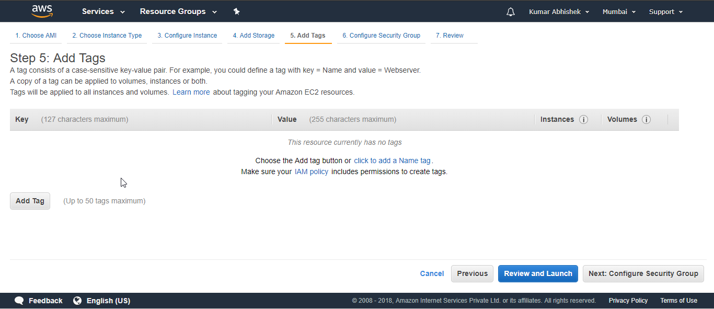

1. Configure Security group. Below security groups are added.

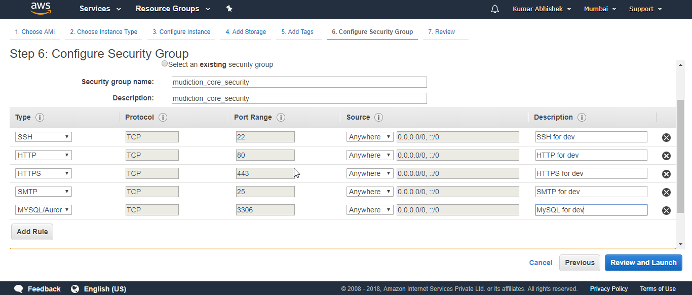

1. Review launch instances. Hit Launch.

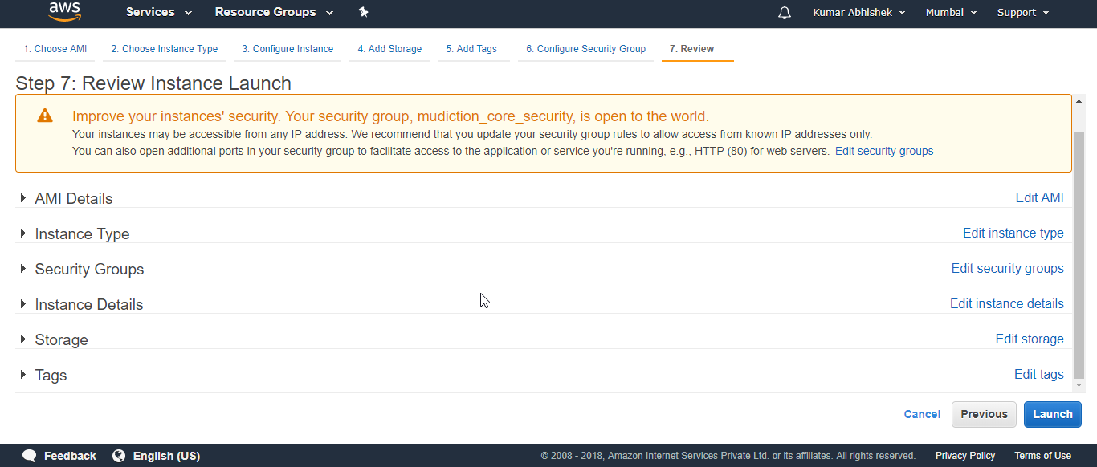

1. Key pair. This is very important. Name a key and a file will be downloaded. Hit ‘Launch Instance’.

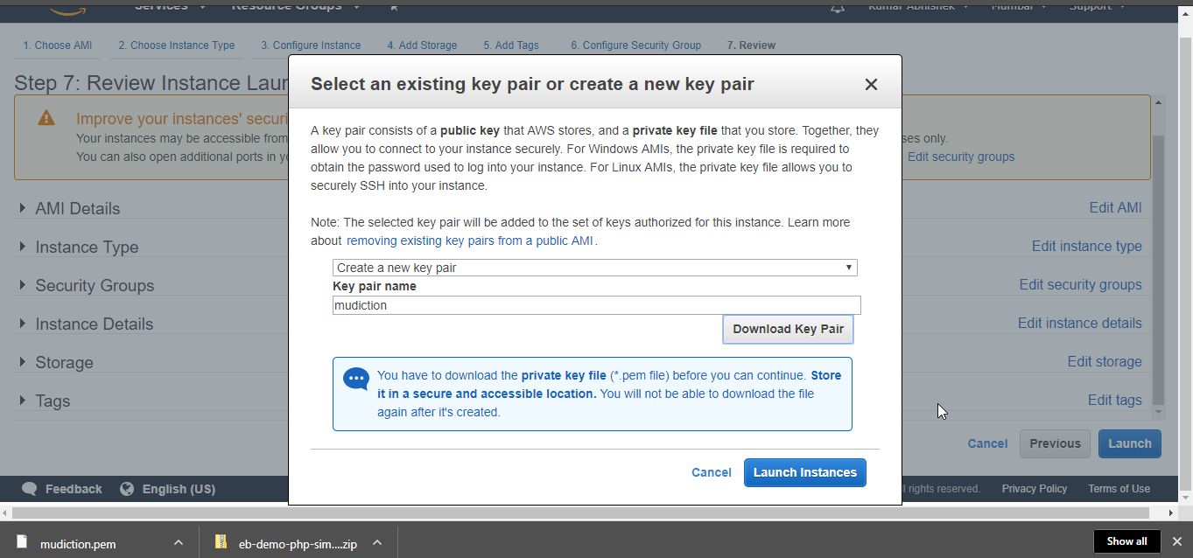

1. And your instance is launched. Click view instances.

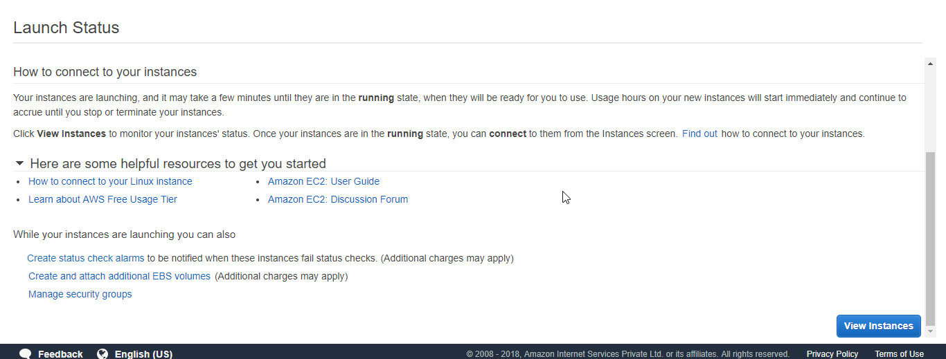

# Using putty to connect to AWS

1. Download puttygen.exe from <https://www.chiark.greenend.org.uk/~sgtatham/putty/latest.html>

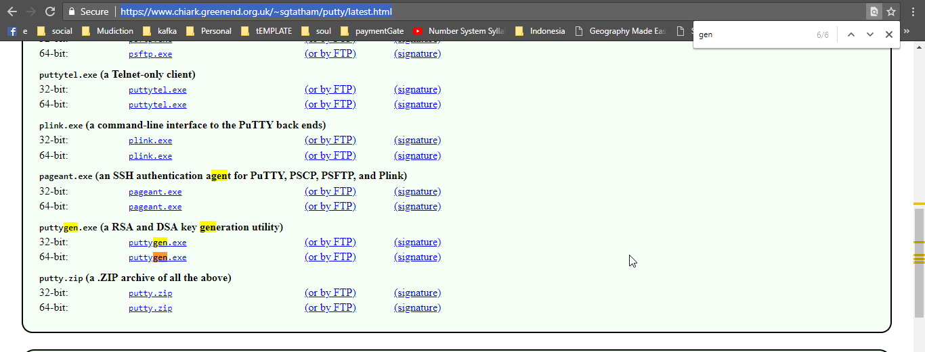

1. Open puttygen, put pem file path downloaded earlier, and then ‘save private key’.
2. Open putty-
3. You need host name. Go to aws and click on connect. Pop up will open with information

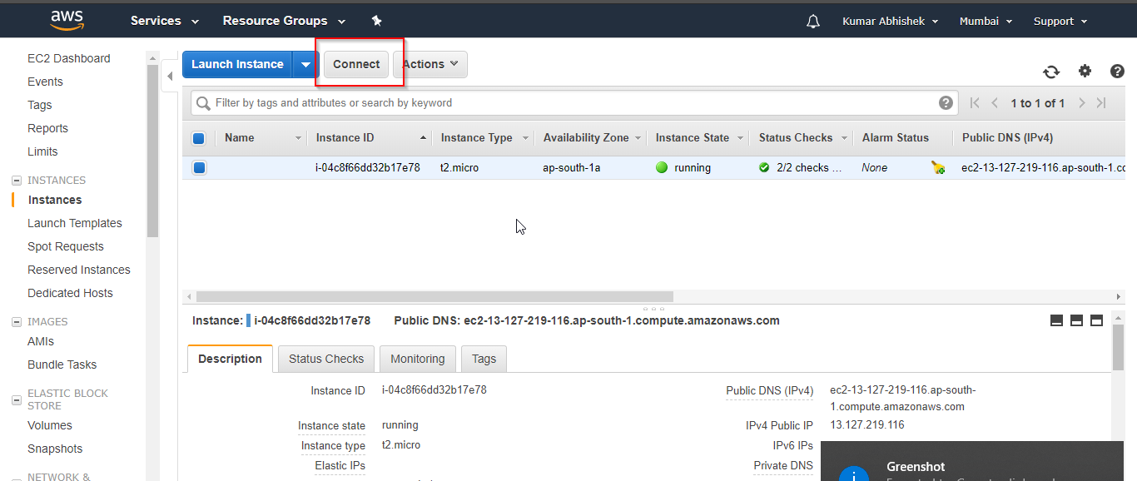

Pop –up

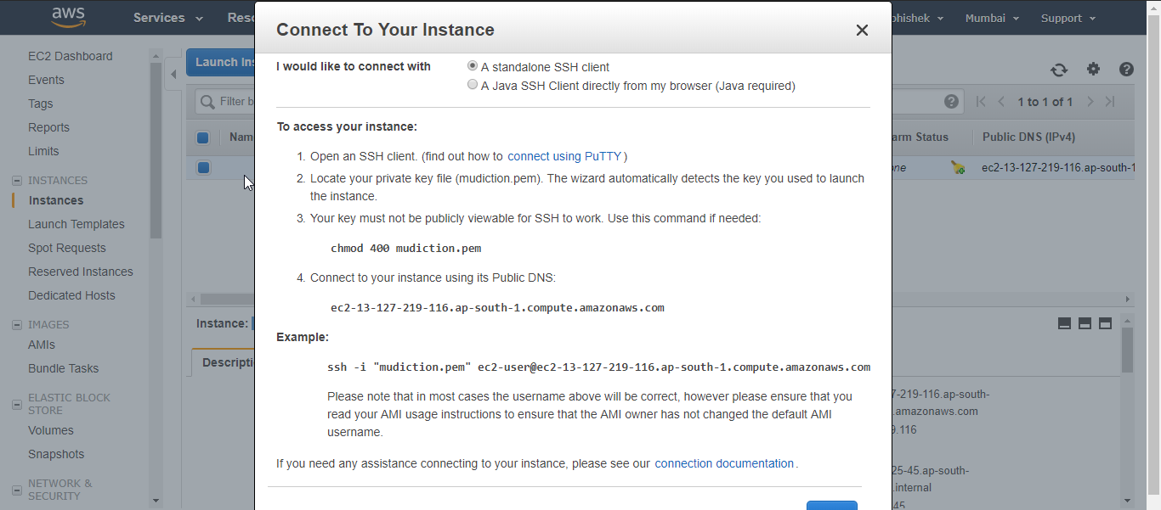

It says hostname as ec2-13-127-219-116.ap-south-1.compute.amazonaws.com

And user name as ec2-user

As password we need to provide the file we generated through puttygen.

Put hostname under ‘Sessions’

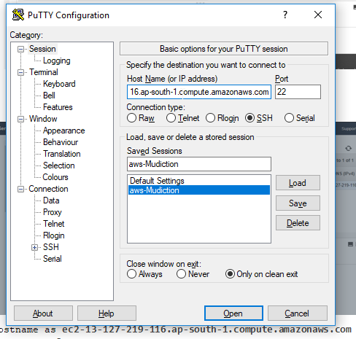

Put username under ‘connections’ > ‘Data’ > Auto-login username : **ec2-user**

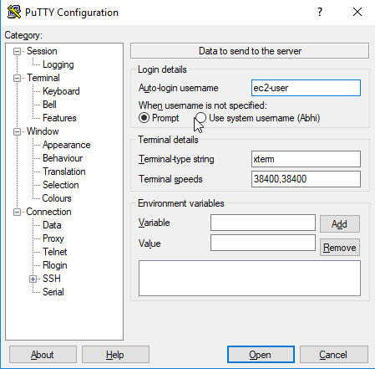

Put password certificate file downloaded from puttygen under ‘Connection’ > ‘SSH’ > ‘Auth’ > Private key file for authentication. Browse your file.

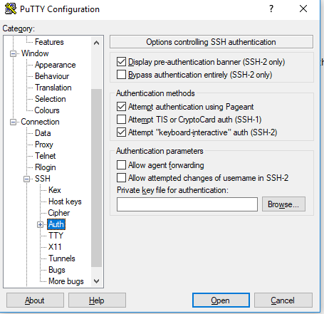

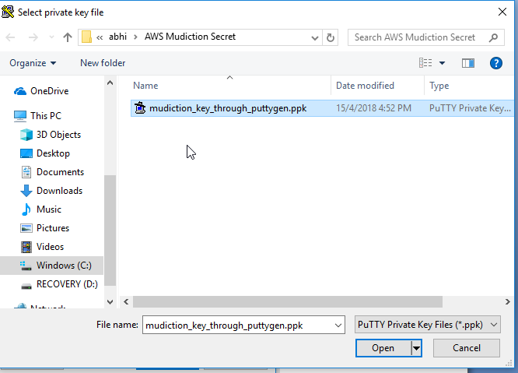

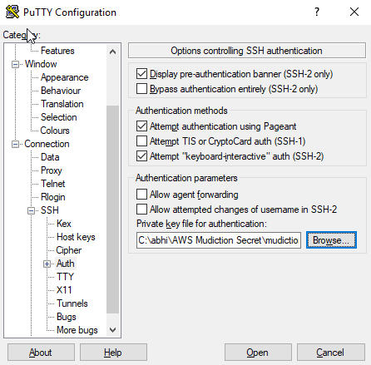

And hit ‘Open’. It will open a putty connection for you.

As it is RedHat os, it will have all the commands for redHat OS working.

# Using filezilla to connect to AWS

1. Go to Edit > Settings

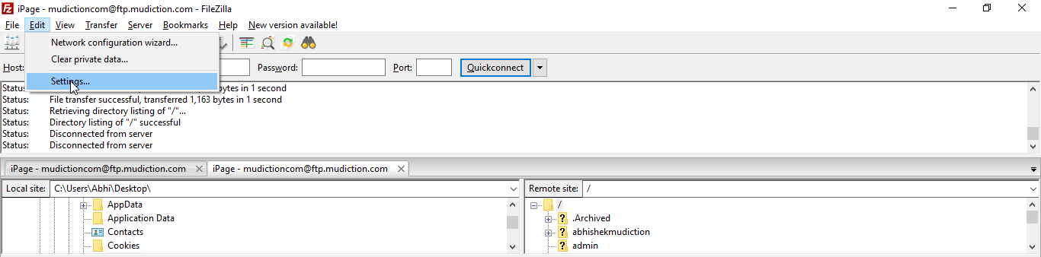

1. Go to Connection > SFTP and Add key file. Add the pem file you downloaded from AWS. It will ask to convert file to ‘ppk’ as ‘pem’ is not supported. Convert and save ppk file(you can also use the ppk file we generated through puttygen in previous steps for putty setup).

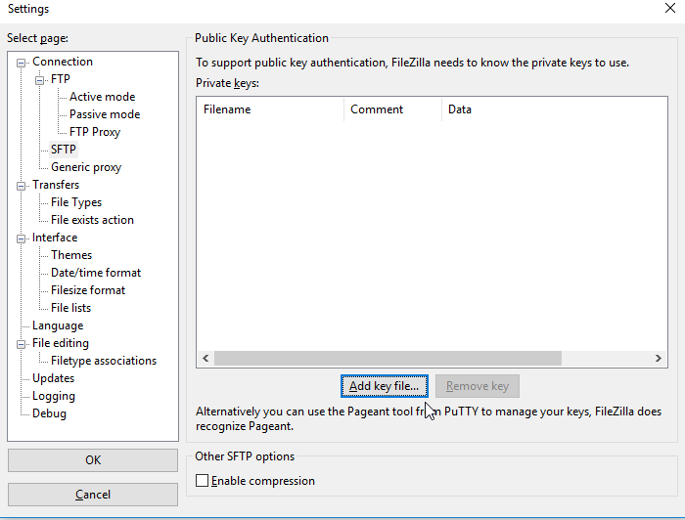

1. Go to AWS and get your Public ipv4. It is **ec2-13-127-219-116.ap-south-1.compute.amazonaws.com** here. Copy it

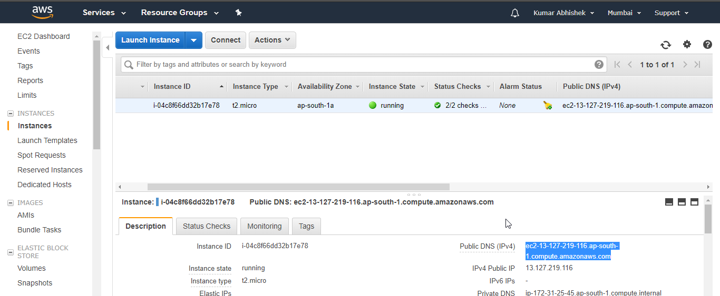

1. Paste public ipv4 in filezilla for ‘Host’.

Put user as **ec2-user**

Keep password blank. Put port as 22.

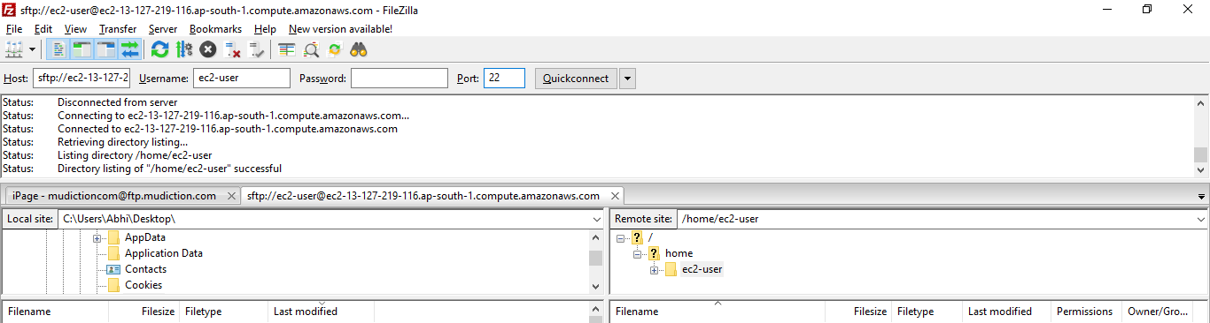

And you are connected to filezilla.

# Installation on AWS

Use below command to install PHP, Apache2 and MySQL

sudo apt-get install php7.0 php7.0-mcrypt php7.0-mysql mysql-server apache2

For mysql, upon pop-up to set username and password set - user : root , password : root

Go to folder - /var/www/html and copy the project files here. It will be shown directly to the public IP http://ec2-13-126-184-254.ap-south-1.compute.amazonaws.com/

# Useful references

EC2 Setup - <https://www.youtube.com/watch?v=wNr7YqjjzOY>

Putty Setup - <https://www.youtube.com/watch?v=bi7ow5NGC-U>

Filezilla setup - <https://www.youtube.com/watch?v=Qxs7CYguo70>