Software Test Plan (STP)
Simple-Shell (Command Line Interpreter)
Version: 1.0
Authors: Diya (QA Lead), Debhargo, Aarush, Prithviraj
Date: [Fill Date]
Status: Draft

1. Introduction
Purpose: This document defines the test plan for Simple-Shell v1.0. It outlines objectives, scope, strategy, resources, schedule, and responsibilities for testing the shell against the Software Requirements Specification (SRS).
Scope: Testing covers the REPL loop, built-in commands, parsing, external command execution, I/O redirection, piping, background execution, environment handling, and the security requirements in SRS §8. Hardware and OS-kernel internals (fork/exec implementation itself) are excluded — only the shell's use of these POSIX APIs is tested.
References: Simple-Shell SRS v1.1, Simple-Shell Software Architecture & Design Specification v1.0, Project Guidelines, POSIX.1 documentation.
Definitions: REPL (Read-Eval-Print Loop), RTM (Requirements Traceability Matrix), STP (Software Test Plan). See SRS Appendix A for the full glossary.

2. Test Items
Test Item
REPL loop and built-in commands (cd, exit, pwd, echo, help)
Command parsing / tokenization
Command execution engine (fork/exec/wait, PATH resolution)
I/O redirection (<, >, >>)
Piping (|) and background execution (&)
Environment variable handling and error handling

3. Features to be Tested
Features mapped to SRS requirement IDs:
REQ-ID(s) | Feature
REQ-1–REQ-4 | REPL prompt loop and built-in commands
REQ-5–REQ-8 | Command parsing: whitespace, quoting, operator recognition
REQ-9–REQ-12 | External command execution and error reporting
REQ-13–REQ-15 | I/O redirection (<, >, >>)
REQ-16–REQ-17 | Piping between two or more commands
REQ-18–REQ-20 | Background execution and environment/PATH handling
REQ-SEC-1–SEC-4 | Security requirements (privilege, path validation, env exposure, input limits)

4. Features Not to be Tested
- The internal implementation of the OS kernel's POSIX system calls themselves (fork, exec, pipe) — assumed correct, as provided by the OS.
- Stretch-goal features (command history, SIGINT/SIGTSTP handling) — only tested if completed after core features; not blocking for Part-1.
- Any third-party external programs invoked by the shell (e.g., ls, grep) — their own correctness is out of scope; only the shell's invocation of them is tested.

5. Test Approach / Strategy
Levels:
- Unit tests — each module (parser, executor, builtins, redirection) tested in isolation by its owner, against stub inputs/outputs as defined in the SAD.
- Integration tests — modules combined in pairs/triples (e.g., parser + executor) to verify the shared Command interface.
- System tests — end-to-end command-line scenarios run against the built myshell executable (see Section 13 test cases).
Types:
- Functional testing — covers REQ-1 through REQ-20 (core features).
- Regression testing — re-running the full test case set after any module change, before merging to the shared branch.
- Performance testing — built-in response time (REQ-1 target: under 100ms).
- Security testing — see Section 5.1 below.
Entry Criteria: a module compiles cleanly via make, and its owner has completed self-review.
Exit Criteria: all planned test cases in Section 13 executed, zero crashes/hangs on any test case, all functional requirements (REQ-1–REQ-20) demonstrated working.

5.1 Security Validation
- Verify the shell never runs commands with privileges different from the invoking user (REQ-SEC-1) — see TC-10.
- Verify redirection targets are validated/canonicalized before opening, and that directory-traversal paths are handled safely (REQ-SEC-2).
- Verify environment variable values are never printed or logged except on explicit user request (REQ-SEC-3).
- Fuzz-test the parser with very long input lines and excessive argument counts to confirm REQ-SEC-4's input limits are enforced without a crash.
- Confirm no file outside of what the user explicitly named (as a command argument or redirection target) is ever read, written, or deleted.

6. Test Environment
Hardware: Any standard development laptop/desktop (no special hardware required).
Software: Ubuntu or macOS (or WSL2 on Windows), GCC/C99 compiler, GNU Make, Bash.
Tools: Manual terminal testing; a Bash test harness (tests/test_cases.sh) for repeatable functional tests; 'time' command for performance timing.
Test Data: Small sample text files created during testing (e.g., for redirection/piping cases); no external or sensitive data is required.

7. Test Schedule
- Test case design: alongside Week 1–2 development (this document).
- Environment setup: Week 1 (shared with development setup).
- Test execution — unit level: ongoing through Week 2–4, as each module is completed.
- Test execution — integration & system level: Week 4–5, per the project plan of work.
- Final test summary: end of Week 5, before submission.

8. Test Deliverables
- This Test Plan document.
- Test cases (Section 13).
- Test scripts (tests/test_cases.sh).
- Test execution notes / defect log (tracked in the team's issue tracker or shared doc).
- Final Test Summary (brief pass/fail record per test case, appended before submission).

9. Roles and Responsibilities
Role | Name | Responsibility
QA Lead | Diya | Prepare plan, coordinate execution, own integration test cases
Test Engineer | Aarush | Design & execute parser and background-execution test cases (TC-04, TC-09), log defects
Test Engineer | Debhargo | Design & execute execution-engine and piping test cases (TC-05, TC-06, TC-08), log defects
Developer | Prithviraj | Support defect fixes for REPL/built-ins, triage

10. Risks and Mitigation
Risk | Mitigation
A module isn't ready when integration testing starts | Each owner unit-tests against a stub interface early (see SAD §4.1); integration testing slots in Week 4–5 regardless
Test environment (Linux/WSL2) unavailable on a teammate's machine | Standardize on WSL2 + Ubuntu early; keep a shared cloud/VM fallback
Flaky timing-sensitive tests (background jobs, performance) | Use generous timing thresholds and repeat timing-sensitive tests 3x before logging a defect

11. Assumptions & Dependencies
- All team members have access to a POSIX-compliant test environment (Linux, macOS, or WSL2).
- Standard external utilities (ls, cat, grep, echo, sleep) are present on the test machine's PATH.
- No external/third-party libraries or services are required for testing.

12. Suspension & Resumption Criteria
Suspend testing if: the build does not compile, or a core module (parser/executor) is unstable enough to block more than 30% of planned test cases.
Resume testing if: the blocking defect is fixed and the module owner confirms a clean local build.

13. Test Case Management & Traceability
The Requirement Traceability Matrix (RTM) below maps each SRS requirement to the test case(s) that verify it; the full test case table follows.

13.1 Traceability Matrix (Summary)
REQ-ID | Test Case(s)
REQ-1, REQ-3 | TC-01
REQ-2 | TC-02
REQ-4 | TC-03
REQ-6 | TC-04
REQ-9, REQ-10, REQ-11 | TC-05
REQ-12 | TC-06
REQ-14 | TC-07
REQ-16, REQ-17 | TC-08
REQ-1 (performance) | TC-09
REQ-SEC-1 | TC-10

13.2 Test Cases

ID | Description / REQ | Type | Steps / Input | Expected Result
TC-01 | Prompt display & pwd built-in (REQ-1, REQ-3) | Functional | Launch myshell; type 'pwd' and press Enter | Current working directory is printed; prompt reappears
TC-02 | Exit terminates the loop (REQ-2) | Functional | Launch myshell; type 'exit' and press Enter | Shell process terminates cleanly with no error
TC-03 | cd to invalid directory (REQ-4) | Functional | Type 'cd /no/such/dir' | Single-line error printed; shell remains in the original directory
TC-04 | Quoted argument parsing (REQ-6) | Functional | Type echo "Hello World" | Output is exactly: Hello World (treated as one argument)
TC-05 | External command execution (REQ-9, 10, 11) | Functional | Type 'ls -l' | Directory listing is printed; shell waits for completion before next prompt; exit status 0
TC-06 | Unknown command handling (REQ-12) | Functional | Type 'notacommand123' | Clear 'command not found' error printed; shell does not crash; prompt reappears
TC-07 | Output redirection overwrite (REQ-14) | Functional | Type echo hi > out.txt twice with different text | out.txt contains only the most recent text (overwritten, not appended)
TC-08 | Piping two commands (REQ-16, 17) | Functional | Create a file with multiple lines; type cat file.txt | grep hi | Only lines containing 'hi' are printed; no hanging process or descriptor leak
TC-09 | Built-in response time (REQ-1, performance) | Non-Functional (Performance) | Time 100 consecutive 'pwd' commands via a test script | Average time to redisplay prompt after a built-in is under 100ms
TC-10 | No privilege escalation (REQ-SEC-1) | Non-Functional (Security) | Inside the shell, run 'whoami' and 'id -u'; compare to the same commands run directly in the host terminal | Output matches exactly — the shell never runs commands with elevated or different privileges

14. Test Metrics & Reporting
Metrics collected: % of test cases executed, % passed/failed, number of defects found, requirement coverage (REQ-IDs with at least one passing test case).
Reports: a brief status note after each test session; a final Test Summary Report compiled before submission, listing pass/fail for every test case in Section 13.

15. Approvals
Role | Name | Signature / Date
QA Lead | Diya | All tests passed (Total=32)
Dev | Debhargo, Aarush, Prithviraj

All the tests passed as of Part 1 deliverables:

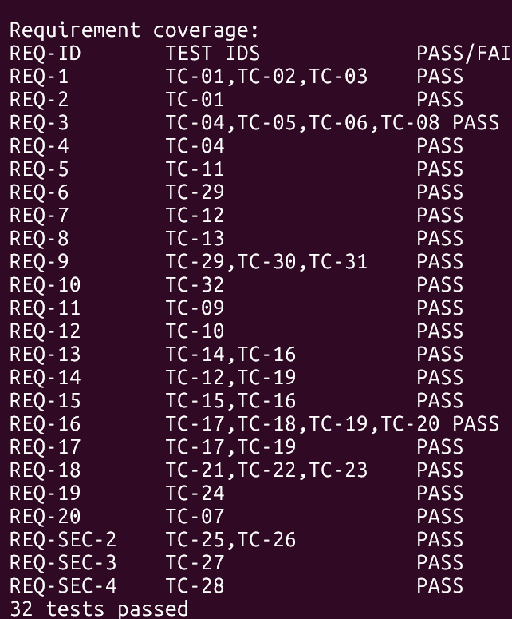

Finalization Addendum - Version 1.1
Date: 30 October 2026
Status: Final for the current implementation baseline
This addendum supersedes earlier test-count summaries and records the final automated coverage, known deviations, and manual screenshot evidence checklist.

Final automated test output
Run from the repository root on a POSIX system:
make clean
make test
Area | Evidence | Result
Parser unit tests | tests/test_parser.c | 12 passed
Executor unit tests | tests/test_executor.c | 9 passed
Integration and regression tests | tests/test_cases.sh | 40 passed
Continuous integration | .github/workflows/build-and-test.yml | Passed on Linux for main and pull requests
Requirements traceability | docs/rtm_code_references.md | REQ-1 through REQ-23 and REQ-SEC-1 through REQ-SEC-4 mapped

Final requirement coverage
The complete requirement-to-source and requirement-to-test mapping is maintained in docs/rtm_code_references.md. Key final coverage includes REQ-6 in TC-29 and TC-35, REQ-14 in TC-12 and TC-19, REQ-18 in TC-21 through TC-23, REQ-19 in TC-23, TC-24, and TC-33, and REQ-SEC-2 in TC-25, TC-26, and TC-36 through TC-40.

Deviations and limitations
? REQ-1 and REQ-2 have implementation evidence but no dedicated timing or EOF-loop test that covers every aspect of the requirement.
? REQ-21 command history, REQ-22 SIGINT handling, and REQ-23 SIGTSTP handling remain unimplemented.
? The shell does not support 2>, &&, fg, or bg; & is supported only at the end of a command line.
? Background timing and lifecycle checks depend on operating-system scheduling and are supplemented by Linux CI.

Screenshot evidence checklist
Capture these terminal states during final demonstration. The checklist is also recorded in docs/test_evidence.md; screenshots should be attached to the coursework submission or demonstration record.
Screenshot | Manual scenario | Evidence location/status
1 | Prompt after an empty line, followed by pwd | docs/test_evidence.md checklist; capture for final submission
2 | Quoted argument with spaces | docs/test_evidence.md checklist; capture for final submission
3 | Output redirection with > followed by cat | docs/test_evidence.md checklist; capture for final submission
4 | Pipeline output using printf and wc | docs/test_evidence.md checklist; capture for final submission
5 | Background sleep followed by jobs | docs/test_evidence.md checklist; capture for final submission
6 | export followed by environment expansion | docs/test_evidence.md checklist; capture for final submission

Finalization Addendum - Version 1.1
Date: 30 October 2026
Status: Final for the current implementation baseline
This addendum supersedes earlier test-count summaries and records the final automated coverage, known deviations, and manual screenshot evidence checklist.
Final automated test output
Run from the repository root on a POSIX system:
make clean
make test
Area | Evidence | Result
Parser unit tests | tests/test_parser.c | 12 passed
Executor unit tests | tests/test_executor.c | 9 passed
Integration and regression tests | tests/test_cases.sh | 40 passed
Continuous integration | .github/workflows/build-and-test.yml | Passed on Linux for main and pull requests
Requirements traceability | docs/rtm_code_references.md | REQ-1 through REQ-23 and REQ-SEC-1 through REQ-SEC-4 mapped
Final requirement coverage
The complete requirement-to-source and requirement-to-test mapping is maintained in docs/rtm_code_references.md. Key final coverage includes REQ-6 in TC-29 and TC-35, REQ-14 in TC-12 and TC-19, REQ-18 in TC-21 through TC-23, REQ-19 in TC-23, TC-24, and TC-33, and REQ-SEC-2 in TC-25, TC-26, and TC-36 through TC-40.
Deviations and limitations
- REQ-1 and REQ-2 have implementation evidence but no dedicated timing or EOF-loop test that covers every aspect of the requirement.
- REQ-21 command history, REQ-22 SIGINT handling, and REQ-23 SIGTSTP handling remain unimplemented.
- The shell does not support 2>, &&, fg, or bg; & is supported only at the end of a command line.
- Background timing and lifecycle checks depend on operating-system scheduling and are supplemented by Linux CI.
Screenshot evidence checklist
Capture these terminal states during final demonstration. The checklist is also recorded in docs/test_evidence.md; screenshots should be attached to the coursework submission or demonstration record.
Screenshot | Manual scenario | Evidence location/status
1 | Prompt after an empty line, followed by pwd | docs/test_evidence.md checklist; capture for final submission
2 | Quoted argument with spaces | docs/test_evidence.md checklist; capture for final submission
3 | Output redirection with > followed by cat | docs/test_evidence.md checklist; capture for final submission
4 | Pipeline output using printf and wc | docs/test_evidence.md checklist; capture for final submission
5 | Background sleep followed by jobs | docs/test_evidence.md checklist; capture for final submission
6 | export followed by environment expansion | docs/test_evidence.md checklist; capture for final submission

