Graph Neural Networks

Graphs are networks that represent relationships between objects through some events. In the real world, graphs are ubiquitous; they can be seen in complex forms such as social networks, biological processes, cybersecurity linkages, fiber optics and as simple as nature’s life cycle.

Since graphs have greater expressivity than images or texts, Graph Neural Network (GNN) applications have increased tremendously in the past decade. They are actively used in drug discovery, human-object interaction, text classification, point cloud classification and segmentation, all of which are discussed in detail later.

# What is a Graph?

A graph comprises nodes (objects or entities) and the links that determine relationships between nodes. Mathematically, the nodes are called “**Vertices**”, and the links are called “**Edges**”. Graphs can be of two forms --- Directed or Undirected Graphs.

## Directed Graphs

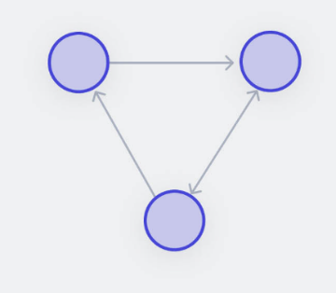Directed Graphs denote the direction of dependency between nodes. It can either be uni-directed or bi-directed.

Figure Directed Graph

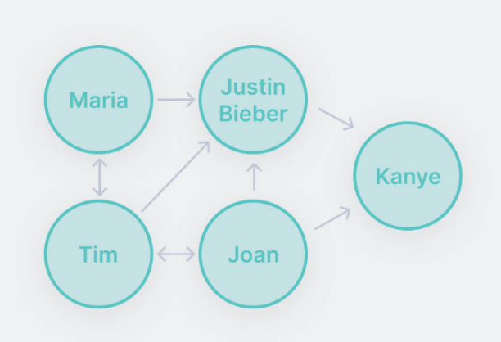A real-word example of directed graphs can be Followers on Instagram.

Figure Real-Word Example: Follower on Instagram

The above figure shows an example of:

**Unidirectional Link**: Maria follows Justine Bieber, but Justin Bieber does not follow Joan back, they are unidirectional link.

**Bi-directional Link**: Since Maria follows Tim and Time also follows Maria, they are bi-directional link.

## Undirected Graphs

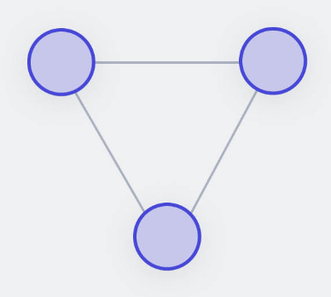Undirected graphs do not have any directions of dependencies; the nodes can be considered mutually linked.

Figure Undirected Graphs

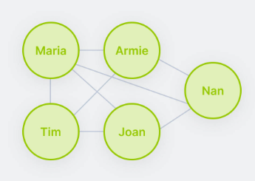A real-word example of undirected graphs can be **Followers on LinkedIn**.

Figure Real-World Example: Followers on LinkedIn

# Types of Graphs Prediction Problems

There are mainly 3 possible types of graph prediction problems --- Graph-Level, Node-Level, and Edge-Level. The basic building block for these graph prediction problems is Graph Convolution.

## Graph Convolution

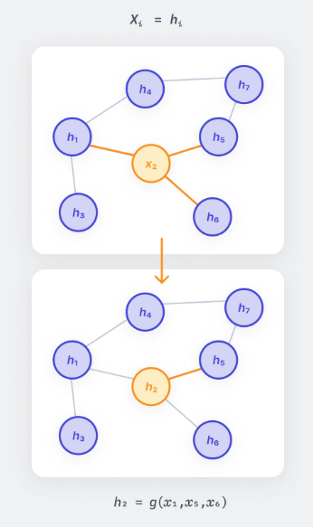Since images comprise pixels, graph nodes can be analogously considered as pixels --- each node (pixel) is connected to adjacent nodes (pixels). Convolution in Convolutional Neural Network (CNN) is a simple sliding window method over the whole image that multiplies the image pixels with the filter weights. Similarly, graph convolution uses information from the neighboring nodes to predict features of a given node *xi* . Convolution is an operation that happens on Euclidean data since data in graphs is unordered and dynamic; it is not-Euclidean data. Hence, a function needs to be applied to the node’s features to transform them into a latent space hi, which can then be used for further algorithmic computation.

Figure Graph Convolution

## Graph-Level Prediction

A graph-level task involves predicting some property for the complete graph. An example of such task could be determining whether a social network group comprises “friends”, “family”, or “corporates”. With images, the graph-level prediction would be analogous to image classification by assigning image labels such as “raining”, “sunny”, or “snowy” to images od different seasons. Similarly for text, it could mean predicting the context of the text, whether it belongs to the “news”, “law” or “education” category.

Let’s talk about a specific task under graph-level prediction, i.e., Graph Classification.

All the node features are aggregated to obtain a classification label for the complete graph, and some permutation-invariant (i.e., indifferent to the order of inputs) function such as mean, sum or pooling is applied to them.

## Node-Level Prediction

A node -level task involves predicting some property for the node or the node object itself. Let’s consider an example from chemistry. In a graph containing the biomolecular structure of a substance comprising two compounds, A and B, predicting whether a node (a molecule) belongs to compound A or compound B denotes node-level prediction. In the case of images, this task is analogous to predicting the class of all individual pixels, such as semantic segmentation, whereas, with text, this is similar to predicting parts of speech.

**Node Classification**

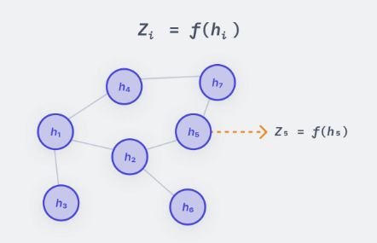To predict a label for an individual node denoted by *Zi*, the function *f* is applied to the individual node features *hi*.

Figure Node Classification

## Edge-Level Prediction

An edge-level prediction involves predicting the relationship between different node objects. Fore example, imagine a cricket scene with a batsman, a bowler, a fielder, an umpire, and the audience. In the graph world, all of these can be represented as nodes having some links with each other. Now, predicting the facts that the bowler “is bowling” to the batsman, or a fielder “is catching the ball,” or the audience “is watching” the match is an example of edge-level prediction. This is analogous to action recognition or scence understanding in images and predicting the dependency tree for words in texts.

Edge Classification

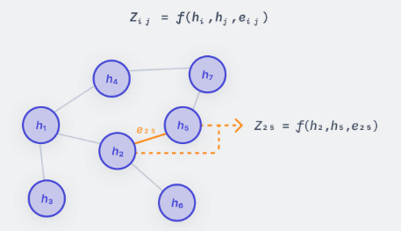To predict the labels for edges, the function f is applied over the features aggregated from the nodes connecting the edges as well as the existing edges features if there are any.

Figure Edge Classification

# Challenges in Analyzing a Graph

One of the significant challenges in analyzing a graph is the non-Euclidean nature of the data.

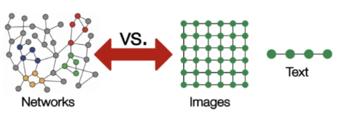The size of graph is dynamic. The number of nodes can range from tens or hundreds to the order of millions; similarly, each node can have a variable number of edges. Due to this property, it is challenging to represent and analyze graphs by existing standard methods for images and texts.

Figure Representation of Networks vs Images and Text

Images and texts have a fixed number of attributes whereas graphs can expand or contract with respect to time. Therefore, representing graphs by an adjacency matrix is inefficient as it can create very sparse metrices. Also, there can be multiple adjacency matrices representing the same graph. They are not permutation invariant as there is no certainty that they will generate the same result. To deal with this problem, adjacency lists can be used to represent graphs as they can handle the problem of sparsity and permutation invariance.

Analyzing graphs is difficult due to their dynamic nature. Standard convolution that is applied on images cannot be applied here. There have been several attempts to modify convolutions to suit the graph data structure.

One is adopting depth wise separable convolutions to handle the dynamic data dimensions.

Another strategy was to use dilated convolutions to increase the receptive field for capturing more features for increasing graph dimensions.

Unfortunately, both these attempts failed because the kernel sizes and dilation rates need to be set up manually depending on the graph, which is undoable in real scenarios. Hence, Graph Neural Networks were proposed to deal with graph prediction problems effectively.

# What is a Graph Neural Network ?

A Graph Neural Network (GNN) is a “Graph In, Graph Out” network. It takes the input graph comprising embeddings for edges, nodes and global comprising embeddings for edges, nodes, and global context and generates the output graph with transformed and updated embeddings by preserving the graph symmetry. GNNs are efficient architectures for solving different graph prediction problems for graph-level, node-level, and edge-level tasks.

# Graph Neural Network Architectures

GNN architectures can mainly be categorized into Spectral, Spatial and Sampling methods.

## Spectral Methods

To understand this domain of methods, let’s first briefly understand some graph theory.

Spectral methods perform graph convolution in the spectral domain. Graphs are converted from spatial domain to spectral domain using the concept of discrete Fourier transform. As the graph is projected to an orthogonal space, a feature matrix U will be obtained from a spectral decomposition of a Laplacian matrix. Hence, U is a matrix comprising eigenvalues of corresponding eigenvectors. The graph Fourier Transform is obtained by taking a dot product of eigenvalues with a function f that maps the graph vertices to some number on the real line which can ultimately represent as:

$$\hat{f}=U^{T}f$$

Since we have obtained the Fourier transform, graph convolution in the spectral domain is simply a multiplication of the spectral input signal and the spectral convolution kernel.

$$F\left[f_{1}\left(t\right)*f_{2}\left(t\right)\right]=F_{1}\left(ω\right)∙F_{2}\left(ω\right)$$

The above equation represents that convolution operation in the spatial domain changes to the product of Fourier Transform of signal (F1) and kernel (F2) in the spectral domain.

Now that you know what spectral methods are, let’s understand the 2 most common GNN architecture under this category.

### Spectral Networks (SCNN)

This method replaces the spectral convolution kernel with a self-learning diagonal matrix. It allows learning the convolutional filters for graph prediction tasks.

The modified convolutional kernel is represented as:

$$X*g_{θ}=UΛU^{T}X$$

Where:

* $g_{θ}$--- is the set of self-learning parameters.
* $X$--- is an N-dimensional input vector.
* $U$--- is the matrix for eigen vectors.
* $Λ$--- is the diagonal matrix.

Given the advantage that the kernel is learnable, there are also some significant disadvantages that make this method inefficient.

1. This method would be computationally inefficient for large graphs as the product of $U$, $Λ$, $U^{T}$ will need to be calculated during each forward pass.
2. The number of parameters in the kernel depends on the number of vertices in the graph. Hence for large graphs, the method remains inefficient.
3. The filter is applied to the whole graph; hence it will be difficult to obtain local information.

### 1.2 Graph Convolutional Networks (GCN)

Graph Convolutional Network (GCN) is one of the most commonly used methods due to its simple, scalable architecture and computational efficiency.

The simplest GCN has three layers.

* Convolution Layer
* Linear Layer
* 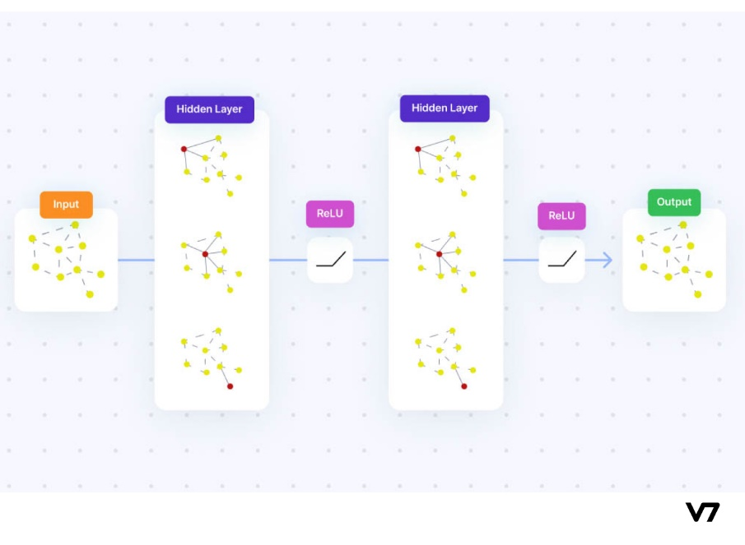Non-linear activation layer

Figure GCN Layers

First, convolution is performed for each node in the convolution layer graph. The feature information from the neighbors of the nodes is aggregated and the nodes are updated likewise. Next, a non-linear activation function such as ReLU is applied to the output of the convolution layer. Similarly, multiple convolutions and non-linear activation layers can be stacked to reach optimal accuracy.

GCNs can perform node-level as well as graph-level prediction tasks. Node-level classification is possible with local output functions which classify individual node features to predict a tag. For graph-level classification, features from the entire graph are aggregated using differentiable pooling, which is then used to predict a label for the complete graph.

While GCNs are easier to code and implement, there are certain limitations accompanying them:

1. GCNs do not support edge features.
2. The notion of message passing is non-existent with GCNs, which restricts its usage to only those cases where all required information is present in the nodes.

## Spatial Methods

Spectral methods have the following disadvantages:

1. They are not suitable for undirected graphs.
2. Contrary to the graph’s dynamic nature, the graph structures cannot be updated during training.
3. They are computationally more intensive than spatial methods.

Therefore, let’s look at what spatial methods offer, and which are commonly used architectures under this category.

Spatial methods follow the standard approach of graph convolution used under graph topology --- Transforming the node’s features with a permutation-invariant function and aggregating those features to update the node’s feature values.

### Message Passing Neural Network (MPNN)

Message-Passing phenomena in the graphs are essential to utilize graph connectivity’s potential fully. Specific information can be encoded in the edges or nearby nodes relevant to the prediction task. Hence, message passing can supply information to the particular node or edge.

Intuitively, message passing is similar to convolution for images. Convolution operation in images parses over the entire image; likewise, in message passing after k layers, a node will be aware of the information in nodes k steps away from it. Mathematically, a message *mij* sent across the edges *i* and *j* can be defined as:

$$m_{ij}=f_{e}(h_{i},h_{j},e_{ij})$$

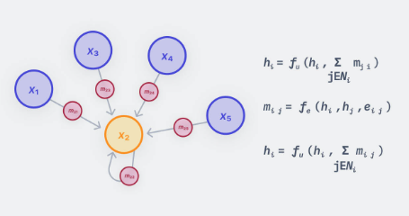Here f is a small Multi-Layer Perceptron (MLP).

Figure Message Passing Neural Network (MPNN)

When a message arrive at nodes, the feature representation of the node will update to contain these messages. All the messages are combined using a permutation-invariant aggregator function such as sum. The messages are combined with the existing features vectors of the node, and they are passed into another MLP to output the final feature vector of the node.

MPNN is a compelling framework to use as it’s very generic, however, it suffers from scalability issues because it needs to process and store edge features as well as node features.

### Graph Attention Network (GAT)

GAT introduces the concept of attention mechanism in graph networks. In typical algorithms, the same convolutional kernel parameters are applied over all nodes of the graph; however, in real scenarios, they can either lead to loss or overestimation of certain information. Therefore, adopting different convolutional parameters would allow adjusting the degree of association between nodes and determining the corresponding importance of nodes.

The attention coefficients are calculated by passing node or edge features into an attention function. The SoftMax function is applied over the obtained value to give the final weights.

$$a_{ij}=attention\left(h_{i},h_{j}\right)=\frac{exp⁡(a_{ij})}{\sum_{kϵN_{i}}{exp⁡(a_{ik})}}$$

Mathematically, the update rule of GAT is represented as:

$${\vec{h}'}_{i}=σ(\frac{1}{K}\sum_{k=1}^{K}{\sum_{jϵN_{i}}{α_{ij}^{k}W^{k}{\vec{h}}_{j})}}$$

Where:

* $α_{ij}^{k}$--- denotes the attention coefficients.
* $W^{k}$--- is the weight matrix.
* ${\vec{h}}_{j}$--- is the node feature.

Overall, GATs are scalable, computationally efficient, and invariant to the choice of attention function used.

## Sampling Methods

In the real world, graphs are usually complex and contain a massive number of nodes and edges. Because of their dynamic nature, they can even expand to larger sizes. In such scenarios, computing feature vectors of nodes by aggregating features from all the neighboring nodes would be computationally inefficient. Hence, to handle the scalability issues, we will sample and use only a subset of nodes instead of all.

We will look at two to the most exciting sampling methods --- GraphSage and DeepWalk.

### Graph Sage

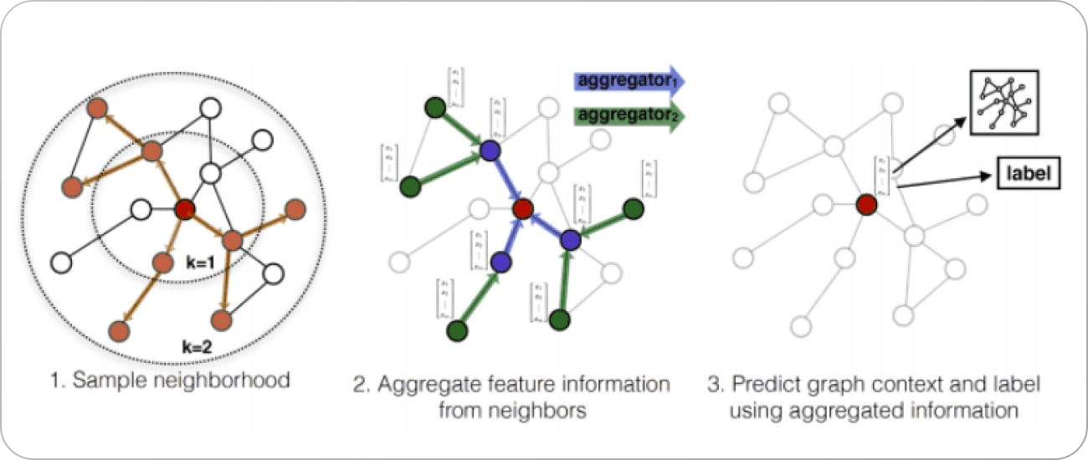GraphSage employs a basic strategy of uniform sampling. The nodes obtained from uniform sampling will only contribute to feature information. The aggregated feature information from these nodes would finally be used to perform node or graph classification.

Figure GraphSage Algorithm

GraphSage extends the neighborhood depth k on each layer. The algorithm will learn feature information from k nodes away with every additional layer. This approach saves a lot of computation time as all nodes are not involved in computation for each layer.

Depending on the task, this algorithm is flexible enough to be trained in either a supervised or unsupervised manner. There is also a possibility to train the following aggregation functions alongside --- mean aggregator, LSTM aggregator, and max pooling aggregator function will aggregate the features better for a specific task.

### DeepWalk

This algorithm works in two stages. The first corresponds to discovering the local graph structure, and the second involves applying a skip-gram model to the sequences detected in the first stage.

**Stage 1: Random Walks**

The network is traversed through random walks. To begin with, a node is selected randomly, then out of all its neighboring nodes, and another node is selected randomly. Likewise, it goes on until the sequence length reaches its limit. The number of random walks is given by parameter ‘k’, and the length of each sequence is denoted by parameter ‘l’. Increasing the parameter ‘k’ would lead to a broader graph exploration, whereas increasing ‘l’ means distant nodes are also similar.

**Stage 2: Skip-gram model**

Skip-gram model is a popular method used to learn word embeddings. This is used here because the distribution of the words in a corpus and the nodes in a graph both follow the power law. In the context of text, given a corpus and window size, the words that appear in the same window tend to have similar meanings and closer word embeddings. Likewise, skip-gram attempts to maximize the similarity of the nodes that occur in the same random walk.

Thereafter, a set of random vectors are generated for each node to learn the node embeddings using the skip-gram method.

Next gradient descent is applied to these vectors to update the node embeddings and maximize the probability of the neighboring nodes given a node by using a SoftMax function. When all walks are covered, further optimization can be continued on the same random walks that can be generated.