Casablanca

Wentworth Institute of Technology

Databases

COMP2650-1

Professor Nguyen Thai

9/30/20

Walid Harkous

This restaurant will be featuring North African cuisine. Customers may sit inside and dine at tables, booths, or choose to dine-in at a patio. Dishes from countries such as Morocco, Algeria, Tunisia, and even Egypt will be on the menu for customers to choose from. Apart from pastries and dessert, the food served will be prepared and cooked in the kitchen using the freshest ingredients. All the cuisine uses a variety of meats, vegetables, and spices and these must all come from a reputable and pure source. Dishes prepared will include Tajine, Harira, Pastilla, and the famous Moroccan Couscous. Desserts will include Baklava, Nut pastries, Baghrir (Moroccan crepes), and Shebakia. Beverages will also include hot items such as tea or chai, and cold drinks will include soda, water, and fruit juices. This restaurant, however, will not be serving alcoholic beverages, as that is not in the culture of North Africa.

**Business Statement**

The key components of some of the business operation will be related to what products will I be providing. For the Main Dishes, I will provide courses like Couscous, Tajine (lamb, chicken, Kefta, Salmon), Rafisa, Pastilla. For Entrees, I will provide meals such as Baghrir, Mesemen, Harsha, Kebab, Harira, Lentil soup. Side dishes will include Escargot Soup, Sambuusa, Za’look, Moroccan Salads, Olives with Hummus and Harissa. Optional Pastries will also be provided like Shebakia, Sello, Briwat w/ chicken, Feq’as, Gazelle Horn, Briwat w/ almond, Milfeull (Napolean). Of course, a restaurant must provide beverages so I for drinks I will have Mint Tea, Arabic Coffee, Water, Carrot Orange juice.

**Key Components**

Other key components will be what facilities and equipment I will be using in the business operation. For this project, I will be using a single-story restaurant-style building. Equipment that is necessary for the business operation include: A gas-operated Oven, Stove, Walk-in refrigerating storage, Walk-in freezing storage, Dishes, Utensils, 3-compartmenet sink, Drink cooler, special regional cookware. Another key aspect of the business operation components is how I will be managing employees and finances. I will use a standard clock-in and clock-out payroll system. My employee will be paid hourly depending on their position. Waiters and waitresses will be paid in tips. I think this is the standard practice in most restaurants.

**Business Operation**

The next area of focus is in regards to business operation rules that are used to manage the business. First. which food will I buy versus which food will I prepare? I will buy Vegetables, Meats, Spices, and Fruits and all of the dishes and courses will be made and prepared in the back kitchen. The bread and pastries will be bakes in the restaurant as well. The types of food are served in all stores include Breakfast and Lunch/Dinner type of dishes. Meals will be available for single servings to full party orders, able to feed whole families. All of the products are prepared in their respected store. Many of the meals are made from ingredients in the store and take anywhere from 20-50 minutes to cook. These will be made in advanced and kept in a hot-well to remain fresh and ready to serve to customers instantly. All of the employees will work at a single store. I will require chefs, assistant chefs, someone to handle finances (cash register), and waiters to serve the customer and take their orders. I will be providing take out options and catering options will be available for special events. These will need to be made in advanced but we also can handle special instructions. We accept all; cash, credit, debit. Even Apple and Samsung Pay. I won’t be doing delivery through the restaurant, but I will opt-in for third-party delivery services such as UberEats, DoorDash, and Grubhub, etc… There will be no such thing as online reservations, however. The restaurant is equipped to handle people with dietary restrictions. We are able to provide many alternative options for customers with dietary restrictions. Some products might be cooked in close areas but we will be able to handle special instructions regarding dietary restrictions.

**Tracking operation costs**

In terms of store location, I will rent the store location under my name. I will initially lease for 10 years, as cost will go up every 5 years. Parking will be paid for by the store, as customer service is valued, and we would like to cater to everyone. Inventory will be paid for using the store bank account. Inventory will be delivered by a reputable and approved supplier once a week. None of my ingredients are weather dependent or are in any political conflict, so I do not have to worry about seasonal products. I do not need to post a high salary to find waiters. The application is open to anybody and my waiters will vary in types of people. I will hire anyone willing to work the job of waiters. Chefs will need a certain level of cooking skills and thus will require a higher salary, but I do not need a 5-star chef or anything close to that. As long as they show the required skill level and are able to learn during training how to prepare and cook any dish on the menu, they will be good enough. Somebody handling the register also would be a minimum wage position as that does not require any manual labor or education/skill levels.

**Tracking important date-to-date operations related to customers**

I understand that certain days are better for businesses. My business will operate more towards the weekdays as most restaurants do. I most likely wont be busy in the mornings as most people are at work or in school, however as the night life begins to grow, I expect more customers I my restaurant. While I will be operating in the weekend, I do not expect it to be as busy as a typical weekday. Many people are taking the day off or have activities planned. However, as a establishment that serves lunch and dinner, I do still expect there to be good business during those times, even during the weekend. No, my business is not seasonal. Business will operate at normal hours for most of the days of the year. My business does just as well on holidays since it is not holiday or seasonal-oriented. Think of fast food chains, which generally stay consistently operated during all times of the year.

**Improving business competitiveness**

The hours I will be open are 12 hours a day, from 10 AM – 10 PM. This is on par to most restaurants. Typical peak hours occur during Lunch (11AM – 2PM) and Dinner (6PM – 9PM). I expect this time to be my busiest time and peak hours of this business operation. Many people are outside looking for either a familiar or new place to eat and I can expect people to come to my store more often during these times. That’s not to say I won’t be getting any customers outside of this time frame. I will offer occasional coupons and discounts as well as a “special of the day” item from my menu which would change every day. This would keep customers coming back either everyday to try something new and different for a discounted price, or at the very least return once a week on their favorite day to get their favorite meal. As for prices, our prices would be affordable and fair. Compared to other areas, they would be about the same or perhaps on the cheaper side. We value customer happiness and I know that price factors into satisfaction of overall experience.

**New Ideas to make business more Competitive**

I will offer authentic and fresh food that is prepared on site, in front of you. Quality over quantity; we will have fewer types of food options than other stores, which allows us to focus on a specific type of food, and get the taste down perfectly. An obvious disadvantage to this is that with fewer options, if customers don’t like our food choices, there aren’t many alternatives that are not as similar to the style of everything else on the menu. Some other ways I could go about bringing more competition to the business is by taking advantage of local advertising, flyers, every-door direct mail coupon books, special promotions,

**MODELING THE DATA**

1. Food items -
   1. COUSCOUS : FoodID, Price, Calories, {ingredients}
   2. PASTILLA : FoodID, Price, Calories, {ingredients}
   3. TAJINE : FoodID, Price, Calories
      1. LAMB : {ingredients}
      2. KEFTA : {ingredients}
      3. CHICKEN : {ingredients}
      4. SALMON : {ingredients}
2. Facilities and equipment -
   1. CASABLANCA : StoreID
   2. FACILITY : FacilityID, BuildingType, Addr. (St., City, State, Zip), YearOpened, [YearsOfOperation]
   3. EQUIPEMENT : EquipementID, DatePurchased
      1. OVEN
      2. GASSTOVE
      3. 3COMPARTMENTSINK
      4. WALKINFREEZER
      5. WALKINFRIDGE
      6. COOKWARE : CookwareID
         1. COUSCOUSPOT
         2. TAJINEPOT
         3. POTS
         4. UTENSILS
         5. DISHES
3. Employee Work hours and salaries -
   1. EMPLOYEE : EmployeeID, StartDate, [YearsWorking]
      1. WAITER : HourlyRate, AvgTips
      2. FULLTIME : SalaryRate
         1. MANAGER
         2. CHEF
4. Day-to-Day cash flow -
   1. CUSTOMER : CustomerID, PartySize, TotalPaid
   2. WEEKLY REVENUE
   3. PROMO INCOME
   4. RENOVATION INCOME
   5. WEEKLY ORDER : OrderID, OrderDate, OrderTotal
5. Competitiveness -
   1. PROMOTIONS : PromoID, StartDate, EndDate
      1. COUPONS
      2. ADVERTISING : {Locations}
      3. SPECIALS
   2. RENOVATIONCOSTS

An EERD Diagram representing my business rules:

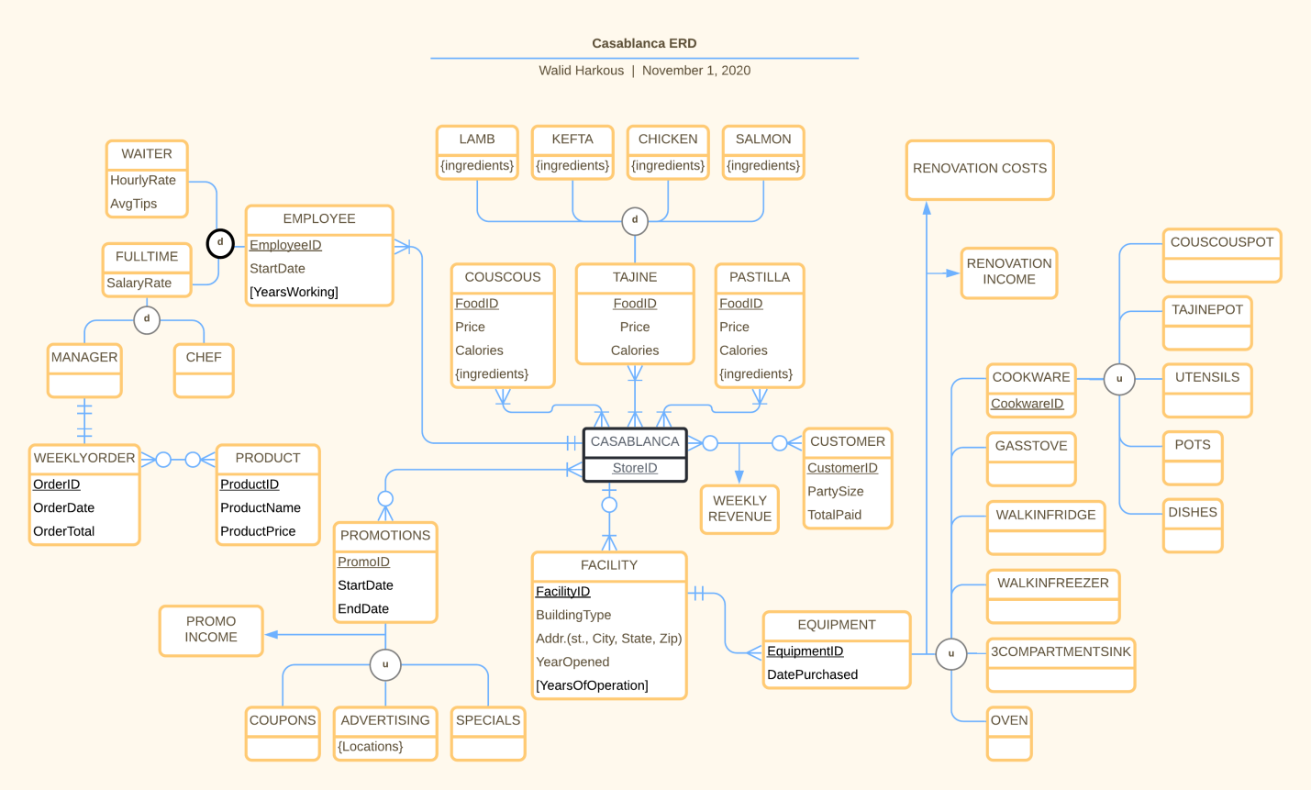

The diagram has a lot of moving parts so I will break it down below. The first category is related to food items. I’ve chosen what I believe will be the three most popular dishes in my restaurant and have represented them as entities:

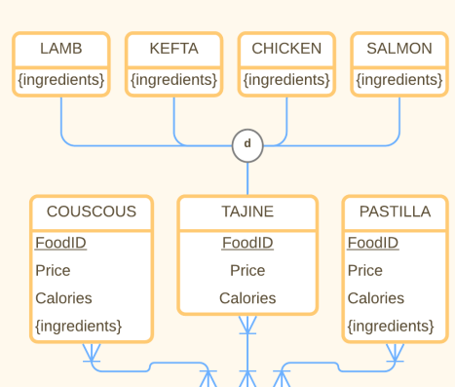

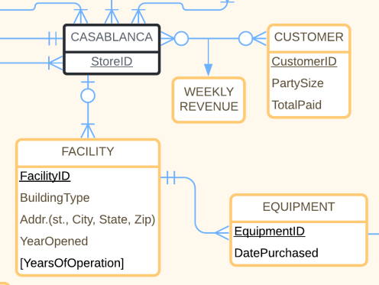The next section is in regards to the facility and equipment management: - 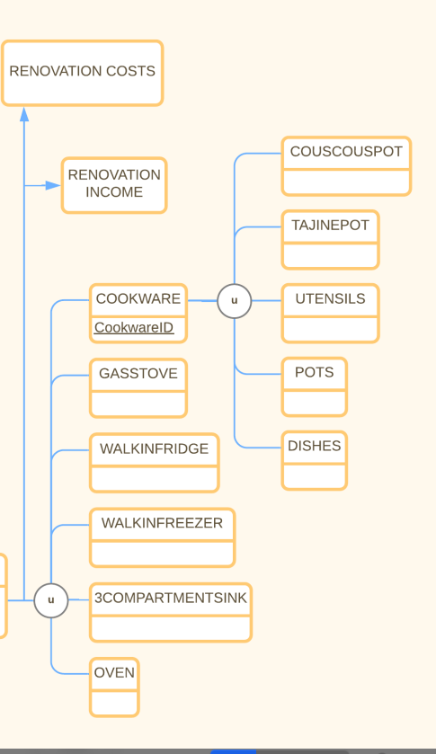

We’ll also take a look at the employee hours and salary section:

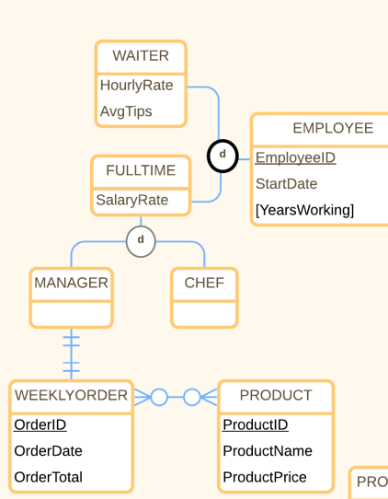

As for revenue and spending, those reports are spread across the EERD as associative entities. For example we can see customers that eat at the restaurant will have a TotalPaid, which will be used to calculate the WEEKLY REVENUE.

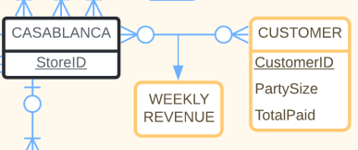

Finally were going to want to look at our competitivess in the returaunt industry and we can see that the restaurant will deploy a variety of strategies to increase the competitiveness of the store and draw in more customers. The biggest of being the advertising in either local places of all over the greater area of the restaurant location.

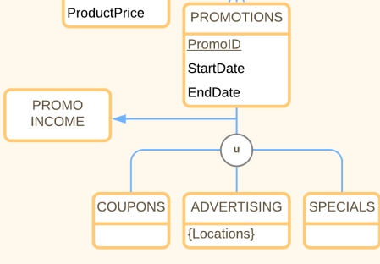

# Database Design

* uploading to BB ruined the formatting so I took screenshots of my work

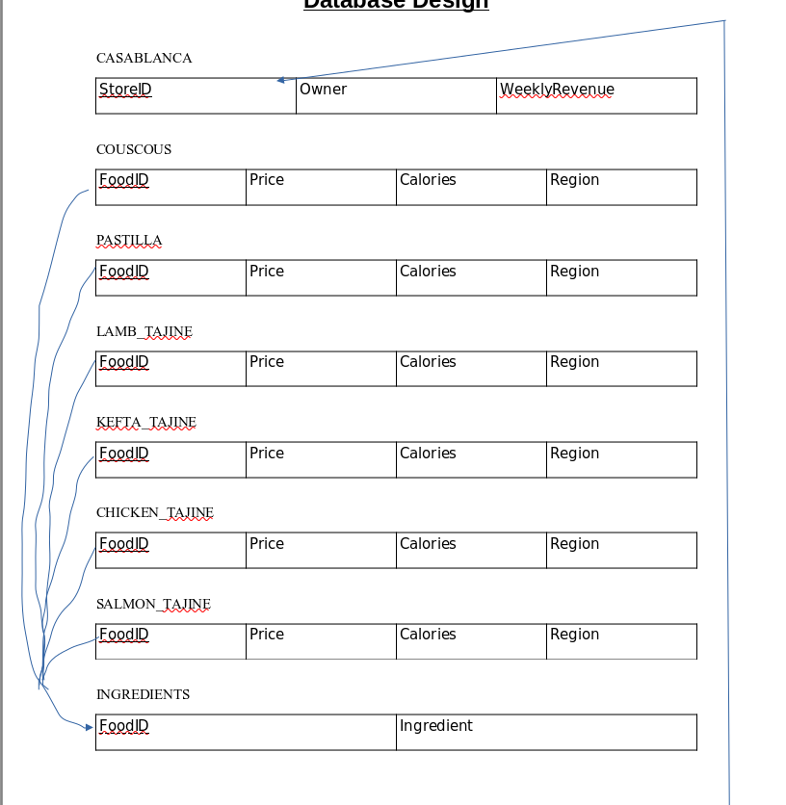.

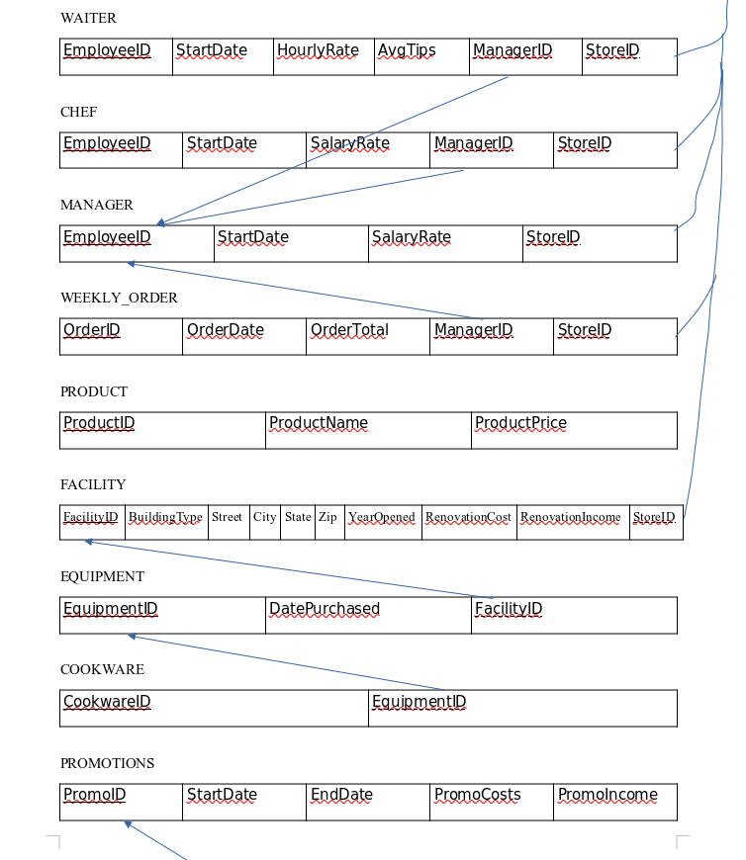

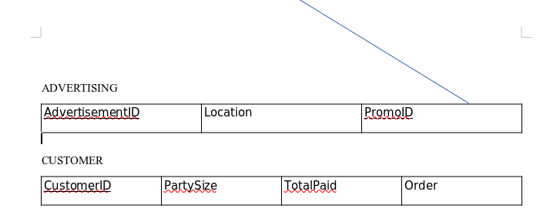

# DATABASE IMPLEMENTATION

Populating the ingredients table with hypothetical data:

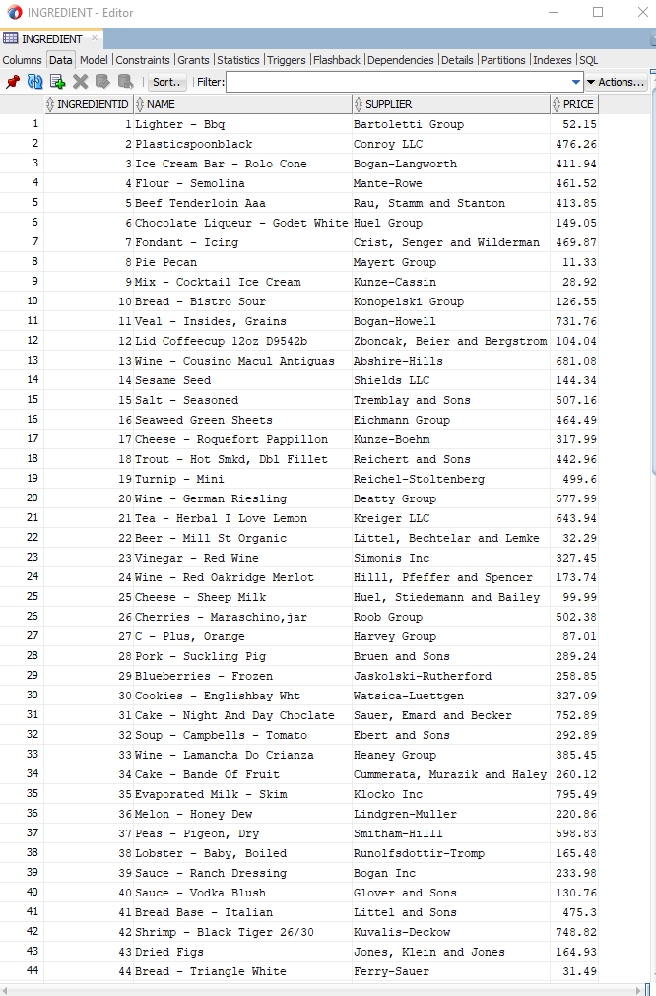

Generating three Hypothetical customers:

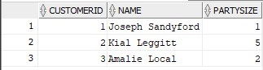

With each a transaction and a receipt:

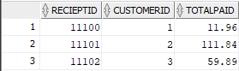

We can refer to Reciept_List table for what each customer ordered:

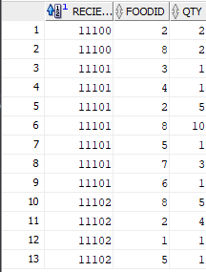

I randomly generated 50 customers, a average number for my store, with several different party sizes and orders. This is how I broke down some of that data.

To find out what the number 1 most popular food item was, I had to filter my query to take the sum of the quantity of each food item and order them by ascending order. This allows me to pick the first row which holds the food that was ordered the most:

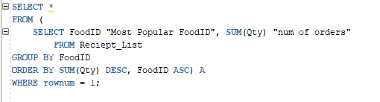

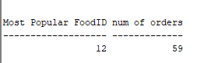

Next, I was curious to see who my employees were and how be able to compare how much each was getting paid:

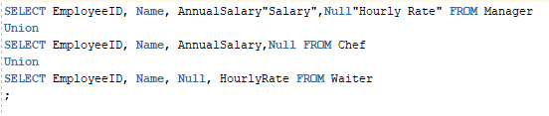

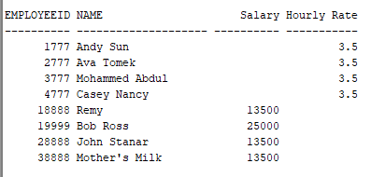

The final report I was able to generate was the monthly revenue. Using the sum of the total amount paid between all customers, I derived the monthly revenue. This was quite simple to achieve thanks to the structure of my database.



