**Lesson 3 Demo 3**

**Demonstrate EC2 Tutorial**



Steps to be followed:

1. Opening the Amazon EC2 console
2. Creating an EC2 instance and launching the instance
3. Clicking on **Download Remote Desktop File** and save it
4. Connecting to the Windows Instance

**Step 1: Opening the Amazon EC2 console**

1. In the console navigation pane, select **EC2 Dashboard**.



**Step 2: Creating and launching the EC2 instance**

1. In the Launch instance section of the console, select **Launch instance**.

1. On the **Choose an Amazon Machine Image (AMI)** page, find the Windows AMI Free tier eligible AMI and then click on **Select**.

1. On **Choose an Instance Type** page, accept the default General Purpose t2.micro Instance type, and then click on **Next: Configure Instance Details**.

1. On **Configure Instance Details** page, accept the default selections or configure them, and then choose **Next: Add Storage**.

1. On **Add Storage** page, accept the default options, and then click **Next: Add Tags**.

1. On **Add Tags** page, click on **Next: Configure Security Group**.

1. On **Configure Security Group page**, click on **Review and Launch**.

1. On **Review Instance Launch** page, review your instance launch details and then click on **Launch**.

1. From **Select an existing key pair or create a new key pair** dialog box, select **Create a new key pair** from the drop-down list that will be used to access the instance. Give the name of the key pair, download it in your system, and then click on **Launch Instances**.

1. On the **Launch Status** page, in the **Your instances are now launching** section, click on **View Instance** to view the status of the instances. When the status checks are completed successfully and the status of the instance state is running, connect to your instance.

**Step 3: Click on New EC2 Experience**

1. Click on New EC2 Experience (left side corner).

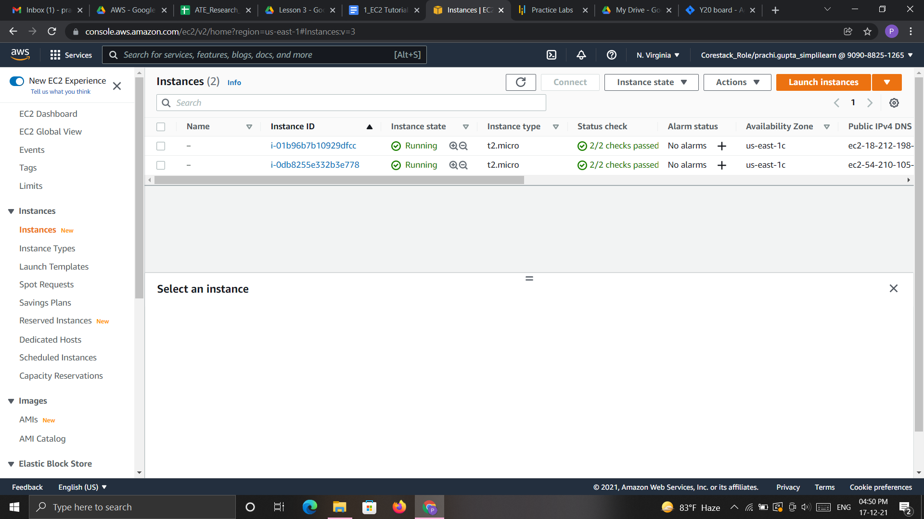

1. Click on **Connect.**

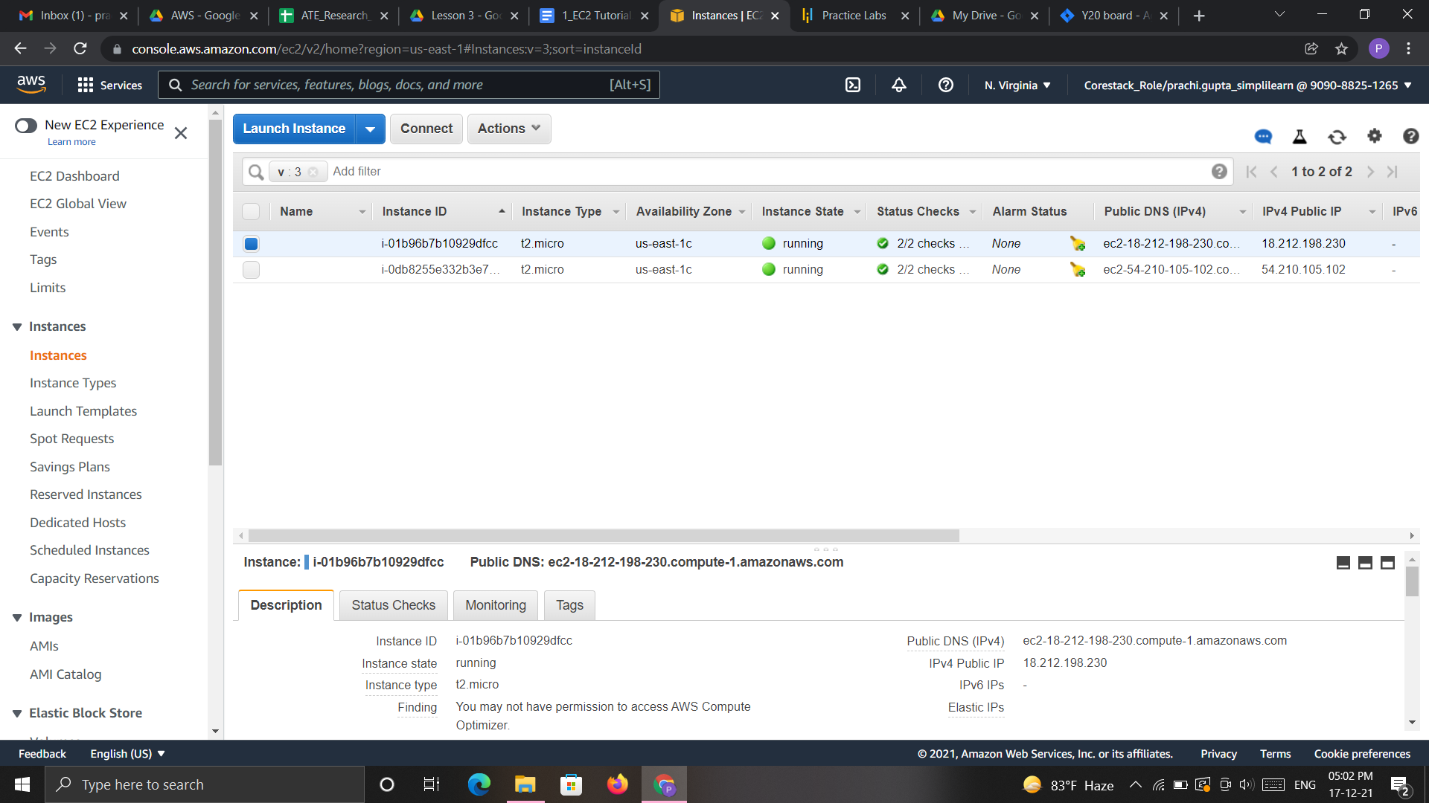

1. Click on **EC2 Instance Connect (browser-based SSH connection)**

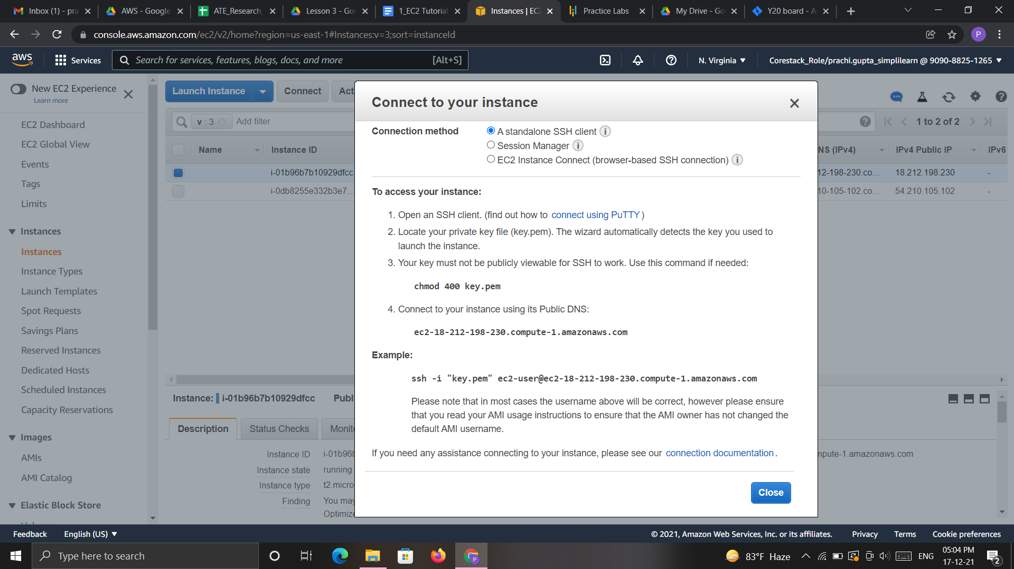

3.4 Click on **Connect**