**Get Started with Functional Testing, TDD, and DevOps Integration**

QA to QE: Lab Guide - Phase 2



This section will guide you to:

* Use practice labs for executing all the demos included in this course

This lab has two subsections, namely:

1. Starting practice labs on LMS
2. Using different IDEs and software required for Phase 2

## **Step 1:** Starting practice labs on LMS

* Log in to the Simplilearn LMS
* Navigate to the respective course and click on it
* You will see the course table of contents page on the left side of the screen. Click on **PRACTICE LABS**

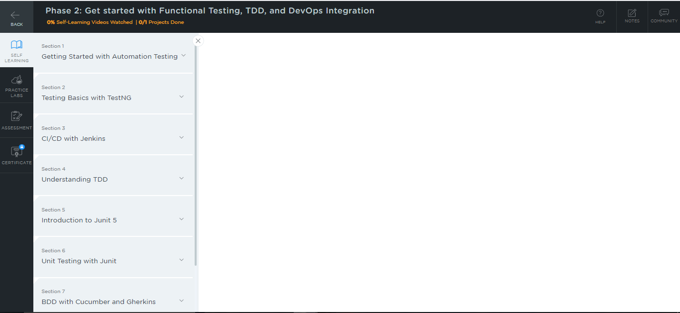

* A new window will open. Go through the instructions and click on **LAUNCH LAB**. This will launch the practice labs for this course.

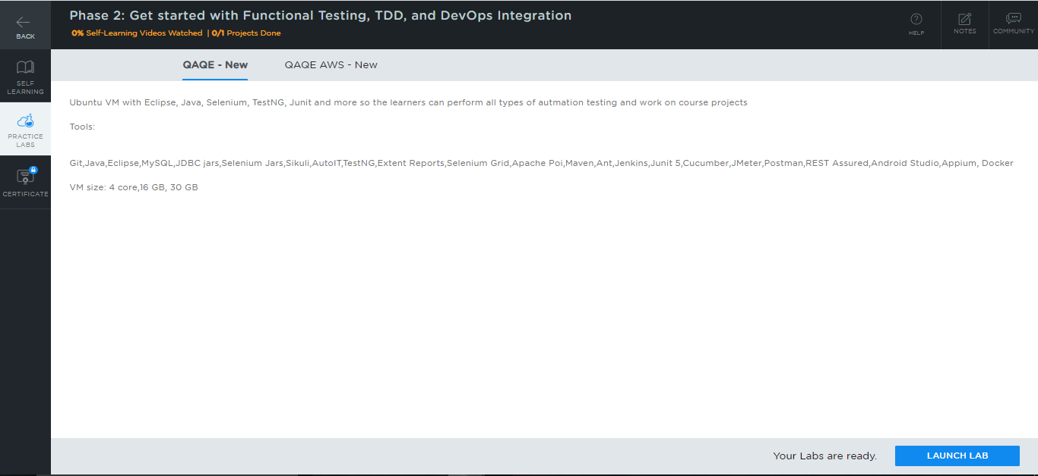

* You will be able to access IDEs and softwares which are present in the labs.

## **Step 2:** Using different IDEs and software required for Phase 2

**Jenkins:**

* Jenkins is already installed in your practice lab. You will find it in the directory **/usr/share/jenkins**
* Use the following commands to navigate to the above-mentioned directory:

*cd /usr/share/jenkins*

*ls*

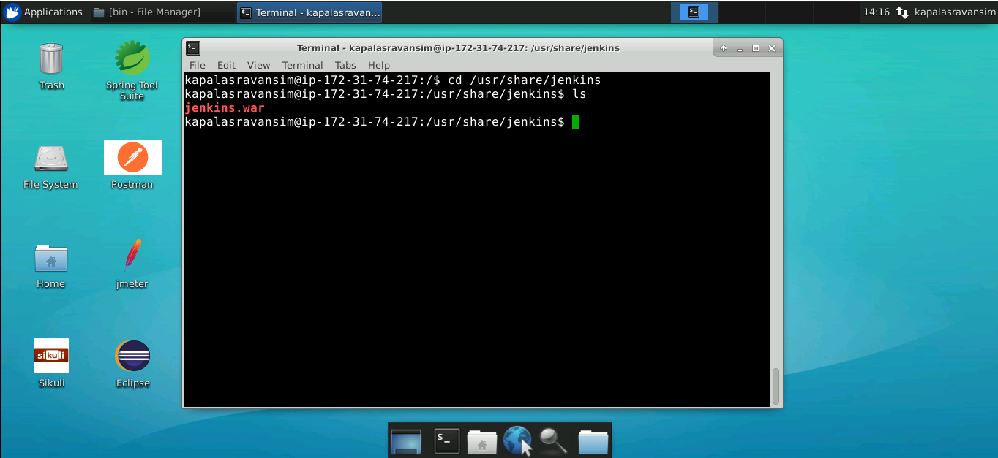

* In case Jenkins is not installed in your practice lab, you can install it using the following commands:

*sudo apt update*

*sudo apt install jenkins*

**TestNG:**

* TestNG is installed as an Eclipse plugin in your practice lab
* To verify the installation:

1. Open your Eclipse environment from the desktop
2. Click on the **Help** tab and select **Install New Software**

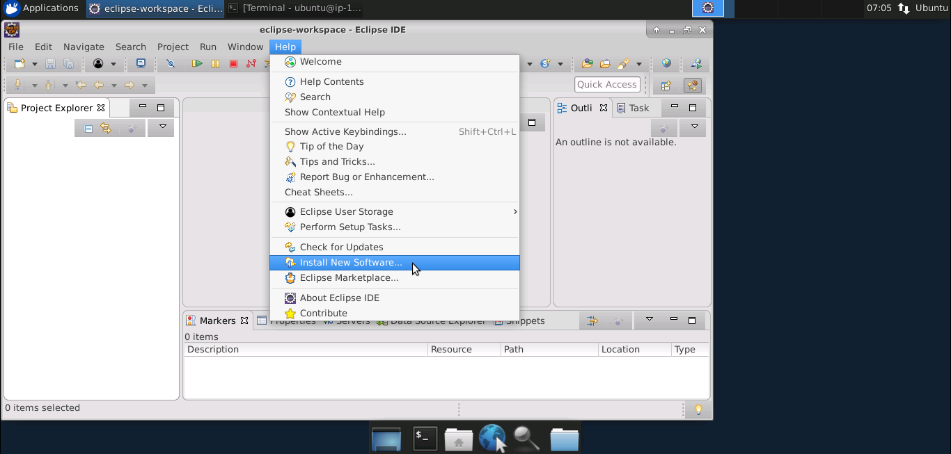

1. In the next window, click on **already installed**

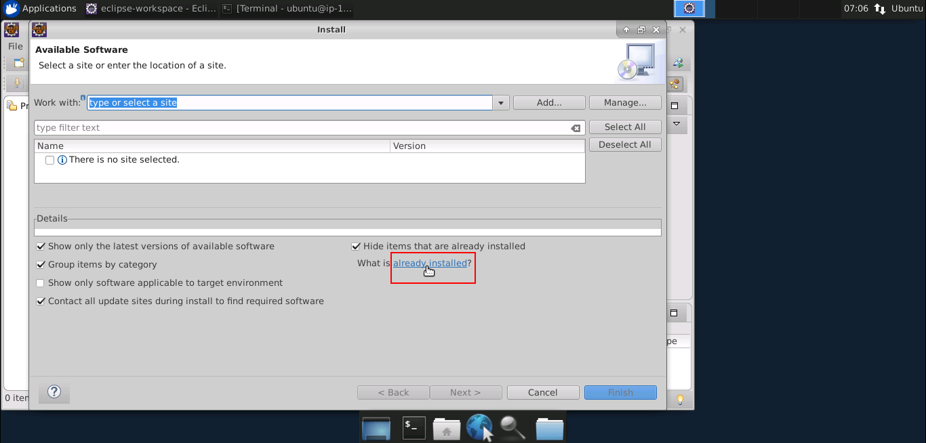

1. In the filter text field, type **TestNG**

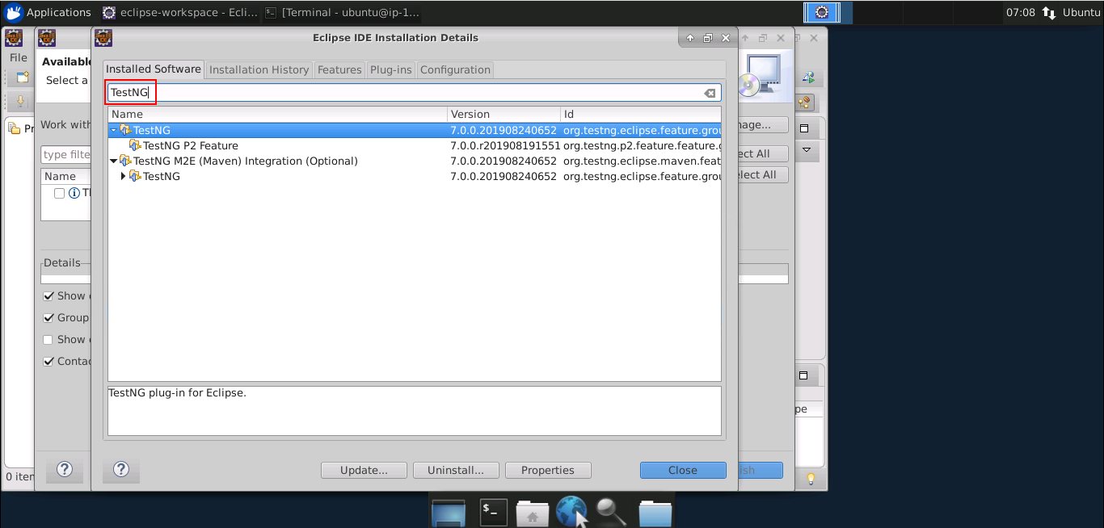

* In case TestNG is not installed in your practice lab, you can install it by following the steps mentioned below:

1. Open Eclipse environment from the desktop, navigate to the **Help** tab, and then click on **Eclipse Marketplace**

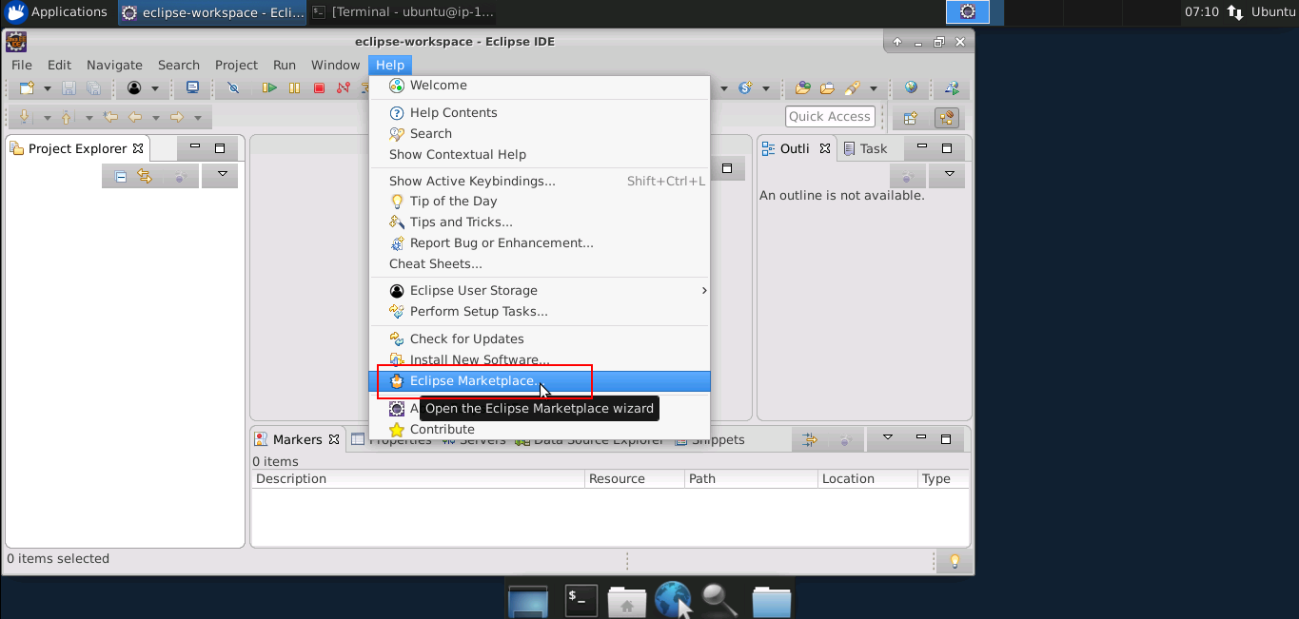

1. Type **TestNG** in the **Find** field, and then click on **Go**

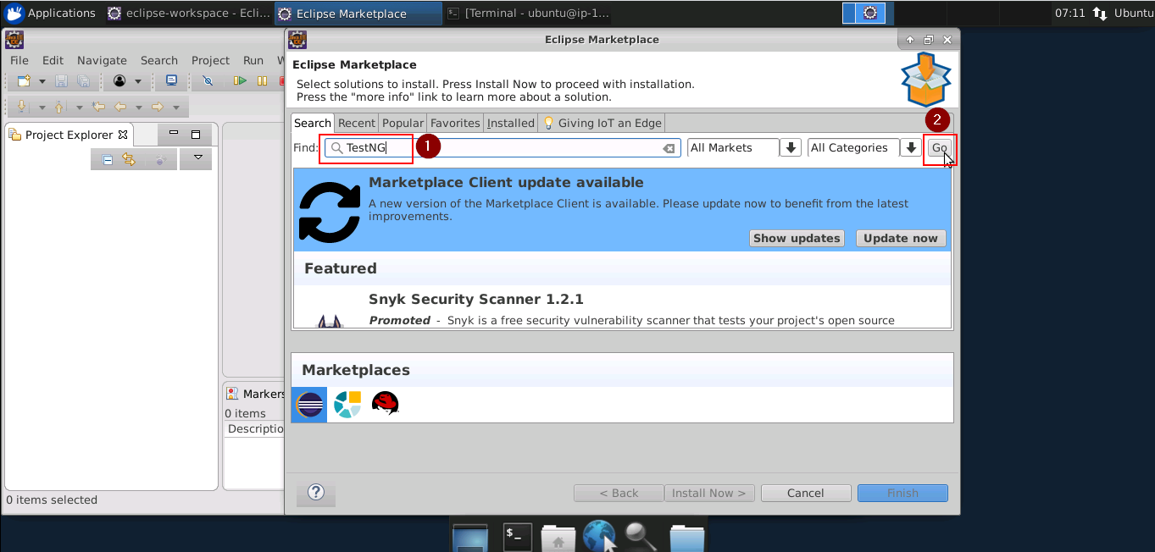

1. In the next window, you will see the TestNG tool listed with the install button. Click on it to start the installation

### **Tomcat:**

* In order to integrate Tomcat with Eclipse, you need to download Tomcat within Eclipse. To do that, follow the steps mentioned below:

1. Open your Eclipse environment from the desktop
2. Select **File** tab, and then click on **New>Other**

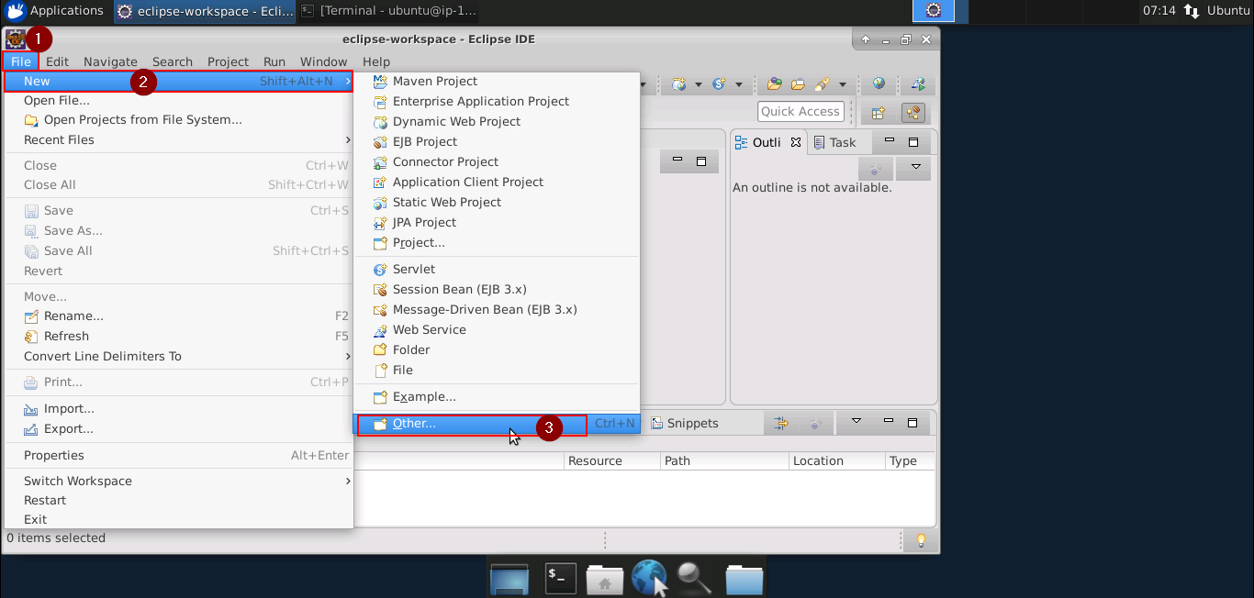

1. In the next page, click on **Server** from the server folder drop-down. Click on **Next**

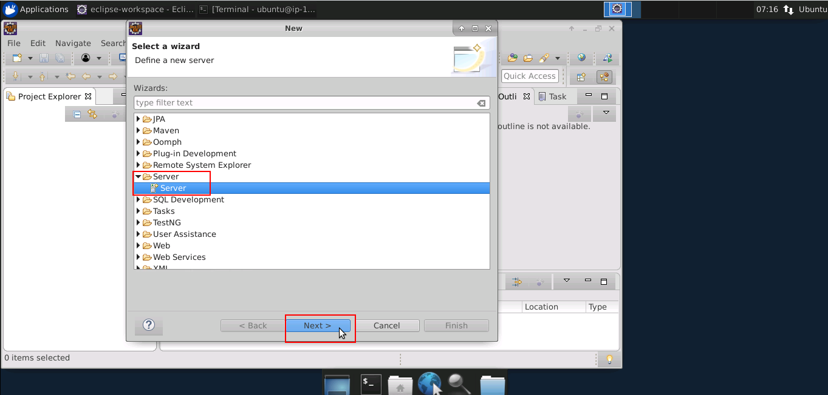

1. Type **Tomcat** in the filter text field. Select the Tomcat version that you would like to install, and then click on **Next**

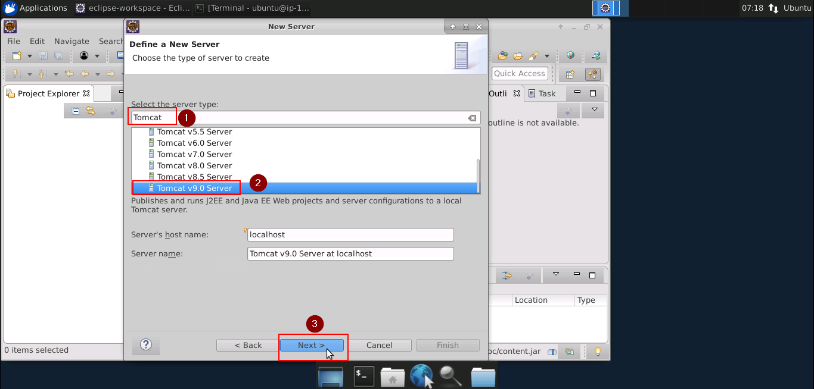

1. Click on **Download and Install**. Choose the directory where you want to download Tomcat, select the installed JRE, and then click on **Finish**

**Selenium:**

* You will find Selenium in the directory ***home/ubuntu/libs***. The same is shown in the screenshot below:

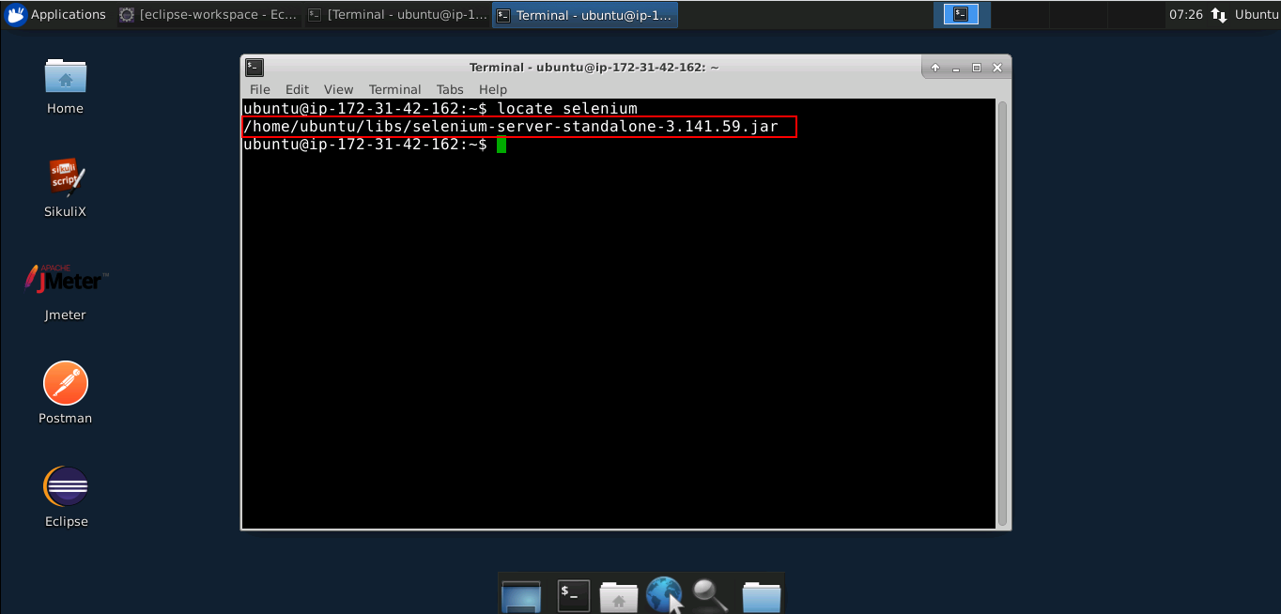

* In case Selenium is not installed in your practice lab, you can install it using the following command:

*sudo npm install selenium-standalone@latest -g*

**Maven:**

* Maven is already installed in your practice lab. You can use the following command to verify the installation:

*mvn -v*

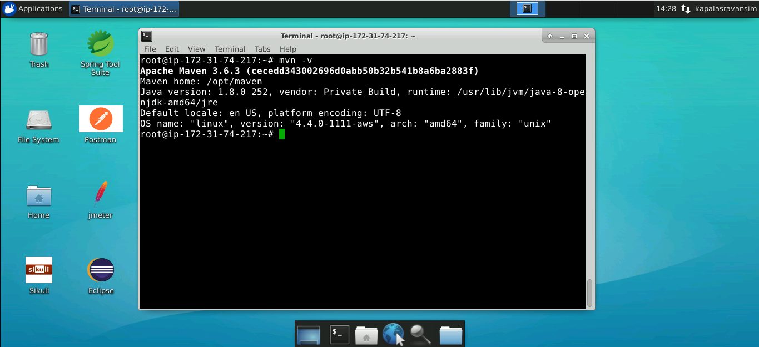

* In case Maven is not installed in your system, you can install it using the following commands:

*sudo apt-get update*

*sudo apt-get install maven*

* Maven integration for Eclipse will be done within Eclipse. To verify the installation:

1. Open Eclipse
2. Click on the **Help** tab
3. Go to **Eclipse Marketplace**
4. Type **Maven** in filter text field

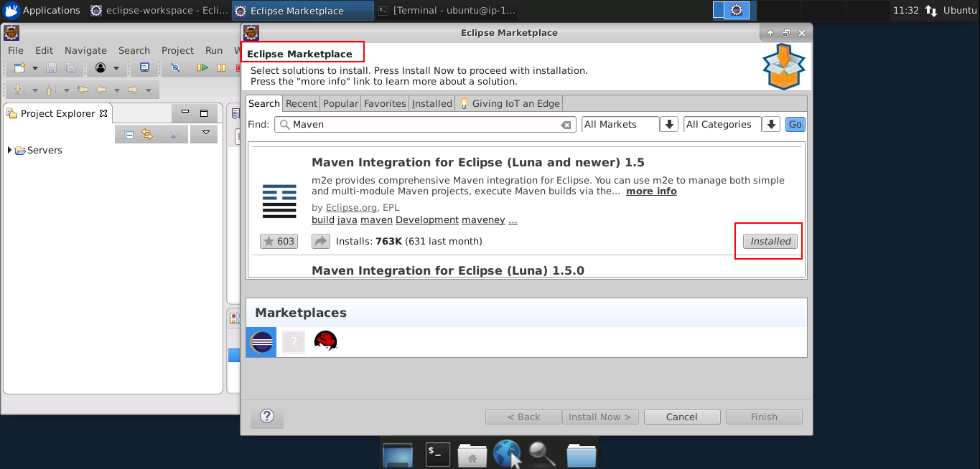

**Ant:**

* Ant is already installed in your practice laband you can find it in the directory ***/usr/bin****.*
* Use the following command to navigate to the above-mentioned directory:

*/usr/bin*

*ls*

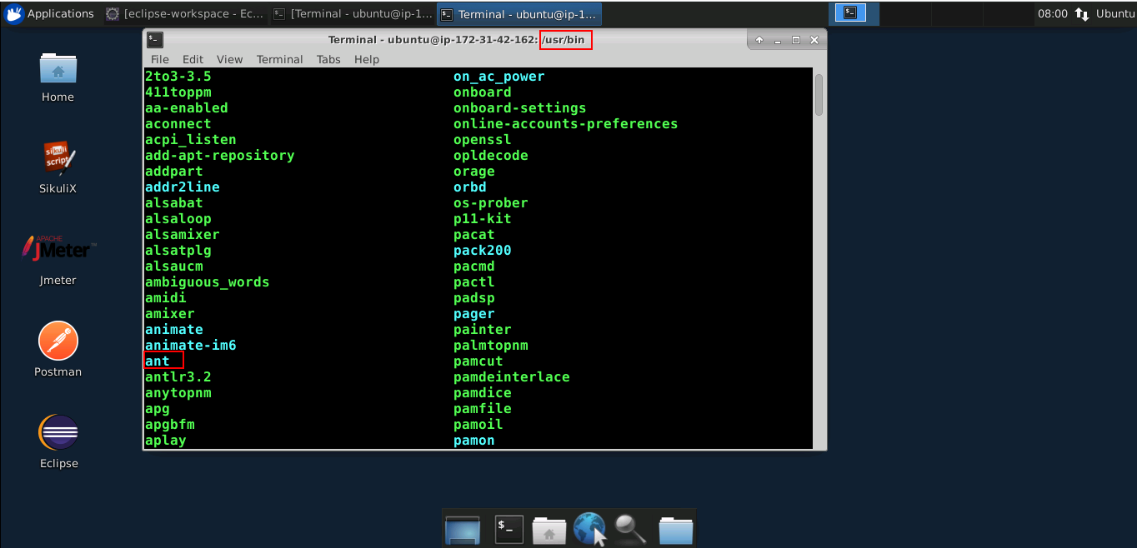

* Use the following command to check the version of Ant installed in your practice lab:

*ant -version*

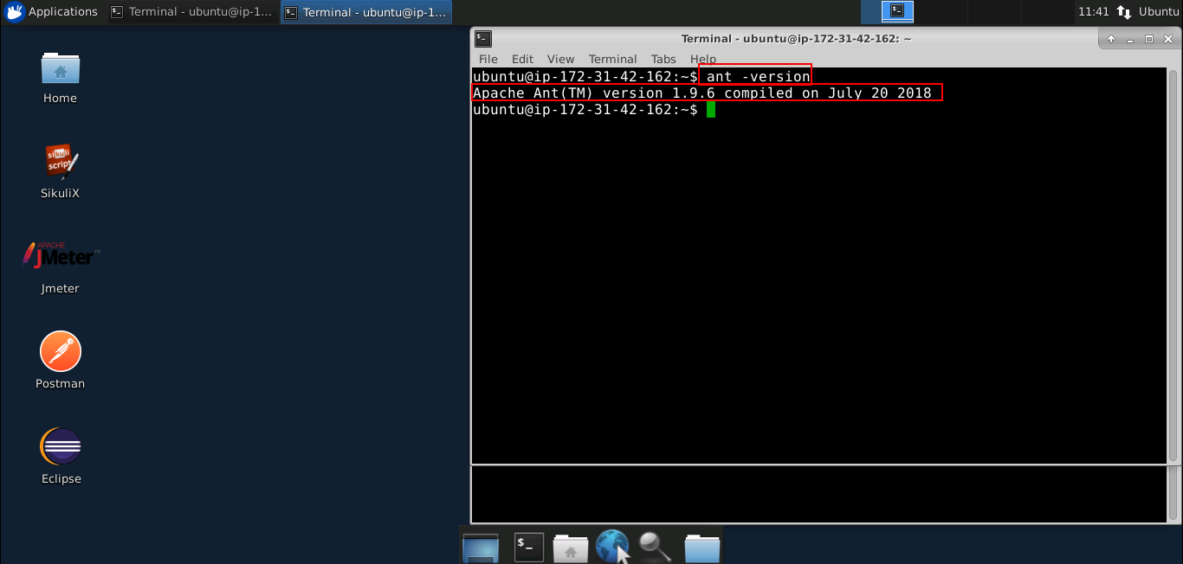

**Junit:**

* Junit is already installed in your practice laband you can find it in the directory ***/var/lib/jenkins/plugins/****.*
* Use the following command to navigate to the above-mentioned directory:

*cd /var/lib/jenkins/plugins/*

*ls*

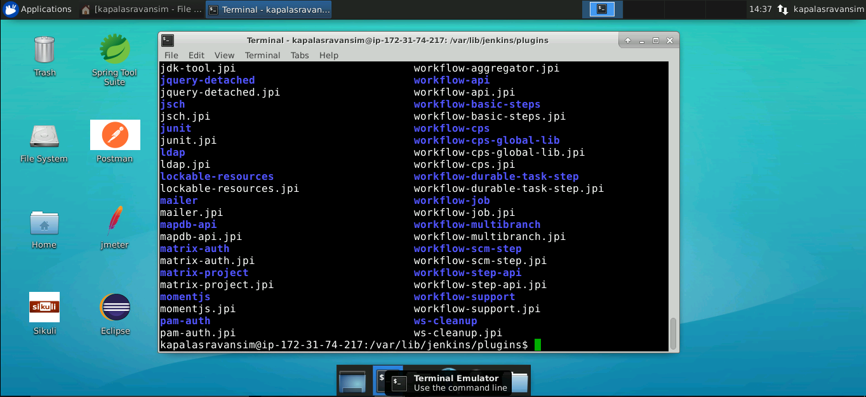

**Cucumber:**

* Cucumber is already installed in your practice laband you can find it in the directory ***/usr/share/doc/***.
* Use the following command to navigate to the above-mentioned directory:

*/usr/share/doc/*

*ls*

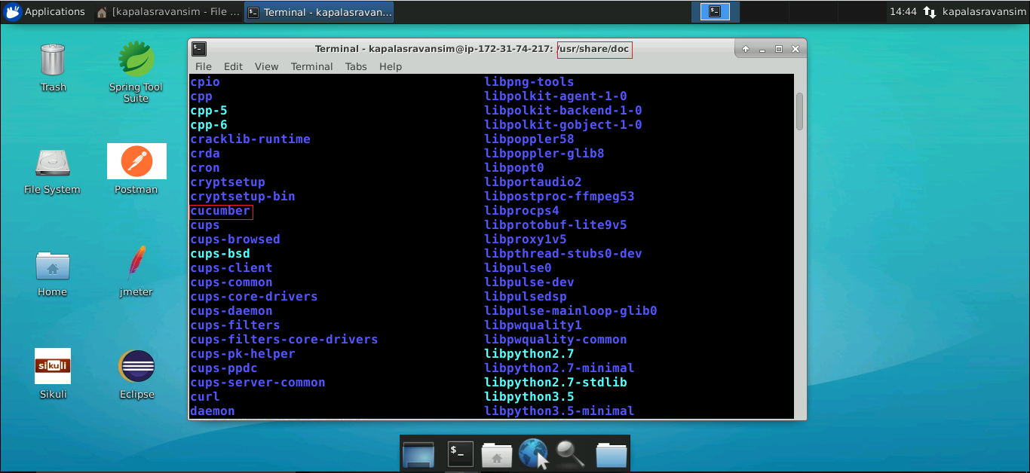

**Apache Poi:**

* Apache Poi is already installed in your practice laband you can find it in the directory ***/usr/share/java***.
* Use the following command to navigate to the above-mentioned directory:

*/usr/share/java*

*ls*

