**Test and Monitor Your Applications Through Non-functional and API Testing**

QA to QE: Lab Guide - Phase 3



This section will guide you to:

* Use practice labs for executing all the demos included in this course

This lab has two subsections, namely:

1. Starting practice labs on LMS
2. Using different IDEs and software required for Phase 3

## **Step 1:** Starting practice labs on LMS

* Log in to the Simplilearn LMS
* Navigate to the respective course and click on it
* You will see the course table of content on the left side of the screen. Click on the **PRACTICE LAB** tab, which you will find below the **SELF LEARNING** tab

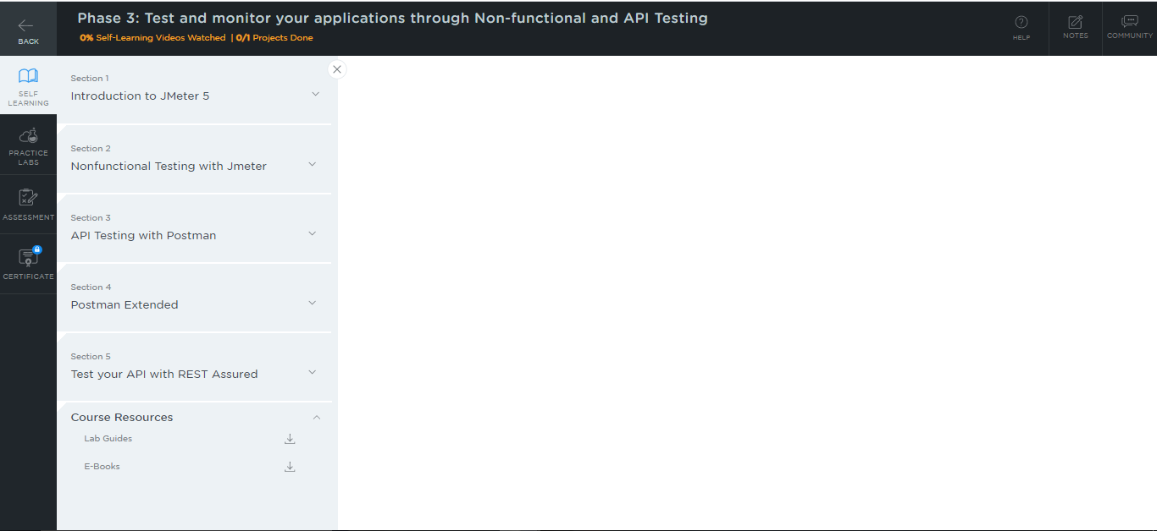

* A new window will open. Go through the instructions and click on **LAUNCH LAB**. This will launch the practice labs for this course.

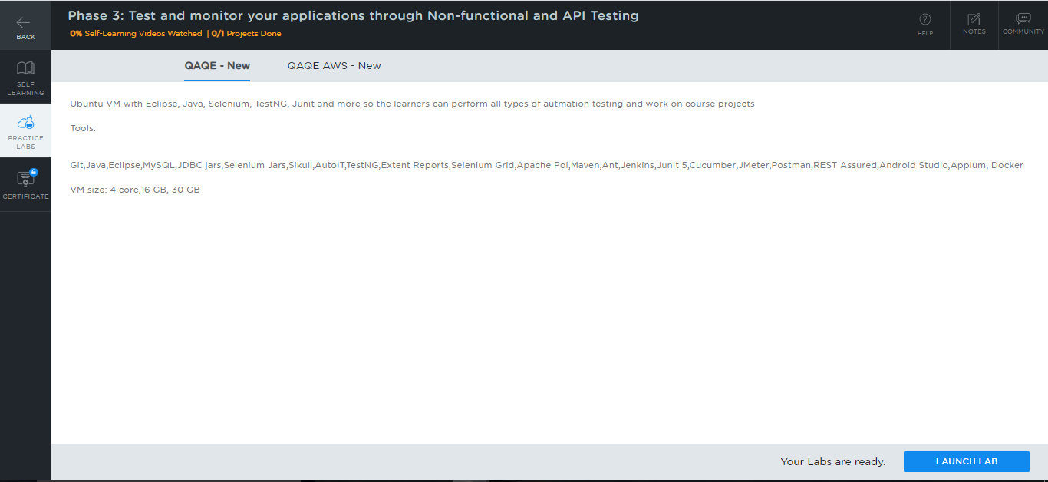

* All the required IDEs and software can be accessed from the lab.

## **Step 2:** Using different IDEs and software required for phase 3

**Jmeter:**

* Jmeter is already installed in your practice lab. You will find it in the

**/*opt*/directory.**

* Use the following commands to navigate to the above-mentioned directory:

*cd /opt/*

*ls*

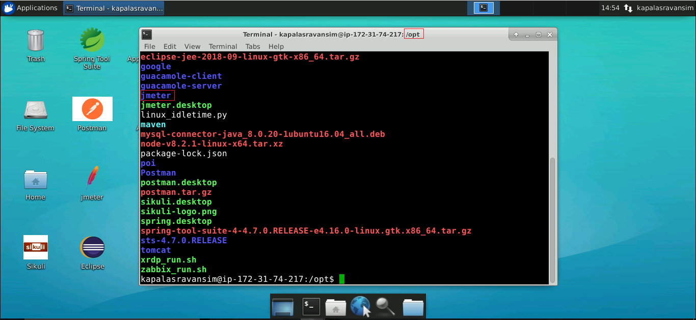

* In case Jmeter is not installed in your practice lab, you can install it using the following commands:

*sudo apt update*

*sudo apt install jmeter*

**Postman:**

* Postman is already installed in your practice lab. You will find it in the

**/*opt*/directory.**

* Use the following commands to navigate to the above-mentioned directory:

*cd /opt/*

*ls*

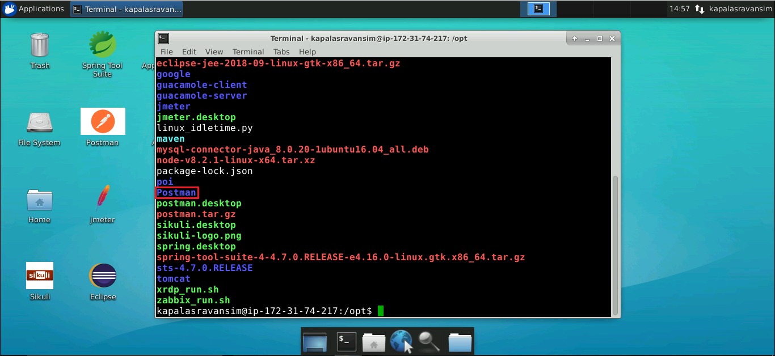

**REST Assured:**

* REST Assured is already installed in your practice lab. You will find it in the directory ***/home/Ubuntu/.m2/repository/io***.
* Use the following commands to navigate to the above-mentioned directory:

*cd /home/Ubuntu/.m2/repository/io*

*ls*

