**Learn Mobile Automation and Cloud Testing**

QA to QE: Lab Guide - Phase 4



This section will guide you to:

* Use practice labs for executing all the demos included in this course

This lab has two subsections, namely:

1. Starting practice labs on LMS
2. Using different IDEs and softwares required for Phase 4

## **Step 1:** Starting Practice Labs on LMS

* Log in to the Simplilearn LMS
* Navigate to the respective course and click on it
* You will see the course table of content on the left side of the screen.Click on the **PRACTICE LAB** tab, which you will find below the **SELF LEARNING** tab

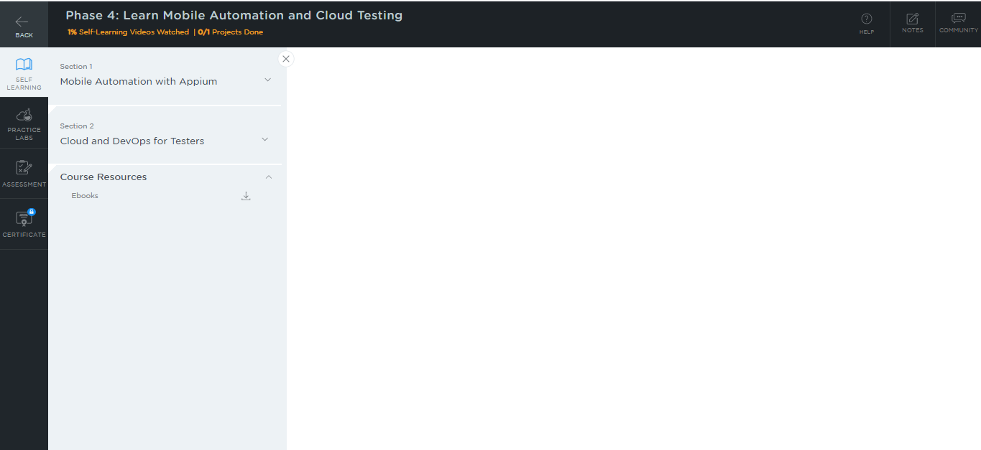

* A new window will open. Go through the instructions and click on **LAUNCH LAB**. This will launch the practice labs for this course.

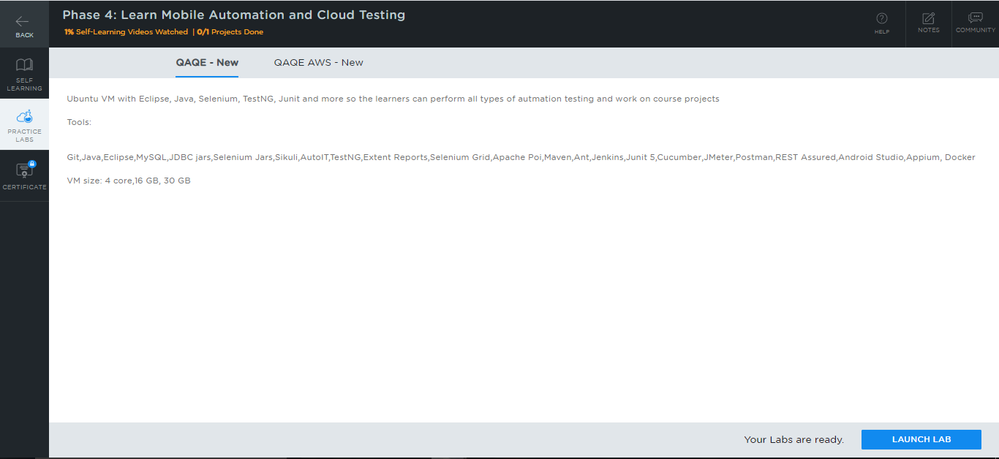

* All the required IDEs and software can be accessed from the lab.

## **Step 2:** Using different IDEs and software required for phase 4

**AWS EC2, AWS S3, and AWS EBS:**

* These services have been enabled in the **AWS Account Plan** lab. Use the following steps to use this lab:

1. Click on the **practice labs tab > QAQE AWS > URL** lab as shown in the screenshot below:

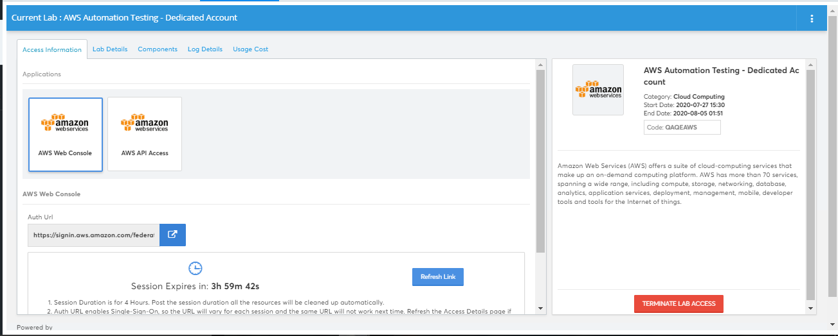

1. After signing in, you will be able to see the AWS Management Console . You can access services such as AWS EC2, AWS S3, and AWS EBS in this console.

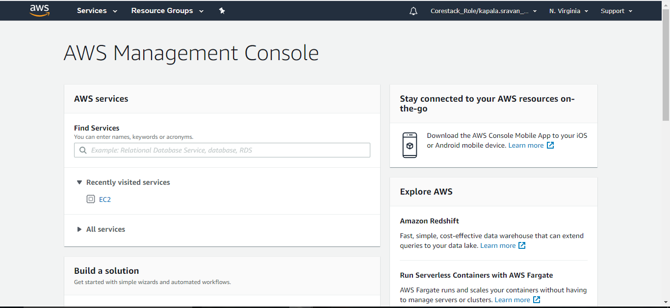

**Docker:**

* Docker version 19.03.11 is installed in your practice lab.
* To verify the installation:

1. Open the command-line interface
2. Type in the command:

*docker --version*

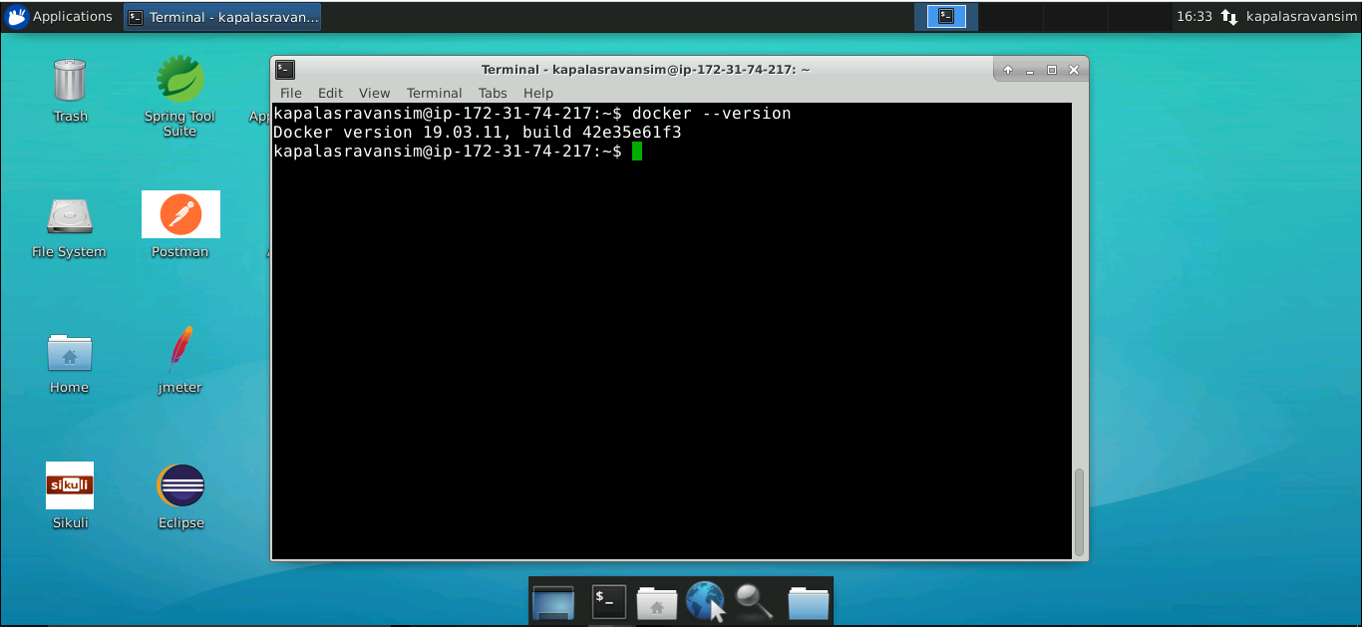

* In case Docker is not installed in your practice lab, you can install it by following the steps mentioned below:

1. Set up the Docker repository using the following commands:

*sudo apt-get update*

*sudo apt-get install apt-transport-https ca-certificates curl software-properties-common*

*curl -fsSL https://download.docker.com/linux/ubuntu/gpg | sudo apt-key add -*

*sudo add-apt-repository "deb [arch=amd64] https://download.docker.com/linux/ubuntu $(lsb_release -cs) stable"*

1. Install Docker using the following command:

*sudo apt-get install docker-ce*