**Certified Kubernetes Administrator (CKA)**

Lab Guide



This section will guide you to:

* Use labs for executing all the demos included in this course

This lab has two subsections, namely:

* + 1. Starting practice labs on LMS
    2. Using different IDEs and software

**Step 1:** Starting practice labs on LMS

* Login to Simplilearn LMS.
* Go to the respective course.
* You will see the page with the course TOC. Click on **PRACTICE LABS**.

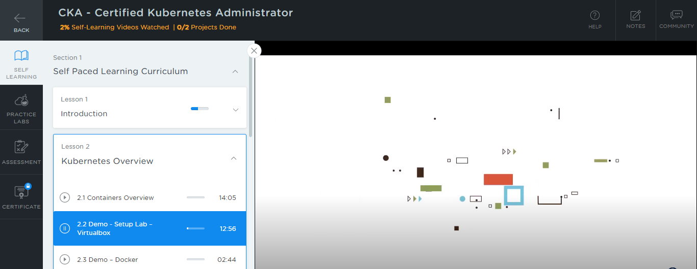

* A new window will open. Read the instructions and click on **LAUNCH LAB.** This will launch practice labs for this course.

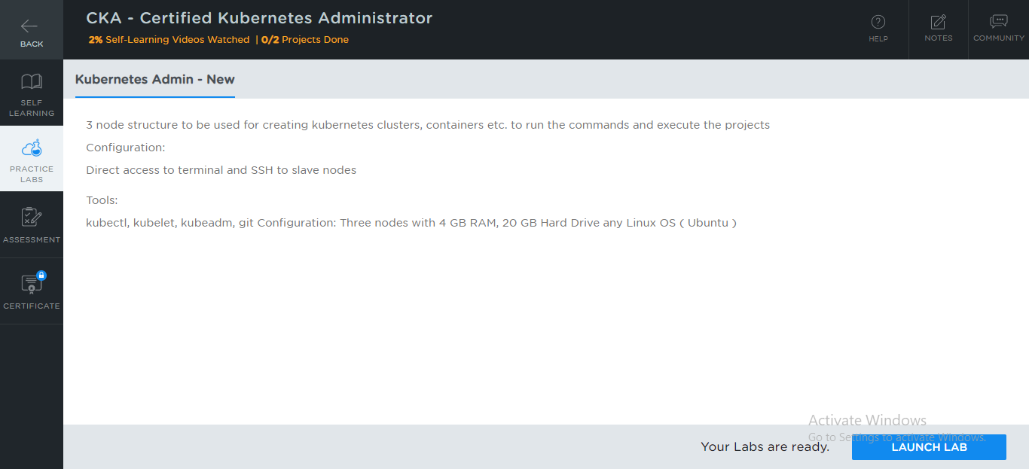

* You will be able to access IDEs and software which are present in the labs.

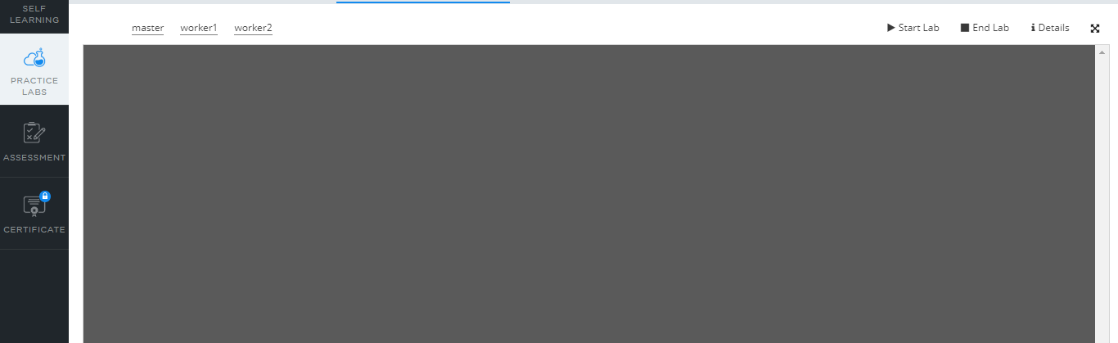

**Step 2:** Using different IDEs and software

**kubectl:**

* *Kubectl* is already installed in your practice lab
* To check the version, type

*kubectl version --client*



* If kubectl is not installed in your lab, then execute the following commands:

*curl -LO "https://storage.googleapis.com/kubernetes-release/release/$(curl -s https://storage.googleapis.com/kubernetes-release/release/stable.txt)/bin/linux/amd64/kubectl"*

*chmod +x ./kubectl*

*sudo mv ./kubectl /usr/local/bin/kubectl*

*kubectl version --client*

**kubeadm:**

* *kubeadm* is already installed in your practice lab
* To verify the installation:

1. Open the command-line interface
2. Type the command:

*kubeadm version*



* In case it is not installed in your practice lab, you can install it following these steps:

1. Set up the repository using the following commands:

*curl -s https://packages.cloud.google.com/apt/doc/apt-key.gpg | apt-key add -*

*echo 'deb http://apt.kubernetes.io/ kubernetes-xenial main' | sudo tee*

*/etc/apt/sources.list.d/kubernetes.list*

1. Install Kubernetes using the command:

*sudo apt-get install kubelet kubeadm kubectl -y*

**kubelet:**

* *kubelet* is already installed in your practice lab
* To verify the installation:

1. Open the command-line interface
2. Type the command:

*sudo kubelet*



**Docker:**

* Docker version 19.03.11 is already installed in your practice lab
* To verify the installation:

1. Open the command-line interface
2. Type the command:

*docker --version*

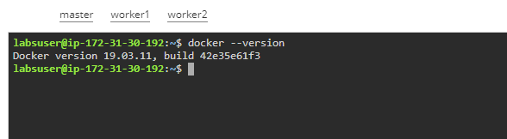

* In case Docker is not installed in your practice lab, you can install it using the following steps:

1. Set up Docker repository using the following commands:

*sudo apt-get update*

*sudo apt-get install apt-transport-https ca-certificates curl software-properties-common*

*curl -fsSL https://download.docker.com/linux/ubuntu/gpg | sudo apt-key add -*

*sudo add-apt-repository "deb [arch=amd64] https://download.docker.com/linux/ubuntu $(lsb_release -cs) stable"*

1. Install Docker using the command:

*sudo apt-get install docker-ce*