**PG DO Certified Kubernetes Administrator Training**

Lab Guide

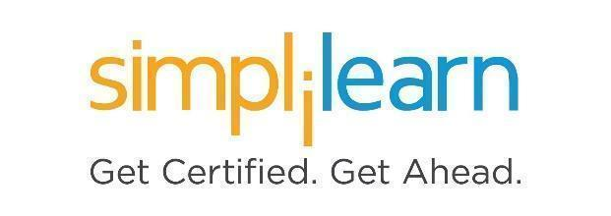

This section will guide you to:

* Use labs to execute all demos included in this course

This lab has two subsections, namely:

1. Starting practice labs on LMS
2. Checking the versions of installed OS and softwares
3. Accessing the Azure Resource Group through VM

**Step 1:** Starting practice labs on LMS

* Login to Simplilearn LMS
* Go to the respective course

* On the left side panel, you will find the course ToC
* To its left, you will find the **PRACTICE LABS** tab
* Click on it

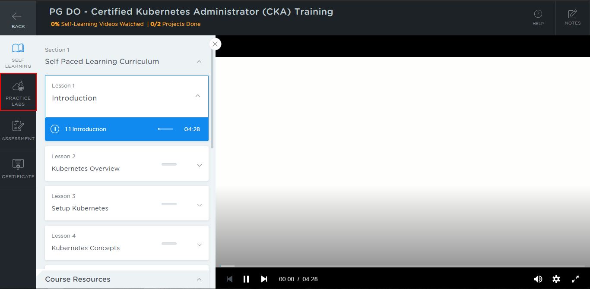

* As a new window opens, read the instructions and click on **LAUNCH LAB**
* This will launch practice labs for this course

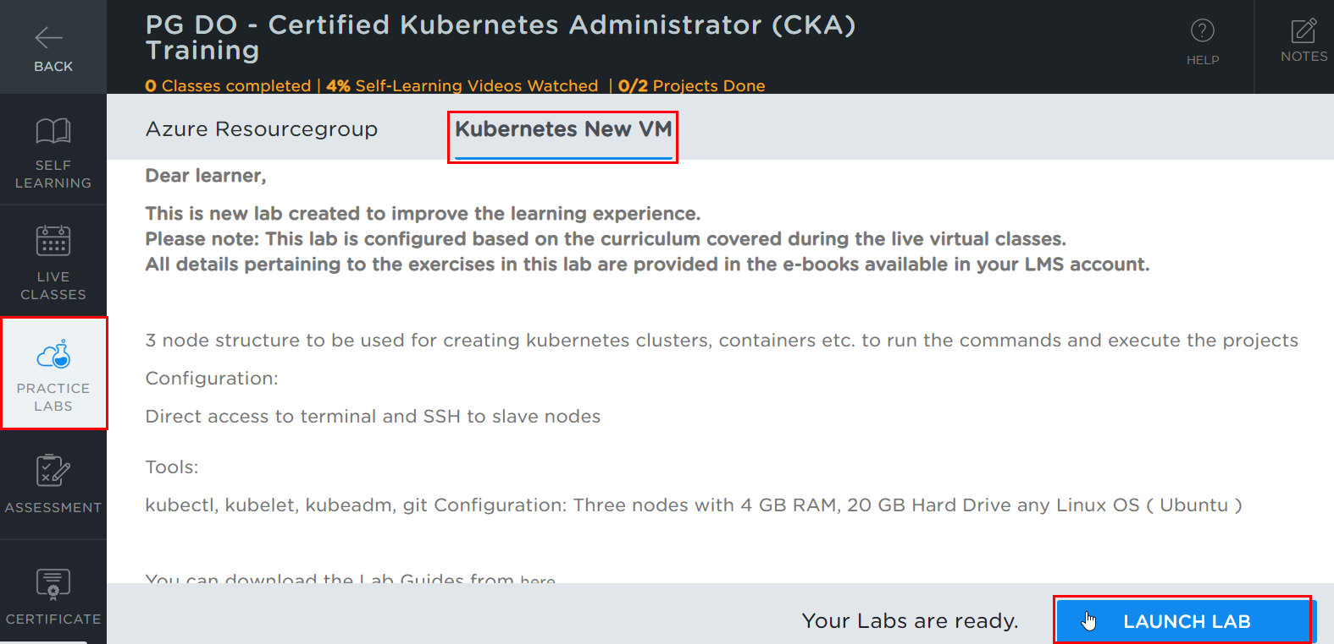

* Once the lab instance is started, click on the *Start Lab* button as shown below:

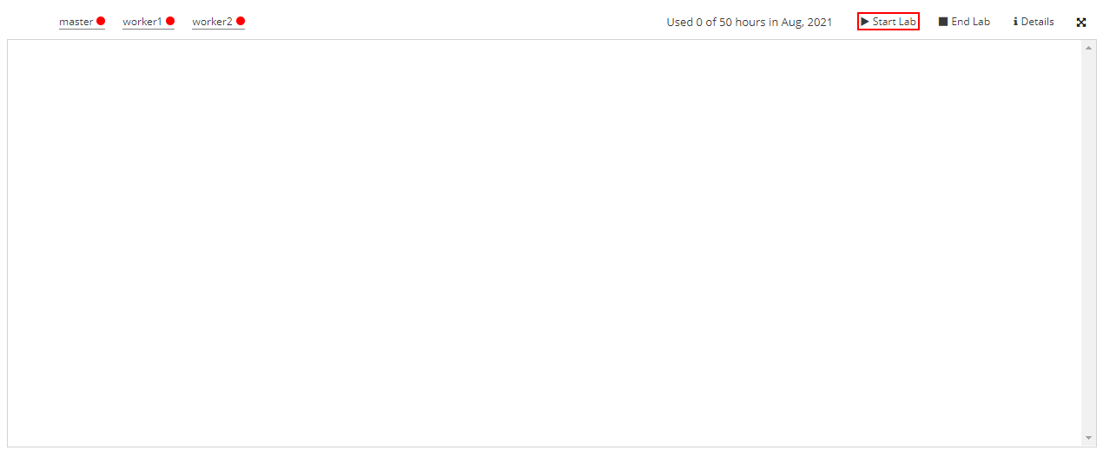

* You will be able to access the master and worker nodes which are present in labs

**Master Node:**

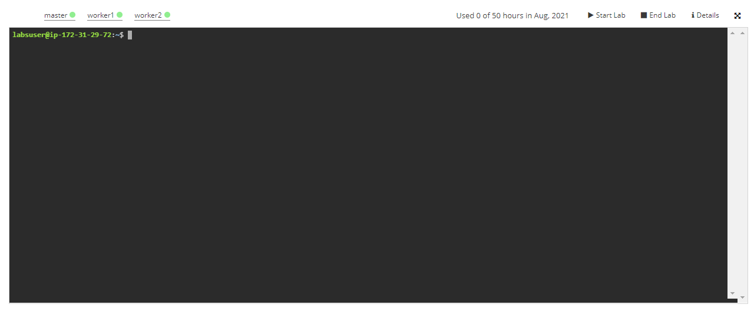

**Worker Node:**

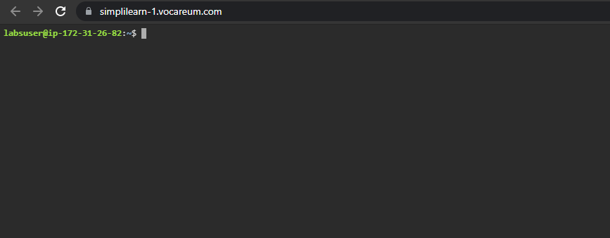

**Step 2:** Checking the versions of installed OS and softwares

* **Linux OS:**

To verify the version of the linux installation, execute the following command:

***lsb_release -a***

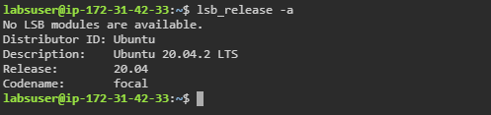

* **Docker:**

Docker is already installed in the labs. To check the Docker version run the following command:

***docker --version***

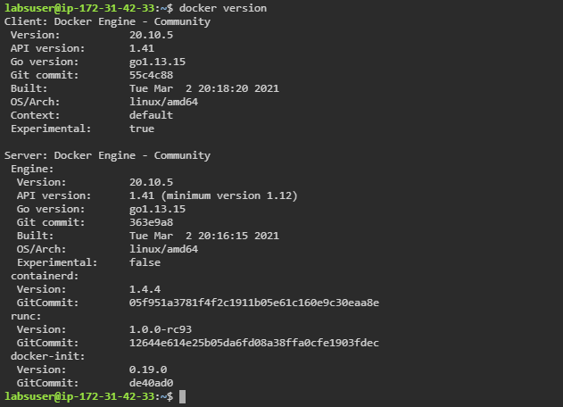

* **Kubernetes:**

Kubernetes is already installed in the labs. To check the versions of kubeadm, kubectl, and kubelet run the following commands:

***kubeadm version***

***kubectl version***

***kubelet --version***

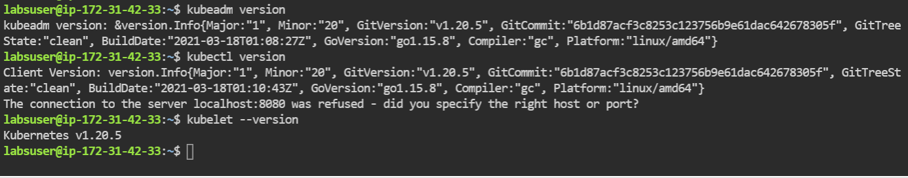

| **Note:** Notice that the installed **Kubernetes version is 1.20.5**. Do not update to the latest version of Kubernetes (v1.22.0) as it will throw errors while setting up a Kubernetes Cluster. |
| --- |

**Step 3:** Accessing the Azure Resource Group through VM

* Select the *Azure Resourcegroup* and click on the **LAUNCH LAB** button

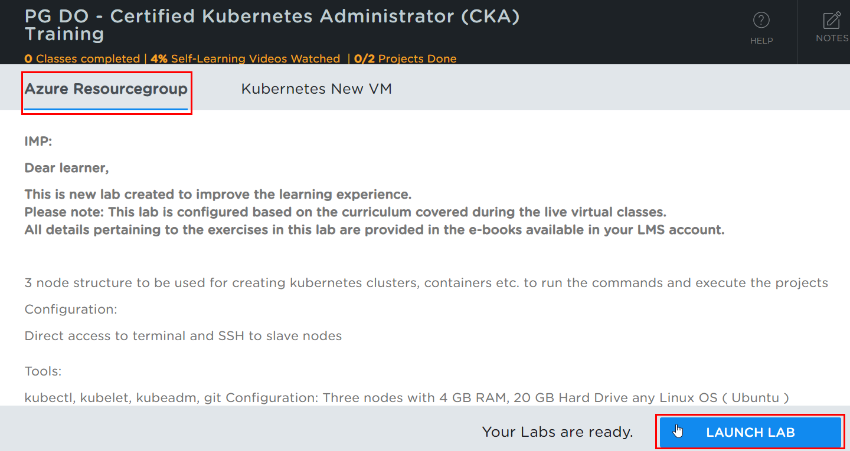

* Click on **Start Lab** button  
  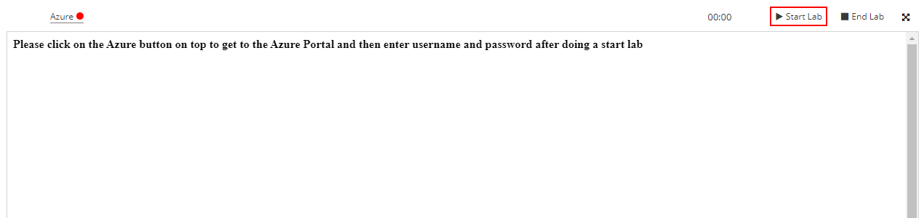
* Once the lab is active, the credentials for the Azure account will be revealed. Note the credentials and click the *Azure* button to launch the portal.  
  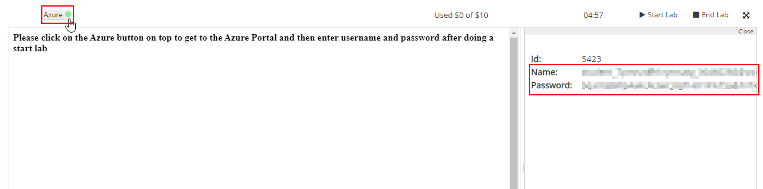
* Enter the email ID provided and click on the **Next** button

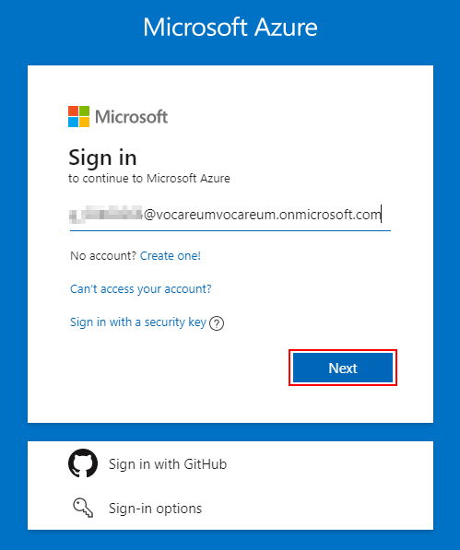

* Type the password and click on the **Sign in** button

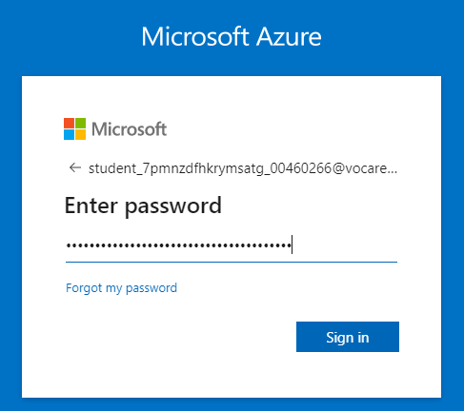

* The Azure portal opens along with the Dashboard and the list of Azure services

