**Get Started with Web Development**

MEAN: Lab Guide - Phase 1



This section will guide you to:

* Use practice labs for executing all the demos included in this course

This lab has two subsections, namely:

1. Starting practice labs on LMS
2. Using different IDEs and software required for phase 1

**Step 1:** Starting practice labs on LMS

* Log in to the Simplilearn LMS
* Navigate to the respective course and click on it
* You will see the course table of contents page on the left side of the screen. Click on **PRACTICE LABS**

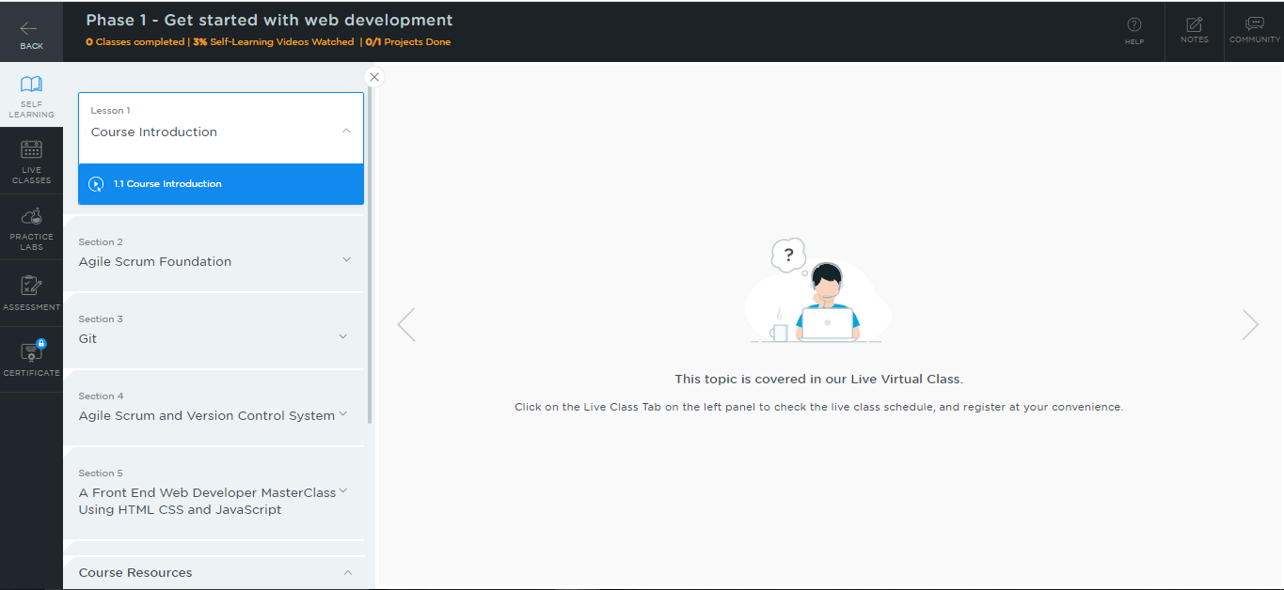

* A new window will open. Read the instructions and click on **LAUNCH LAB.** This will launch the practice labs for this course.

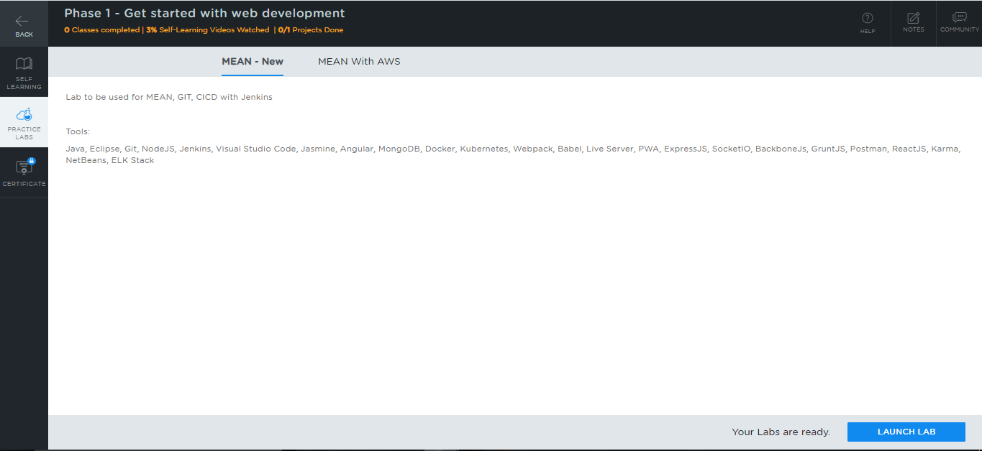

* You will be able to access IDEs and softwares which are present in the labs.

**Step 2:** Using different IDEs and software required for phase 1

**Java:**

* Java 1.8 is installed in your practice lab.
* Open the terminal and type **java -version** to verify whether Java is installed or not

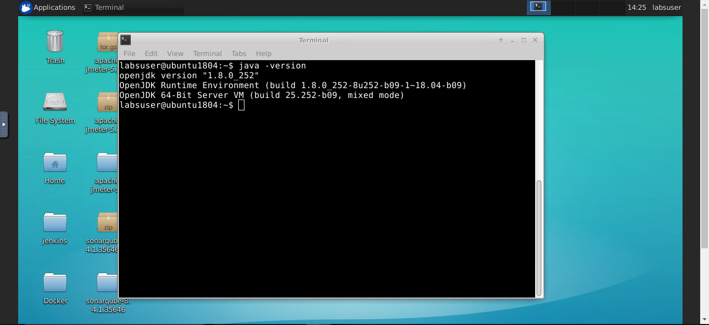

* If Java is not installed in your system, then type the following commands:

*sudo apt-get install openjdk-8-jdk*

*sudo apt-get install openjdk-8-jre*

**Git:**

* Git is installed in your practice lab.
* To check whether Git is installed properly or not:
  + Create a folder named **Demo_Git** on your desktop and open it
  + Create the files: **index.html** and **helloWorld.java**
  + Open the terminal and navigate to the folder that you have created
  + Execute the following command to initialize .git repository:

*git init*

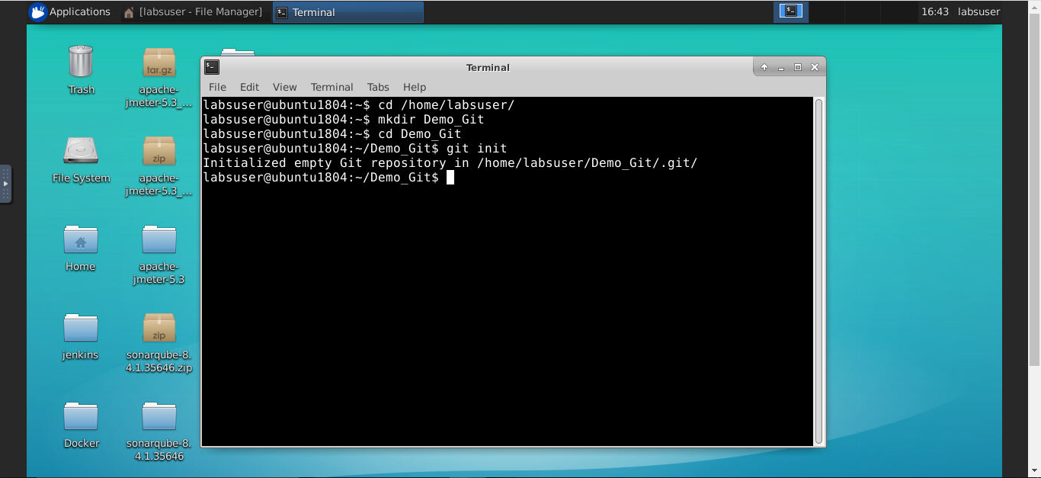

**Visual Studio Code:**

* Visual Studio Code is installed in your practice lab.
* To launch it, click on the **Visual Studio Code** icon on the desktop

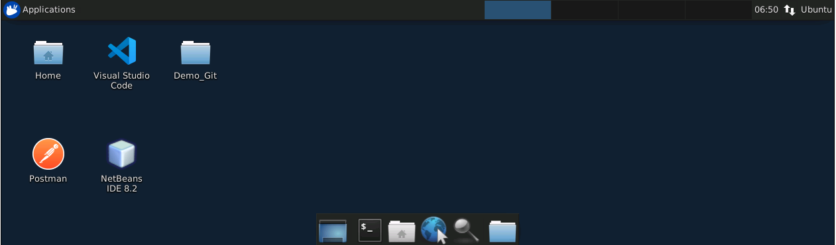

**Node JS:**

* Node JS 10.15.3 version is installed in your practice lab.
* To verify the installation

1. Open the command-line interface
2. Type the following command:

*node -v*

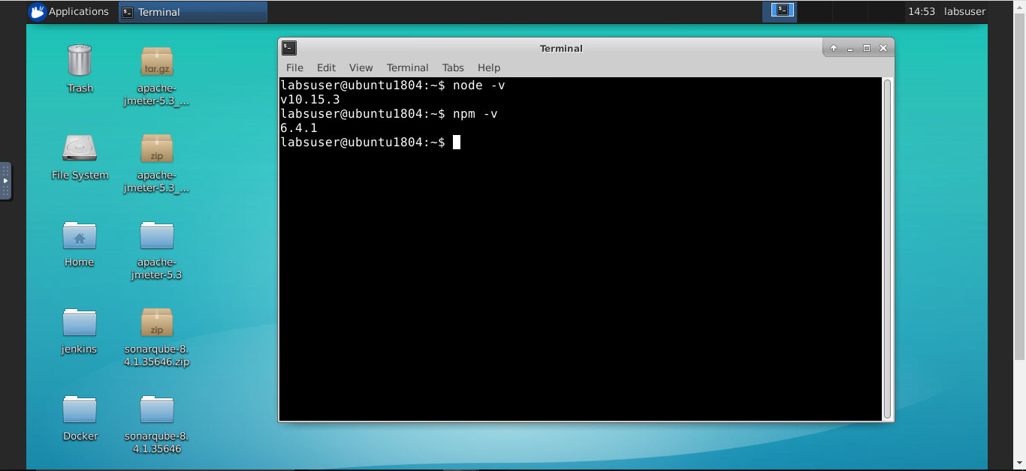

This command displays the Node JS version installed in your practice lab.

* If Node JS is not installed in your practice lab, you can install it using the following commands:

*sudo apt-get update*

*sudo apt-get install nodejs*