**Testing the Application and DevOps**

MEAN: Lab Guide - Phase 4



This section will guide you to:

* Use practice labs for executing all the demos included in this course

This lab has two subsections, namely:

1. Starting practice labs on LMS
2. Using different IDEs and softwares required for phase 4

**Step 1:** Starting practice labs on LMS

* Log in to the Simplilearn LMS
* Navigate to the respective course and click on it
* You will see the course table of contents page on the left side of the screen. Click on **PRACTICE LABS**

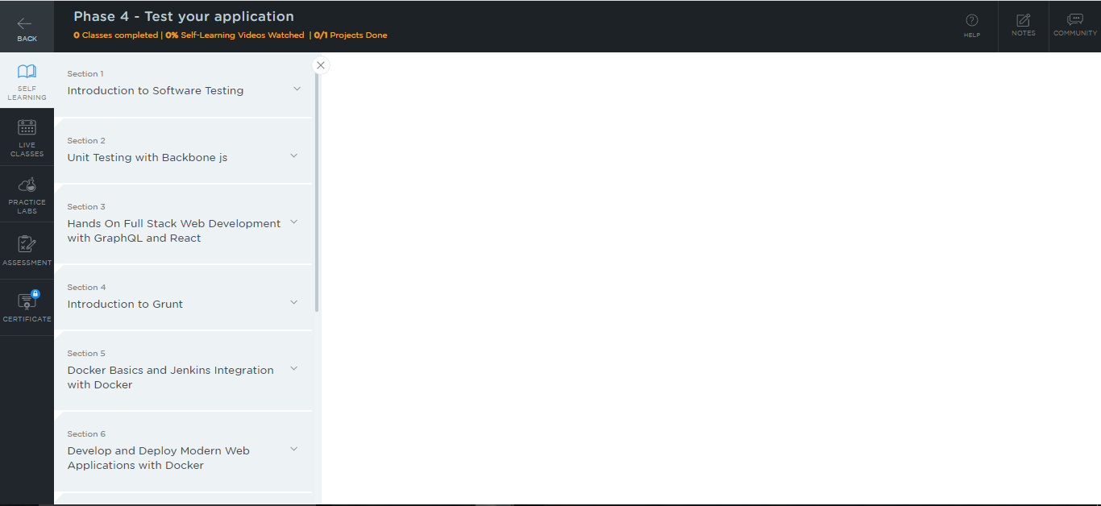

* A new window will open. Read the instructions and click on **LAUNCH LAB.** This will launch the practice labs for this course.

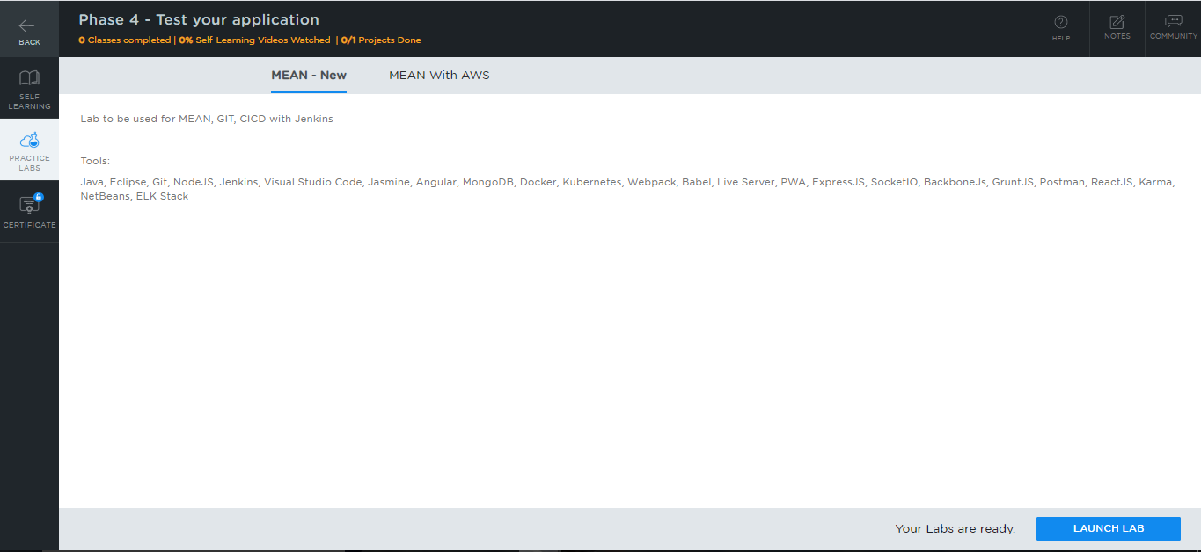

* You will be able to access IDEs and softwares which are present in the labs.

**Step 2:** Using different IDEs and software required for phase 4

**Jasmine:**

* Jasmine is installed in your practice lab using npm.
* To verify the installation:

1. Open the command-line interface
2. Type the command:  
     
   *npm view jasmine version*

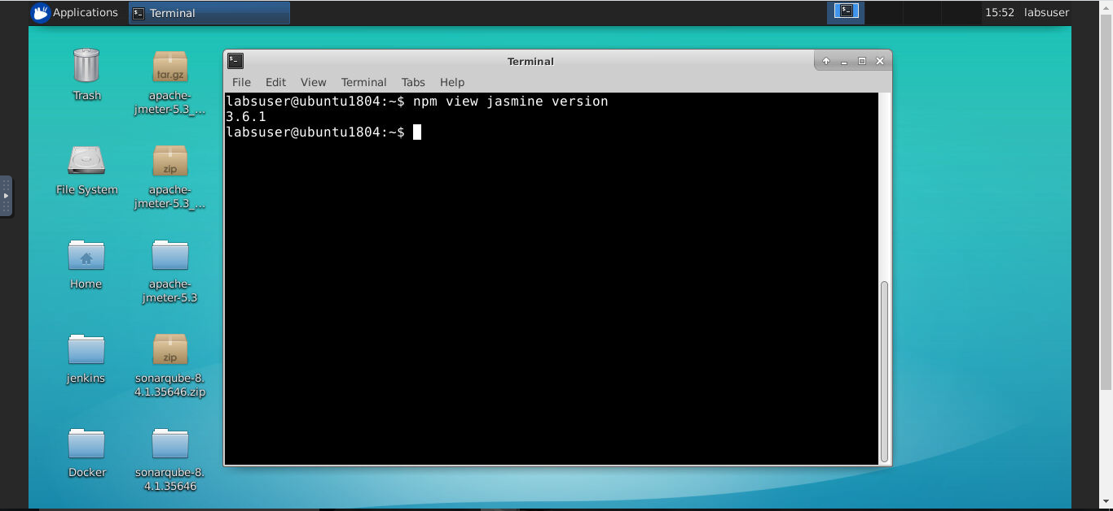

* If Jasmine is not installed in your practice lab, you can install it using the following command:

*npm install -g jasmine*

**Karma:**

* Karma is installed in your practice lab using npm.
* To verify the installation:

1. Open the command-line interface
2. Type the command:  
     
   *npm view jasmine version*

**Docker:**

* Docker version 19.03.11 is installed in your practice lab.
* To verify the installation:

1. Open the command-line interface
2. Type the command:

*docker --version*

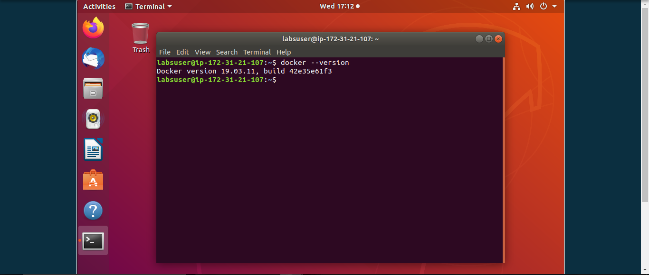

* In case Docker is not installed in your practice lab, you can install it by following the steps mentioned below:

1. Set up the Docker repository using the following commands:

*sudo apt-get update*

*sudo apt-get install apt-transport-https ca-certificates curl software-properties-common*

*curl -fsSL https://download.docker.com/linux/ubuntu/gpg | sudo apt-key add -*

*sudo add-apt-repository "deb [arch=amd64] https://download.docker.com/linux/ubuntu $(lsb_release -cs) stable"*

1. Install Docker using the command:  
     
   *sudo apt-get install docker-ce*

**Jenkins:**

* Jenkins is already installed in your practice lab. You will find it in the directory **/usr/share**.
* Use the following commands to navigate to the above-mentioned directory:

*cd /usr/share*

*ls*

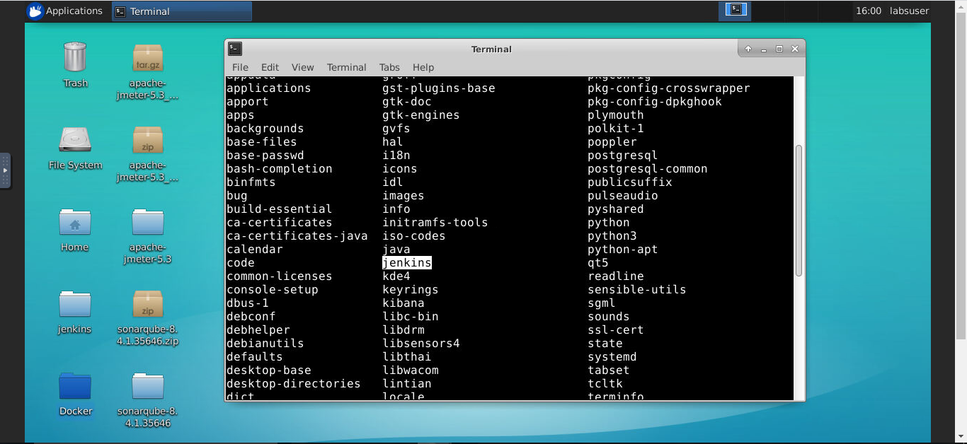

* In case Jenkins is not installed in your practice lab, you can install it using the following commands:

*sudo apt update*

*sudo apt install jenkins*

**AWS EC2, AWS S3, and AWS EBS:**

* These services are enabled in the **Mean Stack with AWS** lab. Follow the steps mentioned below for using this lab:

1. Click on **AWS** to launch the AWS Management Console

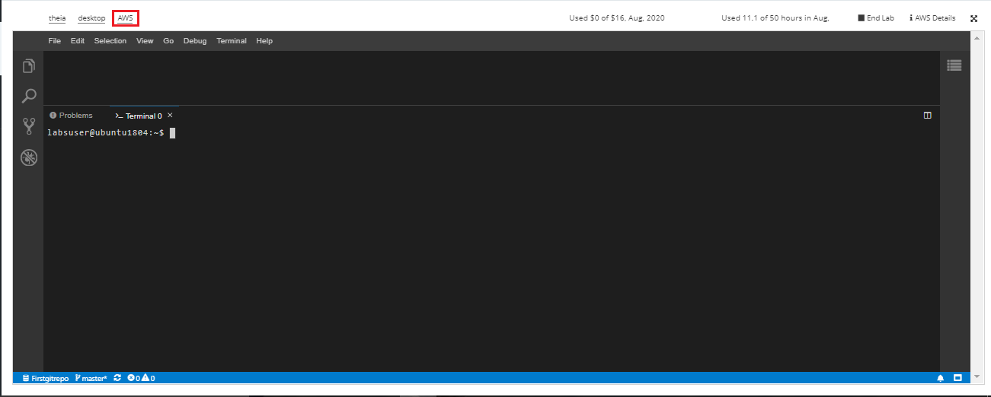

1. The AWS Management Console will open up, and you can access services such as AWS EC2, AWS S3, and AWS EBS in this console.

