**Java Engineer**

Phase End Project(UI) Solution



**Twitter Clone**

**Steps to be followed:**

1. Installing or updating all the project dependencies.
2. Importing the project files into the Visual Studio Code IDE.
3. Starting the Angular Server on 4200 port.
4. Executing the projects in VS Code.

**Step 1: Installing or updating all the project dependencies**

1. Please ensure that the following tools are installed in your system:

* NodeJS 10.20
* Visual Studio Code 8

Note: The guides to install these are available in your course component, and you have already used them in the training.

**Step 2: Importing the project files into the VSC IDE**

1. Open VSC
2. Go to **File**, and click on **Open Folder from File System**

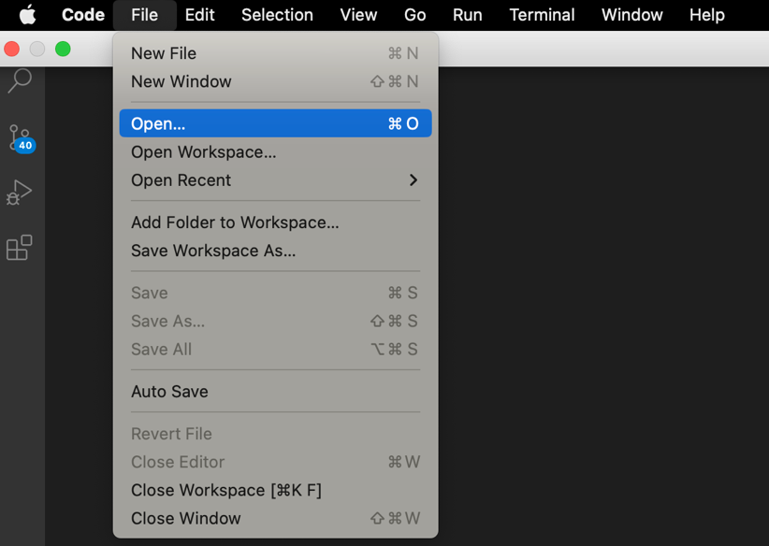

1. Click on the folder that needs to be imported, and then click on **Open**

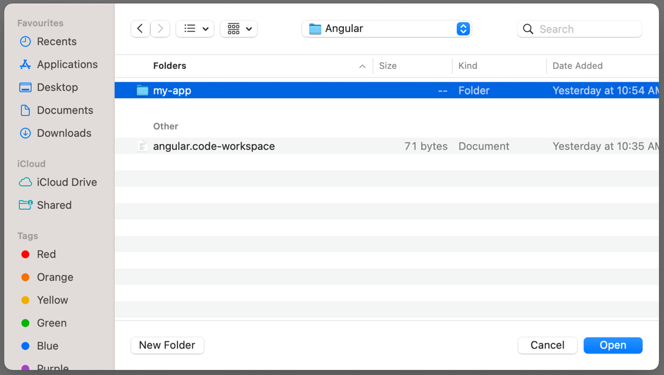

1. Open integrated terminal using **ctrl + `**

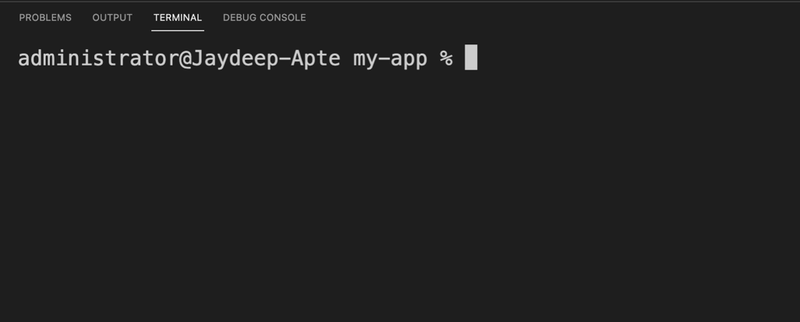

1. Run the command:- npm install

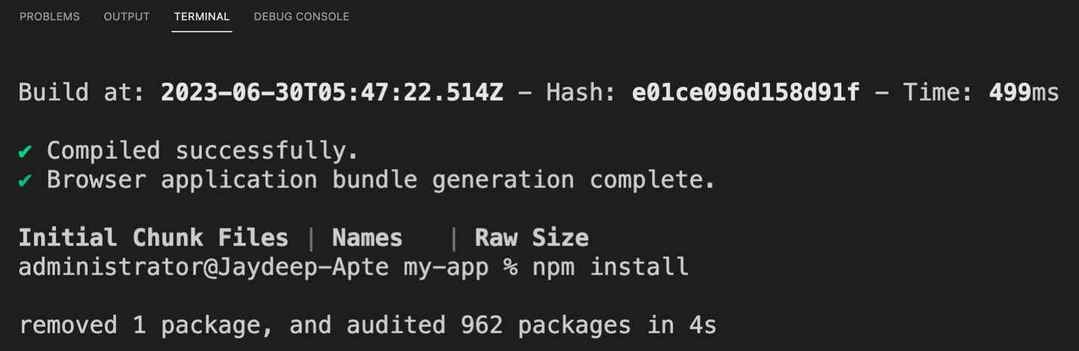

2.6 Run the command ng serve –open

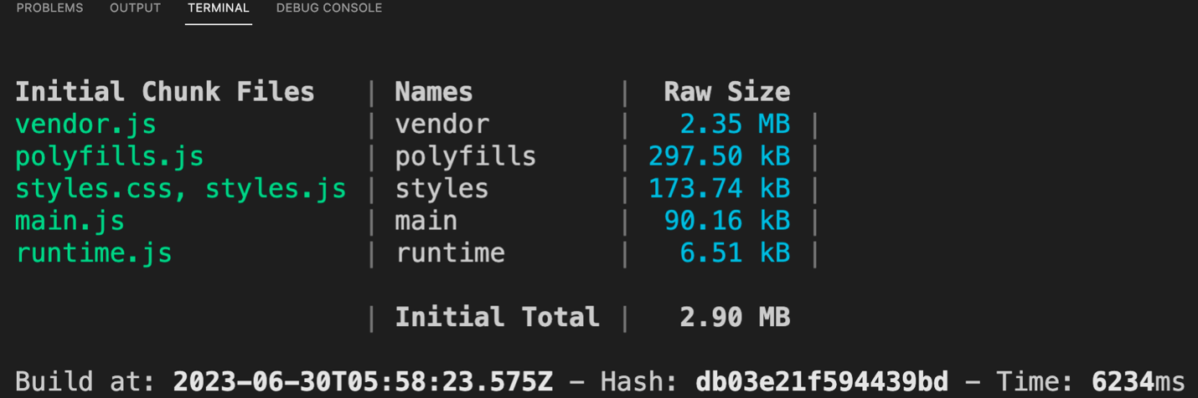

2.7 Observe the output

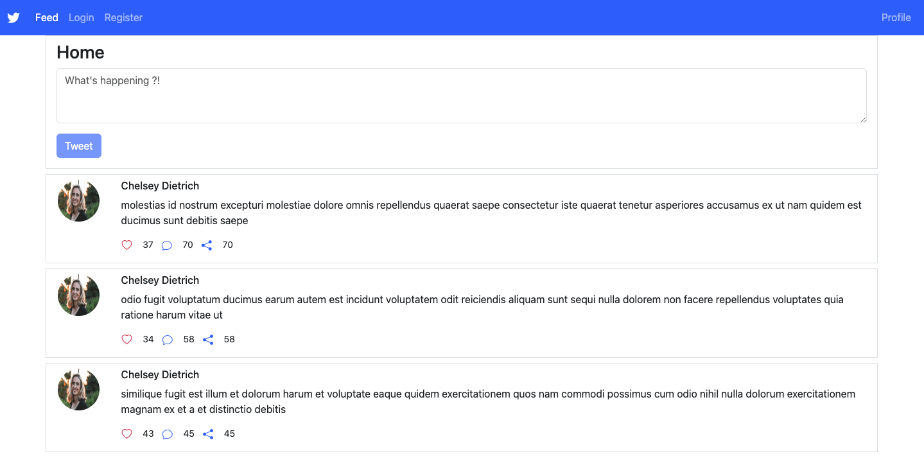

**Step 3: Understanding the Angular Front End Design**

1. **Login Component**
   1. This is the Login Component having proper fields and a submit button.

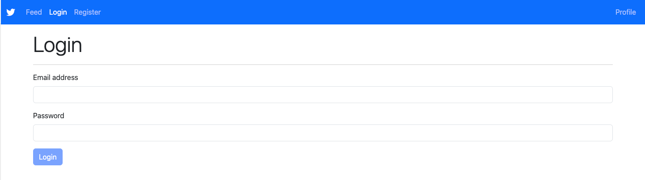

* 1. Let’s look at the validations, details are shared in the problem statement document already.

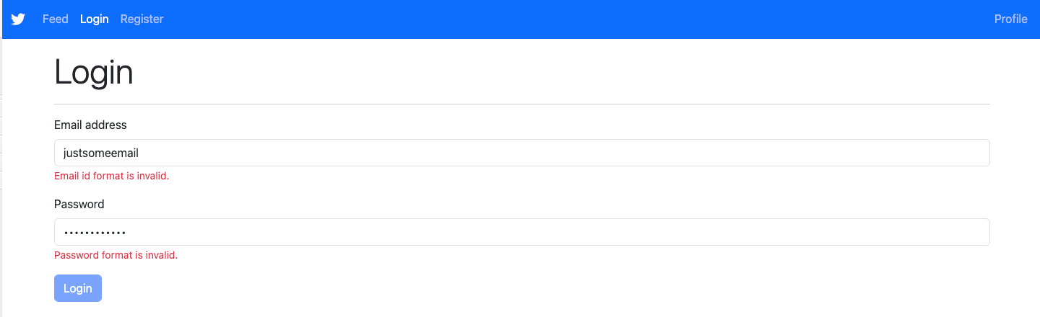

1. **Register Component**
   1. This is the Register Component having proper fields and a submit button.

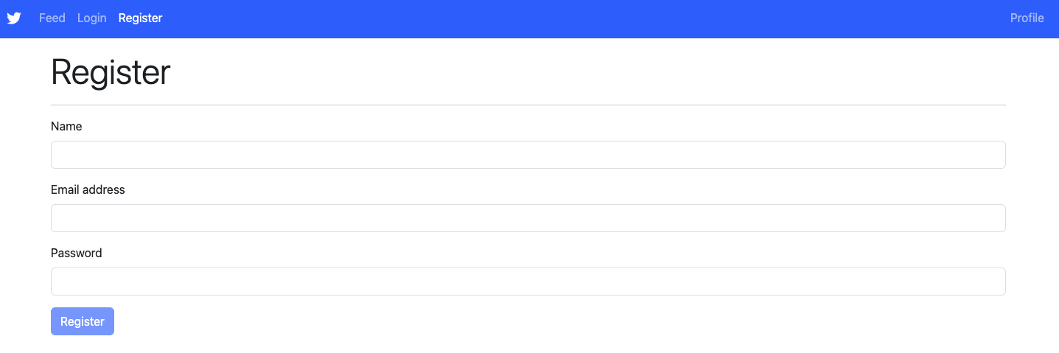

* 1. Let’s look at the validations, details are shared in the problem statement document already.

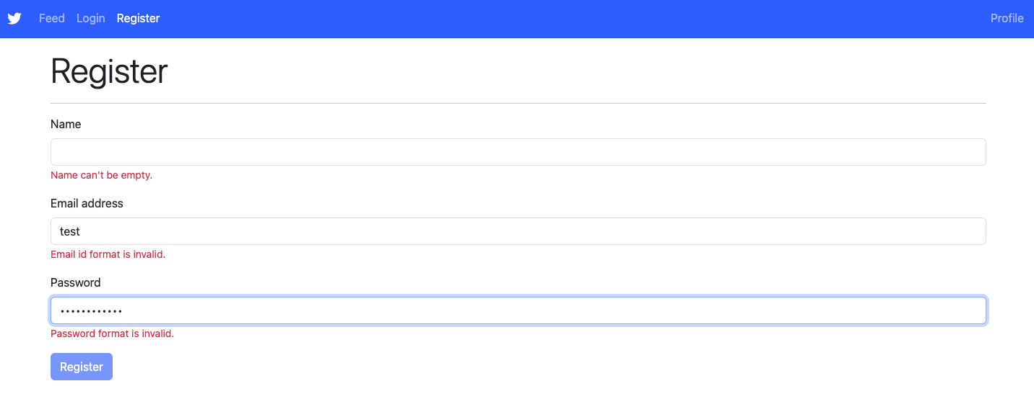

1. **Feed Component**
   1. The tweets are sorted in alphabetical ordering as per mentioned requirement.

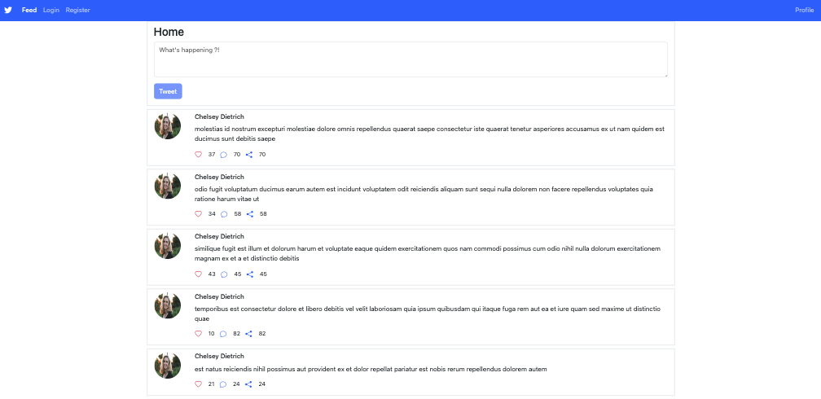

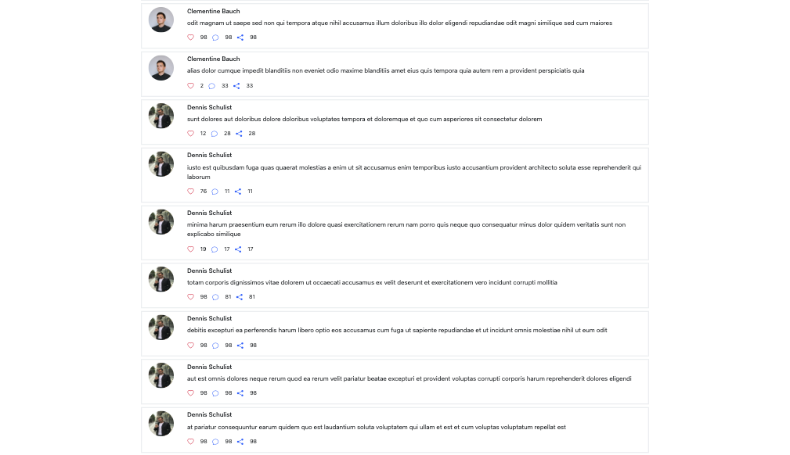

* 1. Add a comment

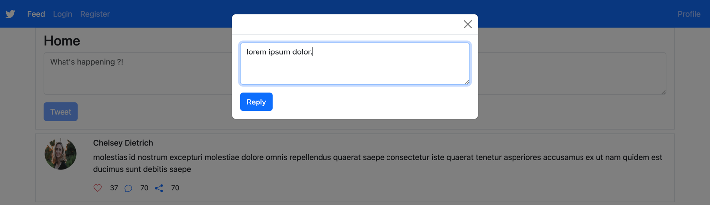

1. **Profile Component**
   1. The profile details of a user can be displayed in this component as below.



* 1. Edit Button allows a user to edit profile details as below.

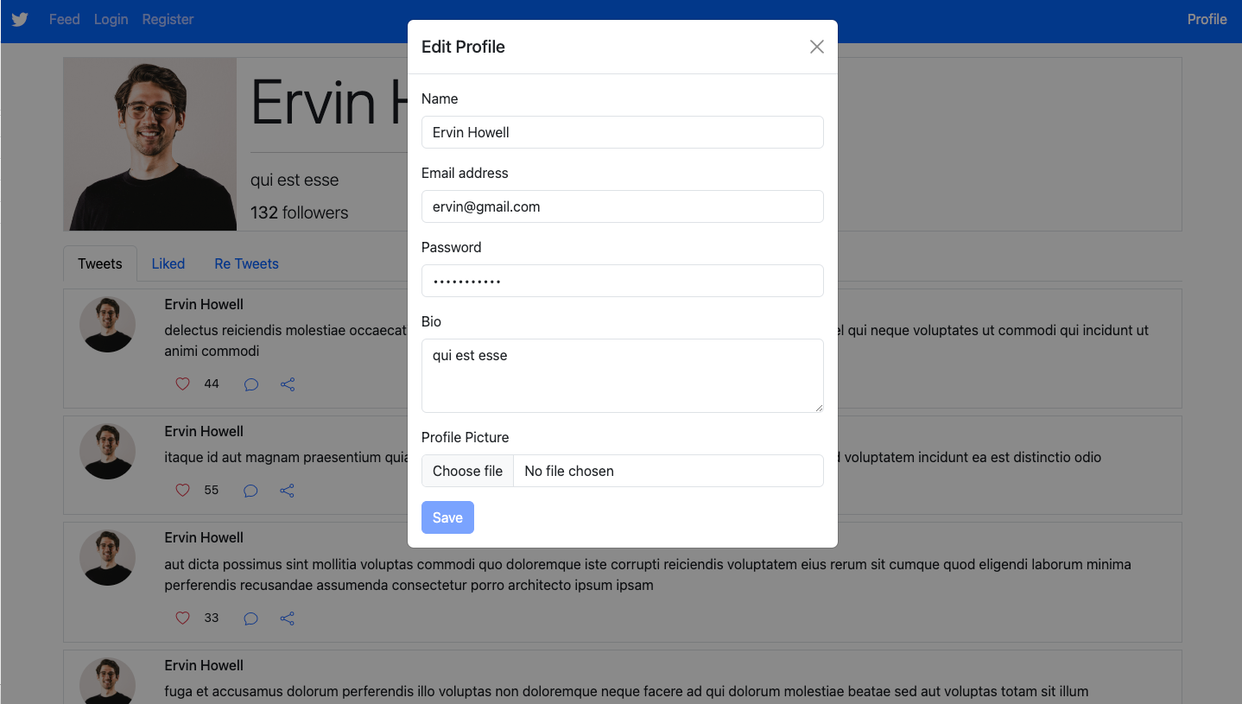

* 1. Tweets button displays all the tweets made by this user.

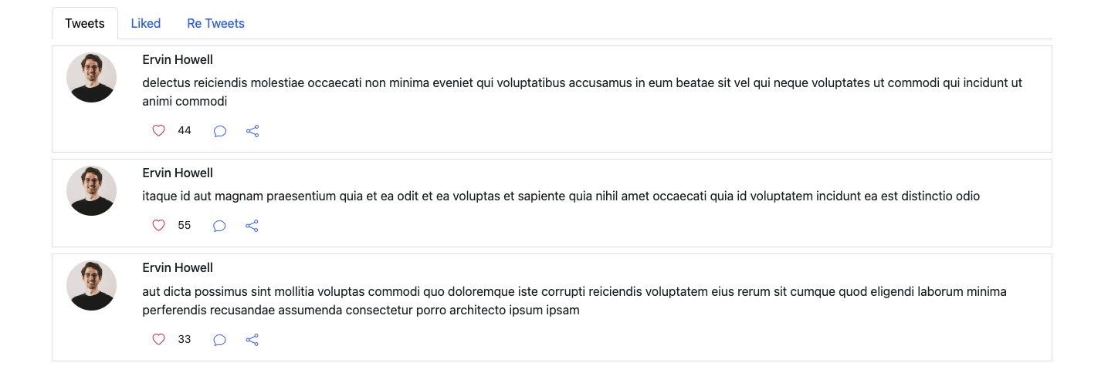

* 1. Liked button displays all the tweets liked by this user.

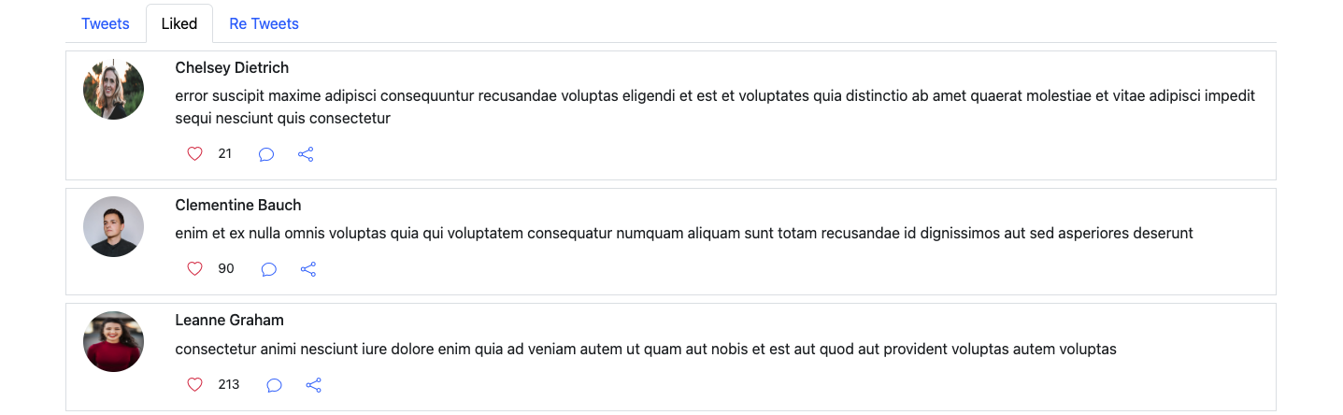

* 1. Re Tweets button displays all the tweets re tweeted by this user.

